Additional file : Supplementary figure 1
Cumulative incidence by median family income. Regional municipalities outside the Quebec City area.

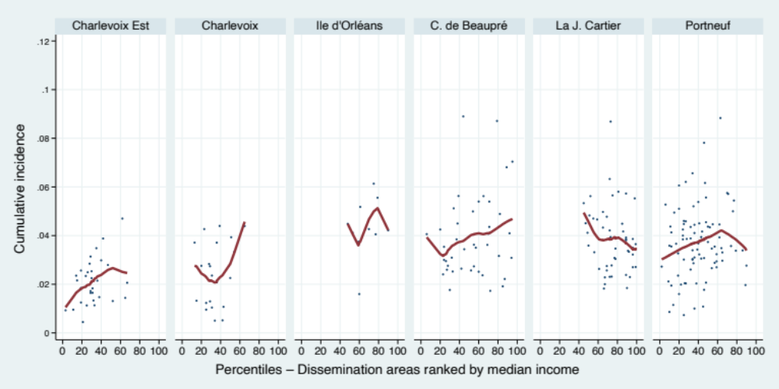

Additional file : Supplementary table 1

Cumulative cases reported as of November 6, 2021, by regional county municipality*.
Capitale-Nationale health region.

Regional county municipality | Number of areas | Number of cases*
Charlevoix-Est | 32 | 329
Charlevoix | 22 | 376
Ile d'Orléans | 11 | 357
Côte de Beaupré | 41 | 1 216
La Jacques-Cartier | 49 | 1 822
Québec | 946 | 29 117
Portneuf | 88 | 88
Non-assigned | - | 55
Total | 1 189 | 35 473
* All reported cases except those residing in long-term care hospitals and correctional facilities

Additional file : Supplementary figure 2

Cumulative incidence and social deprivation by population density.
Subsample of dissemination areas in the Quebec City agglomeration (N = 946).

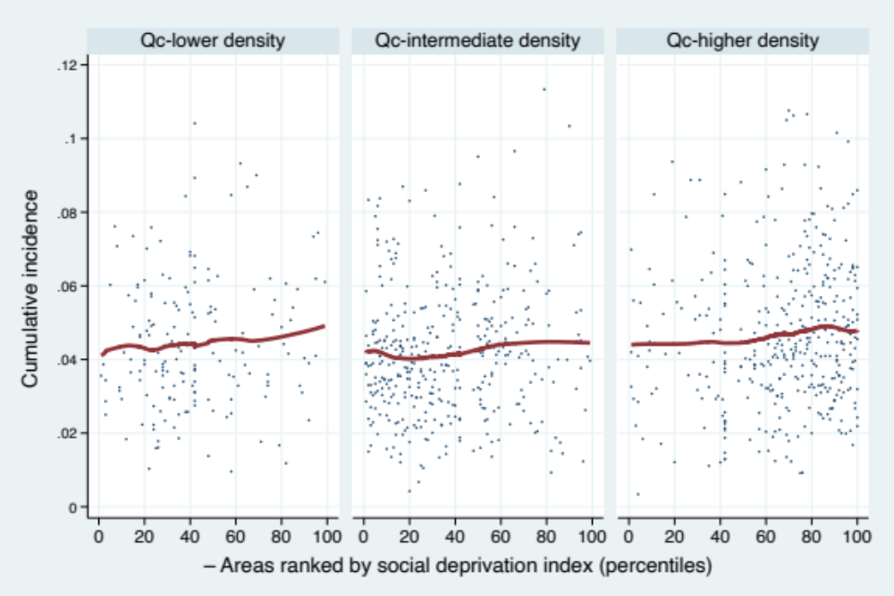

Additional file : Supplementary table 2

Probability that an area will be in the group of areas most exposed or least exposed to the pandemic based on the area’s level of economic deprivation.

 | Probability* that an area  will be in the group of areas: |  | Probability ratios
 | most exposed** | least exposed*** | Probability ratios
Family income stratum
Most economically disadvantaged areas (Q1) | 0.33 | 0.09 | 3.55
 | [.28; .39] | [.07; .12] | [2.02; 5.08]
Most economically advantaged areas (Q5) | .13 | .26 | .52
 | [.10; .17] | [.21; .31] | [.32; .72]

* Predicted probability of being in a given group of areas after adjusting for population density and size, municipality of residence, and proportion of immigrants in the area.
** First quintile of the distribution: cumulative incidence less than 0.027.
*** Fifth quintile of the distribution: cumulative incidence greater than or equal to 0.058.

