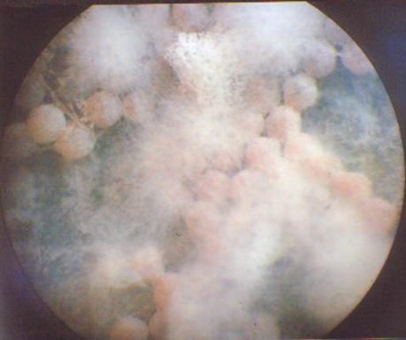
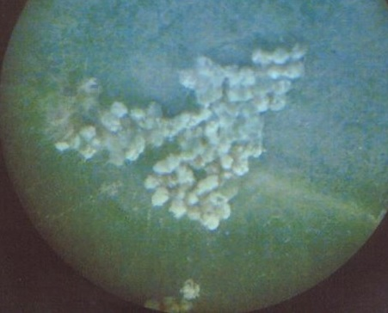
S. 1. Photographs showing infected eggs of the fall armyworm S. frugiperda at 5 days post-fungal application. A) The white fungal hyphae appear spread on the outer surfaces of the eggs. These hyphae of B. bassiana KACC40224 completely covered the eggs 5 days later. B) The insect eggs infected with M. anisopliae KACC40029 showing the green fungal growth on its outer surface five days after exposure to the fungus.

A
B

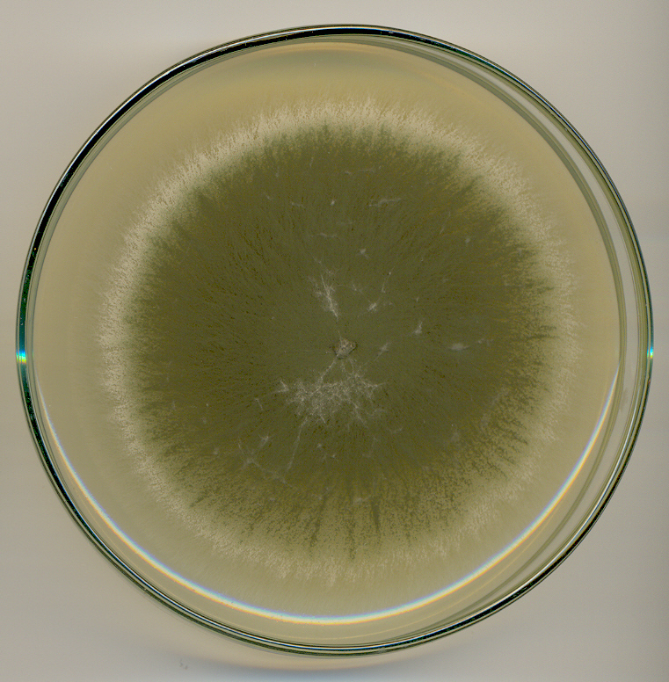
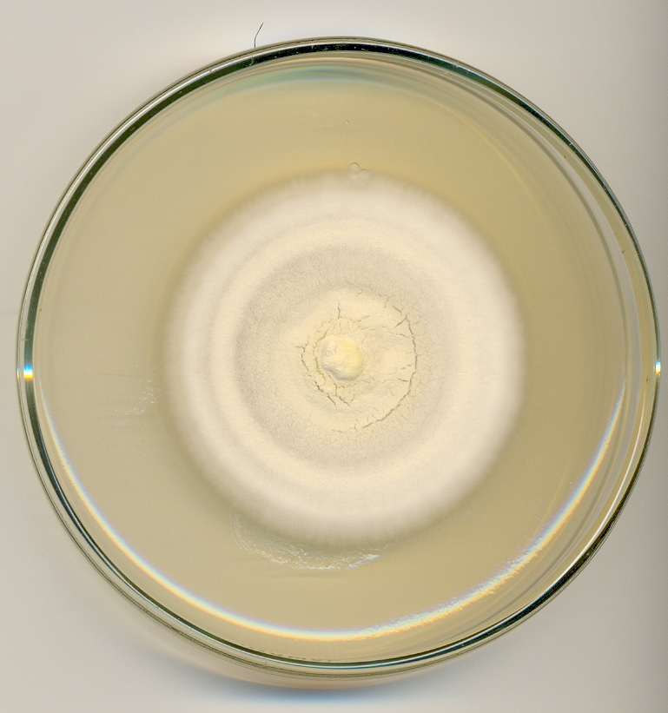
S. 2. MEA 10 days-old cultures of A) Beauveria bassiana KACC40224 and B) Metarhizium anisopliae KACC40029 under 27 ⁰C and full dark conditions.
A
B

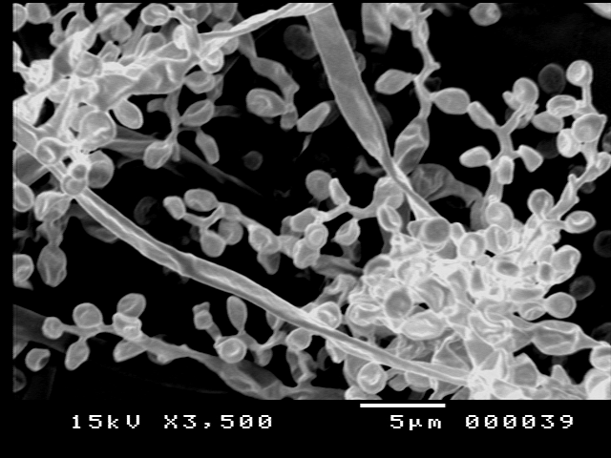
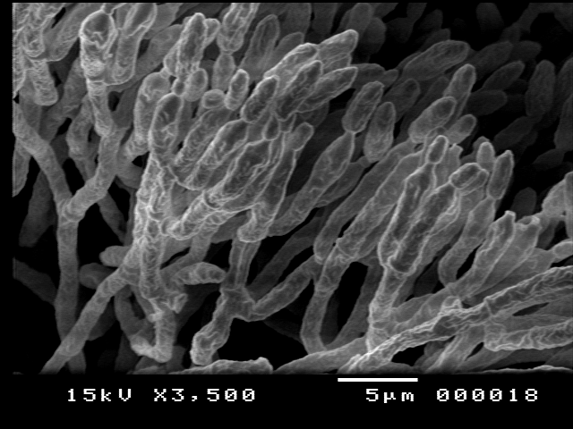
S. 3. Scanning electron micrograph of A) B. bassiana KACC40224 and B) M. anisopliae KACC40029. Conidia (co) and hyphae (hy) (× = 3500).
A
hy
co
B
hy
co

S. 4 A) & B) Side of the damaging effect of the fall armyworm S. frugiperda to the corn crop in the field.

