Article title: Screening Enterococcus isolates for antimicrobial and in vitro antitumor activity against colorectal carcinomas
Journal name: International Journal of Colorectal Disease
Authors: Ayesha Siddiqa^{1*}; Ashba Hassan²; Imran Sajid³
¹School of Biological Sciences, University of the Punjab, Quaid-e-Azam Campus, Lahore, Pakistan
²Institute of Microbiology and Molecular Genetics, University of the Punjab, Quaid-e-Azam campus, Lahore, Pakistan
³Institute of Microbiology and Molecular Genetics, University of the Punjab, Quaid-e-Azam Campus, Lahore, Pakistan
*Corresponding author E-mail: ayeshasiddiqa758@gmail.com
SUPPLEMENTARY DATA
TABLES
Table 1. Morphological characteristics of the selected colonies
Strains | Form | Color | Size | Elevation | Margin | Pigmentation | Texture
AE1 | Circular | Pale yellow | 2 | Raised | Entire | _ | Sticky
AE2 | Circular | Pale yellow | 2 | Raised | Entire | _ | Sticky
AE3 | Circular | Pale yellow | 1 | Raised | Entire | _ | Sticky
AE4 | Circular | Pale yellow | 2 | Raised | Entire | _ | Sticky
AE7 | Circular | Pale yellow | 2 | Raised | Entire | _ | Sticky
AE8 | Circular | Pale yellow | 1 | Raised | Entire | _ | Sticky
AE10 | Regular | Pale yellow | 2 | Raised | Entire | _ | Sticky
AE11 | Circular | Pale yellow | 2 | Raised | Entire | _ | Sticky
AE12 | Circular | Pale yellow | 2 | Raised | Entire | _ | Sticky
AE13 | Circular | Pale yellow | 2 | Raised | Entire | _ | Sticky
AE18 | Regular | Pale yellow | 1 | Raised | Entire | _ | Sticky
WT1 | Circular | Off white | 2 | Convex | Entire | _ | Mucoid
WT2 | Circular | Off white | 3 | Convex | Entire | _ | Mucoid
WT3 | Circular | Off white | 2 | Convex | Entire | _ | Mucoid
WT5 | Circular | Off white | 4 | Convex | Entire | _ | Mucoid
WT8 | Circular | Off white | 3 | Convex | Entire | _ | Mucoid
WT9 | Circular | Off white | 2 | Convex | Entire | _ | Mucoid
YTA | Regular | Pale yellow | 0.5 | Flat | Entire | _ | Dry
YTB | Regular | Pale yellow | 1 | Flat | Entire | _ | Dry
YTC | Circular | Pale yellow | 1 | Flat | Entire | _ | Dry
YTE | Circular | Pale yellow | 1 | Flat | Entire |  | Dry

Table 2. Biochemical characteristics of selected isolates
Strains | CAT | OXI | IND | NIT | VP | H₂S | NaCl | High pH
AE1 | - | - | - | - | - | - | + | +
AE2 | - | - | - | - | - | - | + | +
AE3 | - | - | - | - | - | - | + | +
AE4 | - | - | - | - | - | - | + | +
AE7 | - | - | - | - | - | - | + | +
AE8 | - | - | - | - | - | - | + | +
AE10 | - | - | - | - | - | - | + | +
AE11 | - | - | - | - | - | - | + | +
AE12 | - | - | - | - | - | - | + | +
AE13 | - | - | - | - | - | - | + | +
AE18 | - | - | - | - | - | - | + | +
WT1 | - | - | - | - | - | - | + | +
WT2 | - | - | - | - | - | - | + | +
WT3 | - | - | - | - | - | - | + | +
WT5 | - | - | - | - | - | - | + | +
WT8 | - | - | - | - | - | - | + | +
WT9 | - | - | - |  | - | - | + | +
YTA | - | - | - | - | - | - | + | +
YTB | - | - | - | - | - | - | + | +
YTC | - | - | - | - | - | - | + | +
YTE | - | - | - | - | - | - | + | +
CAT= Catalase, OXI=Oxidase, IND=Indole, NIT=Nitrate Reduction, VP=Voges Proskauer, H₂S=Hydrogen sulphide, NaCl=Sodium chloride, High pH=9.6 pH
Table 3. Sugar utilization test
Strains | Lactose |  |  | Mannose |  |  | Fructose
 | No growth | Medium | High | No growth | Medium | High | No growth | Medium | High
AE1 |  | + |  |  | +
AE2 |  |  |  |  | + |  |  |  | +
AE3 | + |  |  | + |  |  | +
AE4 |  | + |  |  |  |  |  | +
AE7 | + |  |  |  |  | + | +
AE8 | + |  |  | +
AE10 | + |  |  | + |  |  | +
AE11 |  |  |  |  | + |  |  | +
AE12 |  | + |  |  | + |  |  | +
AE13 | + |  |  | + |  |  | +
AE18 |  | + |  |  |  | + |  | +
WT1 | + |  |  |  | + |  |  | +
WT2 | + |  |  | + |  |  |  | +
WT3 |  |  | + |  | + |  | +
WT5 |  | + |  |  |  | + |  |  | +
WT8 |  | + |  |  | + |  |  |  | +
WT9 |  | + |  |  | + |  |  |  | +
YTA |  | + |  |  |  | + |  |  | +
YTB |  | + |  |  |  | + |  | +
YTC
YTE | + |  |  |  |  | + |  | +

Table 4a. Anti-microbial activity of supernatant
Strains | Growth inhibition of pathogenic strains(mm)
Strains | Klebsiella | Staphylococcus | Pseudomonas | Enterobacter
AE3 | - | - | 14 | 8
AE12 | 15 | - | - | -
AE13 | - | 17 | 15 | -
AE18 | 17 | 15 | 11 | -
WT1 | - | - | - | 6
WT5 | 12 | 12 | - | -
WT8 | 11 | 9 | 13 | -
WT9 | 14 | - | 10 | -
YTA | - | 14 | - | 9
YTC | 15 | - | 11 | -
YTE | - | 10 | - | -

Table 4b. Anti-microbial activity of extracts
Strains | Growth inhibition of pathogenic strains(mm)
Strains | Klebsiella | Staphylococcus | Pseudomonas | Enterobacter
AE3 | - | 14 | - | 8
AE12 | 17 | 18 | 20 | -
AE13 | - | - | 12 | 7
AE18 | - | 10 | 13 | -
WT1 | - | 12 | 13 | -
WT5 | 9 | - | 8 | -
WT8 | - | 10 | - | -
WT9 | - | 8 | - | -
YTA | - | - | - | 10
YTC | 7 | - | 14 | -
YTE | 10 | 11 | - | -

FIGURES
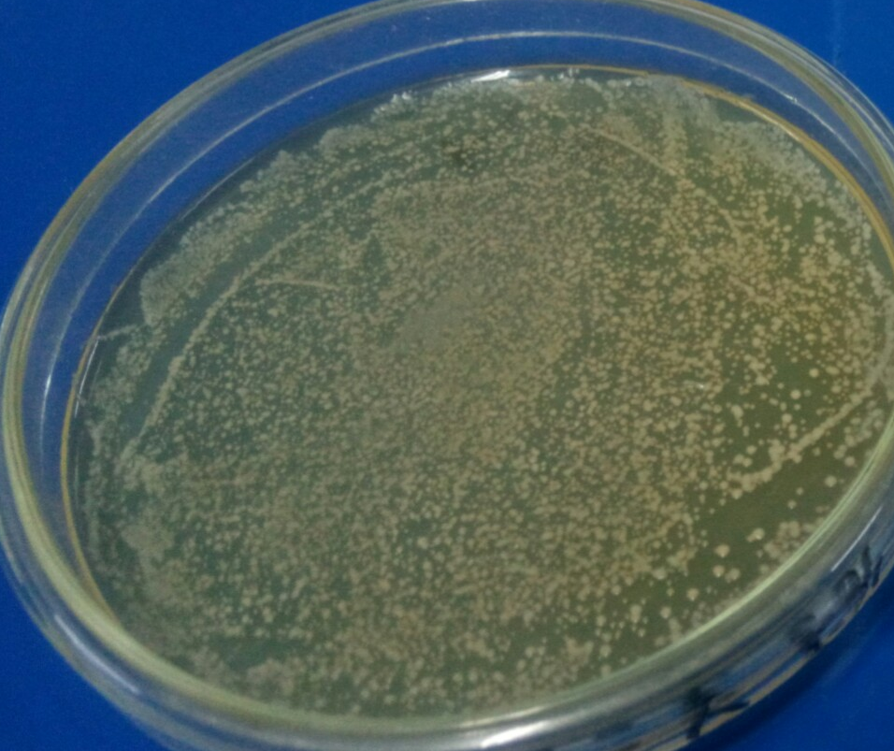
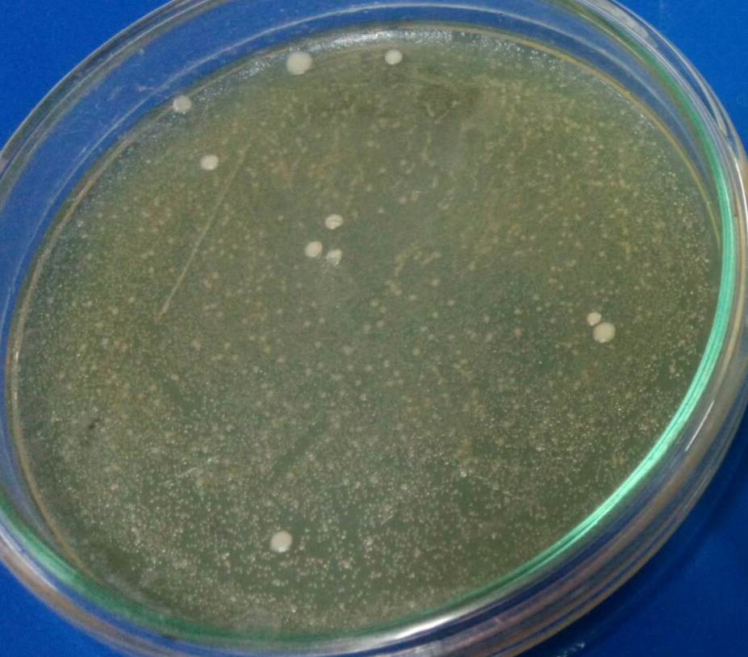

B
A
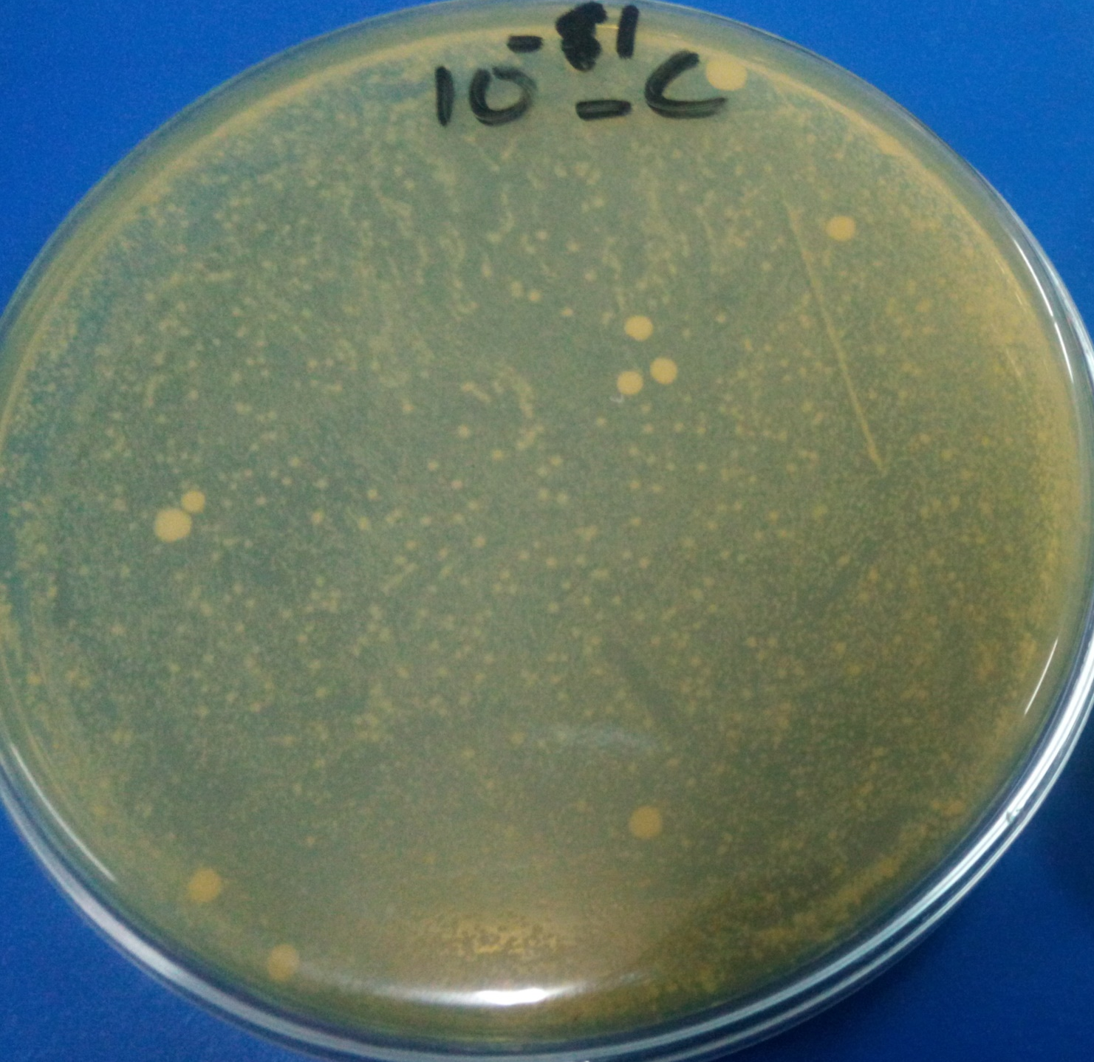
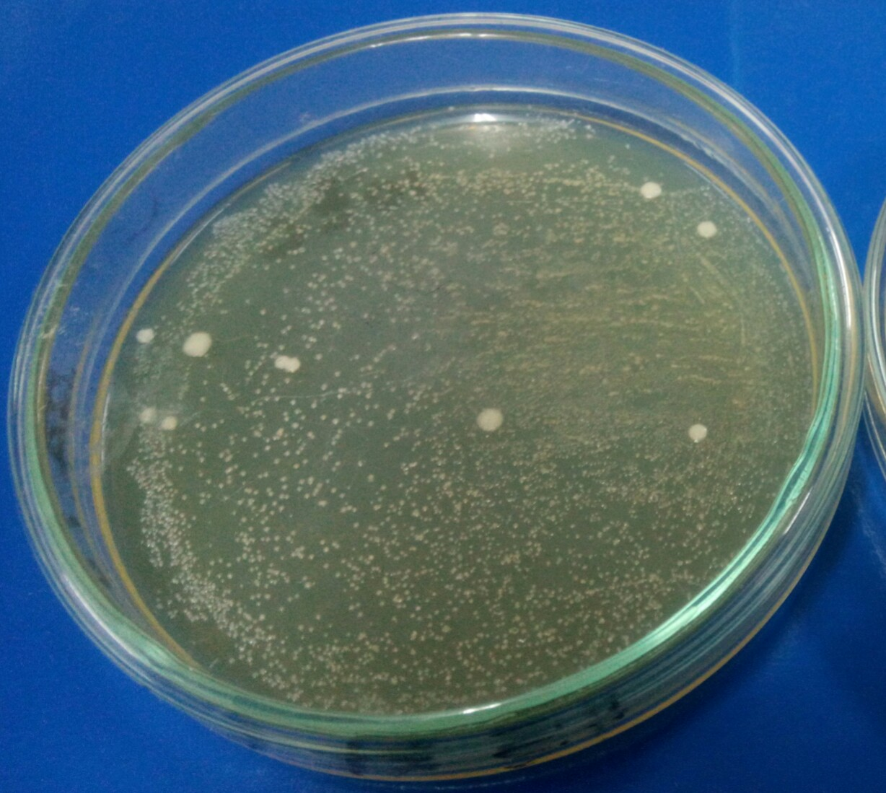

C
D

Figure 1. Spread plate method for the selection of Enterococcus strains. A. 10⁻³ dilution of toddler food sample spread on MRS agar plate, B. 10⁻² dilution of toddler food sample spread on MRS agar plate, C. 10⁻³ dilution of Yogurt sample spread on MRS agar plate, D. 10⁻² dilution of Yogurt sample spread on MRS agar plate
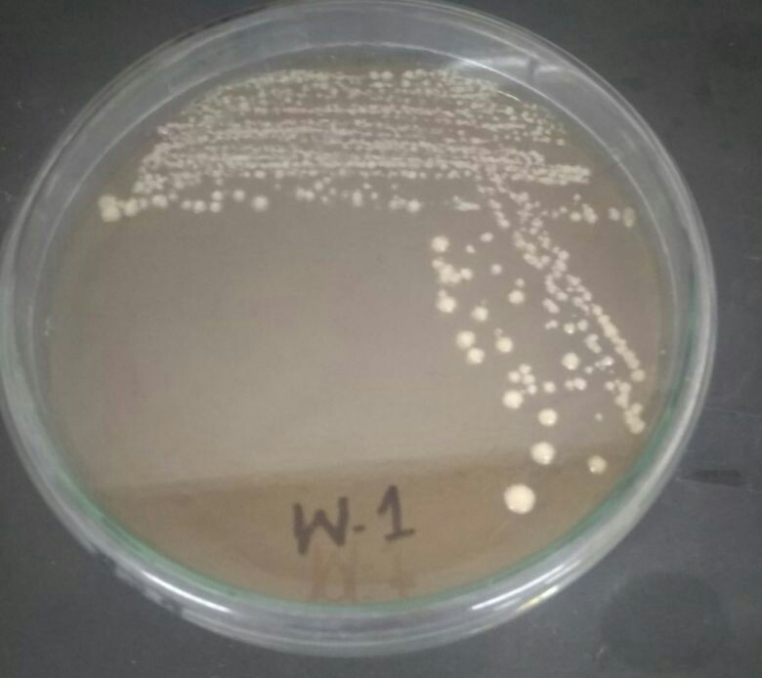
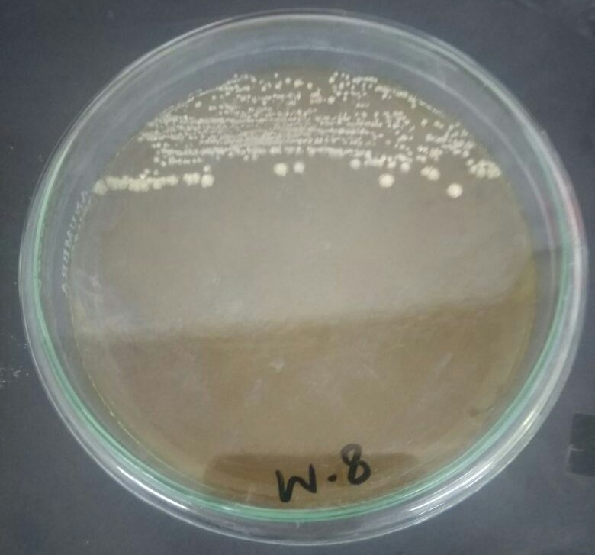

A

B
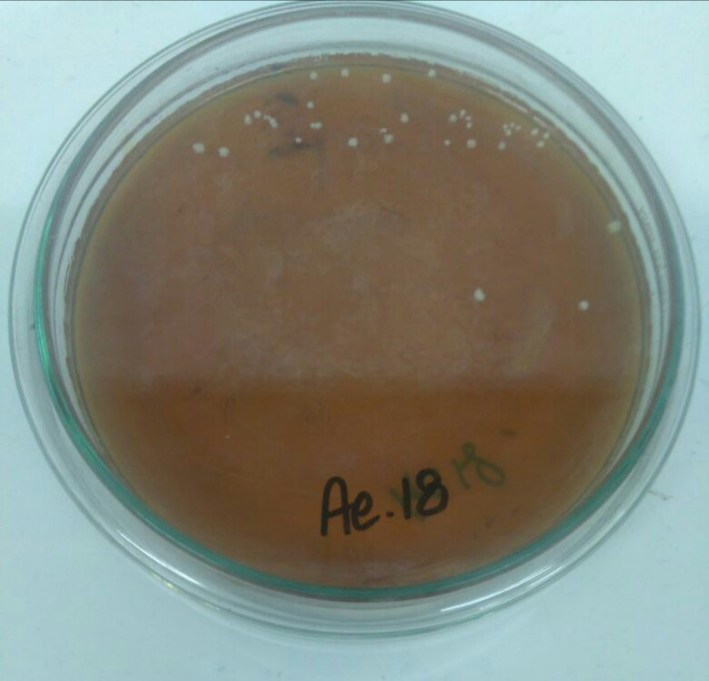
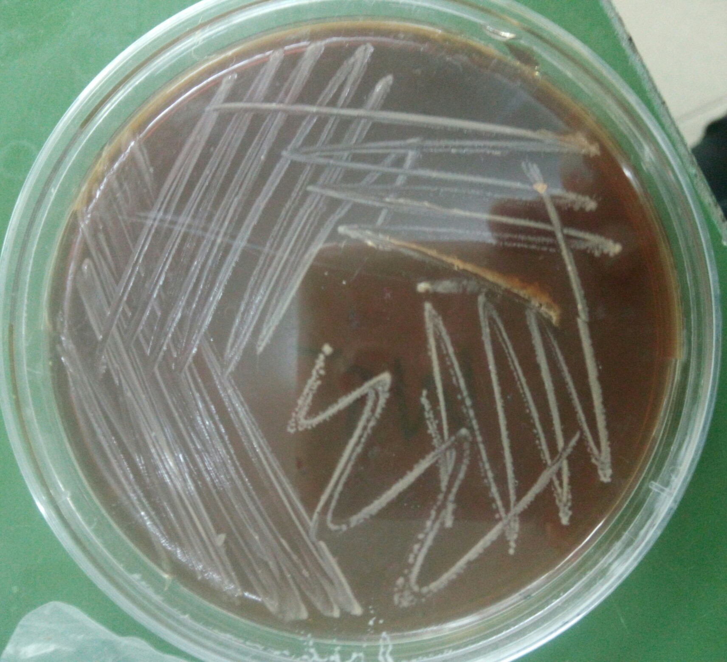

D
C

Figure 2. Pure cultures of selected Enterococcus strains on MRS agar plates. A. WT1, B. WT8, C. AE18, D. WT5
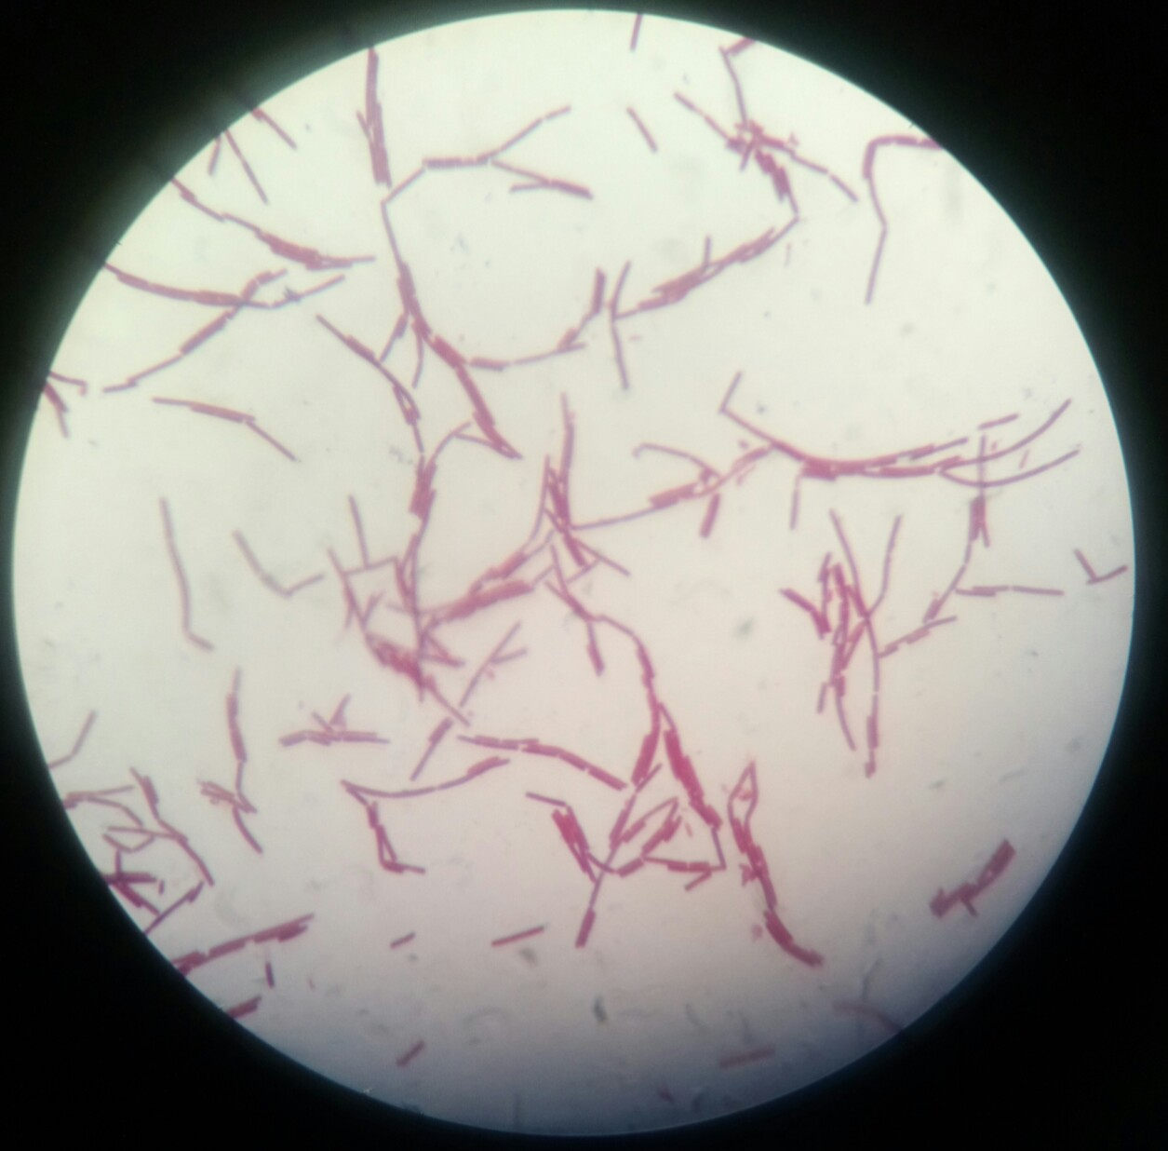
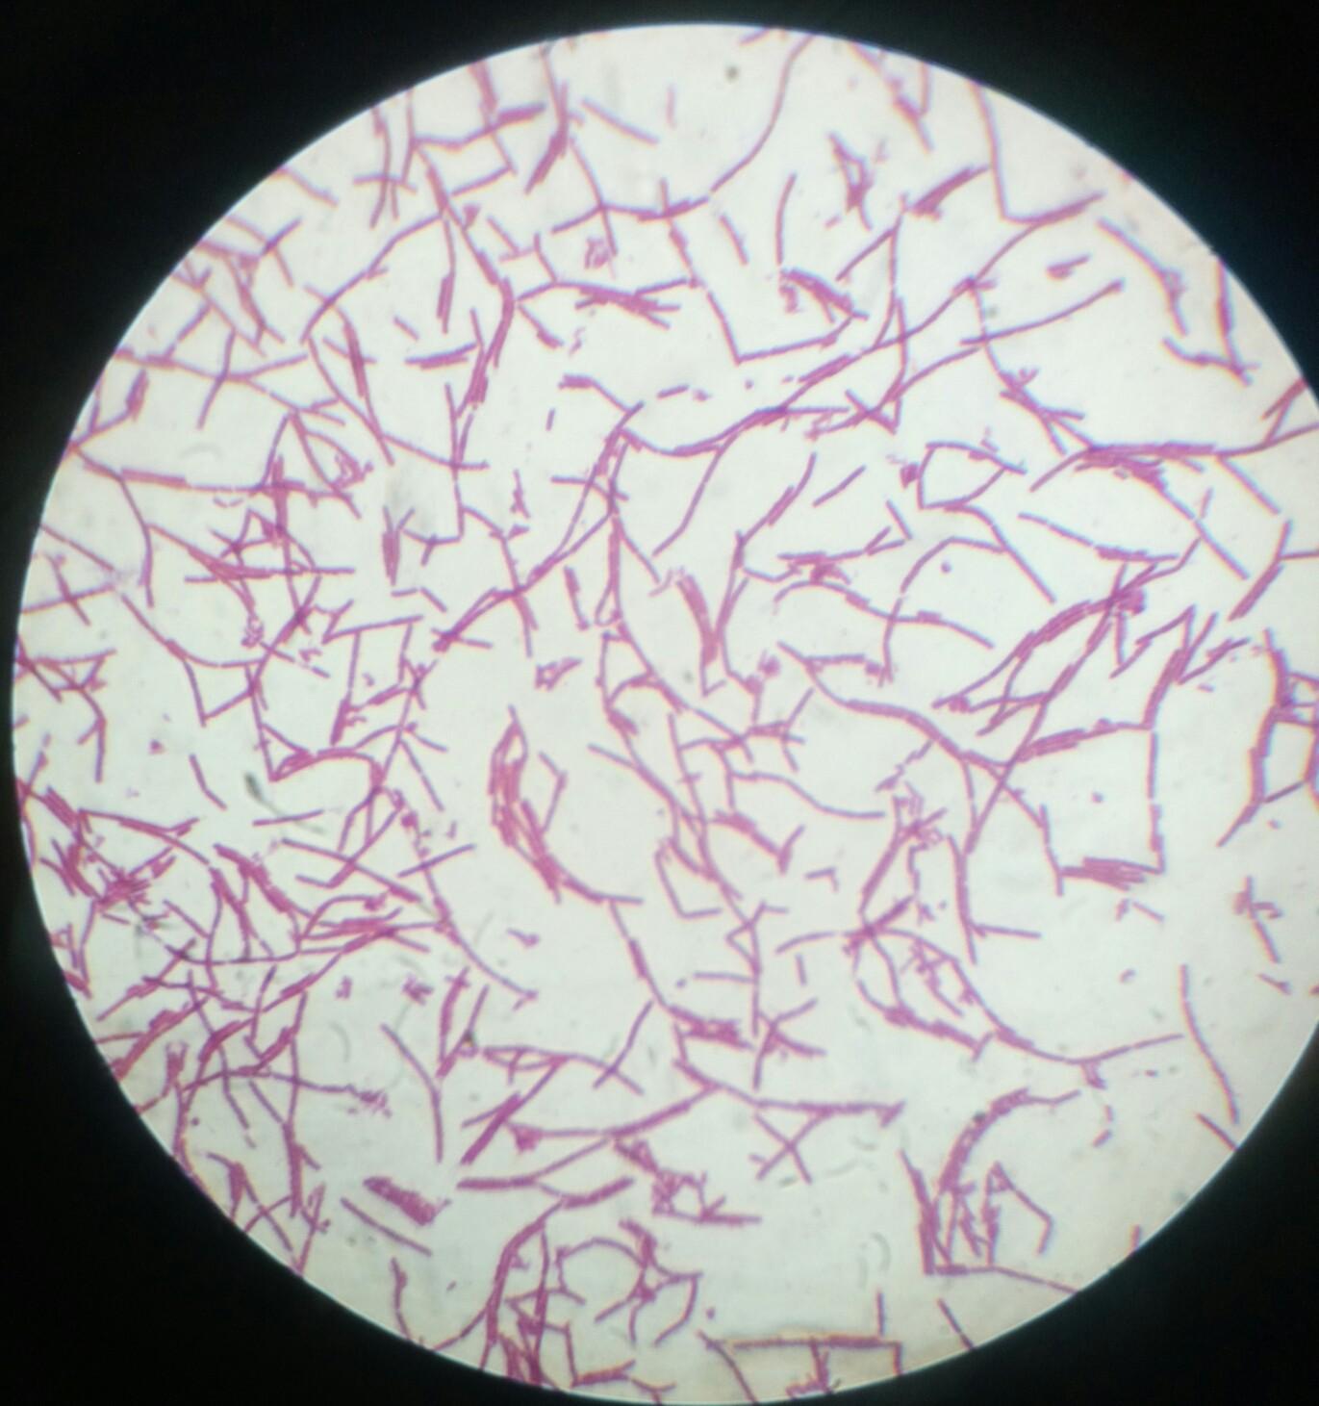

A
B
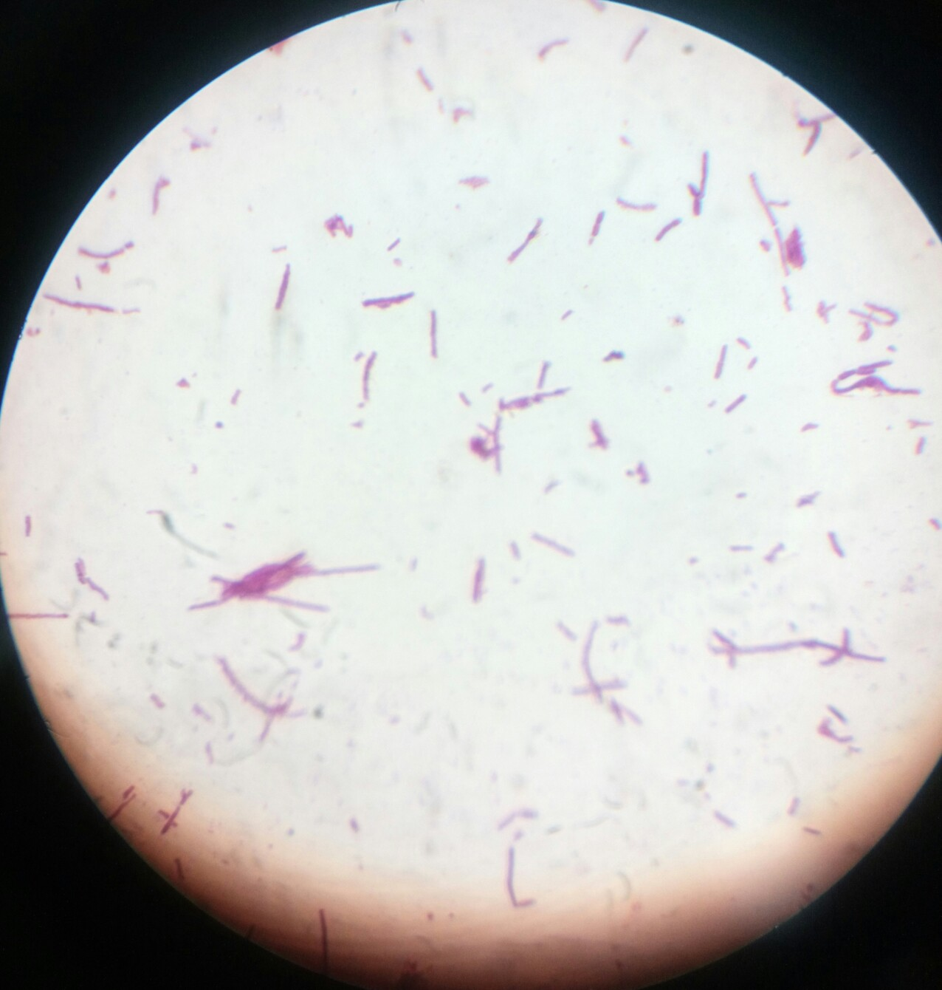
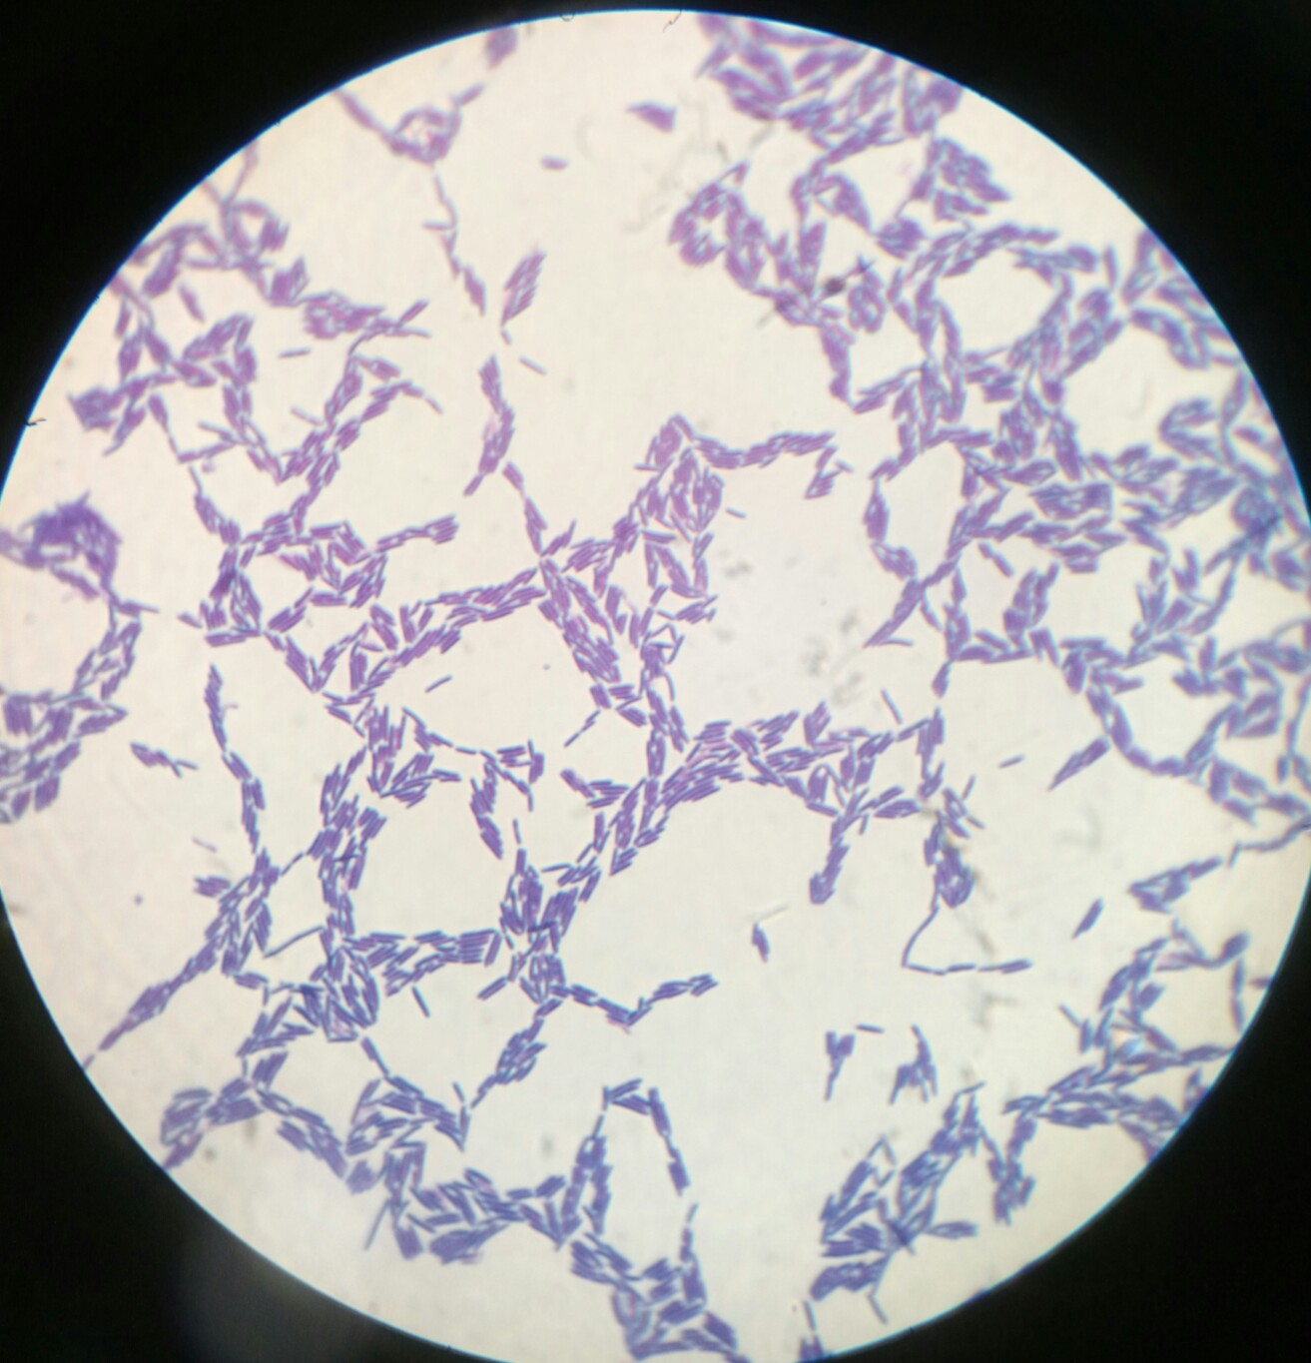

D
C

Figure 3. Gram staining of selected isolates. A. AE18, B. AE10, C. YTC, D. WT1
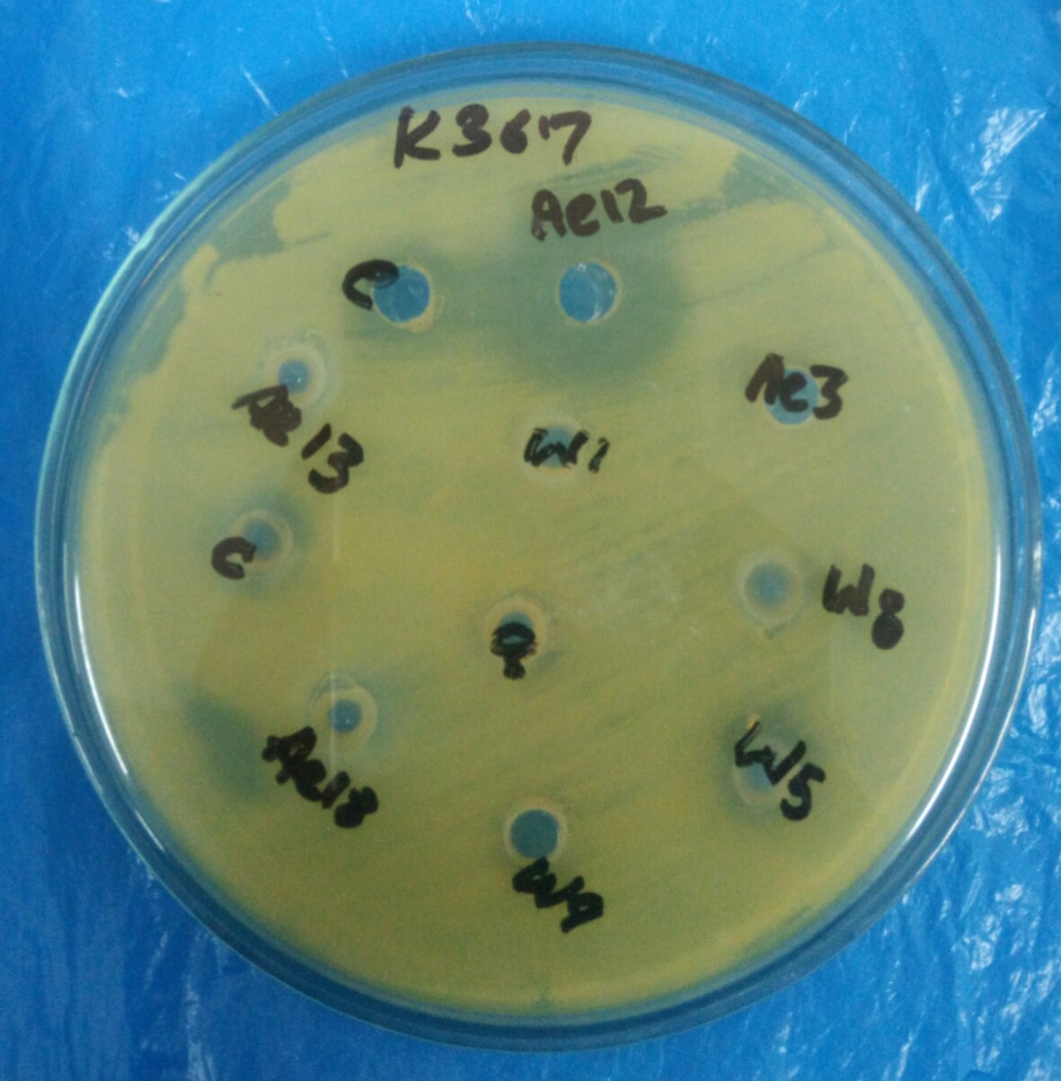
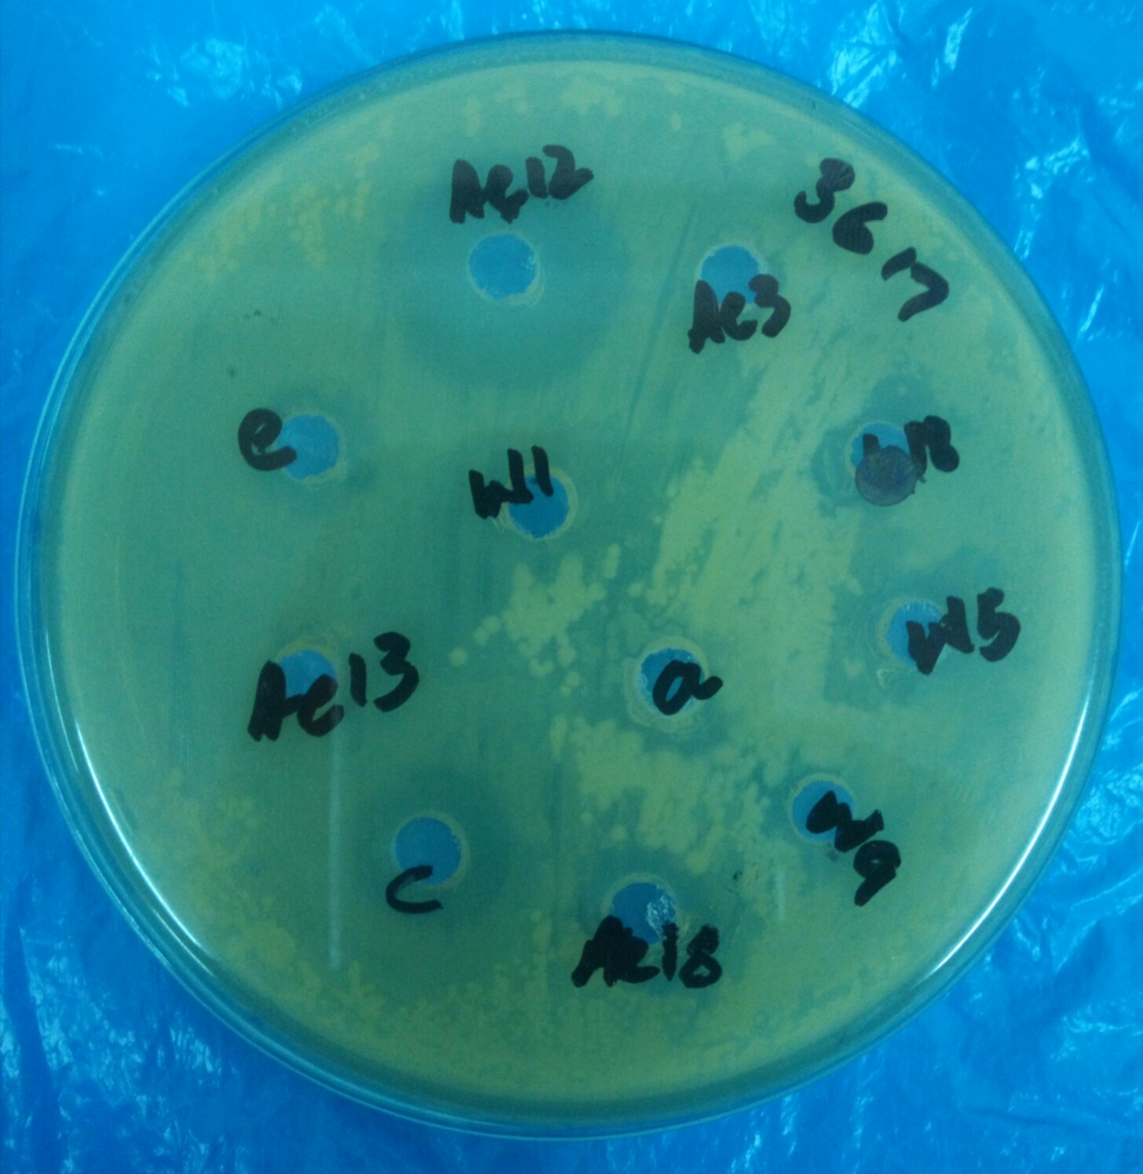

B
A
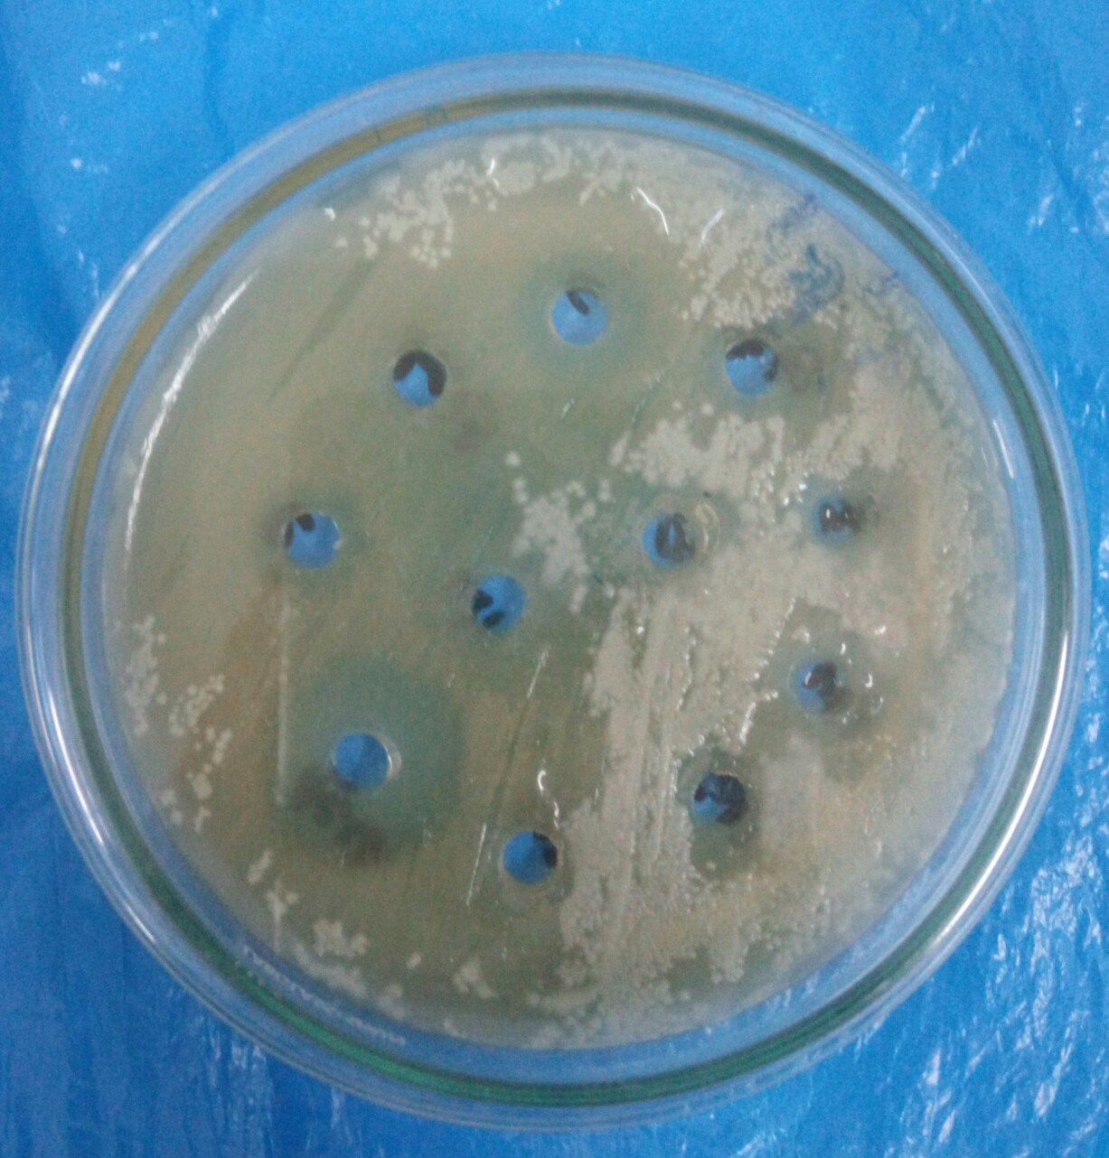
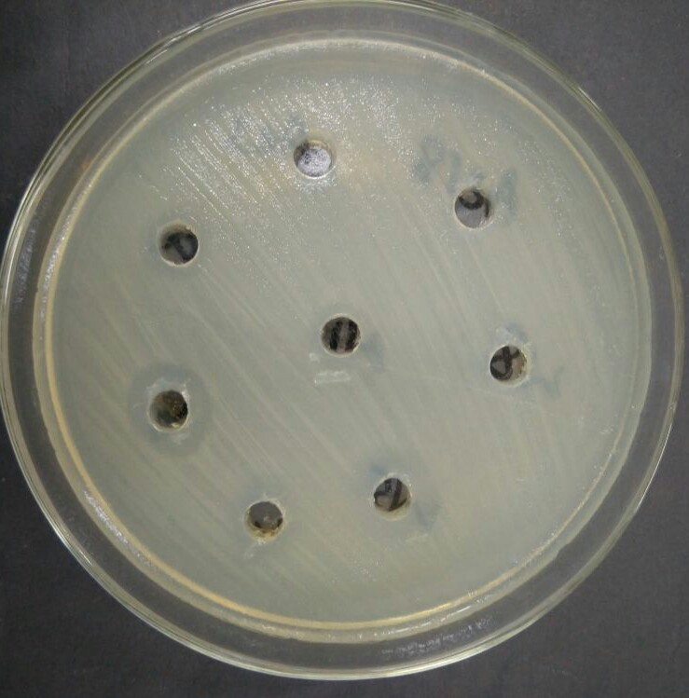

C

D

Figure 4. Antimicrobial activity of Enterococcus isolates. Antimicrobial activity against: A. Pseudomonas, B. Klebsiella, C. Staphylococcus, D. Enterobacter
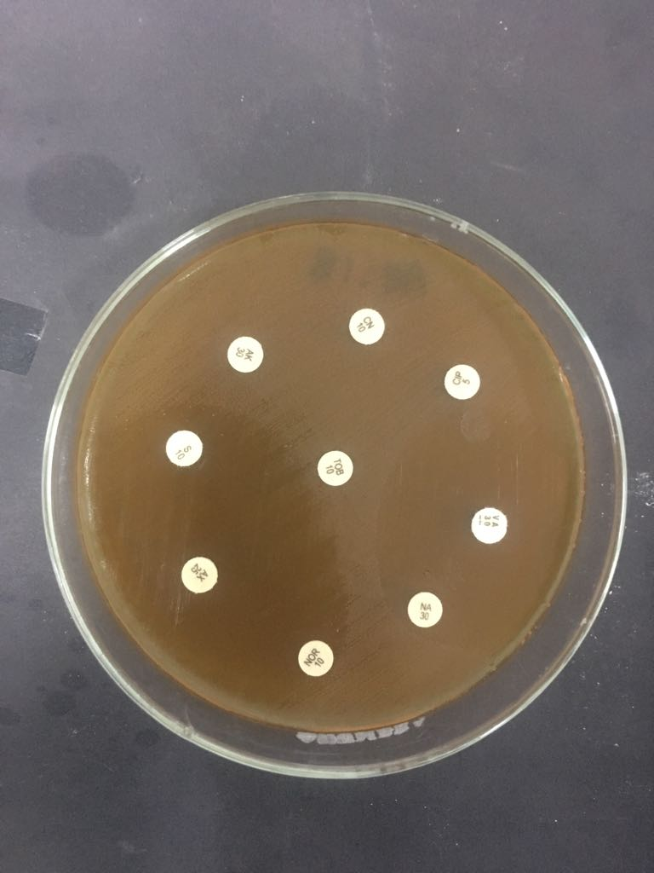
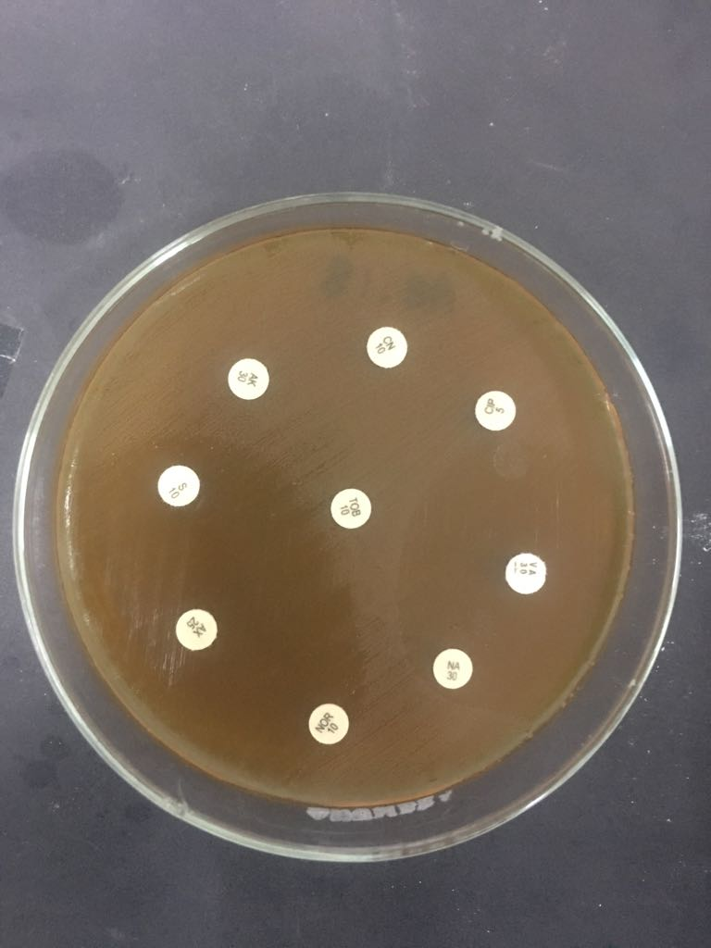

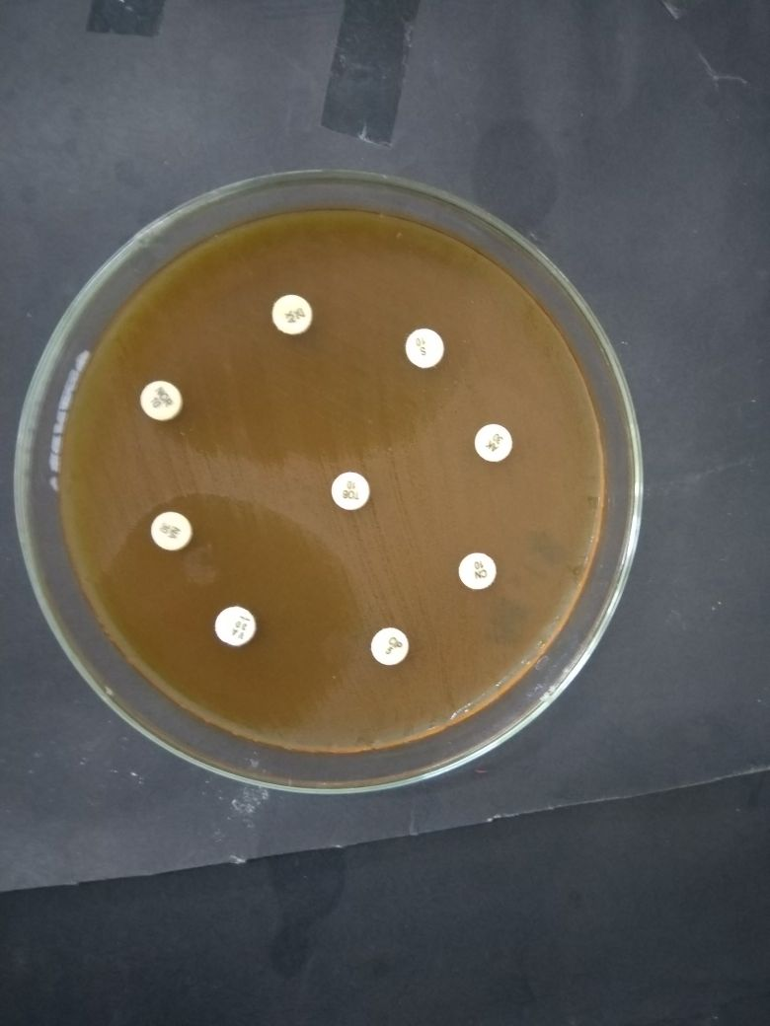
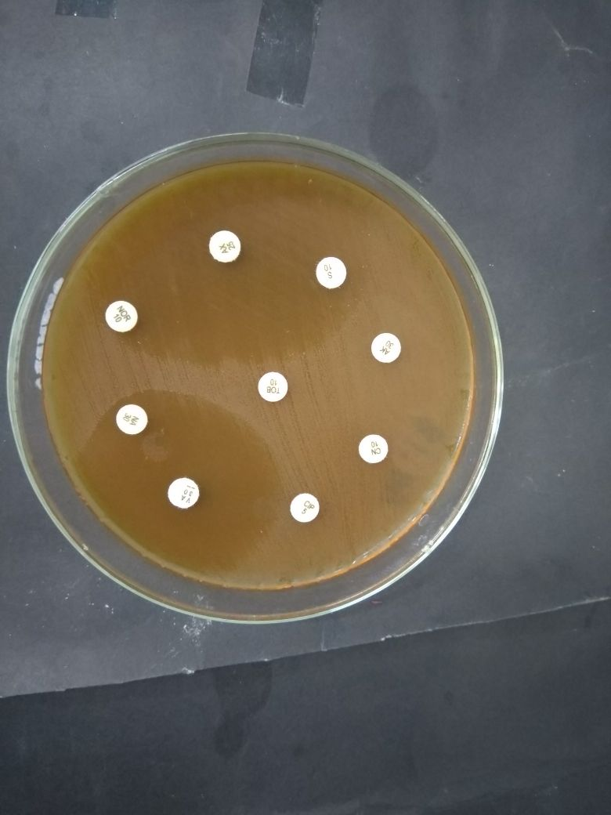

Figure 5. Antimicrobial susceptibility testing of the Enterococcus isolates by using selected antibiotics

