Supplementary Information for

Ultrafast deposition of faceted lithium polyhedra by outpacing SEI formation
Authors: Xintong Yuan¹, Bo Liu¹, Matthew Mecklenburg², and Yuzhang Li^{1*}
Affiliations:
¹Department of Chemical and Biomolecular Engineering, University of California, Los Angeles, California 90095, USA
²California NanoSystems Institute (CNSI), University of California, Los Angeles, California 90095, USA

*Correspondence author: yuzhangli@ucla.edu

Supplementary Figures

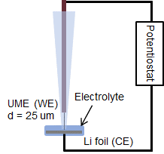
Fig. S1. Schematic of UME platform. UME is the working electrode (WE) and Li foil is counter electrode (CE, only for this Figure).

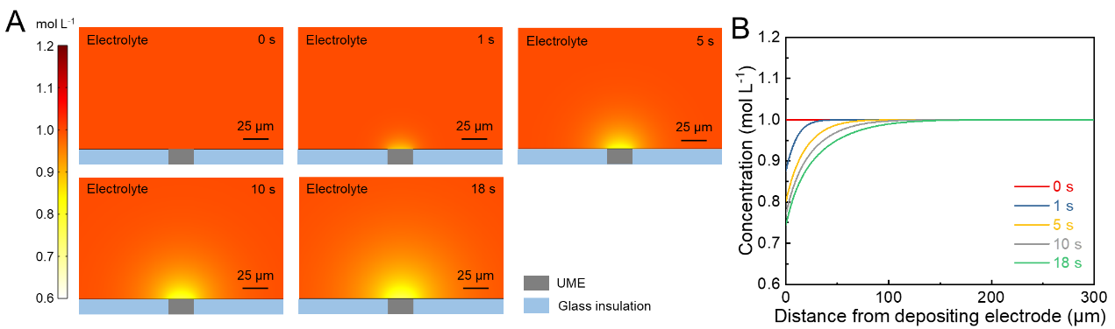
Fig. S2. COMSOL Multiphysics simulation of Li⁺ concentration on UME geometry at 100 mA cm⁻². (A) A two-dimension cross-sectional Li⁺ concentration gradient visualized under current density of 100 mA cm⁻² at different deposition times in UME geometry, the thickness of electrodes is neglected. (B) Li⁺ concentration gradient plots as a function of distance from the working electrode at different times.

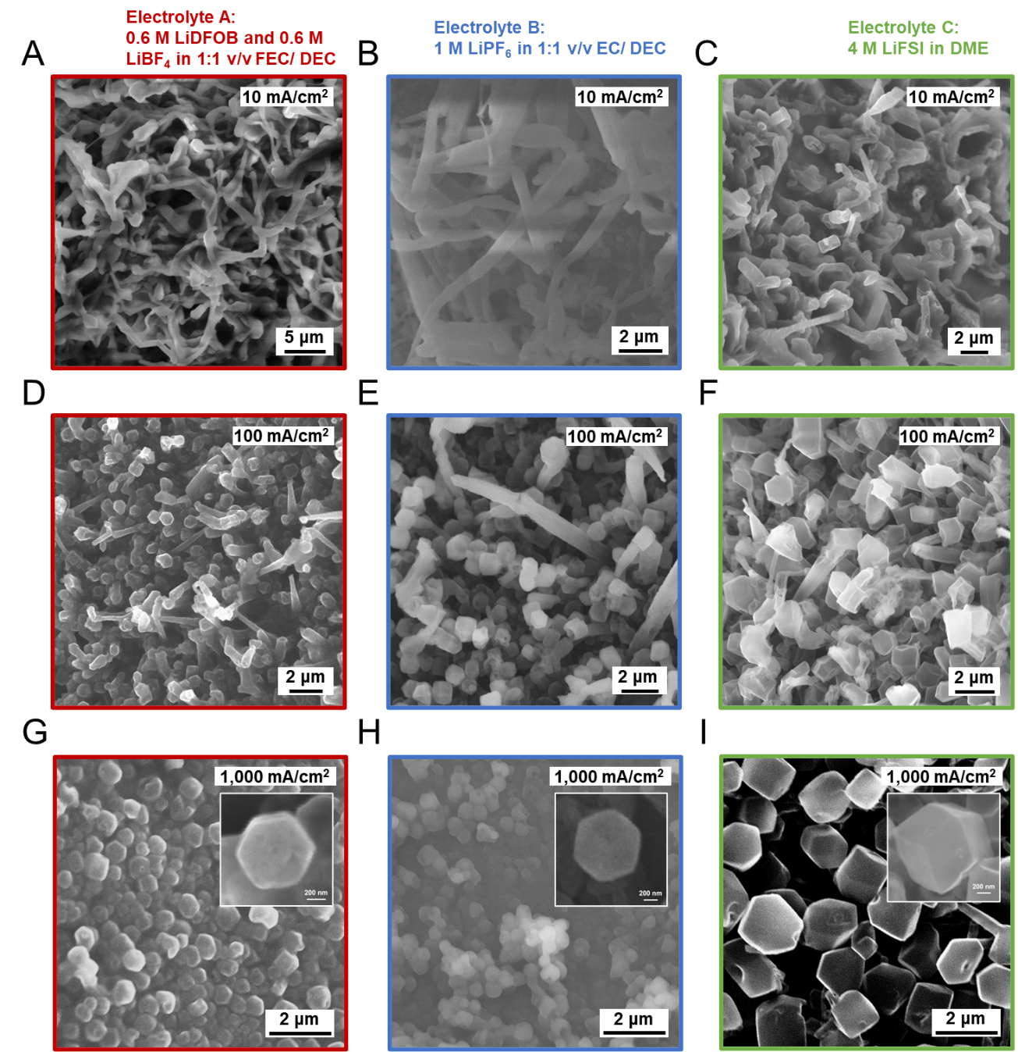
Fig. S3 Transition of different dendritic Li to identical faceted Li particles on UME from 10 to 1,000 mA cm⁻². (A to C) Dendritic Li deposited on UME at 10 mA cm⁻². (D to F) Mixed dendritic and faceted Li particles deposited on UME at 100 mA cm⁻². (G to I) Faceted Li polyhedra deposited on UME at 1,000 mA cm⁻². The electrolyte from left to right are electrolyte A, electrolyte B, and electrolyte C.

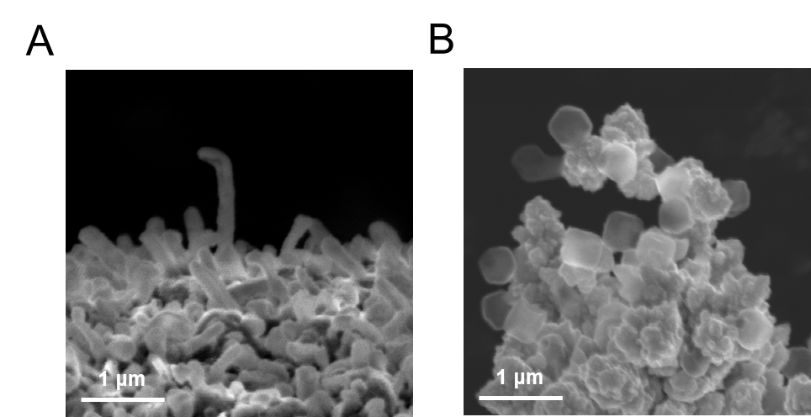
Fig. S4. SEM of dendritic and faceted Li particles deposited on TEM grids. (A) Dendritic Li deposition on bare Cu TEM grid at low current density. (B) Faceted Li polyhedra deposition on Cu chunks-coated TEM grid at ultrahigh current density in electrolyte A: 0.6 M LiDFOB and 0.6 M LiBF₄ in 1:1 v/v FEC/ DEC.

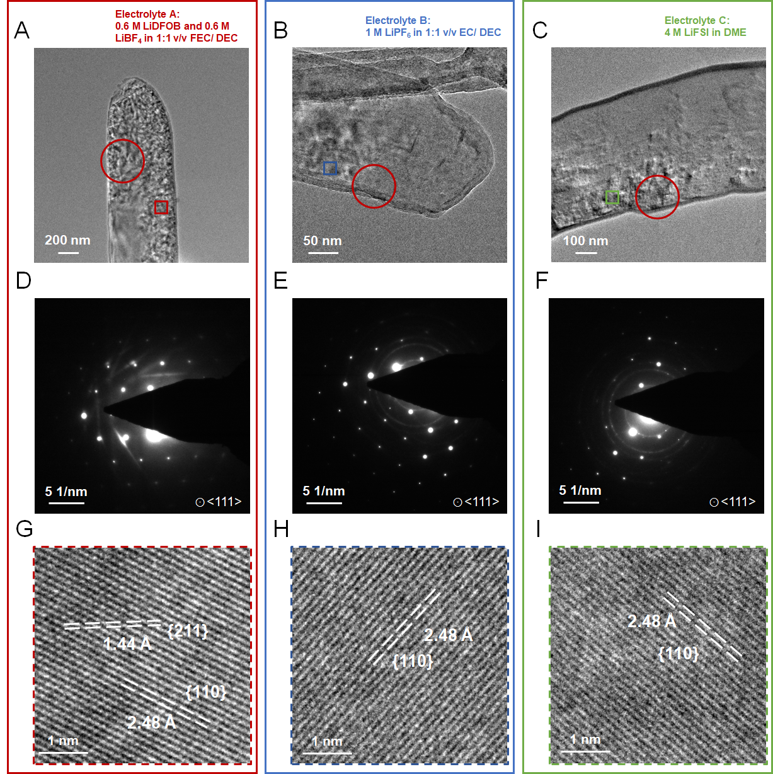
Fig. S5. Cryo-EM showing dendritic Li grown in different electrolyte chemistry. (A to C) Cryo-EM image of a dendritic Li grown on a Cu TEM grid at normal current density. (D to E) SAED patterns of dendritic Li shown in (A to C). (G to I) magnified images of boxed region from (A to C). The electrolyte from left to right are electrolyte A, electrolyte B, and electrolyte C.

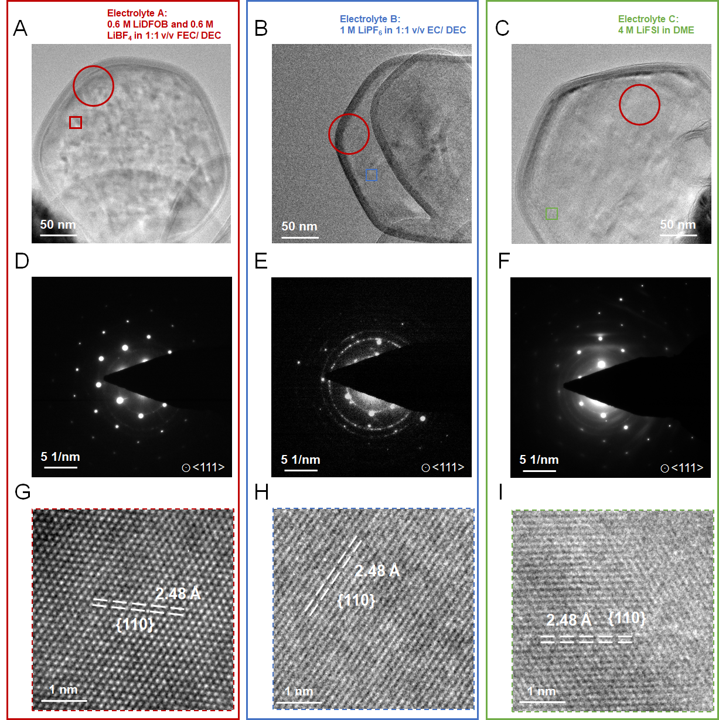
Fig. S6 Cryo-EM showing faceted Li polyhedra grown in different electrolyte chemistry. (A to C) Cryo-EM image of a faceted Li polyhedral grown on the Cu chunks-coated TEM grid at ultrahigh current density. (D to F) SAED patterns of the faceted particles shown in (A to C). (G to I) magnified images of boxed region from (A to C). The electrolyte from left to right are electrolyte A, electrolyte B, and electrolyte C.
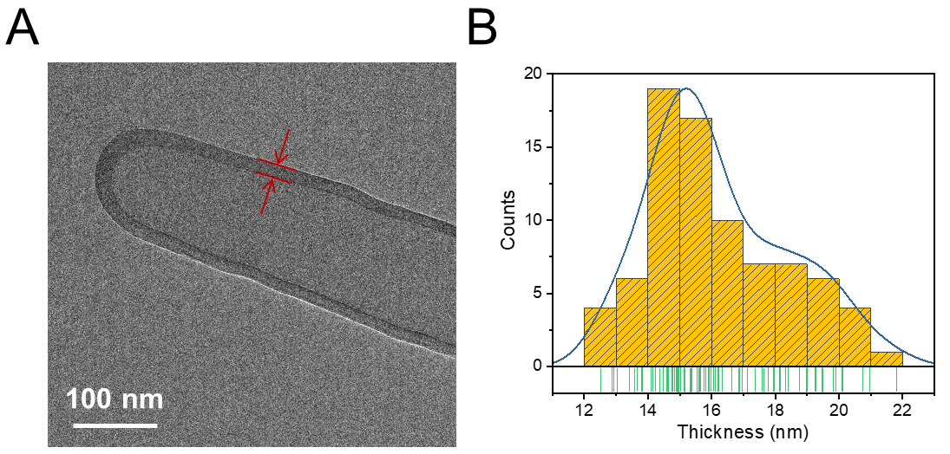
Fig. S7. SEI thickness statistics by cryo-EM. (A) Cryo-EM image of Li dendrite and its SEI. (B) Thickness statistics of SEI (16 nm).
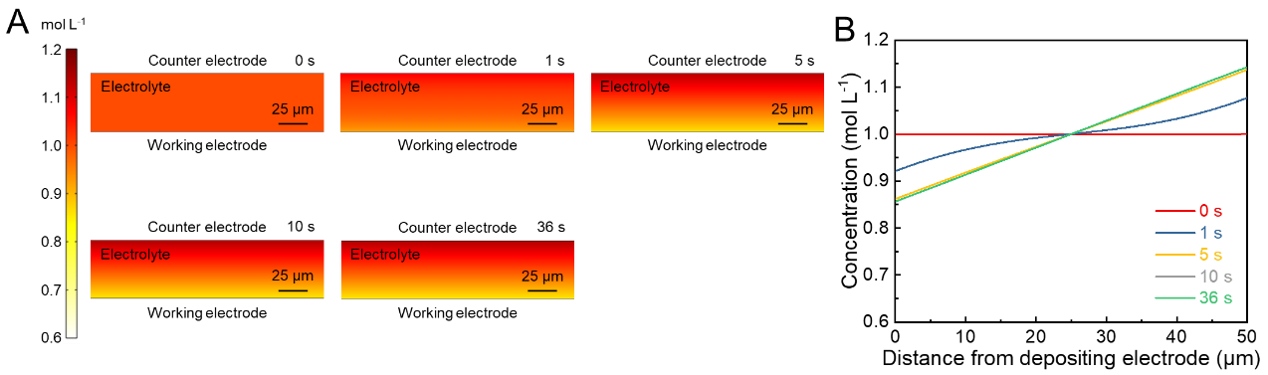
Fig. S8. COMSOL Multiphysics simulation of Li⁺ concentration on coin cell geometry at 50 mA cm⁻². (A) A two-dimension cross-sectional Li⁺ concentration gradient visualized under current density of 50 mA cm⁻² at different deposition times, the thickness of electrodes is neglected. (B) Li⁺ concentration gradient plots as a function of distance from the working electrode at different times.

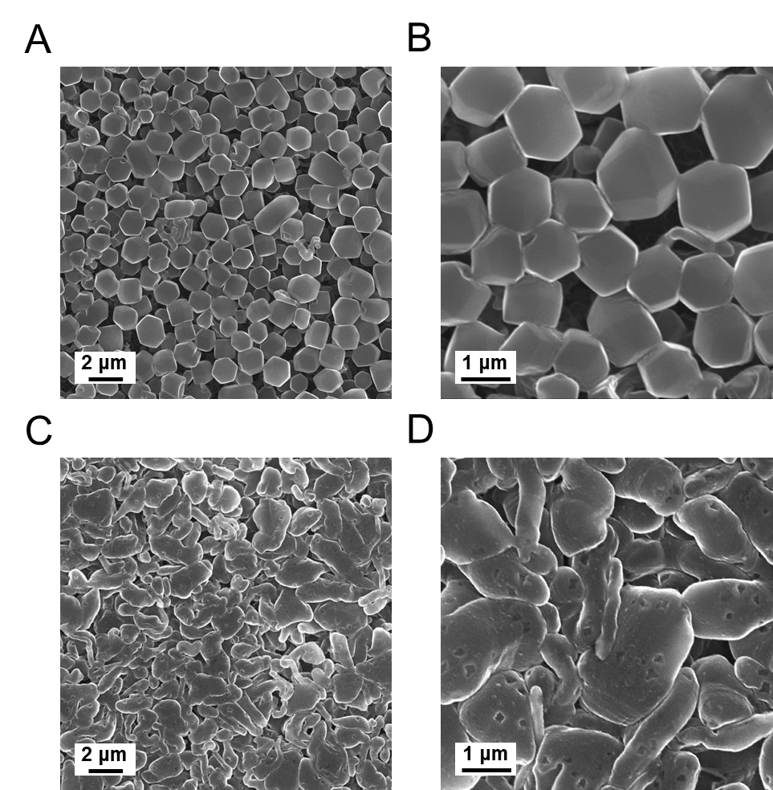
Fig. S9. SEM of faceted and column-like Li deposition on Cu current collector in coin cell. Li polyhedra deposition in Li||Cu coin cell at (A and B) 50 mA cm⁻² with 0.5 mAh cm⁻². SEM of column-like Li deposition in Li||Cu coin cell at (C and D) 1 mA cm⁻² with 0.5 mAh cm⁻². The electrolyte is A: 0.6 M LiDFOB and 0.6 M LiBF₄ in 1:1 v/v FEC/ DEC.

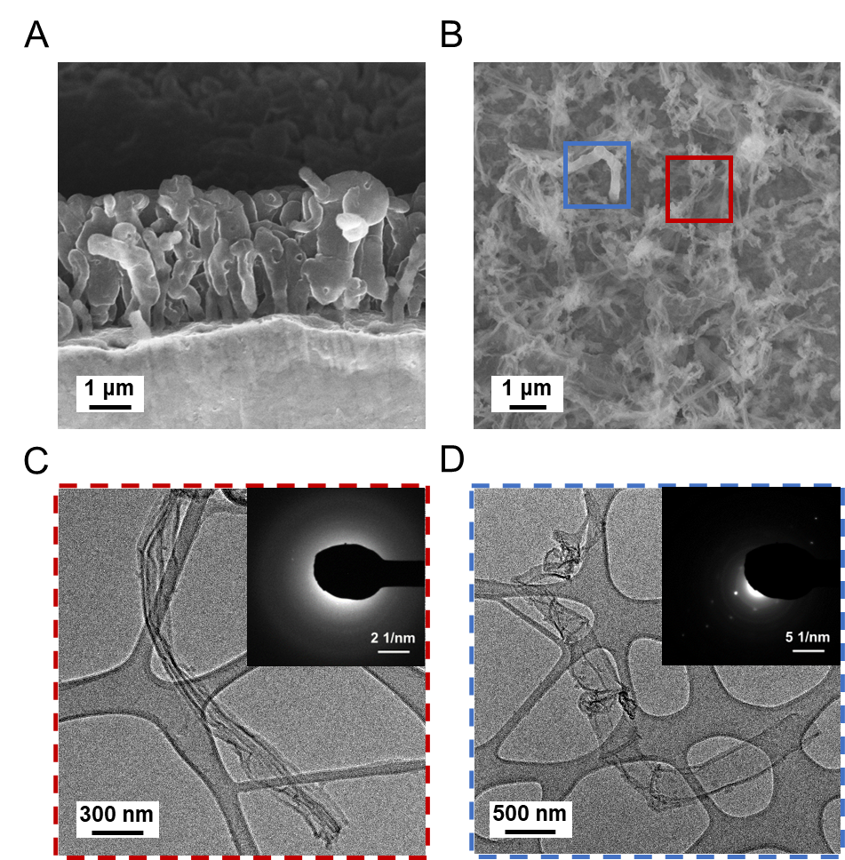
Fig. S10. SEM and cryo-EM showing column-like Li plating and stripping behaviors. (A) Cross-sectional view of Li columns grown on Cu foil at 1 mA cm⁻² with capacity of 0.5 mAh cm⁻². (B) Cu foil with abundant empty SEI shells and limited inactive Li after stripping with 1 V cut-off voltage. (C) Cryo-EM image of empty SEI shell. (D) Cryo-EM image of inactive Li, inserts are SAED patterns.

Supplementary Tables

Table S1. Measured ionic transport properties of the SEI on Li metal. The electrolyte is A: 0.6M LiDFOB and 0.6M LiBF₄ 1:1 v/v FEC/ DEC.
d_{SEI} (nm) | R_{SEI} (Ω cm²) | λ ((Ω cm)⁻¹) | D_{Li+} (cm² s⁻¹) | n_{o} (mol cm⁻³)
16 | 115 | 1.39 × 10⁻⁸ | 4.41 × 10⁻⁹ | 8.39 × 10⁻⁷

