Supplementary information
Photonic higher-order topological insulator with enlarged non-trivial bandgaps
Yuexin Zhang, Xiaoyu Dai, and Yuanjiang Xiang*
School of Physics and Electronics, Hunan University, Changsha 410082, China
*xiangyuanjiang@126.com

Simulations of hinge and surface waves in parallelogram-shaped architectures
Here we discuss another geometrical framework that hosts localized hinge and surface states in a multilayer parallelogram-shaped with two pairs of obtuse-angled corners and acute-angled ones. As displayed in Fig. S1(b), the monolayer meta-cell in the XY-plane consists of a 5×5 photonic PhCs covered by two drilled parallelogram PEC plates. Fig. S1(a) and S1(b) give the bulk spectrum of the 2D meta-lattice along the k_{z} direction and the eigenmode solutions, respectively. Similar to the computation result in the hexagonal sample, the well-distinguished hinge and surface states sustain among the large bulk bandgap. In contrast, two surface state spectrums wrap the lower hinge modes. In particular, we set two scattering boundary conditions on the two edges, and the other two edges are imposed with PEC plates to strengthen the hinge mode reflections. When EM waves reach the two open boundaries, they will directly exit the sample rather than coupling with the PhC array again. Therefore, we could find only two pairs of three upper and lower hinge modes in Fig. S1(b). We intercept the |E_{z}| field distributions of the hinge (9.35, 9.25, 9.21 GHz) and surface states (9.59, 9.45, 9.55 GHz) at k_{z} = 0.2, 0.6, and 0.9 p/h in the lower panel of Fig. S1 (c). Both strongly localized hinge and surface state field distributions are found at these frequencies.
Finally, we establish a sample with ten layers of parallelogram-shaped PhC meta-cell, as illustrated in Fig. S2(a). The two side surfaces are still selected as non-PEC conditions to block the reflection of EM waves. A point source is placed near the middle of the hinge to excite EM waves. For the hinge (surface) states, we choose the excitation frequency of 9.8 (10.2) GHz as we implement in the hexagonal-shaped work. Fig. S2(b) presents the hinge and surface modes distributions at layers 1, 4, 7, and 10 (counting from the top layer of the sample), respectively. It is witnessed in Fig. S2(b) that the hinge states are well-gathered on the hinge of the PEC enclosed boundary, and the same case for the tightly limited surface waves, suggesting the performance of our framework.
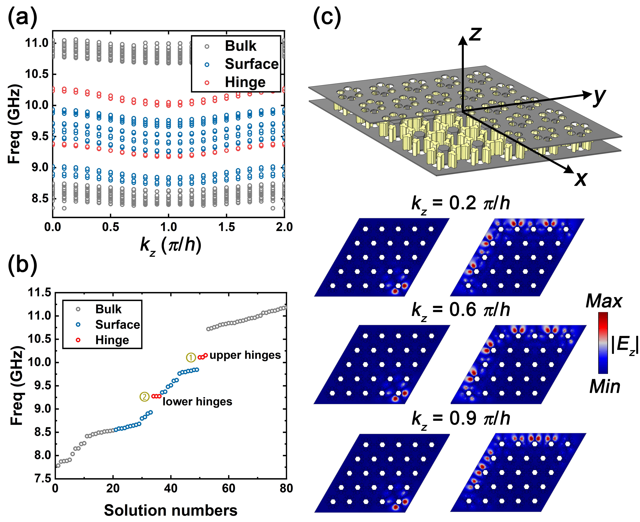
Figure S1. Constructions of the parallelogram photonic PhC array. (a) The spectrum of the parallelogram-shaped meta-sample, the hinge (red hollow circles), surface (hollow blue circles), and bulk (hollow gray circles) modes are well-separated. (b) Solution numbers of the parallelogram PhC array. (c) Upper panel: 3D view of the parallelogram PhC array. Lower panel: The simulated |E_{z}| field distributions of hinge and surface states at k_{z} = 0.2, 0.6, and 0.9 π/h, respectively.
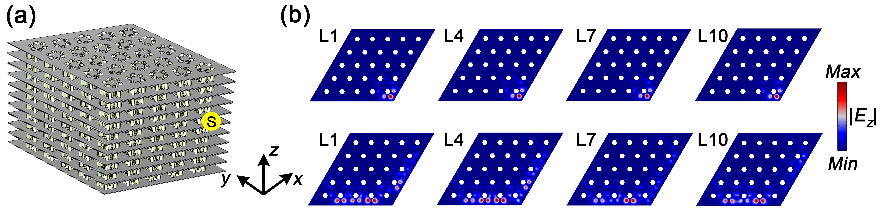
Figure S2. Simulations on real space stacking parallelogram-shaped PhC arrays and corresponding |E_{z}| field distributions. (a) The framework of our 10-layer multilayer PhC arrays. The exaction source (solid yellow circle) is put on the middle hinge of the sample. (b) |E_{z}| field distribution slices for hinge and surface states at layers 1, 4, 7, and 10, respectively.

