SUPPLEMENTARY MATERIAL
Supplementary – Results
Interactions between conditions
We found no interaction between the impact of VR condition and labelling on real-life choice in the iBuffet, b = 0.43, 95% CI [-0.19, 1.04], t(161) = 1.38, p = .170 nor on taste expectations in the iBuffet, b = -0.53, 95% CI [-1.15, 0.08, t(161) = -1.72, p = .088. We also did not find any interaction between the impact of the VR condition and Labeling on intentions, b = -0.44, 95% CI [-1.04, 0.17], t(161) = -1.43, p = .155; or on dietary carbon footprint, b = 0.54, 95% CI [-0.12, 1.19], t(141) = 1.62, p = .107.
Randomization check
As we did not find any interaction between the two independent factors, we conducted randomization checks for the VR and the labelling conditions separately.
We found no difference between the VR conditions in terms of participants’ age, F(1, 163) = 0.31, p = .579, gender, χ² = 0.056, df = 2, p = 0.97, education, F(1, 165) = 0.39, p = .534, climate change anxiety, F(1, 165) = 0.06, p = .814, or dietary carbon footprint, F(1, 165) = 0.00, p = .961.
Similarly, we found no difference between the labeling conditions in terms of participants’ age, F(1, 163) = 0.14, p = .710, gender, χ² = 6.4368, df = 8, p = 0.6, education, F(1, 165) = 1.62, p = .298, climate change anxiety, F(1, 165) = 0.89, p = .348, or dietary carbon footprint, F(1, 165) = 0.21, p = .650.

Supplementary – Methods
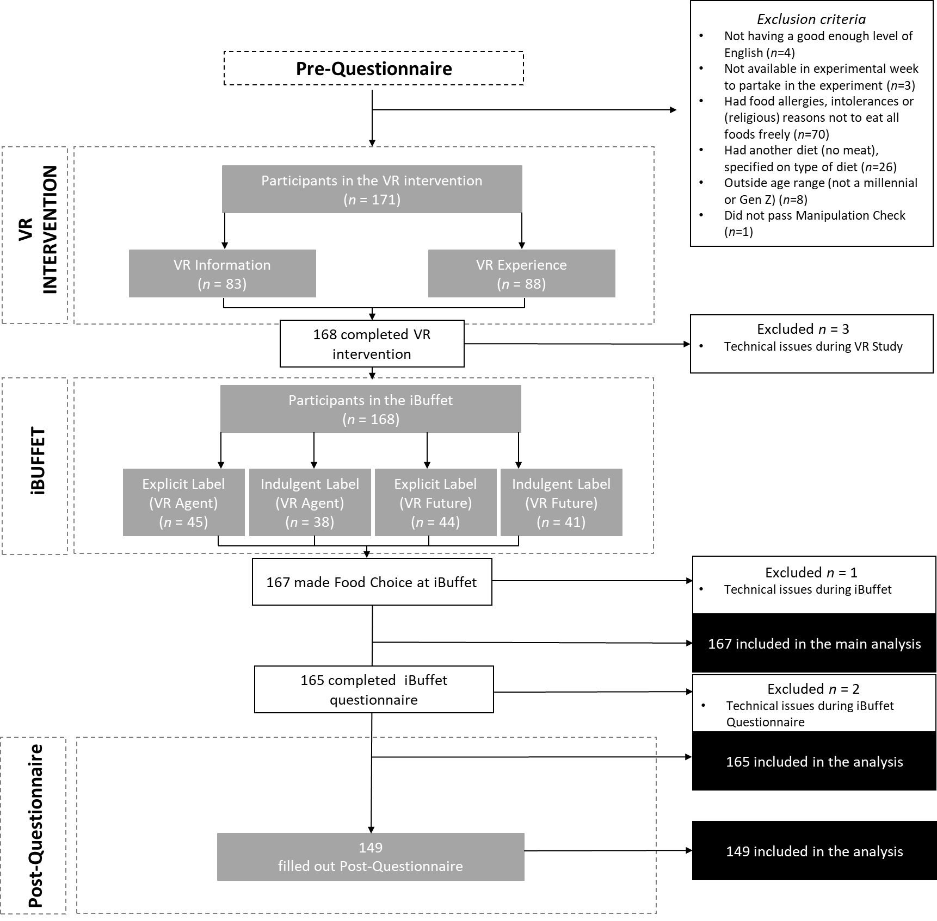

Figure 1 Participant Flow and exclusion criteria.
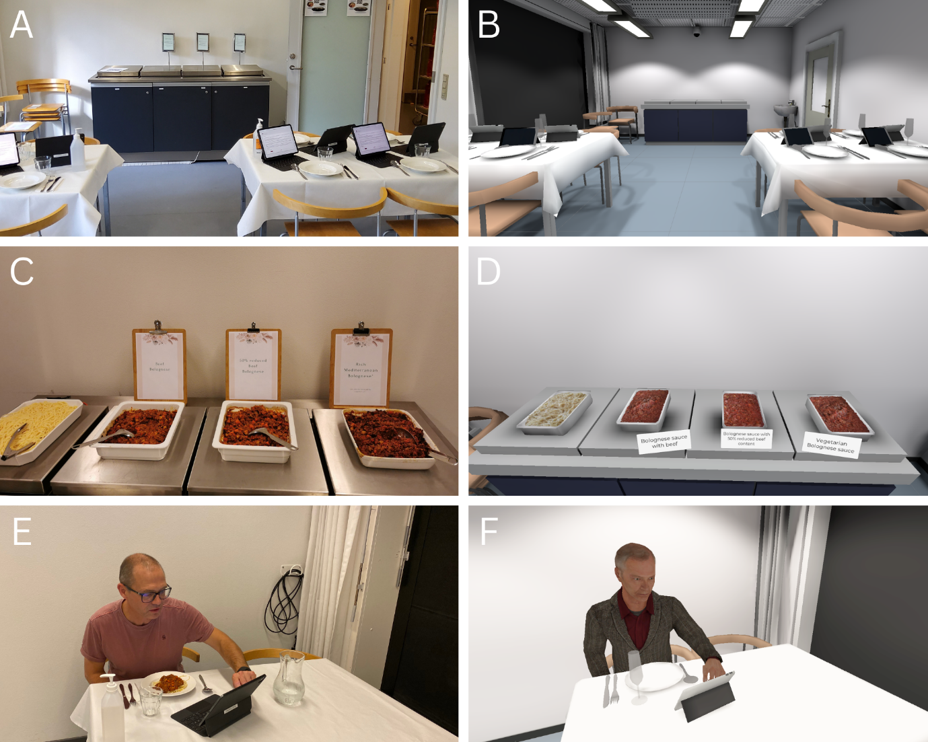Figure 2 iBuffet procedure and comparison of iBuffet setting (on the left) and VR buffet (on the right).
After arriving at the iBuffet (A; see B for VR Buffet), all participants were introduced to the iBuffet and chose one of the three sauces (beef Bolognese, Bolognese with 50% reduced beef content, or vegetarian Bolognese) from the buffet (C; see D for VR Buffet). The participants were at the iBuffet together with other participants from the same time slot (max. 14 participants per group). Before choosing their dish, participants were asked to look at the different sauce options and rate them in terms of their expected taste, healthiness, and satiety (E; see F for VR Buffet). After eating the first few bites, participants rated their liking of the dish in terms of taste, smell and texture. When the participants finished their meal, all plates were cleared and they were given tasting samples of all three sauces (in random order). They were then asked to taste them and rate their liking again (taste, texture and smell). All food waste per person was weighed and documented in a separate room by the experimental staff.

Pre-questionnaire
Welcome to the survey
We are researchers from the University XXX, and we are conducting a study on the choice of dishes in Virtual Reality (VR) and iBuffet settings. In the present survey we collect information about food habits and virtual reality experience, with the purpose of screening potential subjects for an experiment. This survey will take around 3-5 minutes to complete.
The experiment will take place at our campus in XXXX, the experiment will take about 1 hour and will take place between 17h-20h on September 5th to 9th. Via this questionnaire we would like to ask you some questions beforehand and would like to ensure you fit the criteria for our study. When you participate in the experiment, you will receive a free meal (dinner).
Please let us know if you give your consent that the University XXX may register and process your personal data in the abovementioned research project.
By participating in this online survey, i.e., clicking to answer the questions, you agree that we can collect personal data on you.
I give my consent that my personal contact information data can be used to contact me throughout the study. This personal data will be deleted once we have completed the data collection of the study.
I give my consent that my data in anonymized form may be stored in a database for new research projects after the end of this project.
I give my consent that my data in anonymized form may be shared with other research institutions in Denmark or another country within the EU/EEA.
Your consent to the processing of personal data is voluntary and may be withdrawn at any time.
You may at any time change or withdraw your consent by contacting XXX, (XXX) If you withdraw consent, it will take effect from that point in time, and will not affect the legality of our work with your data in connection with the project up to that point. Your data will therefore continue to be included in the work done by the project up until the point at which you withdraw your consent.
I hereby consent to the above-mentioned text and would like to participate in the study.
I do not give my consent to the above-mentioned text and do not want to participate in this study.
Do you understand written and spoken English?
- I do not always understand English
- It is in general no problem for me to understand written and spoken English
Do you live and/or work in XXX or nearby and are you available to join a 1-hour session between 17h-20h on one of the following days:
Monday 05-09-2022
Tuesday 06-09-2022
Wednesday 07-09-2022
Thursday 08-09-2022
Friday 09-09-2022
Note: You will receive dinner.
- Yes, I am available to join on one of these days.
- No, it is not possible for me to join on one of these days.
Do you have any food allergies, intolerances or (religious) reasons not to eat all foods freely? If you answer the text box in the last option, you will later hear back from us if you can participate in the study or not.
- No, I do not have any.
- Yes, I am gluten intolerant. Yes, I do not eat beef.
- Yes, I do not eat pork.
- Yes, something else, please specify:
Please indicate how you would identify your eating pattern (please read all options before answering): I identify as…*NOTE: Meat can be both red meat (for example, beef, veal and/or pork) and/or white meat (for example, chicken and/or turkey).
- Someone who eats meat*
- Someone who eats meat* only occasionally (flexitarian) Someone who only eats fish and no meat (pescetarian) Someone who eats a vegetarian diet
- Someone who eats a vegan diet
- Someone who eats a different type of diet than mentioned above (which includes no meat)
What is your year of birth?
- Before 1980 or 1980.
- Between 1981 and 1996 (both years included) Between 1997 and 2004 (both years included) 2005 or after
What is your experience with virtual reality (VR)?
- I have never tried VR I have tried it once
- I have tried it 2-3 times I tried it 4-5 times
- I have tried it more than 5 times
What is your gender?
- Female
- Male
- Identify otherwise
What is your highest completed level of education?
- Primary school or below High school
- Vocational training
- University or college degree (Bachelor or similar) Master’s degree or higher
- Other, please specify
What is your nationality? From which region are you?
- XXX
- Other country in the Northern Europe (e.g. Sweden or Iceland) or in UK or Ireland Western Europe (e.g. Netherlands, France, Germany)
- Eastern Europe (e.g. Hungary or Poland) Southern Europe (e.g. Spain or Greece) North America
- South America or Central America Africa
- Asia Oceania
How long have you lived in XXX?
- Around 1 year or less Between 1 year and 5 years
- Over 5 years
- I do not live in XXX
Please indicate how many times did you consume the following foods or drinks during the last week (7 days)? Scale Never Once Twice 3 456 7 8 times or more times
Meat products and similar
Served as part of a main meal or as cold cuts (e.g. on a sandwich).

 | Never | Once | Twice | 3 times | 4 times | 5 times | 6 times | 7 times | 8 times or more
Beef
Lam or Veal
Pork
Poultry
Fish
Pork
Poultry
Meat substitute products (for example, Plantefars, tofu)

Please indicate how many times did you consume the following foods or drinks during the last week (7 days)?
Dairy products and similar
 | Never | Once | Twice | 3 times | 4 times | 5 times | 6 times | 7 times | 8 times or more
Cheese
Other dairy products (e.g. milk and yoghurt)
Plant-based dairy alternatives (e.g. oat milk)

Please indicate how many times did you consume the following foods or drinks during the last week (7 days)?
Other products
 | Never | Once | Twice | 3 times | 4 times | 5 times | 6 times | 7 times | 8 times or more
Fruit
Vegetables
Pulses/legumes
Pasta

What is your experience with meat analogue products?
These are products that aim to resemble meat as close as possible in terms of taste, texture and appearance, for example, plantefars.
- I have never eaten it
- I have tried it once or twice
- I eat it once a year or a few times per year I eat it 1-3 per month
- I eat it 1 to 2 times per week I eat it 3-5 times per week
- I eat it 6 or more times per week
On a scale from 1 to 7 where 1 is “not agree at all” and 7 is “agree very much”, how much do you agree with the following statements?
It is important to me that the food I eat on a typical day…
- is healthy
- is mood improving
- is practical
- is tasty
- is natural
- is affordable
- is fair-traded
- is weight controlling
- is familiar
- is climate-friendly
- considers animal-welfare
- is organic
On a scale from 1 to 7 where 1 is “not agree at all” and 7 is “agree very much”, how much do you agree with the following statements?
- I like to try foods I have never tasted before
- I like to experience new and different foods
- I think it is fun to try food items I don't know
- I will try food even though I don't know what it is I enjoy a wide variety of different foods
- I am not afraid of eating things I have not tasted or experienced before
- I don't mind eating foods I am not used to
- I think unfamiliar food looks unappetizing
- I am not wary of trying food I have not tasted before
- I enjoy dining at new restaurants
What is your stance on reducing meat consumption? Please choose one of the following:
- I am not doing this, and I am not willing to.
- I would like to do this, but I do not know how I could do it.
- I would like to do this, and I already know how I could do it. I am doing this already.
- I have done so in the past, but I do not eat like this anymore.
Please answer 2 on this question, to continue
- 1
- 2
- 3
- 4
- 5
- 6
- 7
On a scale from 1 to 7 where 1 is “not agree at all” and 7 is “agree very much”, how much do you agree with the following statements?
- I feel capable of adopting more climate-friendly eating habits.
- I feel capable of consuming more food with a low carbon footprint.
- If most people change their eating habits (according to suggested measures) the consequences of climate change will decrease.
- Consumption of food with a low carbon footprint is an effective measure to mitigate climate change.
- If I change my eating habits (according to suggested measures) the consequences of climate change will decrease.
Over the last 2 weeks, how often have you been bothered by the following problems, when thinking about climate change and other global environmental conditions (e.g., global warming, ecological degradation, resource depletion, species extinction, ozone hole, pollution of the oceans, deforestation)?
On scale: Not at all – Several of the days – Over half the days – Nearly every day
- Not being able to stop or control worrying
- Unable to stop thinking about future climate change and other global environmental problems
- Difficulty working and/or studying
- Feeling anxious about the impact of your personal behaviours on the global environmental conditions
Thank you for filling out this survey, you qualify for participating in this study and we would very much like to see you in week 36 at our campus (XXX).
Your participation will take around an hour and you will receive a free meal (dinner) as well as a goodie bag when completing the study (which includes a very short questionnaire a week after the experiment).
To be able to participate, we need your contact details so we can book you for a timeslot (you will also get more details about where to meet up).
Please fill out your (first) name and fill out your contact details. Please also fill out the days you can participate below.
Name:
Email:
Phone number:
I can participate on the following days (+/- 1 hour between 16:45 and 20:15):
- Monday 05-09-2022
- Tuesday 06-09-2022
- Wednesday 07-09-2022
- Thursday 08-09-2022
- Friday 09-09-2022
We will only store this personal information until we have executed the full data collection.
If you have any questions or would like to request a specific time to participate, please contact: XXX
Thank you for your answers. We really appreciate that you are taking your time to help. However, for this particular study, you are not within the target group to participate further. Thank you very much for your answers and thank you for being a part of our study. You will hear back from us within a few days when you will be expected to join the experiment.
Press "Finish" to close the survey. Kind regards,
XXX on behalf of the researchers involved at the University XXX.

iBuffet Questionnaire
Pre-consumption
Please go up to the buffet and have a look at the dishes offered at the buffet (without choosing any food yet). Then come back to your table and fill out a few questions on your expectations of the dishes on the following page.
How would you rate your taste expectations of the following three dishes?
Not tasty at all (1) 2 3 4 5 6 Very tasty (7)
- Beef Bolognese
- 50% reduced beef Bolognese
- Vegetarian Bolognese
How would you rate your health expectations of the following three dishes?
Not healthy at all (1) 2 3 4 5 6 Very healthy (7)
- Beef Bolognese
- 50% reduced beef Bolognese
- Vegetarian Bolognese
How would you rate your expectations regarding the satiety level (how full you would feel after eating it) of the following three dishes?
Not full at all (1) 2 3 4 5 6 Very full (7)
- Beef Bolognese
- 50% reduced beef Bolognese
- Vegetarian Bolognese
Now go back up to the buffet, remember to take your plate and make a choice for a dish you would like to eat. Then go back to your table and take a few bites. After the first few bites, fill out a few questions on the next page before finishing your plate.
Which dish did you choose?
- Beef Bolognese
- 50% reduced beef Bolognese
- Vegetarian Bolognese
After tasting the dish, how much do you like the appearance of the dish?
Dislike extremely (1) 2 3 4 5 6 7 8 Like extremely (9)
After tasting the dish, how much do like the taste of the dish?
Dislike extremely (1) 2 3 4 5 6 7 8 Like extremely (9)
After tasting the dish, how much do you like the texture of the dish?
Dislike extremely (1) 2 3 4 5 6 7 8 Like extremely (9)
After tasting the dish, how much do you like the smell of the dish?
Dislike extremely (1) 2 3 4 5 6 7 8 Like extremely (9)
You can now finish your plate. If you feel still hungry after finishing your plate, you are welcome to refill your plate with the same sauce and/or spaghetti. Once you are finished eating, please put your wristband on your plate (it is washable and can get dirty) and wait till you get served samples of all three dishes. Then press next.
Please choose one of the samples and taste a few bites then click next.
Which of the sampling dishes are you tasting first?
- Beef Bolognese
- 50% reduced beef Bolognese
- Vegetarian Bolognese
After tasting the beef Bolognese dish/50% reduced beef Bolognese dish/Vegetarian, how much do you like the appearance of the dish?
Dislike extremely (1) 2 3 4 5 6 7 8 Like extremely (9)
After tasting the beef Bolognese dish/50% reduced beef Bolognese dish/Vegetarian, how much do like the taste of the dish?
Dislike extremely (1) 2 3 4 5 6 7 8 Like extremely (9)
After tasting the beef Bolognese dish/50% reduced beef Bolognese dish/Vegetarian, how much do like the texture of the dish?
Dislike extremely (1) 2 3 4 5 6 7 8 Like extremely (9)
After tasting the beef Bolognese dish/50% reduced beef Bolognese dish/Vegetarian, how much do like the smell of the dish?
Dislike extremely (1) 2 3 4 5 6 7 8 Like extremely (9)
After tasting the beef Bolognese dish/50% reduced beef Bolognese dish/Vegetarian, how much do like the appearance of the dish?
Dislike extremely (1) 2 3 4 5 6 7 8 Like extremely (9)
Try now a few bites of one of the other dishes.
Which of the sampling dishes are you trying out now?
- Beef Bolognese
- 50% reduced beef Bolognese
- Vegetarian Bolognese
After tasting the beef Bolognese dish/50% reduced beef Bolognese dish/Vegetarian, how much do like the taste of the dish?
Dislike extremely (1) 2 3 4 5 6 7 8 Like extremely (9)
After tasting the beef Bolognese dish/50% reduced beef Bolognese dish/Vegetarian, how much do like the texture of the dish?
Dislike extremely (1) 2 3 4 5 6 7 8 Like extremely (9)
After tasting the beef Bolognese dish/50% reduced beef Bolognese dish/Vegetarian, how much do like the smell of the dish?
Dislike extremely (1) 2 3 4 5 6 7 8 Like extremely (9)
After tasting the beef Bolognese dish/50% reduced beef Bolognese dish/Vegetarian, how much do like the appearance of the dish?
Dislike extremely (1) 2 3 4 5 6 7 8 Like extremely (9)
Now taste the last dish.
Which of the sampling dishes are you tasting as last?
Beef Bolognese
50% reduced beef Bolognese
Vegetarian Bolognese
After tasting the beef Bolognese dish/50% reduced beef Bolognese dish/Vegetarian, how much do like the taste of the dish?
Dislike extremely (1) 2 3 4 5 6 7 8 Like extremely (9)
After tasting the beef Bolognese dish/50% reduced beef Bolognese dish/Vegetarian, how much do like the texture of the dish?
Dislike extremely (1) 2 3 4 5 6 7 8 Like extremely (9)
After tasting the beef Bolognese dish/50% reduced beef Bolognese dish/Vegetarian, how much do like the smell of the dish?
Dislike extremely (1) 2 3 4 5 6 7 8 Like extremely (9)
After tasting the beef Bolognese dish/50% reduced beef Bolognese dish/Vegetarian, how much do like the appearance of the dish?
Dislike extremely (1) 2 3 4 5 6 7 8 Like extremely (9)
You have now finished the tasting part. We would like to ask you a few more questions before we finish for today. Press next to continue.
Please indicate your stance towards the following statements.
Scale: Not at all, Once in a while, Once a week, Twice a week, Every other meal, Every meal)
- In the future, I intend to cut the number of meals with meat
- In the future, I intend to replace beef meat with chicken/fish/pork.
- In the future, I intend to eat vegetarian food
On a scale from 1 to 7 where 1 is “strongly disagree” and 7 is “strongly agree”, how much do you agree with the following statements?
- I feel capable of adopting more climate-friendly eating habits.
- I feel capable of consuming more food with a low carbon footprint.
- If most people change their eating habits (according to suggested measures) the consequences of climate change will decrease.
- Consumption of food with a low carbon footprint is an effective measure to mitigate climate change.
- If I change my eating habits (according to suggested measures) the consequences of climate change will decrease.
What is your age in years?
What is your participant number? Write down the three-digit number on your chest:
This is the end of today's experiment, thank you very much for participating so far!
Please give your name tag to the researcher in the room.
Remember that in one week you will get a link to a very short survey, please remember to fill this out so we can complete our study. Once you have completed this last survey you can pick up your goodie bag here at Frederiksberg Campus.
Have a nice evening! The research team

Post-questionnaire
Introduction to the post survey
Thank you for participating in our study so far! To complete the study, we ask you to fill out this short survey (about 2-3 minutes). Please answer as accurately as you can. As a thank you for participating in our study, you can pick up a goodie bag (value of 100XX) after you have completed this short survey.
Please indicate how many times did you consume the following foods or drinks during the last week (7 days)? Scale Never Once Twice 3 456 7 8 times or more times
Meat products and similar
Served as part of a main meal or as cold cuts (e.g. on a sandwich).

 | Never | Once | Twice | 3 times | 4 times | 5 times | 6 times | 7 times | 8 times or more
Beef
Lam or Veal
Pork
Poultry
Fish
Pork
Poultry
Meat substitute products (for example, Plantefars, tofu)

Please indicate how many times did you consume the following foods or drinks during the last week (7 days)?
Dairy products and similar
 | Never | Once | Twice | 3 times | 4 times | 5 times | 6 times | 7 times | 8 times or more
Cheese
Other dairy products (e.g. milk and yoghurt)
Plant-based dairy alternatives (e.g. oat milk)

Please indicate how many times did you consume the following foods or drinks during the last week (7 days)?
Other products
 | Never | Once | Twice | 3 times | 4 times | 5 times | 6 times | 7 times | 8 times or more
Fruit
Vegetables
Pulses/legumes
Pasta

What is your stance on reducing meat consumption? Please choose one of the following:
- I am not doing this, and I am not willing to.
- I would like to do this, but I do not know how I could do it.
- I would like to do this, and I already know how I could do it.
- I am doing this already.
- I have done so in the past, but I do not eat like this anymore.
To ensure we can link your answers to your previous answers and to be able to contact you regarding the goodie bag, please fill out your contact details once more (the same details as when you signed up). We will anonymize your answers before we start any data analysis.
Name:
Email address:
Telephone number:
If you remember, please fill out your participant ID number (else fill out: 0):
What do you think the purpose of this study was?
- Do not know
- I think the following:
At what moment did you think this was the purpose of the study?
- Before the experiment
- During the experiment
- After the experiment
Have you talked to anyone about what the purpose of the experiment might be? You can tick off more than one answer.
- No
- Yes, before
- Yes, during
- Yes, after
Is there anything else you would like to share?
- No
- Yes, please fill out:
De-briefing
Now that you have completed all measurements, we can inform you of the purpose of this study.
The purpose of this study was to test the effect of two different Virtual Reality scenarios (a future scenario and a VR agent instruction scenario) and two different labelling conditions of the vegetarian dish (where the vegetarian dish was either indulgently labelled as "Rich Mediterranean Bolognese" or explicitly labelled as vegetarian as "Vegetarian Bolognese") on food choice. We expect that the future scenario in VR would encourage more sustainable food choices and that the indulgent label in the lab would increase vegetarian food choice.
This study has only scientific purposes and no commercial purposes. We aim to publish our results in a scientific journal.
If you do not want to be part of the study anymore after you now have been fully informed of all research purposes, you can withdraw your consent and request that your data will be deleted without giving any reason. To do so, please contact XXX (XXX).
Thank you very much for your participation throughout this study, we really appreciate it!
As a thank you for your time and effort we would like to offer you a goodie bag, you can pick this up at XXX (the building where the experiment took place). Please select a pick up time from the options below. If you have any questions send an email to XXX.
Kind regards,
The research team
When do you want to pick up your goodie bag?
If you can multiple time slots, please pick the time that suits you best.
- Monday 19/09 between 12:00 and 13:00
- Monday 19/09 between 15:00 and 16:00
- Monday 19/09 between 16:00 and 17:00
- Tuesday 20/09 between 15:00 and 16:00
- Tuesday 20/09 between 16:00 and 17:00
- Wednesday 21/09 between 15:15 and 16:00
- Wednesday 21/09 between 16:00 and 17:00
- Thursday 22/09 between 12:00 and 13:00

VR intervention manuscript
The first VR buffet scene
(The VR application begins. The player finds themselves in a space with a panel to input their ID number.)
UI Panel: “Please enter your ID number. If you cannot recall it, please ask the study administrators for help.”
(Upon entering a valid ID:)
UI Panel: “Confirm [number] as your ID number?”
(Upon confirming their number, the scene fades out.)
(The VR application begins. The players find themselves in the virtual food laboratory next to the meals.)
The virtual human: “Hi, and welcome to our food laboratory. As you can see, here we run experiments about food choice - so we are grateful for your participation.”
“Today, we are serving spaghetti Bolognese. We have the spaghetti on the far left, and three variants of Bolognese sauce that you may pick from. But before you select any, allow me to introduce them to you.”
“Our first Bolognese sauce is typical, with regular beef content. The one in the middle is a Bolognese sauce with a 50% reduced beef content. Finally, on the right is a vegetarian Bolognese sauce.”
“Now, could you let me know about your taste expectations of each of these options?”
Questionnaire on expectations
(A user-interface (abbr. UI) panel will appear with the following questions and seven buttons. The player activates the buttons by reaching out their controllers, such that their virtual hands touch the buttons.)
Panel: “How would you rate your taste expectation of the Bolognese sauce with beef?”
Answers: “1 - Low”, “2”, “3”, “4”, “5”, “6”, “7 - High”
Footer: “Not tasty at all | Very tasty”
Panel: “How would you rate your taste expectation of the Bolognese sauce with 50 % reduced beef content?”
Answers: “1 - Low”, “2”, “3”, “4”, “5”, “6”, “7 - High”
Footer: “Not tasty at all | Very tasty”
Panel: “How would you rate your taste expectation of the vegetarian/rich Mediterranean Bolognese sauce which can also be enjoyed by vegetarians?”
Answers: “1 - Low”, “2”, “3”, “4”, “5”, “6”, “7 - High”
Footer: “Not tasty at all | Very tasty”
Panel: “How would you rate your health expectation of the Bolognese sauce with beef?”
Answers: “1 - Low”, “2”, “3”, “4”, “5”, “6”, “7 - High”
Footer: “Not healthy at all | Very healthy”
Panel: “How would you rate your health expectation of the Bolognese sauce with 50 % reduced beef content?”
Answers: “1 - Low”, “2”, “3”, “4”, “5”, “6”, “7 - High”
Footer: “Not healthy at all | Very healthy”
Panel: “How would you rate your health expectation of the vegetarian/rich Mediterranean Bolognese sauce which can also be enjoyed by vegetarians?”
Answers: “1 - Low”, “2”, “3”, “4”, “5”, “6”, “7 - High”
Footer: “Not healthy at all | Very healthy”
Panel: “How would you rate your expectation regarding the level of satiety (how full you would feel after eating it) after eating the Bolognese sauce with beef?”
Answers: “1 - Low”, “2”, “3”, “4”, “5”, “6”, “7 - High”
Footer: “Not satiating at all | Very satiating”
Panel: “How would you rate your expectation regarding the level of satiety (how full you would feel after eating it) after eating the Bolognese sauce with 50 % reduced beef content?”
Answers: “1 - Low”, “2”, “3”, “4”, “5”, “6”, “7 - High”
Footer: “Not satiating at all | Very satiating”
Panel: “How would you rate your expectation regarding the level of satiety (how full you would feel after eating it) after eating the vegetarian/rich Mediterranean Bolognese sauce which can also be enjoyed by vegetarians?”
Answers: “1 - Low”, “2”, “3”, “4”, “5”, “6”, “7 - High”
Footer: “Not satiating at all | Very satiating”
Panel: “How hungry do you feel currently? “
Answers: “1- not at all - “2”, “3”, “4”, “5”, “6”, “7”, “8”, “9”, “10 - extremely hungry”
Footers: “Not at all | Extremely hungry”
(Await the player selects their answers. Then, the questionnaire will disappear.)
The virtual human: “Now, I would like to know which meal you would like to eat.”
(Buttons appear in front of each of the three meals. They are labeled “Regular beef”, “Reduced beef,” and “Plant-based mince” respectively.)
The Virtual human: “All right, thanks for letting me know.”
The Virtual human: “Actually, I would like to show you some more information about each of the Bolognese sauces, starting from the left. They look very similar, but their environmental impact in terms of carbon dioxide emissions varies because of the beef contents.”
(The player will be informed about the carbon footprint of each of the meals through another UI panel.)
Above the dish with the Bolognese sauce with halved contents of meat, a panel is shown. In front of the dish, a button labeled “Continue” is displayed.
(The previous panel disappears and a new one appears above the dish with beef:)
Panel header: “Bolognese sauce with beef”
Panel content: “Traditional Bolognese sauce with minced beef is a less sustainable food choice compared to a reduced meat sauce and a plant-based sauce.
The production of beef used for this dish emits approximately 4.3 kg CO2.”
(Await the player presses the “Continue” button.)
Panel header: “Bolognese sauce with 50% reduced beef content”
Panel content: “Bolognese sauce with reduced beef content is a more sustainable food choice compared to a traditional Bolognese sauce with minced beef.
The production of beef used for this dish emits 50% less CO2 than traditional bolognese.”
(Await the player presses the “Continue” button.)
(The previous panel disappears and a new one appears above the dish with plant-based meat:)
Panel header: “Vegetarian Bolognese sauce”
Panel content: “Vegetarian Bolognese sauce with plant-based meat is a sustainable food choice compared to a traditional Bolognese sauce with minced beef.
The production of plant-based meat used for this dish emits 98% less CO2 than traditional Bolognese.”
(Await the player presses the “Continue” button.)
(The previous panel disappears.)
(From this point onwards, the simulation will branch off into either the Control Condition, or the Full Treatment depending on their ID number.)
Information Condition – Virtual buffet
The Virtual human: “Currently, we are releasing too much carbon into the atmosphere and the planet is getting warmer. If we continue to eat food that has high carbon emissions like meat and dairy there will be more and more carbon in the atmosphere and the planet will continue to get warmer. It is expected that in 30 years, nature will be largely impacted by the higher temperatures. Due to higher temperatures, the snow will melt sooner and fresh water will be scarce. There will be outbreaks of Pine beetles which will make trees vulnerable and dryer, which will consequently increase the incidence of forest fires. It is expected that there will be fewer insects to pollinate the flowers and many animals will lose their natural habitat and will go extinct.”
The Virtual human: “In the beginning, you chose regular beef/reduced beef/plant-based meat. That is bad/good/great for the environment.”
“If we all choose to adopt diets with reduced meat content, we would be able to significantly reduce the impact of climate change and preserve some of our natural resources.
If we all choose to eliminate meat from our diets completely, we could be able to preserve most of our natural resources.”
(At this point, this scenario merges into the second laboratory scene.)
Experience Condition – Natural park
The Virtual human: “Now that you’ve seen the carbon footprint of each of these three meals, I would like to take you on a visit to a national park. I want you to see what the park would look like in the future if everyone else in the world continued to eat the same as they do today.”
(A new panel appears with a “Continue” button beneath it. When pressed, the scene fades out.)
(The player finds themselves in the Rocky Mountains along with the virtual human, who will guide and narrate the events.)
The Virtual human: “Hi! Welcome. It is really nice to have you here. You can look around and see how beautiful this place is.”
“There, look! There are two moose! Wow, not everyone gets to see them. Lots of animals have their natural habitat here.”
“You can see how alive nature is here. You can hear the birds and insects…“
“Sometimes you can also spot a black bear or a wolf. The lake is the main water source for all the animals living in this area. Look how they are gathering around. There are a lot of fish and salamanders living in the lake.”
“But unfortunately, we are releasing too much carbon into the atmosphere and the planet is getting warmer. If we continue to eat food that has high carbon emissions like meat and dairy there will be more and more carbon in the atmosphere and the planet will continue to get warmer. Higher temperatures will threaten nature as we know it.”
“I would actually like to take you forward in time so that you can experience it for yourself. We will see how nature will change as the carbon in the atmosphere increases. We will go forward 30 years to the year 2052 and we will gradually see the changes together. These changes represent what the future is projected to look like if all people continue to eat the way they do today.”
(The environment begins to change.)
The Virtual human: “The temperature is rising. This impacts the snow on the mountains which melts sooner in the spring and there is not enough water in the lake for all the animals.”
“Oh no, I can see outbreaks of Pine beetles which are destroying the trees, it makes them vulnerable and dryer.”
“Now, fires are starting.”
“Look, can you see that there is more dust in the air? I can sense that the air quality is not as good.”
“You can hear it is silent now. There are fewer insects to pollinate the flowers and many animals are losing their natural habitat and are going extinct.”
(The environment change finishes. The Virtual human’s appearance has aged too.)
The Virtual human: “Now we are in the year 2052 and you can see I am 30 years older. The national park looks completely different from what it was like in 2022, the sounds and sights we enjoyed then are gone.”
“You can play a role in reducing carbon dioxide in the atmosphere, and your decisions make a difference. Our food consumption is responsible for more than one-quarter of all carbon emissions. The most problematic is livestock production. It accounts for 80% of the emissions. But what can we do about it? “
“Currently, we eat a lot of meat and dairy. This diet is also dangerous to our health. If we start to eat more plant-based meats instead, we could help our planet and avoid this…”
“Now, I have something exciting for you. I would like to show you how the future changed based on your food choice in the beginning. Have a look at what the national park would look like if all people chose the same food as you. Just have a look at how nature is changing.”
(From being destroyed, the environment is gradually restored depending on the player’s choice of meals. The Virtual human has the following voice lines depending on how low their carbon footprint is:)
The Virtual human: “Look! This is amazing. Nature is preserved!”
“It is not perfect, but nature looks better than before.”
“Oh, this is bad. I do not like the look of it.”
The Virtual human: “Now, based on what you have seen, you can change the future. You can choose again and see how nature would look if everyone chose the same meal.”
(From being destroyed, the environment is gradually restored depending on the player’s choice of meals. The Virtual human has the following voice lines depending on how low their carbon footprint is:)
The Virtual human: “Look! This is amazing. Nature is preserved!”
“It is not perfect, but nature looks better than before.”
“Oh, this is bad. I do not like the look of it.”
The Virtual human: “Now, you can select the last option and see how nature would look if all people made the same choice.”
The Virtual human: “Look! This is amazing. Nature is preserved!”
“It is not perfect, but nature looks better than before.”
“Oh, this is bad. I do not like the look of it.”
(After the player is done seeing various futures:)
The Virtual human: “Thank you for traveling with me. I hope you have enjoyed our journey.”
(Fade out.)
The second VR buffet scene
(From this point, the Full Treatment and Control Conditions converge into the same scenario.)
(The player is back in the virtual laboratory.)
The Virtual human: “Now, I would like to know which meal you would like to eat. ”
(Buttons appear in front of each of the three meals. They are labeled “Regular beef”, “Reduced beef”, and depending on label condition either “Plant-based meat” or “Rich Mediterranean-style” respectively.)
The Virtual human: “Thank you. As the last thing I would like you to respond to a few questions.”
(UI panel will appear with the following questions and seven buttons. The player activates the buttons by reaching out their controllers, such that their virtual hands touch the buttons.)
Panel: “The canteen/national park seemed real to me.”
Answers: “1 - Low”, “2”, “3”, “4”, “5”, “6”, “7 - High”
Panel: “I had a sense of acting in the canteen/national park rather than operating something from outside.”
Answers: “1 - Low”, “2”, “3”, “4”, “5”, “6”, “7 - High”
Panel: “My experience in the canteen/national park seemed consistent with my experiences in the real world.”
Answers: “1 - Low”, “2”, “3”, “4”, “5”, “6”, “7 - High”
Panel: “While I was in the canteen/national park, I had a sense of ‘being there.’”
Answers: “1 - Low”, “2”, “3”, “4”, “5”, “6”, “7 - High”
Panel: “I was completely captivated by the virtual world.”
Answers: “1 - Low”, “2”, “3”, “4”, “5”, “6”, “7 - High
(Wait for the participant to respond and confirm their choice. Display final question.)
Panel: “Please indicate how much each symptom below is affecting you right now.
Headache
Nausea
Dizziness”
Answers: “None (0) - Slight - Moderate - Severe (3)”
(Wait for the participant to respond and confirm their choice.)
The Virtual human: “Thank you for participating. In a moment, the VR portion of the experiment will conclude, and you may take off your headset.”
(Fade out.)
(The application shows the participant’s number in the headset. This is helpful for study-runners.)

