Supplementary Material
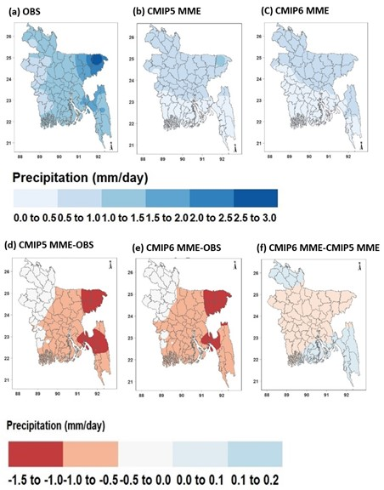
Fig. S1. As in Fig. 2, but for Pre-monsoon precipitation

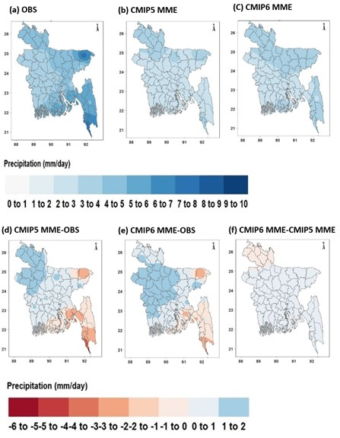
Fig. S2. As in Fig. 2, but for monsoon precipitation

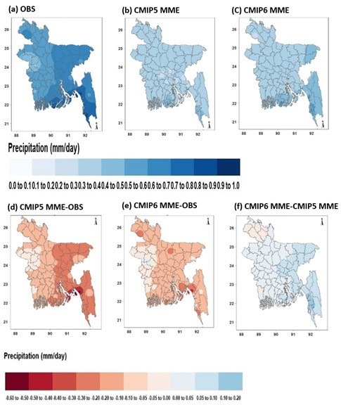
Fig. S3. As in Fig. 2, but for post-monsoon precipitation

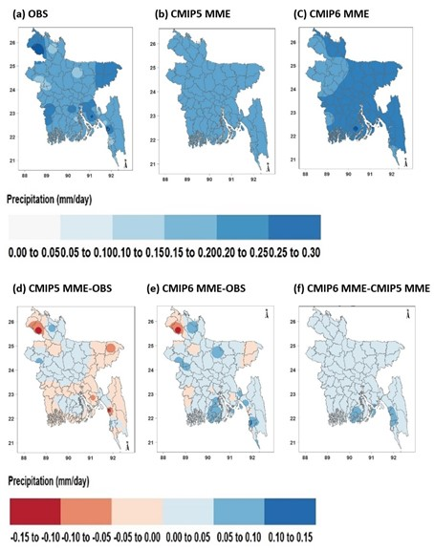
Fig. S4. As in Fig. 2, but for winter precipitation

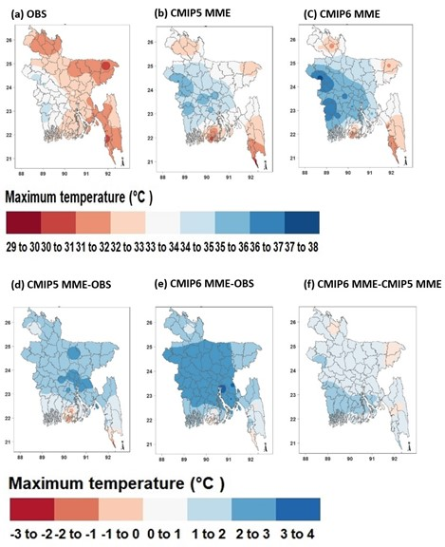
Fig. S5. As in Fig. 2, but for pre-monsoon maximum temperature

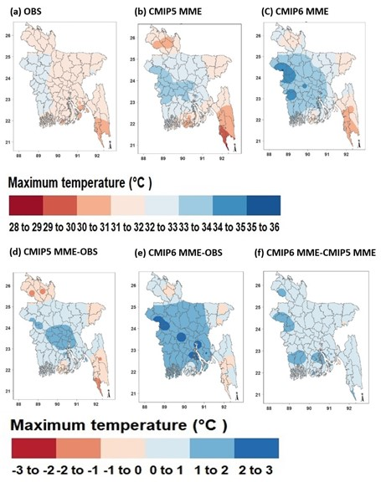
Fig. S6. As in Fig. 2, but for monsoon maximum temperature

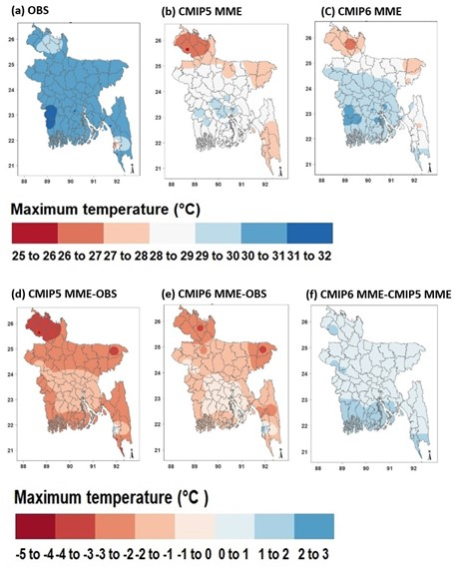
Fig. S7. As in Fig. 2, but for post-monsoon maximum temperature

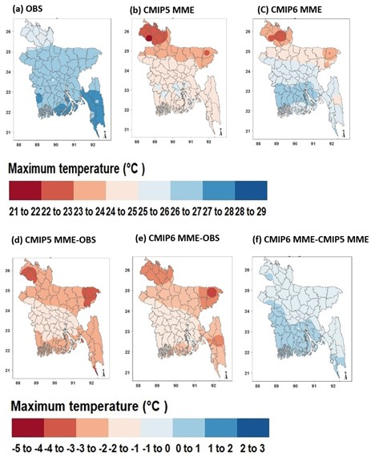
Fig. S8. As in Fig. 2, but for winter maximum temperature

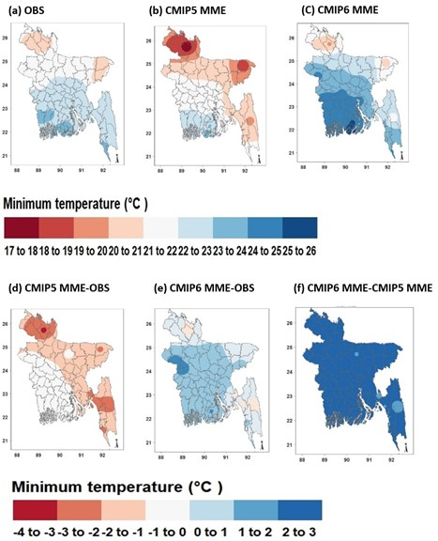
Fig. S9. As in Fig. 2, but for pre-monsoon minimum temperature

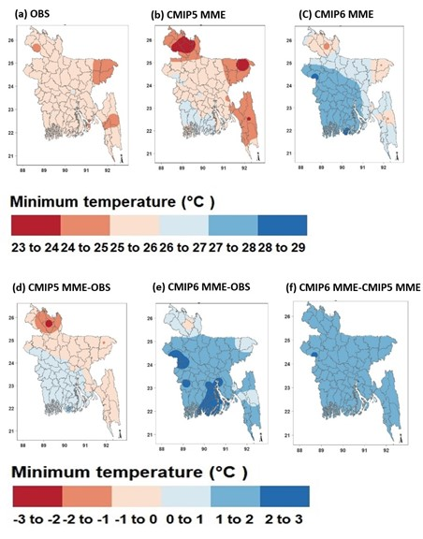
Fig. S10. As in Fig. 2, but for monsoon minimum temperature

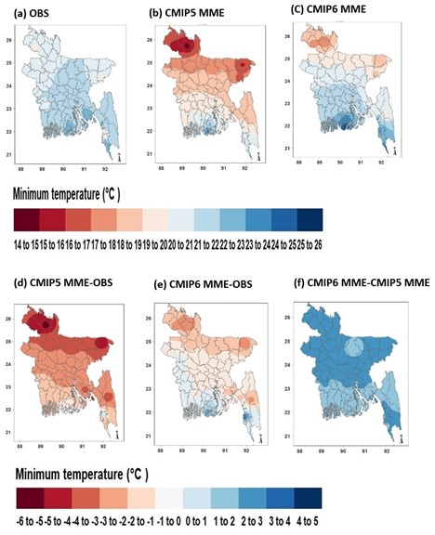
Fig. S11. As in Fig. 2, but for post-monsoon minimum temperature

Fig. S12. As in Fig. 2, but for winter minimum temperature

