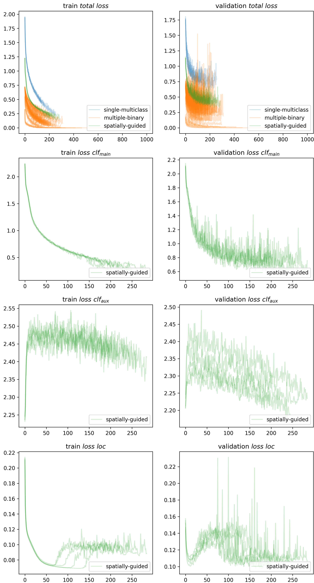
Supplementary Figure 1. Model training metrics (loss) from cross validation of all classifiers.

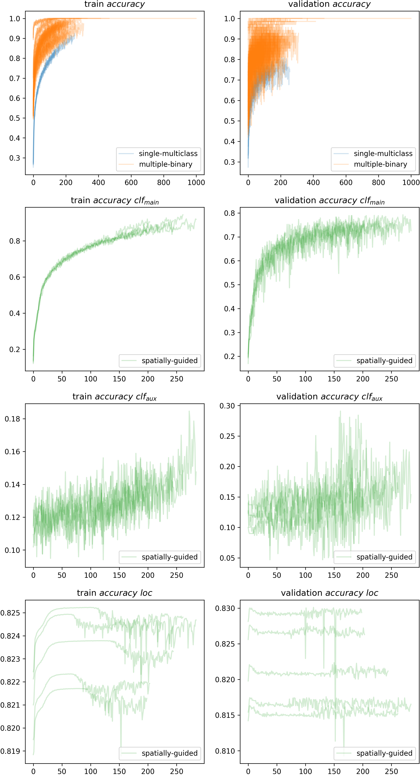
Supplementary Figure 1 (continued). Model training metrics (accuracy) from cross validation of all classifiers.

