Table 3. Heatmap visualizations of comparison classifiers for concordant and true positive glomeruli pattern classification results (cases with high IoU values).
 | Original | Annotation | Single multi-class | Multiple binary | Spatially guided
True label: Crescentic | 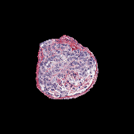 | 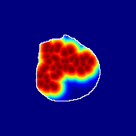 | 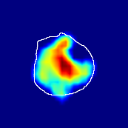 | 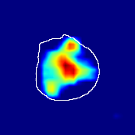 | 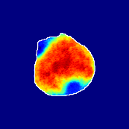
single-multiclass:
Crescentic p = 0.999, IoU = 0.154
multiple-binary:
Crescentic p = 1.000, IoU = 0.128
spatially-guided:
Crescentic p = 0.979, IoU = 0.740
True label: Endocapillary | 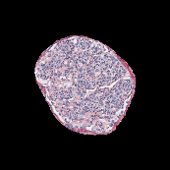 | 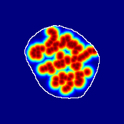 | 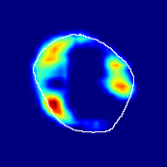 | 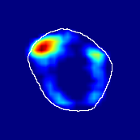 | 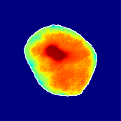
single-multiclass:
Endocapillary p = 1.000, IoU = 0.055
multiple-binary:
Endocapillary p = 0.993, IoU = 0.029
spatially-guided:
Endocapillary p = 0.976, IoU = 0.710
True label: FSGS | 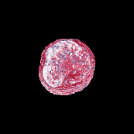 | 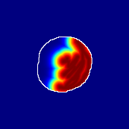 | 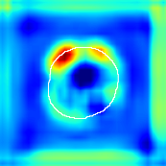 | 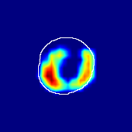 | 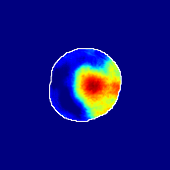
single-multiclass:
FSGS p = 0.964, IoU = 0.063
multiple-binary:
FSGS p = 0.999, IoU = 0.076
spatially-guided:
FSGS p = 0.862, IoU = 0.390
True label: Mesangioproliferative | 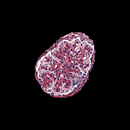 | 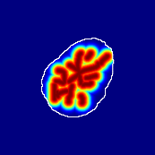 | 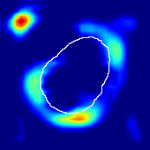 | 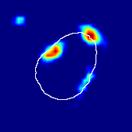 | 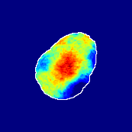
single-multiclass:
Mesangioproliferative p = 0.935, IoU = 0.029
multiple-binary:
Mesangioproliferative p = 0.988, IoU = 0.032
spatially-guided:
Mesangioproliferative p = 0.873, IoU = 0.201

Table 4. Heatmap visualizations of comparison classifiers for concordant and true positive glomeruli pattern classification results (cases with low IoU values).
 | Original | Annotation | Single multi-class | Multiple binary | Spatially guided
True label: Crescentic | 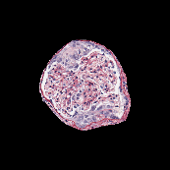 | 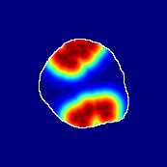 | 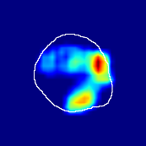 | 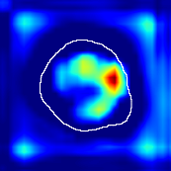 | 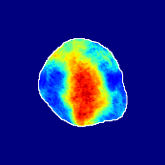
single-multiclass:
Crescentic p = 0.940, IoU = 0.058
multiple-binary:
Crescentic p = 0.959, IoU = 0.048
spatially-guided:
Crescentic p = 0.983, IoU = 0.163
True label: FSGS | 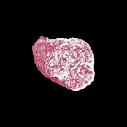 | 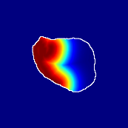 | 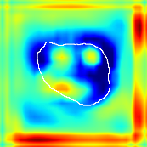 | 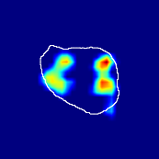 | 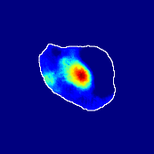
single-multiclass:
FSGS p = 0.960, IoU = 0.058
multiple-binary:
FSGS p = 0.986, IoU = 0.041
spatially-guided:
FSGS p = 0.774, IoU = 0.015
True label: Mesangioproliferative | 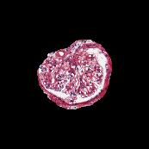 | 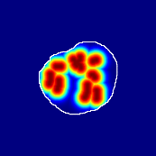 | 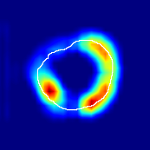 | 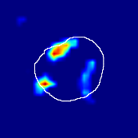 | 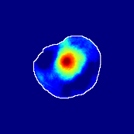
single-multiclass:
Mesangioproliferative p = 0.868, IoU = 0.047
multiple-binary:
Mesangioproliferative p = 0.956, IoU = 0.031
spatially-guided:
Mesangioproliferative p = 0.840, IoU = 0.141

Table 5. Heatmap visualizations of comparison classifiers for false or discrepant glomeruli pattern classification results.
 | Original | Annotation | Single multi-class | Multiple binary | Spatially guided
True label: FSGS | 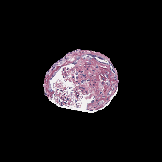 | 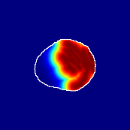 | 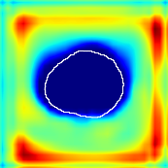 | 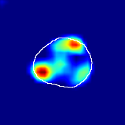 | 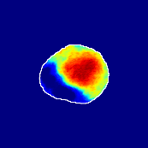
single-multiclass:
FSGS p = 0.672, IoU = 0.056
multiple-binary:
Crescentic p = 0.938, IoU = 0.047
spatially-guided:
Crescentic p = 0.715, IoU = 0.568
True label: FSGS | 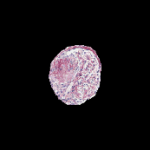 | 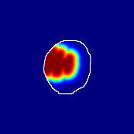 | 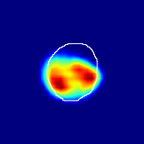 | 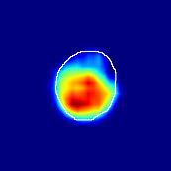 | 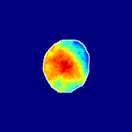
single-multiclass:
Crescentic p = 0.949, IoU = 0.102
multiple-binary:
Crescentic p = 0.990, IoU = 0.118
spatially-guided:
Crescentic p = 0.966, IoU = 0.449
True label: FSGS | 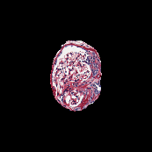 | 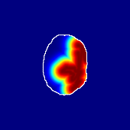 | 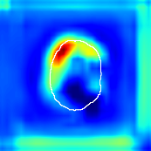 | 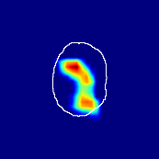 | 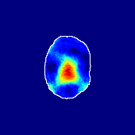
single-multiclass:
Normal p = 0.529, IoU = 0.067
multiple-binary:
FSGS p = 0.752, IoU = 0.070
spatially-guided:
Mesangioproliferative p = 0.588, IoU = 0.121
True label: FSGS | 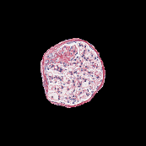 | 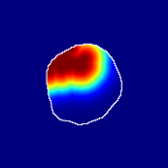 | 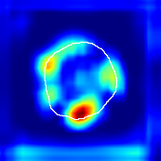 | 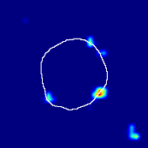 | 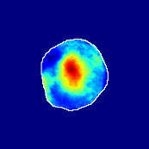
single-multiclass:
Normal p = 0.917, IoU = 0.052
multiple-binary:
FSGS p = 0.414, IoU = 0.000
spatially-guided:
Normal p = 0.817, IoU = 0.199
True label: Endocapillary | 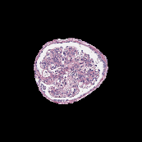 | 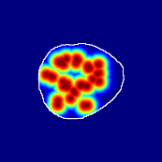 | 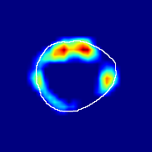 | 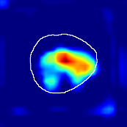 | 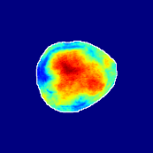
single-multiclass:
Endocapillary p = 0.447, IoU = 0.057
multiple-binary:
Crescentic p = 0.766, IoU = 0.081
spatially-guided:
Membranoproliferative p = 0.833, IoU = 0.484

