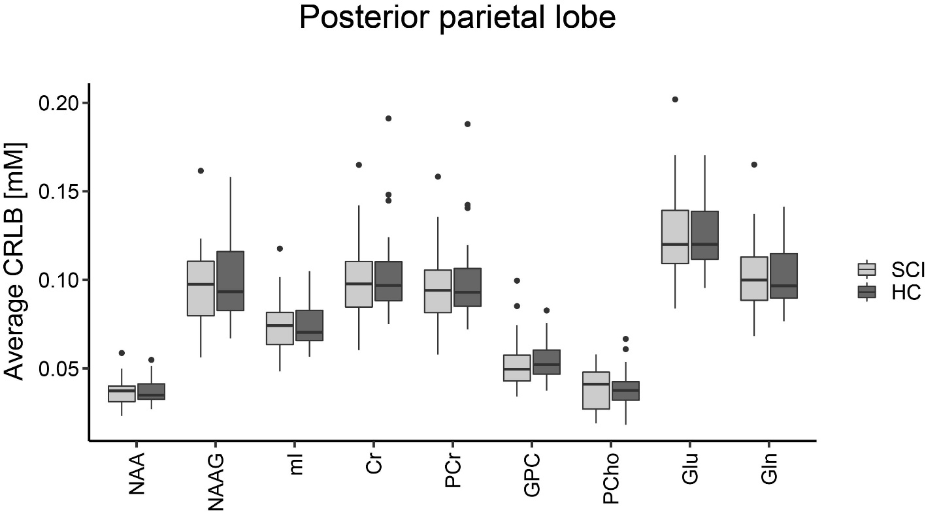
Figure 1 : Group-averaged Cramér-Rao lower bounds (CRLBs) for the constituents of all metabolite measures investigated in the posterior parietal lobe (reference region). The boxplots show the median and interquartile range of the average CRLB which was below 0.5 mM for all of these metabolites. Spinal cord injury patients (SCI) are indicated in light grey and healthy controls (HC) are indicated in dark grey. NAA = N-acetyl aspartate; NAAG = N-acetylaspartylglutamate; mI = myo-inositol; Cr = creatine; PCr = phosphocreatine; GPC = glycerophosphorylcholine; PCho = phosphorylcholine; Glu = glutamate; Gln = glutamine.

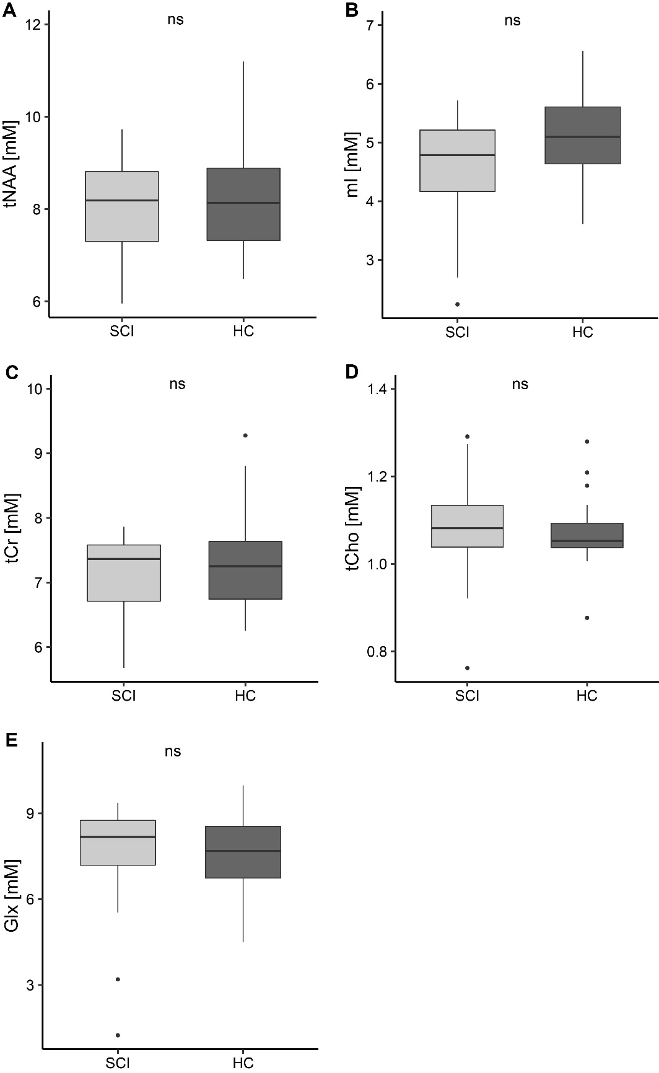
Hippocampal concentrations of all metabolites of interest. The boxplots show the median, interquartile range, and 25th and 75th percentile whiskers of metabolite concentrations in the posterior parietal lobe for spinal cord injury patients (SCI, indicated in light grey) and healthy controls (HC, indicated in dark grey). ns = not significant; tNAA = total N-acetylaspartate; mI = myo-inositol; tCr = total creatine; tCho = choline-containing compounds; Glx = glutamate and glutamine.

