Supporting Information
Zinc Localization and Speciation in Rice Grain Under Variable Nutrient Limitation Conditions
Yating Shen^{1, 2, 3}, Elizabeth Wiita^{1,4}, Athena A. Nghiem¹, Jingyu Liu⁵, Ezazul Haque⁶, Rachel N. Austin⁴, Chheng Y Seng⁷, Kongkea Phan⁷, Yan Zheng^{1, 5}, Benjamin C. Bostick1,*
1) Lamont-Doherty Earth Observatory of Columbia University, Palisades, New York, NY 10964, USA
2) National Research Center for Geo-analysis (NRCGA), Beijing 100037, China
3) Key Laboratory of Eco-Geochemistry, Ministry of Natural Resources of China, Beijing 100037, China
4) Barnard College, Department of Chemistry, New York, NY 10027, USA
5) State Environmental Protection Key Laboratory of Integrated Surface Water-Groundwater Pollution Control, School of Environmental Science and Engineering, Southern University of Science and Technology, Shenzhen 518055, China
6) IDGP in Human Toxicology and Department of Occupational and Environmental Health, University of Iowa, Iowa City, IA 52242, USA
7) Department of Food Chemistry, Faculty of Science and Technology, International University, Phnom Penh 12101, Cambodia

*Corresponding author: Benjamin C. Bostick
61 Route 9W, Palisades, New York, 10964
E-mail: bostick@ldeo.columbia.edu
Phone: +1 845 365 8659 Fax: +1 845 365 8155

Contents

Supplementary Figures
Figure S1. A map showing the locations of the 16 paired Cambodian rice grain and soil samples collected and analyzed in this study.
Figure S2. The masks defined using Sam’s Microprobe Analysis Kit (SMAK).
Figure S3. Zn and P correlations and corresponding localizations in a rice grain cross section.
Figure S4. Zn and S correlations and corresponding localizations in a rice grain cross section.
Figure S5. Example EXAFS data and fitting spectra.
Figure S6. Correlation of phytate Zn and mineral Zn with total Zn in rice grains.

Supplementary Tables
Table S1. Table displaying concentrations in mg kg⁻¹ of various standard reference soils analyzed using X-ray fluorescence spectroscopy (XRF).
Table S2. Comparison of the relative concentration of selected elements localized in embryo and endosperm in barley and rice grain, and the relative ratio between them.
Table S3. Structural parameters and percentage determined by simulating extended X-ray absorption fine structure (EXAFS) spectra for Zn in rice grain with only Zn-O tet and Zn-O oct shells.

Part S1 Quality Control for Soil XRF analysis
QA/QC: Quality assurance and quality control (QA/QC) was carried out to establish the accuracy of analytical XRF measurements. This QA/QC was done by comparing the instrument reported elemental composition with reference standards with known concentrations. We used standard reference material (SRM) purchased from the National Institute of Standards and Technology (NIST, Model- 2709a, San Juaquin soil), Canadian Certified Reference Material Project (CCRMP, Model- Till4) and US Environmental Protection Agency (Model-RCRA 180-661). Our analyses confirmed that our results were similar to reported values. XRF measured concentrations ranged within 15% of certified values for all elements except P and Cu in NIST 2709a, both of which were near the limit of detection. (See Table.S1)

Part S2 Microprobe XRF data processing
Data Analysis. Microprobe-based XRF methods are useful because they allow us to determine the relative abundance of different elements within specific microenvironments within the grain, something difficult to ascertain using traditional chemical extraction methods. Here we use μ-XRF to determine the spatial distribution and relative concentrations of most elements (Z>Si) with 3-micron spatial resolution within the rice grain cross section.
XRF microprobe data was processed with Sam’s Microprobe Analysis Kit (SMAK) (Mayhew et al., 2011). In most cases, total counts or normalized counts are measured and assumed to be proportional to concentration. In practice, total counts are proportional to the mass of an element of the sample within the focused beam, but variations in sample thickness and voids (which affect the excitation volume or mass of sample within the voxel) can make it challenging to translate this elemental mass to concentration. To more accurately reflect sample concentrations, it is necessary to account for this variation in thickness. To do so, the transmission and absorption of each pixel in the thin rice section were calculated using incident and transmitted beam intensities I₀ and I₁, and the total counts for a given element region of interest (ROI) were normalized by this absorption, which is proportional to electron density, and roughly proportional to the amount of sample in the excitation volume:
$$Corrected ROI intensity=\frac{(ROI raw counts)}{ln\left(\frac{I_{0}}{I_{1}}\right)}$$
Because the thin sample section is reasonably flat and free of holes, ln(I₀/I₁) is fairly constant and this correction minimally changed correlations between elements. It is important to note that this is somewhat different from conventional processing that normalizes to incident intensity (ROI raw counts/I_{o}) to correct for variable beam flux.
Filtering XRF Data based on Locations within the Rice Grain. Each portion of the grain had a unique composition. That implies that there was a range of concentrations of each element observed in the whole grain, and that different tissues (the aleurone layer, embryo and endosperm) have different and characteristic ratios of specific elements, depending on that composition. The correlations of different elements in whole grain maps reveal several clusters, each of which corresponds to a given chemical form or region of the grain. In most cases, clustering was strongest by tissue type. This is illustrated in Figure S3, which plots Zn and P concentrations in the grain as a whole, and within the endosperm, aleurone layer, and embryo. Each region has characteristics and different relative P and Zn concentrations and corresponding Zn: P ratios. Three cluster areas of scatter plots are delineated and circled with red lines, relating with scatter plots localized in embryo, aleurone and endosperm, respectively (Fig.S3 a-2, b-2, c-2). For comparison, µ-XRF scatterplots for Zn and S for various concentrations of Zn and S are shown in Figure S4.
Based on this fact, it is readily apparent that it is possible to section the image into three principal regions (the embryo, the aleurone layer and the endosperm), and to evaluate the mean and total elemental concentrations in each based on their summary statistics.

Supplementary Figures
Supporting Information Figure S1. A map showing the locations of the 16 paired Cambodian rice grain and soil samples collected and analyzed in this study. Map created with ArcGIS. Most of the Zn concentrations in soils were less than 11 mg kg ⁻¹.

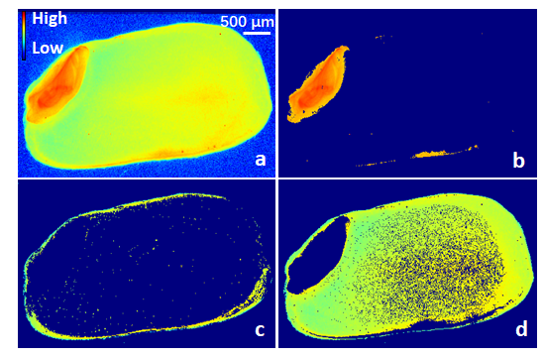
Supporting Information Figure S2. The masks defined using Sam’s Microprobe Analysis Kit (SMAK). This represents the localization of whole grain, embryo, aleurone and endosperm, respectively (Shown with Zn localization). (a) represents the Zn intensity (after thickness correction) from μ-XRF for the whole rice grain section. (b) The embdryo, (c) aleurone and (d) endosperm regions of the grain determined using masks of Zn intensity (after thickness correction).
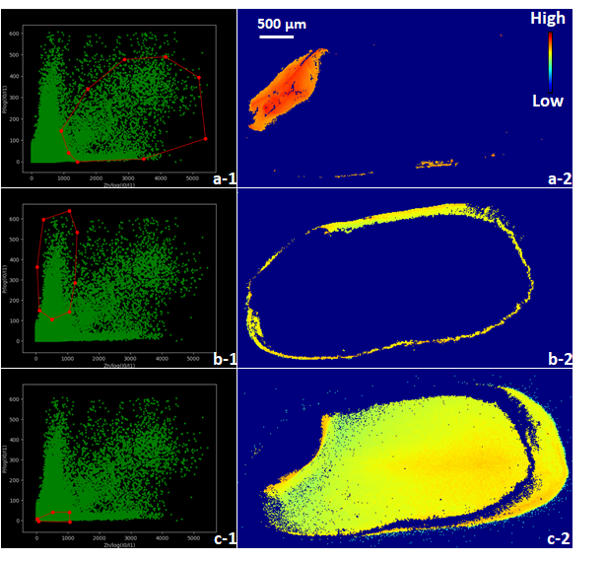
Supporting Information Figure S3. Zn and P correlations and corresponding localizations in a rice grain cross section. Fig. a-1, a-2 and a-3 represent Zn(x-axis) and P(y-axis) raw intensity (after thickness corrections), respectively. All the left figures with different scatter plot groups circled in red (a-1, b-2 and b-3) represent the Zn-P scatter plot correlation of the point sample localized in the corresponding tissues in the right figures(b-1, b-2 and b-3), respectively.

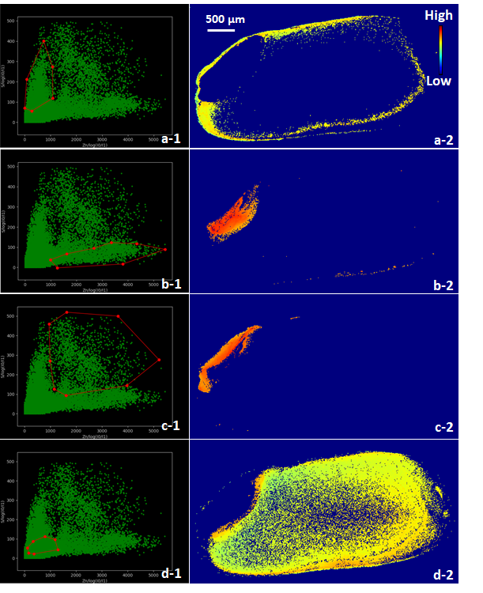
Supporting Information Figure S4. Zn and S correlations and corresponding localizations in a rice grain cross section. Fig. a-1, a-2 and a-3 represent Zn(x-axis) and S(y-axis) raw intensity (after thickness corrections), respectively. All the left figures with different scatter plot groups circled in red (Fig. a-1, b-2 and b-3) represent the Zn-S scatter plot correlation of the point sample localized in the corresponding tissues in the right (Fig. b-1, b-2 and b-3), respectively.

Supporting Information Figure S5. Example EXAFS data and fitting spectra. (a) k³ -weighted EXAFS spectra of Zn for PP119_22R, over k range of 1- 11 Å⁻¹. (b) Corresponding radial structure functions for PP110_22R, over R range of 0.0 - 5.0 Å. (c) k³ -weighted EXAFS spectra of Zn for PP3_Rice1, over k range of 1 -7.5 Å⁻¹. (d) Corresponding radial structure functions for PP3_Rice1, over R range of 0.0 - 5.0 Å. Details about these samples are in Table 3, and SI excel files contain data and fits of every sample in this study.

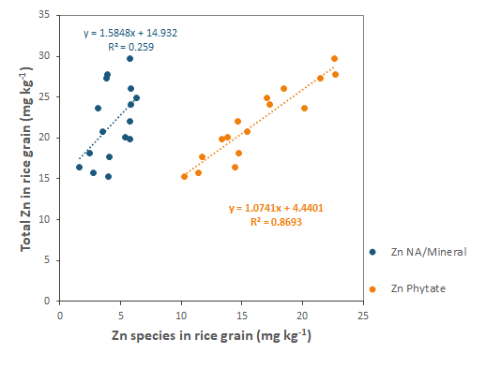
Supporting Information Figure S6. Correlation of phytate Zn and mineral Zn with total Zn in rice grains. Specation of Zn based on the local structure estimated based on EXAFS spectral fitting. Each Zn specie concentration was calculated by multiplying the specie percentage with total Zn concentration. There is a clear relationship between the Zn-phytate complex, but not other forms of Zn in rice, and total rice Zn.

Supplementary Tables
Supporting Information Table S1. Table displaying concentrations in mg kg⁻¹ of various standard reference soils analyzed using X-ray fluorescence spectroscopy (XRF). NIST2709a, CCRMP-TILL and RCRA are soil reference materials with a wide range of metal concentrations. Recoveries for most elements were within an acceptable range of 80% to 120%. The detection limit of Zn is about 4 mg kg⁻¹. Percent coefficient of variance (%CV) is based on triplicate measurements.

Element | Certified Value (mg kg⁻¹) |  |  |  | Measured Value (%CV) (mg kg⁻¹) |  |  |  | LOD  (mg kg⁻¹)
Element | NIST 2709a | CCRMP-TILL4 | RCRA |  | NIST 2709a | CCRMP-TILL4 | RCRA |  | LOD  (mg kg⁻¹)
P | 688 | 880 |  |  | 1256 (17) | 1772 (18) |  |  | 55
S |  | 800 |  |  |  | 1593 (1) |  |  | 38
K | 21100 |  |  |  | 17729 (1) |  |  |  | 31
Ca | 19100 |  |  |  | 19230 (2) |  |  |  | 7
Mn | 529 | 490 |  |  | 493 (3) | 455 (7) |  |  | 21
Fe | 33600 | 39700 |  |  | 33259 (1) | 39431 (1) |  |  | 21
Cu | 34 | 237 |  |  | 41 (2) | 241 (3) |  |  | 6
Zn | 103 | 70 |  |  | 89 (2) | 65 (3) |  |  | 4
As | 11 | 111 | 500 |  | 9 (8) | 101 (4) | 452 (1) |  | 2
Se |  |  | 500 |  |  |  | 466 (2) |  | 2
Pb | 17 | 50 | 500 |  | 17 (11) | 52 (2) | 614 (2) |  | 2

Supporting Information Table S2. Comparison of the relative concentration of selected elements localized in embryo and endosperm in barley and rice grain, and the relative ratio between them. The relative concentrations of Zn are higher than P and S in this study because of the low energy of P and S fluorescent photons decreasing their counts relative to Zn. As a consequence, it is only possibly to compare ratios of concentrations of the same elements between tissues, not ratios of elemental concentrations.
Sample and Resource | Tissue | Chemical unit | Concentration |  |  | Embryo and Endosperm Ratio
Sample and Resource | Tissue | Chemical unit | Zn | P | S | Zn | P | S
Barley grain(Persson et al., 2009) | Embryo | mg kg⁻¹ | 164 | 13600 | 3990 | 11.7 | 8.3 | 3.4
Barley grain(Persson et al., 2009) | Endosperm | mg kg⁻¹ | 14 | 1640 | 1160 | 11.7 | 8.3 | 3.4
Barley grain(Persson et al., 2009) | Embryo | mmol kg⁻¹ | 2.5 | 438.7 | 124.7 | 11.7 | 8.3 | 3.4
Barley grain(Persson et al., 2009) | Endosperm | mmol kg⁻¹ | 0.21 | 52.9 | 36.2 | 11.7 | 8.3 | 3.4
Rice grain  (this research) | Embryo | Relative concentration* | 2481 | 161 | 44 | 5.7 | 4.1 | 2.3
Rice grain  (this research) | Endosperm | Relative concentration* | 438 | 39 | 19 | 5.7 | 4.1 | 2.3
Note (*): Average concentration after μ-XRF raw counts with thickness correction based on three tissues’ masks calculation.

Supporting Information Table S3. Structural parameters and percentage determined by simulating extended X-ray absorption fine structure (EXAFS) spectra for Zn in rice grain with only Zn-O tet and Zn-O oct shells. The tetrahedral Zn-O likely represents Zn phytate complexes, and the octahedral Zn-O is likely representative of Zn nicotinamide(NA) complexes or Zn mineral. Amplitude was set to 0.9 for each fitting; the two paths shared the same σ. EO, σ, del R and coordination number(CN) for each path were guessed.
Sample ID | Amplitude | E_{O} | σ | χ2 | Reduced χ2 | R factor | Coordination Number |  | Normalization  Factor | Normalized Fraction
 |  |  |  |  |  |  | Zn-O tet  [Zn Phytate]  (1.95 Å) | Zn-O oct  [Zn-NA/mineral]  (2.11Å) | Normalization  Factor | Zn-O tet  [Zn Phytate] | Zn-O oct  [Zn-NA/mineral]
KCH119_102R^{(a)} | 0.9 | 1.789 | 0.0026 | 75.87 | 22.07 | 0.0106 | 2.5±0.6 | 0.8±0.3 | 0.77 | 0.82±0.27 | 0.18±0.07
KCH119_104R^{(a)} | 0.9 | 1.372 | 0.0024 | 46.57 | 13.54 | 0.0138 | 2.4±0.6 | 1.1±0.4 | 0.78 | 0.77±0.34 | 0.23±0.08
KPC119_8R^{(a)} | 0.9 | 1.214 | 0.0054 | 114.34 | 33.26 | 0.0105 | 2.4±0.4 | 0.9±0.3 | 0.75 | 0.79±0.32 | 0.21±0.06
PP119_22R^{(b)} | 0.9 | 1.017 | 0.0053 | 79.86 | 23.23 | 0.0108 | 2.4±0.5 | 0.9±0.3 | 0.74 | 0.81±0.29 | 0.19±0.07
PP119_2R^{(a)} | 0.9 | 1.656 | 0.0050 | 31.80 | 9.25 | 0.0092 | 2.6±0.5 | 1.3±0.3 | 0.85 | 0.76±0.37 | 0.24±0.07
PP119_3R^{(a)} | 0.9 | 1.610 | 0.0044 | 158.77 | 46.18 | 0.0084 | 2.3±0.4 | 0.9±0.3 | 0.72 | 0.78±0.32 | 0.22±0.06
PP119_103R^{(b)} | 0.9 | 0.593 | 0.0033 | 46.75 | 13.60 | 0.0159 | 2.9±0.8 | 0.7±0.5 | 0.85 | 0.87±0.20 | 0.13±0.10
PP119_13R^{(b)} | 0.9 | 1.684 | 0.0023 | 20.85 | 6.06 | 0.0064 | 2.6±0.4 | 1.0±0.3 | 0.81 | 0.80±0.30 | 0.20±0.05
PP3_Rice1^{(b)} | 0.9 | 1.069 | 0.0030 | 42.99 | 12.50 | 0.0093 | 2.8±0.6 | 0.7±0.4 | 0.83 | 0.86±0.22 | 0.14±0.07
PP3_Rice2^{(b)} | 0.9 | 1.701 | 0.0034 | 25.73 | 7.48 | 0.0078 | 2.6±0.5 | 1.0±0.3 | 0.83 | 0.79±0.31 | 0.21±0.06
PP5_Rice1^{(b)} | 0.9 | 1.453 | 0.0040 | 290.74 | 84.58 | 0.0100 | 2.7±0.6 | 1.2±0.4 | 0.86 | 0.78±0.34 | 0.22±0.07
PP6_Rice1^{(b)} | 0.9 | 1.223 | 0.0039 | 35.96 | 10.46 | 0.0089 | 2.8±0.6 | 0.9±0.3 | 0.84 | 0.82±0.27 | 0.18±0.07
PP7_Rice1^{(b)} | 0.9 | 0.651 | 0.0047 | 37.34 | 10.86 | 0.0130 | 3.1±0.8 | 0.6±0.5 | 0.87 | 0.89±0.16 | 0.11±0.10
PT3_Rice1^{(a)} | 0.9 | 1.259 | 0.0038 | 58.32 | 16.96 | 0.0182 | 2.6±0.8 | 1.0±0.5 | 0.82 | 0.79±0.31 | 0.21±0.09
PT5_Rice1^{(b)} | 0.9 | 0.723 | 0.0040 | 52.16 | 15.17 | 0.0120 | 3.0±0.8 | 0.7±0.5 | 0.87 | 0.87±0.19 | 0.13±0.09
PT8_Rice1^{(b)} | 0.9 | 0.675 | 0.0042 | 38.48 | 11.19 | 0.0101 | 3.1±0.7 | 0.5±0.5 | 0.86 | 0.91±0.13 | 0.09±0.09
Market2^{(c)} | 0.9 | 1.879 | 0.0022 | 22.57 | 6.56 | 0.0095 | 2.5±0.5 | 1.1±0.3 | 0.79 | 0.78±0.34 | 0.22±0.07
Market3^{(c)} | 0.9 | 1.495 | 0.0023 | 68.12 | 19.81 | 0.0153 | 2.5±0.7 | 0.9±0.4 | 0.78 | 0.81±0.28 | 0.19±0.09
Market9^{(c)} | 0.9 | 1.289 | 0.0042 | 33.49 | 9.74 | 0.0108 | 2.7±0.6 | 1.0±0.4 | 0.85 | 0.81±0.29 | 0.19±0.07
Notes
(a): Rice grains are grown in soil with less Zn deficiency (high soil bioavailable Zn);
(b): Rice grains are grown in soil with more Zn deficiency (low soil bioavailable Zn);
(c): Market rice grains are grown under unknown levels of Zn deficiency.

References
Mayhew L, Webb S, Templeton A (2011) Microscale imaging and identification of Fe speciation and distribution during fluid–mineral reactions under highly reducing conditions. Environmental science & technology 45: 4468-4474
Persson DP, Hansen TH, Laursen KH, Schjoerring JK, Husted S (2009) Simultaneous iron, zinc, sulfur and phosphorus speciation analysis of barley grain tissues using SEC-ICP-MS and IP-ICP-MS. Metallomics 1: 418-426

