Supplementary Material

Crosstalk between miRNA and protein expression profiles in nitrate exposed brain cells

Saumya Mishra^{1,2}, Sana Sarkar¹, Anuj Pandey¹, Sanjeev Kumar Yadav^{1,2}, Renu Negi^{1,2}, Sanjay Yadav³, AB Pant^{1,2}*
¹Systems Toxicology and Health Risk Assessment Group, CSIR- Indian Institute of Toxicology Research (CSIR-IITR), Vishvigyan Bhawan, Lucknow-226001, Uttar Pradesh, India. ²Academy of Scientific and Innovative Research (AcSIR), AcSIR Headquarters CSIR-HRDC Campus, Postal Staff College Area, Sector 19, Kamla Nehru Nagar, Ghaziabad-201002, Uttar Pradesh, India, ³All India Institute of Medical Sciences (AIIMS), Raebareli-229405, Uttar Pradesh, India.

*Correspondence
Dr AB Pant
Developmental Toxicology Division,
System Toxicology and Health Risk Assessment Group,
CSIR-Indian Institute of Toxicology Research,
Vishvigyan Bhawan, 31, Mahatma Gandhi Marg, Lucknow-226001
Email address- abpant@iitr.res.in

Supplementary Material

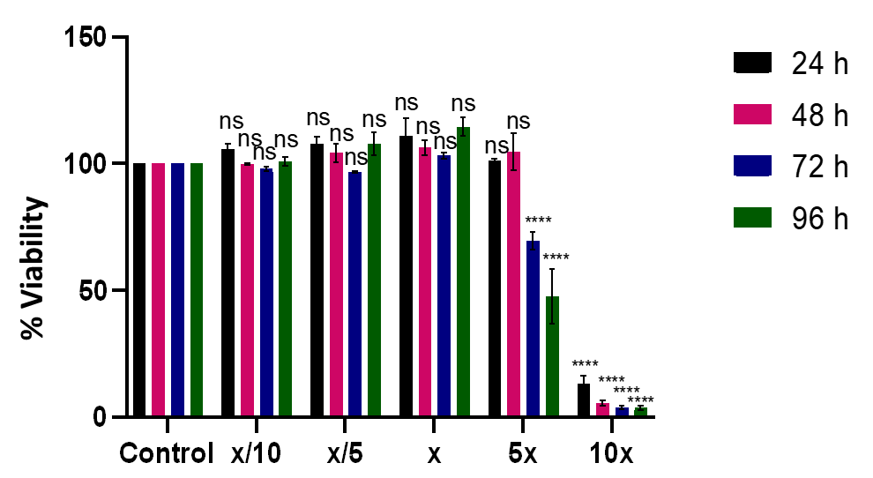
Figures
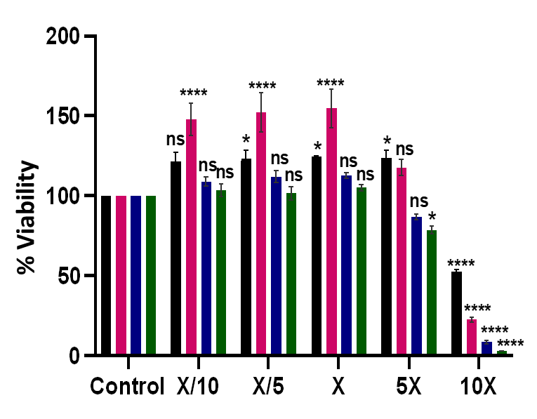
Figure S 1: Cell viability assay of HMC3 and SH-SY5Y cell line with different doses of nitrate using alamarBlue cell viability reagent. Cell viability of HMC3 cell line (A) and SH-SY5Y (B) at 24, 48, 72 and 96h. Data are presented as mean ± SEM of the three biological representative experiments using two-way ANOVA. *p < 0.05, ****p < 0.0001, versus control.
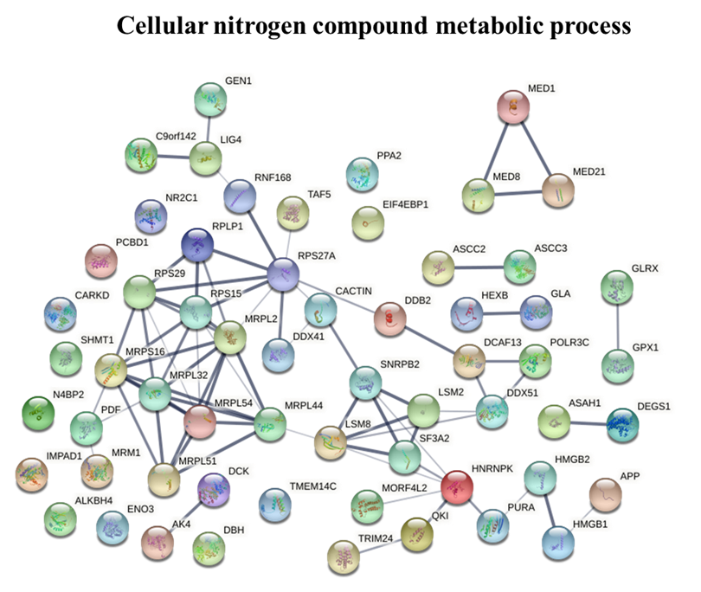
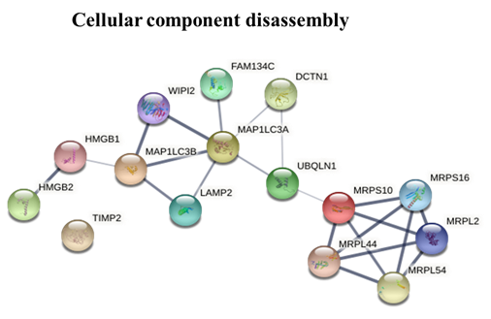
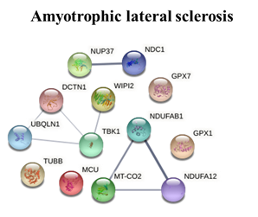
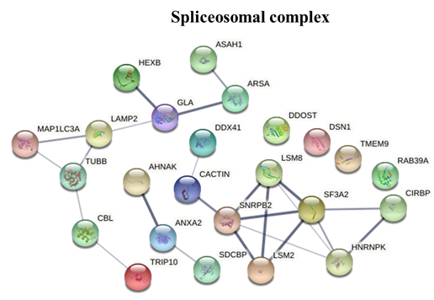
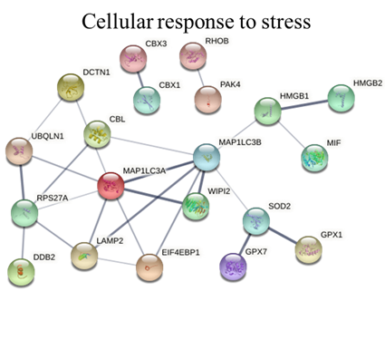

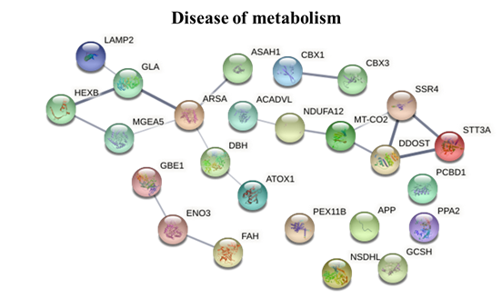
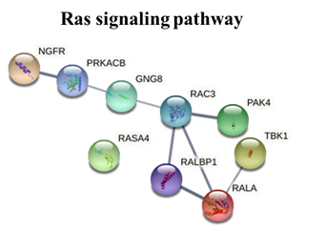
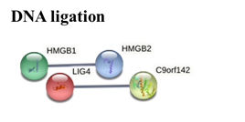

Figure S 2: Protein-protein interaction network analysis in SH-SY5Y cell line. Functional interaction network of differentially expressed proteins identified from cells exposed to nitrates using STRING networks.

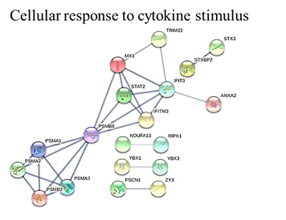
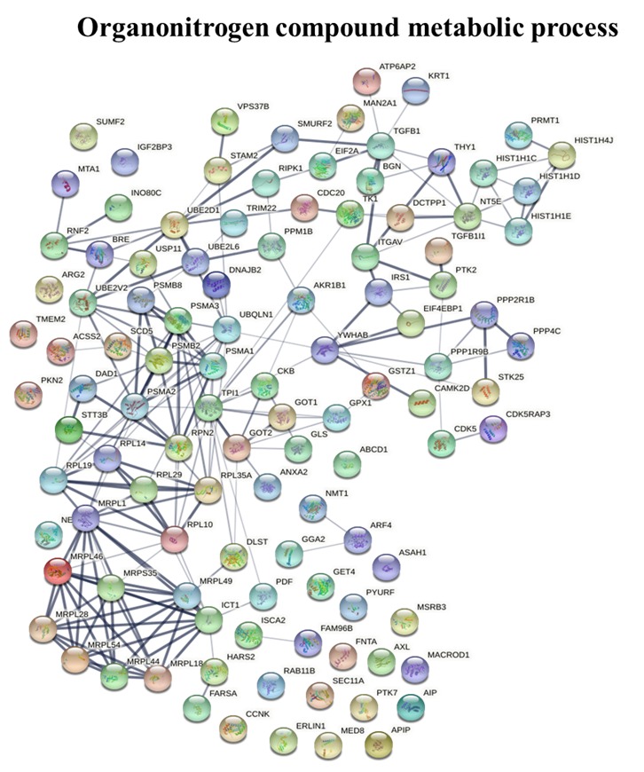
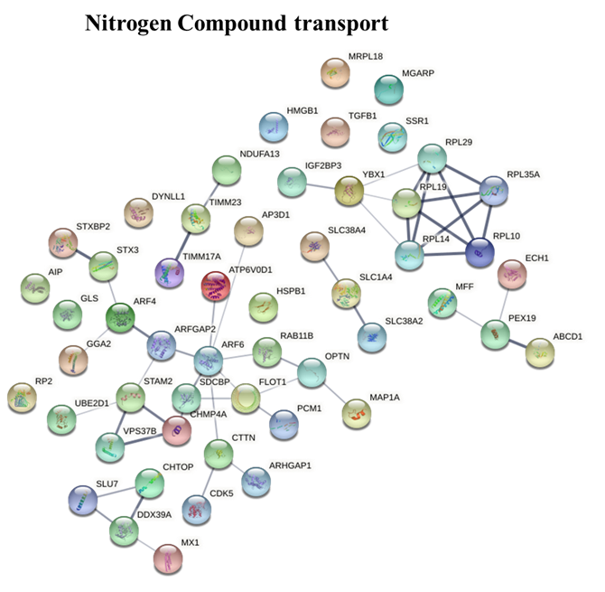

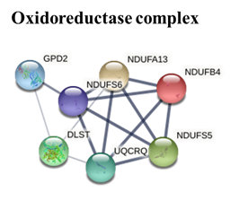
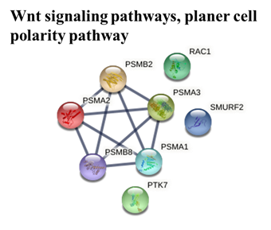
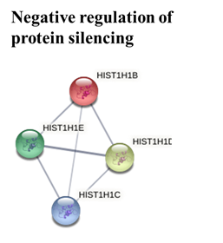

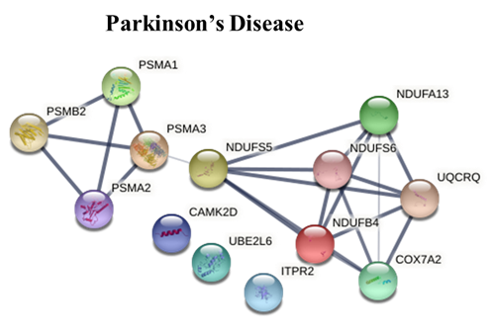
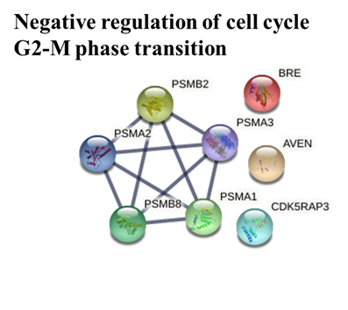
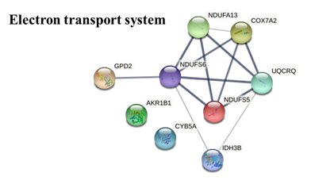
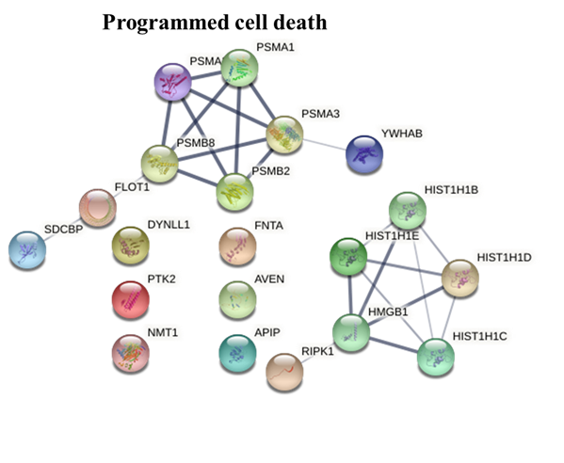
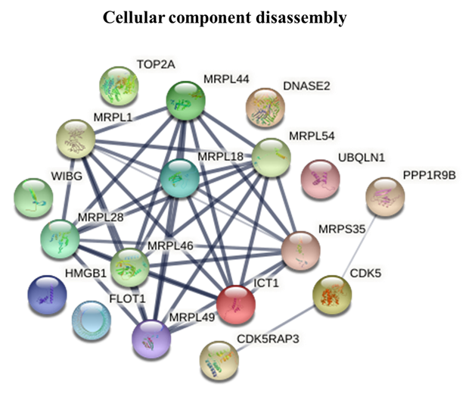
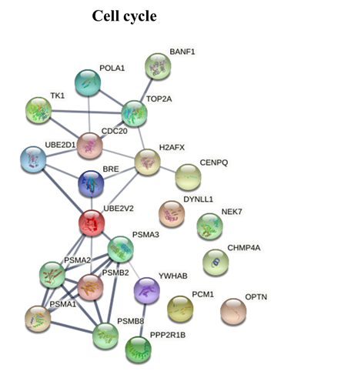

Figure S 3: Protein-protein interaction network analysis in HMC3 cell line. Functional interaction network of differentially expressed proteins identified from cells exposed to nitrates using STRING networks

Tables
Supplementary table 1: List of microRNAs in custom openArray plate
U6 snRNA | hsa-miR-145 | hsa-miR-204 | hsa-miR-494
RNU44 | hsa-miR-144 | hsa-miR-20a | hsa-miR-543
RNU48 | hsa-miR-146a | hsa-miR-217 | hsa-miR-487b
RNU58A | hsa-miR-141 | hsa-miR-218 | ath-miR159a
snoRNA202 | hsa-miR-150 | hsa-miR-219 | hsa-miR-143
snoRNA234 | mmu-miR-153 | hsa-miR-296-3p | hsa-miR-193a-3p
snoRNA55 | hsa-miR-26b | hsa-miR-363 | hsa-miR-181a
hsa-miR-29a | hsa-miR-30a-5p | hsa-miR-490 | hsa-miR-185
hsa-miR-29b | hsa-miR-30e | mmu-miR-499 | hsa-miR-15b
hsa-miR-29c | hsa-miR-199a-3p | hsa-miR-9 | ipu-miR-155
hsa-miR-30b | hsa-miR-138 | mmu-miR-96 | hsa-miR-214
hsa-miR-30c | hsa-miR-149 | hsa-miR-205 | hsa-miR-210
hsa-miR-22 | hsa-miR-186 | hsa-let-7i | hsa-miR-181c
hsa-miR-335 | hsa-miR-192 | hsa-miR-16 | mmu-miR-155
hsa-miR-142-5p | hsa-miR-194 | hsa-miR-148b | hsa-miR-411
hsa-miR-19a | hsa-miR-191 | hsa-miR-219-2-3p | hsa-miR-27a
hsa-miR-19b | hsa-miR-17 | hsa-miR-339-5p | dme-miR-7
hsa-miR-21 | hsa-miR-132 | hsa-miR-331-5p | hsa-let-7f
hsa-miR-26a | hsa-miR-125b | hsa-miR-101 | mmu-miR-34b-3p
hsa-miR-24 | api-miR-7 | mmu-miR-137 | mmu-miR-217
hsa-miR-222 | hsa-miR-338-5P | hsa-let-7e | hsa-miR-15a
hsa-miR-221 | hsa-miR-213 | hsa-miR-126 | hsa-miR-19b-1*
hsa-miR-133b | hsa-miR-206 | hsa-miR-103 | mmu-miR-92a-1*
hsa-miR-433 | hsa-miR-203 | hsa-miR-214* | hsa-miR-92a-1*
hsa-miR-34c | hsa-miR-200a | hsa-miR-93* | hsa-miR-129
hsa-miR-34a | hsa-miR-200b | hsa-let-7a | hsa-miR-135a
hsa-miR-34b | hsa-miR-200c | hsa-miR-18a | hsa-miR-27b
hsa-miR-338-3p | hsa-miR-199a | hsa-miR-124* | hsa-miR-382

Supplementary table 2: List of upregulated proteins in HMC3 exposed to X dose of nitrates
S. No. | Description | Gene Symbol | Abundance Ratio | P-Value
 | Protein-tyrosine sulfotransferase | TPST1 | 12.666 | 2E-15
 | Thymidylate synthase (Fragment) | TYMS | 9.878 | 4.18E-06
 | Pannexin-1 | PANX1 | 6.729 | 1.25E-06
 | Deoxyuridine 5'-triphosphate nucleotidohydrolase, mitochondrial | DUT | 5.042 | 1E-17
 | ATPase H(+)-transporting lysosomal accessory protein 2 (Fragment) | ATP6AP2 | 4.124 | 0.003052
 | 4F2 cell-surface antigen heavy chain | SLC3A2 | 3.593 | 0.000322
 | Protein PAXX | PAXX | 3.532 | 2.1E-05
 | ITGA7 variant protein (Fragment) | ITGA7 variant protein | 3.491 | 0.00025
 | Serine-protein kinase ATM | ATM | 3.45 | 0.005293
 | Molybdopterin synthase sulfur carrier subunit | MOCS2 | 3.42 | 0.000135
 | SAFB2 protein (Fragment) | SAFB2 | 3.402 | 0.000117
 | DDB1- and CUL4-associated factor 12-like protein 1 | DCAF12L1 | 3.176 | 0.002632
 | rRNA methyltransferase 1, mitochondrial | MRM1 | 3.068 | 9.91E-06
 | Connective tissue growth factor | CTGF | 2.992 | 0.009022
 | Gamma-ECS OS=Homo sapiens | GCLC | 2.977 | 0.003783
 | Armadillo repeat-containing protein 10 | ARMC10 | 2.857 | 1.27E-05
 | Chromatin modification-related protein MEAF6 | MEAF6 | 2.83 | 0.001582
 | Iron-sulfur cluster assembly 2 homolog, mitochondrial | ISCA2 | 2.731 | 0.004413
 | cDNA FLJ75083, highly similar to Homo sapiens amine oxidase (flavin containing) domain 2 (AOF2),mRNA | not available | 2.725 | 0.018105
 | Mediator of ErbB2-driven cell motility 1 | MEMO1 | 2.672 | 0.001011
 | Calcium activated nucleotidase 1, isoform CRA_b | CANT1 | 2.593 | 0.006445
 | Kinesin-like protein KIF15 | KIF15 | 2.489 | 0.011966
 | Biglycan | BGN | 2.457 | 0.032909
 | Sentrin-specific protease 3 | SENP3 | 2.453 | 0.001908
 | Fructose-bisphosphate aldolase | ALD | 2.447 | 0.021586
 | Pyridoxal-dependent decarboxylase domain-containing protein 1 | PDXDC1 | 2.445 | 0.010219
 | Cleavage and polyadenylation specificity factor subunit 4 | CPSF4 | 2.441 | 0.042673
 | Condensin-2 complex subunit H2 | NCAPH2 | 2.383 | 0.018015
 | cAMP-regulated phosphoprotein 19 | ARPP19 | 2.343 | 1.25E-05
 | SDF2 protein | SDF2 | 2.331 | 0.005555
 | Pre-rRNA-processing protein TSR2 homolog | TSR2 | 2.314 | 0.018573
 | Epididymis secretory sperm binding protein | not available | 2.301 | 0.042823
 | Magnesium transporter protein 1 | MAGT1 | 2.266 | 0.028154
 | DNA damage-binding protein 2 (Fragment) | DDB2 | 2.21 | 0.006308
 | Pumilio homolog 1 (Fragment) | PUM1 | 2.176 | 0.030701
 | MHC class I antigen (Fragment) | HLA-C | 2.148 | 0.037657
 | cDNA FLJ33764 fis, clone BRCOC2000360, highly similar to Vacuolar ATP synthase subunit S1 | not available | 2.11 | 0.000479
 | Receptor protein-tyrosine kinase (Fragment) | EPHB2 variant protein | 2.092 | 0.009677
 | Transcription regulator protein BACH1 | BACH1 | 2.049 | 0.042368
 | Nucleosome assembly protein 1-like 1 (Fragment) | NAP1L1 | 2.036 | 9.47E-06
 | Multiple PDZ domain protein | MPDZ | 2.025 | 0.013731
 | Transcription termination factor 4, mitochondrial | MTERF4 | 2.014 | 0.003733
 | Glycerol kinase | GK | 2.011 | 0.049994
 | Centrin-2 | CETN2 | 2.01 | 0.014249

Supplementary table 3: List of down-regulated proteins in HMC3 exposed to X dose of nitrates
S. No. | Description | Gene Symbol | Abundance Ratio | P-Value
 | Putative deoxyribonuclease TATDN1 | TATDN1 | 0.498 | 0.03254
 | Mitochondrial ribosomal protein S30 variant (Fragment) | MRPS30 | 0.497 | 0.019742
 | 60S ribosomal protein L23a (Fragment) | RPL23A | 0.496 | 0.004956
 | GTP-binding protein 1 | GTPBP1 | 0.495 | 0.011763
 | Farnesyl pyrophosphate synthase | FDPS | 0.494 | 0.008952
 | 60S ribosomal protein L14 | RPL14 | 0.493 | 0.008488
 | RNA helicase | MOV10 | 0.493 | 0.044583
 | Protein TFG | TFG | 0.491 | 0.004736
 | 60S ribosomal protein L34 | RPL34 | 0.491 | 0.033412
 | Histone H1.0 | H1-0 | 0.489 | 0.007055
 | Lysosomal-associated membrane protein 1, isoform CRA_a | LAMP1 | 0.486 | 0.014073
 | Epididymis secretory sperm binding protein (Fragment) | MIF | 0.484 | 0.003338
 | Ras-GTPase activating protein SH3 domain-binding protein 2, isoform CRA_b | G3BP2 | 0.483 | 0.048284
 | Interferon-induced GTP-binding protein Mx1 | MX1 | 0.48 | 0.00288
 | Uncharacterized protein | not available | 0.48 | 0.017276
 | 60S ribosomal protein L14 | RPL14 | 0.48 | 0.03532
 | Constitutive coactivator of PPAR-gamma-like protein 1 | FAM120A | 0.478 | 0.005666
 | Synaptic functional regulator FMR1 | FMR1 | 0.476 | 0.034795
 | Ubiquitin-conjugating enzyme E2 T | UBE2T | 0.473 | 0.009993
 | Cysteine-rich protein 2 | CRIP2 | 0.473 | 0.013755
 | Eukaryotic translation initiation factor 2A | EIF2A | 0.472 | 0.002086
 | RAB5C, member RAS oncogene family, isoform CRA_a | RAB5C | 0.472 | 0.002157
 | Argininosuccinate lyase isoform 3 (Fragment) | ASL | 0.472 | 0.009683
 | Programmed cell death protein 10 (Fragment) | PDCD10 | 0.467 | 0.004086
 | DNA polymerase | POLA1 | 0.466 | 0.020848
 | Histone H4 | HIST1H4J | 0.463 | 0.021501
 | Kinesin-like protein KIF22 | KIF22 | 0.46 | 0.018249
 | PEST proteolytic signal-containing nuclear protein | PCNP | 0.457 | 0.012361
 | Coxsackievirus and adenovirus receptor | CXADR | 0.454 | 0.039098
 | Cysteine--tRNA ligase, cytoplasmic | CARS1 | 0.448 | 0.022439
 | Histone H2A.V | H2AZ2 | 0.445 | 0.008945
 | Dihydropyrimidinase-related protein 2 | DPYSL2 | 0.445 | 0.017921
 | Testis tissue sperm-binding protein Li 64n | TSBP | 0.439 | 0.044581
 | Exosome complex component CSL4 (Fragment) | EXOSC1 | 0.438 | 0.01313
 | Splicing factor, arginine/serine-rich 19 | SCAF1 | 0.438 | 0.013695
 | Protein AAR2 homolog | AAR2 | 0.428 | 0.033591
 | Flotillin (Fragment) | FLOT1 | 0.426 | 0.003805
 | Histone H3.3 | H3-3A; H3-3B | 0.426 | 0.043444
 | DnaJ homolog subfamily C member 17 | DNAJC17 | 0.42 | 0.026389
 | Dyslexia-associated protein KIAA0319-like protein (Fragment) | KIAA0319L | 0.416 | 0.047001
 | Uncharacterized protein | not available | 0.415 | 0.019287
 | Alpha- and gamma-adaptin-binding protein p34 | AAGAB | 0.414 | 0.015657
 | Ribonuclease | JUNB | 0.41 | 0.003372
 | Cyclin-dependent-like kinase 5 | CDK5 | 0.41 | 0.029224
 | Secretory carrier-associated membrane protein 2 | SCAMP2 | 0.403 | 0.003321
 | Methylthioribulose-1-phosphate dehydratase | APIP | 0.403 | 0.014085
 | Ribonucleoside-diphosphate reductase subunit M2 | RRM2 | 0.399 | 0.001327
 | Protein YIPF | YIP1 | 0.396 | 0.042916
 | Abl interactor 1 | ABI1 | 0.393 | 0.015877
 | Angio-associated migratory cell protein | AAMP | 0.393 | 0.035766
 | Histone cluster 1, H1e | HIST1H1E | 0.384 | 3.16E-05
 | N-acyl-L-amino-acid amidohydrolase | HEL-S-5 | 0.384 | 0.02908
 | Deoxyribonuclease II | DNASE2 | 0.383 | 0.00013
 | Golgin subfamily A member 1 | GOLGA1 | 0.383 | 0.000201
 | S-phase kinase-associated protein 2 | SKP2 | 0.372 | 0.024865
 | HSD17B8 | HSD17B8 | 0.368 | 0.023405
 | Histone H1.2 | H1-2 | 0.361 | 7.18E-06
 | Pre-mRNA-splicing factor SLU7 | SLU7 | 0.36 | 0.00032
 | Reactive oxygen species modulator 1 | ROMO1 | 0.36 | 0.049583
 | Proteasomal ubiquitin receptor ADRM1 | ADRM1 | 0.358 | 0.001333
 | Transmembrane protein 230 | TMEM230 | 0.358 | 0.012557
 | E3 ubiquitin-protein ligase NEDD4-like | NEDD4L | 0.357 | 0.011528
 | DNA-directed RNA polymerase subunit beta | POLR2B | 0.357 | 0.025425
 | Cactin | CACTIN | 0.356 | 0.025785
 | Translocon-associated protein subunit delta | SSR4 | 0.355 | 0.000467
 | Heat shock 70 kDa protein 14 | HSPA14 | 0.354 | 0.016893
 | Proteasome subunit beta | PSMB9 | 0.354 | 0.019293
 | Ras-related protein Ral-A | RALA | 0.353 | 0.00016
 | Neurochondrin | NCDN | 0.349 | 5.35E-06
 | Leukocyte receptor cluster member 1 | LENG1 | 0.347 | 0.014474
 | Epididymis secretory sperm binding protein | not available | 0.346 | 0.001092
 | Protein O-GlcNAcase | OGA | 0.346 | 0.003185
 | Major centromere autoantigen B | CENPB | 0.344 | 0.000994
 | Centromere protein Q | C6orf139 | 0.342 | 0.000712
 | cDNA FLJ78690, highly similar to Homo sapiens protein phosphatase 4, regulatory subunit 1 (PPP4R1), mRNA | not available | 0.34 | 0.022612
 | Tripartite motif-containing 22 | TRIM22 | 0.338 | 0.000605
 | BRCA1-A complex subunit BRE (Fragment) | BABAM2 | 0.336 | 0.004719
 | Histone H1.5 | H1-5 | 0.332 | 7.76E-07
 | Insulin-like growth factor-binding protein 7 | IGFBP7 | 0.331 | 0.014807
 | Signal transducer and activator of transcription | STAT2 | 0.329 | 0.000655
 | Zyxin (Fragment) | ZYX | 0.327 | 2.41E-06
 | Integrator complex subunit 3 | INTS3 | 0.324 | 0.003628
 | SNARE-associated protein Snapin | SNAPIN | 0.314 | 0.003101
 | Centrosome-associated protein CEP250 | CEP250 | 0.313 | 1.53E-05
 | Non-specific serine/threonine protein kinase | MAP4K5 | 0.312 | 0.015643
 | Uncharacterized protein C1orf50 | C1orf50 | 0.312 | 0.023249
 | Glutaryl CoA dehydrogenase | GCDH | 0.31 | 0.012894
 | Kinetochore-associated protein DSN1 homolog | DSN1 | 0.309 | 0.013407
 | YrdC domain-containing protein, mitochondrial | YRDC | 0.308 | 0.00222
 | Protein phosphatase inhibitor 2 (Fragment) | PPP1R2 | 0.299 | 0.000611
 | Calcium binding protein P22, isoform CRA_a | CHP | 0.298 | 0.004023
 | Leukocyte surface antigen CD47 | CD47 | 0.291 | 6.56E-05
 | Signal transducing adapter molecule 1 | STAM | 0.287 | 0.000547
 | Mediator of RNA polymerase II transcription subunit 8 | MED8 | 0.287 | 0.005159
 | Protein MGARP | MGARP | 0.283 | 0.000339
 | Transmembrane protein 192 | TMEM192 | 0.282 | 0.000856
 | Zinc finger protein 185 | ZNF185 | 0.279 | 1.71E-08
 | Signal transducing adapter molecule 2 | STAM2 | 0.277 | 2.6E-06
 | Septin-10 | SEPTIN10 | 0.276 | 0.000262
 | Sec1 family domain-containing protein 2 | SCFD2 | 0.274 | 0.013621
 | E3 ubiquitin-protein ligase RBX1 | RBX1 | 0.268 | 0.00523
 | Triosephosphate isomerase (Fragment) | TPI | 0.266 | 0.001868
 | Cyclin-dependent kinase inhibitor isoform | not available | 0.266 | 0.004625
 | cDNA FLJ77865 | not available | 0.257 | 0.00925
 | Nuclear factor NF-kappa-B p100 subunit | NFKB2 | 0.241 | 0.00248
 | Methyl-CpG-binding domain protein 2 | MBD2 | 0.232 | 9.97E-05
 | Torsin-1A-interacting protein 1 | TOR1AIP1 | 0.231 | 0.001025
 | Ethanolaminephosphotransferase 1 | SELENOI | 0.227 | 0.000811
 | Erlin-1 | ERLIN1 | 0.219 | 7.99E-05
 | MHC class I antigen (Fragment) | HLA-A | 0.215 | 4.57E-08
 | Mediator of RNA polymerase II transcription subunit 10 | MED10 | 0.207 | 5.53E-05
 | Tubulin folding cofactor E-like | TBCEL | 0.194 | 0.000872
 | Ephrin-B1 | EFNB1 | 0.193 | 0.000698
 | E3 ubiquitin-protein ligase SMURF2 | SMURF2 | 0.191 | 0.000845
 | Vesicle transport through interaction with t-SNAREs homolog 1A | VTI1A | 0.181 | 0.000807
 | A-kinase anchor protein 17A | AKAP17A | 0.18 | 0.000341
 | G2 and S phase-expressed protein 1 | GTSE1 | 0.174 | 1.66E-08
 | Cysteinyl-tRNA synthetase | CARS | 0.173 | 1.89E-11
 | Hepatoma-derived growth factor, related protein 3, isoform CRA_a | HDGFRP3 | 0.167 | 0.000136
 | Charged multivesicular body protein 4a | CHMP4A | 0.16 | 6.64E-05
 | cDNA FLJ56758, highly similar to Dolichyl-phosphate beta-glucosyltransferase | ALG5 | 0.157 | 2.96E-08
 | Ras-related C3 botulinum toxin substrate 2 (Rho family, small GTP binding protein Rac2), isoform CRA_a | RAC2 | 0.151 | 0.000154
 | Uncharacterized protein C1orf122 | C1orf122 | 0.148 | 1.23E-08
 | Complex I assembly factor TIMMDC1, mitochondrial | TIMMDC1 | 0.144 | 4.42E-11
 | Histone H1.3 | H1-3 | 0.123 | 8.88E-15
 | Protein MIS12 homolog | MIS12 | 0.116 | 5.62E-09
 | Gasdermin-D (Fragment) | GSDMD | 0.11 | 6.99E-10
 | Syntaxin-16 | STX16 | 0.108 | 2.05E-09
 | Acetyl-coenzyme A synthetase (Fragment) | ACSS2 | 0.043 | 2.22E-16

Supplementary table 4: List of up-regulated proteins in HMC3 exposed to 5X dose of nitrates
S. No. | Description | Gene Symbol | Abundance Ratio | P-Value
 | ATPase H(+)-transporting lysosomal accessory protein 2 (Fragment) | ATP6AP2 | 14.936 | 4.86E-06
 | cDNA FLJ77904, highly similar to Homo sapiens ADP-ribosylation factor-like 15 | Not available | 9.064 | 5.42E-05
 | Mitochondrial import inner membrane translocase subunit Tim17-A | TIMM17A | 8.897 | 3.06E-06
 | Dolichyl-diphosphooligosaccharide--protein glycosyltransferase subunit DAD1 | DAD1 | 8.102 | 2.08E-08
 | MICOS complex subunit | Not available | 8.094 | 2.23E-05
 | Torsin-1B | TOR1B | 7.854 | 5.36E-05
 | SAFB2 protein (Fragment) | SAFB2 | 7.669 | 1.78E-06
 | cDNA FLJ52663, highly similar to SET and MYND domain-containing protein 5 | Not available | 7.319 | 0.002765
 | Protein-serine/threonine phosphatase (Fragment) | PPM1B | 7.212 | 1.26E-06
 | Mitochondrial import inner membrane translocase subunit Tim23 | TIMM23 | 7.168 | 1.82E-06
 | Iron-sulfur cluster assembly 2 homolog, mitochondrial | ISCA2 | 7.027 | 6.35E-05
 | Coxsackievirus and adenovirus receptor | CXADR | 6.492 | 6.45E-08
 | Tumor necrosis factor receptor superfamily member 10D | TNFRSF10D | 6.264 | 7.72E-06
 | E3 ubiquitin-protein ligase RING2 | RNF2 | 6.169 | 0.000373
 | Acid ceramidase | ASAH1 | 5.867 | 0.000967
 | Small integral membrane protein 12 | SMIM12 | 5.829 | 0.009026
 | U6 snRNA-associated Sm-like protein LSm2 | LSM2 | 5.51 | 2.77E-05
 | Optineurin | OPTN | 5.348 | 0.001913
 | Nuclear factor of activated T-cells 5 | NFAT5 | 5.344 | 0.00338
 | Mitochondrial ribosomal protein L18, isoform CRA_b | MRPL18 | 5.23 | 0.000104
 | Aryl hydrocarbon receptor-interacting protein AIP722 | AIP | 5.212 | 0.001165
 | Septin 6 isoform E | Not available | 5.17 | 0.021264
 | cDNA FLJ76619 | Not available | 5.032 | 0.018555
 | Dolichyl-diphosphooligosaccharide--protein glycosyltransferase subunit STT3B | STT3B | 5.026 | 7.83E-05
 | Aldo-keto reductase family 1 member B1 | AKR1B1 | 4.95 | 1.17E-06
 | Pleckstrin homology domain-containing family A member 5 | PLEKHA5 | 4.933 | 0.021913
 | Nuclear receptor coactivator 5 | NCOA5 | 4.848 | 0.001755
 | Cell division cycle protein 20 homolog | CDC20 | 4.793 | 0.020787
 | Cytosolic iron-sulfur assembly component 2B | CIAO2B | 4.668 | 0.000193
 | Rho-related GTP-binding protein RhoC (Fragment) | RHOC | 4.644 | 4.78E-05
 | Histidine--tRNA ligase | HARS2 | 4.611 | 0.011733
 | Protein XRP2 | RP2 | 4.595 | 0.000181
 | Cellular retinoic acid-binding protein 2 | CRABP2 | 4.497 | 0.00091
 | Glutamine-rich 1 | QRICH1 | 4.477 | 0.032782
 | cDNA FLJ75877, highly similar to Homo sapiens 5'-nucleotidase, cytosolic II (NT5C2), mRNA | Not available | 4.462 | 0.000343
 | MICA protein (Fragment) | MICA | 4.457 | 0.013681
 | Thy-1 antigen (Fragment) | Thy1 | 4.311 | 8.45E-06
 | Ecto-5'-nucleotidase | NT5E | 4.261 | 3.95E-05
 | cDNA FLJ51412, highly similar to GDNF family receptor alpha-1 | Not available | 4.195 | 0.041093
 | Cytochrome b-c1 complex subunit 8 | UQCRQ | 4.185 | 0.003398
 | Vacuolar protein sorting-associated protein 37B (Fragment) | VPS37B | 4.173 | 0.003891
 | Cerebellar degeneration-related protein 2 | CDR2 | 4.172 | 0.014925
 | Solute carrier family 38, member 2, isoform CRA_b | SLC38A2 | 4.143 | 8.21E-05
 | Biglycan | BGN | 4.141 | 0.022191
 | cDNA FLJ77865 | Not available | 4.101 | 0.000632
 | Ubiquitin-conjugating enzyme E2 D1 | UBE2D1 | 4.069 | 0.022655
 | Ras-related protein Rab-11B | RAB11B | 4.002 | 0.00071
 | Protein CutA | CUTA | 3.998 | 1.6E-05
 | CDK5 regulatory subunit-associated protein 3 (Fragment) | CDK5RAP3 | 3.942 | 0.044716
 | Glutathione peroxidase | GPX1 | 3.862 | 0.00722
 | Ubiquitin carboxyl-terminal hydrolase | USP11 | 3.812 | 0.000291
 | Fructose-bisphosphate aldolase | ALD | 3.744 | 0.013169
 | ADP-ribosylation factor-binding protein GGA2 | GGA2 | 3.642 | 0.020585
 | UDP-glucuronate decarboxylase 1 | UXS1 | 3.559 | 0.032347
 | ADP-ribosylation factor 6 | ARF6 | 3.513 | 0.002364
 | Golgi to ER traffic protein 4 homolog | GET4 | 3.509 | 0.012027
 | Cell death regulator Aven | AVEN | 3.478 | 0.016275
 | ER membrane protein complex subunit 2 | EMC2 | 3.474 | 0.001064
 | Microtubule-associated protein 1A | MAP1A | 3.464 | 0.002258
 | Serine/threonine-protein kinase Nek7 (Fragment) | NEK7 | 3.398 | 0.038709
 | Transcription factor MafF | MAFF | 3.382 | 0.001175
 | Glutaminase kidney isoform, mitochondrial | GLS | 3.379 | 0.000175
 | Ribonuclease P protein subunit p30 (Fragment) | RPP30 | 3.351 | 0.003124
 | Protein preY, mitochondrial | PYURF | 3.34 | 0.045867
 | Tudor and KH domain-containing protein | Not available | 3.336 | 0.003215
 | cDNA FLJ53045, highly similar to Synaptobrevin-like protein 1 | Not available | 3.325 | 0.04497
 | NADH dehydrogenase [ubiquinone] 1 beta subcomplex subunit 4 | NDUFB4 | 3.298 | 0.015173
 | DnaJ homolog subfamily B member 2 (Fragment) | DNAJB2 | 3.287 | 0.021308
 | Osteoclast-stimulating factor 1 | OSTF1 | 3.261 | 0.003341
 | Nexilin | NEXN | 3.261 | 0.000739
 | Mitochondrial nucleoid factor 1 (Fragment) | UQCC2 | 3.224 | 0.001395
 | ATPase PAAT | PAAT | 3.189 | 0.016049
 | cDNA FLJ54305, highly similar to Serum paraoxonase/arylesterase 2 | Not available | 3.181 | 0.005034
 | Isopentenyl-diphosphate Delta-isomerase 1 | IDI1 | 3.18 | 0.011178
 | Isocitrate dehydrogenase [NAD] subunit beta, mitochondrial | IDH3B | 3.165 | 0.004785
 | SPRY domain-containing protein 4 | SPRYD4 | 3.164 | 0.022197
 | Complement decay-accelerating factor | CD55 | 3.161 | 0.022107
 | cDNA FLJ33764 fis, clone BRCOC2000360, highly similar to Vacuolar ATP synthase subunit S1 | Not available | 3.094 | 0.002528
 | Creatine kinase U-type, mitochondrial | CKMT1A; CKMT1B | 3.087 | 0.005892
 | Signal peptidase complex catalytic subunit SEC11 | SEC11A | 3.076 | 0.017448
 | 39S ribosomal protein L54, mitochondrial | MRPL54 | 3.072 | 0.032373
 | Cytokeratin-1 | KRT1 | 3.061 | 0.000578
 | cDNA FLJ60669, highly similar to Acyl-coenzyme A thioesterase 8 | Not available | 3.048 | 0.006662
 | Sterol-4-alpha-carboxylate 3-dehydrogenase, decarboxylating (Fragment) | NSDHL | 3.033 | 0.002119
 | Cleft lip and palate transmembrane protein 1 | CLPTM1 | 3.026 | 0.026302
 | Translocon-associated protein subunit delta | SSR4 | 3.015 | 0.000862
 | U6 snRNA-associated Sm-like protein LSm8 | LSM8 | 3.014 | 0.008373
 | Cytochrome b5 | CYB5A | 3.009 | 0.007252
 | MAGUK p55 subfamily member 6 | PALS2 | 2.998 | 0.020299
 | Cell surface glycoprotein MUC18 | MCAM | 2.966 | 0.000814
 | cDNA FLJ55357, highly similar to Calmegin | Not available | 2.954 | 0.01233
 | Nucleolar complex protein 2 homolog | NOC2L | 2.951 | 0.032947
 | Syntaxin-3 | STX3 | 2.942 | 0.009121
 | Dolichyl-diphosphooligosaccharide--protein glycosyltransferase subunit 2 | RPN2 | 2.912 | 0.000874
 | 39S ribosomal protein L46, mitochondrial | MRPL46 | 2.877 | 0.001119
 | Protein arginine N-methyltransferase 1 transcript variant 22 | PRMT1 | 2.854 | 0.001219
 | 60S ribosomal protein L35a | RPL35A | 2.83 | 0.003275
 | Arginase | ARG2 | 2.828 | 0.012447
 | Heat shock factor-binding protein 1 | HSBP1 | 2.826 | 0.010987
 | Syndecan binding protein (Syntenin), isoform CRA_c | SDCBP | 2.825 | 0.010285
 | Armadillo repeat containing, X-linked 3, isoform CRA_a | ARMCX3 | 2.817 | 0.012194
 | Activating transcription factor 6 beta | ATF6B | 2.796 | 0.036839
 | V-type proton ATPase subunit | ATP6V0D1 | 2.796 | 0.011585
 | Paired box protein Pax-8 | PAX8 | 2.78 | 0.011819
 | Alpha-internexin | INA | 2.761 | 0.004122
 | Cytochrome c oxidase subunit 7A2, mitochondrial | COX7A2 | 2.734 | 0.012888
 | Signal sequence receptor subunit alpha | SSR1 | 2.722 | 0.002069
 | 39S ribosomal protein L28, mitochondrial | MRPL28 | 2.718 | 0.004442
 | NADH dehydrogenase [ubiquinone] 1 alpha subcomplex subunit 13 | NDUFA13 | 2.717 | 0.014531
 | Peptide deformylase, mitochondrial | PDF | 2.713 | 0.005353
 | Uncharacterized protein | Not available | 2.704 | 0.00915
 | Complex I-15 kDa | NDUFS5 | 2.701 | 0.012356
 | Creatine kinase | HEL-S-29 | 2.689 | 0.002329
 | Alpha-mannosidase 2 | MAN2A1 | 2.682 | 0.006864
 | Cyclin-K | CCNK | 2.666 | 0.023707
 | 3-beta-hydroxysteroid-Delta(8),Delta(7)-isomerase (Fragment) | EBP | 2.664 | 0.005007
 | Mitochondrial Rho GTPase 2 | RHOT2 | 2.644 | 0.039056
 | Exosome complex component RRP40 | EXOSC3 | 2.64 | 0.005162
 | Protein BUD31 homolog | BUD31 | 2.596 | 0.028356
 | ITGAV protein | ITGAV | 2.551 | 0.003304
 | PHD finger-like domain-containing protein 5A | PHF5A | 2.516 | 0.04661
 | dCTP pyrophosphatase 1 | DCTPP1 | 2.457 | 0.010276
 | Thioredoxin-related transmembrane protein 2 | TMX2 | 2.451 | 0.013918
 | 39S ribosomal protein L1, mitochondrial | MRPL1 | 2.45 | 0.013622
 | 40S ribosomal protein S19-binding protein 1 | RPS19BP1 | 2.444 | 0.021325
 | NADH dehydrogenase [ubiquinone] iron-sulfur protein 6, mitochondrial | NDUFS6 | 2.428 | 0.019721
 | 39S ribosomal protein L44, mitochondrial | MRPL44 | 2.408 | 0.006291
 | Dihydrolipoyllysine-residue succinyltransferase component of 2-oxoglutarate dehydrogenase complex, mitochondrial | DLST | 2.405 | 0.006964
 | Heat shock 70 kDa protein 13 | HSPA13 | 2.387 | 0.014224
 | Farnesyltransferase, CAAX box, alpha, isoform CRA_a | FNTA | 2.377 | 0.032583
 | Protein MGARP | MGARP | 2.367 | 0.022946
 | 39S ribosomal protein L49, mitochondrial | MRPL49 | 2.351 | 0.016572
 | L-xylulose reductase (Fragment) | DCXR | 2.348 | 0.039089
 | Transforming growth factor beta | TGFB | 2.348 | 0.0258
 | Peptidyl-tRNA hydrolase ICT1, mitochondrial (Fragment) | MRPL58 | 2.34 | 0.04349
 | Ribonuclease P protein subunit p40 | RPP40 | 2.324 | 0.019994
 | NudC domain-containing protein 1 | NUDCD1 | 2.304 | 0.036634
 | Histone H2AX | H2AX | 2.3 | 0.031143
 | Sodium/myo-inositol cotransporter | SLC5A3 | 2.3 | 0.018867
 | Unconventional myosin-Ib | MYO1B | 2.284 | 0.046178
 | Endothelial protein C receptor | PROCR | 2.255 | 0.043731
 | CD59 glycoprotein (Fragment) | CD59 | 2.254 | 0.010452
 | Glutaminase (Fragment) | Not available | 2.24 | 0.011778
 | ADP-ribosylation factor 4 | ARF4 | 2.222 | 0.042633
 | Serine/threonine-protein phosphatase | PPP4C | 2.215 | 0.009236
 | Histone H4 | HIST1H4J | 2.211 | 0.030635
 | DNA topoisomerase 2-alpha | TOP2A | 2.197 | 0.015426
 | Fascin | FSCN1 | 2.194 | 0.02732
 | Uncharacterized protein (Fragment) | Not available | 2.194 | 0.013922
 | ATP-dependent RNA helicase DDX39A | DDX39A | 2.159 | 0.03461
 | Epididymis secretory sperm binding protein | Not available | 2.137 | 0.043661
 | cDNA, FLJ96805, highly similar to Homo sapiens SHC SH2-domain binding protein 1 (SHCBP1), mRNA | Not available | 2.134 | 0.046995
 | Integrin, alpha 5 (Fibronectin receptor, alpha polypeptide), isoform CRA_b | ITGA5 | 2.126 | 0.030637
 | Pentraxin-related protein PTX3 | PTX3 | 2.106 | 0.018001
 | Sidoreflexin | SFXN3 | 2.092 | 0.045579
 | Annexin A2 | ANXA2 | 2.092 | 0.02053
 | Glycerol-3-phosphate dehydrogenase, mitochondrial | GPD2 | 2.087 | 0.022429
 | Delta(3,5)-Delta(2,4)-dienoyl-CoA isomerase, mitochondrial | ECH1 | 2.078 | 0.035092
 | Mitochondrial genome maintenance exonuclease 1 OS=Homo sapiens OX=9606 GN=MGME1 PE=1 SV=1 | MGME1 | 2.077 | 0.022728
 | Annexin A5 | ANXA5 | 2.054 | 0.023668
 | 14-3-3 protein beta/alpha | YWHAB | 2.052 | 0.023858
 | Thymidine kinase, cytosolic | TK1 | 2.035 | 0.025366
 | Hyaluronoglucosaminidase | TMEM2 | 2.002 | 0.03149

Supplementary table 5: List of down-regulated proteins in HMC3 exposed to 5X dose of nitrates
S. No. | Description | Gene Symbol | Abundance Ratio | P-Value
1 | Insulin-like growth factor 2 mRNA-binding protein 3 | IGF2BP3 | 0.5 | 0.047162
2 | PDZ and LIM domain protein 7 | PDLIM7 | 0.49 | 0.048657
3 | Phosphatidylinositol transfer protein alpha isoform | PITPNA | 0.49 | 0.048382
4 | Aspartate aminotransferase OS=Homo sapiens | GOT2 | 0.486 | 0.045782
5 | Interferon-induced protein with tetratricopeptide repeats 3, isoform CRA_a | IFIT3 | 0.481 | 0.048748
6 | Nucleolar and spindle-associated protein 1 | NUSAP1 | 0.481 | 0.030482
7 | Proteasome subunit alpha type-2 | PSMA2 | 0.479 | 0.041829
8 | Serine/threonine-protein phosphatase 2A 65 kDa regulatory subunit A beta isoform | PPP2R1B | 0.477 | 0.040514
9 | Focal adhesion kinase 1 | PTK2 | 0.472 | 0.031449
10 | Constitutive coactivator of PPAR-gamma-like protein 1 | FAM120A | 0.471 | 0.023319
11 | Chromatin target of PRMT1 protein | CHTOP | 0.47 | 0.045388
12 | cDNA FLJ75784, highly similar to Homo sapiens CD3E antigen, epsilon polypeptide associated protein (CD3EAP), mRNA | Not available | 0.47 | 0.040895
13 | cDNA FLJ55671, highly similar to Ubiquitin-associated protein 2-like | Not available | 0.469 | 0.024696
14 | Na(+)/H(+) exchange regulatory cofactor NHE-RF2 | SLC9A3R2 | 0.461 | 0.036559
15 | Signal transducing adapter molecule 2 | STAM2 | 0.457 | 0.035225
16 | 60S ribosomal protein L19 | RPL19 | 0.457 | 0.01979
17 | Barrier to autointegration factor 1, isoform CRA_a | BANF1 | 0.456 | 0.04229
18 | Proteasome subunit beta type-2 | PSMB2 | 0.455 | 0.026114
19 | Interferon-induced GTP-binding protein Mx1 | MX1 | 0.452 | 0.026859
20 | Y-box-binding protein 1 | YBX1 | 0.452 | 0.022218
21 | Inactive tyrosine-protein kinase 7 | PTK7 | 0.451 | 0.027628
22 | Epididymis secretory sperm binding protein (Fragment) | MIF | 0.451 | 0.026787
23 | Heat shock protein beta-1 | HSPB1 | 0.45 | 0.02613
24 | Calponin-3 | CNN3 | 0.449 | 0.025718
25 | Epsin-1 | EPN1 | 0.447 | 0.044167
26 | Heterochromatin protein 1-binding protein 3 | HP1BP3 | 0.447 | 0.028934
27 | Protein Niban 1 | NIBAN1 | 0.447 | 0.027861
28 | Glycylpeptide N-tetradecanoyltransferase (Fragment) | NMT1 | 0.447 | 0.025508
29 | AP-3 complex subunit delta-1 | AP3D1 | 0.446 | 0.033328
30 | Acidic (Leucine-rich) nuclear phosphoprotein 32 family, member B variant (Fragment) | ANP32B | 0.446 | 0.027324
31 | Src substrate cortactin | CTTN | 0.446 | 0.024915
32 | Proteasome subunit alpha type-1 | PSMA1 | 0.442 | 0.021702
33 | Mitochondrial fission factor | MFF | 0.439 | 0.015209
34 | 60S ribosomal protein L29 | RPL29 | 0.438 | 0.0146
35 | Sulfatase modifying factor 2 isoform 2 | SUMF2 | 0.435 | 0.036969
36 | Histone H1.5 | H1-5 | 0.434 | 0.019673
37 | Calponin-1 | CNN1 | 0.431 | 0.011907
38 | Tripartite motif-containing 22 | TRIM22 | 0.43 | 0.034843
39 | High mobility group protein B1 | HMGB1 | 0.43 | 0.015399
40 | cDNA FLJ52573, highly similar to Elongation factor 1-alpha 1 | Not available | 0.429 | 0.01792
41 | Ras-related C3 botulinum toxin substrate 1 (Rho family, small GTP binding protein Rac1) | RAC1 | 0.424 | 0.034727
42 | Eukaryotic translation initiation factor 4E-binding protein 1 | EIF4EBP1 | 0.423 | 0.032934
43 | Aspartate aminotransferase, cytoplasmic | GOT1 | 0.423 | 0.016162
44 | DNA polymerase | POLA1 | 0.417 | 0.03407
45 | Galectin (Fragment) | Not available | 0.417 | 0.030194
46 | Transforming growth factor beta-1-induced transcript 1 protein | TGFB1I1 | 0.416 | 0.014893
47 | Mini-chromosome maintenance complex-binding protein | MCMBP | 0.414 | 0.015892
48 | Coiled-coil domain-containing protein 9B | CCDC9B | 0.413 | 0.042739
49 | Pericentriolar material 1 protein | PCM1 | 0.412 | 0.031252
50 | Eukaryotic translation initiation factor 2A | EIF2A | 0.412 | 0.012933
51 | Ataxin-10 | ATXN10 | 0.409 | 0.028242
52 | Centromere protein Q | C6orf139 | 0.406 | 0.024063
53 | Transcription initiation factor TFIID subunit 6 | TAF6 | 0.405 | 0.01113
54 | Splicing factor, arginine/serine-rich 19 | SCAF1 | 0.404 | 0.033486
55 | Phenylalanine--tRNA ligase | FARSLA | 0.404 | 0.007849
56 | DBIRD complex subunit ZNF326 | ZNF326 | 0.403 | 0.028346
57 | EKC/KEOPS complex subunit GON7 | GON7 | 0.402 | 0.022819
58 | Pre-mRNA-processing factor 31 | PRPF31 | 0.399 | 0.041868
59 | Rho GTPase-activating protein 1 | ARHGAP1 | 0.398 | 0.01818
60 | Neutral amino acid transporter A | SLC1A4 | 0.395 | 0.012122
61 | Maleylacetoacetate isomerase | GSTZ1 | 0.394 | 0.028335
62 | Basic leucine zipper and W2 domain-containing protein 2 | BZW2 | 0.391 | 0.021917
63 | Proteasome subunit alpha type-3 | PSMA3 | 0.39 | 0.009225
64 | ADP-ribose glycohydrolase MACROD1 | MACROD1 | 0.389 | 0.048219
65 | Calcium/calmodulin-dependent protein kinase type II subunit delta | CAMK2D | 0.389 | 0.008381
66 | Ubiquitin-conjugating enzyme E2 variant 2 | UBE2V2 | 0.388 | 0.013655
67 | Golgin subfamily A member 1 | GOLGA1 | 0.383 | 0.004752
68 | Probable tRNA pseudouridine synthase 1 | TRUB1 | 0.381 | 0.008688
69 | Epidermal growth factor receptor kinase substrate 8-like protein 2 | EPS8L2 | 0.378 | 0.006827
70 | Serine/threonine-protein kinase N2 | PKN2 | 0.377 | 0.027304
71 | Partner of Y14 and mago | PYM1 | 0.374 | 0.015002
72 | 28S ribosomal protein S35, mitochondrial | MRPS35 | 0.372 | 0.017326
73 | ADP-ribosylation factor GTPase-activating protein 2 | ARFGAP2 | 0.355 | 0.030392
74 | COMM domain-containing protein 9 | COMMD9 | 0.353 | 0.004904
75 | Dynein light chain | DNCL1 | 0.352 | 0.010443
76 | Protein THEM6 | THEM6 | 0.347 | 0.037074
77 | Metastasis-associated protein MTA1 | MTA1 | 0.345 | 0.007732
78 | Uncharacterized protein C1orf122 | C1orf122 | 0.34 | 0.018232
79 | Cyclin-dependent-like kinase 5 | CDK5 | 0.332 | 0.037835
80 | BRCA1-A complex subunit BRE (Fragment) | BABAM2 | 0.33 | 0.028506
81 | Leukocyte receptor cluster member 1 | LENG1 | 0.328 | 0.006289
82 | Histone H2A type 2-C | H2AC20 | 0.324 | 0.001404
83 | Histone H1.2 | H1-2 | 0.32 | 0.001232
84 | Proteasome subunit beta (Fragment) | PSMB8 | 0.315 | 0.001954
85 | Synembryn-A | RIC8A | 0.312 | 0.001442
86 | Stearoyl-CoA desaturase 5 | SCD5 | 0.31 | 0.036691
87 | G patch domain-containing protein 8 | GPATCH8 | 0.308 | 0.029572
88 | Ubiquilin-1 | UBQLN1 | 0.306 | 0.017188
89 | Syntaxin-binding protein 2 (Fragment) | STXBP2 | 0.302 | 0.020984
90 | Protein CMSS1 (Fragment) | CMSS1 | 0.299 | 0.011859
91 | Receptor-interacting serine/threonine-protein kinase 1 | RIPK1 | 0.298 | 0.03432
92 | Y-box-binding protein 3 | YBX3 | 0.298 | 0.004879
93 | 60S ribosomal protein L14 | RPL14 | 0.298 | 0.000815
94 | Coiled-coil-helix-coiled-coil-helix domain-containing protein 2 | CHCHD2 | 0.292 | 0.002587
95 | cDNA FLJ55643, highly similar to SEC23-interacting protein | Not available | 0.292 | 0.000843
96 | Histone cluster 1, H1e | HIST1H1E | 0.292 | 0.000537
97 | Arginine/proline rich coiled-coil 1, isoform CRA_b | MAP7D1 | 0.289 | 0.001118
98 | Poly(A)-specific ribonuclease PARN | PARN | 0.284 | 0.040225
99 | E3 ubiquitin-protein ligase SMURF2 | SMURF2 | 0.277 | 0.015287
100 | L-methionine (R)-S-oxide reductase (Fragment) | MSRB3 | 0.277 | 0.013418
101 | GATA zinc finger domain containing 2A, isoform CRA_b | GATAD2A | 0.266 | 0.043641
102 | cDNA, FLJ92106, highly similar to Homo sapiens adaptor-related protein complex 3, sigma 1 subunit(AP3S1), mRNA | Not available | 0.266 | 0.01603
103 | Bifunctional polynucleotide phosphatase/kinase | PNKP | 0.263 | 0.001099
104 | Galectin-3-binding protein | LGALS3BP | 0.261 | 0.000158
105 | Charged multivesicular body protein 4a | CHMP4A | 0.259 | 0.038419
106 | Acetyl-coenzyme A synthetase (Fragment) | ACSS2 | 0.258 | 0.011112
107 | Peroxin-19 | Pex19 | 0.256 | 0.004738
108 | Complex I assembly factor TIMMDC1, mitochondrial | TIMMDC1 | 0.25 | 0.000196
109 | HIG1 domain family, member 2A, isoform CRA_a | HIGD2A | 0.248 | 0.003612
110 | Mediator of RNA polymerase II transcription subunit 8 | MED8 | 0.247 | 0.014865
111 | cDNA FLJ56906, highly similar to RNA-binding protein 16 | Not available | 0.245 | 0.011427
112 | Neurabin-2 | PPP1R9B | 0.244 | 0.015267
113 | Histone H1.3 | H1-3 | 0.242 | 0.000218
114 | Insulin receptor substrate 1 | IRS1 | 0.241 | 0.000393
115 | Erlin-1 | ERLIN1 | 0.239 | 0.008643
116 | Mapk-regulated corepressor-interacting protein 1 | MCRIP1 | 0.238 | 0.010563
117 | Triosephosphate isomerase (Fragment) | TPI | 0.227 | 0.004226
118 | Ubiquitin/ISG15-conjugating enzyme E2 L6 | UBE2L6 | 0.22 | 0.000293
119 | Zyxin (Fragment) | ZYX | 0.217 | 3.98E-06
120 | Ephrin-B1 | EFNB1 | 0.211 | 0.000341
121 | 60S ribosomal protein L14 | RPL14 | 0.207 | 0.000121
122 | cDNA, FLJ94136, highly similar to Homo sapiens synaptotagmin binding, cytoplasmic RNA interacting protein (SYNCRIP), mRNA | Not available | 0.207 | 3.6E-05
123 | Dyslexia-associated protein KIAA0319-like protein (Fragment) | KIAA0319L | 0.205 | 0.004892
124 | Tyrosine-protein kinase receptor UFO | AXL | 0.204 | 0.000136
125 | Ribosomal protein L10 isoform A (Fragment) | RPL10 | 0.203 | 9.46E-05
126 | Galectin-related protein | LGALSL | 0.201 | 0.006907
127 | Flotillin (Fragment) | FLOT1 | 0.201 | 2.52E-05
128 | NADH dehydrogenase [ubiquinone] 1 alpha subcomplex assembly factor 4 | NDUFAF4 | 0.194 | 0.001258
129 | Transcription termination factor 3, mitochondrial | MTERF3 | 0.185 | 0.000727
130 | C12orf10 protein (Fragment) | C12orf10 | 0.179 | 0.002288
131 | Solute carrier family 12 member 9 (Fragment) | FLJ00009 | 0.172 | 0.000357
132 | Tubulin folding cofactor E-like | TBCEL | 0.165 | 0.006073
133 | Signal transducer and activator of transcription | STAT2 | 0.164 | 0.000265
134 | Inositol 1,4,5-trisphosphate receptor type 2 | ITPR2 | 0.149 | 0.000778
135 | INO80 complex subunit C | INO80C | 0.144 | 0.002809
136 | NGFI-A-binding protein 2 | NAB2 | 0.144 | 0.00015
137 | Methylthioribulose-1-phosphate dehydratase | APIP | 0.139 | 8.55E-05
138 | Protein SMG9 | FLJ12886 | 0.132 | 0.00025
139 | Serine/threonine kinase 25 (STE20 homolog, yeast), isoform CRA_a (Fragment) | STK25 | 0.097 | 0.000319
140 | DNA helicase | Not available | 0.096 | 0.000385
141 | Deoxyribonuclease II | DNASE2 | 0.086 | 1.02E-10
142 | Interferon-induced transmembrane protein 3 | IFITM3 | 0.074 | 1.4E-12
143 | Pre-mRNA-splicing factor SLU7 | SLU7 | 0.065 | 7.89E-13

Supplementary table 6: List of upregulated proteins in SH-SY5Y exposed to X dose of nitrates
S. No. | Description | Gene Symbol | Abundance Ratio | P-Value
1 | Epoxide hydrolase | EPHX1 | 2.067 | 6.74693E-06
2 | Histone H2B type 2-F | H2BC18 | 2.101 | 9.53083E-08
3 | Ras association (RalGDS/AF-6) and pleckstrin homology domains 1, isoform CRA_b | RAPH1 | 2.12 | 0.0053516
4 | Poliovirus receptor-related 1 (Fragment) | PVRL1 | 2.172 | 0.00235275
5 | cDNA, FLJ79104 | Not available | 2.185 | 0.000895419
6 | Mortality factor 4-like protein 2 | MORF4L2 | 2.197 | 0.001117648
7 | Exocyst complex component 6 | EXOC6 | 2.212 | 0.019270646
8 | 39S ribosomal protein L51, mitochondrial | MRPL51 | 2.213 | 6.02812E-05
9 | Activating signal cointegrator 1 complex subunit 3 | ASCC3 | 2.229 | 0.008028449
10 | Voltage-dependent anion-selective channel protein 1 | VDAC1 | 2.277 | 1E-17
11 | Dermcidin | DCD | 2.315 | 0.005401105
12 | DNA ligase | LIG4 | 2.333 | 5.22635E-07
13 | E3 ubiquitin-protein ligase RNF168 | RNF168 | 2.387 | 0.01187568
14 | DDB1- and CUL4-associated factor 13 | DCAF13 | 2.436 | 0.008897885
15 | Ankyrin repeat and MYND domain containing 2, isoform CRA_b | ANKMY2 | 2.448 | 0.008342692
16 | Glycine hydroxymethyltransferase | SHMT | 2.479 | 0.000289449
17 | 2-phospho-D-glycerate hydro-lyase | EDARADD | 2.488 | 1.75043E-05
18 | 1,2-dihydroxy-3-keto-5-methylthiopentene dioxygenase | ADI1 | 2.557 | 3.5605E-05
19 | Aftiphilin protein isoform b variant (Fragment) | Not available | 2.619 | 0.002656959
20 | Acid ceramidase | ASAH1 | 2.62 | 4.4668E-05
21 | cDNA FLJ10101 fis, clone HEMBA1002475, weakly similar to SKIN SECRETORY PROTEIN XP2 (Fragment) | Not available | 2.766 | 0.000618899
22 | U6 snRNA-associated Sm-like protein LSm2 | LSM2 | 2.806 | 2.9696E-09
23 | 3-ketodihydrosphingosine reductase | KDSR | 2.948 | 6.94424E-07
24 | Exportin-4 | XPO4 | 2.98 | 7.24394E-06
25 | KAT8 regulatory NSL complex subunit 1 (Fragment) | KANSL1 | 2.981 | 7.23414E-06
26 | NGFI-A-binding protein 2 | NAB2 | 3.081 | 2.02211E-06
27 | UPF0690 protein C1orf52 | C1orf52 | 3.09 | 0.000213925
28 | Serine/threonine-protein kinase 26 | STK26 | 3.231 | 0.00057989
29 | Mitochondrial ribosomal protein L32 | MRPL32 | 3.588 | 0.000207285
30 | Zinc finger protein-like 1 | ZFPL1 | 4.077 | 4.39218E-05
31 | 39S ribosomal protein L54, mitochondrial | MRPL54 | 4.568 | 1E-17
32 | G2 and S phase-expressed protein 1 | GTSE1 | 5.024 | 4.04121E-14
33 | Insulin receptor substrate 2 | IRS2 | 5.043 | 1E-17
34 | Microtubule-associated protein 4 | MAP4 | 7.03 | 1E-17

Supplementary table 7: List of down-regulated proteins in SH-SY5Y exposed to X dose of nitrates
S. No. | Description | Gene Symbol | Abundance Ratio | P-Value
1 | Epididymis secretory sperm binding protein | PEF1 | 0.19 | 2.56E-07
2 | Acyl-CoA dehydrogenase short/branched chain isoform 1 (Fragment) | ACADSB | 0.355 | 4.06E-09
3 | BAG family molecular chaperone regulator 2 | BAG2 | 0.375 | 6.59E-05
4 | Tripartite motif-containing 24, isoform CRA_a | TRIM24 | 0.385 | 2.27E-06
5 | Chromatin modification-related protein MEAF6 | MEAF6 | 0.419 | 0.000415
6 | Leucine-rich repeat and calponin homology domain-containing protein 2 | LRCH2 | 0.425 | 0.000144
7 | Aflatoxin B1 aldehyde reductase member 2 | AKR7A2 | 0.438 | 0.000342
8 | rRNA methyltransferase 1, mitochondrial | MRM1 | 0.453 | 0.028951
9 | Transcription initiation factor TFIID subunit 5 | TAF5 | 0.463 | 0.00428
10 | Paraplegin | SPG7 | 0.463 | 2.27E-10
11 | Biogenesis of lysosome-related organelles complex 1 subunit 1 | BLOC1S1 | 0.464 | 0.0019
12 | SorCS1c-beta | SORCS1 | 0.465 | 0.014132
13 | cDNA FLJ59619, highly similar to Epoxide hydrolase 2 | Not available | 0.473 | 0.034341
14 | Transcriptional activator protein Pur-alpha | PURA | 0.477 | 0.000221
15 | Plexin-B2 | PLXNB2 | 0.478 | 7.06E-07
16 | Protein OS-9 | OS9 | 0.486 | 0.000167
17 | Alpha-ketoglutarate-dependent dioxygenase alkB homolog 4 | ALKBH4 | 0.491 | 5.13E-05

Supplementary table 8: List of up-regulated proteins in SH-SY5Y exposed to 5X dose of nitrates
S. No. | Description | Gene Symbol | Abundance Ratio | P-Value
1 | Transmembrane 9 superfamily member | TMEM9 | 2.006 | 0.013696
2 | Cytochrome c oxidase subunit 2 | COX2 | 2.016 | 0.001509
3 | cDNA FLJ54305, highly similar to Serum paraoxonase/arylesterase 2 | Not available | 2.018 | 0.030728
4 | Actinin alpha 4 isoform 1 (Fragment) | ACTN4 | 2.029 | 0.04259
5 | Histone acetyltransferase type B catalytic subunit | HAT1 | 2.031 | 0.001294
6 | Cactin OS=Homo sapiens | CACTIN | 2.031 | 0.049813
7 | COMM domain-containing protein 4 | COMMD4 | 2.041 | 0.048508
8 | Syndecan binding protein (Syntenin), isoform CRA_c | SDCBP | 2.042 | 0.024333
9 | RAS p21 protein activator 4 | RASA4 | 2.043 | 0.011378
10 | 1,2-dihydroxy-3-keto-5-methylthiopentene dioxygenase | ADI1 | 2.049 | 0.047346
11 | CREB-regulated transcription coactivator 2 | CRTC2 | 2.078 | 0.020412
12 | Glutathione peroxidase 7 | GPX7 | 2.092 | 0.007149
13 | Very long-chain specific acyl-CoA dehydrogenase, mitochondrial | ACADVL | 2.093 | 0.000762
14 | Ubiquitin-conjugating enzyme E2 H | UBE2H | 2.094 | 0.047905
15 | Guanine nucleotide-binding protein G(I)/G(S)/G(O) subunit gamma-8 | GNG8 | 2.095 | 0.007565
16 | Serine/threonine-protein kinase TBK1 | TBK1 | 2.105 | 0.024162
17 | Dolichyl-diphosphooligosaccharide--protein glycosyltransferase subunit STT3A | STT3A | 2.119 | 0.023261
18 | Beta-N-acetylhexosaminidase | HEXB | 2.126 | 0.04012
19 | cDNA FLJ56160 | Not available | 2.134 | 0.010047
20 | 14-3-3 protein beta/alpha | YWHAB | 2.144 | 0.000271
21 | 39S ribosomal protein L44, mitochondrial | MRPL44 | 2.152 | 0.005145
22 | Methyltransferase-like protein 7A (Fragment) | METTL7A | 2.159 | 0.001045
23 | DNA damage-binding protein 2 (Fragment) | DDB2 | 2.164 | 0.025682
24 | Amyloid-beta A4 protein | APP | 2.171 | 0.016998
25 | Protein canopy homolog 4 (Fragment) | CNPY4 | 2.233 | 0.001192
26 | ATP-dependent (S)-NAD(P)H-hydrate dehydratase | FLJ10769 | 2.236 | 0.033966
27 | Protein S100 | HEL-S-43 | 2.239 | 0.001086
28 | Histone H2B type 2-F | H2BC18 | 2.244 | 0.001492
29 | Sphingolipid 4-desaturase | DEGS1 | 2.256 | 0.044023
30 | Cold-inducible RNA-binding protein | CIRBP | 2.257 | 0.000149
31 | Cdc42-interacting protein 4 | TRIP10 | 2.258 | 0.005251
32 | Protein arginine N-methyltransferase 1 transcript variant 22 | PRMT1 | 2.301 | 7.53E-05
33 | Dolichyl-diphosphooligosaccharide--protein glycosyltransferase 48 kDa subunit | DDOST | 2.322 | 5.25E-05
34 | Estradiol 17-beta-dehydrogenase 11 | HSD17B11 | 2.358 | 0.002564
35 | Chromobox protein homolog 1 (Fragment) | CBX1 | 2.374 | 0.006999
36 | Chromosome transmission fidelity protein 18 homolog | CHTF18 | 2.397 | 0.036916
37 | Protein PRRC2B | PRRC2B | 2.435 | 0.011404
38 | NGFI-A-binding protein 2 | NAB2 | 2.457 | 0.032013
39 | Sterol-4-alpha-carboxylate 3-dehydrogenase, decarboxylating (Fragment) | NSDHL | 2.476 | 0.01325
40 | Deoxycytidine kinase | DCK | 2.488 | 0.020966
41 | Cytosolic iron-sulfur assembly component 2B | CIAO2B | 2.498 | 0.001989
42 | Protein PAXX | PAXX | 2.501 | 0.014982
43 | RPLP1 protein | RPLP1 | 2.515 | 8.33E-05
44 | Chromobox homolog 3 (HP1 gamma homolog, Drosophila) | CBX3 | 2.518 | 3.4E-05
45 | Nucleoporin Nup37 (Fragment) | NUP37 | 2.525 | 0.004437
46 | Neuroblast differentiation-associated protein AHNAK | AHNAK | 2.613 | 5.1E-06
47 | U6 snRNA-associated Sm-like protein LSm8 | LSM8 | 2.614 | 0.003844
48 | Plexin-A2 | PLXNA2 | 2.625 | 0.003098
49 | cAMP-dependent protein kinase catalytic subunit beta | PRKACB | 2.638 | 0.03814
50 | Rho-related GTP-binding protein RhoB | RHOB | 2.64 | 0.022436
51 | Methionine aminopeptidase 2 | METAP2 | 2.641 | 0.00027
52 | cDNA, FLJ93143, highly similar to Homo sapiens complement component 7 (C7), mRNA | Not available | 2.674 | 0.0098
53 | Probable cytosolic iron-sulfur protein assembly protein CIAO1 | CIAO1 | 2.687 | 0.035832
54 | 14 kDa phosphohistidine phosphatase OS=Homo sapiens | PHPT1 | 2.688 | 8.58E-06
55 | Dynactin subunit 1 | DCTN1 | 2.716 | 0.000653
56 | Peptide deformylase, mitochondrial | PDF | 2.731 | 0.007079
57 | Tubulin beta chain | TUBB | 2.826 | 1.16E-06
58 | Zyxin | ZYX | 2.88 | 0.005255
59 | Integrin alpha-1 | ITGA1 | 2.893 | 0.001345
60 | E3 ubiquitin-protein ligase NEDD4-like | NEDD4L | 2.921 | 0.002953
61 | Reticulophagy regulator 3 | RETREG3 | 2.932 | 0.00133
62 | Golgi-resident adenosine 3',5'-bisphosphate 3'-phosphatase | BPNT2 | 2.962 | 0.008759
63 | Dystonia 1 protein | TOR1A | 3.089 | 0.000497
64 | Lysosome-associated membrane glycoprotein 2 | LAMP2 | 3.132 | 0.00054
65 | Vimentin | HEL113 | 3.176 | 4.59E-08
66 | Translocon-associated protein subunit delta | SSR4 | 3.177 | 1.25E-05
67 | Inorganic pyrophosphatase 2, mitochondrial | PPA2 | 3.188 | 0.008807
68 | Arylsulfatase A, isoform CRA_a | ARSA | 3.19 | 0.006687
69 | Integrin alpha-2 | ITGA2 | 3.27 | 0.00022
70 | Alpha-galactosidase | GLA | 3.372 | 0.000797
71 | Beta-enolase | ENO3 | 3.374 | 0.00142
72 | Metalloproteinase inhibitor 2 | TIMP2 | 3.386 | 0.001027
73 | U6 snRNA-associated Sm-like protein LSm2 | LSM2 | 3.416 | 0.001055
74 | Probable C-mannosyltransferase DPY19L1 | DPY19L1 | 3.514 | 0.011234
75 | Ras-related protein Rab-39A | RAB39A | 3.578 | 0.001308
76 | Chromosome 1 open reading frame 121, isoform CRA_b | C1orf121 | 3.587 | 0.000698
77 | Annexin A2 | ANXA2 | 3.889 | 1.48E-10
78 | Secretogranin-2 | SCG2 | 4.166 | 1.72E-11
79 | Acid ceramidase | ASAH1 | 4.21 | 0.000182
80 | Filamin-C | FLNC | 4.434 | 5.6E-06
81 | Engulfment and cell motility protein 1 | ELMO1 | 4.566 | 0.000159
82 | Epiplakin | EPPK1 | 4.854 | 1.28E-05
83 | 39S ribosomal protein L54, mitochondrial | MRPL54 | 4.862 | 1.53E-05
84 | Heterogeneous nuclear ribonucleoprotein K | HNRPK | 4.98 | 1.62E-12
85 | cDNA FLJ45199 fis, clone BRCAN2003814, highly similar to Homo sapiens phosphatidylinositol-specific phospholipase C, X domain containing 3 (PLCXD3), mRNA | Not available | 5.067 | 0.000115
86 | Activating signal cointegrator 1 complex subunit 2 | ASCC2 | 5.238 | 0.000986
87 | DNA-directed RNA polymerase III subunit RPC3 | POLR3C | 5.604 | 1.26E-06
88 | Transcriptional activator protein Pur-alpha | PURA | 6.093 | 3.38E-06
89 | Transgelin | TAGLN | 7.027 | 2.22E-16
90 | Glutaredoxin (Thioltransferase), isoform CRA_c | GLRX | 7.442 | 3.51E-07
91 | Signal sequence receptor subunit alpha | SSR1 | 12.511 | 1E-17

Supplementary table 9: List of down-regulated proteins in SH-SY5Y exposed to 5X dose of nitrates
1 | WD repeat domain phosphoinositide-interacting protein 2 | WIPI2 | 0.31 | 0.005797
2 | Profilin | PFN | 0.333 | 0.021537
3 | Transcriptional adapter 1 | TADA1 | 0.345 | 0.048941
4 | E3 ubiquitin-protein ligase CBL | CBL | 0.304 | 0.000123
5 | DNA-binding protein inhibitor ID-1 | ID1 | 0.303 | 0.015923
6 | Uncharacterized protein C1orf50 | C1orf50 | 0.294 | 0.010193
7 | Mediator of RNA polymerase II transcription subunit 1 | MED1 | 0.335 | 0.000428
8 | cDNA FLJ32300 fis, clone PROST2002227, highly similar to U3 small nucleolar ribonucleoprotein protein MPP10 (Fragment) | Not available | 0.292 | 0.000956
9 | Paired mesoderm homeobox protein 2A | PHOX2A | 0.328 | 4.45E-06
10 | Serine/threonine-protein kinase DCLK2 | DCLK2 | 0.288 | 0.016036
11 | HCG1741805, isoform CRA_c | PPP1R9A | 0.288 | 0.00309
12 | Calcium uniporter protein, mitochondrial | MCU | 0.286 | 0.002557
13 | Protein quaking | QKI | 0.284 | 0.010608
14 | RALBP1 (Fragment) | RALBP1 | 0.284 | 0.007119
15 | SPG3A protein | SPG3A | 0.325 | 0.017135
16 | Phosphatidylinositol-3,5-bisphosphate 3-phosphatase | MTM | 0.345 | 0.021128
17 | Ubiquilin-1 | UBQLN1 | 0.284 | 2.44E-07
18 | Condensin-2 complex subunit H2 | NCAPH2 | 0.336 | 0.010399
19 | E3 ubiquitin-protein ligase KCMF1 | KCMF1 | 0.341 | 0.010197
20 | Microtubule-associated proteins 1A/1B light chain 3A | MAP1LC3A | 0.266 | 0.001528
21 | Vascular endothelial zinc finger 1 | VEZF1 | 0.265 | 0.013196
22 | ATPase MORC2 | MORC2 | 0.263 | 0.001196
23 | Transmembrane protein 14C variant (Fragment) | TMEM14C | 0.26 | 0.010487
24 | Midkine | MDK | 0.259 | 0.000487
25 | Superoxide dismutase (Fragment) | SOD2 | 0.255 | 1.65E-08
26 | 40S ribosomal protein S29 | RPS29 | 0.254 | 6.33E-06
27 | Transcription factor Sp4 | SP4 | 0.248 | 0.000759
28 | POTE ankyrin domain family member J | POTEJ | 0.248 | 0.000651
29 | Galanin peptides | GAL | 0.248 | 1.89E-06
30 | Stromal membrane-associated protein 2 | SMAP2 | 0.234 | 0.000666
31 | Nuclear receptor subfamily 2 group C member 1 | NR2C1 | 0.222 | 0.000405
32 | Nedd4 binding protein 2 | N4BP2 | 0.22 | 0.000261
33 | RNA-binding protein 45 | RBM45 | 0.209 | 0.000146
34 | Pterin-4-alpha-carbinolamine dehydratase | PCBD1 | 0.206 | 2.92E-09
35 | Chromosome 11 open reading frame 54, isoform CRA_a | C11orf54 | 0.332 | 0.00119
36 | Beta-synuclein (Fragment) | SNCB | 0.19 | 1.44E-06
37 | Epididymis secretory sperm binding protein (Fragment) | MIF | 0.188 | 1.69E-14
38 | Tyrosine-protein kinase receptor | ALK | 0.187 | 3.71E-05
39 | 39S ribosomal protein L2, mitochondrial | MRPL2 | 0.358 | 0.024447
40 | ATP-dependent RNA helicase DDX51 | DDX51 | 0.184 | 8.06E-05
41 | MAP1LC3B-a | MAP1LC3B | 0.344 | 0.00255
42 | Mediator of RNA polymerase II transcription subunit 8 | MED8 | 0.178 | 0.000181
43 | Centrosomal protein of 44 kDa | CEP44 | 0.178 | 1.41E-07
44 | WD repeat and coiled-coil-containing protein | WDCP | 0.177 | 1.48E-05
45 | Bleomycin hydrolase | BLMH | 0.169 | 1.8E-13
46 | Ras-related C3 botulinum toxin substrate 3 | RAC3 | 0.352 | 0.006445
47 | Glycine cleavage system H protein, mitochondrial (Fragment) | GCSH | 0.167 | 7.69E-09
48 | Ataxin-1 ubiquitin-like interacting protein variant (Fragment) | ATXN1 | 0.145 | 5.3E-11
49 | SF3A2 protein (Fragment) | SF3A2 | 0.345 | 8.84E-05
50 | PHD finger protein 21A | PHF21A | 0.329 | 0.014575
51 | Zinc finger E-box-binding homeobox 2 (Fragment) | ZEB2 | 0.134 | 5.87E-06
52 | Nucleoporin NDC1 | NDC1 | 0.358 | 0.006423
53 | Histone chaperone ASF1B | ASF1B | 0.361 | 0.020678
54 | Glutathione peroxidase | GPX1 | 0.373 | 0.000109
55 | 1,4-alpha-glucan-branching enzyme | GBE1 | 0.375 | 0.003421
56 | Protein O-GlcNAcase | OGA | 0.376 | 0.000613
57 | Active breakpoint cluster region-related protein | ABR | 0.379 | 0.030404
58 | Flap endonuclease GEN homolog 1 | GEN1 | 0.386 | 0.024093
59 | Adenylate kinase 4, mitochondrial | AK4 | 0.392 | 0.000192
60 | 40S ribosomal protein S15 | RPS15 | 0.396 | 5.94E-05
61 | Protein PIMREG | PIMREG | 0.396 | 0.036936
62 | Retrotransposon-like protein 1 | RTL1 | 0.4 | 7.28E-05
63 | Peroxisomal biogenesis factor 11B, isoform CRA_a | PEX11B | 0.402 | 0.018371
64 | Melanoma antigen family D, 1, isoform CRA_a | MAGED1 | 0.402 | 0.028456
65 | 28S ribosomal protein S16, mitochondrial | MRPS16 | 0.403 | 0.003401
66 | Epididymis secretory protein Li 31 | HEL-S-31 | 0.412 | 0.018548
67 | Elongation of very long chain fatty acids protein | ELOVL | 0.419 | 0.010968
68 | Syntaxin-18 | STX18 | 0.42 | 0.041046
69 | Haloacid dehalogenase-like hydrolase domain-containing 5 | HDHD5 | 0.422 | 0.00056
70 | Vasodilator-stimulated phosphoprotein isoform 2 (Fragment) | VASP | 0.423 | 0.008141
71 | NADH dehydrogenase [ubiquinone] 1 alpha subcomplex subunit 12 (Fragment) | NDUFA12 | 0.423 | 0.049047
72 | Protein FAM162A | FAM162A | 0.425 | 0.000723
73 | Mitochondrial 18 kDa protein | MTP18 | 0.434 | 0.048975
74 | SLC35A4 upstream open reading frame protein | SLC35A4 | 0.438 | 0.030572
75 | Dopamine beta-hydroxylase | DBH | 0.454 | 0.000361
76 | Acyl carrier protein, mitochondrial | NDUFAB1 | 0.454 | 0.001152
77 | Sodium/potassium-transporting ATPase subunit beta-3 | ATP1B3 | 0.454 | 0.009202
78 | Eukaryotic translation initiation factor 4E-binding protein 1 | EIF4EBP1 | 0.456 | 0.010757
79 | High mobility group protein B1 | HMGB1 | 0.462 | 0.000482
80 | Serine/threonine-protein phosphatase 2A 56 kDa regulatory subunit | PPP2R5A | 0.462 | 0.025709
81 | Histone-lysine N-methyltransferase 2A | KMT2A | 0.468 | 0.003968
82 | U2 small nuclear ribonucleoprotein B'' | SNRPB2 | 0.47 | 0.018654
83 | High mobility group protein B2 | HMGB2 | 0.471 | 0.000682
84 | Non-specific serine/threonine protein kinase | PAK4 | 0.473 | 0.021369
85 | 40S ribosomal protein S27a | HEL112 | 0.474 | 0.000756
86 | Female-lethal(2)D homolog | Not available | 0.475 | 0.026593
87 | Oligosaccharyltransferase complex subunit | OSTC | 0.489 | 0.001624
88 | EKC/KEOPS complex subunit GON7 | GON7 | 0.489 | 0.018781
89 | Kinetochore-associated protein DSN1 homolog | DSN1 | 0.489 | 0.041853
90 | Probable ATP-dependent RNA helicase DDX41 | DDX41 | 0.49 | 0.03606
91 | Fumarylacetoacetase | FAH | 0.491 | 0.030235
92 | Mediator of RNA polymerase II transcription subunit 21 | MED21 | 0.491 | 0.04238
93 | Histone H2A type 2-C | H2AC20 | 0.495 | 0.001506
94 | Copper transport protein ATOX1 | ATOX1 | 0.496 | 0.005612
95 | DNA helicase | HEL | 0.497 | 0.026534
96 | Multiple myeloma tumor-associated protein 2 | MMTAG2 | 0.5 | 0.033441

Supplementary table 10: Gene ontology analysis using DAVID database of HMC3 cell line exposed to X dose of nitrates
S.No. | Term | Count | Percent | P-value
 | Biological Process
1 | DNA repair | 9 | 5.882353 | 0.001409
2 | Cellular response to DNA damage stimulus | 8 | 5.228758 | 0.004105
3 | Intracellular protein transport | 8 | 5.228758 | 0.010217
4 | Nucleosome assembly | 7 | 4.575163 | 2.81E-04
5 | Protein polyubiquitination | 7 | 4.575163 | 0.001677
6 | Proteasome-mediated ubiquitin-dependent protein catabolic process | 7 | 4.575163 | 0.004385
7 | Regulation of cell cycle | 7 | 4.575163 | 0.028131
8 | Mitotic cell cycle | 6 | 3.921569 | 0.005386
9 | Defense response to virus | 6 | 3.921569 | 0.026952
10 | Chromosome condensation | 5 | 3.267974 | 2.13E-05
11 | Negative regulation of chromatin silencing | 4 | 2.614379 | 1.29E-04
12 | Negative regulation of DNA recombination | 4 | 2.614379 | 1.97E-04
13 | Nucleosome positioning | 4 | 2.614379 | 1.97E-04
14 | Synaptic vesicle transport | 4 | 2.614379 | 2.37E-04
15 | Protein K48-linked ubiquitination | 4 | 2.614379 | 0.011344
16 | Macroautophagy | 4 | 2.614379 | 0.013363
17 | Nucleus organization | 3 | 1.960784 | 0.017532
18 | Multivesicular body assembly | 3 | 1.960784 | 0.021264
19 | Double-strand break repair via nonhomologous end joining | 3 | 1.960784 | 0.026701
20 | Membrane fission | 3 | 1.960784 | 0.034191
21 | Embryo implantation | 3 | 1.960784 | 0.039031
22 | Response to ionizing radiation | 3 | 1.960784 | 0.042393
23 | Protein monoubiquitination | 3 | 1.960784 | 0.042393
24 | Histone H3-T3 phosphorylation involved in chromosome passenger complex localization to kinetochore | 2 | 1.30719 | 0.021654
25 | Negative regulation of chromosome condensation | 2 | 1.30719 | 0.021654
26 | Dtmp biosynthetic process | 2 | 1.30719 | 0.028768
27 | Regulation of centromere complex assembly | 2 | 1.30719 | 0.028768
28 | Pericentric heterochromatin assembly | 2 | 1.30719 | 0.042843
29 | Histone H3-S10 phosphorylation | 2 | 1.30719 | 0.042843
30 | Regulation of gene silencing by mirna | 2 | 1.30719 | 0.042843
 | Cellular Component
12 | Cytosol | 70 | 45.75163 | 1.62E-07
2 | Nucleus | 62 | 40.52288 | 9.23E-04
3 | Nucleoplasm | 56 | 36.60131 | 2.56E-07
4 | Cytoplasm | 56 | 36.60131 | 0.005082
5 | Extracellular exosome | 34 | 22.22222 | 4.13E-05
6 | Membrane | 33 | 21.56863 | 0.00117
7 | Golgi apparatus | 16 | 10.45752 | 0.015947
8 | Cell surface | 10 | 6.535948 | 0.042405
9 | Golgi membrane | 10 | 6.535948 | 0.045998
10 | Lysosomal membrane | 9 | 5.882353 | 0.005836
11 | Nucleosome | 8 | 5.228758 | 6.89E-05
12 | Nuclear speck | 8 | 5.228758 | 0.03779
13 | Postsynaptic density | 6 | 3.921569 | 0.044815
14 | Melanosome | 5 | 3.267974 | 0.00667
15 | Spliceosomal complex | 5 | 3.267974 | 0.012605
16 | Growth cone | 5 | 3.267974 | 0.023104
17 | Kinetochore | 5 | 3.267974 | 0.027392
18 | Ribosome | 5 | 3.267974 | 0.038398
19 | Early endosome membrane | 5 | 3.267974 | 0.046196
20 | Cytoplasmic stress granule | 4 | 2.614379 | 0.025243
21 | Condensed chromosome inner kinetochore | 3 | 1.960784 | 7.64E-04
22 | Multivesicular body | 3 | 1.960784 | 0.040295
23 | ESCRT-0 complex | 2 | 1.30719 | 0.021533
24 | MIS12/MIND type complex | 2 | 1.30719 | 0.028608
25 | Nuclear MIS12/MIND complex | 2 | 1.30719 | 0.028608
26 | Cul4B-RING E3 ubiquitin ligase complex | 2 | 1.30719 | 0.035631
27 | Barr body | 2 | 1.30719 | 0.049528
 | Molecular Function
1 | Protein binding | 129 | 84.31373 | 1.14E-08
2 | RNA binding | 30 | 19.60784 | 2.94E-06
3 | Nucleosomal DNA binding | 7 | 4.575163 | 6.34E-07
4 | Structural constituent of chromatin | 7 | 4.575163 | 1.27E-04
5 | Microtubule binding | 7 | 4.575163 | 0.018289
6 | Cadherin binding | 7 | 4.575163 | 0.037993
7 | Mrna binding | 6 | 3.921569 | 0.04285
8 | Double-stranded DNA binding | 5 | 3.267974 | 0.013437
9 | Chromatin DNA binding | 4 | 2.614379 | 0.02728
10 | TAP binding | 2 | 1.30719 | 0.023262
11 | Satellite DNA binding | 2 | 1.30719 | 0.030896

Supplementary table 11: Gene ontology analysis using DAVID database of HMC3 cell line exposed to 5X dose of nitrates
S.No. | Term | Count | Percent | P-value
 | Biological Process
1 | Negative regulation of apoptotic process | 18 | 6.818182 | 4.74E-04
2 | Translation | 12 | 4.545455 | 1.51E-04
3 | Intracellular protein transport | 11 | 4.166667 | 0.010036
4 | Mitochondrial translation | 9 | 3.409091 | 3.28E-05
5 | In utero embryonic development | 9 | 3.409091 | 0.006355
6 | Cell migration | 9 | 3.409091 | 0.02274
7 | Ubiquitin-dependent protein catabolic process | 9 | 3.409091 | 0.029537
8 | Proteasome-mediated ubiquitin-dependent protein catabolic process | 8 | 3.030303 | 0.019044
9 | Defense response to virus | 8 | 3.030303 | 0.029862
10 | Response to virus | 7 | 2.651515 | 0.003095
11 | RNA splicing | 7 | 2.651515 | 0.044518
12 | Mrna splicing, via spliceosome | 7 | 2.651515 | 0.046326
13 | Mitochondrion organization | 6 | 2.272727 | 0.00408
14 | Response to oxidative stress | 6 | 2.272727 | 0.019317
15 | Nucleosome assembly | 6 | 2.272727 | 0.021243
16 | Neuron projection development | 6 | 2.272727 | 0.025462
17 | Proteasomal ubiquitin-independent protein catabolic process | 5 | 1.893939 | 1.93E-04
18 | Protein targeting to mitochondrion | 5 | 1.893939 | 4.25E-04
19 | Proteasomal protein catabolic process | 5 | 1.893939 | 9.05E-04
20 | Proteolysis involved in cellular protein catabolic process | 5 | 1.893939 | 0.003561
21 | Response to endoplasmic reticulum stress | 5 | 1.893939 | 0.022941
22 | Cytoplasmic translation | 5 | 1.893939 | 0.028647
23 | Viral entry into host cell | 5 | 1.893939 | 0.04112
24 | Cell-matrix adhesion | 5 | 1.893939 | 0.049032
25 | 2-oxoglutarate metabolic process | 4 | 1.515152 | 0.001475
26 | Chromosome condensation | 4 | 1.515152 | 0.003054
27 | Cell motility | 4 | 1.515152 | 0.012637
28 | Regulation of protein phosphorylation | 4 | 1.515152 | 0.032023
29 | Response to unfolded protein | 4 | 1.515152 | 0.033559
30 | Establishment or maintenance of cell polarity | 4 | 1.515152 | 0.035133
31 | Regulation of mitotic cell cycle | 4 | 1.515152 | 0.047189
32 | Mitochondrial respiratory chain complex I assembly | 4 | 1.515152 | 0.047189
33 | Axonal transport of mitochondrion | 3 | 1.136364 | 0.008351
34 | Negative regulation of chromatin silencing | 3 | 1.136364 | 0.013472
35 | Negative regulation of DNA recombination | 3 | 1.136364 | 0.017469
36 | Nucleosome positioning | 3 | 1.136364 | 0.017469
37 | Regulation of mitochondrion organization | 3 | 1.136364 | 0.03198
38 | Protein N-linked glycosylation via asparagine | 3 | 1.136364 | 0.034734
39 | Protein refolding | 3 | 1.136364 | 0.040507
40 | Glutamate catabolic process to 2-oxoglutarate | 2 | 0.757576 | 0.02549
41 | Glutamate catabolic process to aspartate | 2 | 0.757576 | 0.02549
42 | D-xylose metabolic process | 2 | 0.757576 | 0.037992
43 | Co-translational protein modification | 2 | 0.757576 | 0.037992
44 | Response to amino acid starvation | 2 | 0.757576 | 0.037992
45 | Aspartate biosynthetic process | 2 | 0.757576 | 0.037992
 | Cellular Component
1 | Cytosol | 118 | 44.69697 | 8.62E-11
2 | Nucleus | 111 | 42.04545 | 1.73E-06
3 | Cytoplasm | 110 | 41.66667 | 1.16E-07
4 | Nucleoplasm | 95 | 35.98485 | 6.15E-11
5 | Extracellular exosome | 68 | 25.75758 | 5.70E-12
6 | Membrane | 54 | 20.45455 | 1.48E-04
7 | Mitochondrion | 52 | 19.69697 | 1.25E-11
8 | Mitochondrial inner membrane | 25 | 9.469697 | 5.69E-09
9 | Focal adhesion | 24 | 9.090909 | 4.95E-09
10 | Endoplasmic reticulum membrane | 22 | 8.333333 | 0.0255
11 | Macromolecular complex | 20 | 7.575758 | 0.001562
12 | Perinuclear region of cytoplasm | 17 | 6.439394 | 0.032918
13 | Cell surface | 16 | 6.060606 | 0.015775
14 | Cytoskeleton | 13 | 4.924242 | 0.042206
15 | Mitochondrial matrix | 12 | 4.545455 | 0.010919
16 | Membrane raft | 11 | 4.166667 | 0.001368
17 | Nuclear speck | 11 | 4.166667 | 0.047319
18 | Ribosome | 10 | 3.787879 | 3.91E-04
19 | Adherens junction | 9 | 3.409091 | 0.001739
20 | Actin cytoskeleton | 9 | 3.409091 | 0.016932
21 | Mitochondrial large ribosomal subunit | 8 | 3.030303 | 7.19E-06
22 | Cell cortex | 8 | 3.030303 | 0.004854
23 | Lamellipodium | 8 | 3.030303 | 0.011119
24 | Endosome membrane | 8 | 3.030303 | 0.041821
25 | Chromosome | 8 | 3.030303 | 0.04409
26 | Proteasome complex | 7 | 2.651515 | 8.01E-05
27 | Melanosome | 7 | 2.651515 | 0.001951
28 | Ficolin-1-rich granule lumen | 7 | 2.651515 | 0.0049
29 | Growth cone | 7 | 2.651515 | 0.011636
30 | Cell-cell junction | 7 | 2.651515 | 0.035137
31 | Cytosolic large ribosomal subunit | 6 | 2.272727 | 9.49E-04
32 | Axon cytoplasm | 6 | 2.272727 | 0.001272
33 | Ruffle membrane | 6 | 2.272727 | 0.008371
34 | Ruffle | 6 | 2.272727 | 0.009086
35 | Nucleosome | 6 | 2.272727 | 0.03154
36 | Endomembrane system | 6 | 2.272727 | 0.033244
37 | Proteasome core complex | 5 | 1.893939 | 1.25E-04
38 | Cytosolic ribosome | 5 | 1.893939 | 0.016273
39 | Filopodium | 5 | 1.893939 | 0.019248
40 | Sarcolemma | 5 | 1.893939 | 0.045208
41 | Precatalytic spliceosome | 4 | 1.515152 | 0.001924
42 | Integral component of mitochondrial outer membrane | 4 | 1.515152 | 0.003292
43 | MLL1 complex | 4 | 1.515152 | 0.009617
44 | Mitochondrial respiratory chain complex I | 4 | 1.515152 | 0.025103
45 | U2-type precatalytic spliceosome | 4 | 1.515152 | 0.025103
46 | Euchromatin | 4 | 1.515152 | 0.045201
47 | Proteasome core complex, alpha-subunit complex | 3 | 1.136364 | 0.008073
48 | Oligosaccharyltransferase complex | 3 | 1.136364 | 0.013029
49 | Mitochondrial ribosome | 3 | 1.136364 | 0.039237
50 | Condensed chromosome | 3 | 1.136364 | 0.045163
51 | Alphav-beta3 integrin-HMGB1 complex | 2 | 0.757576 | 0.037335
 | Molecular Function
1 | Protein binding | 223 | 84.4697 | 4.98E-14
2 | RNA binding | 50 | 18.93939 | 3.26E-09
3 | Identical protein binding | 40 | 15.15152 | 9.03E-04
4 | Structural constituent of ribosome | 13 | 4.924242 | 1.08E-05
5 | Cadherin binding | 13 | 4.924242 | 0.001318
6 | Enzyme binding | 12 | 4.545455 | 0.017794
7 | Double-stranded DNA binding | 8 | 3.030303 | 0.001084
8 | Transcription corepressor activity | 8 | 3.030303 | 0.017714
9 | Protein C-terminus binding | 8 | 3.030303 | 0.023597
10 | Histone deacetylase binding | 7 | 2.651515 | 0.009276
11 | Ubiquitin binding | 6 | 2.272727 | 0.009487
12 | Electron carrier activity | 5 | 1.893939 | 0.015044
13 | Virus receptor activity | 5 | 1.893939 | 0.019776
14 | Endopeptidase activity | 5 | 1.893939 | 0.030615
15 | Structural constituent of chromatin | 5 | 1.893939 | 0.045756
16 | Polyubiquitin binding | 4 | 1.515152 | 0.009951
17 | NADH dehydrogenase (ubiquinone) activity | 4 | 1.515152 | 0.020393
18 | Protein kinase C binding | 4 | 1.515152 | 0.042163
19 | L-aspartate:2-oxoglutarate aminotransferase activity | 2 | 0.757576 | 0.040121
20 | Purine nucleotide binding | 2 | 0.757576 | 0.040121

Supplementary table 12: Gene ontology analysis using DAVID database of SH-SY5Y cell line exposed to X dose of nitrates
S.No. | Term | Count | Percent | P-value
 | Biological Process
1 | Chromatin organization | 5 | 10.86957 | 0.002233
2 | Regulation of apoptotic process | 4 | 8.695652 | 0.015353
3 | Mitochondrial translation | 3 | 6.521739 | 0.018607
4 | Histone H4-K8 acetylation | 2 | 4.347826 | 0.034346
5 | Histone H4-K5 acetylation | 2 | 4.347826 | 0.034346
6 | Isotype switching | 2 | 4.347826 | 0.038558
7 | Histone H2A acetylation | 2 | 4.347826 | 0.046927
 | Cellular Component
1 | Cytosol | 19 | 41.30435 | 0.028945
2 | Nucleoplasm | 16 | 34.78261 | 0.014403
3 | Mitochondrion | 8 | 17.3913 | 0.032305
4 | Histone acetyltransferase complex | 3 | 6.521739 | 0.001767
5 | Mitochondrial large ribosomal subunit | 3 | 6.521739 | 0.006685
6 | Nucleosome | 3 | 6.521739 | 0.035959
7 | Mitochondrial permeability transition pore complex | 2 | 4.347826 | 0.01495
 | Molecular Function
1 | protein binding | 42 | 91.30435 | 1.33E-04
2 | RNA binding | 11 | 23.91304 | 0.002093
3 | translation repressor activity, nucleic acid binding | 2 | 4.347826 | 0.039915

Supplementary table 13: Gene ontology analysis using DAVID database of SH-SY5Y cell line exposed to 5X dose of nitrates
S.No. | Term | Count | Percent | P-value
 | Biological Process
1 | Nervous system development | 9 | 5.389222 | 0.023341
2 | Response to drug | 8 | 4.790419 | 0.011773
3 | Actin cytoskeleton organization | 7 | 4.191617 | 0.004339
4 | Neuron projection development | 6 | 3.592814 | 0.0046
5 | Mrna splicing, via spliceosome | 6 | 3.592814 | 0.027638
6 | Translation | 6 | 3.592814 | 0.039624
7 | Autophagosome assembly | 5 | 2.994012 | 0.002145
8 | Response to oxidative stress | 5 | 2.994012 | 0.018299
9 | Autophagy | 5 | 2.994012 | 0.038111
10 | Positive regulation of MAPK cascade | 5 | 2.994012 | 0.045504
11 | Positive regulation of interferon-beta production | 4 | 2.39521 | 0.005186
12 | Autophagosome maturation | 4 | 2.39521 | 0.005186
13 | Positive chemotaxis | 4 | 2.39521 | 0.005911
14 | Neuron apoptotic process | 4 | 2.39521 | 0.024136
15 | Cellular response to starvation | 4 | 2.39521 | 0.025862
16 | Chromosome segregation | 4 | 2.39521 | 0.025862
17 | Locomotory behavior | 4 | 2.39521 | 0.036511
18 | Mitochondrial translation | 4 | 2.39521 | 0.046647
19 | Negative regulation of protein localization to nucleus | 3 | 1.796407 | 0.013145
20 | Protein N-linked glycosylation via asparagine | 3 | 1.796407 | 0.015665
21 | Neuron cellular homeostasis | 3 | 1.796407 | 0.022778
22 | Response to gamma radiation | 3 | 1.796407 | 0.024332
23 | Positive regulation of innate immune response | 3 | 1.796407 | 0.02593
24 | Positive regulation of phosphorylation | 3 | 1.796407 | 0.027568
25 | Positive regulation of DNA binding | 3 | 1.796407 | 0.030966
26 | Positive regulation of erythrocyte differentiation | 3 | 1.796407 | 0.032724
27 | Double-strand break repair via nonhomologous end joining | 3 | 1.796407 | 0.03452
28 | Iron-sulfur cluster assembly | 3 | 1.796407 | 0.036354
29 | Cellular response to nerve growth factor stimulus | 3 | 1.796407 | 0.048104
30 | Response to cold | 3 | 1.796407 | 0.048104
31 | Endothelial cell development | 2 | 1.197605 | 0.024875
32 | Co-translational protein modification | 2 | 1.197605 | 0.024875
33 | Cellular process | 2 | 1.197605 | 0.024875
34 | Positive regulation of plasma membrane repair | 2 | 1.197605 | 0.024875
35 | DNA geometric change | 2 | 1.197605 | 0.03303
36 | Regulation of Rap protein signal transduction | 2 | 1.197605 | 0.03303
37 | N-terminal protein amino acid modification | 2 | 1.197605 | 0.03303
38 | Peptidyl-methionine modification | 2 | 1.197605 | 0.049135
39 | Protein lipoylation | 2 | 1.197605 | 0.049135
 | Cellular Component
1 | Cytosol | 80 | 47.90419 | 2.36E-09
2 | Nucleus | 71 | 42.51497 | 9.36E-05
3 | Cytoplasm | 63 | 37.72455 | 0.001626
4 | Nucleoplasm | 62 | 37.12575 | 4.33E-08
5 | Membrane | 39 | 23.35329 | 8.43E-05
6 | Extracellular exosome | 38 | 22.75449 | 9.50E-06
7 | Mitochondrion | 24 | 14.37126 | 0.001048
8 | Focal adhesion | 16 | 9.580838 | 1.59E-06
9 | Macromolecular complex | 15 | 8.982036 | 0.001517
10 | Cytoskeleton | 13 | 7.784431 | 0.001347
11 | Perinuclear region of cytoplasm | 12 | 7.185629 | 0.041942
12 | Synapse | 9 | 5.389222 | 0.041908
13 | Membrane raft | 8 | 4.790419 | 0.004048
14 | Lysosome | 8 | 4.790419 | 0.012057
15 | Azurophil granule lumen | 7 | 4.191617 | 8.86E-05
16 | Cell projection | 7 | 4.191617 | 0.00351
17 | Spliceosomal complex | 6 | 3.592814 | 0.003165
18 | Mitochondrial membrane | 6 | 3.592814 | 0.008509
19 | Ribosome | 6 | 3.592814 | 0.013164
20 | Catalytic step 2 spliceosome | 5 | 2.994012 | 0.005597
21 | Lysosomal lumen | 5 | 2.994012 | 0.007296
22 | Ficolin-1-rich granule lumen | 5 | 2.994012 | 0.017382
23 | Growth cone | 5 | 2.994012 | 0.031422
24 | Cell cortex | 5 | 2.994012 | 0.042031
25 | U2-type precatalytic spliceosome | 4 | 2.39521 | 0.007385
26 | Autophagosome | 4 | 2.39521 | 0.022036
27 | Intercellular bridge | 4 | 2.39521 | 0.037195
28 | Lipid particle | 4 | 2.39521 | 0.049215
29 | Melanosome | 4 | 2.39521 | 0.049215
30 | Oligosaccharyltransferase complex | 3 | 1.796407 | 0.005384
31 | Core mediator complex | 3 | 1.796407 | 0.018067
32 | Condensed chromosome | 3 | 1.796407 | 0.019412
33 | Small ribosomal subunit | 3 | 1.796407 | 0.022222
34 | Site of DNA damage | 3 | 1.796407 | 0.02519
35 | Mediator complex | 3 | 1.796407 | 0.044077
36 | Growth cone lamellipodium | 2 | 1.197605 | 0.023698
37 | MMXD complex | 2 | 1.197605 | 0.039185
38 | CIA complex | 2 | 1.197605 | 0.039185
 | Molecular function
1 | Protein binding | 141 | 84.43114 | 7.23E-09
2 | Identical protein binding | 35 | 20.95808 | 3.02E-06
3 | RNA binding | 27 | 16.16766 | 3.43E-04
4 | Chromatin binding | 9 | 5.389222 | 0.04942
5 | Transcription coactivator activity | 8 | 4.790419 | 0.007126
6 | Structural constituent of ribosome | 7 | 4.191617 | 0.005981
7 | Protein domain specific binding | 7 | 4.191617 | 0.026574
8 | Integrin binding | 6 | 3.592814 | 0.012872
9 | Chemoattractant activity | 5 | 2.994012 | 2.52E-04
10 | SH3 domain binding | 5 | 2.994012 | 0.026747
11 | RAGE receptor binding | 3 | 1.796407 | 0.003852
12 | Four-way junction DNA binding | 3 | 1.796407 | 0.009209
13 | Ephrin receptor binding | 3 | 1.796407 | 0.029111
14 | Supercoiled DNA binding | 2 | 1.197605 | 0.042329
15 | Collagen binding involved in cell-matrix adhesion | 2 | 1.197605 | 0.042329
16 | Dolichyl-diphosphooligosaccharide-protein glycotransferase activity | 2 | 1.197605 | 0.042329

Supplementary table 14: KEGG pathway analysis using DAVID database of HMC3 cell line
S.No. | Term | Count | Percent | P-value
 | X dose of HMC3
1 | Endocytosis | 8 | 5.228758 | 0.008043
2 | Epstein-Barr virus infection | 7 | 4.575163 | 0.010457
3 | Ubiquitin mediated proteolysis | 5 | 3.267974 | 0.041401
4 | Pyrimidine metabolism | 4 | 2.614379 | 0.016051
5 | Viral myocarditis | 4 | 2.614379 | 0.017571
6 | p53 signaling pathway | 4 | 2.614379 | 0.029352
7 | Nucleotide metabolism | 4 | 2.614379 | 0.043139
 | 5X dose of HMC3
1 | Pathways of neurodegeneration - multiple diseases | 17 | 6.439394 | 0.006887
2 | Amyotrophic lateral sclerosis | 14 | 5.30303 | 0.009035
3 | Parkinson disease | 13 | 4.924242 | 0.001895
4 | Prion disease | 13 | 4.924242 | 0.002354
5 | Alzheimer disease | 13 | 4.924242 | 0.030567
6 | Huntington disease | 11 | 4.166667 | 0.035931
7 | Protein processing in endoplasmic reticulum | 9 | 3.409091 | 0.008719
8 | Diabetic cardiomyopathy | 9 | 3.409091 | 0.022512
9 | Non-alcoholic fatty liver disease | 8 | 3.030303 | 0.016539
10 | Ribosome | 8 | 3.030303 | 0.01819
11 | Oxidative phosphorylation | 7 | 2.651515 | 0.026732
12 | Proteasome | 5 | 1.893939 | 0.007575
13 | Arginine and proline metabolism | 5 | 1.893939 | 0.010147
14 | Arginine biosynthesis | 4 | 1.515152 | 0.005884
15 | Tyrosine metabolism | 4 | 1.515152 | 0.022954
16 | Various types of N-glycan biosynthesis | 4 | 1.515152 | 0.028321
17 | Phenylalanine metabolism | 3 | 1.136364 | 0.0296
18 | 2-Oxocarboxylic acid metabolism | 3 | 1.136364 | 0.040806

Supplementary table 1: KEGG pathway analysis using DAVID database of SH-SY5Y cell line
S.No. | Term | Count | Percent | P-value
 | X dose of SH-SY5Y
 | Significantly not found
 | 5X dose of SH-SY5Y
1 | Amyotrophic lateral sclerosis | 14 | 8.383234 | 3.14E-04
2 | Pathways of neurodegeneration - multiple diseases | 13 | 7.784431 | 0.009685
3 | Focal adhesion | 8 | 4.790419 | 0.009327
4 | Autophagy – animal | 7 | 4.191617 | 0.006226
5 | Sphingolipid metabolism | 5 | 2.994012 | 0.003396

Name of miRNA | Target | Group Comparison
SH-SY5Y X vs 5X
miR-27b (up) | PURA (down) | Found in both
 | QKI (down) | SH-SY5Y 5X
 | KCMF1 (down) | SH-SY5Y 5X
 | ZEB2 (down) | SH-SY5Y 5X
 | AK4 (down) | SH-SY5Y 5X
 | KMT2A (down) | SH-SY5Y 5X
miR-155 (down) | RAPH1 (up) | SH-SY5Y X
 | KANSL1 (up) | SH-SY5Y X
 | SCG2 (up) | SH-SY5Y 5X
HMC3 X vs 5X
miR-143 (up) | SLU7 (down) | Found in both
miR-145 (up) | RAB5C (down) | HMC3 X
 | DPYSL2 (down) | HMC3 X
 | NEDD4L (down) | HMC3 X
 | STAM (down) | HMC3 X
 | MBD2 (down) | HMC3 X
 | STX16 (down) | HMC3 X
 | ERLIN1 (down) | Found in both
 | KIAA0319L (down) | Found in both
 | EPN1 (down) | HMC3 5X
 | CAMK2D (down) | HMC3 5X
 | PKN2 (down) | HMC3 5X
 | IRS1 (down) | HMC3 5X
 | STK25 (down) | HMC3 5X
5X of HMC3 vs SH-SY5Y
miR-210 (down) | not found in both | -
miR-200c (up) | not found in both | -
miR-34a (down) | VPS37B (up) | HMC3 5X
miR-34c (up) | ABR (down) | SH-SY5Y 5X
 | ANP32B (down) | HMC3 5X
 | AXL (down) | HMC3 5X
miR-339-5p (down) | PDF (up) | Found in both
 | NEDD4L (up) | SH-SY5Y 5X
miR-143 (up) | QKI (down) | SH-SY5Y 5X
 | CBL (down) | SH-SY5Y 5X
 | KCMF1 (down) | SH-SY5Y 5X
 | BLMH (down) | SH-SY5Y 5X
 | SLC35A4 (down) | SH-SY5Y 5X
 | SLU7 (down) | HMC3 5X
Supplementary table 16: Targetscan analysis predicted correlation between common significantly deregulated miRNAs and their target proteins in both cell line

