Supplementary Material

Indicating Approval and Waiver of Consent

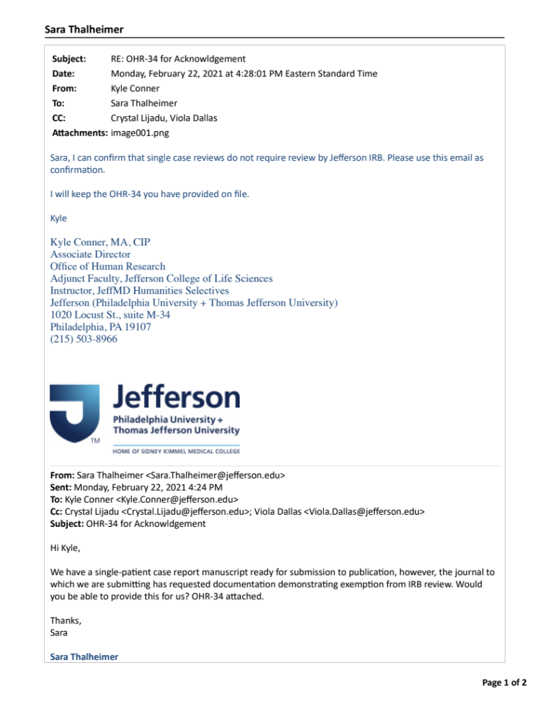

JEFFERSON—Office of Human Research

Research Not Requiring IRB Review: A Checklist
Version Date – FOR OHR USE: 9/4/20

STUDY TITLE: Sleep Apnea and Unilateral Upper and Lower Extremity Allodynia as a Result of a Large Thoracic Disc Herniation: A Case Report

PRINCIPAL INVESTIGATOR: Joshua Heller, MD

TELEPHONE #: (215) 955-7000 E-MAIL: Joshua.heller@jefferson.edu

Instructions: Use this form as a checklist to certify that the research you intend to conduct fits completely into one or more of the following categories. These categories do not meet federal definitions of human subjects research as cited in HHS and FDA regulations at 45 CFR 46.102 & 21 CFR 50.3, respectively, and, therefore, do not fall under IRB purview and do not require IRB review.

Please check the applicable categories of research you intend to conduct:

_____ (1) Scholarly and journalistic activities (e.g., oral history, journalism, biography, literary criticism, legal research, and historical scholarship), including the collection and use of information, that focus directly on the specific individuals about whom the information is collected.

____ (2) Public health surveillance activities, including the collection and testing of information or biospecimens, conducted, supported, requested, ordered, required, or authorized by a public health authority. Such activities are limited to those necessary to allow a public health authority to identify, monitor, assess, or investigate potential public health signals, onsets of disease outbreaks, or conditions of public health importance (including trends, signals, risk factors, patterns in diseases, or increases in injuries from using consumer products). Such activities include those associated with providing timely situational awareness and priority-setting during the course of an event or crisis that threatens public health (including natural or man-made disasters).

____ (3) Quality assurance or quality improvement projects in which the data collected will be used only to verify, alter or improve quality of care or efficiency within the Jefferson entity. (If external publication or public presentation of data is intended, project may require IRB review. Please consult with Office of Human Research)

____ (4) Information-gathering interviews, questionnaires & surveys where questions focus on factual information and opinions about processes, services, or policies, and do not gather personal information about living individuals, or; research gathering factual information from source texts.

____ (5) Research involving cadavers, autopsy materials or bio-specimens from deceased individuals. (Note: HIPAA does not exempt decedent research, and so this research requires review by the Privacy Officer. Please complete form OHR-17 and submit to the Legal Office.)

____ (6) Coded or anonymous private information or biological specimens that were not collected originally for the currently proposed research and that cannot be re-identified by the Investigator. (Note: This research requires that you submit OHR-19 form to the Office of Human Research.)

____ (7) Research that does not involve collection of private information about living individuals. (This category excludes observation of public behavior, which is considered a category 2 exemption, for which you should submit OHR-18 to the IRB.)

____ (8) Research where Jefferson is not engaged in the research. Examples of this include: when Jefferson’s employees or agents 1) act as consultants or provide paid service for research but at no time obtain, receive, or possess identifiable private information, or 2) inform prospective subjects about the availability of research. (Note: this is not a complete list of examples.)

X (9) Case reports of one or two cases. (Three or more case reports in one series require IRB review). While one or two case reports do not require IRB review, they do require review by the Privacy Office.

____ (10) Collection and analysis of information, biospecimens, or records by or for a criminal justice agency for activities authorized by law or court order solely for criminal justice or criminal investigative purposes.

____ (11) Authorized operational activities (as determined by the relevant federal agency) in support of intelligence, homeland security, defense, or other national security missions.

By signing below, the Principal Investigator certifies that the entirety of his/her research fits into one or more of the above categories.
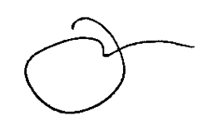

______________________________________22-FEB-2021_______________________
Principal Investigator Date

WRITTEN DETERMINATIONS

If a determination is required by a funding agency or sponsor, the investigator may submit a request for written confirmation along with the OHR-34 to the IRB, which will provide a written response.

