TABLE S1 Corresponding global warming periods for CMIP5 GCMs under RCP8.5
CMIP5 | 1.5°C |  | 2.0°C |  | 3.0°C
ACCESS1-0 | 2013 | 2042 | 2026 | 2055 | 2046 | 2075
ACCESS1-3 | 2016 | 2045 | 2028 | 2057 | 2047 | 2076
CMCC-CESM | 2023 | 2052 | 2033 | 2062 | 2053 | 2082
CMCC-CMS | 2015 | 2044 | 2027 | 2056 | 2047 | 2076
CMCC-CM | 2015 | 2044 | 2027 | 2056 | 2047 | 2076
CNRM-CM5 | 2016 | 2045 | 2031 | 2060 | 2053 | 2082
CSIRO-Mk3-6-0 | 2020 | 2049 | 2030 | 2059 | 2051 | 2080
CanESM2 | 1999 | 2028 | 2012 | 2041 | 2035 | 2064
FGOALS-g2 | 2016 | 2045 | 2031 | 2060 | 2060 | 2089
FGOALS-s2 | 1985 | 2014 | 1999 | 2028 | 2025 | 2054
GFDL-CM3 | 2008 | 2037 | 2020 | 2049 | 2040 | 2069
GFDL-ESM2G | 2023 | 2052 | 2040 | 2069 | 2066 | 2095
GFDL-ESM2M | 2022 | 2051 | 2037 | 2066 | 2068 | 2097
GISS-E2-H | 2006 | 2035 | 2022 | 2051 | 2052 | 2081
GISS-E2-R | 2018 | 2047 | 2038 | 2067 | 2072 | 2101
HadGEM2-AO | 2019 | 2048 | 2030 | 2059 | 2047 | 2076
HadGEM2-CC | 2013 | 2042 | 2026 | 2055 | 2042 | 2071
HadGEM2-ES | 2009 | 2038 | 2021 | 2050 | 2040 | 2069
IPSL-CM5A-LR | 1996 | 2025 | 2012 | 2041 | 2033 | 2062
IPSL-CM5A-MR | 2001 | 2030 | 2016 | 2045 | 2036 | 2065
IPSL-CM5B-LR | 2008 | 2037 | 2023 | 2052 | 2047 | 2076
MIROC5 | 2019 | 2048 | 2034 | 2063 | 2058 | 2087
MPI-ESM-LR | 2003 | 2032 | 2023 | 2052 | 2047 | 2076
MPI-ESM-MR | 2006 | 2035 | 2025 | 2054 | 2046 | 2075
MRI-CGCM3 | 2027 | 2056 | 2038 | 2067 | 2062 | 2091
MRI-ESM1 | 2023 | 2052 | 2036 | 2065 | 2059 | 2088
inmcm4 | 2030 | 2059 | 2043 | 2072 | 2069 | 2098
NorESM1-M | 2018 | 2047 | 2034 | 2063 | 2059 | 2088

TABLE S2 Corresponding global warming periods for CMIP6 GCMs under SSP5-8.5
CMIP6 | 1.5°C |  | 2.0°C |  | 3.0°C
ACCESS-CM2 | 2011 | 2040 | 2024 | 2053 | 2041 | 2070
ACCESS-ESM1-5 | 2013 | 2042 | 2025 | 2054 | 2046 | 2075
BCC-CSM2-MR | 2016 | 2045 | 2029 | 2058 | 2051 | 2080
CAMS-CSM1-0 | 2030 | 2059 | 2046 | 2075 | 2073 | 2102
CMCC-CM2-SR5 | 2007 | 2036 | 2019 | 2048 | 2038 | 2067
CanESM5 | 1998 | 2027 | 2008 | 2037 | 2026 | 2055
EC-Earth3-CC | 1993 | 2022 | 2022 | 2051 | 2042 | 2071
EC-Earth3-Veg-LR | 2014 | 2043 | 2027 | 2056 | 2047 | 2076
EC-Earth3-Veg | 1997 | 2026 | 2013 | 2042 | 2036 | 2065
EC-Earth3 | 2010 | 2039 | 2021 | 2050 | 2043 | 2072
FGOALS-g3 | 2015 | 2044 | 2033 | 2062 | 2060 | 2089
GFDL-CM4 | 2015 | 2044 | 2027 | 2056 | 2045 | 2074
GFDL-ESM4 | 2025 | 2054 | 2038 | 2067 | 2061 | 2090
HadGEM3-GC31-MM | 2011 | 2040 | 2020 | 2049 | 2035 | 2064
INM-CM4-8 | 2016 | 2045 | 2032 | 2061 | 2055 | 2084
INM-CM5-0 | 2016 | 2045 | 2032 | 2061 | 2060 | 2089
IPSL-CM6A-LR | 2004 | 2033 | 2020 | 2049 | 2036 | 2065
KACE-1-0-G | 2000 | 2029 | 2009 | 2038 | 2029 | 2058
KIOST-ESM | 2003 | 2032 | 2024 | 2053 | 2050 | 2079
MIROC6 | 2026 | 2055 | 2039 | 2068 | 2062 | 2091
MPI-ESM1-2-HR | 2019 | 2048 | 2035 | 2064 | 2059 | 2088
MPI-ESM1-2-LR | 2020 | 2049 | 2034 | 2063 | 2057 | 2086
MRI-ESM2-0 | 2012 | 2041 | 2024 | 2053 | 2050 | 2079
NESM3 | 2006 | 2035 | 2019 | 2048 | 2040 | 2069
NorESM2-MM | 2025 | 2054 | 2040 | 2069 | 2062 | 2091

TABLE S3 CORDEX RCMs and corresponding global warming periods for downscaled CMIP5 GCMs under RCP8.5
RCM | GCM | 1.5°C |  | 2.0°C |  | 3.0°C
CLMcom-CCLM4-8-17 | CNRM-CM5 | 2016 | 2045 | 2031 | 2060 | 2053 | 2082
CLMcom-CCLM4-8-17 | MPI-ESM-LR | 2003 | 2032 | 2023 | 2052 | 2047 | 2076
CLMcom-CCLM4-8-17 | HadGEM2-ES | 2009 | 2038 | 2021 | 2050 | 2040 | 2069
CLMcom-CCLM4-8-17 | EC-EARTH | 2006 | 2035 | 2021 | 2050 | 2035 | 2064
DMI-HIRHAM5 | EC-EARTH | 2006 | 2035 | 2021 | 2050 | 2035 | 2064
GERICS-REMO2009 | IPSL-CM5A-MR | 2001 | 2030 | 2016 | 245 | 2036 | 2065
GERICS-REMO2009 | IPSL-CM5A-LR | 1996 | 2025 | 2012 | 2041 | 2033 | 2062
GERICS-REMO2009 | MIROC5 | 2019 | 2048 | 2034 | 2063 | 2058 | 2087
GERICS-REMO2009 | HadGEM2-ES | 2009 | 2038 | 2021 | 2050 | 2040 | 2069
GERICS-REMO2009 | GFDL-ESM2G | 2023 | 2052 | 2040 | 2069 | 2066 | 2095
GERICS-REMO2009 | EC-EARTH | 2006 | 2035 | 2021 | 2050 | 2035 | 2064
ICTP-RegCM4-3 | HadGEM2-ES | 2009 | 2038 | 2021 | 2050 | 2040 | 2069
ICTP-RegCM4-3 | IPSL-CM5A-MR | 2001 | 2030 | 2016 | 2045 | 2036 | 2065
KNMI-RACMO22T | EC-EARTH | 2006 | 2035 | 2021 | 2050 | 2035 | 2064
KNMI-RACMO22T | HadGEM2-ES | 2009 | 2038 | 2021 | 2050 | 2040 | 2069
SMHI-RCA4 | EC-EARTH | 2006 | 2035 | 2021 | 2050 | 2035 | 2064
SMHI-RCA4 | CNRM-CM5 | 2016 | 2045 | 2031 | 2060 | 2053 | 2082
SMHI-RCA4 | CSIRO-Mk3-6-0 | 2020 | 2049 | 2030 | 2059 | 2051 | 2080
SMHI-RCA4 | CanESM2 | 1999 | 2028 | 2012 | 2041 | 2035 | 2064
SMHI-RCA4 | GFDL-ESM2M | 2022 | 2051 | 2037 | 2066 | 2068 | 2097
SMHI-RCA4 | HadGEM2-ES | 2009 | 2038 | 2021 | 2050 | 2040 | 2069
SMHI-RCA4 | IPSL-CM5A-MR | 2001 | 2030 | 2016 | 2045 | 2036 | 2065
SMHI-RCA4 | MIROC5 | 2019 | 2048 | 2034 | 2063 | 2058 | 2087
SMHI-RCA4 | MPI-ESM-LR | 2003 | 2032 | 2023 | 2052 | 2047 | 2076
SMHI-RCA4 | NorESM1-M | 2018 | 2047 | 2034 | 2063 | 2059 | 2088

TABLE S4 CORE RCMs and corresponding global warming periods for downscaled CMIP5 GCMs under RCP8.5
RCM | GCM | 1.5°C |  | 2.0°C |  | 3.0°C
CLMcom- CCLM5-0-15 | MPI-ESM-LR | 2003 | 2032 | 2023 | 2052 | 2047 | 2076
CLMcom- CCLM5-0-15 | HadGEM2-ES | 2009 | 2038 | 2021 | 2050 | 2040 | 2069
CLMcom- CCLM5-0-15 | NorESM1-M | 2018 | 2047 | 2034 | 2063 | 2059 | 2088
GERICS-REMO2015 | MPI-ESM-LR | 2003 | 2032 | 2023 | 2052 | 2047 | 2076
GERICS-REMO2015 | HadGEM2-ES | 2009 | 2038 | 2021 | 2050 | 2040 | 2069
GERICS-REMO2015 | NorESM1-M | 2018 | 2047 | 2034 | 2063 | 2059 | 2088
ICTP-RegCM 4.7 | MPI-ESM-MR | 2006 | 2035 | 2025 | 2054 | 2046 | 2075
ICTP-RegCM 4.7 | HadGEM2-ES | 2009 | 2038 | 2021 | 2050 | 2040 | 2069
ICTP-RegCM 4.7 | NorESM1-M | 2018 | 2047 | 2034 | 2063 | 2059 | 2088

TABLE S5 The median values of the avoided impact (AI in %) of extreme precipitation indices (CDD, CWD, RR1, R10mm, R20mm and SDII) under 1.5°C (2.0°C) global warming relative to 2.0°C and 3.0°C (3.0°C) global warming. The numbers represent the AI at 0.5/1.0/1.5°C temperature differences
 | CDD avoided impact (%) |  |  |  | CWD avoided impact (%)
 | Limpopo | Okavango | Orange | Zambezi | Limpopo | Okavango | Orange | Zambezi
CMIP5 | 18/29/57 | 27/19/57 | 32/40/51 | 46/26/30 | 11/39/58 | 28/39/69 | 20/32/48 | 44/37/64
CMIP6 | 29/1/26 | 33/15/33 | 34/30/38 | 43/56/65 | 32/50/60 | 5/28/18 | 29/30/59 | 19/24/54
CORDEX | 2/43/14 | 19/61/76 | 46/29/70 | 62/30/54 | 39/65/70 | 30/31/50 | 57/30/65 | 33/40/46
CORE | 29/72/67 | -5/75/73 | 28/48/63 | 68/46/28 | 30/22/75 | 34/47/64 | 18/22/38 | 53/43/82
 | RR1 avoided impact (%) |  |  |  | SDII avoided impact (%)
CMIP5 | 16/42/63 | 37/41/69 | 40/31/54 | 31/42/64 | 36/47/65 | 41/36/73 | 30/67/70 | 40/38/60
CMIP6 | 35/48/72 | 32/30/53 | 22/39/54 | 18/30/51 | 44/51/70 | 59/59/94 | 11/65/78 | 39/45/74
CORDEX | 11/36/31 | 27/27/50 | 47/39/55 | 33/51/76 | 15/33/67 | 30/23/54 | 56/34/75 | 45/38/63
CORE | 18/53/76 | 24/51/67 | 18/24/54 | 55/48/81 | 23/49/59 | 28/29/47 | 23/39/120 | 34/31/60
 | R10mm avoided impact (%) |  |  |  | R20mm avoided impact (%)
CMIP5 | 18/47/73 | 40/53/59 | 44/13/58 | 40/32/60 | 39/57/91 | 31/37/60 | 44/26/65 | 47/33/68
CMIP6 | 55/62/99 | 30/23/53 | 10/61/79 | 2/41/62 | 57/58/89 | 55/48/83 | 26/43/70 | 43/54/82
CORDEX | 17/35/45 | 38/31/56 | 43/43/62 | 5/19/25 | -7/19/34 | 32/11/39 | 39/32/47 | 35/12/39
CORE | 87/53/96 | 54/90/81 | 36/39/66 | 36/59/89 | 56/49/67 | 44/-5/53 | 44/35/68 | 14/6/40

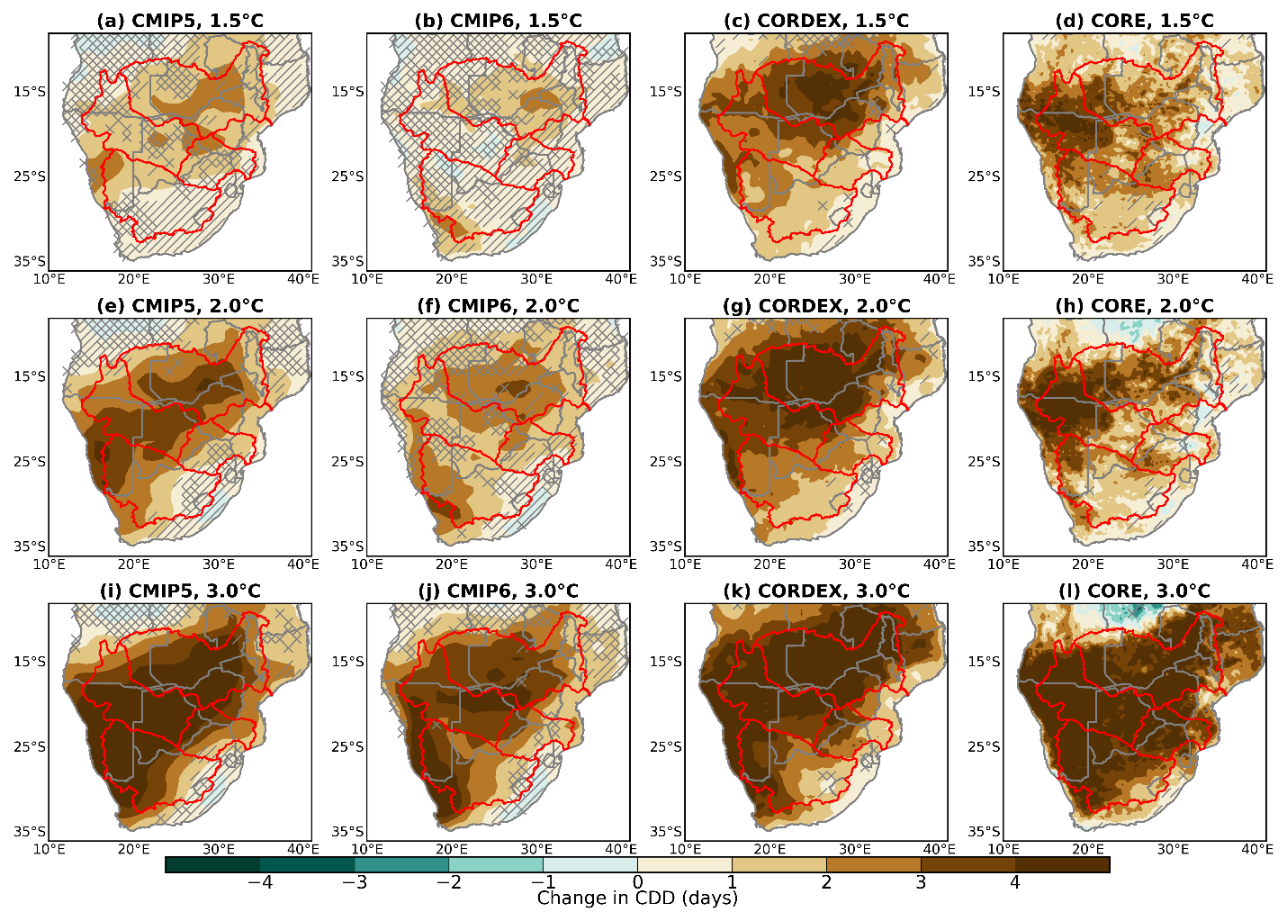
Fig. S1 Spatial distribution of MAM changes in CDD for the CMIP5 (first column), CMIP6 (second column), CORDEX (third column), and CORE (fourth column) multi-model ensemble means under 1.5°C (a-d), 2.0°C (e-h), and 3.0°C global warming levels. The regions with no overlays have robust change. Diagonal and crossed lines represent regions with non-significant and uncertain changes respectively
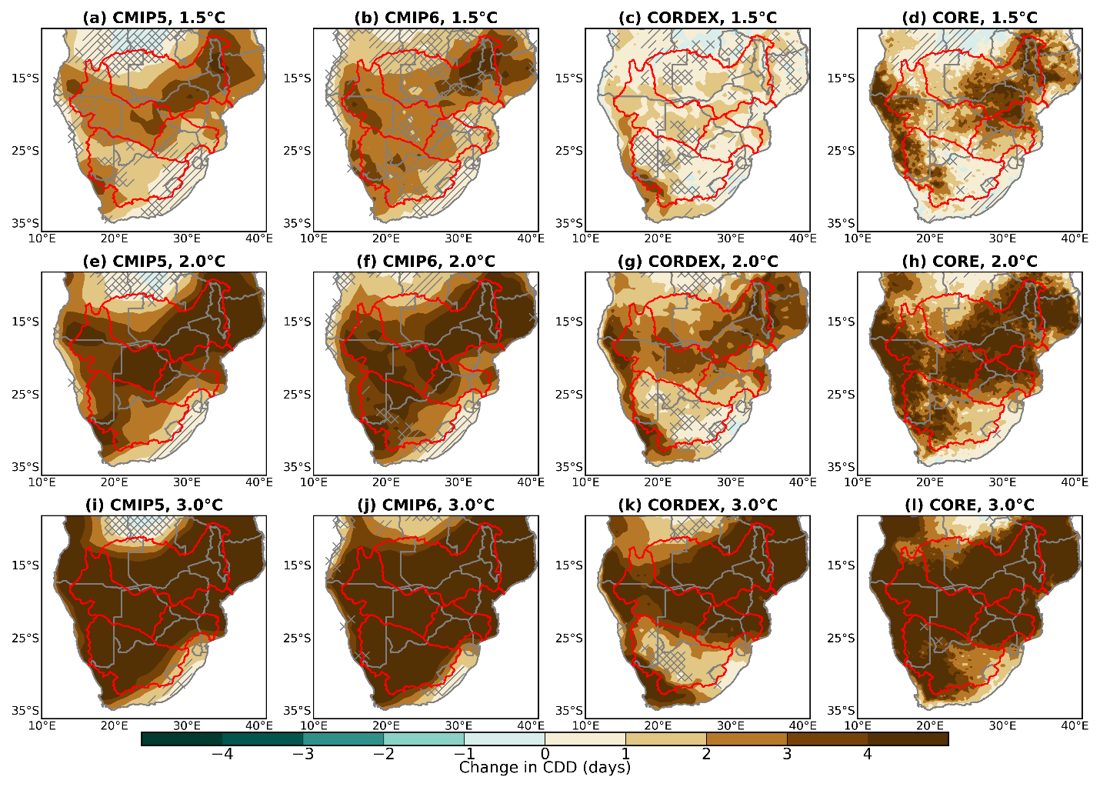
Fig. S2 Spatial distribution of SON changes in CDD for the CMIP5 (first column), CMIP6 (second column), CORDEX (third column), and CORE (fourth column) multi-model ensemble means under 1.5°C (a-d), 2.0°C (e-h), and 3.0°C global warming levels. The regions with no overlays have robust change. Diagonal and crossed lines represent regions with non-significant and uncertain changes respectively
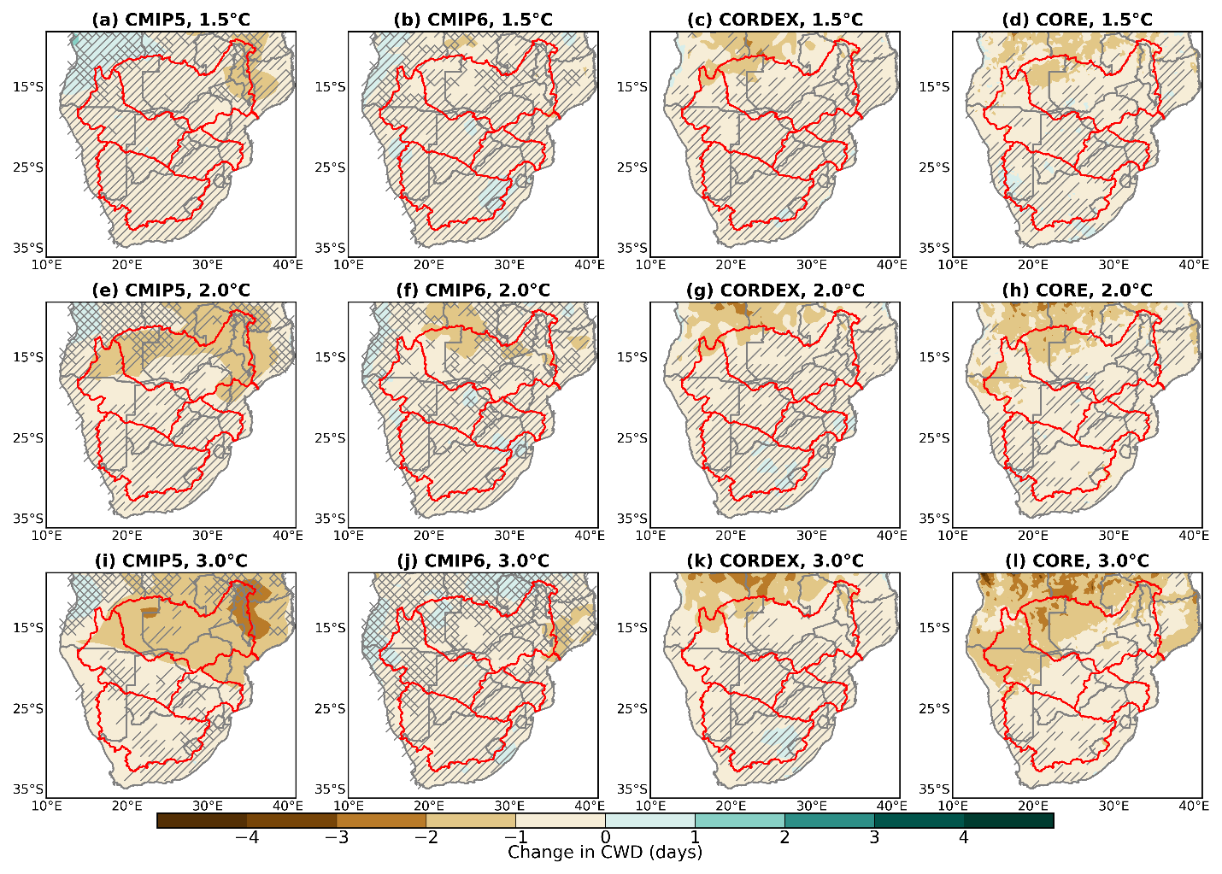
Fig. S3 Spatial distribution of MAM changes in CWD for the CMIP5 (first column), CMIP6 (second column), CORDEX (third column), and CORE (fourth column) multi-model ensemble means under 1.5°C (a-d), 2.0°C (e-h), and 3.0°C global warming levels. The regions with no overlays have robust change. Diagonal and crossed lines represent regions with non-significant and uncertain changes respectively
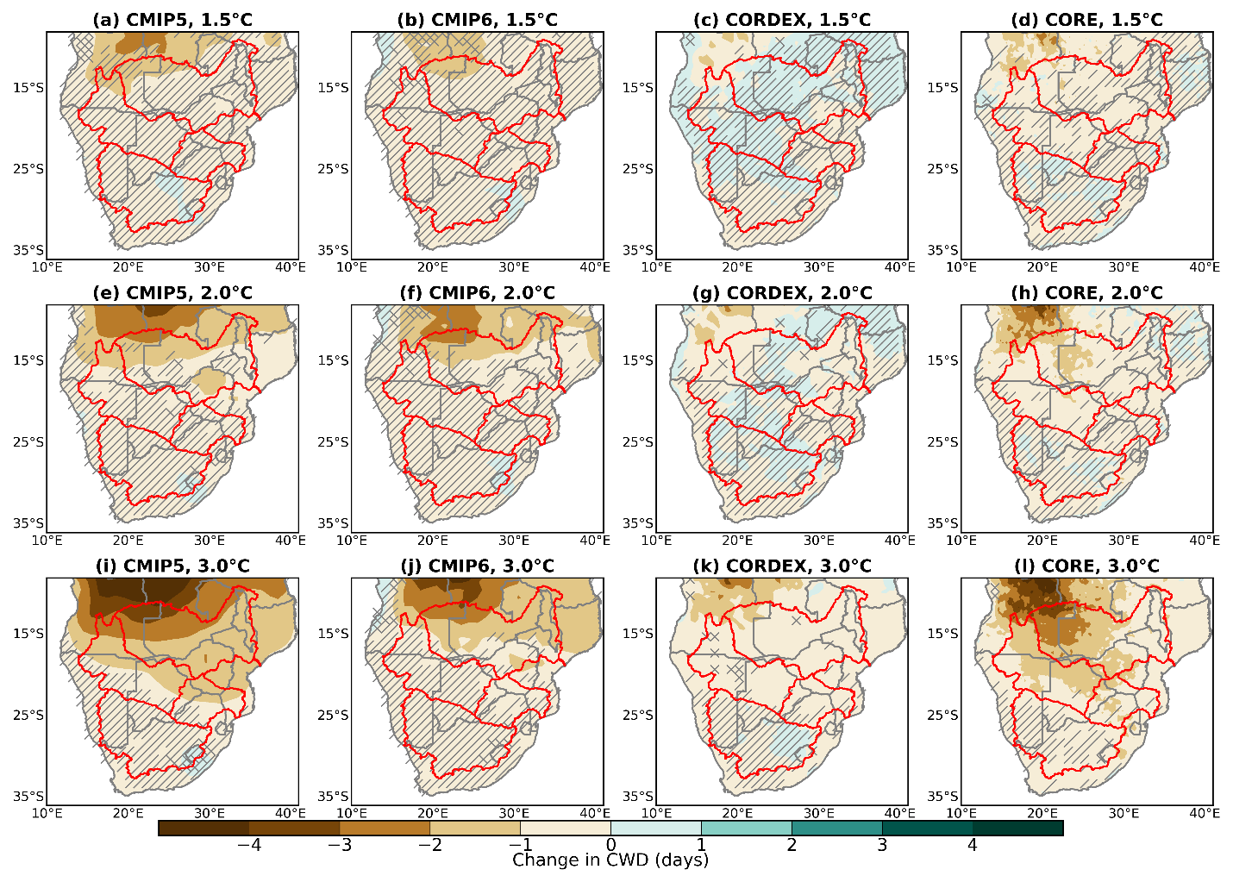
Fig. S4 Spatial distribution of SON changes in CWD for the CMIP5 (first column), CMIP6 (second column), CORDEX (third column), and CORE (fourth column) multi-model ensemble means under 1.5°C (a-d), 2.0°C (e-h), and 3.0°C global warming levels. The regions with no overlays have robust change. Diagonal and crossed lines represent regions with non-significant and uncertain changes respectively
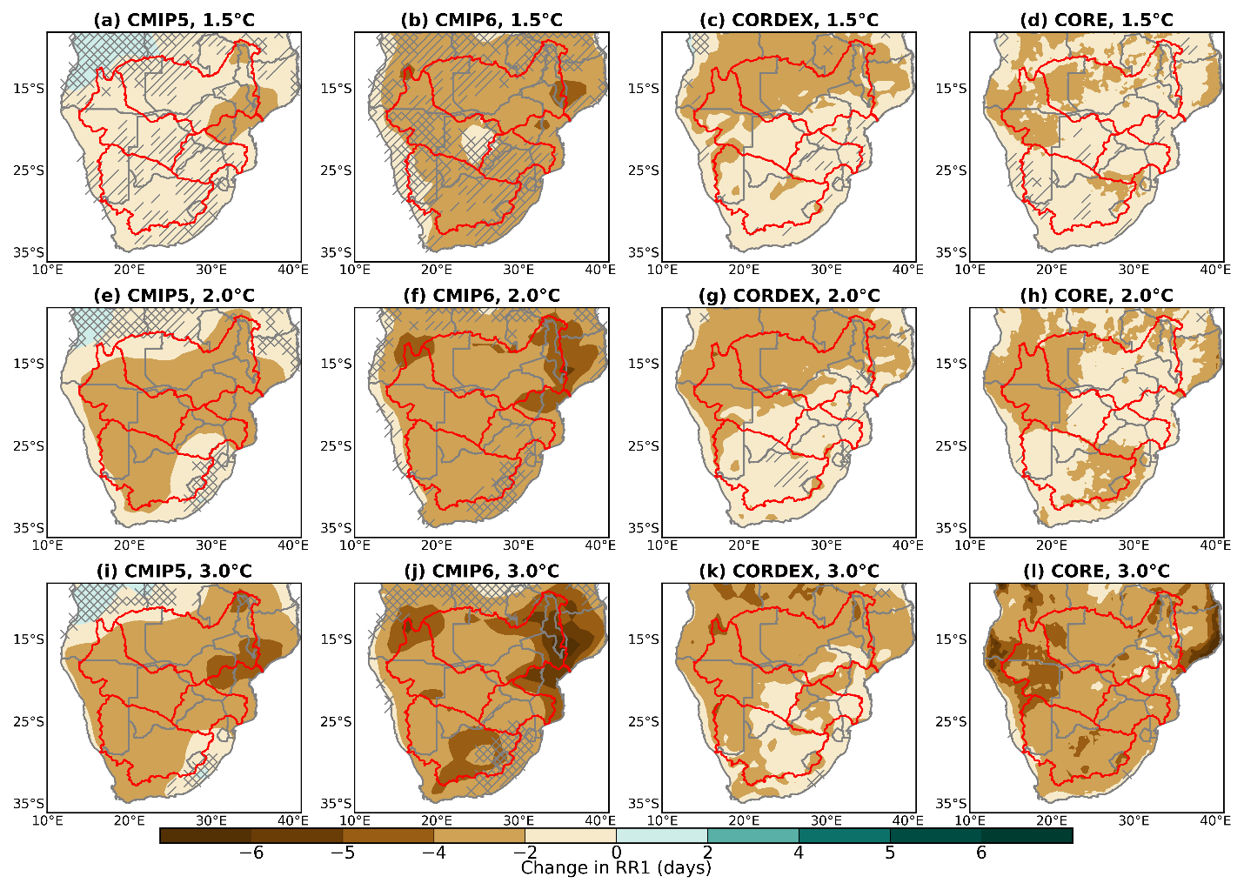
Fig. S5 Spatial distribution of MAM changes in RR1 for the CMIP5 (first column), CMIP6 (second column), CORDEX (third column), and CORE (fourth column) multi-model ensemble means under 1.5°C (a-d), 2.0°C (e-h), and 3.0°C global warming levels. The regions with no overlays have robust change. Diagonal and crossed lines represent regions with non-significant and uncertain changes respectively
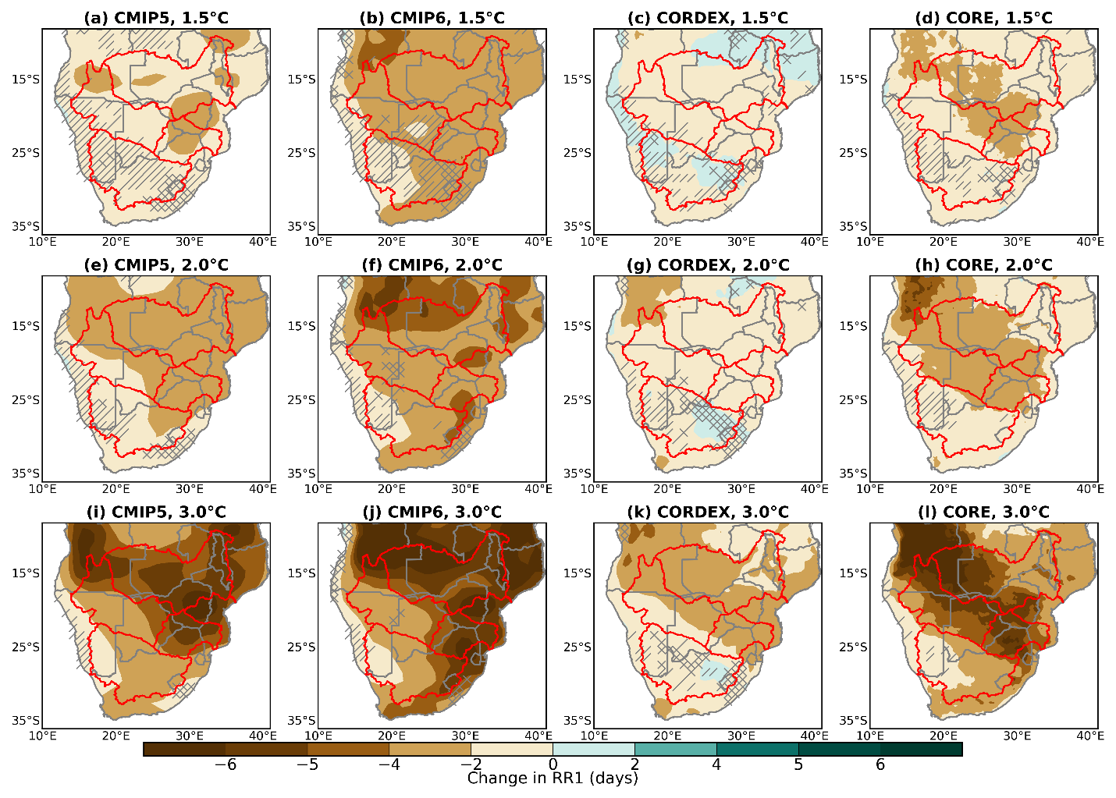
Fig. S6 Spatial distribution of SON changes in RR1 for the CMIP5 (first column), CMIP6 (second column), CORDEX (third column), and CORE (fourth column) multi-model ensemble means under 1.5°C (a-d), 2.0°C (e-h), and 3.0°C global warming levels. The regions with no overlays have robust change. Diagonal and crossed lines represent regions with non-significant and uncertain changes respectively
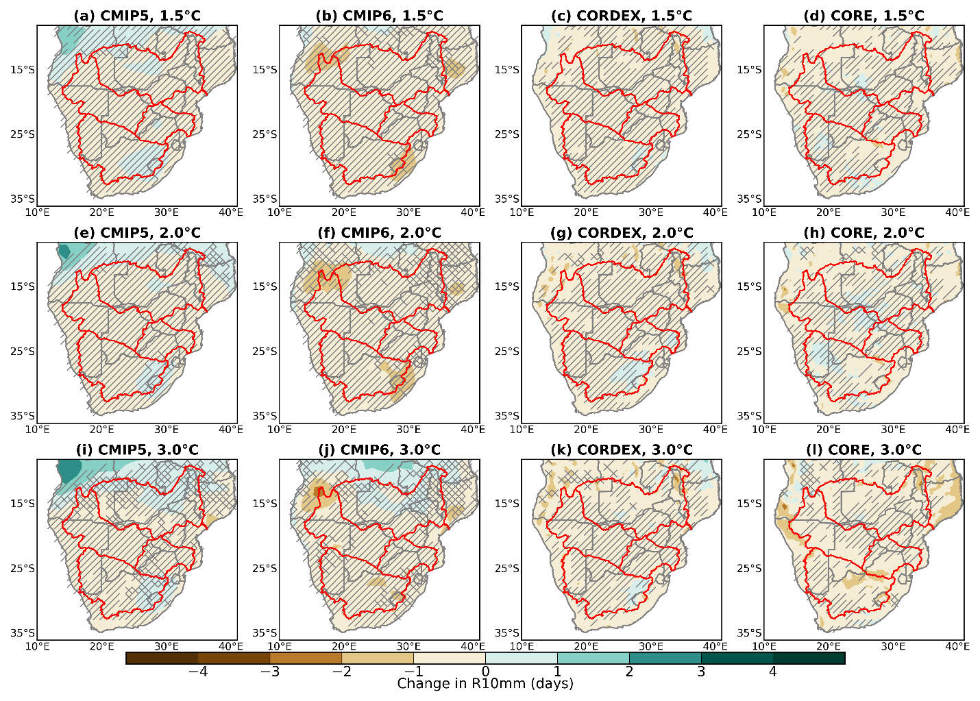
Fig. S7 Spatial distribution of MAM changes in R10mm for the CMIP5 (first column), CMIP6 (second column), CORDEX (third column), and CORE (fourth column) multi-model ensemble means under 1.5°C (a-d), 2.0°C (e-h), and 3.0°C global warming levels. The regions with no overlays have robust change. Diagonal and crossed lines represent regions with non-significant and uncertain changes respectively
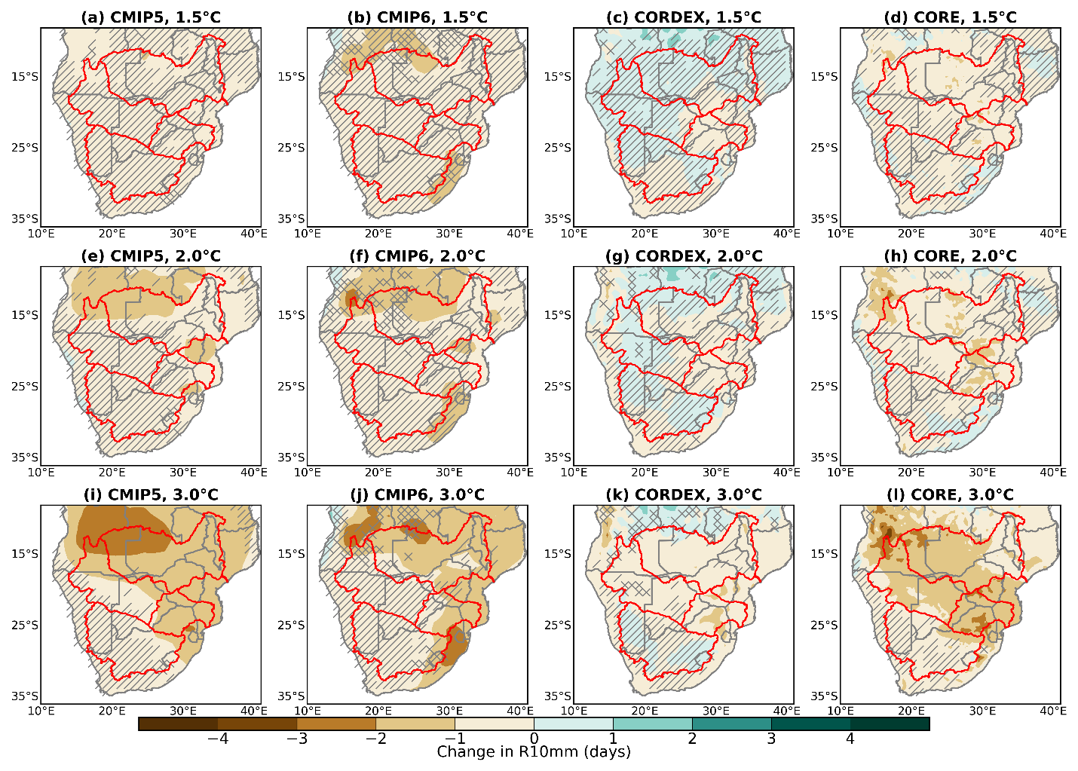
Fig. S8 Spatial distribution of SON changes in R10mm for the CMIP5 (first column), CMIP6 (second column), CORDEX (third column), and CORE (fourth column) multi-model ensemble means under 1.5°C (a-d), 2.0°C (e-h), and 3.0°C global warming levels. The regions with no overlays have robust change. Diagonal and crossed lines represent regions with non-significant and uncertain changes respectively
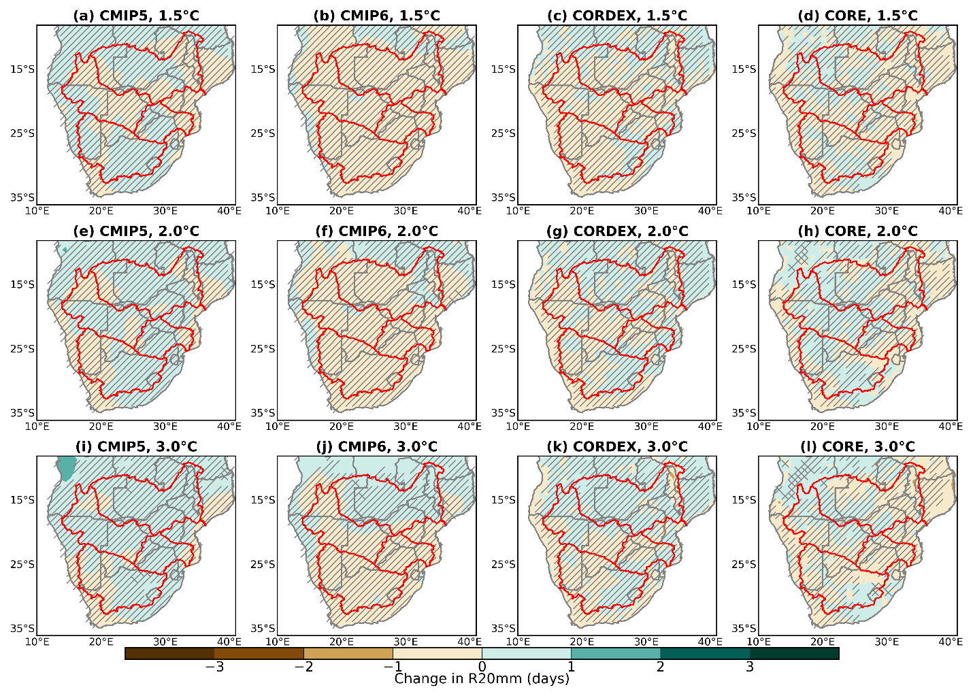
Fig. S9 Spatial distribution of MAM changes in R20mm for the CMIP5 (first column), CMIP6 (second column), CORDEX (third column), and CORE (fourth column) multi-model ensemble means under 1.5°C (a-d), 2.0°C (e-h), and 3.0°C global warming levels. The regions with no overlays have robust change. Diagonal and crossed lines represent regions with non-significant and uncertain changes respectively
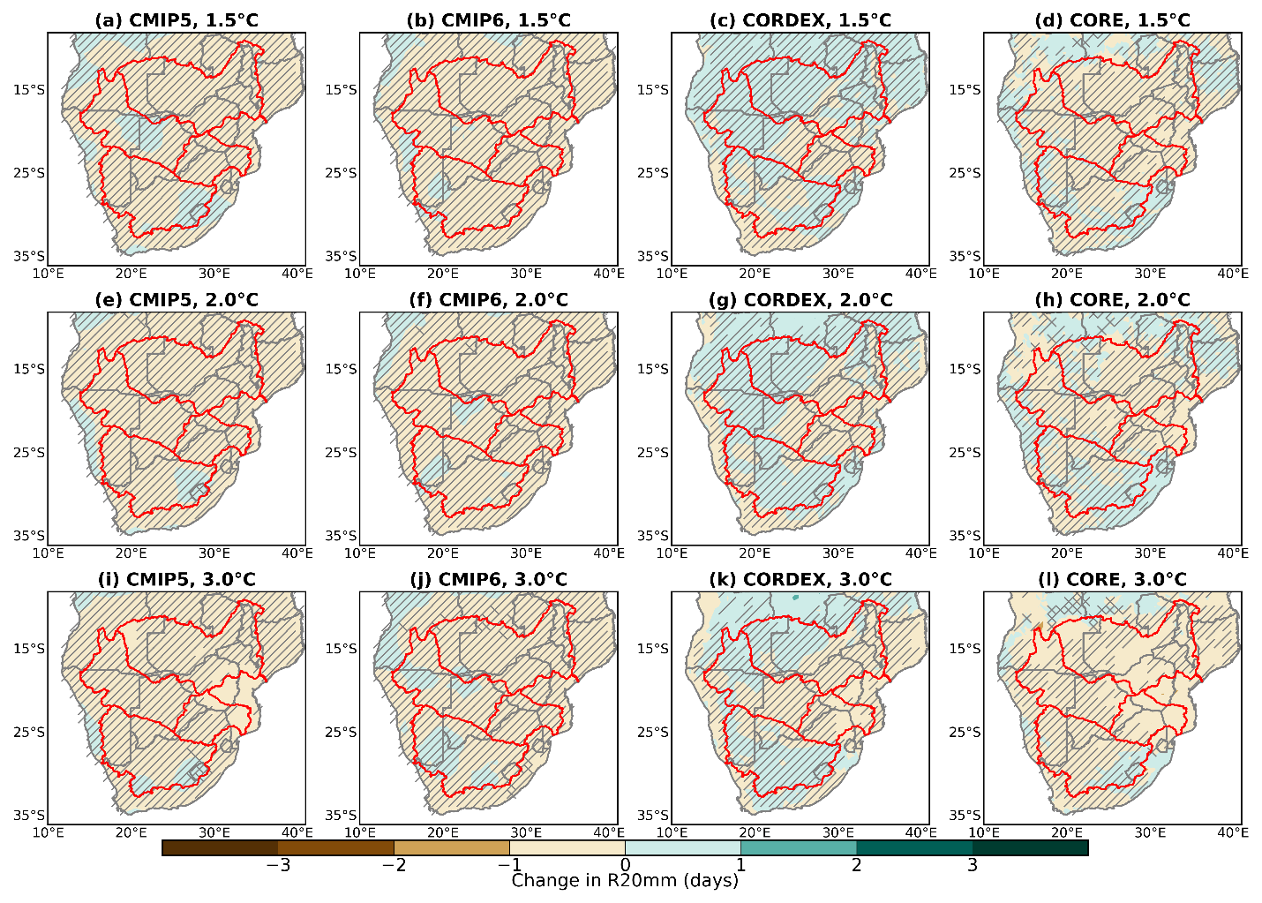
Fig. S10 Spatial distribution of SON changes in R20mm for the CMIP5 (first column), CMIP6 (second column), CORDEX (third column), and CORE (fourth column) multi-model ensemble means under 1.5°C (a-d), 2.0°C (e-h), and 3.0°C global warming levels. The regions with no overlays have robust change. Diagonal and crossed lines represent regions with non-significant and uncertain changes respectively
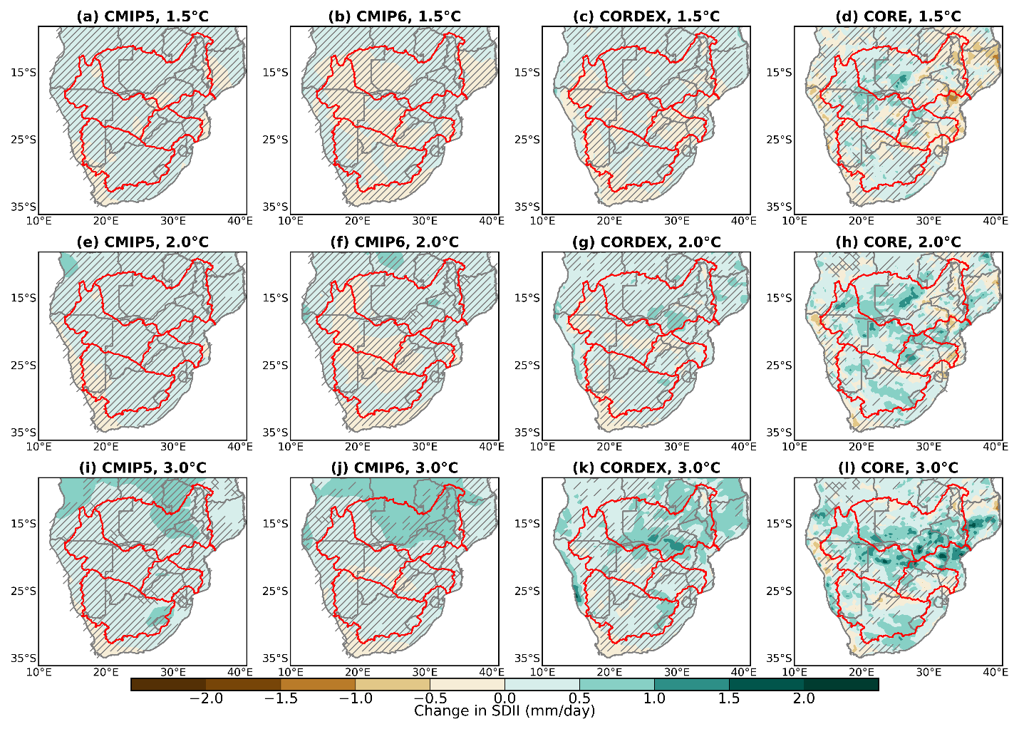
Fig. S11 Spatial distribution of MAM changes in SDII for the CMIP5 (first column), CMIP6 (second column), CORDEX (third column), and CORE (fourth column) multi-model ensemble means under 1.5°C (a-d), 2.0°C (e-h), and 3.0°C global warming levels. The regions with no overlays have robust change. Diagonal and crossed lines represent regions with non-significant and uncertain changes respectively
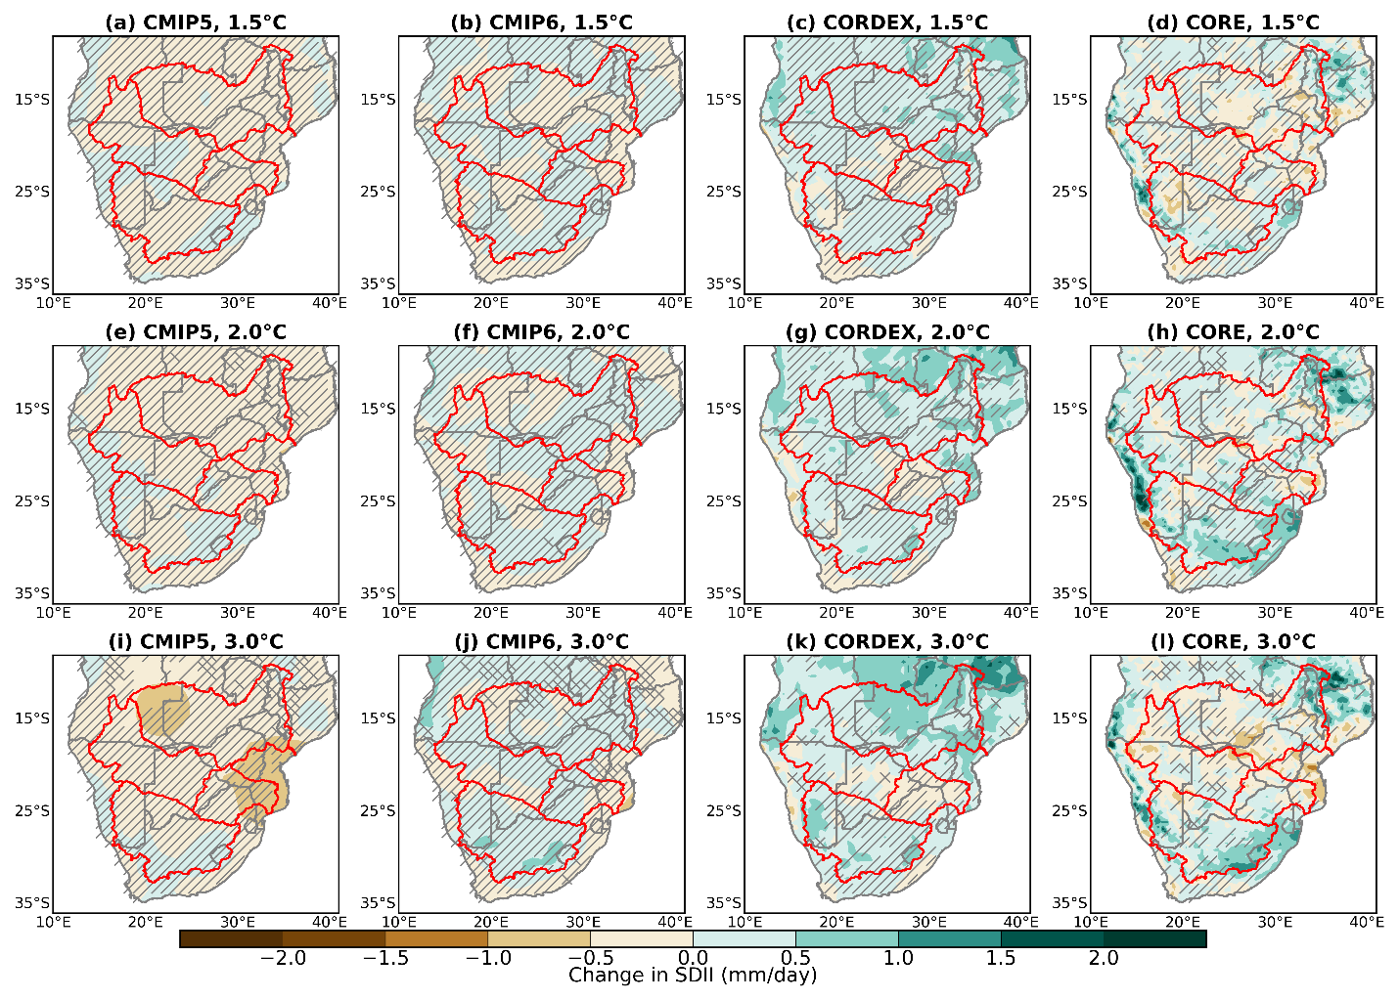
Fig. S12 Spatial distribution of SON changes in SDII for the CMIP5 (first column), CMIP6 (second column), CORDEX (third column), and CORE (fourth column) multi-model ensemble means under 1.5°C (a-d), 2.0°C (e-h), and 3.0°C global warming levels. The regions with no overlays have robust change. Diagonal and crossed lines represent regions with non-significant and uncertain changes respectively
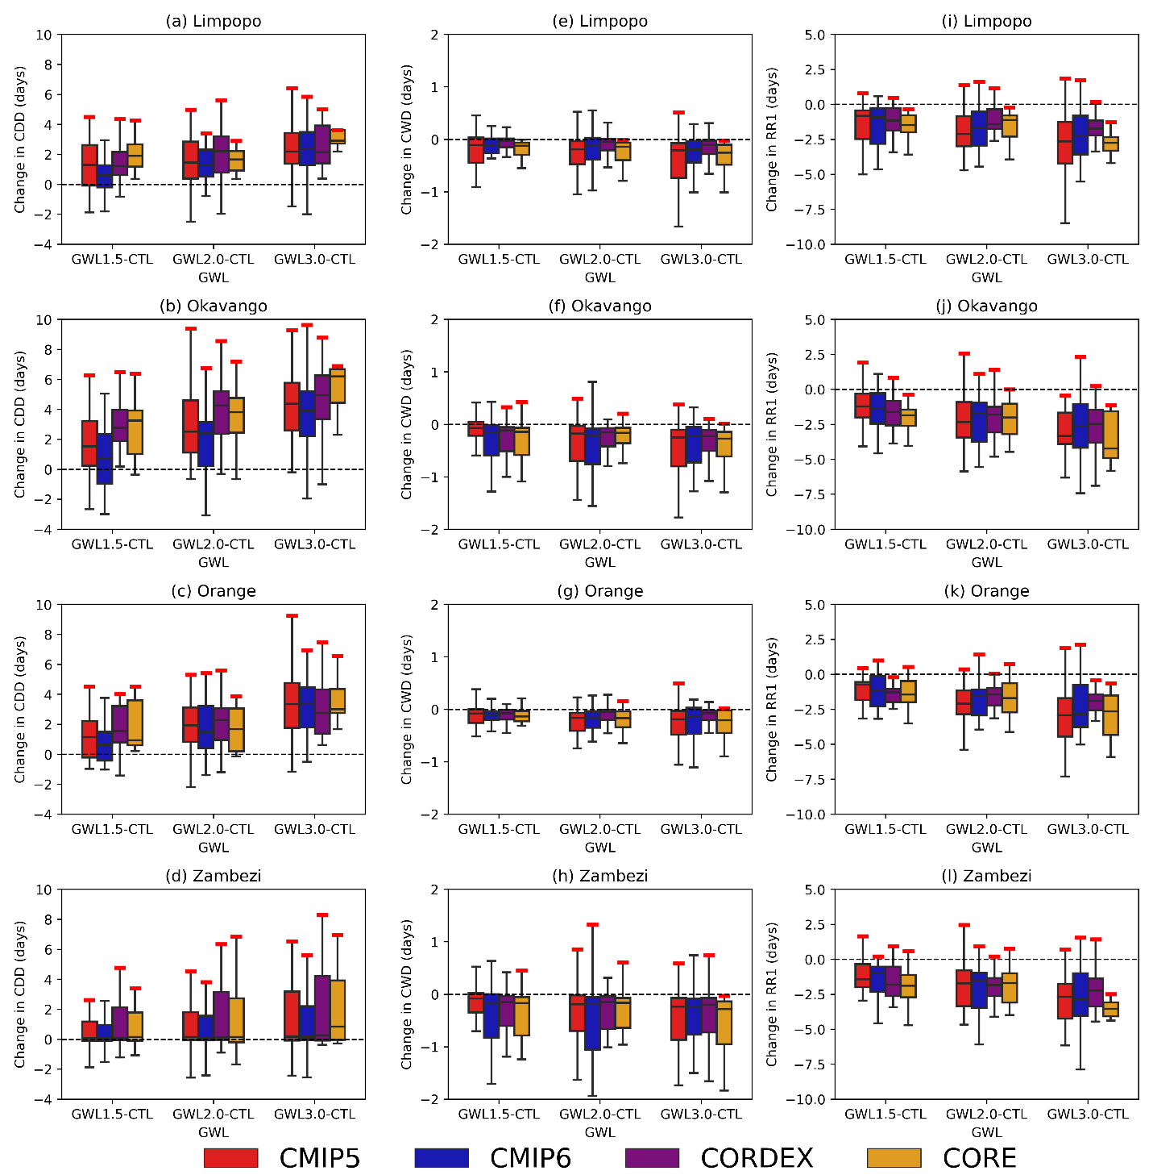
Fig. S13 Boxplot of MAM projected changes in CDD, CWD and RR1 under 1.5°C, 2.0°C and 3.0 GWLs over the Limpopo, Okavango, Orange and Zambezi basins. The red maximum indicates that the change is robust over more than 30% of land grid points
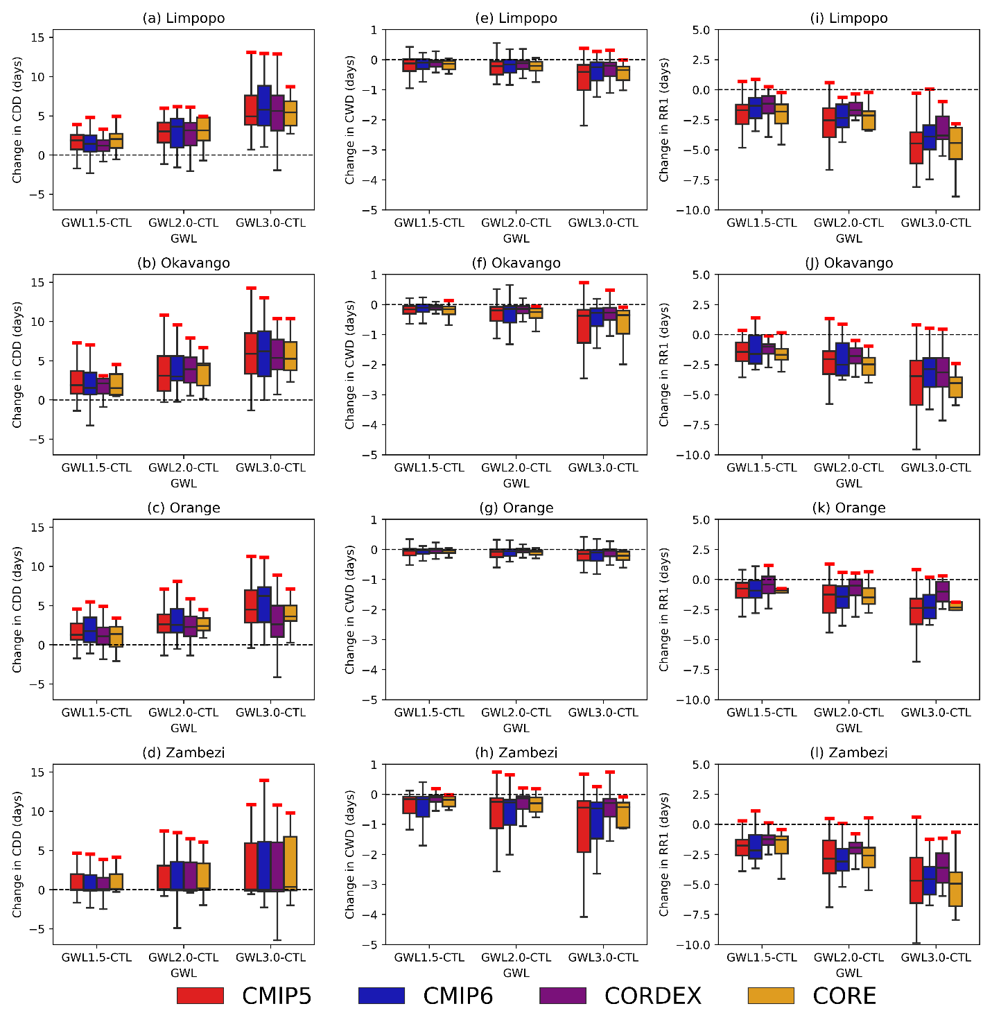
Fig. S14 Boxplot of SON projected changes in CDD, CWD and RR1 under 1.5°C, 2.0°C and 3.0 GWLs over the Limpopo, Okavango, Orange and Zambezi basins. The red maximum indicates that the change is robust over more than 30% of land grid points
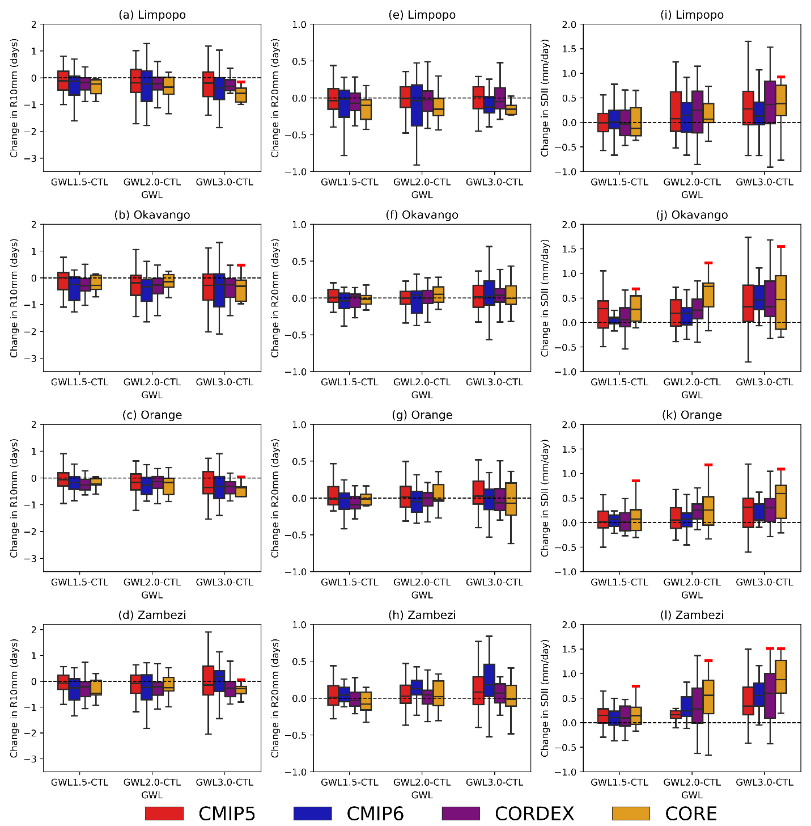
Fig. 15 Boxplot of MAM projected changes in R10mm, R20mm and SDII under 1.5°C, 2.0°C and 3.0 GWLs over the Limpopo, Okavango, Orange and Zambezi basins. The red maximum indicates that the change is robust over more than 30% of land grid points
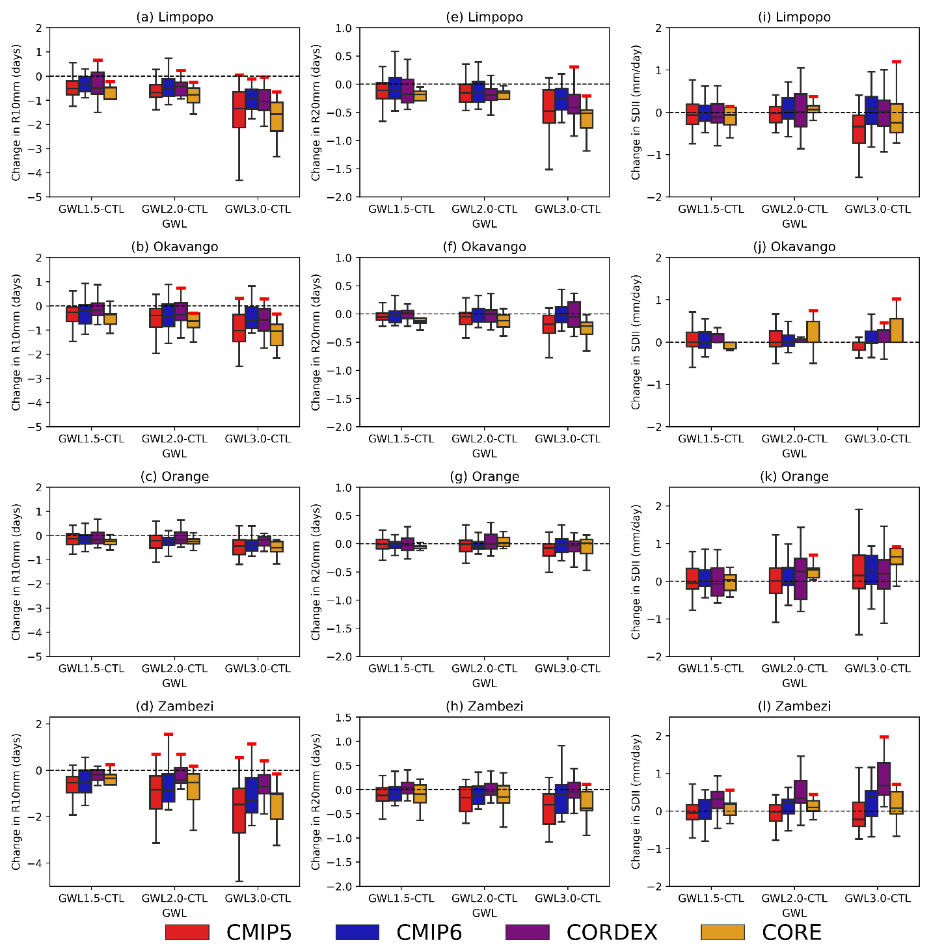
Fig. 16 Boxplot of SON projected changes in R10mm, R20mm and SDII under 1.5°C, 2.0°C and 3.0 GWLs over the Limpopo, Okavango, Orange and Zambezi basins. The red maximum indicates that the change is robust over more than 30% of land grid points

