Figures in Research Article

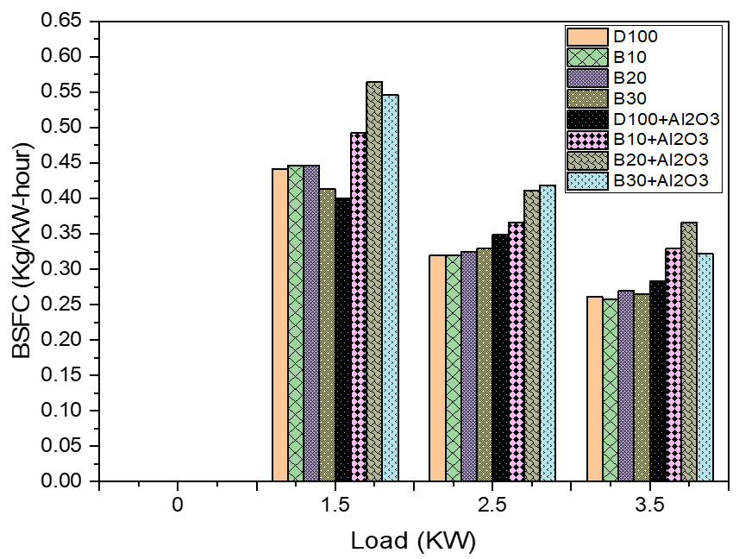
Figure 1 Graph for brake specific fuel Consumption.
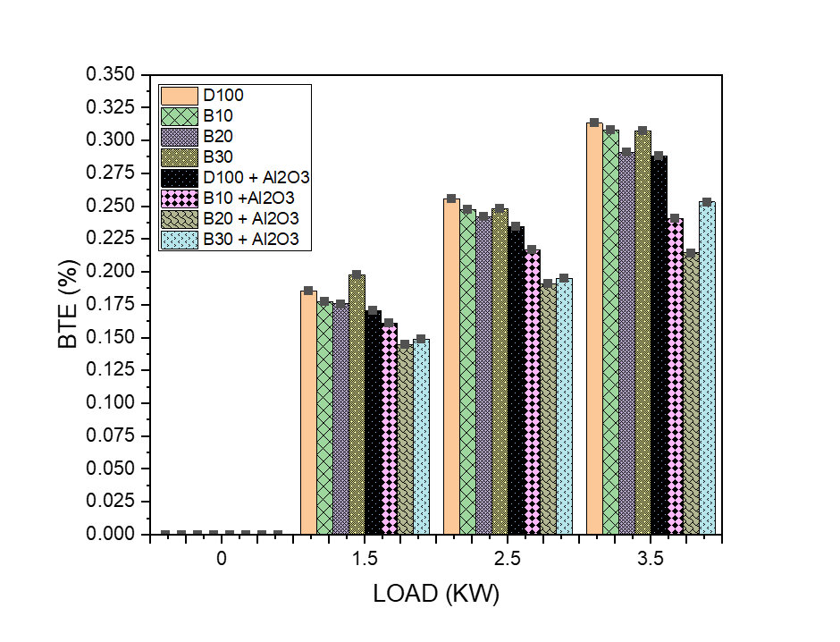
Figure 2 Graph for Brake thermal Efficiency.
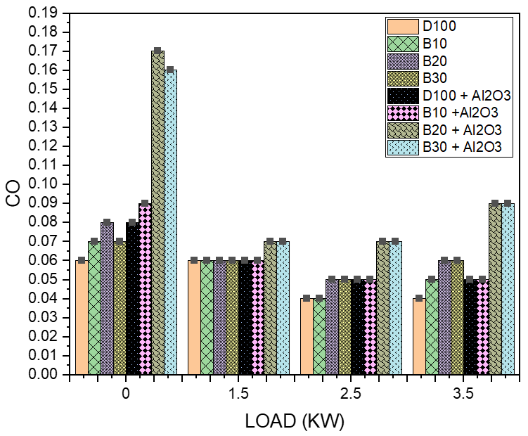
Figure 3 Graph for carbon mono-oxide emission.
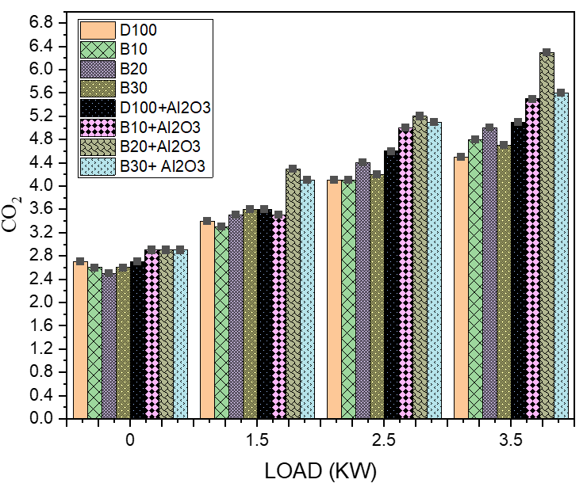
Figure 4 Graph for Carbon di-oxide emission.

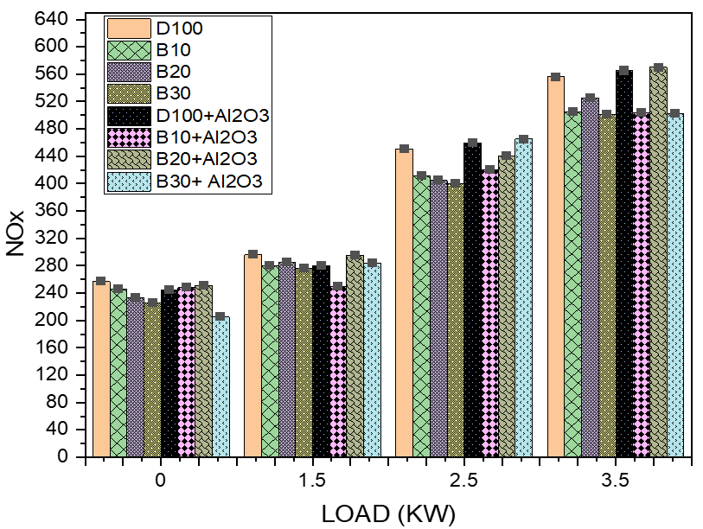
Figure 5 Graph for oxides of nitrogen emission.

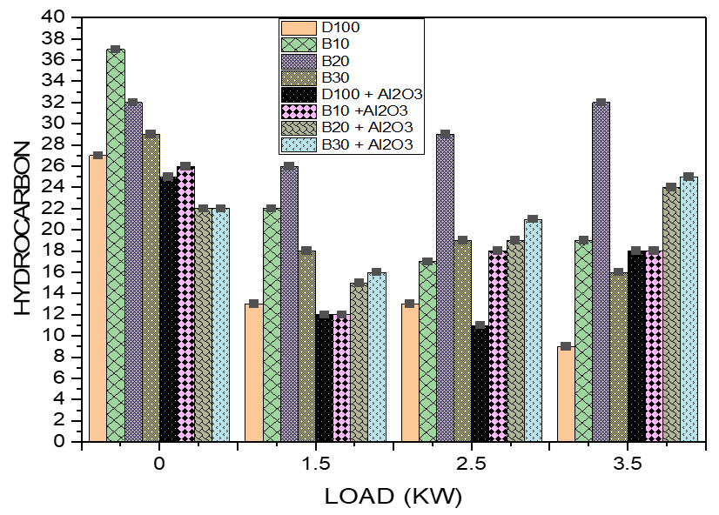
Figure 6 Graph for unburnt Hydrocarbon Emission.

