The global scenario of hydrogeochemical research on glacier meltwater: A bibliometric and visualization analysis
Ramesh Kumar¹, Prity S Pippal¹, Rajesh Kumar¹, Pankaj Kumar², Atar Singh¹, Payal Sharma¹
¹Department of Environmental Science, School of Earth Sciences, Central University of Rajasthan, Ajmer, India.
²Department of Environmental Science, Parul Institute of Applied Sciences, Parul University, Vadodara, Gujarat, India.
Email: rameshkumar9234@gmail.com
Figure S1: Networking and clustering of authors’ keywords used during the study period 2002-2022.
Figure S2: Tree mapping for authors’ keywords showing frequency and contribution in entire documentation during the study period (2002-2022).
Figure 3a: Trending topic and b. Growth of major five key terms during this bibliometric analysis during the study period 2002-2022.
Figure S4: overlay visualization of co-occurrences of authors on basis of the total document written by author in a year.
Figure S5: overlay visualization of co-occurrences of authors on basis of total average citation over the authors’ documents per year during the study period 2002-2022
Figure S6: Sankey diagrams through the three field plots during the study period 2002-2022 a. Relationship between the authors (AU), author keywords (DE), and author’s affiliations and university (AU_UN) b. Relationship between author (AU), author keywords (DE), and author’s country (AU_CO)
Figure S7: Bradford’s law shows source rank on basis of their contribution to the study during the period 2002-2022.
Figure S8: Lotka’s law represents the actual contribution by the author through the dotted line.
Figure S9: Annual scientific production by different countries during the study period. Dark blue color represented the highest production while light blue to low production countries. The gray color represented the absence of publication during the study period. The bar graph represents the contribution by the top ten publishers during the study period.
Figure S10: Degree nodes for author’s keyword used during the study period 2002-2022.

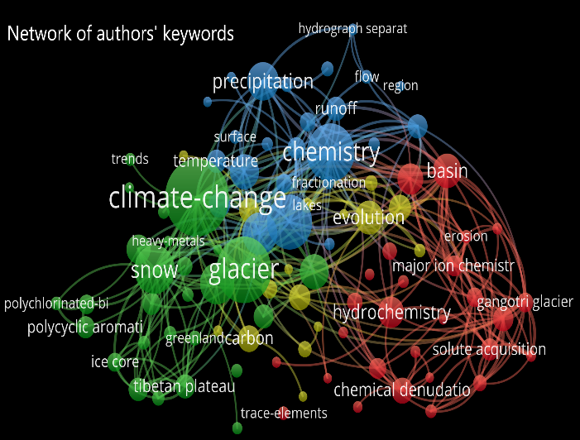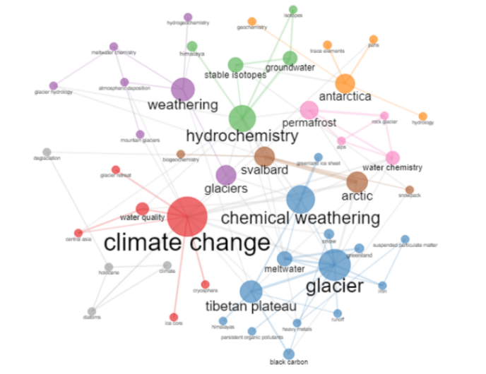
Clustering of authors’ keywords
Figure S1: Networking and clustering of authors’ keywords used during the study period 2002-2022.
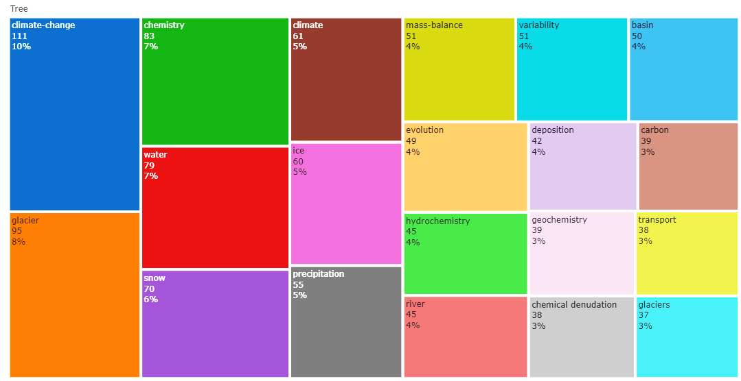
Figure S2: Tree mapping for authors’ keywords showing frequency and contribution in entire documentation during the study period (2002-2022).
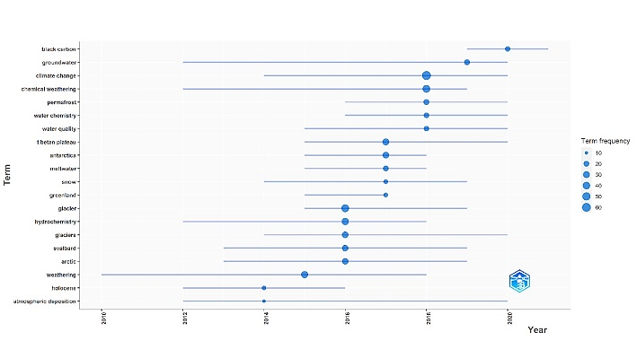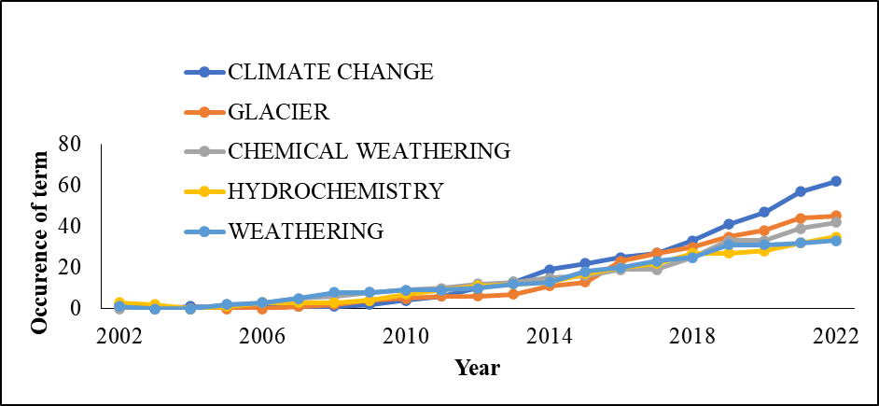
Figure 3a: Trending topic and b. Growth of major five key terms during this bibliometric analysis during the study period 2002-2022.

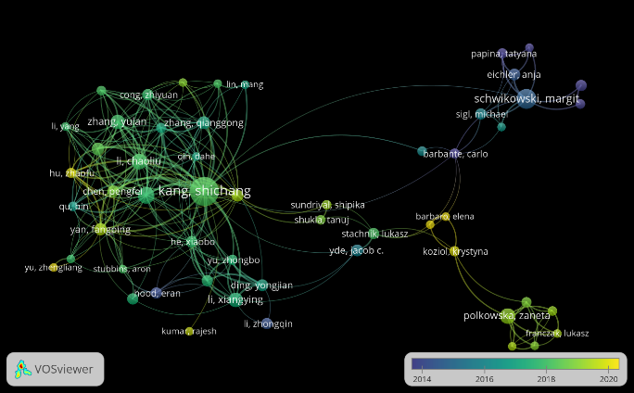Figure S4: overlay visualization of co-occurrences of authors on basis of the total document written by author in a year.
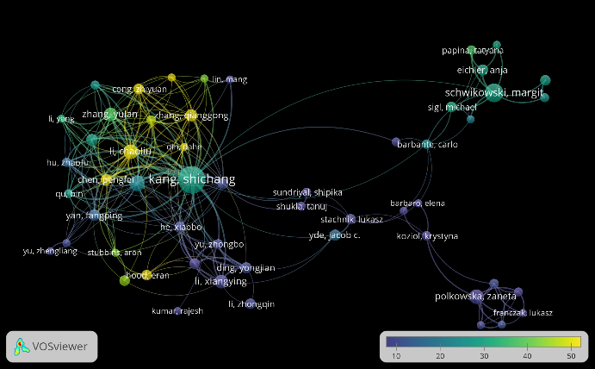
Figure S5: overlay visualization of co-occurrences of authors on basis of total average citation over the authors’ documents per year during the study period 2002-2022

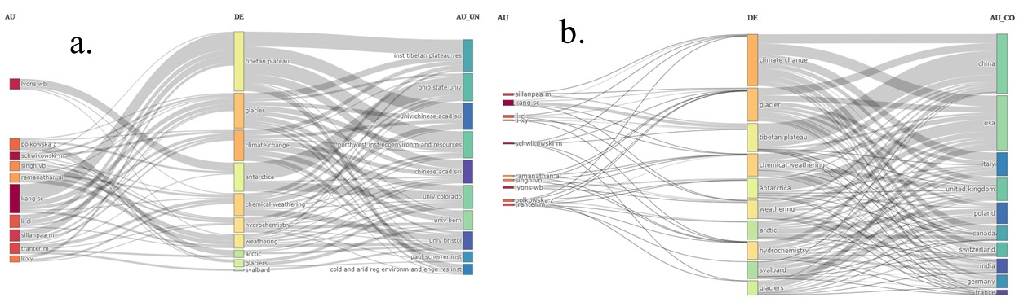
Figure S6: Sankey diagrams through the three field plots during the study period 2002-2022 a. Relationship between the authors (AU), author keywords (DE), and author’s affiliations and university (AU_UN) b. Relationship between author (AU), author keywords (DE), and author’s country (AU_CO)
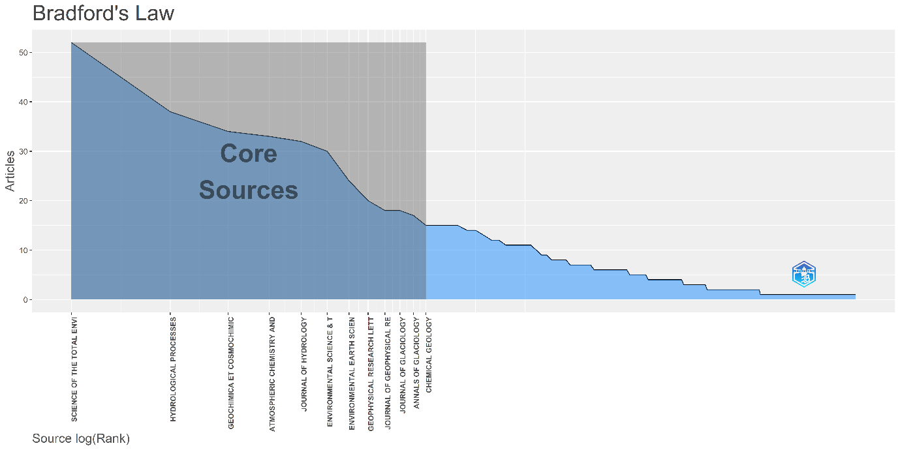
Figure S7: Bradford’s law shows source rank on basis of their contribution to the study during the period 2002-2022.
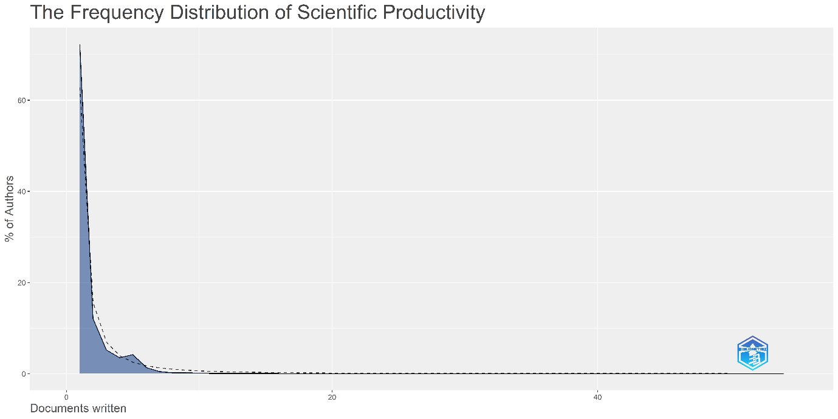
Figure S8: Lotka’s law represents the actual contribution by the author through the dotted line.
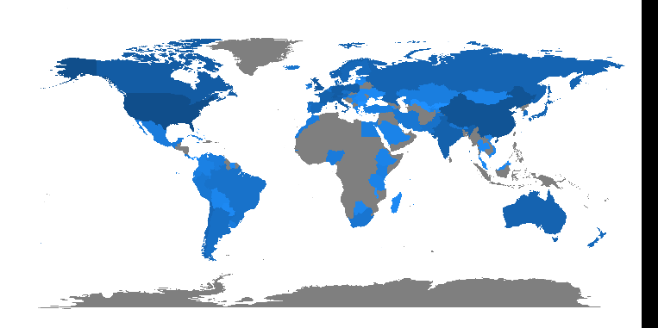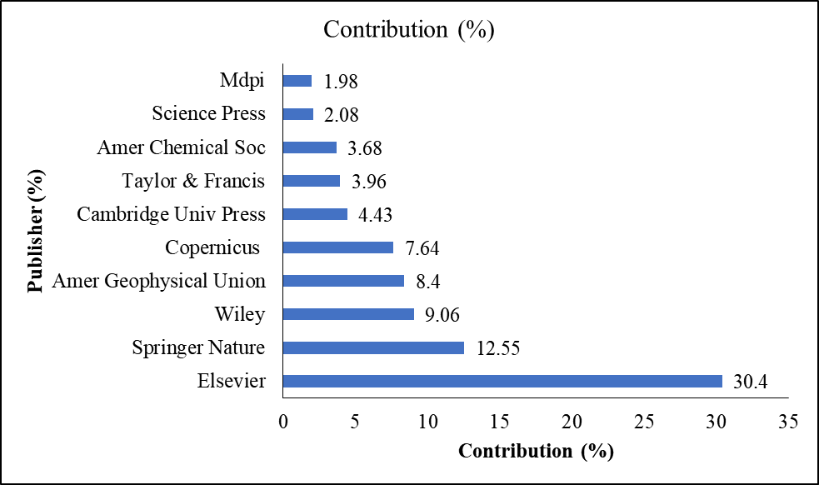
Figure S9: Annual scientific production by different countries during the study period. Dark blue color represented the highest production while light blue to low production countries. The gray color represented the absence of publication during the study period. The bar graph represents the contribution by the top ten publishers during the study period.
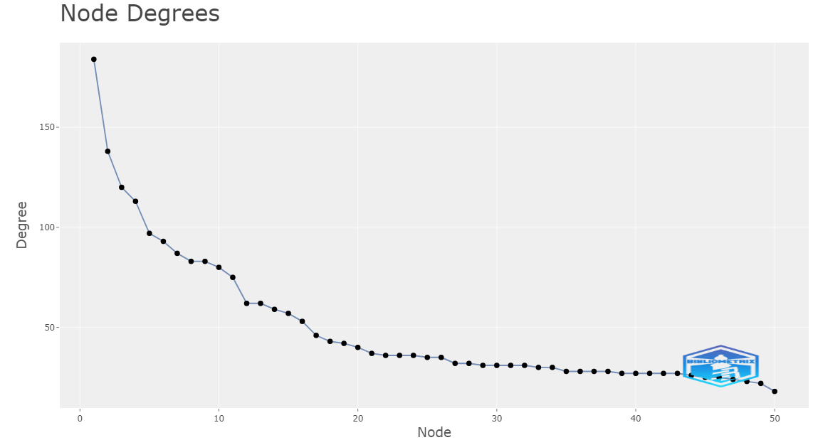
Figure S10: Degree nodes for author’s keyword used during the study period 2002-2022.

Table S1: Scientific Contribution on basis of the document and language type.
Sr. No. | Document Type | No. of Articles | Contribution (%) | Language | No. of Articles | Contribution (%)
1 | Research Article | 1001 | 94.43% | English | 1,057 | 99.72%
2 | Review Article | 51 | 4.81% | Chinese | 1 | 0.09%
3 | Proceeding Paper | 44 | 4.15% | French | 1 | 0.09%
4 | Early Access | 6 | 0.57% | German | 1 | 0.09%
5 | Editorial Material | 4 | 0.38%
6 | Data Paper | 3 | 0.28% | Indices
7 | Correction | 2 | 0.19% | Science Citation Index Expanded (SCI-EXPANDED) | 1,059 | 99.91%
8 | Book Chapters | 1 | 0.09% | Conference Proceedings Citation Index – Science (CPCI-S) | 43 | 4.06%
9 | Letter | 1 | 0.09% | Social Sciences Citation Index (SSCI) | 17 | 1.60%
10 | Meeting Abstract | 1 | 0.09% | Others | 5 | 0.47%

