Supplementary Information

What caused the cold condition over northeast Asia during April 2020?
Go-Un Kim¹, Hyoeun Oh¹, Yong Sun Kim^{1,2}, Jun-Hyeok Son¹, and Jin-Yong Jeong¹*‬‬‬‬‬‬‬‬‬‬‬‬‬‬‬‬‬‬
¹Korea Institute of Ocean Science and Technology, Busan, South Korea
²Ocean Science and Technology School, Korea Maritime and Ocean University, Busan, South Korea

*Corresponding author:
Jin-Yong Jeong
Korea Institute of Ocean Science and Technology
49111 385, Haeyang-ro, Yeongdo-gu, Busan, South Korea
Phone: +82-51-664-3701
Fax: +82-51-403-7692
Email: yjeong@kiost.ac.kr

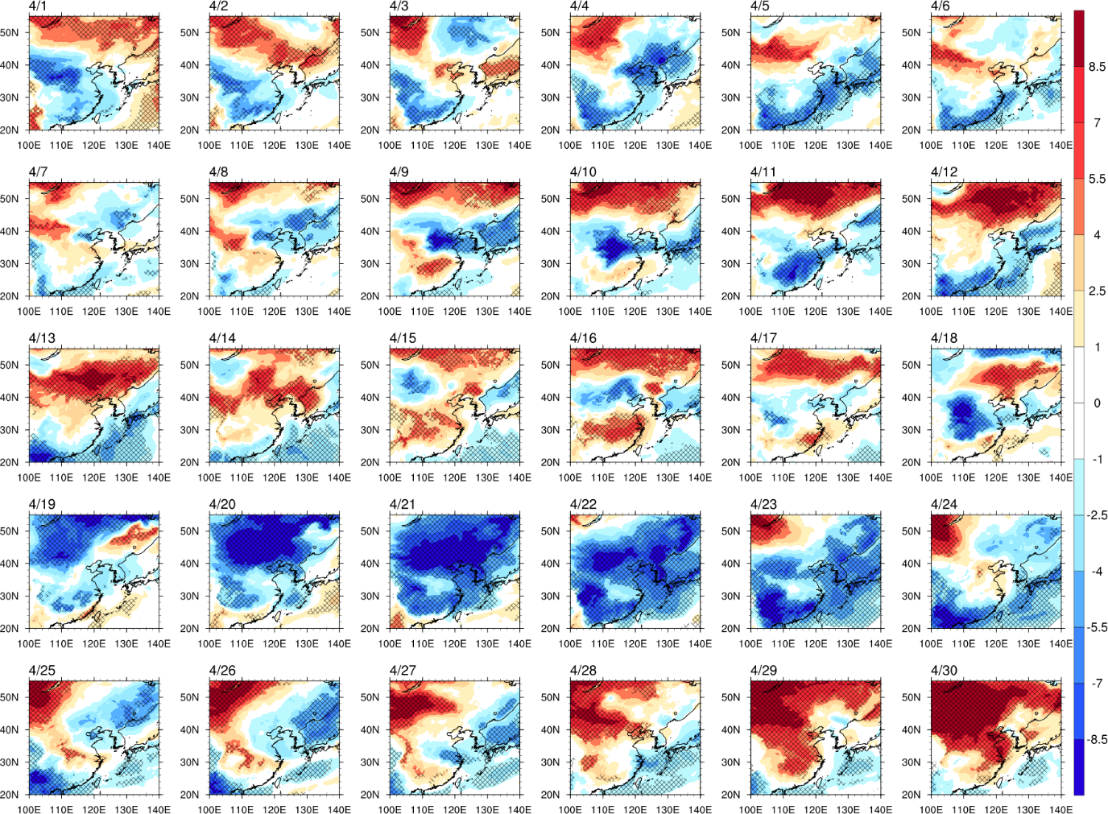

Supplementary Figure S1. Maps of cold condition in April 2020. Same as Fig. 1a, but showing the period of 1–30 April, 2020 in the ERA5.

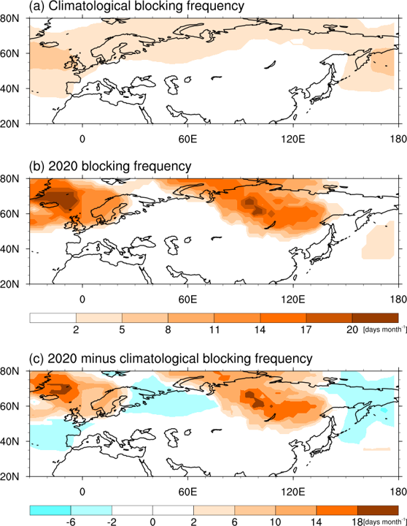

Supplementary Figure S2. Distribution of blocking occurrence. Total number of blocking frequency (shading, days per month) in April (a) climatological period 1982–2019, (b) 2020, and (c) 2020 minus climatology from ERA5. Black boxes indicate the Siberia region (50–70 °N, 80–120 °E).

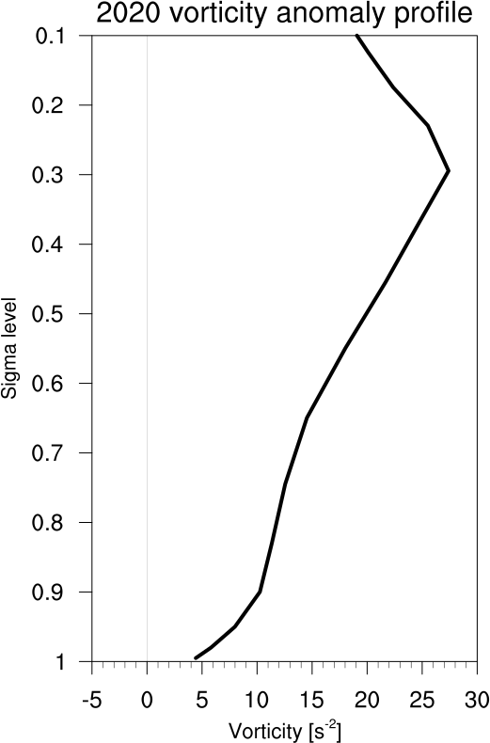

Supplementary Figure S3. Vertical forcing profiles. Vertical profiles of vorticity forcing averaged over the northwest/central Russia region (50–70 °N, 30–60 °E).

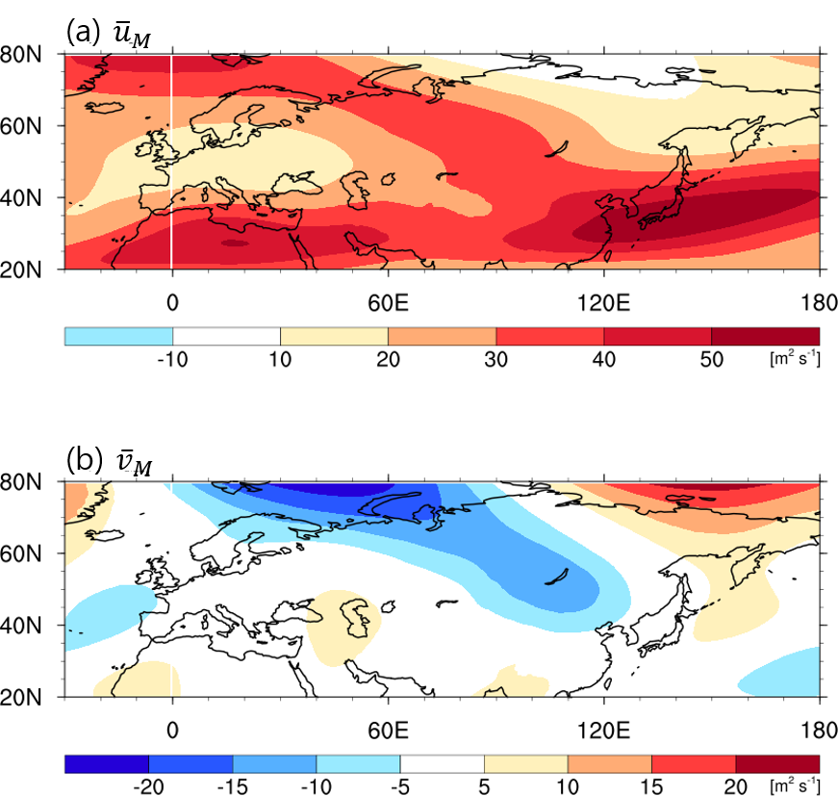

Supplementary Figure S4. Potential causes for the cold condition. Same as Fig. 5a, but for (a) 200 hPa zonal wind (${\overline{u}}_{M}$, m s⁻¹), and (b) 200 hPa meridional wind (${\overline{v}}_{M}$, m s⁻¹) in the Mercator coordinate.

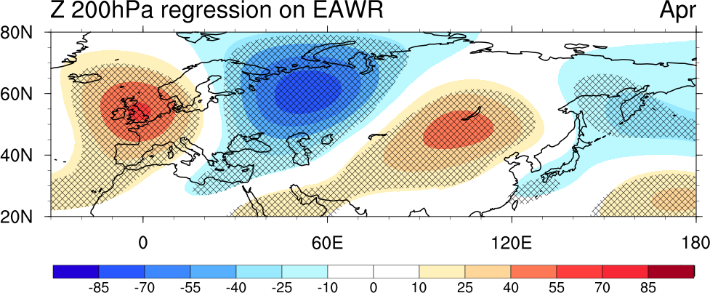

Supplementary Figure S5. Regression pattern associated with the East Atlantic/Western Russia (EAWR) index. Regressed field for 200 hPa geopotential height anomalies against the EAWR index in April during 1982–2020. Hatched areas indicate values significant at 90% confidence level.

