Extended Data for

Targeting a secreted fungal effector protein providing a novel concept in combating rice blast
Muxing Liu^{a, 1}, Fangfang Wang^{b, 1}, Bo He^{a, 1}, Jiexiong Huª, Ying Daiª, Weizhong Chenª, Haifeng Zhangª, Yonghao Yeª, Zhongli Cui^{c}, Xiaobo Zhengª, Ping Wang^{d}, Weiman Xing^{e,} * and Zhengguang Zhang^{a,} *^{, 2}

*Corresponding author. Email: zhgzhang@njau.edu.cn, weimanxing@shnu.edu.cn

This PDF file includes:

Methods
Extended Data Figs. 1-19
Extended Data Tables and captions 1-3, 5-8
Key Resources Table

Other Extended Data for this manuscript include the following:

Extended Data Table S4

Methods
Fungal strains and cultures
M. oryzae strain Guy11 was used as the wild-type strain in this study. The knockout mutant ∆Mosyn8 was characterized and described previously by us²². All strains were cultured in a complete medium (CM). Liquid CM medium was used to prepare mycelia for DNA and RNA extraction. For conidiation, strain blocks were maintained on straw decoction and corn (SDC) agar media at 28°C for 7 days in the dark followed by 3 days of continuous illumination under fluorescent light.

Secreted protein extraction
Secreted proteins were prepared as described previously²³. Briefly, fungal strains were cultured in a liquid N starvation minimal medium (MM-N) medium for 2 days at 28°C, and the cultures were collected. The cultures were extracted with 0.5 volume of phenol by shaking on ice for 15 min, followed by centrifugation at 3500 rpm for 20 min. The phenol extraction was repeated twice. The phenol layer was precipitated by adding 4 volumes of 100 mM ammonium acetate in methanol at -20°C for 5 h. The precipitated proteins were recovered by centrifugation at 3500 rpm for 15 min. The pellet was washed twice with 80% methanol containing 100 mM ammonium acetate and then 80% acetone prior to storage at -20°C.

Two-dimensional electrophoresis (2-DE) and quantitative analysis
For 2-DE, the secreted protein crude extracts were vacuum dried and then dissolved in 800 μl lysis solution containing 7 M urea, 2 M thiourea, 4% (w/v) CHAPS, 65 mM DTT, 1 mM PMSF and 0.5% (v/v) biolytes (Bio-Rad). Insoluble materials were removed by centrifugation and proteins were quantified using the Bradford method. About 1,200 μg protein was separated by loading the sample on an 18 cm pH4-7 nonlinear gradient IPG strip (GE Healthcare). The second electrophoretic dimension was carried out on a 12% SDS-PAGE. The signal was observed by CBB G-250. The gel image was digitalized with a gel scanner (Powerlook 2100XL, UMAX), and analyzed with PDQuestTM software package (Version 7.2.0; BioRad). Spots were detected, matched, and normalized on the basis of the total density of gels with the parameter of percent volume according to the software guide. For each spot, the mean relative volume (RV) was computed at every sample, and the spots showing a mean RV that changed more than 1.5 folds and p < 0.05 in different stages were considered differentially expressed proteins.

MALDI-TOF analysis
For in-gel digestion and MALDI-TOF analysis, protein spots with differential expression patterns were manually excised from gels, washed with Millipore pure water for three times, and destained twice with 50 mM NH₄HCO₃ in 50% acetonitrile for CBB G-250 staining spots. Samples were then processed by the flowing steps: reduction with 10 mM DTT in 50 mM NH₄HCO₃, alkylation with 40 mM iodoacetamide in 50 mM NH₄HCO₃, drying twice with 100% acetonitrile, and digestion overnight at 37℃ with sequencing grade modified trypsin (Promega, Madison, WI, USA) in 50 mM NH₄HCO₃. The peptides were extracted twice with 0.1% TFA in 50% acetonitrile. Extracts were pooled and lyophilized. The resulting lyophilized tryptic peptides were dissolved in 5 mg/ml CHCA containing 0.1% TFA and 50% acetonitrile. MALDI-TOF-TOF MS analyses were conducted using a Bruker Daltonics Ultraflex MALDI-TOF-TOF_{TM} Analyzer. All spectra of proteins were submitted to database searching using the online MASCOT program (http://www.matrixscience.com), against NCBInr databases. The searching parameters were as follows: 0.15 Da mass tolerance for peptides and 0.25 Da mass tolerance of TOF-TOF fragments, one allowed trypsin miscleavage, carbamidomethyl of Cys as fixed modification, and oxidation of Met, pyro-Glu formation of N-terminal Gln and Glu as variable modification. Only significant hits, as defined by the MASCOT probability analysis (p < 0.05), were accepted.

Construction of MoERS1 vectors
In order to analyze the function of the MoERS1 gene, we created the targeted genes deletion vector pMD-MoERS1-HPH by inserting the HPH gene cassette between the two flanking sequences of the MoERS1 gene. 1 kb upstream flanking sequence and 1 kb downstream flanking sequence were amplified from M. oryzae genomic DNA by PCR using primer pairs MoERS1-p1 (F)/MoERS1-p2 (R) and MoERS1-p3 (F)/MoERS1-p4 (R), respectively. The two flanking sequences were linked by overlap PCR with primer pairs MoERS1-p1 (F)/MoERS1-p4 (R), and the amplified 2 kb fragments were purified and cloned into a pMD19-T vector (Takara Co, China) to generate plasmid pMD-MoERS1. An EcoRV restriction site was incorporated into primers MoERS1-p2/MoERS1-p3. The HPH gene cassette was prepared by PCR from the plasmid pCB1003 with primer pairs FL1111/FL1112 and inserted into the EcoRV site of pMD-MoERS1 to generate the final disruption construct pMD-MoERS1-HPH. The 3.4 kb fragment was amplified with MoERS1-p1 (F)/MoERS1-p4 (R) primers and transformed into Guy11.
The transformants were screened using primers MoERS1-p5 (F)/MoERS1-p6 (R). For Southern blotting, the MoERS1 gene probe was amplified using the primers MoERS1-p5 (F)/MoERS1-p6 (R), and the HPH gene probe was amplified using the primers FL1111/ FL1112.
For complementation, we amplified a fragment that contains the MoERS1 gene and its native promoter regions by PCR with primers MoERS1-p7 (F)/MoERS1-p8 (R) and inserted into the pYF11 (bleomycin resistance) vector, generating pYF11-MoERS1-GFP. Then the construct was used for protoplast transformation of the ∆Moers1 mutant. The resulting transformants were first screened by phenotype characterization, followed by PCR amplification, and verified by fully restored growth.

Infection assays
For the virulence test, conidia were suspended to a concentration of 5 x 10⁴ spores/ml in a 0.2% (w/v) gelatin solution and 4 ml each was sprayed on two-week-old rice seedlings (Oryza sativa CO39). Inoculated plants were kept in a growth chamber at 25°C with 90% humidity and in the dark for the first 24 hours, followed by a 16/8 hours light/dark cycle. The disease severity was assessed at 7 days after inoculation. The fungal growth was determined using quantitative PCR to measure the amount of M. oryzae genomic 28S rDNA relative to rice genomic Rubq1 DNA. PCR primers are listed in table S8. For observation of the penetration and invasive growth in rice cells, conidial suspensions (1×10⁵ spores/ml) were injected into the leaf sheath. At 28°C for 24 or 48 hours, the inner epidermis of infected sheaths was observed under a microscope.

ROS observation
To observe ROS derived from rice, the rice leaves or sheaths were stained with DAB (Sigma-Aldrich) as previosuly described⁵². For the measurement of ROS levels, leaves were cut into discs with a cork borer and pre-incubated overnight in sterile-distilled water. After the leaf disks were treated with DMSO, flg22, or compounds, ROS production was monitored by the luminol chemiluminescence assay²⁶.

RNA isolation and qRT-PCR
For quantification of gene expression, RNA was isolated by TRIzol (Invitrogen Life Technologies, Shanghai, China). cDNA synthesis was performed by PrimeScriptTM RT Reagent Kit (TaKaRa). Quantitative RT-PCR was performed with the ABI 7500 Fast Real-Time System and transcripts were analyzed by the 7500 System SDS software. To compare the relative abundance of PR genes transcripts, the average threshold cycle (Ct) was normalized to rice actin for each of the treated samples as 2^{-∆Ct}, where -∆Ct= (Ct, target gene-Ct, actin). Fold changes calculated as 2^{-∆∆Ct}, -∆∆Ct= (Ct, experiment-Ct, actin) - (Ct, control-Ct, actin). All experiments were repeated three times independently. The primers were list in Table S8.

Generation and characterization of the transgenic rice
Oryza sativa japonica cv. TP309 was transformed with the constructs pCam2300-Pro_{actin1}:OsRD21-FLAG, pCam2300-Pro_{actin1}:MoERS1-FLAG, and CRISPR-Cas9:OsRD21, respectively, with Agrobacterium tumefaciens-mediated transformation at Edgene Bio (Wuhan, China). The overexpression lines were characterized by Western blotting and knockout lines were characterized by DNA sequencing.

Yeast two-hybrid assay
For the yeast-two-hybrid assay, the MoERS1 or PLCPs cDNA sequence was amplified and cloned into pGBKT7 or pGADT7, respectively. Yeast transformation and screening were performed according to the manufacturer’s instructions (Clontech; Mountain View, CA, USA). Yeast AH109 cells were co-transformed with specific bait and prey constructs. All of the yeast transformants were grown on an SD/-Leu/-Trp/-His/-Ade medium for selection.

Co-Immunoprecipitation (co-IP)
Co-IP from N. benthamiana cells was performed as described previously⁵³. Briefly, samples were extracted with the IP buffer (50 mM Tris-HCl pH7.5, 150 mM NaCl, 0.5% NP-40, 5 mM DTT and protease inhibitor cocktail). The mixtures were kept at 4°C with gentle shaking for 1 h. The IP complex was captured by adding 50 μl GFP-Trap® (ChromoTek, Germany) or Anti-FLAG M2 affinity gel (Sigma), following by shaking at 4°C for another 1 h. The beads were recovered by centrifugation at 2500×g for 30 sec and washing six times with cold TBS (50 mM Tris-HCl pH7.5, 150 mM NaCl). Then 50 μl of glycine eluting solution (PH 2.5) was added to the beads. After boiling for 5 min, the samples were loaded onto the SDS-PAGE gels for western blot analysis.

Microscale Thermophoresis (MST) analysis
Binding reactions of recombinant GST-MoErs1 and its interaction sites mutation proteins with OsRD21 or compounds were measured by MST in a Monolith NT.Label Free (Nano Temper Technologies GMBH) instrument. Labeled GST-MoErs1 (10 μM) was displaced by a buffer. A range of concentrations of OsRD21 or compounds in the assay buffer was incubated with labeled protein (1:1, v/v) for 10 min. The samples were loaded into the NT.Label Free standard capillaries and measured with 20% LED power and 40% MST power. The KD Fit function of the Nano Temper Analysis Software (Version 1.5.41) was used to fit the curve and calculate the value of the dissociation constant (Kd).

Protein crystallization
Construction of expression vectors: the MoErs1 (21-214 aa) coding sequence was amplified from the cDNA library of M. oryzae strain Guy11 and cloned into the modified pET15b vector (Novagen, Madison, WI, USA). Site-directed mutagenesis of MoErs1^{E112M/E191M} was carried out using the overlap PCR method. All plasmids were verified by DNA sequencing before protein expression and purification.
Protein expression and purification: MoErs1 (21-214 aa) containing N-terminal 6xHis tag, MysB protein, and a cleavage site for the tobacco etch virus (TEV) protease was overexpressed in E. coli BL21 (DE3). E. coli cells were grown in liquid LB medium at 37°C to an OD₆₀₀ of 0.4-0.8. The temperature of the culture was then lowered to 16°C, and the expression of MoErs1 was induced by the addition of 0.4 mM isopropyl β-D-1- thiogalactopyranoside. After 12h, cells were harvested by centrifugation at 5,300g for 15min. The cell pellet was re-suspended in lysis buffer (20 mM Tris-HCl, pH 8.0, 200 mM NaCl, 10mM imidazole) supplemented with 1mM PMSF, lysed with a high-pressure homogenizer, and then centrifuged at 37,000g for 50 minutes at 4°C. The supernatant was loaded to a Nickel affinity column (GE Healthcare, Uppsala, Sweden). Ten-bed volumes of wash buffer (20 mM Tris-HCl, pH 8.0, 200 mM NaCl, 30 mM imidazole) were used to wash the resin and 3 bed volumes of elution buffer (20 mM Tris-HCl, pH 8.0, 200 mM NaCl, 200mM imidazole) were used to elute the target protein. The purity of the target protein was analyzed by SDS-PAGE. The affinity-enriched proteins were further purified using an anion exchange column (GE Healthcare, Uppsala, Sweden) and the tag was cleaved overnight at 4°C with a molar ratio 1:20 TEV protease. Subsequently, the protein was purified by a Nickel affinity column and gel filtration chromatography (GE Healthcare, Uppsala, Sweden). The protein peak was collected, and then concentrated to 10 mg/ml (20 mM Tris-HCl, pH 8.0, 800 mM NaCl, 5 mM DTT). All purification process was performed at 4°C.
Protein crystallization: MoErs1 crystal was initially screened using the sitting drop method at 4℃. After mixing 0.4 μL MoErs1 protein (10 mg/ml in 20 mM Tris-HCl, pH 8.0, 800 mM NaCl, 5 mM DTT) with 0.4μL reservoir solution, the screening plates were placed at 4 degrees for crystal growing. MoErs1 yielded crystals after 3 days. The hanging drop method was then used to further optimize the growth. 1.5μL MoErs1 (10 mg/ml in 20 mM Tris-HCl, pH 8.0, 800 mM NaCl, 5 mM DTT) was mixed with the equal volume (1.5 μL) of the reservoir solution consisting of 0.05 M Zinc acetate dihydrate, 20% PEG 3,350. Before data collection, all crystals were cryo-protected by gradient transferring them into the reservoir solution containing 25% glycerol and flash-frozen in liquid nitrogen.
Data collection and structure determination: the diffraction data of native MoErs1 (2.5Å) and Se-Met MoErs1^{E112M/E191M} (2.2Å) for these crystals were collected at BL18U1 and BL17U1 beamline at the Shanghai Synchrotron Radiation Facility (SSRF). The diffraction images were processed and scaled using HKL2000/3000 package (HKL Research Inc., Charlottesville, VA, USA). Phases were initially obtained with data Se-Met MoErs1^{E112M/E191M} (21-214 aa). The structure of MoErs1 was solved using the single-wavelength anomalous diffraction (SAD) method²⁸ as executed in Phenix⁵⁴. The structural models were obtained by using autosol and autobuild in Phenix, and manually rebuild by COOT⁵⁵, and Phenix was used to refine the structure further. All of the structure-related pictures in this research were produced using Pymol version 2.1.0 (Schrödinger, LLC, Portland, OR, USA).

Syntheses of target compounds
All solvents used were in either the chemically pure or analytically pure grade. The purity of commercially available reaction materials was maintained above 95%. The whole synthetic scheme of target compound FY21001 was shown below.
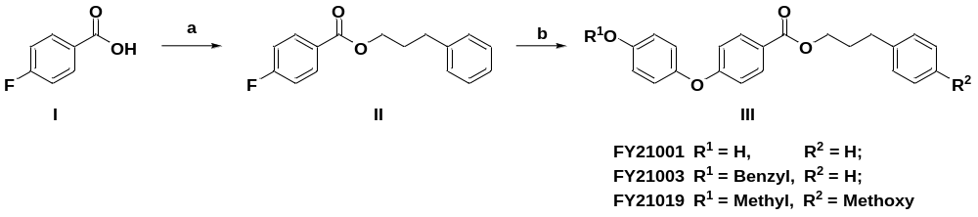Synthetic route of the title compound. Reagents and conditions: (a) (COCl)₂, DMF, substituted 3-phenylpropan-1-ol, DCM, 0℃; (b) substituted phenol, K₂CO₃, DMF, 100℃.
Syntheses of 3-phenylpropyl 4-fluorobenzoate (II): 4-fluorobenzoic acid (I, 2.0 mmol) dissolved in the anhydrous dichloromethane. (COCl)₂ (2.5 mmol) was slowly added dropwise to the reaction system at 0℃. After stirring for 4 hours, the reaction solution was removed under vacuum distillation. Dichloromethane was used to dissolve remaining solids and phenylpropanol (2.5 mmol) and trimethylamine (2.5 mmol) were then added. After 2h, a NaHCO₃ solution (30 mL) was added to the reaction mixture with stirring and the organic phase was separated. The organic phases were combined, dried with Na₂SO₄, and purified by column chromatography to give the Intermediate II 3-phenylpropyl 4-fluorobenzoate. Yield = 80%, ¹H NMR (500 MHz, DMSO-d₆) δ 8.01 (dd, J = 9.0, 5.5 Hz, 2H), 7.39 – 7.33 (m, 2H), 7.32 – 7.27 (m, 2H), 7.26 – 7.23 (m, 2H), 7.22 – 7.17 (m, 1H), 4.26 (t, J = 6.4 Hz, 2H), 2.77 – 2.71 (m, 2H), 2.07 – 1.99 (m, 2H).
Syntheses of 3-phenylpropyl 4-(4-hydroxyphenoxy) benzoate (FY21001): In N₂ atmosphere, intermediate II (2.0 mmol), hydroquinone (4.0 mmol), K₂CO₃ (4.0 mmol) and DMF (10 ml) were added together into 100 ml two-necked bottle. The mixture was stirred at 80℃ for 6 h. When the reaction was complete, 50 ml H₂O was added into the reaction system. The aqueous layer was extracted with ethyl acetate (20 mL) about two times and the organic layers combined, flowing by drying with Na₂SO₄ and column chromatography purification to give the title compound FY21001. Yield = 50%, High Resolution Mass Spectrum (HRMS): m/z [M+H]+ calcd. for [C22H21O4]: 349.1439, Found:349.1433. 1H NMR (500 MHz, Chloroform-d) δ 7.97 (d, J = 8.5 Hz, 2H), 7.31 – 7.26 (m, 2H), 7.23 – 7.18 (m, 3H), 6.97 – 6.90 (m, 4H), 6.86 (d, J = 9.0 Hz, 2H), 4.32 (t, J = 6.5 Hz, 2H), 2.80 – 2.74 (m, 2H), 2.09 (m, 2H). Other derivatives were synthesized similarly.
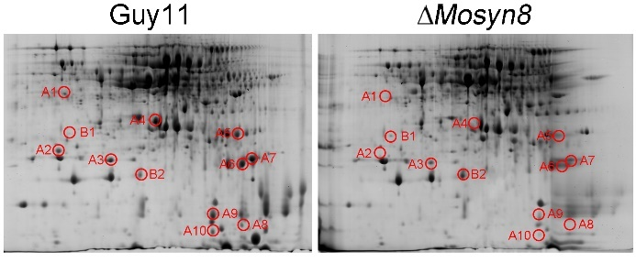

Extended Data Fig. 1. Identification of secreted protein spots from wild-type Guy11 and the ∆Mosyn8 mutant by 2-DE analysis.
The numbers with arrows indicate the differentially expressed and identified protein spots. 12 spots exhibiting different levels of accumulation in WT and the ∆Mosyn8 mutant are marked by circles, numbered, and analyzed by MALDI-TOF mass-spec. Protein information in each spot is shown in Table S1.

Extended Data Fig. 2. Correction and sequence alignment of the MoERS1 gene in M. oryzae.
(a and b) The sequence of the predicted MGG_13009 gene model was suggested to be 885 bp with two introns. The sequence of the corrected gene model was 762 bp with one intron. F1/R1 and F2/R2 were the two primer pairs used to verify the gene model. The PCR products from wild-type cDNA could not be obtained using F1/R1 but could be obtained with F2/R2. M, marker. (c) Sequence alignment of the corrected MoERS1 gene in contrast to predicted MoERS1 in M. oryzae. The red line labeled codons encode the interactive amino acid residues between MoErs1-OsRD21.

Extended Data Fig. 3. Transcriptional patterns and target deletion of MoERS1 gene.
(a) MoErs1 is secreted in the infection stage. The Flag-tagged Slp1, MoErs1and GFP was expressed in the Guy11 strain, respectively. Total secreted proteins were extracted from the cultures in 4-day old CM, MMN liquid culture or infectious stage (48 hpi), and separated by SDS-PAGE, and detected by anti-Flag antibody. (b) The expression pattern of MoERS1 in different developmental stages. Relative expression levels of MoERS1, BAS4 and AvrPi9 in mycelia (MY) inoculated on CM liquid media, conidia (CO), and infectious stages (8, 24, 36, 48, and 72 hpi) were determined by qPCR. Error bars show standard deviations of results from three replicates. (c) Southern hybridization was used to analyze the MoERS1 gene copy number and validate the deletion of MoERS1 and the addition of a single copy integration of the HPH gene in the mutant. When hybridized with the specific MoERS1 gene probe, bands were observed in Guy11 but not in the mutant. When hybridized with the HPH probe, the mutant but not Guy11 exhibited specific bands characteristic of the gene replacement event.

Extended Data Fig. 4. MoErs1 is important for suppressing the production of ROS in rice cells.
(a) MoErs1 is important for normal invasion growth. Leaf penetration assay in rice leaf sheaths from 4-week-old rice seedlings that were inoculated with conidial suspension (1x10⁵ spores/ml each). Invasive hyphae were examined at 24 and 48 hpi. Scale bars, 10 μm. (b and c) The ∆Moers1 mutant cannot inhibit the ROS burst in rice cells. DAB staining on infected leaf sheath of CO39 with Guy11, ∆Moers1 mutant, and the complement strains at 24 and 48 hpi. Graphics represents the number of appressoria (n = 100) that induce H₂O₂ in the invaded rice cells. The experiments were repeated three times and showed similar results. AP, appressoria. IH, invasive hyphae. the asterisks indicate a significant difference (p < 0.01). (d and e) Invasive growth of ∆Moers1 mutant was restored by DPI treatment. Statistics of invasive hyphal growth at 100 appressorium penetration sites by rating the hyphal growth from level I to IV (I, appressoria without primary invasive hypha; II, with primary invasive hypha; III, secondary invasive hypha does not extend to the neighboring plant cells; IV, invasive hypha extended into neighboring plant cells). The experiments were repeated three times and showed similar results. DMSO treatment (*), DPI treatment (**). Error bars represent the SD. Scale bar, 10 μm.

Extended Data Fig. 5. The function of MoErs1 in virulence.
(a and c) Blast resistance of MoERS1 (without the signal peptide) overexpression plants (MoERS1^{∆SP}-OX) using spraying inoculation. Numbers “1” and “2” mean 2 independent transformants. Fungal growth measured by quantifying M. oryzae genomic 28S rDNA relative to rice genomic Rubq1 DNA. The mean values of 3 determinations with SDs are shown. The asterisks indicate a significant difference (p < 0.01). (b and d) Invasive growth of Guy11 and ∆Moers1 mutant strains on TP309 and MoERS1^{∆SP}-OX leaf sheath at 24 and 48 hpi. Statistics of invasive hyphal growth at 100 appressorium penetration sites by rating the hyphal growth from level I to IV. The experiments were repeated three times and showed similar results. Scale bars, 10 μm. (e and f) The ∆Moers1 mutant can produce typical lesions on MoERS1^{∆SP}-OX rice leaves. Conidiation lesions on surface-sterilized rice leaves in (a) were counted and photographed. The lesions producing conidia are typical lesions and the lesions that fail to produce conidia are necrotic lesions.

Extended Data Fig. 6. MoErs1 is not required for the secretion of effectors.
(a and b) MoErs1 is not required for the recognition between R-Avr proteins. Whole-plant assays with cultivars LTH, LTH-Pia or LTH-Piz-t inoculated with Guy11ª (Guy11 expressed Avr-Pia), ∆Moers1ª (∆Moers1 expressed Avr-Pia), Guy11^{b} (Guy11 expressed Avr-Piz-t) or ∆Moers1^{b} (∆Moers1 expressed Avr-Piz-t), respectively. Incompatible Guy11ª, Guy11^{b}, ∆Moers1ª, and ∆Moers1^{b} generally failed to form visible symptoms on LTH-Pia and LTH-Piz-t, respectively, while they generated typical expanding lesions on the compatible cultivar LTH. Photographs were taken 7 dpi. (c and d) In susceptible LTH sheath cells, Avr-Pia:GFP or Avr-Piz-t:GFP fluorescence was secreted and accumulated in BIC (arrowhead) in both Guy11 and ∆Moers1 mutant. Photos were taken at 24 hpi with Guy11 and 32 hpi with ∆Moers1 mutant. Scale bar, 10 μm. (e) MoErs1 is not involved in the secretion of apoplast effector Slp1. In LTH sheath cells, Slp1:GFP expressed by Guy11 and ∆Moers1 mutant was secreted and accumulated in the EIHM. Photos were taken at 24 hpi with Guy11/Slp1:GFP and 32 hpi with ∆Moers1/Slp1:GFP strain. Bar = 10 μm.

Extended Data Fig. 7. The structure of MoErs1.
(a) The overall structure of MoErs1 in two orientations. Ribbon diagram of MoErs1 with annotation of secondary structure elements (left), and rotated 180° as shown by the arrow (right). (b) A close-up view of the disulfide bond in the MoErs1. Residues involved in the disulfide bond are shown as sticks and labeled. (c) S2 Structure alignment of MoErs1, WSCP (6S2Z), and trypsin protein inhibitor 2 (5XOZ). Structure superpositions of MoErs1 with WSCP and MoErs1 with trypsin protein inhibitor 2 reveal a similar structure, with an overall Cα RMSD value of 3.4Å. The MoErs1, WSCP and trypsin protein inhibitor 2 were colored green, pale cyan, and gray, respectively.

Extended Data Fig. 8. OsRD21 mainly localizes on plasma membrane in N. benthamiana and rice cells.
(a and b) OsRD21 localizes on PM and ER in N. benthamiana. Co-expression of Pro-RD21-GFP proteins with a PM marker Remorin-RFP or ER marker SP-RFP-HDEL through agroinfiltration in N. benthamiana respectively, and treated with 1 M NaCl for plasmolysis, empty-GFP was used as control, revealed that OsRD21 is localized on PM and ER in N. benthamiana. Fluorescence from epidermal cells in the infiltrated tissues was observed by confocal microscopy at 48 h. (c) OsRD21 localizes on PM in rice protoplast. The Pro-RD21-GFP proteins and Remorin-RFP were co-expressed in rice protoplast. (d) MoErs1 localizes in the whole cytoplasm. The GFP tagged MoErs1 without signal peptide was expressed in rice protoplast. (e) The protein levels of Pro-RD21-GFP, Remorin-RFP, SP-RFP-HDEL, and MoErs1-GFP expressed in N. benthamiana or rice protoplast can be normally detected by appropriate antisera.

Extended Data Fig. 9. Interaction between MoErs1 and OsRD21 in vitro and in vivo.
(a) Yeast two-hybrid assay between AD-OsRD21 and BD-MoErs1 (without the signal peptide sequence) or the interaction site mutations in Figure 2. Cells were plated on SD-Ade-Leu-Trp-His media. (b) Co-IP analysis of OsRD21-Flag and MoErs1-GFP (without the signal peptide sequence) or the interaction site mutations in vivo. The OsRD21-Flag and MoErs1-GFP or the interaction site mutations genes were co-expressed in N. benthamiana using Agrobacterium-mediated infection. The co-IP experiment was performed with the anti-GFP antibody, and the isolated protein was analyzed by immunoblot using an anti-FLAG antibody to detect OsRD21 and an anti-GFP antibody to detect MoErs1. (c) MoErs1 exhibits stronger OsRD21 binding affinity than other mutations, as assessed using MST. 10 μM GST-MoErs1 was labeled by RED-NHS. The raw data were integrated and fitted to a binding model using the MST analysis software. The recombinant proteins were contained in NT standard capillaries. The solid curve is the fit of the data points to the standard Kd-fit function. Kd, dissociation constant.

Extended Data Fig. 10. 3D-modeling of OsRD21.
OsRD21 structure was modeled using the 3D structure of the barley EP-B2 cysteine endoprotease (PDB-ID: 2FO5) as the template in SWISS-MODEL. The sequence identity was 59.63%, and the Global Model Quality Estimation (GMQE) was 0.39, indicating that the model is trustable. The structures were aligned using PyMOL, and the root-mean-square deviation (RMSD) is 0.505.

Extended Data Fig. 11. Determination of the resistance of the OsRD21 knockout and overexpression transgenic lines.
(a) Target site designed and verified for knocking out the OsRD21 gene by CRISPR/Cas9 system. The OsRD21-KO lines were verified by PCR-based sequencing. The transgenic lines are generated from the TP309 genetic background. (b) The co-IP assay was used to evaluate the inhibition of OsRD21 activity in a MoErs1-dependent manner during the infection stage. The OsRD21-OX rice lines (plasmid with Flag tag) were inoculated with the wild strain Guy11, the ∆Moers1 mutant, the point mutation mutants (GFP tagged), and the complement strains with the native MoERS1 promoter and constructive rp27 promoter (GFP tagged). The background rice line TP309 was used as a control. Total proteins were extracted and purified by Anti-FLAG M2 affinity gel (Sigma), and then labeled with 2 μM DCG-04 for 4 h. Proteins were separated by SDS-PAGE and detected with streptavidin-HRP and chemiluminescence, and immunoblotting with anti-Flag and anti-GFP antibodies. (c and d) Infection phenotype of OsRD21-KO and OsRD21-OX lines against M. oryzae. The leaves of 4-week-old plants were infected with the above strains using punch inoculation. Photos were taken at 6 dpi. The fungal growth was evaluated by quantifying M. oryzae genomic 28S rDNA relative to rice genomic Rubq1 DNA. The mean values of 3 determinations with SDs are shown. Significant differences were determined by Duncan's new multiple range tests and marked with different letters. (e and f) Infection phenotype of OsRD21-KO and OsRD21-OX lines against B. oryzae and X. oryzae. The DLA and lesion length are displayed as boxes with individual data points. The error bars represent maximum and minimum values. Center line, median; box limits, 25th, and 75th percentiles.

Extended Data Fig. 12. MoErs1 can bind multiple rice cysteine proteases.
Yeast two-hybrid assay between MoErs1 (without signal peptide) and each cysteine protease. Cells were plated on SD-Ade-Leu-Trp-His media.

Extended Data Fig. 13. FY21001 specifically interacts with MoErs1.
(a) MST assay showed a low binding affinity of FY21001 with AtWSCP and OsWSCP. 10 μM GST fused MoErs1, AtWSCP, and OsWSCP expressed and purified from E. coli cells were labeled by RED-NHS. The raw data were integrated and fitted to a binding model using the MST analysis software. The recombinant proteins were contained in NT standard capillaries. The solid curve is the fit of the data points to the standard Kd-fit function. Kd, dissociation constant. (b) FY21001 exhibits a stronger MoErs1 binding affinity than its mutations, as assessed using MST.

Extended Data Fig. 14. Diphenyl ether ester compounds FY21003 and FY21019 bind MoErs1 to inhibit its function.
(a) FY21003 and FY21019 exhibit affinity with MoErs1, as assessed by MST. 10 μM GST-MoErs1 and GST-empty were labeled by RED-NHS. The raw data were integrated and fitted to a binding model using the MST analysis software. The recombinant proteins were contained in NT standard capillaries. The solid curve is the fit of the data points to the standard Kd-fit function. Kd, dissociation constant. (b) GST-tagged MoErs1 was expressed and purified from E. coli strain BL21. Flag-tagged OsRD21 was transiently expressed in N. benthamiana. Total proteins were extracted and labeled with 2 μM DCG-04 for 4 h in the presence of compounds FY21003 and FY21019. Proteins were separated by SDS-PAGE and detected with streptavidin-HRP and chemiluminescence and immunoblotting with anti-Flag and anti-GST antibodies.

Extended Data Fig. 15. FY21001 shows a better control effect against rice blast than fungicides cafenstrole and metazachlor.
Rice leaves sprayed with DMSO, 500 μM FY21001, 500 μM cafenstrole, or 500 μM metazachlor 24 h pre-inoculation with Guy11 spores at a concentration of 1×10⁵ per ml. The DLA was assessed by Image J software, and the fungal growth was evaluated by quantifying M. oryzae genomic 28S rDNA relative to rice genomic Rubq1 DNA. The mean values of 3 determinations with SDs are shown. Significant differences were determined by Duncan's new multiple range tests and marked with different letters.

Extended Data Fig. 16. FY21001 does not have a control effect against rice brown spot and rice bacterial blight.
(a and c) Leaves were inoculated with B. oryzae strain Qujiang52#. The DLA was measured at 4 dpi. Data are displayed as boxes with individual data points. The error bars represent maximum and minimum values. Centerline, median; box limits, 25th, and 75th percentiles. (b and d) Leaves were inoculated with Xoo strain PXO99. The lesion length was measured at 14 dpi. Data are displayed as boxes with individual data points. The error bars represent maximum and minimum values. Centerline, median; box limits, 25th, and 75th percentiles.
Extended Data Fig. 17. Diphenyl ether ester compounds do not affect the development of M. oryzae.
(a and b) The wild-type strain Guy11, the ∆Moers1 mutant, and complemented strain were inoculated on CM and MMN media with DMSO or 500 μM Diphenyl ether ester compounds and cultured at 28°C in the dark for 7 days, and then photographed and measured the radius. Different letters show a significant difference (p < 0.05). (c and d) Conidia formation was observed under a light microscope 24 h at room temperature after induction of conidiation under coverslips. Numbers of conidia were harvested from a 9 cm SDC plate on day 10 after incubation at 28°C.

Extended Data Fig. 18. Diphenyl ether ester compounds inhibit the ability of rice blast fungus to suppress host immune response.
(a) Diphenyl ether ester compounds inhibit the invasive growth of M. oryzae. Close observation and statistics for invasive growth of Guy11 in rice leaf sheath at 30 hpi in the presence of diphenyl ether ester compounds. Statistics of invasive hyphal growth at 100 appressorium penetration sites by rating the hyphal growth from level I to IV (I, appressoria without primary invasive hypha; II, with primary invasive hypha; III, secondary invasive hypha does not extend to the neighboring plant cells; IV, invasive hypha extended into neighboring plant cells). The experiments were repeated three times and showed similar results. (b) DAB staining and inclusion deposition on infected leaf sheath of CO39 with Guy11 at 24 hpi in the presence of diphenyl ether ester compounds. The percentage of a pattern shown in the image was calculated by observation for 100 penetration sites that were randomly chosen, and observation was conducted 3 times. Scale bar, 10 μm.

Extended Data Fig. 19. FY21001 cannot induce rice immune response.
(a and b) Examination of the transcript level of defense-related genes (OsPR1, OsPBZ1, OsAOS2, and OsLOX1) and two NADPH oxidases (RBOHA and RBOHB) in rice plants treated with FY21001 at 24 or 48 h, DMSO treatment was used as control. qPCR was performed with gene-specific primers (Table S8). Values are the means of three replications, and error bars represent the SD (n = 3). The asterisks indicate a significant difference according to Student’s t-test (p < 0.01). (c) FY21001 cannot induce rice ROS burst. Rice leaf disks from TP309, OsRD21-OX, and OsRD21-KO were treated with DMSO, FY21001 (20 μM), and the bacterial PAMP flg22 (1 μM), ROS were detected with a luminol-chemiluminescent assay. Error bars represent the SD (n = 3).

Extended Data Table 3. The statistics of MoErs1_{(21-214 aa)} X-ray Data collection and refinement.
Structure | Native | SeMet^{E112M/E191M} derivative
Data collection parameters
Wavelength (Å) | 0.9791 | 0.9791
Space group | P4₃2₁2 | P4₃2₁2
Cell parameters
a (Å)  b (Å)  c (Å) | 105.081  105.081  67.568 | 105.709  105.709  68.296
Resolution (Å) | 50.0-2.50 (2.54-2.50) | 50.0-2.20 (2.24-2.20)
Observed reflections | 101,079 | 153,678
Unique reflections (I/s(I)>0) | 13,576 | 20,108
Average redundancy | 7.4 (6.5) | 7.6 (7.7)
Average I/σ(I) | 33 (4.75) | 41.26 (7.5)
Completeness (%) | 99.3(95.0) | 99.4 (99.2)
R_{merge} | 0.050 (0.237) | 0.037 (0.294)
Refinement parameters
No. of reflections  (Fo>0s(Fo)) | 12,791
Working set | 12,122
Test set | 669
R_{work} / R_{free} factor | 0.2156/0.2501
Total protein atoms | 1449
Wilson B factor (Å²) | 36.2
Average B factor (Å²) | 37.45
Protein atoms | 37.34
Water atoms | 38.83
RMS deviations
Bond lengths (Å) | 0.002
Bond angles (°) | 0.522
Ramachandran plot (%)
Most favored | 95.74
Allowed | 4.26
Disallowed | 0

Extended Data Table 5. The spectra of representative compound FY21001.

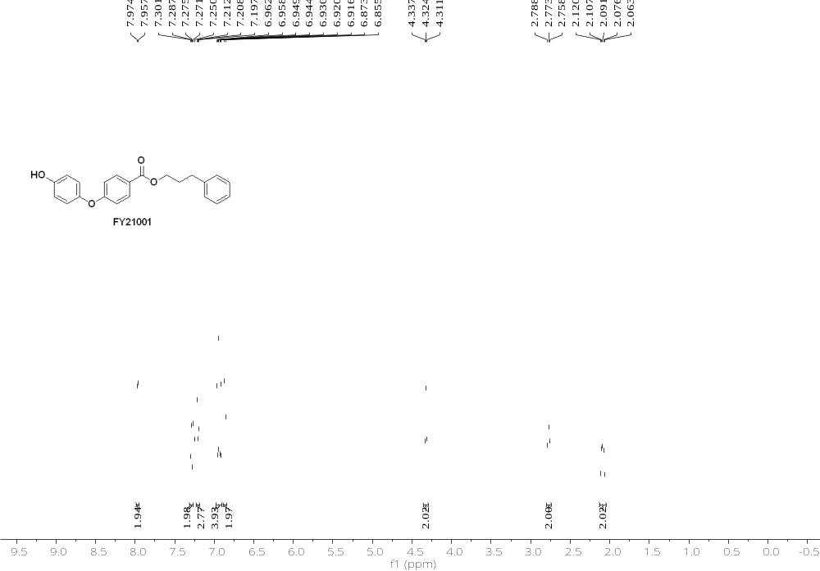

¹H NMR (500 MHz, DMSO-d₆) δ 9.47 (s, 1H), 7.90 – 7.84 (m, 2H), 7.27 – 7.22 (m, 2H), 7.21 – 7.17 (m, 2H), 7.17 – 7.13 (m, 1H), 6.95 – 6.88 (m, 4H), 6.81 – 6.76 (m, 2H), 4.18 (t, J = 6.5 Hz, 2H), 2.71 – 2.65 (m, 2H), 2.00 – 1.91 (m, 2H)。

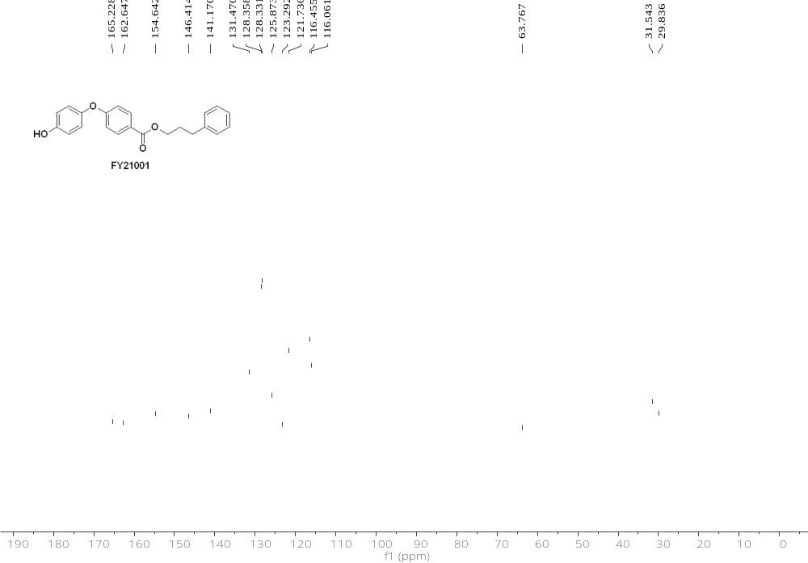
¹³C NMR (126 MHz, DMSO-D₆) δ 165.23, 162.65, 154.64, 146.41, 141.17, 131.47, 128.36, 128.33, 125.87, 123.29, 121.73, 116.46, 116.06, 63.77, 40.00, 39.83, 39.67, 39.50, 39.33, 39.17, 39.00, 31.54, 29.84.

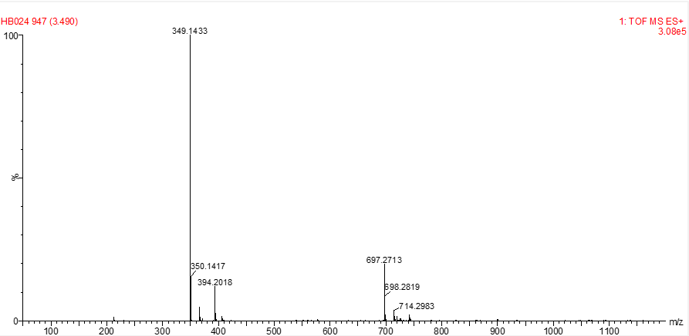
ESI-HRMS: m/z [M+H]⁺ calcd. for [C₂₂H₂₁O₄]: 349.1434. Found: 349.1433.

Extended Data Table 8. Primers used in this study.
Primer No. | Oligonucleotide sequence (5’-3’)
Primers used for MoERS1 gene sequencing
F1  R1  F2  R2 | ATGCGCACCCAGTTCTC  TCAGACCGACGGGAGCTGGG  ATGCGCACCCAGTTCTC  TCAAGCAGCACGCACAAAG
Primers used for MoERS1 gene deletion
MoERS1-p1 (F)  MoERS1-p2 (R) | GTGTGCGTACGACAATGCTTG  CAGCAAAATGTTATGTCAGGCgatatcTTTGACTAAAGTTTTCGGTGC
MoERS1-p3 (F) | GCACCGAAAACTTTAGTCAAAgatatcGCCTGACATAACATTTTGCTG
MoERS1-p4 (R) | CACCGTTCGTCCTACGGTAAG
MoERS1-p5 (F) | GAGGCTACCGAATTCATATTC
MoERS1-p6 (R) | CAGTACGAGATCCGTCTTCTG
MoERS1-p7 (F)  MoERS1-p8 (R) | ACTCACTATAGGGCGAATTGGGTACTCAAATTGGTTCATATAGGTAGACATATCT  TGG  CACCACCCCGGTGAACAGCTCCTCGCCCTTGCTCACAGCAGCACGCACAAAGC  C
Constriction of fluorescent vectors of MoERS1
MoErs1-RFP (F1)  MoErs1-RFP (R1)  MoErs1-RFP (F2)  MoErs1-RFP (R2) | ACTCACTATAGGGCGAATTGGGTACTCAAATTGGTTCATATAGGTAGACATATCT  TGG  GTCCTCGGAGGAGGCCATGACCGACGGGAGCTGGGTG  CACCCAGCTCCCGTCGGTCATGGCCTCCTCCGAGGAC  CACCACCCCGGTGAACAGCTCCTCGCCCTTGCTCACGGCGCCGGTGGAGTGG
MoErs1-RFP-NLS(F1) | ACTCACTATAGGGCGAATTGGGTACTCAAATTGGTTCATATAGGTAGACATATCT  TGG
MoErs1-RFP-NLS (F2) | GTCCTCGGAGGAGGCCATGACCGACGGGAGCTGGGTG
MoErs1-RFP-NLS (R1)  MoErs1-RFP-NLS (R2) | CACCCAGCTCCCGTCGGTCATGGCCTCCTCCGAGGAC  CACCACCCCGGTGAACAGCTCCTCGCCCTTGCTCACttaaacctttctcttcttcttaggaacctttctcttcttcttaggaacctttctcttcttcttaggGGCGCCGGTGGAGTGG
Primers used for HPH gene cloning
FL1111 | GGAGGTCAACACATCAATG
FL1112 | CTCTATTCCTTTGCCCTCG
Primers used for qRT-PCR
Q- MoErs1-F | ACGATCACTTCTTCGCCAAC
Q- MoErs1-R | AAGCCCCTGAACTCTCCATT
Q-Os07g03710(OsPR1)-F  Q-Os07g03710(OsPR1)-R  Q-Os12g36880(OsPBZ1)-F  Q-Os12g36880(OsPBZ1)-R  Q-Os03g12500(AOS2)-F  Q-Os03g12500(AOS2)-R  Q-Os02g10120(OsLOX1)-F  Q-Os03g10120(OsLOX1)-R  Q-Os01g53294(OsRBOHA)-F  Q-Os01g53294(OsRBOHA)-R  Q-Os01g25820(OsRBOHB)-F  Q-Os01g25820(OsRBOHB)-R | TCTTCATCACCTGCAACTACTC  ATTCATCGGATTTATTCTCACC  CTACTATGGCATGCTCAAGAT  ATAGAAAGGCACATAAACACAA  CAATACGTGTACTGGTCGAATGG  AAGGTGTCGTACCGGAGGAA  GCATCCCCAACAGCACATC  AATAAAGATTTGGGAGTGACATATTGG  TGGGATAATGGCTGGGTTGT  TGCAGCCCTTGTATTCCTCA  GGTTCCGACGTAACAAGCTC  AACAGGAACAGCGAGGTACA
Q-Os03g08020(OsACTIN)-F | GCGTGGACAAAGTTTTCAACCG
Q-Os03g08020(OsACTIN)-R | TCTGGTACCCTCATCAGGCATC
Primers used for detecting the relative fungal growth in rice
28S rDNA-F  28S rDNA-R  Rubq1-F  Rubq1-R | TACGAGAGGAACCGCTCATTCAGATAATTA  TCAGCAGATCGTAACGATAAAGCTACTC  GTGGTGGCCAGTAAGTCCTC  GGACACAATGATTAGGGATCA
Construction of expression vectors for protein crystallization
pET15b- MoErs1-F | aaaacctctacttccaatcgATGCCCTCCACGCTCGAGGC
pET15b- MoErs1-R | ccacactcatcctccggTCAAGCAGCACGCACAAAGC
pET15b- MoErs1^{E191M}-F | cgaccagtacatgatccgtcttctgaagagcg
pET15b- MoErs1 ^{E191M}-R | ggatcatgtactggtcgaacggctcac
pET15b- MoErs1^{E112M}-F | GGCGAAatGGGACTCCGCACCCGCACGCACGGCGACTGGAGA
pET15b- MoErs1^{E112M}-R | GCGTGCGGGTGCGGAGTCCCATTTCGCCGCCGTCGGGGAAGC
Primers used for yeast two hybrid
BD- MoErs1-F | GGAATTCCATATGATGCCCTCCACGCTCGAGGC
BD- MoErs1-R | CGGGATCCTCAAGCAGCACGCACAAAGC
AD-mRD21-F  AD-mRD21-R  AD-Os04g57490-F  AD-Os04g57490-R  AD-Os05g43230-F  AD-Os05g43230-R  AD-Os09g39070-F  AD-Os09g39070-R  AD-Os09g39060-F  AD-Os09g39060-R  AD-Os09g39140-F  AD-Os09g39140-R  AD-Os11g14900-F  AD-Os11g14900-R  AD-Os08g44270-F  AD-Os08g44270-R  AD-Os05g24550-F  AD-Os05g24550-R  AD-Os09g32230-F  AD-Os09g32230-R  AD-Os04g12660-F  AD-Os04g12660-R  AD-Os04g13090-F  AD-Os04g13090-R  AD-Os12g17540-F  AD-Os12g17540-R  AD-Os04g13140-F  AD-Os04g13140-R  AD-Os03g54130-F  AD-Os03g54130-R  AD-Os09g38920-F  AD-Os09g38920-R  AD-Os01g24560-F  AD-Os01g24560-R  AD-Os01g22670-F  AD-Os01g22670-R  AD-Os01g11830-F  AD-Os01g11830-R  AD-Os01g24550-F  AD-Os01g24550-R  AD-Os01g22680-F  AD-Os01g22680-R  AD-Os09g39160-F  AD-Os09g39160-R  AD-Os01g24570-F  AD-Os01g24570-R  AD-Os01g04030-F  AD-Os01g04030-R  AD-Os01g11840-F  AD-Os01g11840-R  AD-Os01g67980-F  AD-Os01g67980-R  AD-Os01g42790-F  AD-Os01g42790-R  AD-Os01g73980-F  AD-Os01g73980-R  AD-Os02g27030-F  AD-Os02g27030-R  AD-Os02g48450-F  AD-Os02g48450-R  AD-Os04g01710-F  AD-Os04g01710-R  AD-Os04g24600-F  AD-Os04g24600-R  AD-Os05g01810-F  AD-Os05g01810-R  AD-Os07g29760-F  AD-Os07g29760-R  AD-Os09g21370-F  AD-Os09g21370-R  AD-Os09g39100-F  AD-Os09g39100-R  AD-Os11g23770-F  AD-Os11g23770-R  AD-Os09g39110-F  AD-Os09g39110-R  AD-Os09g27030-F  AD-Os09g27030-R  AD-Os01g24600-F  AD-Os01g24600-R  AD-Os11g12430-F  AD-Os11g12430-R  AD-Os09g39120-F  AD-Os09g39120-R  AD-Os06g38450-F  AD-Os06g38450-R  AD-Os09g39090-F  AD-Os09g39090-R  AD-Os01g42780-F  AD-Os01g42780-R  AD-Os07g01800-F  AD-Os07g01800-R | GGAATTCCATATGCTGCCGGAGTCCGTCGACTGG  CGGGATCCTGGGGGAGGTGGTGTTGGAGG  GTACCAGATTACGCTCATATGGCGCCGCCGGACATCATGT ATGCCCACCCGGGTGGAATTCTACTAGATCTTCCCTATTCAA  GTACCAGATTACGCTCATATGGGTAGCGGTGGTGGTGGCGTGG  ATGCCCACCCGGGTGGAATTCCTGATCCAACAGTTCCAACAA  GTACCAGATTACGCTCATATGCACGACGACGACGACGTGCCATTCA  ATGCCCACCCGGGTGGAATTCGTAGGAGTCGACAGCATCAACGACCATA  GTACCAGATTACGCTCATATGGCGTCGGCGCCTCAGCCGCATGT  ATGCCCACCCGGGTGGAATTCAATTCGATTAATTACCTCCTT  GTACCAGATTACGCTCATATGCATGACGTCCCAATTACG  ATGCCCACCCGGGTGGAATTCGGATTGCCACCCAGTATT  GTACCAGATTACGCTCATATGATCCCGTTCACGGAGAGCGACCTC  ATGCCCACCCGGGTGGAATTCCATCTCGTCTTTAACCACT  GTACCAGATTACGCTCATATGATGGAGTTCGGCGACAAGGAC  ATGCCCACCCGGGTGGAATTCGAGTTCGTCGTGGTGGCGG  GTACCAGATTACGCTCATATGGCAAAGCCAATCCCAAAT  ATGCCCACCCGGGTGGAATTCAACTATGGCCGTTCCGACTC  GTACCAGATTACGCTCATATGGATCTCATGCTGGACAGGTTC  ATGCCCACCCGGGTGGAATTCCATGACGGGGTAGCTCGG  GTACCAGATTACGCTCATATGGCTCGTGAGCTGAGCGATGAC  ATGCCCACCCGGGTGGAATTCTGCAGTAGGGTAGGAAGGCTC  GTACCAGATTACGCTCATATGGCTCGCGAGCAGAGCGACCACG  ATGCCCACCCGGGTGGAATTCCGCAGTTGGGTATGAAGG  GTACCAGATTACGCTCATATGGGCGCCATTGTCGCGGCGGC  ATGCCCACCCGGGTGGAATTCCTCAGTAGGGTAGGAAGGCTGCA  GTACCAGATTACGCTCATATGGCGCGCGACCTTGTCGAC  ATGCCCACCCGGGTGGAATTCCGCCGTCGGGTAGGAGGC  GTACCAGATTACGCTCATATGGCCCTTGGCCGCGAGCTCGC  ATGCCCACCCGGGTGGAATTCGACGGGGTAGGAGGCCATCTG  GTACCAGATTACGCTCATATGCGCCGCGTCACCGAGGGCGAACCG  ATGCCCACCCGGGTGGAATTCCATGAGCGGGAATGACGG  GTACCAGATTACGCTCATATGTACTACAACAACGGCAGC  ATGCCCACCCGGGTGGAATTCGACGGTGGGGTAGAATGGTGA  GTACCAGATTACGCTCATATGGCGGACGCCTACTACGACAA  ATGCCCACCCGGGTGGAATTCGACGGTGGGGTAGAACGGCG  GTACCAGATTACGCTCATATGGCGGACGCCTACGGCGGCGGC  ATGCCCACCCGGGTGGAATTCCACGGTGGGGTAGAAGGGC  GTACCAGATTACGCTCATATGGCGGCGAACCCTCAGCCGCCGC  ATGCCCACCCGGGTGGAATTCAACCGTGGGGTAGAATGGGGA  GTACCAGATTACGCTCATATGAACCCGCCGCCGCCGCCGCCGC  ATGCCCACCCGGGTGGAATTCGGCCGTCGGGTAGAAGGG  GTACCAGATTACGCTCATATGGCGGTGGTGAAGGCAGAC  ATGCCCACCCGGGTGGAATTCCGCCGCTTCTGCTGCTGC  GTACCAGATTACGCTCATATGGCAGCGAGCGCCTACTACAACAA  ATGCCCACCCGGGTGGAATTCCTCACCTTTCTACCCCACCGTC  GTACCAGATTACGCTCATATGTTCCACGTCCCCTCCGTCCAG  ATGCCCACCCGGGTGGAATTCAGATGTATAGGAGTCTGGCAG  GTACCAGATTACGCTCATATGAACCCGTCGCCGTCGCCGCCGCC  ATGCCCACCCGGGTGGAATTCGGCCGTCGGGTAGAAGGGCGAG  GTACCAGATTACGCTCATATGATACCGTTCGACGAGAGGGATTTG  ATGCCCACCCGGGTGGAATTCCCCTTGGCGCCAAGGAAACCCAG  GTACCAGATTACGCTCATATGGCTCCAGCTCCGGAGGACGACC  ATGCCCACCCGGGTGGAATTCGACGAAGGGGTAGGCGGGGC  GTACCAGATTACGCTCATATGATGCCCAGTGAATTGTCCATAG  ATGCCCACCCGGGTGGAATTCAGCGTTCTTGGTTGGGTAGGAGGCC  GTACCAGATTACGCTCATATGTCAGTCCCCGGCGAGGAGGAG  ATGCCCACCCGGGTGGAATTCCTCCTTTGAGGTGTGGATGGC  GTACCAGATTACGCTCATATGGCTAGTCACCATGATCCTTCCG  ATGCCCACCCGGGTGGAATTCTGAACCCCAGCCAGTGACGTT  GTACCAGATTACGCTCATATGGACGATCTCACCGCCACCATGAC  ATGCCCACCCGGGTGGAATTCCCGAATGGTGGGAAAGGTCGGC  GTACCAGATTACGCTCATATGCTGTCGTCATCGGCGGCGGAG  ATGCCCACCCGGGTGGAATTCCTCCTCCTTTTTGGAGGTATGG  GTACCAGATTACGCTCATATGGCCGCCGGCCGCAGCGGCGGCGAG  ATGCCCACCCGGGTGGAATTCGTTGTCCTTGGTGGGGTAAGAGGC  GTACCAGATTACGCTCATATGGACGGCGACGCCGGCGTCATCC  ATGCCCACCCGGGTGGAATTCCGGCGGCGGCGGGGCGACAGC  GTACCAGATTACGCTCATATGGGCAGTTGCTTGGACGTCGGCGAC  ATGCCCACCCGGGTGGAATTCCAGGGTCAGGGTCGGGTAGGCG  GTACCAGATTACGCTCATATGCAGGACGTCGACCTGACGGTGAC  ATGCCCACCCGGGTGGAATTCGTAGGCAGCAACAGCAGCAGCAGC  GTACCAGATTACGCTCATATGAGCAGCTGCTTGGACGTCGGCGAC  ATGCCCACCCGGGTGGAATTCTTTTGAATATGTTGGGTCGTCGTGC  GTACCAGATTACGCTCATATGGTGGACGTGACGGTGAGGGACAG  ATGCCCACCCGGGTGGAATTCGTACGCAGCAACATCAGCATCATC  GTACCAGATTACGCTCATATGGCCGCGTCCTCCGGCTTCGACGAC  ATGCCCACCCGGGTGGAATTCTGCAACAATAGGGTAGGATGCGC  GTACCAGATTACGCTCATATGGCGGCGAACCCTCAGCCGCCGCCGC  ATGCCCACCCGGGTGGAATTCAACCGTGGGGTAGAATGGGGAGG  GTACCAGATTACGCTCATATGATGAAGGGTATTTTTGCAGG  ATGCCCACCCGGGTGGAATTCTACGGAAGAGAAAAGAGCTAAAAC  GTACCAGATTACGCTCATATGATGGCGGTGGCGGCCGTGCAGG  ATGCCCACCCGGGTGGAATTCGTATAAAGCAGCATCAGCAATAAC  GTACCAGATTACGCTCATATGATGGCTATCG CGTCGTCGTC  ATGCCCACCCGGGTGGAATTCGGCAACGGGGTAAGAGGGTTGC  GTACCAGATTACGCTCATATGATGGCGATGGCTGATGAGGA G  ATGCCCACCCGGGTGGAATTCGTAGGAGGCGATGATAGTGGGAG  GTACCAGATTACGCTCATATGATGGCACGGGTTCCCGTCTC  ATGCCCACCCGGGTGGAATTCGCTGTCCATGGTCGGGTAGAAG  GTACCAGATTACGCTCATATGATGGCAGCCTCGCTGCTGCT C  ATGCCCACCCGGGTGGAATTCGGCAGAGACGACAGGGTAG
Primers used for co-IP
pBIN-ProRD21-Flag-F1 | acgatagccggtacccccgggATGGCCGCCCGCGCCGCC
pBIN-ProRD21-Flag-R1  pBIN-ProRD21-Flag-F2  pBIN-ProRD21-Flag-R2 | CTTGTCATCGTCGTCCTTGTAATCTGGGGGAGGTGGTGTTGG  GATTACAAGGACGACGATGACAAGTCCGCCCCTGACCATGTC  gcccttgctcaccatcccgggTGCGGTGTTCAGCTTAGCG
pBIN-MoErs1-GFP-F | TCCCCCGGGATGCCCTCCACGCTCGAGGC
pBIN-MoErs1-GFP-R | ACGCGTCGACAGCAGCACGCACAAAGCC
Primers used for BiFC
pICH86988-MoErs1-cYFP-F  pICH86988-MoErs1-cYFP-1  pICH86988-MoErs1-cYFP-2  pICH86988-MoErs1-cYFP-R  pICH86988-OsRD21-nYFP-F  pICH86988-OsRD21-nYFP-1  pICH86988-OsRD21-nYFP-2  pICH86988-OsRD21-nYFP-3  pICH86988-OsRD21-nYFP-4  pICH86988-OsRD21-nYFP-R | TTACAATTATCGATACAATGATGCCCTCCACGCTCGAGGC  CGTTCTTCTGCTTGTCGGCAGCAGCACGCACAAAGCCC  GGGCTTTGTGCGTGCTGCTGCCGACAAGCAGAAGAACG  CTCATTAAAGCAGGACAAGCTTACTTGTACAGCTCGTCCATG  TTACAATTATCGATACAATGATGGCCGCCCGCGCCGCC  CCTCGCCCTTGCTCACCATCTCCTCCACCCCG  CGGGGTGGAGGAGATGGTGAGCAAGGGCGAGG  CCAGTCGACGGACTCCGGCAGCATGATATAGACGTTGTG  CCACAACGTCTATATCATGCTGCCGGAGTCCGTCGACTGG  CTCATTAAAGCAGGACAAGCTCATGCGGTGTTCAGCTTAGCG
Primers used for expression of MoErs1 protein in vitro
pGEX-4T-2-MoErs1-F | CGGGATCCATGCCCTCCACGCTCGAGGC
pGEX-4T-2-MoErs1-R | ACGCGTCGACAGCAGCACGCACAAAGCC
Primers used for MoErs1 substitution
MoErs1^{L2}-F  MoErs1^{L2}-R  MoErs1^{L4}-F  MoErs1^{L4}-R  MoErs1^{L8}-F  MoErs1^{L8}-R  MoErs1^{β11}-F  MoErs1^{β11}-R | GACGCAACCGAGGCACCTGTCGCTGCCGCTGCC  GGCAGCGGCAGCGACAGGTGCCTCGGTTGCGTC  GAATCGCCGTCGCCGGAGATC  GATCTCCGGCGACGGCGATTC  CAACGGCACGGCACAGCCCGG  CCGGGCTGTGCCGTGCCGTTG  CTTCTCGGCAAAGGCAGCCAGCG  CGCTGGCTGCCTTTGCCGAGAAG
Primers used for transgenic rice plants construction
pCAM2300-ProRD21 (F1)  pCAM2300-ProRD21 (R1)  pCAM2300-ProRD21 (F2)  pCAM2300-ProRD21 (R2) | taggtagaagaggtacccgggATGGCCGCCCGCGCCGCC  CTTGTCATCGTCGTCCTTGTAATCTGGGGGAGGTGGTGTTGG  GATTACAAGGACGACGATGACAAGTCCGCCCCTGACCATGTC  atccttgtaatccatcccgggTCATGCGGTGTTCAGCTTAG
pCAM2300-MoErs1 (F)  pCAM2300-MoErs1 (R) | ACGCGTCGACATGCCCTCCACGCTCGAGGC  AACTGCAGAGCAGCACGCACAAAGCC

Key Resources Table
REAGENT OR RESOURCES SOURCE IDENTIFIER
Bacterial and fungal strains
Magnaporthe oryzae：Guy11  Bipolaris oryzae：Qujiang52 #  Xanthomonas oryzae：PXO99  E. coli strain DH5a  E. coli strain BL21  A. tumefaciens strain GV3101  S. cerevisiae strain AH109 | This paper N/A  This paper N/A  This paper N/A  KT Health Cat#KTSM101L  KT Health Cat#KTSM104L  Weidi Biotechnology Cat#AC1001  Weidi Biotechnology Cat#YC1010
Biological Samples
Rice varieties: CO39  Rice varieties: TP309  Rice varieties: LTH  Rice varieties: LTH-Pia  Rice varieties: LTH-Pizt | This paper N/A  This paper N/A  This paper N/A  This paper N/A  This paper N/A
Recombinant DNA Plasmids
pMD:MoERS1  pYF11:MoERS1-RFP  pYF11:MoERS1-RFP-NLS  pBIN:GFP-Flag  pBIN:Slp1-Flag  pBIN:OsRD21-Flag  pBIN:OsRD21-GFP  pBIN:MoERS1-GFP  pBIN:Remorin-RFP  pBIN:SP-RFP-HDEL  pICH86988:OsRD21-nYFP  pICH86988:OsRD21-cYFP  pGBKT7:MoErs1  pGADT7:PLCPs  pGEX4T-2:OsRD21:HIS  pET32a:MoErs1:GST | This paper N/A  This paper N/A  This paper N/A  This paper N/A  This paper N/A  This paper N/A  This paper N/A  This paper N/A  This paper N/A  This paper N/A  This paper N/A  This paper N/A  This paper N/A  This paper N/A  This paper N/A  This paper N/A
Critical Commercial Assays
3,3’-diaminobenzidine (DAB) Sigma-Aldrich CAS: 91-95-2
Luminol Sigma-Aldrich CAS: 521-31-3
Peroxidase from horseradish Sigma-Aldrich CAS: 9003-99-0
Clarity Western ECL Substrate Bio-Rad Cat#1705060
Monolith Protein Labeling Kit RED-NHS 2nd Generation NanoTemper Technologies Cat#MO-L011
Macerozyme R-10 Yakult Pharmaceutical CAS: 9032-75-1
Cellulase R-10 Yakult Pharmaceutical CAS: 9012-54-8
DO Supplement -Leu/-Trp Clontech Cat#630417
DO Supplement -His/-Leu/-Trp Clontech Cat#630419
DO Supplement -His/-Leu/-Trp/-Ade Clontech Cat#630428
HiScript II Q Select RT Super Mix Vazyme R232-01
HiScript II One Step qRT-PCR SYBR Green Kit Vazyme R221-01
Antibodies
Anti-Flag Antibody  Anti-GFP Antibody  Anti-GST Antibody  Anti-RFP Antibody  Streptavidin-HRP Antibody | Engibody AT0022  Abmart M20004  Abmart M20007L  Abbkine A02120  Abcam ab7403
Oligonucleotides
Primers see Table S7 | This paper N/A
Acronyms
Hygromycin B phosphotransfer (HPH)
Effector Regulated by MoSyn8 (MoErs1)
Papain-like cysteine protease (PLCP)
Water-soluble chlorophyll protein (WSCP)
Pathogen-associated molecular pattern (PAMP) Triggered immunity (PTI)
Effector-triggered immunity (ETI)
N starvation minimal medium (MM-N)
Hours post-inoculation (hpi)
Reactive oxygen species (ROS)
Biotrophic interfacial complex (BIC)
Extra-invasive hyphal membrane (EIHM)
Single-nucleotide polymorphism (SNP)
Disease lesion area (DLA)

