Supplementary Material

Environmental impact assessment and normalization of different expressway sub-projects during construction

Yimiao Huang¹, Xiaokuan Zhao¹, Ruochen Zhang^{1*}, Panpan Xie¹, Guixiang Xue², Guowei Ma¹

1 School of Civil and Transportation Engineering, Hebei University of Technology, Tianjin, 300401, China
2 School of Artificial Intelligence, Hebei University of Technology, Tianjin, 300401, China

*Corresponding author e-mail: zhrch1027@163.com (Ruochen Zhang)

Supporting Information

Summary

Number of Pages: Page S1–Page S9

Number of Texts: Text S1
Number of Tables: Table S1-Table S6
Number of Figures: Figure S1-Figure S3

Text S1 | Calculation of gas pollutants concentration
Table S1 | Inventory of materials and energy consumption during expressway construction
Table S2 | Solar radiation in modified Pasquill stability categories
Table S3 | Atmospheric stability in modified Pasquill stability categories
Table S4 | Stability parameter of Birgis City diffusion model
Table S5 | Air pollutants concentration change from April to September
Table S6 | Air pollutants concentration change from October to March
Figure S1 | Scope and boundary of whole-life cycle environmental impact assessment of expressway construction
Figure S2 | General framework for evaluating the environmental price of pollutants
Figure S3 | Environmental sensitivity of different materials in various sub-projects

Text S1 Calculation of gas pollutants concentration
In this study, the Gaussian ground continuous point source diffusion model is used to calculate the concentration of gas pollutants. There are four assumptions: (1) the concentration of pollutants is distributed in a normal distribution in the Y and Z wind direction; (2) the entire diffusion space and wind speed is uniform and unchanged; (3) Source strength is continuous and uniform; (4) The pollutants is mass conservation during diffusion. Diffusion coefficient of the model is related to the atmospheric turbulence structure, height above ground, ground roughness wind speed and distance from the equivalent source. It is determined according to the modified Pasquill stability categories recommended by existing regulations (including two parts: solar radiation (Table S2), atmospheric stability (Table S3)) and the parameters in Briggs urban diffusion model (Table S4).
The construction time, location, wind direction, wind speed and sunshine time of the project can be queried from the design description, the Shandong statistical yearbook and the Environmental Monitoring Bureau. The model selects the average wind direction from April to September and October to March as the wind direction axis. X is the distance to the farthest city in the wind direction. Y and z are both 0. The pollutant concentration change from April to September and October to March are shown in Tables S5 and S6, respectively.

Table S1 Inventory of materials and energy consumption during expressway construction

 | Unit | Subgrade | Roadway | Bridges and culverts | Tunnel | SMEP | GEPF
Material
cement | t | 462.28 | 652.52 | 7633.92 | 8853.58 | 31.02 | 31.33
gravel | t | 20771.13 | 17680.95 | 35733.14 | 22742.17 | 98.24 | 102.73
asphalt | t | 0.96 | 251.63 | 130.16 | 1.39
steel | kg | 13286.06 | 2748.44 | 2550070.60 | 1574157.69 | 65288.53 | 20229.86
iron | kg | 34321.55 | 145.25 | 21881.94 | 15695.63 | 60509.15 | 388.33
sand | t | 1962.63 | 499.62 | 12803.32 | 15713.28 | 59.30 | 59.44
brick | kg | 2910.93
wood | m³ | 1.70 | 5.37 | 55.22 | 60.18 | 0.31 | 0.05
fly ash | kg | 30890.07
welding rod | kg | 2.18 | 0.95 | 9771.55 | 5240.44 | 341.88 | 22.93
concrete | m³ | 4.77
explosive | kg | 17562.10 |  | 253.51 | 37954.08
plastic | kg | 666.76 | 1615.14 | 41005.60 | 19567.72 | 1227.28 | 5.70
breeze | t |  | 212.96 | 131.18
rubber | kg |  |  | 35.22 | 27854.98
putty powder | t |  |  | 7.98
Transportation
cement | tkm | 55473.45 | 78302.45 | 916069.95 | 1062429.96 | 3722.48 | 3759.77
gravel | tkm | 415422.52 | 353618.94 | 714662.86 | 454843.43 | 1964.81 | 2054.52
asphalt | tkm | 95.60 | 25163.02 | 13016.09 | 139.11
steel | tkm | 5314.42 | 1099.38 | 1020028.24 | 629663.07 | 26115.41 | 8091.94
iron | tkm | 13728.62 | 58.10 | 8752.78 | 6278.25 | 24203.66 | 155.33
sand | tkm | 39252.64 | 9992.36 | 256066.33 | 314265.57 | 1185.96 | 1188.80
brick | tkm | 291.09
wood | tkm | 136.21 | 322.08 | 3313.22 | 4814.78 | 25.18 | 3.93
fly ash | tkm | 3706.81
welding rod | tkm | 0.22 | 0.10 | 977.15 | 524.04 | 34.19 | 2.29
concrete | tkm | 447.98
explosive | tkm | 1756.21 |  | 25.35 | 3795.41
plastic | tkm | 66.68 | 161.51 | 4100.56 | 1956.77 | 122.73 | 0.55
breeze | tkm |  | 4259.20 | 2623.57
rubber | tkm |  |  | 3521.70 | 2785.50
putty powder | tkm |  |  | 798
Onsite construction
petrol | kg | 1495.90 | 128.99 | 202.16 | 14955.39 | 899.56 | 495.12
diesel | kg | 103907.51 | 12005.55 | 65858.79 | 66981.98 | 69.31 | 9.42
electricity | kW·h | 8228.05 | 17919.43 | 685862.26 | 1075968.85 | 4378.58 | 686.25
mazut | kg |  | 35543.56 | 25890.96
coal | kg |  | 10.31 |  | 283.55

Table S2 Solar radiation in modified Pasquill stability categories

Cloud volume, 1/10 | Solar radiation level
Total cloud volume/low cloud volume | night | h₀≤15° | 15＜h₀≤35° | 35＜h₀≤65° | h₀＞65°
≤4/≤4 | -2 | -1 | 1 | 2 | 3
5-7/≤4 | -1 | 0 | 1 | 2 | 3
≥8/≤4 | -1 | 0 | 0 | 1 | 1
≥5/≤5-7 | 0 | 0 | 0 | 0 | 1
≥8/≥8 | 0 | 0 | 0 | 0 | 0

Table S3 Atmospheric stability in modified Pasquill stability categories

Ground wind speed, m/s | Sun radiation level
Ground wind speed, m/s | 3 | 2 | 1 | 0 | 1 | 2
≤1.9 | A | A-B | B | D | E | F
2-2.9 | A-B | B | C | D | E | F
3-4.9 | B | B-C | C | D | D | E
5-5.9 | C | C-D | D | D | D | D
≥6 | D | D | D | D | D | D

Table S4 Stability parameter of Birgis urban diffusion model

stability | $$σ_{y}$$ | $$σ_{z}$$
A-B | 0.32x(1+0.0004x)^{-1/2} | 0.24x(1+0.0001x) ^{-1/2}
C | 0.22x(1+0.0004x)^{-1/2} | 0.20x
D | 0.16x(1+0.0004x)^{-1/2} | 0.14x(1+0.0003x) ^{-1/2}
E-F | 0.11x(1+0.0004x)^{-1/2} | 0.08x(1+0.0015x) ^{-1/2}

Table S5 Air pollutants concentration from April to September

Atmospheric stability | A-B | C | D | E-F
duration（h） | 902.36 | 328.13 | 246.10 | 2903.41
$$σ_{y}$$ | 6807.69 | 4680.28 | 3403.84 | 2340.14
$$σ_{z}$$ | 10011.68 | 36700 | 3431.44 | 883.23
Concentration when Q* = 1kg/ year（ug/m³） | 5.92*10⁻⁸ | 2.35*10⁻⁸ | 3.46*10⁻⁷ | 1.95*10⁻⁶
*Q is the equivalent source strength.

Table S6 Air pollutants concentration from October to March

Atmospheric stability | A-B | C | D | E-F
duration（h） | 626.64 | 227.87 | 170.9 | 3354.59
$$σ_{y}$$ | 7046.02 | 4844.14 | 3523.01 | 2422.07
$$σ_{z}$$ | 10375.23 | 39280 | 3552.09 | 913.86
Concentration when Q* = 1kg/ year（ug/m³） | 5.52*10⁻⁸ | 2.12*10⁻⁸ | 3.23*10⁻⁷ | 1.82*10⁻⁶
*Q is the equivalent source strength.

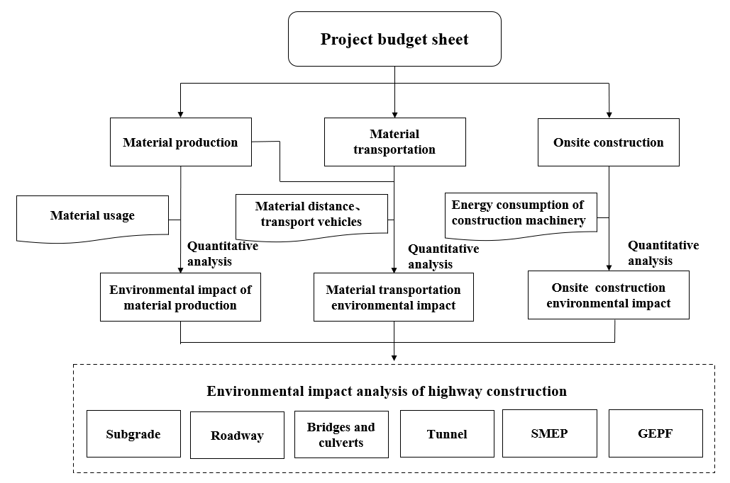
Figure S1 Scope and boundary of whole-life cycle environmental impact assessment of expressway construction

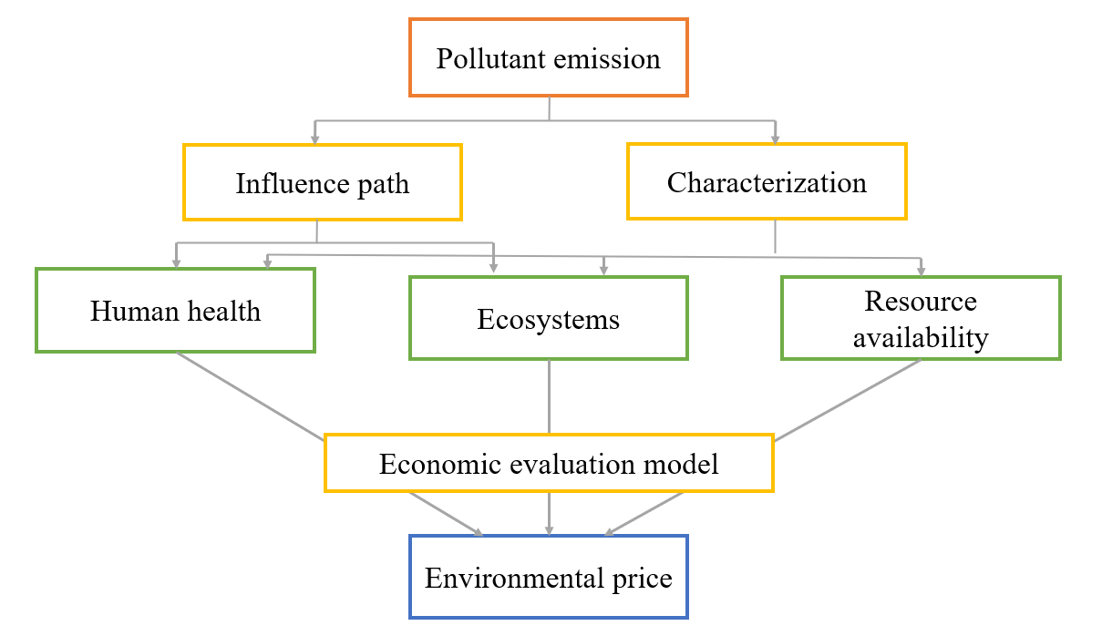
Figure S2 General framework for evaluating the environmental price of pollutants

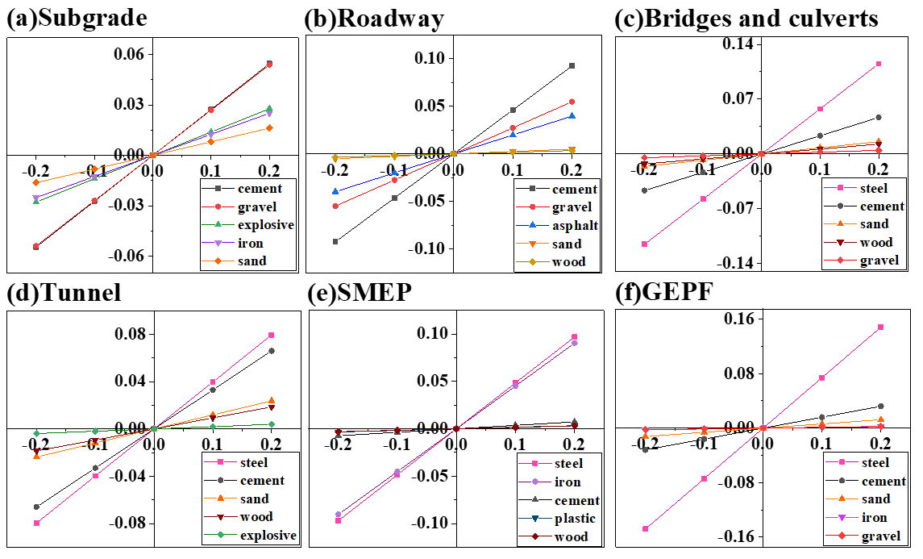
Figure S3 Environmental sensitivity of different materials in various sub-projects

