Supplementary Materials

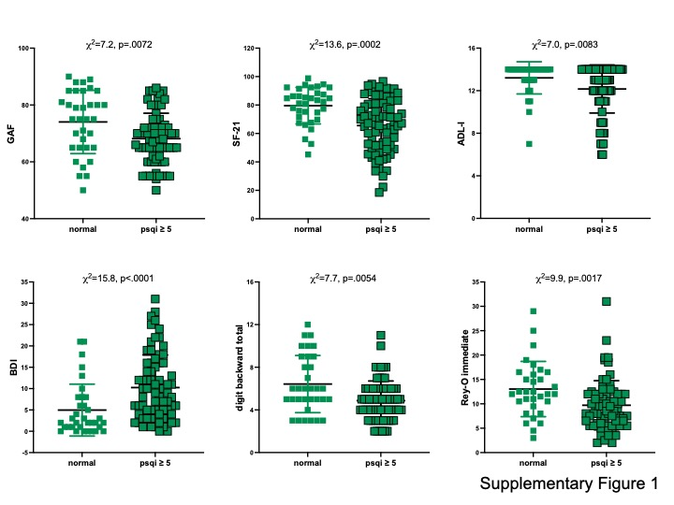
Figure S1. Variables different between PLWH with PSQI>5 relative to PLWH with scores below cutoff. GAF = Global Assessment of Functioning, SF-21 = Medical Outcomes Study (MOS), 21-item, short form, ADL-I = Activities of Daily Living – Instrumental, BDI = Beck Depression Index.

