Supplementary Figures

Figure S1: Graphical Depcition of Cross Validation

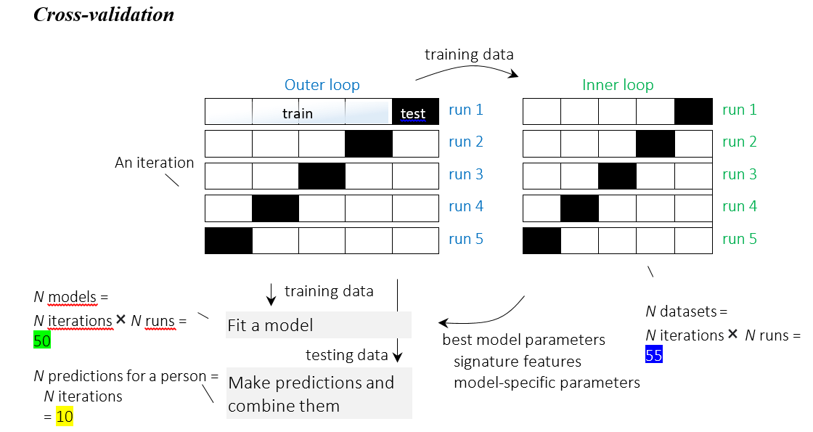

Figure S2: Calibration Curves
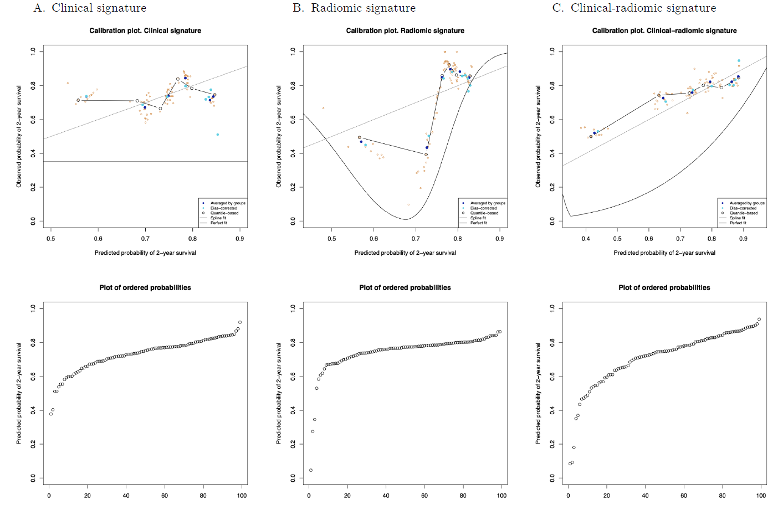

Figure S3: Nomogram for CT mean intensity calculated on the complete dataset for 24 month freedom from biochemical failure (FFBF).
