Appendices

Appendix A
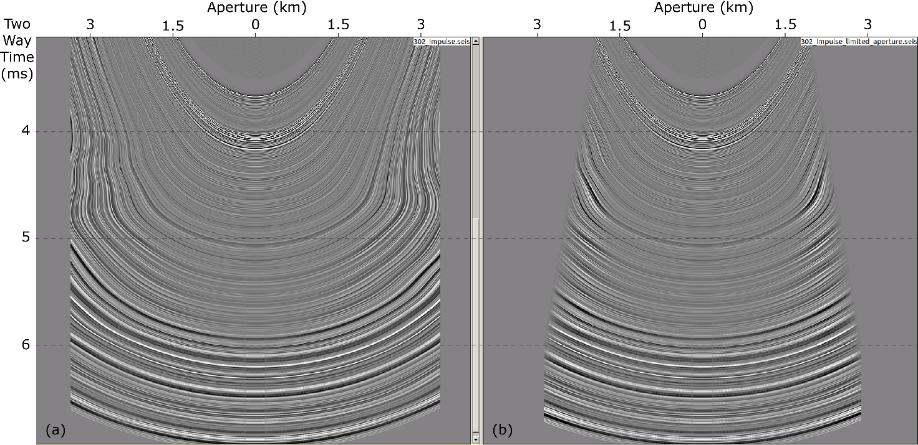
Figure 1 Impulse response of the Kirchhoff Pre-Stack time migration in the deep Algerian basin, without (a) and with an angle aperture (b)

Appendix B
Table 1 List of the parameters used for the Kirchhoff pre-stack depth migration
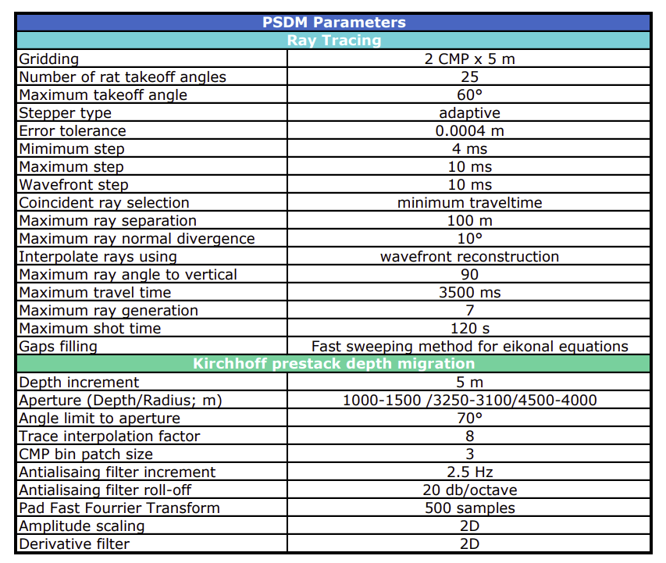

Appendix C
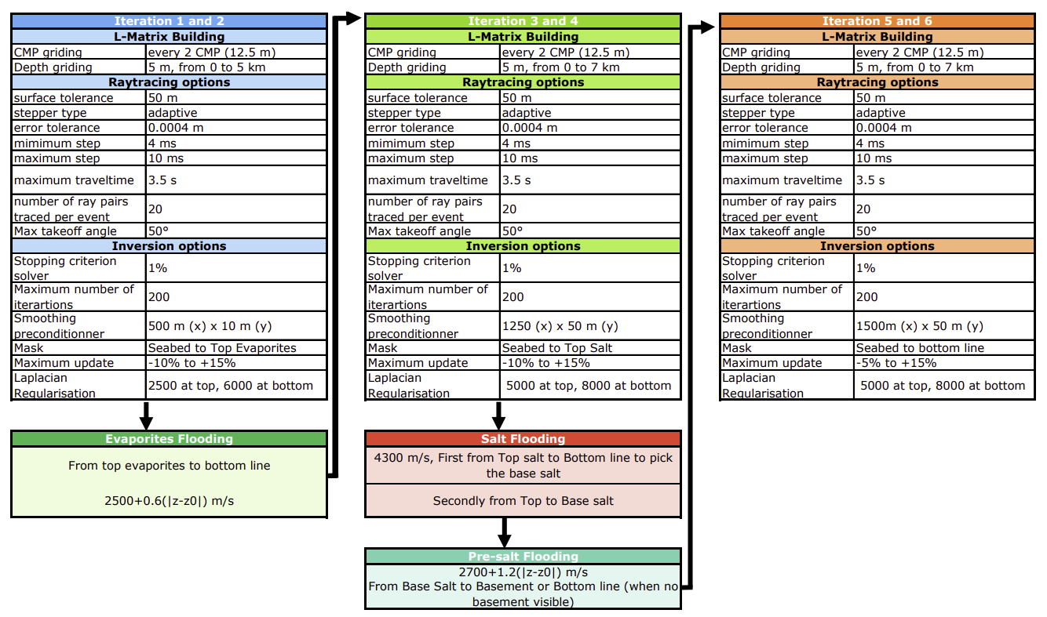
Figure 2 Depth imaging flow and list of the parameters used for the different tomographic inversion and velocity updates during the velocity model building

