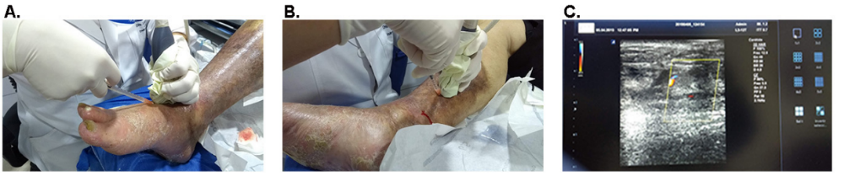
Supplementary figure 1. Delivery route of the treatments. Representative image of auto-BM-MNC, allo-WJ-MSCs or placebo solution administration into the periadventitial layer of the arterial walls under eco-Doppler guidance at day 0.

