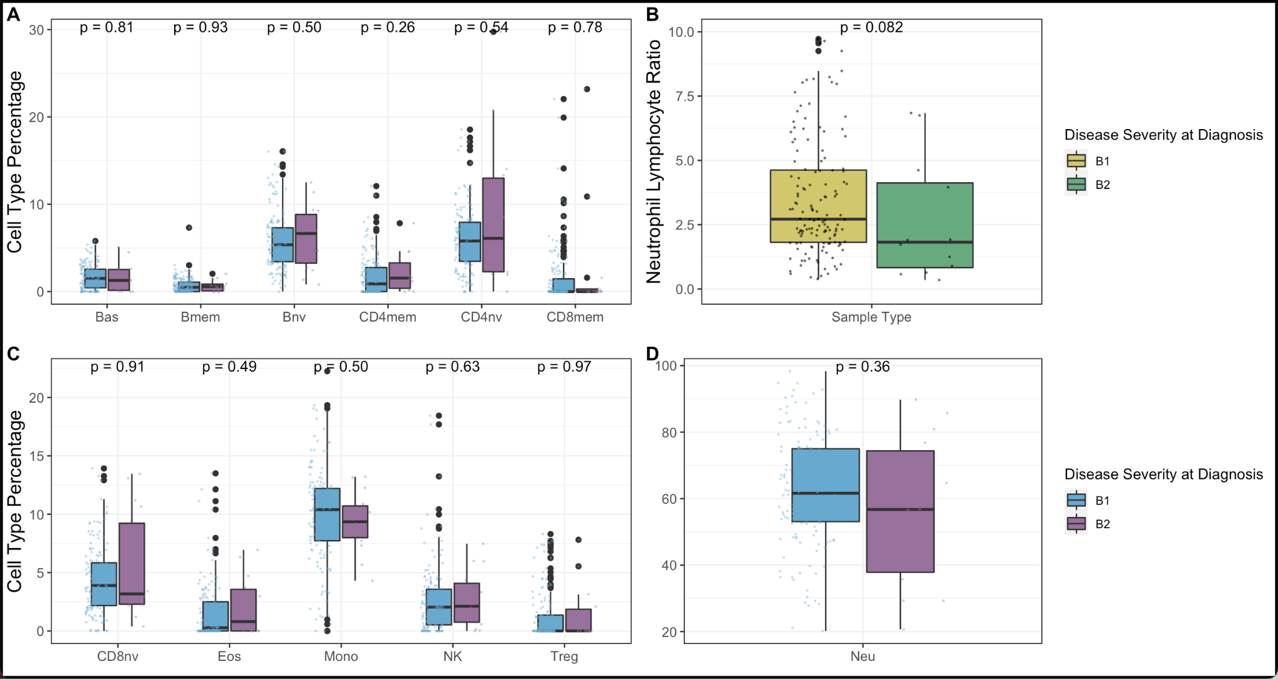
Supplementary Figure 1. Cell Type Proportions in Crohn’s Patients at Diagnosis did not differ by disease stage. Panels A, C, and D compare cell type proportions between diagnosis and control. Panel D compares neutrophil to lymphocyte ratios. No significant difference was observed between immune cell type proportions in Crohn’s patients with stage one and stage two at diagnosis.

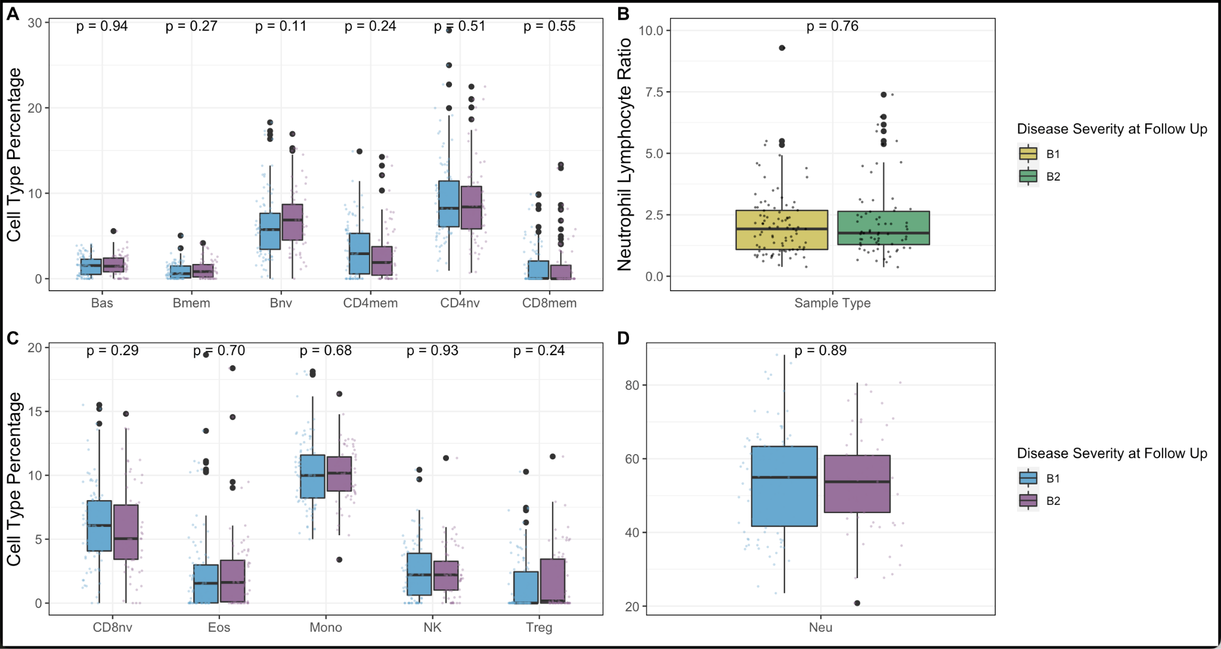Supplementary Figure 2. Cell Type Proportions in Crohn’s Patients at Follow-Up. Panels A, C, and D compare cell type proportions between diagnosis and control. Panel D compares neutrophil to lymphocyte ratios. No significant difference was observed between immune cell type proportions in Crohn’s patients with B1 and B2 phenotypes at follow-up.

