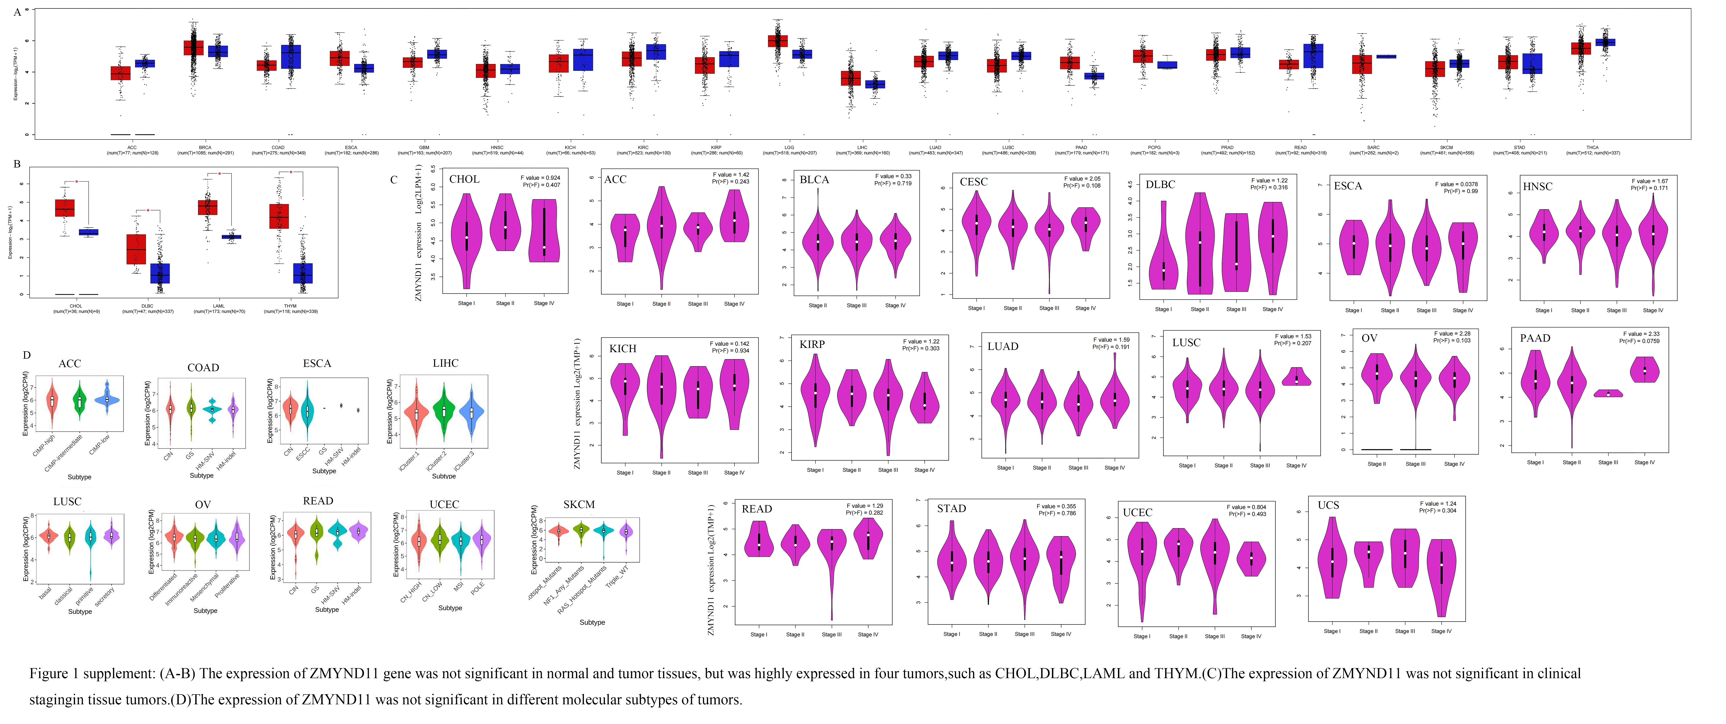
Figure 1 supplement: Expression of ZMYND11 in tumour tissue and normal tissue in other tumours. (a-b) The expression of ZMYND11 gene was not significant in normal and tumor tissues (*p-value>0.05) but was highly expressed in four tumors, such as CHOL, DLBC, LAML, and THYM(*p-value<0.05). (c)The expression of ZMYND11 was not significant in clinical staging in tissue tumors(*p-value>0.05). (d)The expression of ZMYND11 was not significant in different molecular subtypes of tumors(*p-value>0.05).

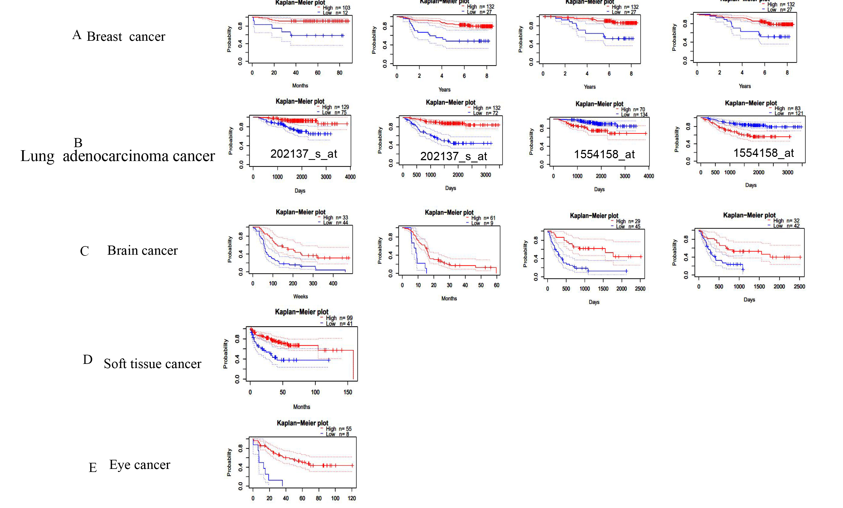
Figure 2 supplement. The prognostic value of the ZMYND11 gene in PrognoScan. (a) We used the PrognoScan tool to perform Distant Metastasis Free Survival，Relapse Free Surviva，Disease Specific Survival，Overall Survival in breast cancer (b) Overall Survival,Relapse Free Survival,Overall Survival Relapse Free Survival, lung adenocarcinoma cancer.(c)Overall Survival in GSE4271-GPL96, GSE7696, GSE4412-GPL96, GSE4412-GPL96 Brain cancer (d) Distant Recurrence Free Survival in Soft tissue cancer(e)Distant Mrvietastasis Free Suval in Eye cancer by ZMYND11 gene expression. The survival map and Kaplan-Meier curves with positive results are given(*p-value<0.05).

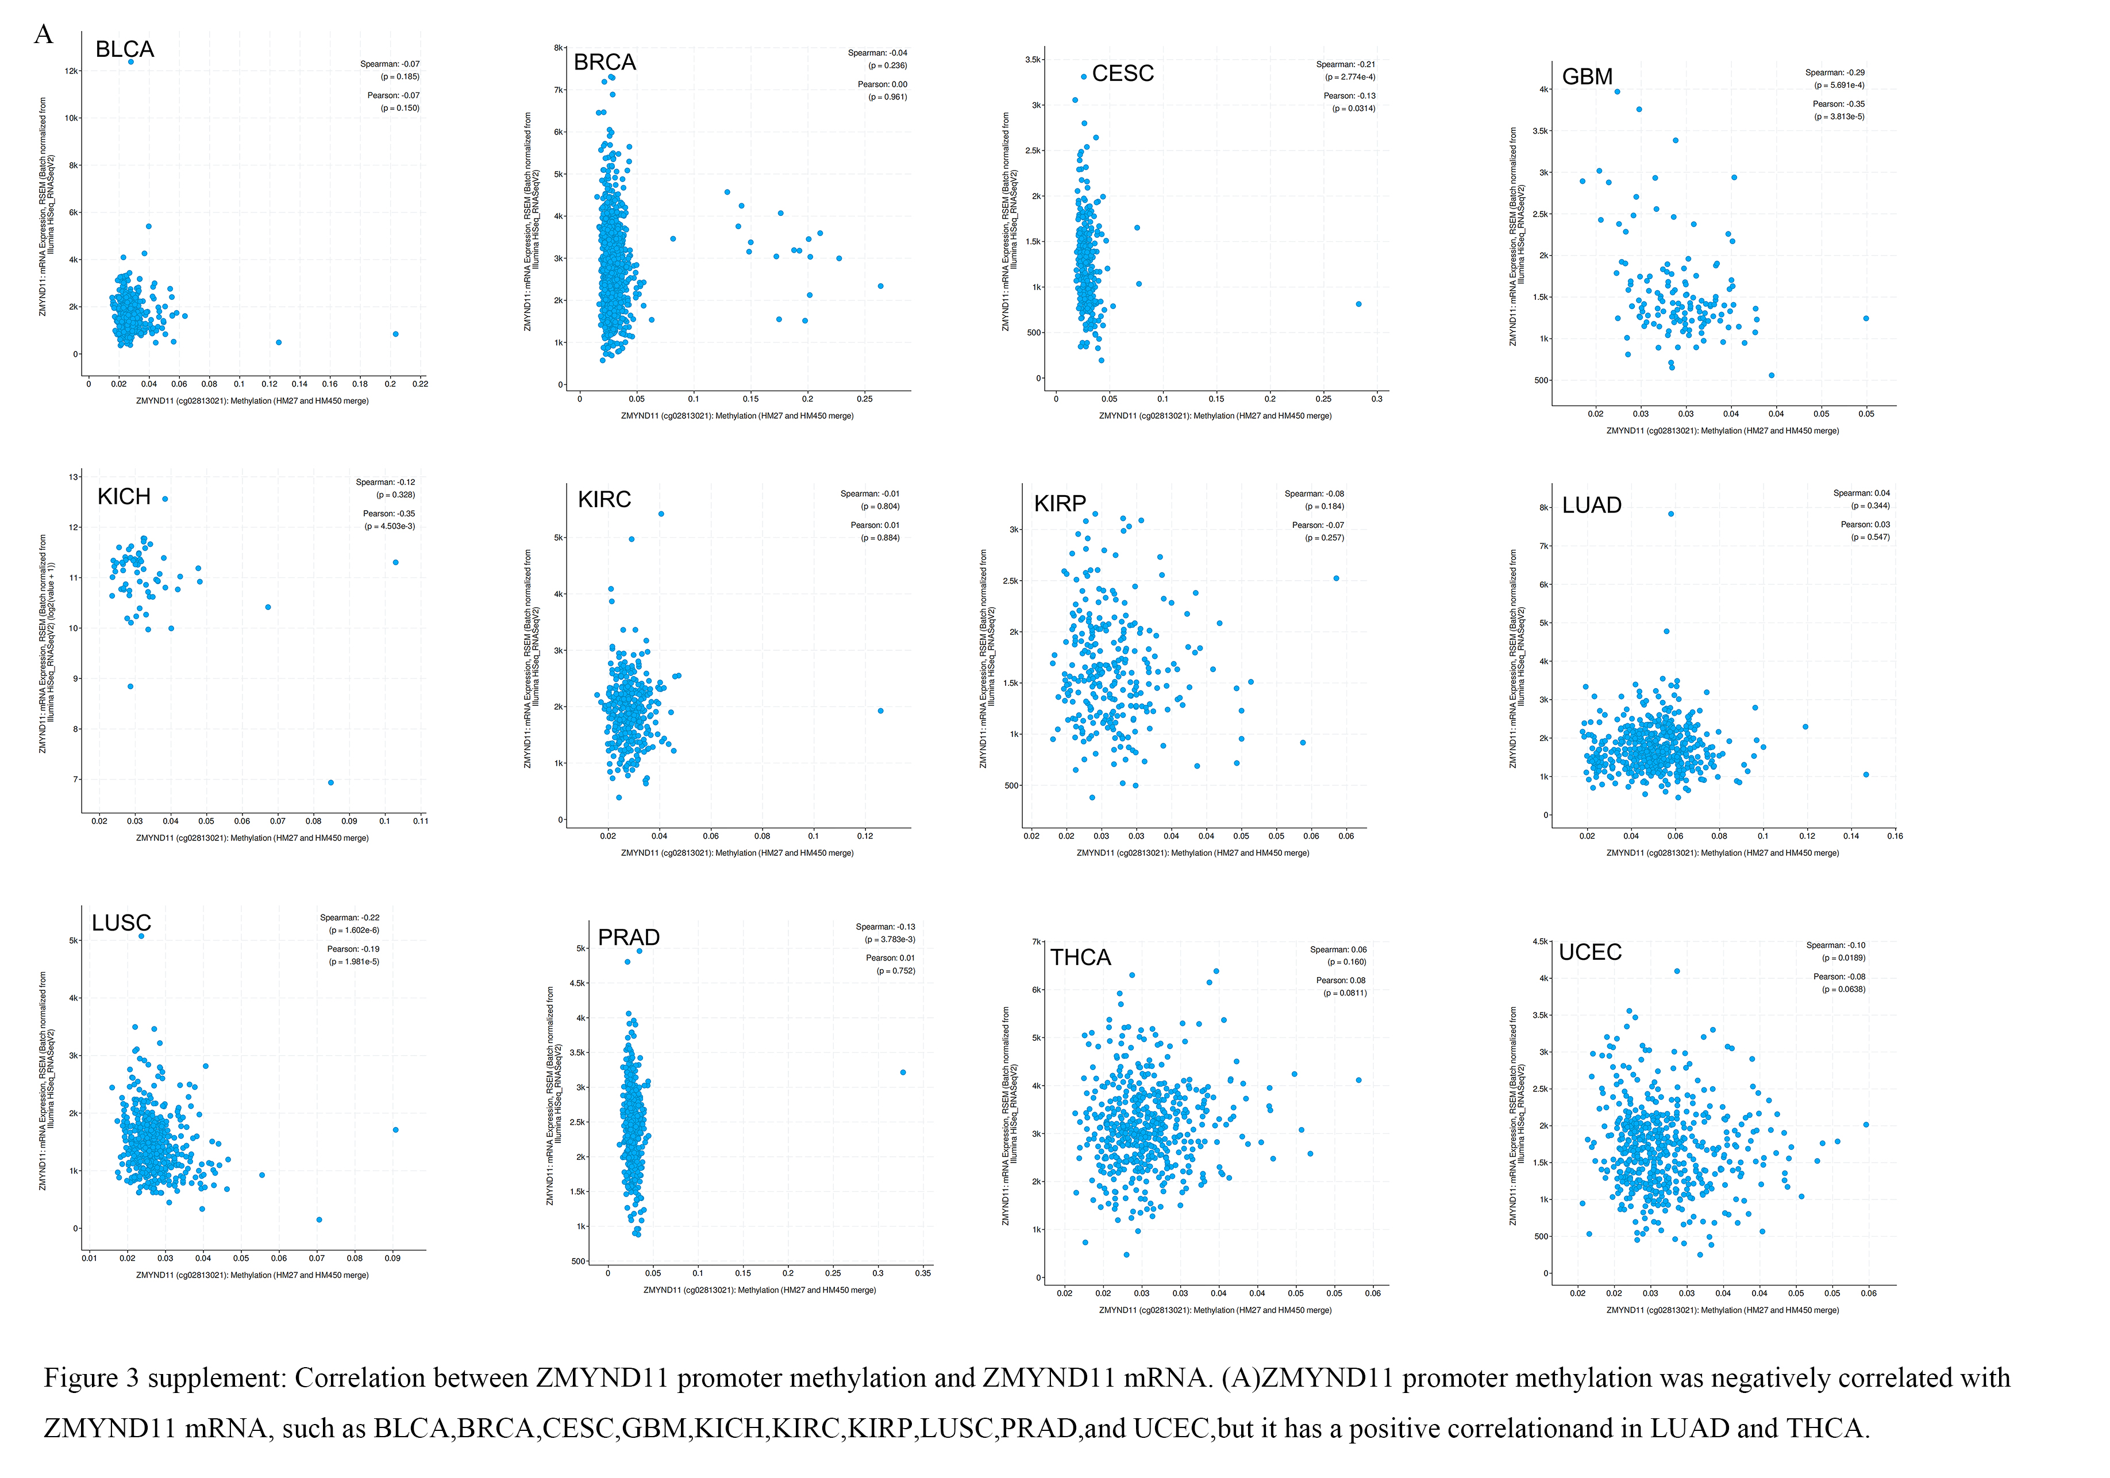
Figure 3 supplement. Correlation between ZMYND11 promoter methylation and ZMYND11 mRNA. (a)ZMYND11 promoter methylation was negatively correlated with ZMYND11 mRNAs, such as BLCA, BRCA, CESC,GBM, KICH, KIRC, KIRP, LUAD, LUSC, PRAD, THCA and UCEC.The weak positively correlation LUAD and THCA was not statistically significant.

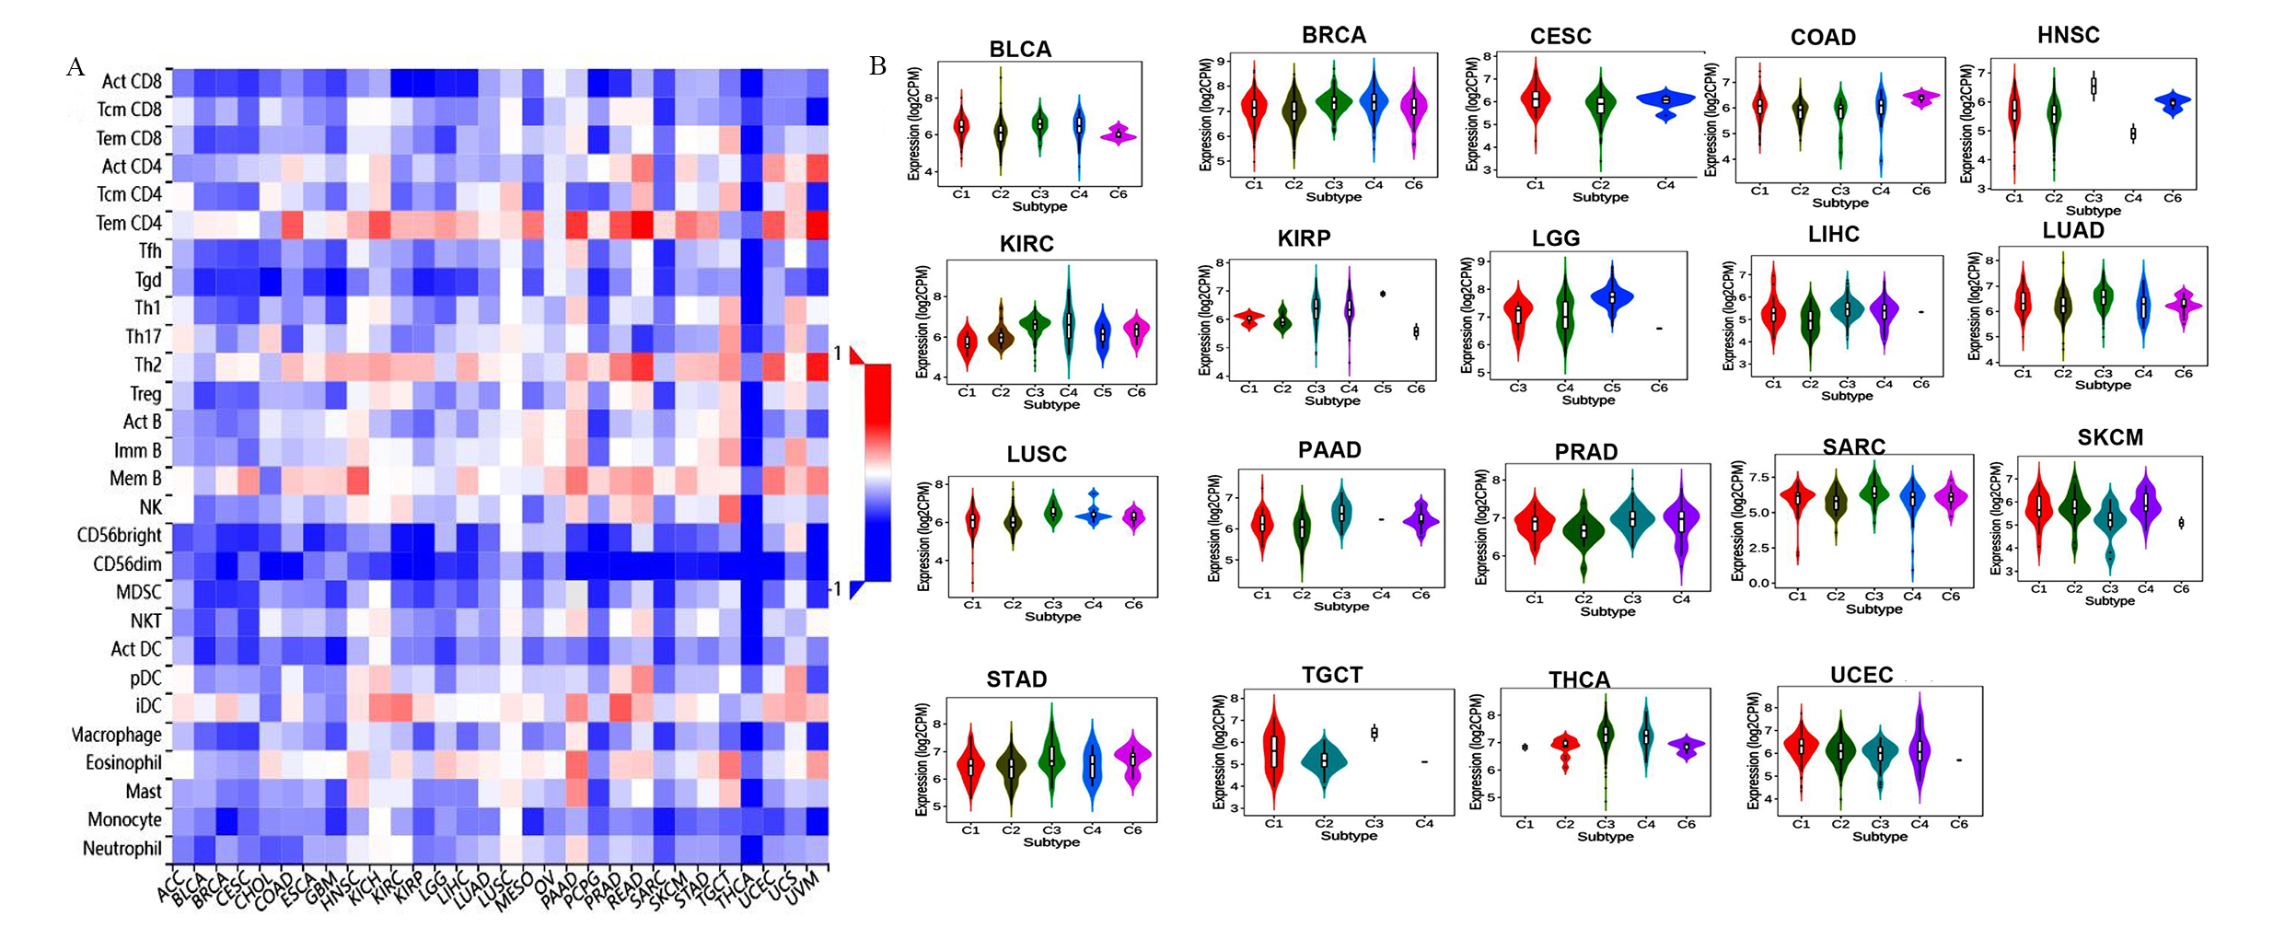
Figure 4 supplement. the correlation between ZMYND11 expression and tumor-infiltrating immune cells. (a)An analysis of the correlation between ZMYND11 expression and tumor-infiltrating immune cells. (b) ZMYND11 expression in different immune subtypes in BLCA, BRCA, CESC, COAD, HNSC, KIRC, KIRP, LGG, LIHC, LUAD, LUSC, PAAD, PRAD, SARC, SKCM, STAD, TCGT, THCA and UCEC via TISIDB (*p-value<0.05).

