Table 1. Movement control exercises
 | Flexion |  | Extension |  | Lateral flexion and rotation
1. | Waiters bow | 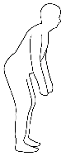 | Pelvic tilt | 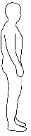 | One leg stance with weight shift | 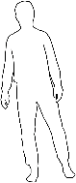
2. | One leg raise on standing | 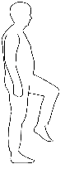 | Lunge | 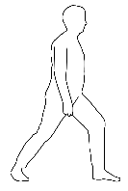 | Transverse lunge | 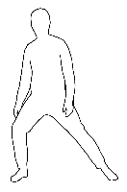
3. | Squat | 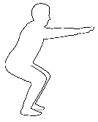 | All fours forwards | 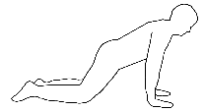 | All fours rotation | 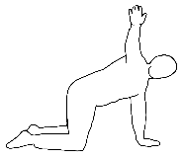
4. | Leg extension on sitting | 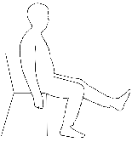 | All fours forward arm raise | 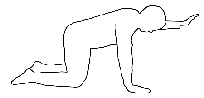 | All fours knee sideway raise | 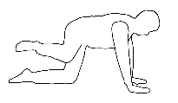
5. | All fours backwards | 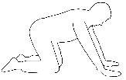 | All fours leg raise backwards | 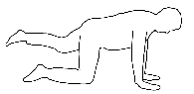 | Prone knee hip internal rotation | 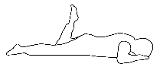
6. | All fours hip flexion | 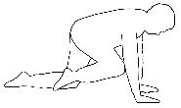 | All fours alternative leg and arm raise | 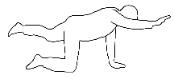
7. | Camel exercise | 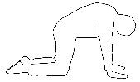 | Cat exercise | 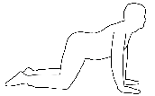
8. | Dead bug exercise | 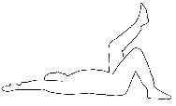 | Prone knee flexion | 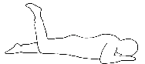
9. | Kneeling forward bending | 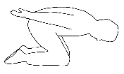 | Bridge | 