Extended Data
Extended Data Table 1. Data collection and refinement statistics
 | Water | 3ms | 6ms | 15ms | 30ms | 240ms | 700ms | 3 h soak
Space Group |  |  |  | P2₁
a,b,c (Å), β (°) | 79.6,98.1, 110.9,108.5 | 80.5,98.8,  111.5,108.5 | 80.4,8.8,  112.1,108.7 | 80.3,98.6, 112.1,108.8 | 80.2,98.5, 112.3,108.9 | 79.8,97.9, 113.2,109.3 | 80.0,8.3, 112.1,108.8 | 79.4, 96.7, 111.1,108.5
Resolution range (Å) | 22.14-2.2 (2.3 -2.2)† | 22.01-2.6 (2.75-2.6) | 20.53-2.75 (2.85-2.75) | 20.86-2.65 (2.75-2.65) | 20.4-2.95 (3.06-2.95) | 22.42-2.35 (2.43-2.34) | 20.94-3.2 (3.38-3.2) | 22.3-2.7 (2.8-2.7)
Hits | 88,978 | 61,508 | 26,309 | 51,166 | 27,143 | 75,038 | 2,854
Indexed patterns | 73,965 | 36,400 | 17,596 | 31,958 | 11,123 | 59,928 | 2,740
Observed Reflections | 37,857,581 | 14,718,802 | 6,258,604 | 11,092,596 | 3,888,789 | 29,990,504 | 1,582,566
Unique reflections | 83,447 | 42,822 | 43,284 | 40,586 | 32,517 | 68,441 | 27,514 | 38,773
Multiplicity | 453(335) | 343(164) | 144(69) | 273(130) | 119(67) | 446(306) | 57(35) | 79(28)
Completeness | 100(100) | 100(100) | 100(100) | 100(100) | 100(100) | 100(100) | 99.9(99.9) | 100(100)
R_{split/merge} (%) | 23.3(528) | 23.4(427) | 24.3(354) | 23.6(316) | 30.4(176) | 28.8(689) | 44.6(208) | 18.2(803)
CC* (%) | 99.6(69.8) | 99.3(55.9) | 99.0(51.6) | 98.9(58.7) | 98.2(52.9) | 99.3(64.2) | 95.9(51.3) | 99.6(64.2)
Resolution range | 22.14-2.2 | 22.01-2.6 | 20.53-2.75 | 20.86-2.65 | 20.4-2.95 | 22.42-2.35 | 20.94-3.2 | 22.3-2.6
Reflections used | 68064 | 40968 | 41929 | 38742 | 33082 | 53680 | 27127 | 25,400
R_{cryst}/R_{free} | 0.22/0.25 | 0.22/0.24 | 0.22/0.24 | 0.23/0.26 | 0.22/0.26 | 0.23/0.25 | 0.27/0.29 | 0.22/0.27
Occupancy  (in %) | n.a | n.a. | n.a. | TEN^{B}: 96 TEN^{D}: 90 | SUB^{A}: 52  TEN^{B}: 85  SUB^{C}: 63 TEN^{D}: 77 | TEN^{A}: 100  TEN^{B}: 100  TEN^{C}: 100 TEN^{D}: 100 | TEN^{A}:100  TEN^{B}:100  TEN^{C}:100 TEN^{D}:100 | TEN^{A}:98  TEN^{B}:96  TEN^{C}:98 TEN^{D}:88
r.m.s.d‡ bond length | 0.004 | 0.002 | 0.003 | 0.003 | 0.003 | 0.003 | 0.002 | 0.003
r.m.s.d bond angles | 0.641 | 0.545 | 0.601 | 0.642 | 0.768 | 0.65 | 0.428 | 0.584
No. of H₂O | 447 | 140 | 203 | 183 | 44 | 311 | 16 | 90
† Values in parentheses represent the highest resolution bin
^{A,B,C,D} The superscript letters represent corresponding subunits.

Extended Data Table 2. Important distances (in Å) in the active centers of subunit A and B.
 | 0 ms | 3ms | 6ms | 15ms | 30ms | 240ms | 700ms
(a) Distance between side chain of some active residues in subunit A
Ser70 OG to Arg173 CZ | 10.9 | 11.6 (2.7) † | 12.1 (3.1) | 10.7 (1.2) | 11.0 (1.6) | 10.4 (1.4) | 10.2 (1.3)
Ser70 OG to Gln112^{B} CD | 10.6 | 12.0 (2.2) | 10.9 (0.4) | 10.9 (1.3) | 10.6 (0.4) | 9.9  (0.5) | 9.8  (0.2)
Ser70 OG to Gln109^{B} CD | 9.0 | 10.2 | 10.0 | 10.3 | 10.2 | 8.6 | 8.7
(b) Distance between side chains of some active residues in subunit B
Ser70 OG to Arg173 CZ | 13.9 | 13.2 (2.1) | 13.9 (1.7) | 14.4 (1.6) | 14.8 (0.9) | 14.9 (1.5) | 14.4 (1.2)
( c) Distances from BlaC side chains to selected SUB and TEN atoms in subunit A
Thr239 O to SUB O12 | - | - | - | - | 2.7 | - | -
Gln112^{B} NE2 to SUB O8 | - | - | - | - | 2.7 | - | -
Lys73 NZ to TEN O8 | - | - | - | - | - | 2.5 | 3.1
Glu168 OE2 to TEN O8 | - | - | - | - | - | 2.6 | 2.5
Asn172 ND2 to TEN O12 | - | - | - | - | - | 2.5 | 2.9
(d) Distances from BlaC side chains to selected TEN atoms in subunit B
Thr239 O to TEN O8 | - | - | - | 2.9 | 3 | 3.1 | 3.2
Gln109^{A} NE2 to TEN O12 | - | - | - | 3.9 | 3.4 | 3.2 | 4.1
†Values in parentheses represent the change in the position [in Å] of the terminal side chain atom from its original position at 0 ms.
^{A,B} subunits that host the amino acid.

Extended Data Table 3. Relaxation times and amplitudes determined from fitting Eqn. 2 to the significant rSVs.
 | Subunit A | Subunit B | Subunit C | Subunit D
λ (ms⁻¹) | 0.25 | 0.51 | 0.33 | 0.69
τ₁ (ms) | 23.26 | 10.17 | 25.53 | 9.81
τ₂ (ms) | 86.03 | 80.41 | 90.01 | 88.15
rSV₁
A_{0,1} | 11.72 | 38.32 | 8.89 | 32.77
A_{1,1} | 118.95 | 195.44 | 113.3 | 155.37
A_{2,1} | 134.48 | 122.15 | 152.08 | 137.01
rSV₂
A_{0,2} | -17.96 | -0.25 | -12.95 | 3.23
A_{1,2} | -90.67 | -41.79 | -74.92 | 26.54
A_{2,2} | 142.88 | 64.27 | 117.31 | -48.72
λ, τ₁ and τ₂ are global fit parameters for all significant rSVs; the amplitudes A’s are determined independently for each rSV.

Extended Data Table 4. Characterization of SUB diffusion and reaction rate coefficients.
Parameters to estimate the diffusion of SUB into the unit cells (Eqn. 3).
μ | 0.59 ms⁻¹
t₀ | 7 ms
Rate coefficients and approximate characteristic times as estimated from the half maximum of the curves shown in Figs. 5 a and b.
 | Subunits A and C |  | Subunits B and D
Rate Coefficientsª | k_{max,entry} = 0.06 s⁻¹; ΔI_{c} = 25 mM k_{ncov} = 1.5 mM⁻¹s⁻¹  k_{cov} = 10 s⁻¹ |  | k_{ncov} = 1.5 mM⁻¹ s⁻¹ (estimated)  k_{cov} > 8000 s⁻¹
I_{out} | 7 ms | Fig. 5 b blue dotted line | 7 ms | Fig. 5 a blue line
I_{in} | 20.1 ms | Fig. 5 b blue line | not observed
E:I formation | 21.2 ms | Fig. 5 b orange line | not observed
E-I* formation | 93.4 ms | Fig. 5 b green line | 11.5 ms | Fig. 5 a green line
ªfrom Eqns. 4, 5 and 6.

Extended Data Table 5. Injector geometry and sample flow rates
 | Water | Sulbactam
Δt_{misc} (ms) | 0 | 3 | 6 | 15 | 30 | 240 | 700
Ligand concentration (mM) | n.a. | 150
Ligand buffer | water | 50 mM Ammonium Phosphate (pH 4.5)
Injector ID | 3 | 1 | 1 | 2 | 2 | 3 | 4
Crystal flow rate (μl/min) | 10 | 7.7 | 7.6 | 7.7 | 11.1 | 10.1 | 11
Ligand flow rate (μl/min) | 70 | 142.3 | 67.4 | 143.1 | 63.1 | 70 | 57
Constriction inner diameter (μm) | 100 | 50 | 50 | 50 | 50 | 100 | 100
Constriction length (mm) | 82.7 | 10.3 | 10.3 | 40.7 | 40.7 | 82.7 | 35‡
Timing uncertainty (ms) | n.a. | ±1.0 | ±2.0 | ±1.1 | ±3.5 | ±18.8 | ±29.5
Ligand concentration at the end of constriction (mM) | n.a. | 58.5 | 58.5 | 100.5 | 88.5 | 112.5 | 99
‡For timepoints longer than 500 ms, an additional delay stage is added immediately after constriction.

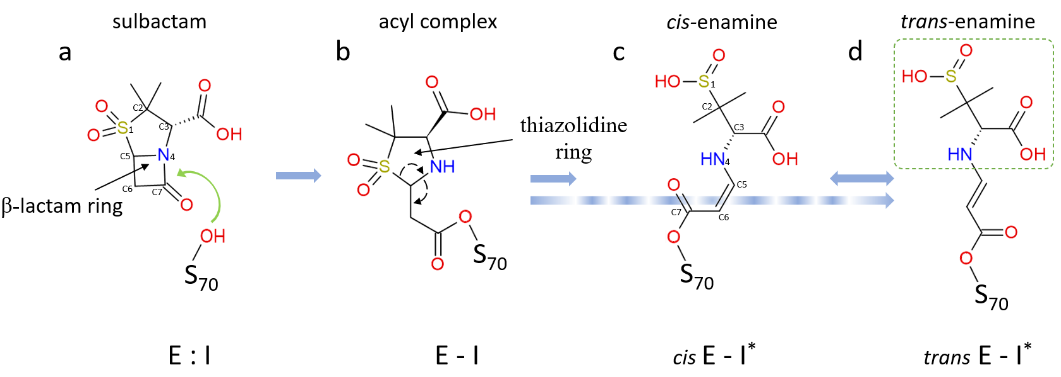
Extended Data Figure 1. Simplified mechanism of sulbactam inhibition reaction of BlaC. (a) Non-covalent enzyme-inhibitor complex formation (E:I). The characteristic β-lactam ring is marked. The nucleophilic attack by Ser70 is shown by a green arrow. (b) The β-lactam ring opens, and a covalent bond is formed between Ser70 and sulbactam resulting in the acyl-enzyme complex (E-I). In this current state, the E-I is very unstable and causes reorganization of bonds shown by dotted arrows. This modification leads to permanent opening of the 5-member thiazolidine ring and formation of either (c) cis-enamine (cis E-I*) and then to (d) trans-enamine (trans E-I*) or directly to trans-enamine following the blue dotted arrow. Cis- and trans-enamines differ in the configuration of the C5=C6 double bond. A second nucleophilic attack by Ser128 on C5 may lead to cleavage of the fragment shown by dotted box in (d). Further modifications are possible which are not shown here.

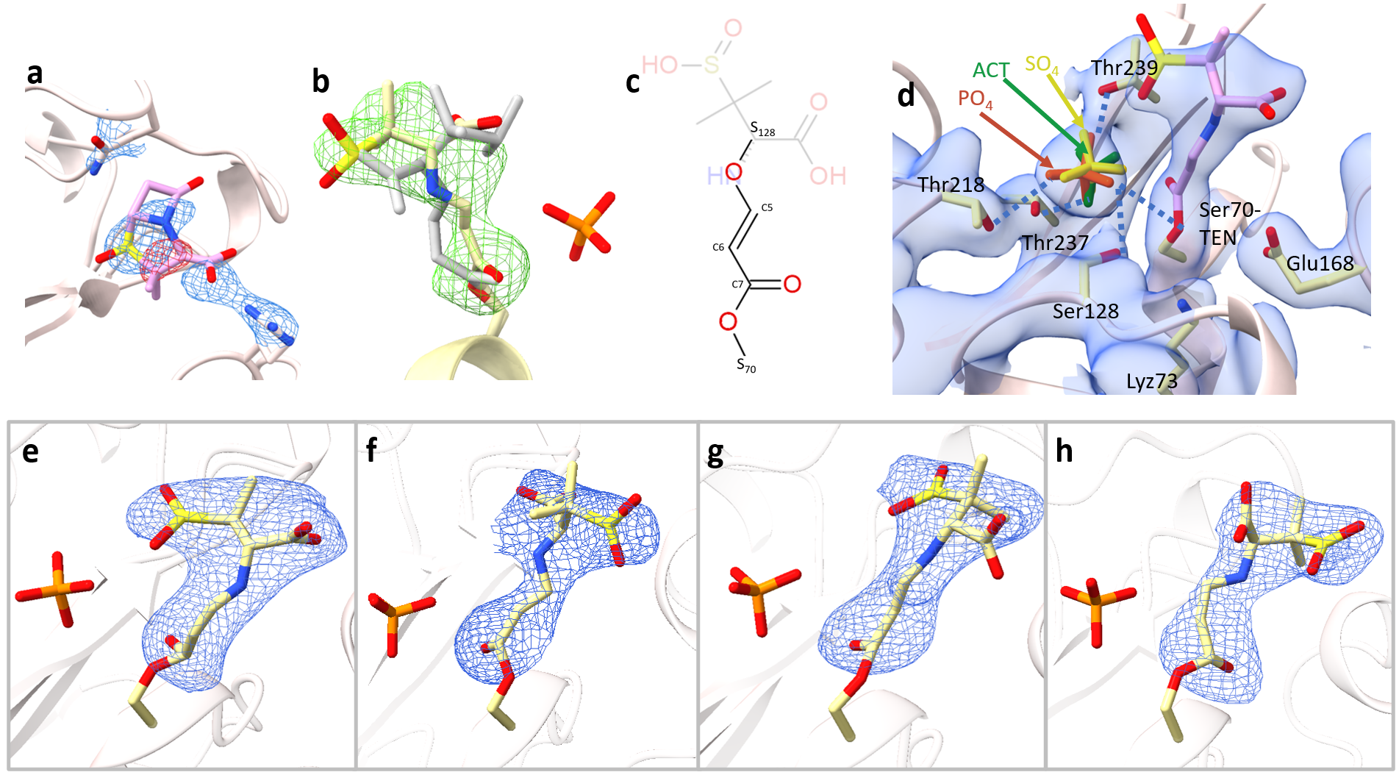
Extended Data Figure 2. SUB and TEN structures in various environments. (a) The appearance of SUB at the entrance of the active site. SUB (shown in purple) was placed in the DED_{omit} feature near the guardian residues observed at Δt_{misc} = 3 ms (Fig. 4 a) and refined. After refinement negative density (red contour lines) appear in the F_{obs}- F_{calc} map (displayed on the ±3σ level). The B-factors of all SUB atoms are in excess of 120 Å². Translational and rotational disorder of the free SUB near the guardian residues renders the refinement of a single conformation difficult. (b) Cis-enamine (shown in grey) poorly fits the electron density at Δt_{misc} = 15ms. (c) Chemical structure of the TEN after the formation of cross-linked species. The leaving group is shown in pale color. (d) A 2F_{obs}-F_{calc} map (blue, 1 σ contour level) is shown near the active site of subunit B at Δt_{misc} = 240ms. Key active site residues and the TEN (purple) are marked. The sulphate (SO₄, yellow) and acetate (ACT, green) observed in other β-lactamases (PDB entries 5OYO and 7A71, respectively) are overlayed. Hydrogen bonds established by phosphate (PO₄, orange) with TEN and surrounding residues are depicted by blue dotted lines. TEN might not be able to get close to Ser128 without displacing the phosphate. (e-h) Polder omit maps, contoured at 2.5 σ, determined in each subunit of BlaC (A - D), respectively, after 3 h of soaking with SUB. All the species are characterized by covalently bound TENs.

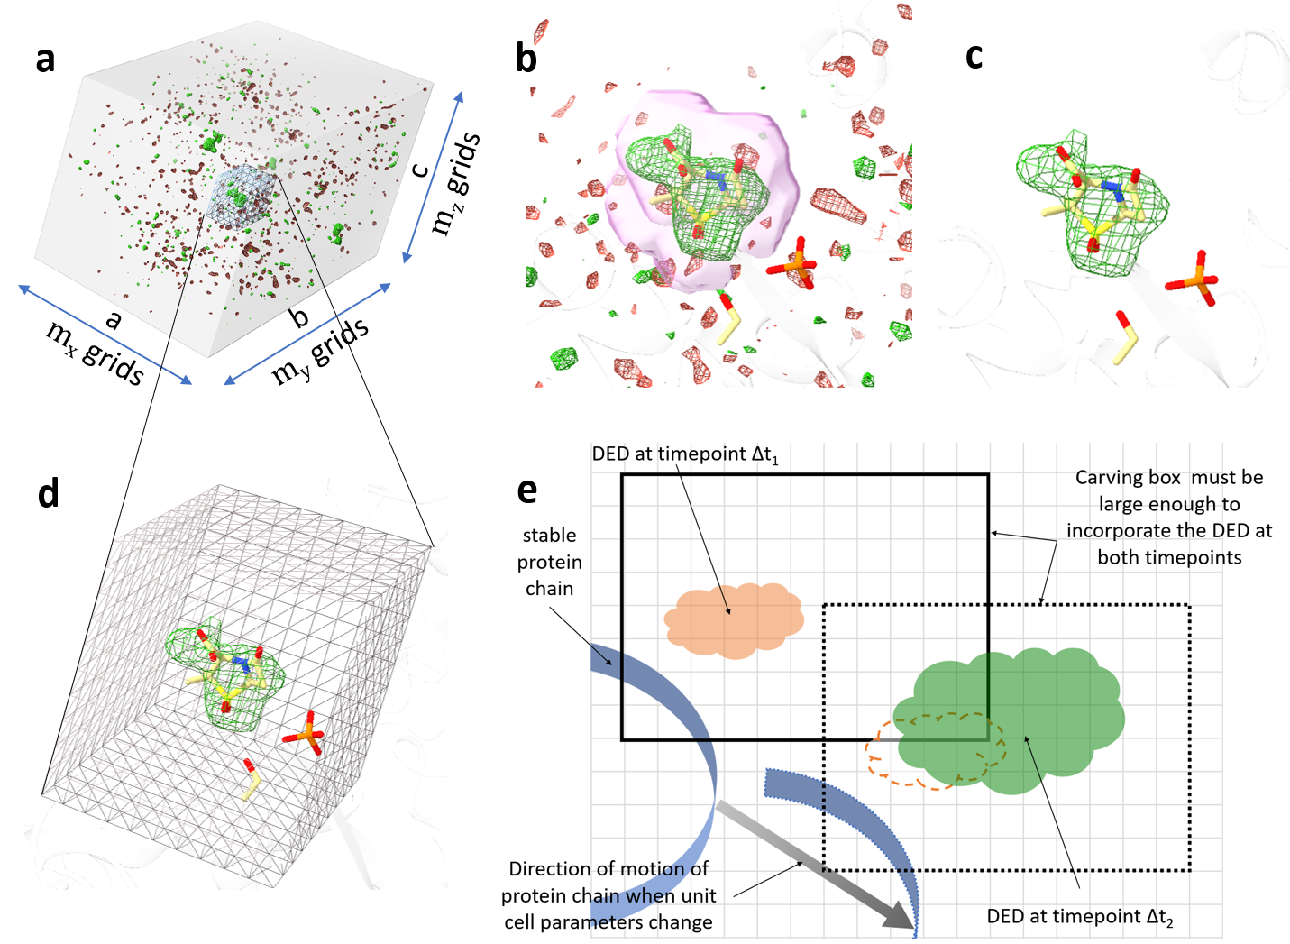
Extended Data Figure 3. Establishing the region of interest (ROI) from DED maps when unit cell parameters change. (a) DED map of the entire BlaC unit cell at Δt_{misc} = 30ms contoured at ±2.5 σ (b) The same map as in (a) is now displayed with the focus on the active site of subunit A. Strong DED is present where the SUB molecule resides. A mask around the SUB atom is represented by a pink surface. The density inside the mask is left unaltered while that outside the mask is set to zero. (c) The map after the masking operation. (d) A box which is a part of overall map covers the ROI. (e) A simple 2D diagram showing how to choose the box. The square grey grid represents the voxels. The box shown by the solid line includes the ROI at Δt₁ and it is large enough to cover the evolving DED features at all other time points. The orange cloud represents the DED features at timepoint Δt₁. At Δt₂, the entire protein chain displaces to a new position (grey arrow) due to unit cell changes. In addition, more extensive DED features appear as shown by the green cloud. The dashed cloud next to the green DED is the relative position of the DED at Δt₁. As the protein chain displaces when the unit cell parameters change, the entire box moves accordingly in the same direction (shown by the dotted box). Since the number of grid points are adjusted linearly with the changing unit cell parameters, the number of voxels within the box as well as the voxel size does not change.
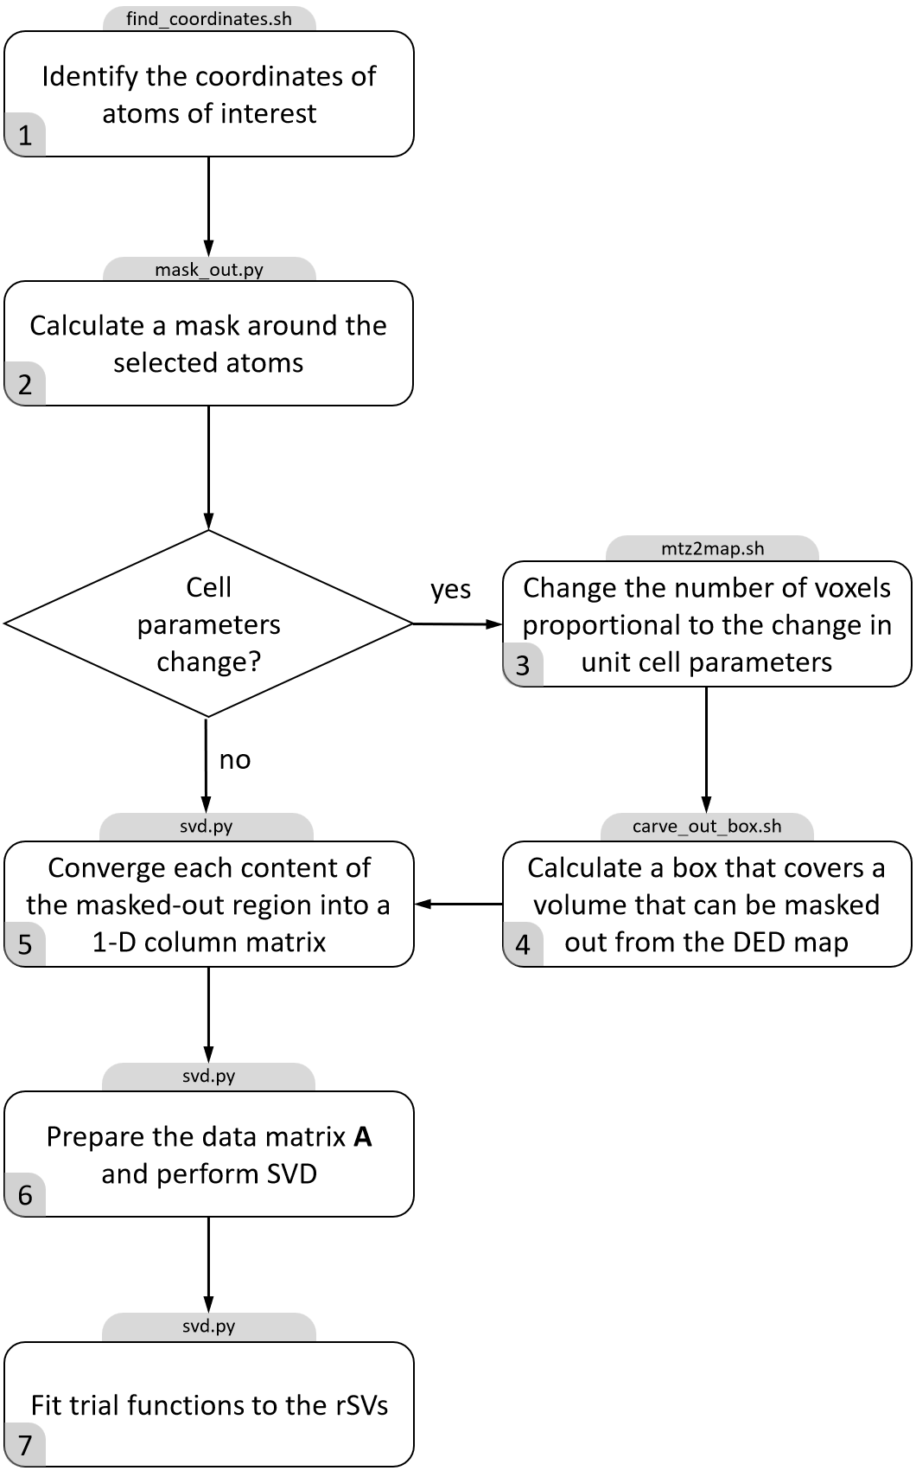
Extended Data Figure 4. Flow chart for an SVD analysis of time-dependent crystallographic difference maps. The grey boxes on top are the scripts/programs developed and used to accomplish each step.

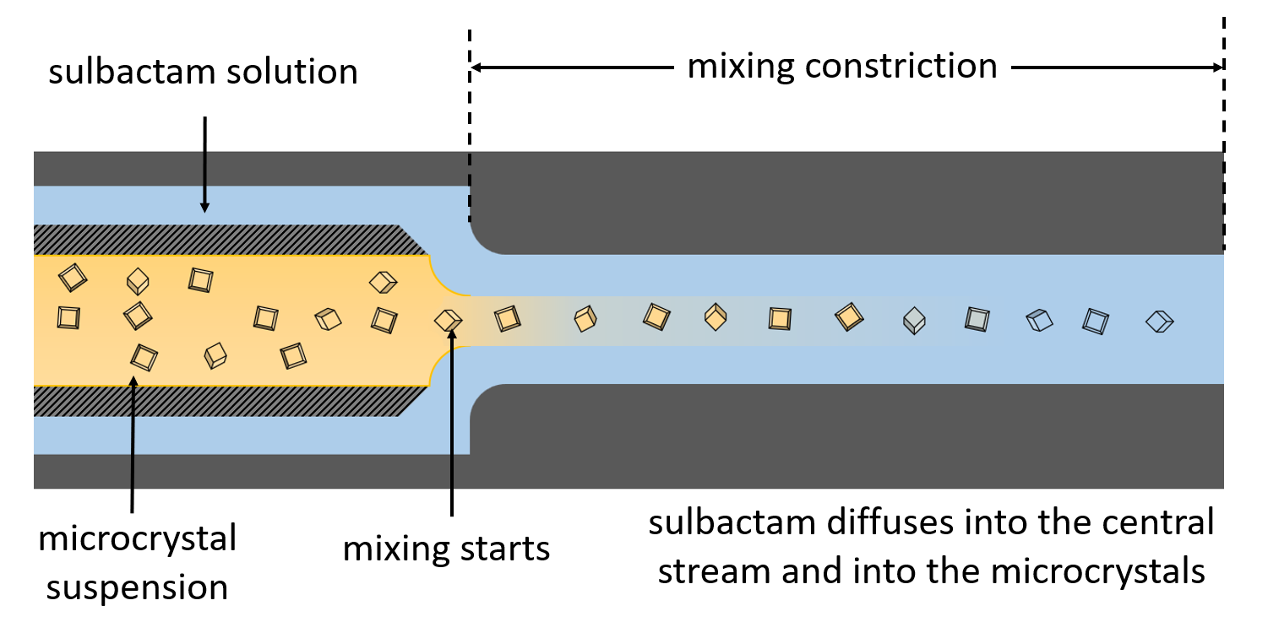
Extended Data Figure 5. Cartoon cross section of the injector focused on the mixing region adapted from Calvey et al.⁷⁴. Randomly oriented BlaC microcrystals flow through an inner capillary, whereas the sulbactam solution flows concentrically through the outer capillary. Both flows are combined into a single outlet of reduced diameter called the mixing constriction. The time taken by crystals to move from the start of the mixing constriction until they are injected into the X-ray interaction region determines the MISC time delay. The sulbactam diffuses into the central flow containing crystals. ~100 mM of ligand concentration in the central flow is reached after 15 ms.

