Supplementary Materials for

Elucidation of the Molecular Bases and Cellular Functions of Vinculin-Actin Directional Catch Bonding

Venkat R. Chirasani,¹† Mohammad Ashhar I. Khan,¹† Juilee N. Malavade,²† Nikolay V. Dokholyan,³‡ Brenton D. Hoffman,^{2,4}‡* Sharon L. Campbell^{1,5}‡*

†These authors contributed equally to this work.
‡These authors contributed equally to this work.
*Corresponding authors. Email: brenton.hoffman@duke.edu (B.D.H.); campbesl@med.unc.edu (S.L.C.)

This PDF file includes:

Supplementary Figs. S1 to S12
Movies S1 to S6
Table S1 in Supplementary PDF file

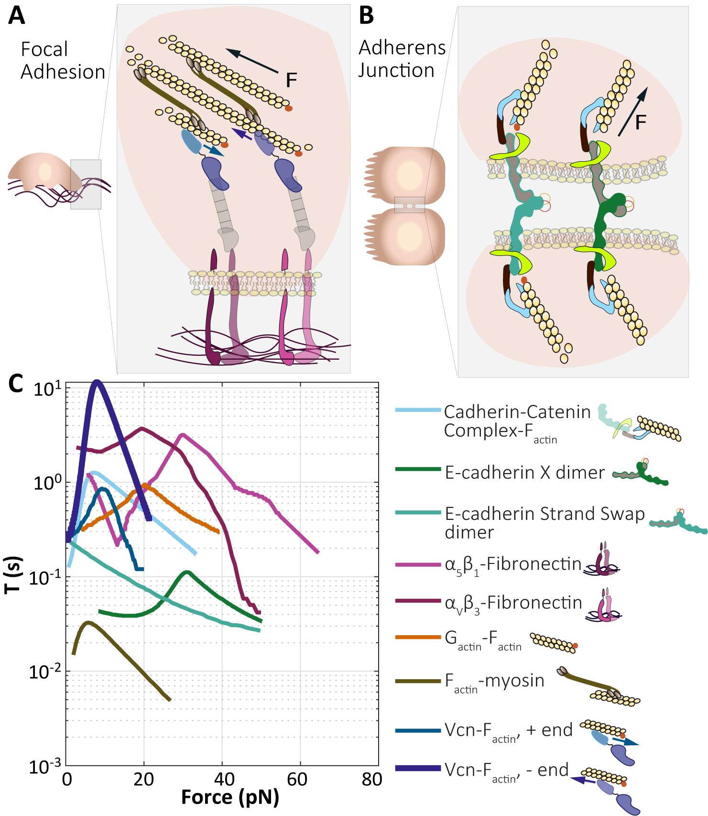

Fig. S1. Lifetimes of single interface protein-protein interactions at FAs and AJs.
Schematic representations of force-sensitive cellular adhesion structures (A) linking the cell to the extracellular matrix or (B) to other cells. (C) Bond lifetimes for single interface protein-protein interactions measured via single molecule force spectroscopy studies (SMFS) at FAs and AJs.

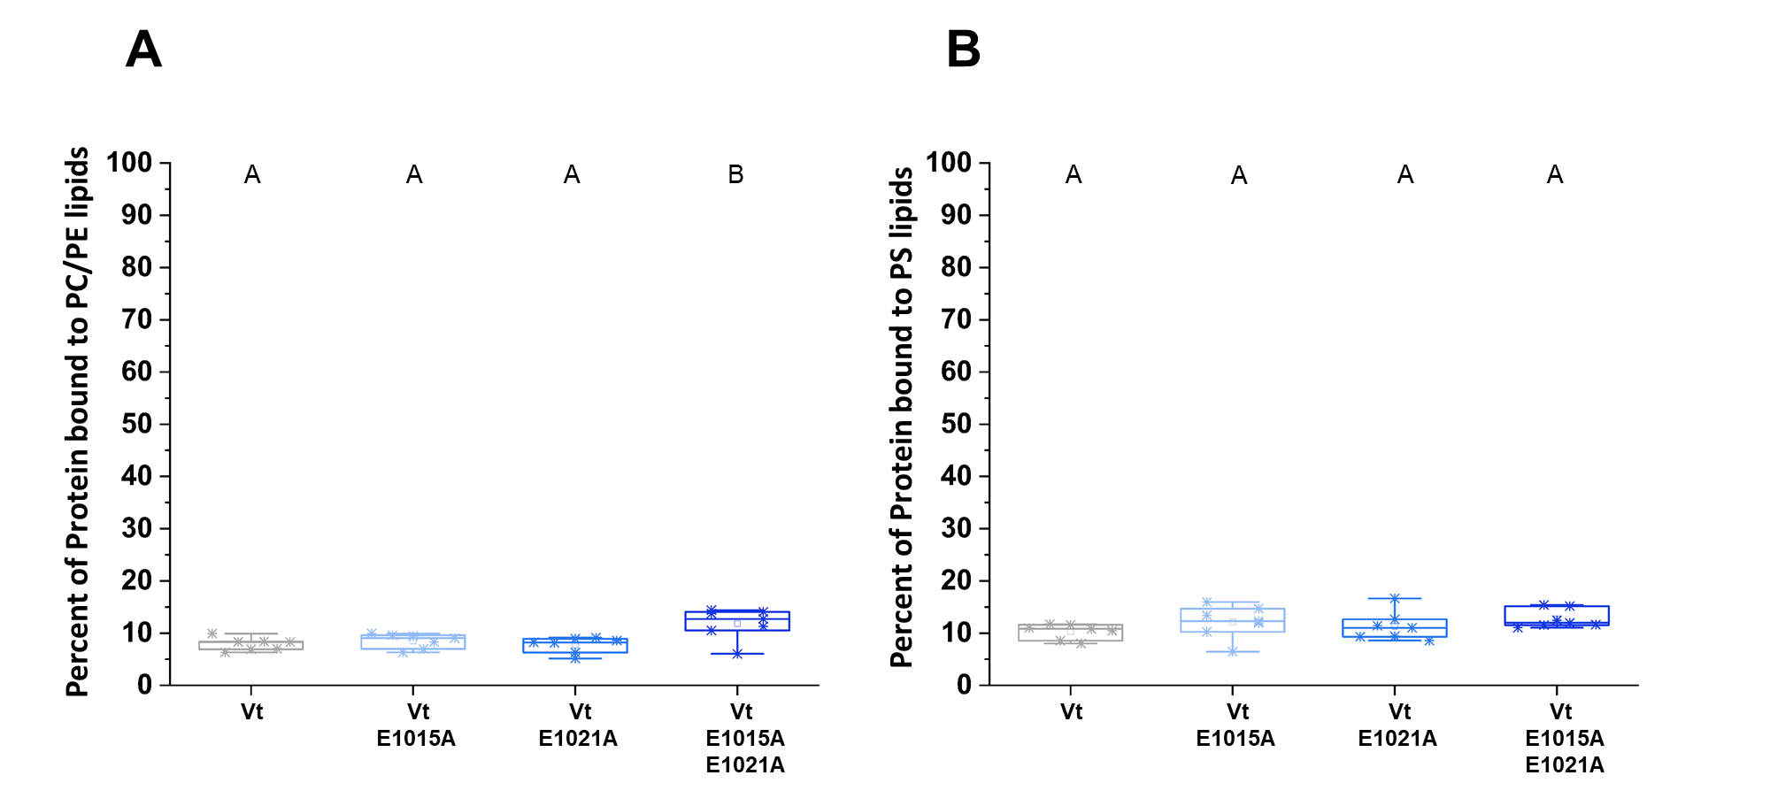

Fig. S2. DAFS residues retain the Vt:Lipid interactions.

Lipid co-sedimentation assay comparing association of WT Vt and DAFS Vt variants with large unilamellar vesicles (LUVs). The DAFS Vt variants exhibit similar lipid binding for (A) neutral and (B) anionic phospholipids relative to WT Vt. Box-whisker plot with 7 data points from 2 independent experiments are presented. One-way ANOVA and Tukey’s HSD Test were used for statistical analysis. Different letters denote significant difference at p<0.05. See Table S1 for a detailed listing of p-values.

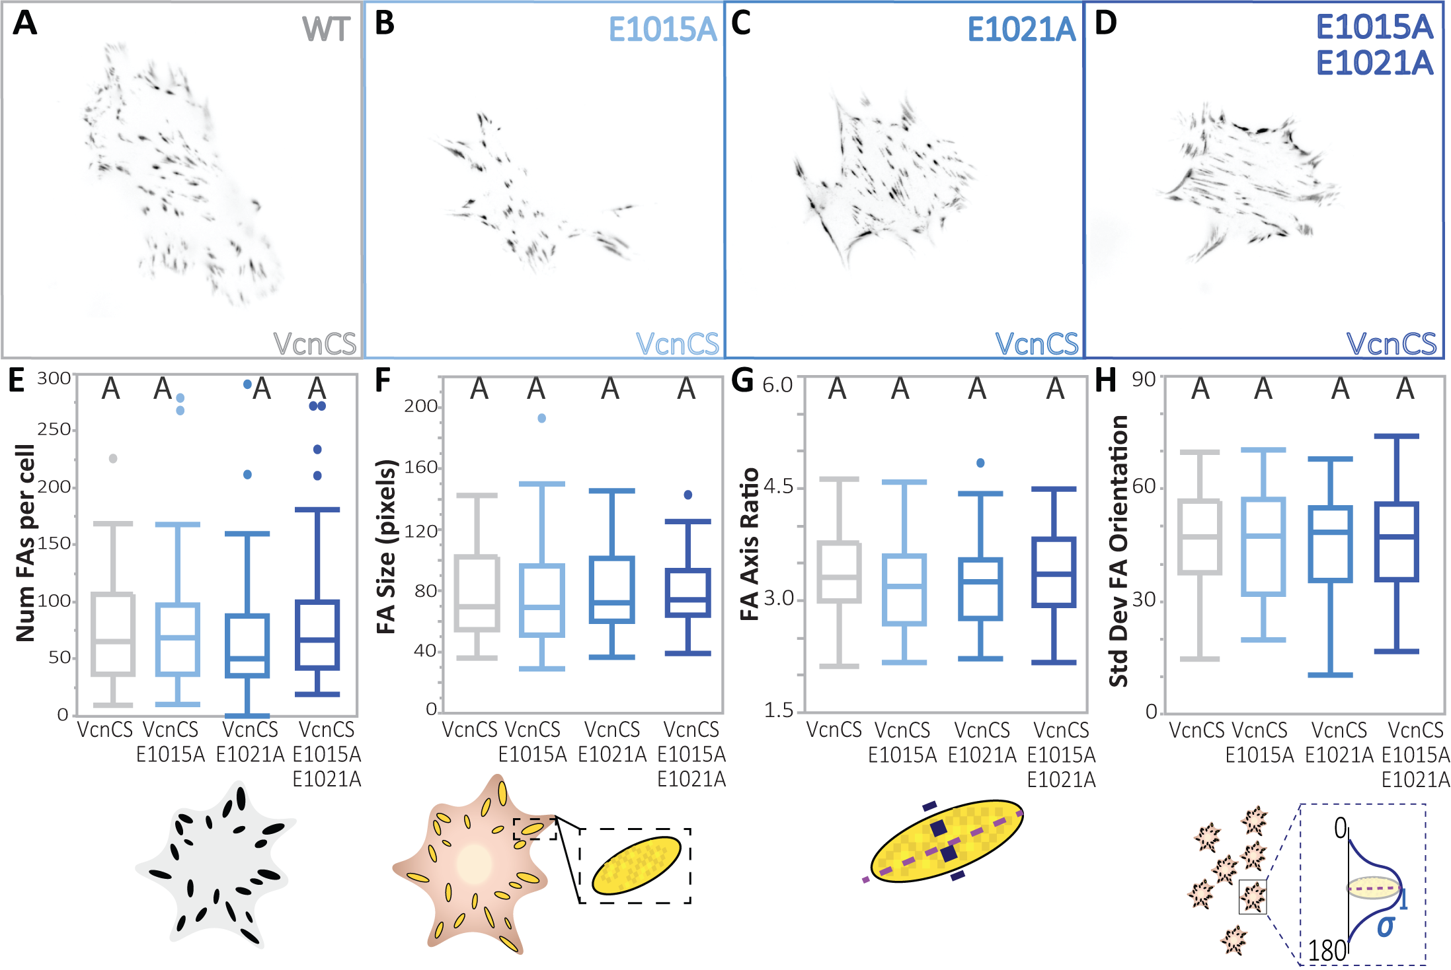

Fig. S3. VcnCS DAFS variants do not display altered FA characteristics.

(A-D) Representative images of Vcn^{-/-} MEFs expressing WT VcnCS or DAFS variants of VcnCS. WT VcnCS is shown in gray and variants of VcnCS are shown in shades of blue. Quantification of FA morphometric characteristics including (E) FA number, (F) FA area, (G) FA axis ratio, and (H) standard deviation of FA orientation. Plots shown for WT VcnCS and DAFS variants of VcnCS (n= 37, 41, 47, 53 cells, respectively, collected over 3 independent experiments). One-way ANOVA followed by a Steel-Dwass test (E, F, G) or Tukey’s HSD test (H), conducted across all VcnVenus, VcnCS and VcnTS constructs were used for statistical analysis. Differing letters denote significant difference at p<0.05. See Supplement tables for statistical significance of individual construct comparisons. See Table S1 for a detailed listing of p-values.

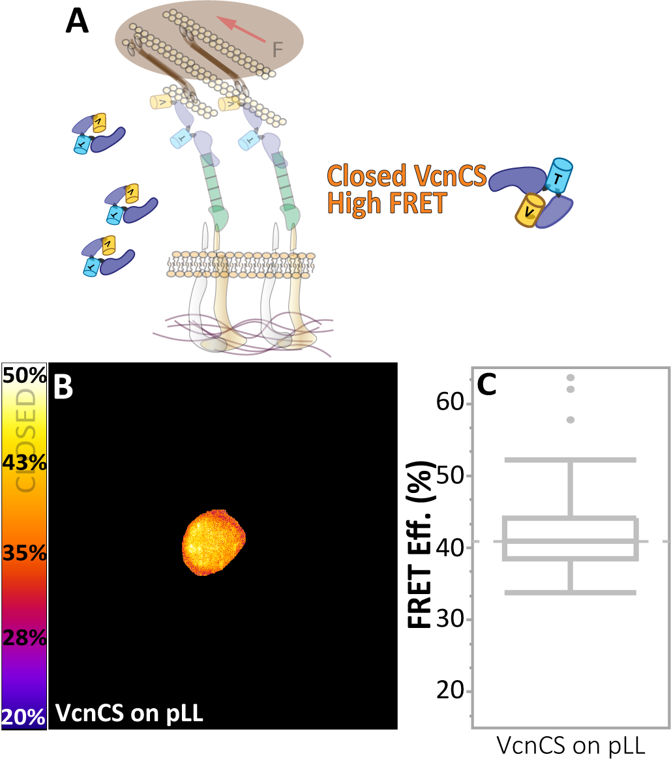

Fig. S4. VcnCS expressing cells plated on poly-L-lysine coated glass show closed VcnCS FRET efficiency.
(A) Schematic depicting closed conformation of VcnCS in the cytosol (high FRET). (B) Masked FRET efficiency image of Vcn^{-/-} MEF expressing VcnCS, which localizes diffusely in the cytosol when plated on pLL-coated glass. (C) Box-whisker plot of FRET efficiency (n = 82 cells, respectively, from 3 independent experimental days). See Table S1 for a detailed listing of p-values.

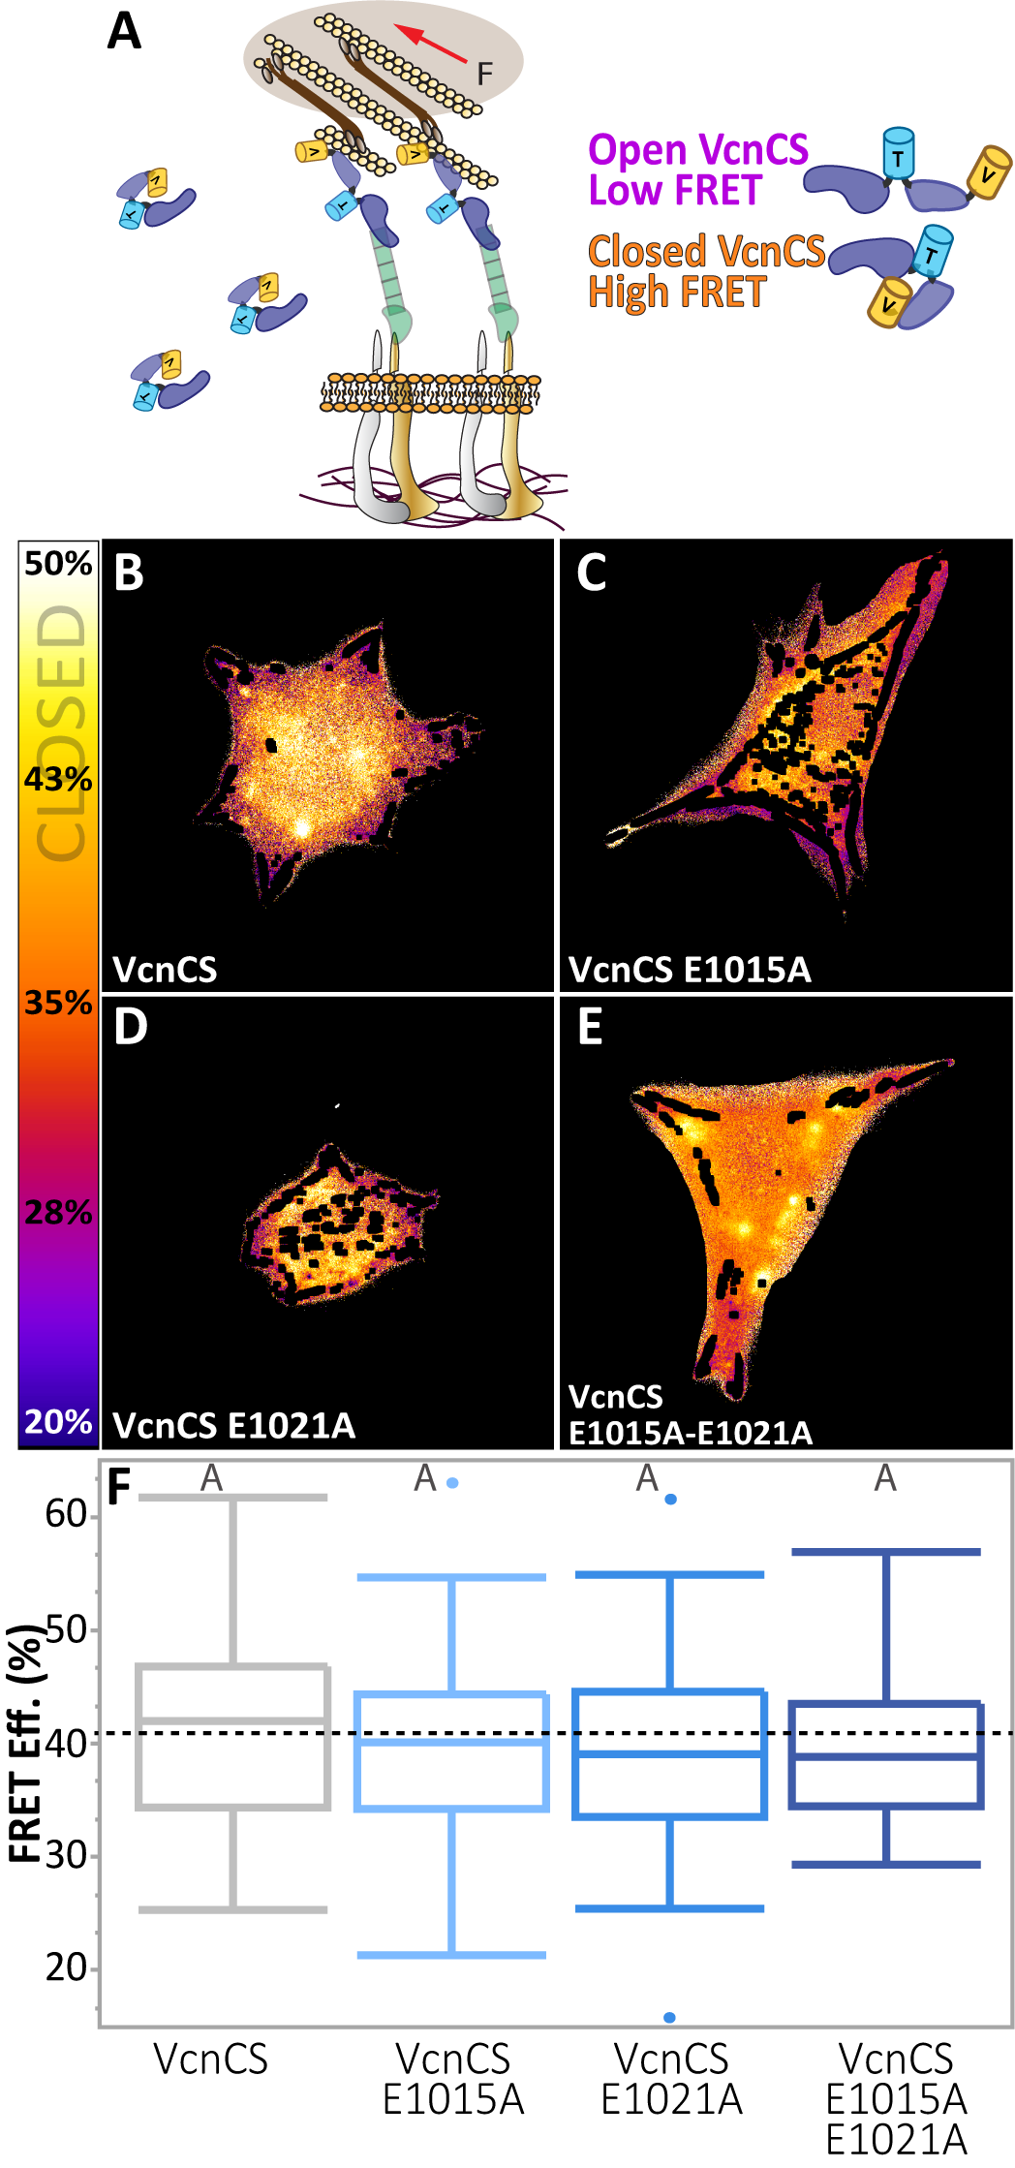

Fig. S5. WT VcnCS and VcnCS DAFS variants maintain closed conformation in the cytosol.
(A) Schematic depicting anticipated conformations of VcnCS, open (low FRET) in a FA and closed (high FRET) in the cytosol. (B-E) Cytosol masked FRET efficiency images of Vcn^{-/-} MEFs expressing each VcnCS construct. (F) Box-whisker plots of the FRET efficiency of cytosolic VcnCS and VcnCS variants (n = 49, 53, 54, 63 cells, respectively, from 3 independent experimental days). Dotted line represents closed VcnCS FRET efficiency (Fig. S4). One-way ANOVA of VcnCS, VcnCS DAFS variants and VcnCS on pLL followed by post-hoc Steel-Dwass test were used for statistical analysis. Differing letters denote significant difference at p<0.05. See Table S1 for a detailed listing of p-values.

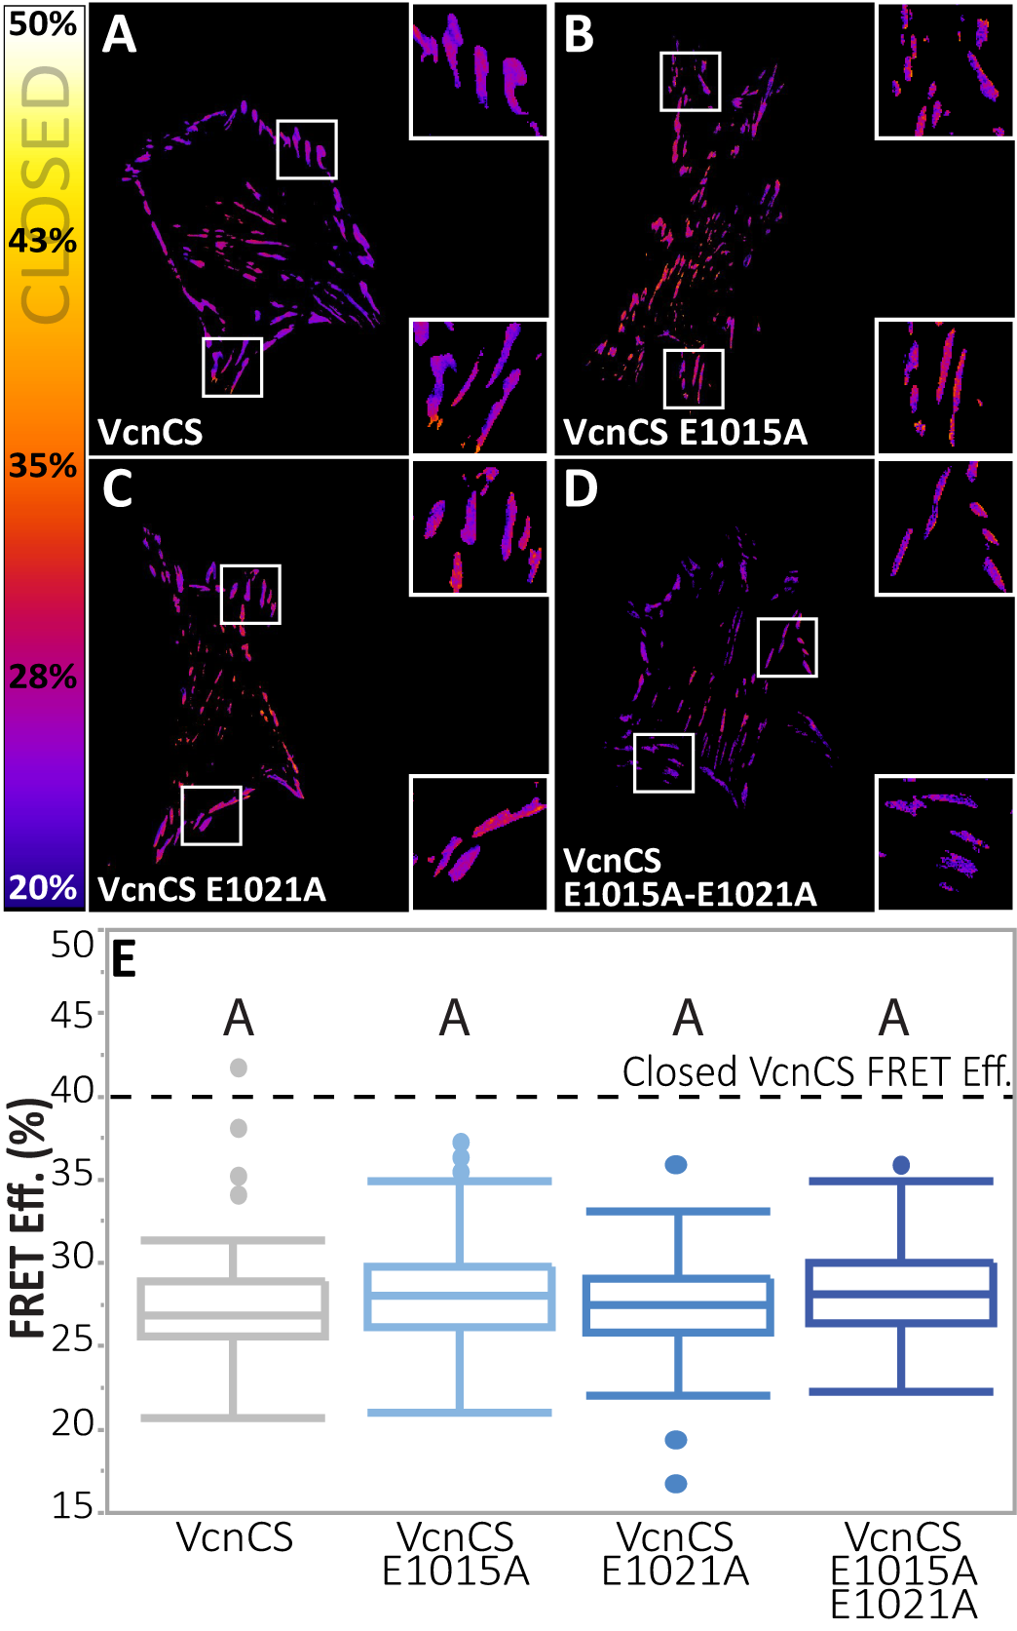

Fig. S6. WT VcnCS and DAFS variant VcnCS maintain open conformation at FAs.

(A-D) FA masked FRET efficiency is shown for single Vcn^{-/-} MEFs expressing each VcnCS construct. (E) Box-whisker plots are shown for cell-averaged FRET efficiency of FA VcnCS and VcnCS variants (n = 76, 94, 99, 109 cells, respectively, from 5 independent experimental days) compared to closed Vcn FRET efficiency (dotted line). One-way ANOVA and Tukey’s HSD test were used for statistical analysis. Different letters denote significant difference at p<0.05. See Table S1 for a detailed listing of p-values.

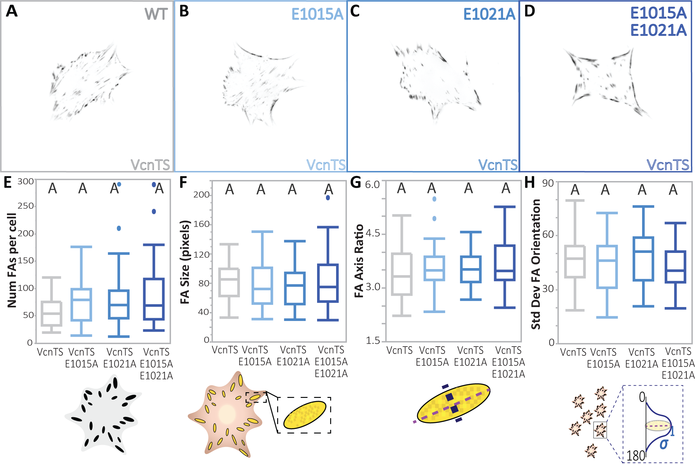

Fig. S7. DAFS variant VcnTSs do not display altered FA characteristics.

(A-D) Representative images of Vcn^{-/-} MEFs expressing WT VcnTS and DAFS variants of VcnVenus. WT VcnTS is shown in gray and variants of VcnTS are shown in shades of blue. Quantification of FA morphometric characteristics including (E) FA number, (F) FA area, (G) FA axis ratio, and (H) standard deviation of FA orientation. Plots shown for WT VcnTS and DAFS variants of VcnTS (n= 45, 49, 48, 46 cells, respectively, collected over 3 independent experiments). One-way ANOVA paired with a Steel-Dwass test (E, F, G) or Tukey’s HSD test (H) conducted across all VcnVenus, VcnCS and VcnTS constructs were used for statistical analysis. Differing letters denote significant difference at p<0.05. See Table S1 for a detailed listing of p-values.

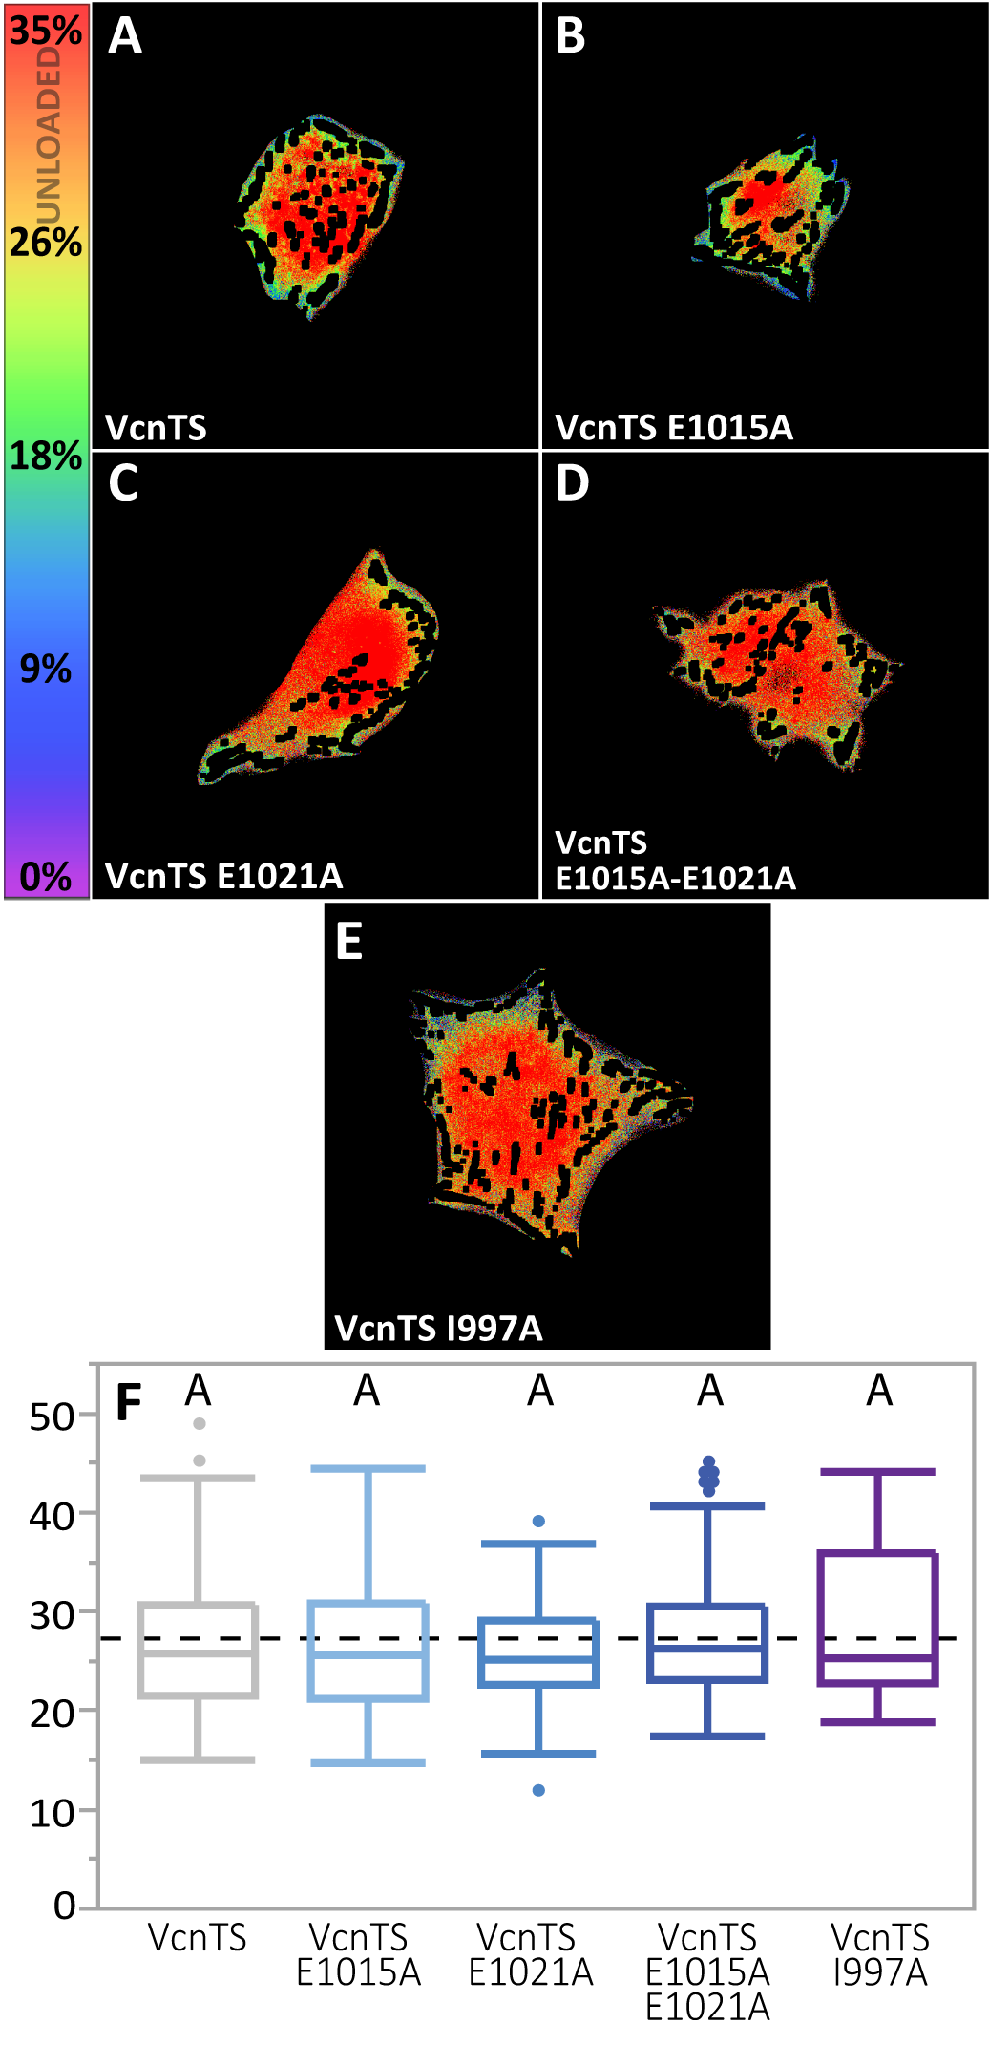

Fig. S8. WT VcnTS and DAFS variant VcnTSs are unloaded in the cytosol.

(A-E) Cytosol masked FRET efficiency images are shown for single Vcn^{-/-} MEFs expressing each VcnTS construct. (F) Box-whisker plots are shown for FRET efficiency of cytosolic VcnTS and DAFS variants of VcnTS (n = 47, 55, 63, 87, 44 cells, respectively). One-way ANOVA and Tukey’s HSD Test were used for statistical analysis. Different letters denote significant difference at p<0.05. See Table S1 for a detailed listing of p-values.

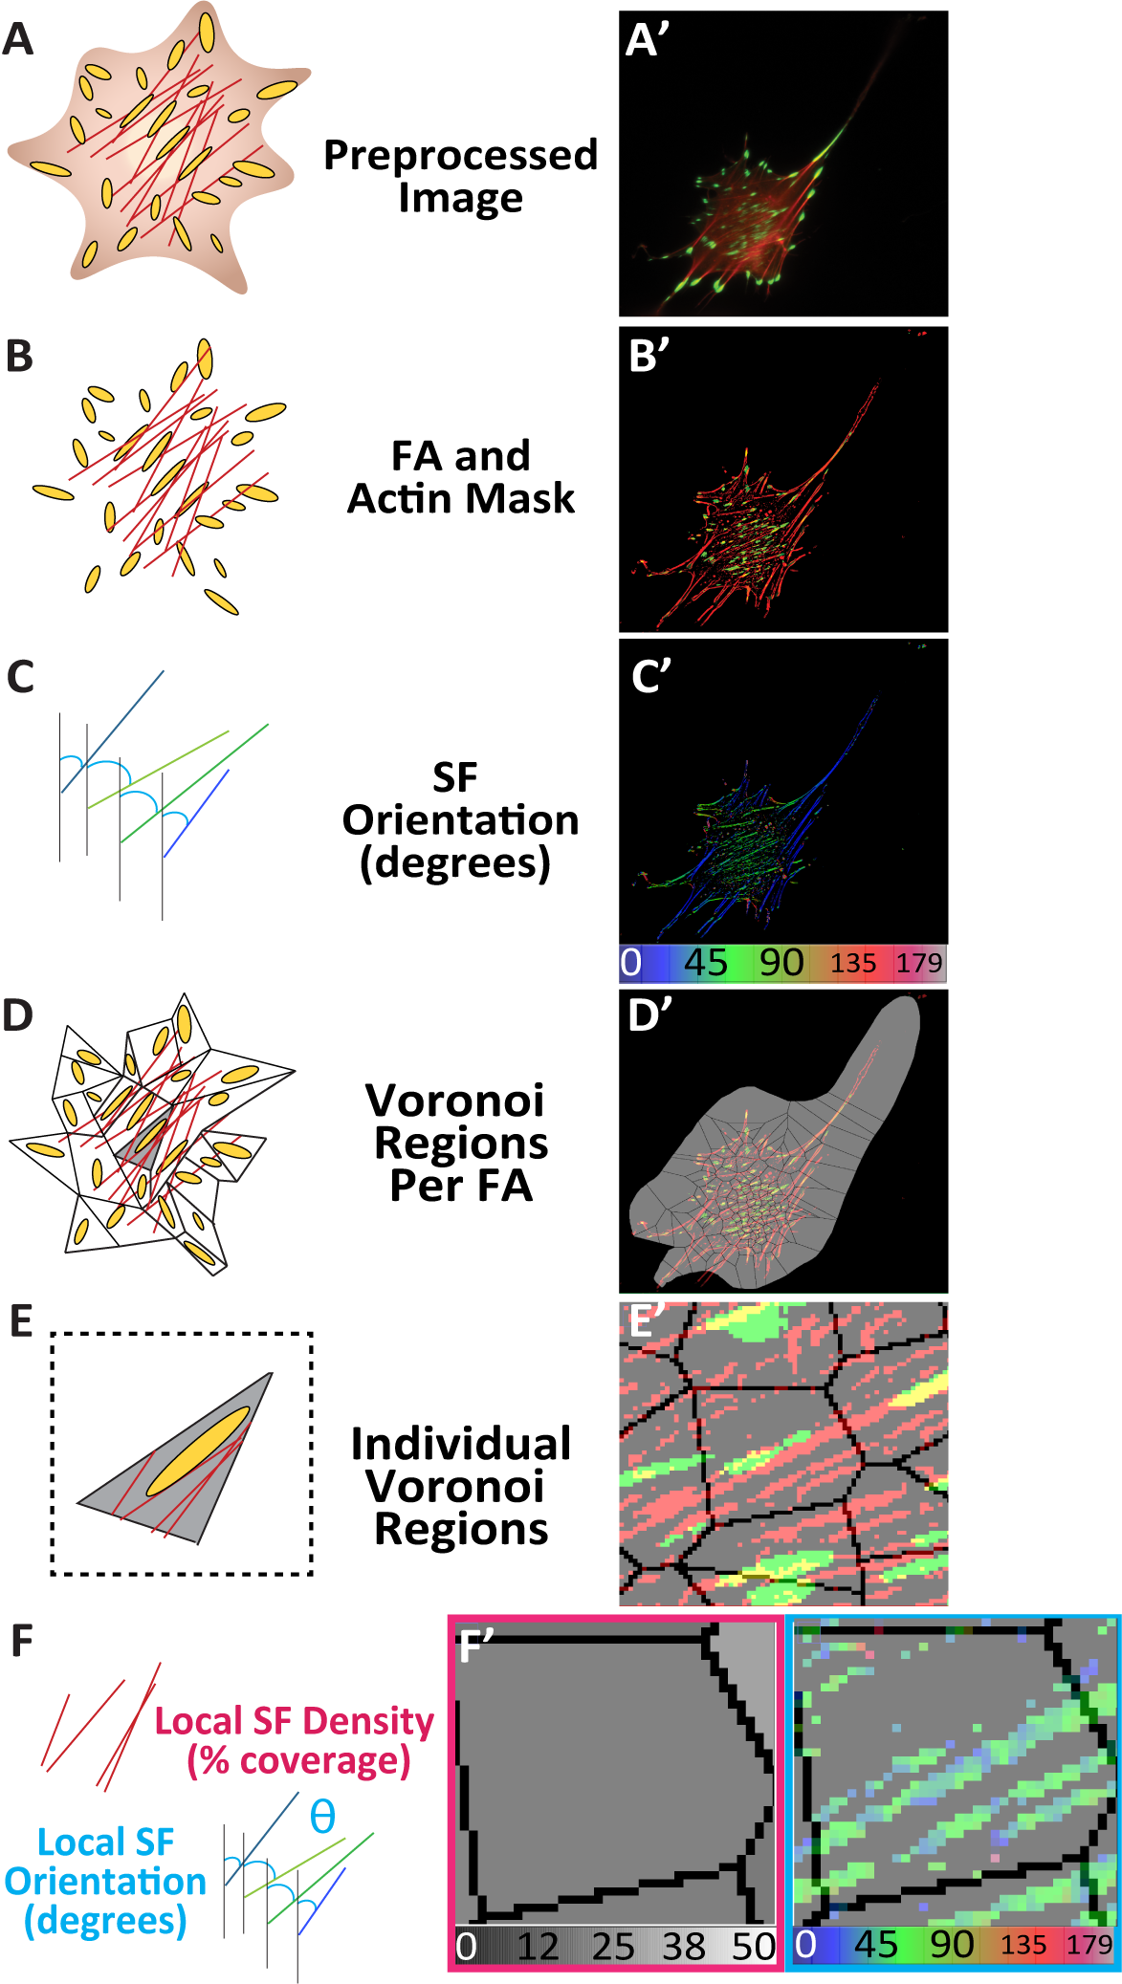Table S1.

Fig. S9. Image processing approach for quantifying SF organization metrics.
(A) Schematic and (A’) representative background subtracted image of Vcn^{-/-} MEF stably expressing VcnTS, stained for actin (red). (B) Schematic and (B’) representative image of merged actin mask (red) and FA mask (green). (C) Schematic and (C’) representative image of SF orientations within the whole cell (D) Schematic and (D’) representative image of Voronoi regions overlay atop B’. (E) Schematic and (E’) representative image of zoomed in, singular Voronoi region overlay atop B’. (F) Schematics and (F’) representative map of local SF density percentage and SF orientation per Voronoi region.

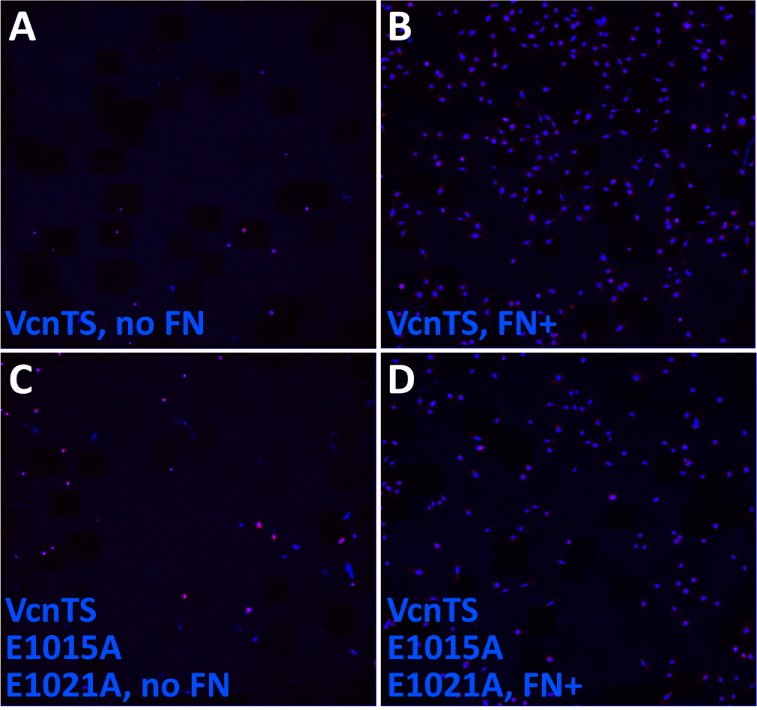

Fig. S10. Figure 8 Additional Material: Western and representative Boyden chamber assay images.

(A-D) Representative image frames of haptotaxis assay experimental results (Fig. 7H).

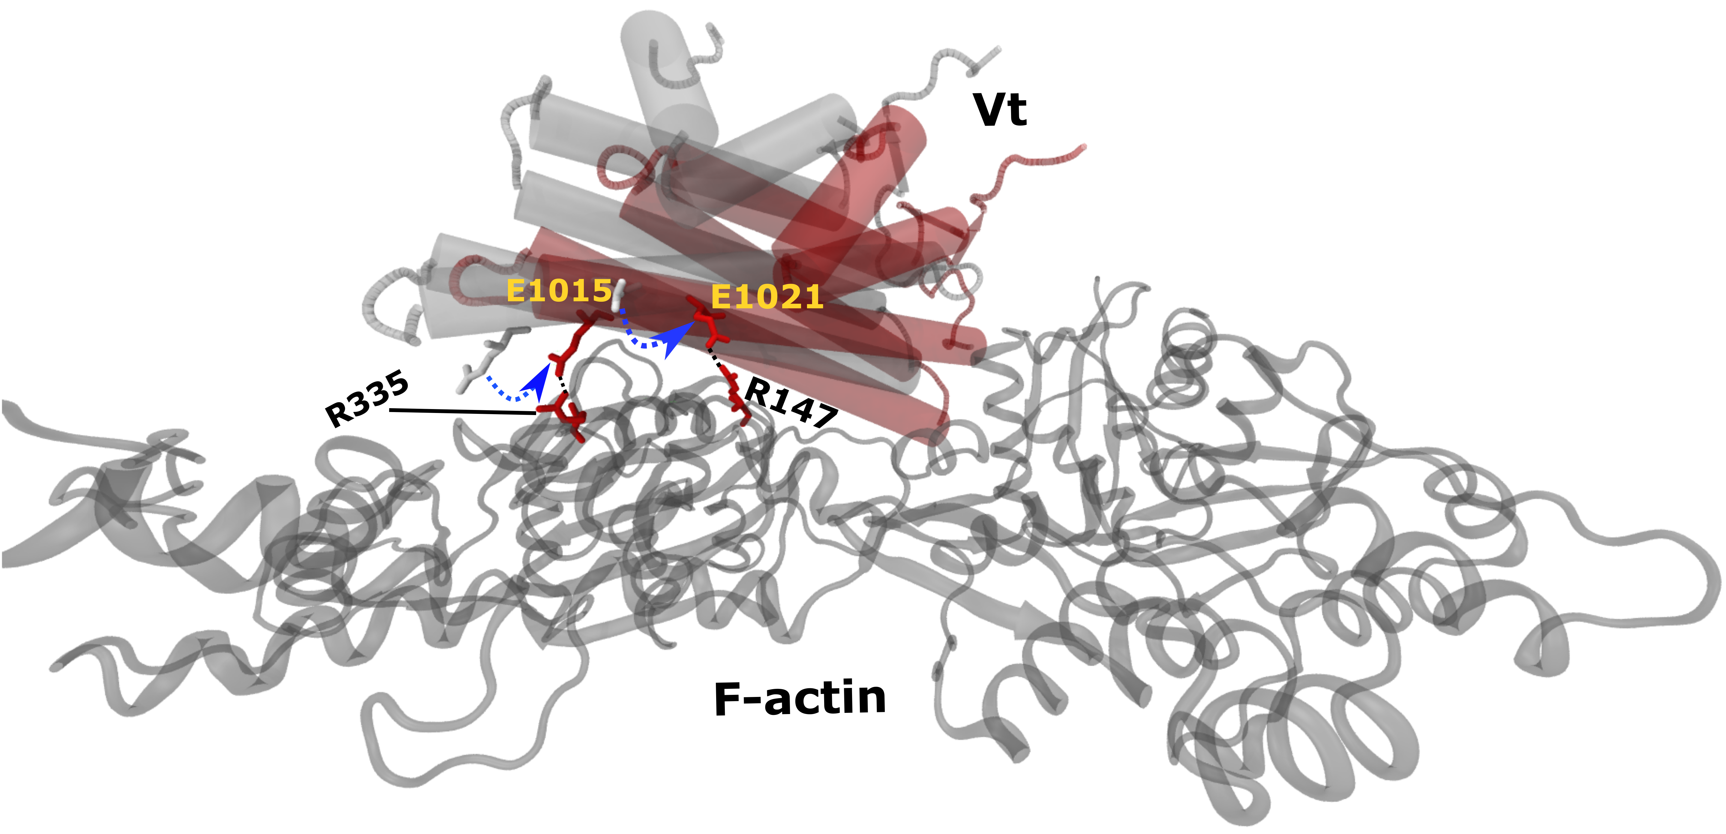

Fig. S11. F_{P}-directed pulling force induces structural changes in the Vt helical bundle to strengthen existing and new catch bonds between F-actin and Vt.

DMD pulling simulation trajectories depict twisting and conformational reorientation of helix-4 and helix-5 of Vt in the F_{P} direction that exposes side chains of E1015 and E1021 to generate a new actin binding interface. These structural changes also reinforce existing H-bonds between helix-4 of Vt and F-actin. Color scheme: Vt is shown in red and F-actin is shown in gray. The catch bond forming residue pairs are shown in licorice representation.

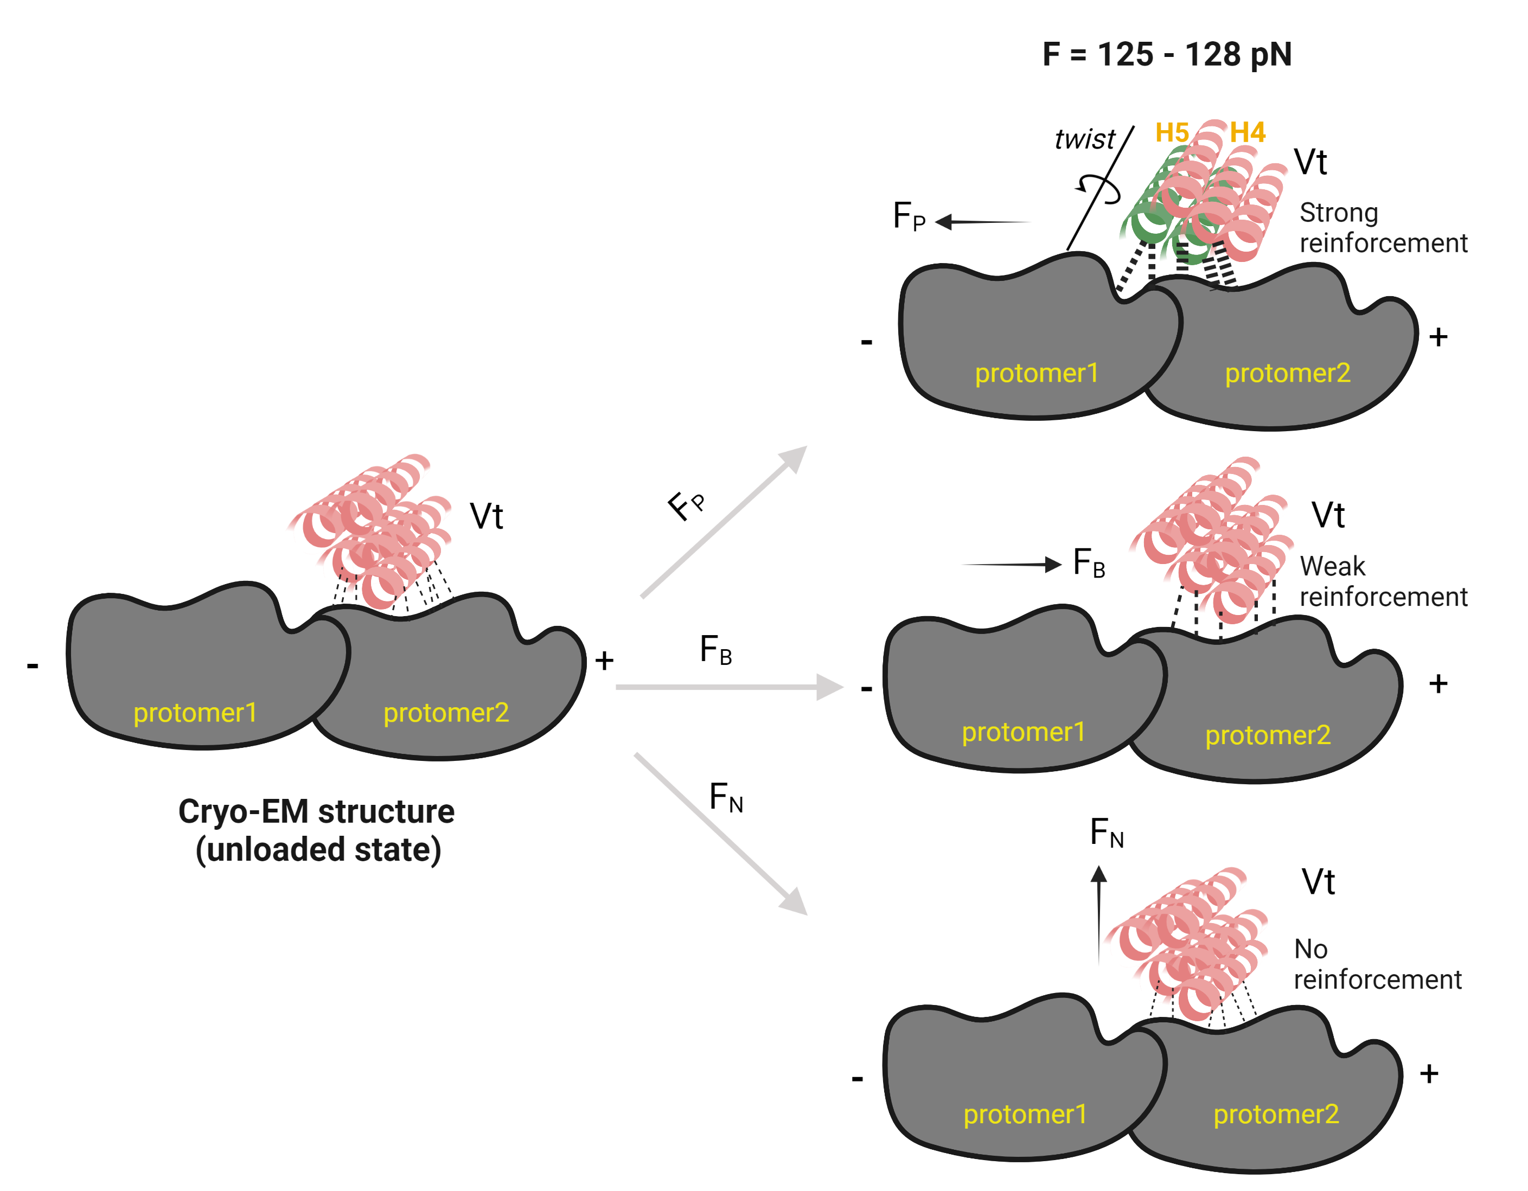

Fig. S12. A schematic representation of directional catch bonding in Vcn.

Force-induced structural changes in Vt facilitate formation of directionally asymmetric catch bonds with F-actin. Specifically, pulling force in the F_{P} direction induces a twisting rearrangement of the Vt helical bundle along the short-axis of the actin filament. This twisting motion generates a new binding interface at the C-terminal end of helix-4 and helix-5 that promotes formation of new H-bond interactions as well as strengthens existing H-bonds. In contrast, the strength of existing H-bonds in F_{B} trajectories was reduced relative to F_{P}, whereas only weak and transient interactions were observed in F_{N} trajectories.

Table S1. Detailed list of p-values for analyses involving multiple comparisons. This table, organized by figure and comparison, contains a listing of p-values for multiple comparisons made in the study.

Movies S1-S6. Trajectory movies depicting constant-force pulling of Vt by harmonically restraining the position of F-actin in three pulling directions. Movies S1, S2, and S3 visualize F-actin:Vt complex at F= 125 pN in F_{P}, F_{B}, and F_{N} directions respectively. Movies S4, S5, and S6 visualize F-actin:Vt complex at F= 130 pN in F_{P}, F_{B}, and F_{N} directions respectively.

