Supplemental File for Jiang et al. RVFScan predicts virulence factor genes and hypervirulence of the clinical metagenome

I Supplementary Materials

II Supplementary Tables
Table S1. The 24 clinically pathogenic bacteria and primary VFs and VFGs.
Table S2. VFG detection rates of A. baumannii, K. pneumoniae, and P. aeruginosa in DNA and RNA samples.
Table S3. The 53 VFGs with significantly higher detection rates in hvKps than in cKps.
Table S4. The clinical information and K. pneumoniae VFG profile of 84 infected patients.
Table S5. Diagnostic performance of the hvKp-like score by RVFScan in the prospective cohort.

III Supplementary Figures
Figure S1. The effect of sequencing depth and read length on VFG detection. a-b. The effect of sequencing depth on VFG detection by RVFScan and ShortBRED. c-d. Effect of read length on the performance of RVFScan.
Figure S2. The rate of VFG detection for pathogens ranked according to VF units. Colors represent the VFG detection rates from high to low (red to blue). a and b indicate DNA and RNA levels, respectively.
Figure S3. The functional units of high-frequency VFGs detected in DNA and RNA samples from infected patients. The left panel is the heatmap of high-frequency VFG (detection rate ≥ 0.3) in DNA samples. The right panel is the heatmap of high-frequency VFG (detection rate ≥ 0.1) in RNA samples.
Figure S4. VFG co-occurrence network in K. pneumoniae. Different colors represent different functional units. The node size represents the frequency of VFGs at the DNA level. The node label represents the VFG symbol and the frequency at the DNA and RNA levels.
Figure S5. Four most relevant P. aeruginosa VFGs detected in mNGS samples using RVFScan. The four most relevant P. aeruginosa VFGs (exoU, exoS, exoY and exoT) were validated using RVFScan based on 311 mNGS samples. A total of 86 samples with total reads of these four VFGs > = 10 were selected and presented in the cluster diagram. Green shows the presence of the VFG, while gray indicates the absence of the VFG. ExoU and exoS are mutually exclusive in P. aeruginosa. This cluster diagram indicates that RVFScan could aid in the detection of hypervirulent P. aeruginosa infections.
Supplementary Materials
Section 1: RVFScan Construction
Local VFG database
First, a total of 24 clinically pathogenic bacteria that are clinically common or highly pathogenic microorganisms causing human infectious diseases, including 14 gram-positive and 10 gram-negative bacteria, were selected in this study. Then, three public virulence factor (VF) databases, VFDB (http://www.mgc.ac.cn/VFs/), Victors (http://www.phidias.us/victors/), and Pathosystems Resource Integration Center (https://www.patricbrc.org/), were used to construct the RVFScan back-end VFG reference database. The corresponding DNA and encoded protein sequences of 2009 VFGs of 24 target pathogens (Table S1) were downloaded from the VFDB (release-2021_3) and integrated with sequences downloaded from Victors and PATRIC. After removing invalid sequences, which were annotated as hypothetical, speculative, probable, predicted, or identified as duplicates and fragments, BLASTP v2.2.30+ was used to search NCBI RefSeq (ftp://ftp.ncbi.nlm. nih.gov/refseq/release/) with the parameters of identity $≥$80% and reference coverage $≥$ 80% to obtain additional homologous VFGs, and only sequences with the best hits were retained. A similarity matrix using bit-score was generated using all-versus-all BLAST for these VFG proteins, and this matrix served as input for the Markov clustering algorithm (MCL) to create the clusters of homologous genes with inflation parameter i = 6.0. Finally, a total of 1,898,441 proteins and corresponding coding sequences (CDSs) were collected. Then, CD-hit was employed to reduce redundancy with the parameter “-c 0.98”; only one representative sequence of each cluster was kept and a total of 19,745 representative VFG sequences were stored in the local VFG database (Fig. 1 and Fig. 2a).
Criteria for VFGs
We calculated a threshold score for each gene family based on the similarity matrix of representative sequences within and between genes using an all-to-all pairwise comparison. The homology score (H-score) of each gene is the minimum similarity value of all member pairs, while the paralog score (P-score) is the maximum value of all member and intergenic sequence pairs. Therefore, the criterion for gene i is defined as the max (Pi-score, Hi-score) and is stored in the local database for VFG prediction (Fig. 2b).
VFG identification
RVFScan requires users to register an account with their email address, which facilitates the acceptance of the status of submitted tasks. Users can submit data to RVFScan in FASTQ format using a user-friendly interface (Fig. 2c). After uploading the metagenomic reads, the quality control (QC) module preprocesses them for quality scoring and removal of low-quality sequences. The retained high-quality reads (namely, "clean reads") were mapped to the local VFG database in single-ended mode using BLAST, and then VFGs were determined by the following rules: more than one read was mapped to ${Gene}_{i}$ with coverage > 95% and identity > $ω_{ }∗G_{i}$; $ω$: correction factor for read length, $G_{i}$: the criterion for gene i.

Section 2: Evaluation of RVFScan performance using the simulated mNGS datasets
We constructed the true positive (TP) and true negative (TN) datasets as the simulated datasets (Fig. 1). A total of 1031 VFG sequences of four pathogens, including two gram-positive bacteria (Staphylococcus aureus (S. aureus) and Streptococcus pneumoniae (S. pneumoniae)) and two gram-negative bacteria (A. baumannii and K. pneumoniae) were collected from the VFDB as the TP dataset. The TN dataset consisted of 2000 essential gene sequences from the Database of Essential Genes (DEG) after removing those genes with annotations similar to those of genes in the positive datasets. These genes in the negative datasets were considered essential for survival and are therefore “non-virulent”. The simulated datasets were created by spiking certain TP and TN data into the human background, and the relative abundance of each component was chosen to be as close to clinical reality as possible. For example, there was a high proportion of human DNA (95%) and relatively low proportions across the four target pathogenic bacteria, including K. pneumoniae (0.81%), A. baumannii (0.72%), S. aureus (0.54%), and S. pneumoniae (0.13%). Single-ended reads (20 M, the most common sequencing depth for clinical mNGS) were generated for each simulated dataset using gene sequences of the TP and TN datasets by WgSim software (v1.11) with read lengths of 50, 75, 100, 150, 250 and 300 bp, respectively, while the average sequencing error rate was ~0.1%, based on that for Illumina.
Evaluation definition
All these simulated datasets were analyzed by RVFScan and existing VFG prediction tools (MP3, PathoFact, DeepVF, VFanalyzer, and ShortBRED), and their performances were evaluated in terms of sensitivity (SN), specificity (SP), accuracy (ACC), and F-score.
$$SN=\frac{TP}{TP+FN}$$
$$SP=\frac{TN}{FP+TN}$$
$$ACC=\frac{TP+TN}{TP+FN+FP+TN}$$
$$F−score=2×\frac{TP}{2TP+FP+FN}$$
Here, TP indicates the number of true positives, FP indicates the number of false positives, TN indicates the number of true negatives, and FN indicates the number of false negatives.

Section 3: Clinical WGS and mNGS data of paired samples for RVFScan evaluation
Six paired mNGS and whole-genome sequencing (WGS) samples were collected to evaluate the performance of assembly-free RVFScan in the VFG assay. Each of the paired mNGS and WGS samples was analyzed for at least one of the four pathogens (P. aeruginosa, S. aureus, K. pneumoniae, and A. baumannii) by PACESeq v1.2 (Hugobiotech, Beijing, China) and Kraken2. Adapters and short or low-quality reads were removed using FASTP with the following parameters: "-c -q 20 -u 40 -n 5 -e 2-1 45 --cut_right --cut_mean_quality 20 --cut_window_size 5 --trim_poly_x". The qualified WGS reads were assembled into contigs or scaffolds using SPADES (v3.13.0) with default parameters. These assembled sequences were mapped to the local VFG database by BLAST with parameters of identity >90% and coverage >60% for VFG prediction, whereas mNGS data were predicted by RVFScan using default parameters.

Section 4: Co-occurrence network
The co-occurrence network was inferred based on the Spearman correlation matrix constructed based on VFG abundance. The VFG abundance was calculated using 16S reads (SILVA v138.1) as previously described ²⁷.
The co-occurrence network was visualized with CytoScape v3.8.2. As shown in Fig. S4, the nodes in the co-occurrence network represented the VFGs, and the edges connecting these nodes represented the co-occurrence relations between these VFGs. Namely, two VFGs detected in the same sample were considered “co-occurrence”. The cutoff of the FDR-adjusted p value was 0.05. The cutoff of the correlation coefficients was determined to be 0.7 through random matrix theory-based methods. The VFGs of each target pathogenic bacterium were divided into six VF function modules: adherence, enzyme, evasion & resistance, nutrient, secretion system and toxin.
Section 5: Clinical hvKp identification
hvKp-like score based on RVFScan and assembly-free clinical metagenomic data
The previously published and tagged hvKp strains were defined mainly based on a positive string test, carrirage of several VFGs, a wax moth (Galleria mellonella) larva infection model, a mouse systemic infection model, a human neutrophil assay, or clinical features. We collected genomes of previously published hvKp (166) and cKp (241) strains from the NCBI public database. After VFG annotation, there was a significant difference between the two groups in the detection rates of 53 VFGs in seven VFs (the difference in detection rates was > 0.3, P value < 0.05, Fish’s test). Based on this set of differential VFGs, a weighted hvKp-like score was calculated to estimate the potential likelihood of hvKp in the mNGS samples, defined as the ratio of the sum of weighted gene detection rates to the expected value.
$$hpscore=\frac{\sum_{i=1}^{n}{w_{i}×g_{i}}}{\sum_{i=1}^{n}{w_{i}×G_{i}}}$$
$hpscore$ > 40 was predicted as having suspected hvKp. where $n$ is the number of virulence factors related to hvKp; $w_{i}$ is the weighting factor for genes in each virulence factor; $g_{i}$ is the number of genes detected in each virulence factor; and $G_{i}$ is the number of expected genes in each virulence factor.
Clinically diagnosed hvKp infections and subsequent confirmation of VFG PCR and/or WGS
The suspected hvKp samples were assessed and confirmed by two senior physicians based on a positive string test and if they met three of the following clinical criteria: 1) acute onset and rapid progression due to infection and severe infection; 2) community-acquired infection; 3) nonimmunodeficiency; 4) common infection syndromes (endophthalmitis, meningitis, brain abscess, gangrenous fasciitis, splenic abscess, or epidural abscess); 5) single pathogen; and 6) multiple-site infection. In the absence of string test results due to negative culture results, high clinical presentation and therapeutic compliance with hvKp was needed, and infection was subsequently confirmed by VFG PCR or WGS detection.
The VFG PCR primers were as follows: forward and reverse PCR primers targeting the Aerobactin and RmpA genes of hvKp: Aerobactin: GCATAGGCGGATACGAACAT (forward) and CACAGGGCAATTGCTTACC (reverse); RmpA：ACTGGGCTACCTCTGCTTCA (forward) and CTTGCATGAGCCATCTTTCA (reverse). Each 25-μl PCR mixture comprised 10 μl of 2×Taq Master Mix, 10 μl of ddH2O, 2 μl of primers, and 3 μl of DNA template. The thermal cycling profile was as follows: initial denaturation at 95°C for 5 min; 35 cycles of 95°C for 30 s and 55°C for 40 s; and a final extension at 72°C for 5 min.
For WGS detection, a single colony of K. pneumoniae samples was selected, and DNA was extracted. The genomic DNA was sequenced using the Illumina NovaSeq 6000 instrument. The reads in fastq format were collected and used for preprocessing. We executed FastP (v0.20.1) to trim and filter the raw reads with the following parameters: ‘-c -q 20 -u 40 -n 5 -e 20 -l 55 --cut_right --cut_mean_quality 20 --cut_window_size 5 --trim_poly_x’. Genomes were assembled for WGS data using Unicycler (v0.4.8), a tool for assembling bacterial genomes from a combination of short and long reads, with the following parameters: ‘--min_fasta_length 500 -t 20 --keep 2’. The assembled contigs were annotated by BLAST (2.10.1+) against the custom reference database with the following parameters : ‘-evalue 1e-5 -max_target_seqs 100000 -qcov_hsp_perc 50 -perc_identity 50’. Finally, the VFGs were identified with identity >90 and qcovhsp > 60.
II Supplementary Tables
Table S1 | The 24 clinically pathogenic bacteria and primary VFs and VFGs
Species | Genus | VF | VFG | VF_function
Acinetobacter baumannii | Acinetobacter | Phospholipase C | plc | Phospholipase C contributes to the pathogenesis by aiding in the lysis of host cells, via cleavage of phospholipids present in the host cell membrane, and by degrading phospholipids present at mucosal barriers to contribute to Acinetobacter baumannii cytotoxicity.
Bacillus anthracis | Bacillus | Anthrax toxin | lef,pagA,cya | Bacillus anthracis anthrax toxin are consists of protective antigen (PA), edema factor (EF) and lethal factor (LF). The combination of PA and EF is edema toxin (EdTx), the combination of PA and LF is lethal toxin (LeTx). EdTx can cause edema and phagocytic dysfunction, increase the susceptibility of host cells, and lead to the typical edema of cutaneous anthrax. LeTx can lead to the dissolution of endothelial cells, macrophages and other cells, and is closely related to the pathogenic process of Bacillus anthracis.
Brucella melitensis | Brucella | lipopolysaccharide | pgm,manAoAg,manCoAg,pmm,wbkA,et al | Lipopolysaccharide (LPS) is an essential virulence factor of Brucella which changes the pathogen-associated molecular mode and plays a role in entry and early survival inside macrophages. The strains with S-LPS are able to restrain host cell apoptosis and contribute to avoid host immune surveillance.
Clostridium botulinum | Clostridium | Botulinum neurotoxin A | bont/a | Botulinum neurotoxin A (BoNT/A) binds and internalizes to neuronal cells, finally causes flaccid paralysis by inhibiting acetycholine release at the neuromuscular junction. Due to extreme toxicity, BoNT/A are responsible for many cases of foodborne botulism that is a severe neuroparalytic disease.
Clostridium perfringens | Clostridium | Alpha-toxin | plc | Alpha-toxin (phospholipase C), which is produced by all strains of Clostridium perfringens, it is able to hydrolyse cell membrane phospholipids, which eventually leads to hemolysis, lethality and dermonecrosis.This toxin is essential for gas gangrene pathology, especially for Clostridium perfringens type A.
Clostridium tetani | Clostridium | Tetanus toxin | tetX | Tetanus toxin (TeNT) is a neurospecific toxin that causes tetanus, a ubiquitous neurologic disease, characterized by spastic paralysis, that has a worldwide distribution in humans and animals. TeNT blocks the release of neurotransmitters and effectively block the neuronal discharge, resulting in the loss of spinal inhibitory control of motorneuron activity.
Corynebacterium diphtheriae | Corynebacterium | Diphtheria toxin | tox | Diphtheria toxin (DT) is a protein toxin produced by Corynebacterium diphtheria, which can Inhibit protein synthesis in the host cell and involve in the formation of the pharyngeal pseudomembrane in respiratory diphtheria, eventually causes diphtheria, an acute and communicable disease.
Enterococcus faecalis | Enterococcus | Cytolysin | cylL,cylS,cylM,cylR2 | Enterococcus faecalis cytolysin (Cyl) is lethal for a broad range of prokaryotic and eukaryotic cells, such as erythrocytes, polymorphonuclear leukocytes and macrophages. Cytolysin is an important determinant of lethality in endocarditis.
Enterococcus faecium | Enterococcus | Acm | acm | Acm mediates adherence to collagen and participates in the adhesion of Enterococcus faecium, which is important in endocarditis caused by E. faecium.
Escherichia coli | Escherichia | α haemolysin | hlyA,hlyB,hlyC,hlyD | The α haemolysin (HlyA), a toxin causing eukaryotic cell death and lysis by forming a pore within the cytoplasmic membrane, is produced by several pathogenic types of Escherichia coli causing extra-intestinal (cystitis, nephritis, meningitis, septicaemia in humans and animals) and intestinal (enteritis and enterotoxaemia in piglets) infections, more especially NTEC, ETEC, and VTEC strains.
Haemophilus influenzae | Haemophilus | Capsule | bexA,bexB,bexC,bexD,bsc1,et al | Capsule protects the Haemophilus influenzae strains from phagocytosis and the bactericidal activity of complement, and promotes bacterial adherence and leads to infections. The symptoms caused by unencapsulated H.influenzae strains are milder than those caused by encapsulated strains.
Klebsiella pneumoniae | Klebsiella | RmpA | rmpA | RmpA (Regulator of mucoid phenotype A) is a plasmid-located virulence factor of Klebsiella pneumoniae, regulating the synthesis of capsular polysaccharides. RmpA-carrying strains were significantly associated with high-mucus phenotype of hypervirulent K. pneumoniae (hvKP), and with purulent tissue infection such as liver abscess.
Legionella pneumophila | Legionella | Dot/Icm type IV secretion system | ralF,lidA,lepA,lepB,sidC,et al | The Dot/Icm type IV secretion system consisting of several components is the key virulence factor of Legionella pneumophila. Not only is the Dot/Icm system required for intracellular replication and the establishment of the Legionella-containing vacuole (LCV), it is also involved in bacterial entry, the inhibition of host cell apoptosis, and the egress of L. pneumophila from host cells.
Listeria monocytogenes | Listeria | Listeriolysin O | hly | The pore-forming toxin listeriolysin O (LLO) is required for host cell invasion and pathogenesis as LLO-deficient L. monocytogenes strains are avirulent. LLO forms pores across host cell membranes leading to ionic fluxes, activation of signaling pathways, and mitochondrial remodeling, which facilitate L. monocytogenes internalization, vacuolar escape, cell-to-cell spread, and intracellular proliferation.
Mycobacterium tuberculosis | Mycobacterium | ESX-1 | eccA1,eccB1,eccCa1,eccCb1,PE35,et al | Mycobacterium tuberculosis ESX-1, a type VII secretion system (T7SS) which is necessary for virulence, causes several cellular pathological effects include induction of necrosis, NOD2 signaling, type I interferon production, autophagy, lysis of macrophage, phagosomal rupture, bacterial dissemination, granuloma formation, and ESX-1 is required for survival of mycobacteria in vivo.
Neisseria meningitidis | Neisseria | Capsule | siaD/synD,siaC/synC,siaB/synB,siaA/synA,ctrA,et al | Neisseria meningitidis capsule is required for systemic invasive meningococcal disease with the ability to enhance cell attachment, cell entry, microcolony formation and to facilitate a carriage state at human mucosal surfaces, and it also results in immune escape.Non-capsular strains rarely cause invasive disease.
Pseudomonas aeruginosa | Pseudomonas | Exotoxin A | toxA | Exotoxin A (ExoA) apparently causes disease by inhibition of protein synthesis, direct cytopathic effects, and interference with cellular immune functions of the host.
Salmonella enterica | Salmonella | Typhoid toxin | cdtB | Typhoid toxin, an atypical AB toxin, is responsible for symptom development and transition from acute to chronic state during typhoid fever. In there, CdtB subunit induces G2/M cell cycle arrest through its DNase-I-like activity by damaging the host cell DNA, and inducing the DNA-damage response, which is subsequently involved in acute symptoms of typhoid fever, including fever and abdominal pain.
Staphylococcus aureus | Staphylococcus | Panton-Valentine Leucocidin | lukF-PV,lukS-PV,lukD | Panton-Valentine Leucocidin (PVL) is a cytotoxin that affects leukocytes and causes tissue necrosis and has been associated to furuncles, cutaneous abscesses and severe necrotic skin infections. PVL is strongly associated with virulent strains and could cause deadly infections in healthy people.
Streptococcus agalactiae | Streptococcus | β-hemolysin/cytolysin | cylE | β-hemolysin/cytolysin (βH/C), a pore-forming toxin that is cytolytic for a broad range of eukaryotic cells, βH/C also induces apoptosis, recruits neutrophils, stimulates cytokine release, and enhances bacterial intracellular invasion. Therefore, βH/C an important role for βH/C in invasive neonatal diseases including sepsis, pneumonia, and meningitis.
Streptococcus mutans | Streptococcus | SpaP | spaP | SpaP is a crucial adhesion and colonization factor of Streptococcus_mutans which mediates the adherence of S. mutans to the saliva-coated tooth surface by interacting specifically with a salivary component, salivary agglutinin (SAG), and SpaP is related to dental caries.
Streptococcus pneumoniae | Streptococcus | Pneumolysin | ply | Pneumolysin causes cell lysis, promotes the formation of biofilms, reduces mucus clearance of the bacterium, and it can interfere with the host's immune system. It is also a pro-inflammatory toxin which causes damage to host cells, and this pro-inflammation also assists with host-to-host transmission. Pneumolysin is associated with pneumonia, bacteremia, acute lung injury and myocardial injury.
Streptococcus pyogenes | Streptococcus | Streptococcal pyrogenic exotoxins | speK,speL,speB,speC | Streptococcal pyrogenic exotoxins, acting as superantigens which interact with major histocompatibility complex (MHC) class II molecules and a limited number of Vβ regions of the T-lymphocyte receptor to activate massive numbers of T cells nonspecifically, are responsible for the rash, strawberry tongue, and desquamation of the skin seen in scarlet fever.
Vibrio cholerae | Vibrio | Cholera toxin | ctxA,ctxB | Cholera toxin (CT), a member of the AB toxin family with unusual characteristics such as its unique structure, retrograde transport, retrotranslocation and mono-ADP-ribosyltransferase activity, induces elevated intracellular cAMP levels that provoke loss of water and electrolytes which is manifested as the typical diarrhoea.

Table S2 | VFGs detection rates of A. baumannii, K. pneumoniae, P. aeruginosa in DNA and RNA samples
Species | Gene symbol | Detection rate in DNA level | Detection rate in RNA level | Class
Acinetobacter baumannii | csgD | 0.02 | 0.21 | Adherence
Acinetobacter baumannii | pcr3 | 0.01 | 0 | Secretion_system
Acinetobacter baumannii | fleP | 0.01 | 0.01 | Adherence
Acinetobacter baumannii | flgN | 0.04 | 0.01 | Adherence
Acinetobacter baumannii | phzA1 | 0.01 | 0.01 | Unclassified
Acinetobacter baumannii | katA | 0.55 | 0.22 | Enzyme
Acinetobacter baumannii | plc | 0.72 | 0.34 | Enzyme
Acinetobacter baumannii | plc | 0.64 | 0.3 | Enzyme
Acinetobacter baumannii | plcD | 0.63 | 0.3 | Enzyme
Acinetobacter baumannii | basJ | 0.56 | 0.26 | Nutrient
Acinetobacter baumannii | basI | 0.5 | 0.14 | Nutrient
Acinetobacter baumannii | basH | 0.52 | 0.21 | Nutrient
Acinetobacter baumannii | barB | 0.63 | 0.32 | Nutrient
Acinetobacter baumannii | barA | 0.6 | 0.28 | Nutrient
Acinetobacter baumannii | basG | 0.58 | 0.22 | Nutrient
Acinetobacter baumannii | basF | 0.55 | 0.22 | Nutrient
Acinetobacter baumannii | entE | 0.61 | 0.25 | Nutrient
Acinetobacter baumannii | basD | 0.72 | 0.32 | Nutrient
Acinetobacter baumannii | basC | 0.61 | 0.23 | Nutrient
Acinetobacter baumannii | bauA | 0.61 | 0.31 | Nutrient
Acinetobacter baumannii | bauB | 0.53 | 0.23 | Nutrient
Acinetobacter baumannii | bauE | 0.51 | 0.19 | Nutrient
Acinetobacter baumannii | bauC | 0.59 | 0.15 | Nutrient
Acinetobacter baumannii | bauD | 0.59 | 0.25 | Nutrient
Acinetobacter baumannii | basB | 0.64 | 0.25 | Nutrient
Acinetobacter baumannii | basA | 0.63 | 0.29 | Nutrient
Acinetobacter baumannii | bauF | 0.51 | 0.15 | Nutrient
Acinetobacter baumannii | csuA/B | 0.45 | 0.16 | Adherence
Acinetobacter baumannii | csuA | 0.44 | 0.18 | Adherence
Acinetobacter baumannii | csuB | 0.47 | 0.2 | Adherence
Acinetobacter baumannii | csuC | 0.51 | 0.16 | Adherence
Acinetobacter baumannii | csuD | 0.64 | 0.28 | Adherence
Acinetobacter baumannii | csuE | 0.53 | 0.15 | Adherence
Acinetobacter baumannii | bap | 0.84 | 0.55 | Adherence
Acinetobacter baumannii | pgaA | 0.68 | 0.3 | Adherence
Acinetobacter baumannii | pgaB | 0.6 | 0.25 | Adherence
Acinetobacter baumannii | pgaC | 0.6 | 0.24 | Adherence
Acinetobacter baumannii | pgaD | 0.4 | 0.12 | Adherence
Acinetobacter baumannii | adeF | 0.61 | 0.2 | Adherence
Acinetobacter baumannii | adeG | 0.7 | 0.38 | Adherence
Acinetobacter baumannii | adeH | 0.63 | 0.25 | Adherence
Acinetobacter baumannii | ompA | 0.58 | 0.49 | Adherence
Acinetobacter baumannii | abaI | 0.47 | 0.14 | Evasion_Resistance
Acinetobacter baumannii | abaR | 0.53 | 0.18 | Evasion_Resistance
Acinetobacter baumannii | bfmR | 0.54 | 0.19 | Evasion_Resistance
Acinetobacter baumannii | bfmS | 0.65 | 0.35 | Evasion_Resistance
Acinetobacter baumannii | spcS | 0.03 | 0.01 | Secretion_system
Acinetobacter baumannii | fimE | 0.05 | 0 | Adherence
Acinetobacter baumannii | fimA | 0.05 | 0.01 | Adherence
Acinetobacter baumannii | fimC | 0.06 | 0.02 | Adherence
Acinetobacter baumannii | entD | 0.02 | 0 | Nutrient
Acinetobacter baumannii | vipA/tssB | 0.04 | 0.01 | Secretion_system
Acinetobacter baumannii | dotU/tssL | 0.06 | 0.01 | Secretion_system
Acinetobacter baumannii | sciN/tssJ | 0.09 | 0.03 | Secretion_system
Acinetobacter baumannii | galF | 0.02 | 0 | Evasion_Resistance
Acinetobacter baumannii | rcsB | 0.11 | 0.05 | Evasion_Resistance
Acinetobacter baumannii | fimF | 0.02 | 0.03 | Adherence
Acinetobacter baumannii | fimG | 0.02 | 0 | Adherence
Acinetobacter baumannii | algQ | 0.04 | 0.02 | Evasion_Resistance
Acinetobacter baumannii | algU | 0.03 | 0.02 | Evasion_Resistance
Acinetobacter baumannii | pilT | 0.56 | 0.25 | Adherence
Acinetobacter baumannii | pilG | 0.02 | 0.01 | Adherence
Acinetobacter baumannii | icaR | 0.02 | 0 | Adherence
Pseudomonas aeruginosa | xcpV | 0.33 | 0.07 | Secretion_system
Pseudomonas aeruginosa | xcpU | 0.37 | 0.11 | Secretion_system
Pseudomonas aeruginosa | xcpT | 0.31 | 0.08 | Secretion_system
Pseudomonas aeruginosa | xcpS | 0.46 | 0.14 | Secretion_system
Pseudomonas aeruginosa | xcpR | 0.47 | 0.19 | Secretion_system
Pseudomonas aeruginosa | xcpP | 0.38 | 0.14 | Secretion_system
Pseudomonas aeruginosa | xcpQ | 0.56 | 0.19 | Secretion_system
Pseudomonas aeruginosa | pscU | 0.47 | 0.13 | Secretion_system
Pseudomonas aeruginosa | pscT | 0.41 | 0.12 | Secretion_system
Pseudomonas aeruginosa | pscS | 0.22 | 0.06 | Secretion_system
Pseudomonas aeruginosa | pscR | 0.39 | 0.13 | Secretion_system
Pseudomonas aeruginosa | pscQ | 0.42 | 0.11 | Secretion_system
Pseudomonas aeruginosa | pscP | 0.31 | 0.05 | Secretion_system
Pseudomonas aeruginosa | pscO | 0.31 | 0.07 | Secretion_system
Pseudomonas aeruginosa | pscN | 0.42 | 0.12 | Secretion_system
Pseudomonas aeruginosa | popN | 0.43 | 0.12 | Secretion_system
Pseudomonas aeruginosa | pcr1 | 0.28 | 0.04 | Secretion_system
Pseudomonas aeruginosa | cheY | 0.27 | 0.12 | Adherence
Pseudomonas aeruginosa | pcr2 | 0.27 | 0.05 | Secretion_system
Pseudomonas aeruginosa | pcr3 | 0.28 | 0.02 | Secretion_system
Pseudomonas aeruginosa | pcr4 | 0.26 | 0.06 | Secretion_system
Pseudomonas aeruginosa | pcrD | 0.52 | 0.19 | Secretion_system
Pseudomonas aeruginosa | pcrR | 0.27 | 0.03 | Secretion_system
Pseudomonas aeruginosa | pcrG | 0.28 | 0.07 | Secretion_system
Pseudomonas aeruginosa | pcrV | 0.38 | 0.12 | Secretion_system
Pseudomonas aeruginosa | pcrH | 0.35 | 0.09 | Secretion_system
Pseudomonas aeruginosa | popB | 0.48 | 0.14 | Secretion_system
Pseudomonas aeruginosa | popD | 0.41 | 0.13 | Secretion_system
Pseudomonas aeruginosa | exsC | 0.31 | 0.1 | Secretion_system
Pseudomonas aeruginosa | exsE | 0.28 | 0.05 | Secretion_system
Pseudomonas aeruginosa | flgB | 0.32 | 0.11 | Adherence
Pseudomonas aeruginosa | fleI/flag | 0.09 | 0.03 | Adherence
Pseudomonas aeruginosa | fliS | 0.1 | 0.02 | Adherence
Pseudomonas aeruginosa | fleP | 0.03 | 0.01 | Adherence
Pseudomonas aeruginosa | fleS | 0.48 | 0.15 | Adherence
Pseudomonas aeruginosa | fliK | 0.48 | 0.12 | Adherence
Pseudomonas aeruginosa | fliL | 0.36 | 0.09 | Adherence
Pseudomonas aeruginosa | fliA | 0.42 | 0.18 | Adherence
Pseudomonas aeruginosa | exsB | 0.31 | 0.08 | Secretion_system
Pseudomonas aeruginosa | flgA | 0.37 | 0.13 | Adherence
Pseudomonas aeruginosa | flgM | 0.27 | 0.06 | Adherence
Pseudomonas aeruginosa | flgN | 0.33 | 0.11 | Adherence
Pseudomonas aeruginosa | motB | 0.47 | 0.13 | Adherence
Pseudomonas aeruginosa | motA | 0.43 | 0.21 | Adherence
Pseudomonas aeruginosa | motC | 0.39 | 0.18 | Adherence
Pseudomonas aeruginosa | motD | 0.4 | 0.12 | Adherence
Pseudomonas aeruginosa | motY | 0.44 | 0.11 | Adherence
Pseudomonas aeruginosa | algC | 0.62 | 0.38 | Evasion_Resistance
Pseudomonas aeruginosa | mucD | 0.51 | 0.17 | Evasion_Resistance
Pseudomonas aeruginosa | exsA | 0.41 | 0.13 | Secretion_system
Pseudomonas aeruginosa | algW | 0.47 | 0.13 | Evasion_Resistance
Pseudomonas aeruginosa | mucE | 0.32 | 0.1 | Evasion_Resistance
Pseudomonas aeruginosa | mucP | 0.47 | 0.13 | Evasion_Resistance
Pseudomonas aeruginosa | rhlC | 0.53 | 0.18 | Evasion_Resistance
Pseudomonas aeruginosa | exoU | 0.17 | 0.06 | Secretion_system
Pseudomonas aeruginosa | phzA1 | 0.42 | 0.13 | Unclassified
Pseudomonas aeruginosa | phzB1 | 0.25 | 0.07 | Unclassified
Pseudomonas aeruginosa | phzC1 | 0.55 | 0.19 | Unclassified
Pseudomonas aeruginosa | phzD1 | 0.46 | 0.14 | Unclassified
Pseudomonas aeruginosa | phzE1 | 0.63 | 0.23 | Unclassified
Pseudomonas aeruginosa | exsD | 0.43 | 0.12 | Secretion_system
Pseudomonas aeruginosa | phzF1 | 0.42 | 0.11 | Unclassified
Pseudomonas aeruginosa | phzG1 | 0.49 | 0.16 | Unclassified
Pseudomonas aeruginosa | phzH | 0.51 | 0.2 | Unclassified
Pseudomonas aeruginosa | pvdQ | 0.55 | 0.18 | Nutrient
Pseudomonas aeruginosa | pvdP | 0.52 | 0.2 | Nutrient
Pseudomonas aeruginosa | pvdM | 0.51 | 0.2 | Nutrient
Pseudomonas aeruginosa | pvdN | 0.44 | 0.16 | Nutrient
Pseudomonas aeruginosa | pvdO | 0.31 | 0.07 | Nutrient
Pseudomonas aeruginosa | pvdF | 0.41 | 0.2 | Nutrient
Pseudomonas aeruginosa | pvdJ | 0.46 | 0.18 | Nutrient
Pseudomonas aeruginosa | pscB | 0.33 | 0.09 | Secretion_system
Pseudomonas aeruginosa | pvdI | 0.62 | 0.29 | Nutrient
Pseudomonas aeruginosa | pvdH | 0.55 | 0.27 | Nutrient
Pseudomonas aeruginosa | pvdL | 0.77 | 0.39 | Nutrient
Pseudomonas aeruginosa | pvdG | 0.39 | 0.11 | Nutrient
Pseudomonas aeruginosa | pscC | 0.44 | 0.13 | Secretion_system
Pseudomonas aeruginosa | pscD | 0.43 | 0.15 | Secretion_system
Pseudomonas aeruginosa | pscE | 0.22 | 0.03 | Secretion_system
Pseudomonas aeruginosa | pscF | 0.27 | 0.08 | Secretion_system
Pseudomonas aeruginosa | pscG | 0.3 | 0.06 | Secretion_system
Pseudomonas aeruginosa | pscH | 0.31 | 0.04 | Secretion_system
Pseudomonas aeruginosa | pscI | 0.28 | 0.11 | Secretion_system
Pseudomonas aeruginosa | pscJ | 0.36 | 0.11 | Secretion_system
Pseudomonas aeruginosa | katA | 0.06 | 0.01 | Enzyme
Pseudomonas aeruginosa | pscK | 0.38 | 0.12 | Secretion_system
Pseudomonas aeruginosa | pscL | 0.36 | 0.11 | Secretion_system
Pseudomonas aeruginosa | basI | 0.05 | 0.01 | Nutrient
Pseudomonas aeruginosa | tagQ | 0.49 | 0.15 | Secretion_system
Pseudomonas aeruginosa | vgrG1b | 0.32 | 0.12 | Secretion_system
Pseudomonas aeruginosa | tse1 | 0.34 | 0.07 | Secretion_system
Pseudomonas aeruginosa | tse2 | 0.31 | 0.11 | Secretion_system
Pseudomonas aeruginosa | tse3 | 0.49 | 0.14 | Secretion_system
Pseudomonas aeruginosa | spcS | 0.23 | 0.06 | Secretion_system
Pseudomonas aeruginosa | spcU | 0.12 | 0.05 | Secretion_system
Pseudomonas aeruginosa | pvcA | 0.38 | 0.08 | Nutrient
Pseudomonas aeruginosa | pvcB | 0.38 | 0.12 | Nutrient
Pseudomonas aeruginosa | pvcC | 0.48 | 0.09 | Nutrient
Pseudomonas aeruginosa | pvcD | 0.34 | 0.06 | Nutrient
Pseudomonas aeruginosa | ptxR | 0.43 | 0.12 | Nutrient
Pseudomonas aeruginosa | mbtH-like | 0.26 | 0.12 | Nutrient
Pseudomonas aeruginosa | vipA/tssB | 0.01 | 0 | Secretion_system
Pseudomonas aeruginosa | exlA | 0.01 | 0 | Toxin
Pseudomonas aeruginosa | pilA | 0.13 | 0.07 | Adherence
Pseudomonas aeruginosa | pilB | 0.56 | 0.26 | Adherence
Pseudomonas aeruginosa | pilC | 0.48 | 0.21 | Adherence
Pseudomonas aeruginosa | xcpA/pilD | 0.46 | 0.14 | Adherence
Pseudomonas aeruginosa | toxA | 0.46 | 0.16 | Toxin
Pseudomonas aeruginosa | algB | 0.57 | 0.33 | Evasion_Resistance
Pseudomonas aeruginosa | algP/algR3 | 0.49 | 0.13 | Evasion_Resistance
Pseudomonas aeruginosa | algQ | 0.17 | 0.03 | Evasion_Resistance
Pseudomonas aeruginosa | algR | 0.43 | 0.17 | Evasion_Resistance
Pseudomonas aeruginosa | algZ | 0.54 | 0.24 | Evasion_Resistance
Pseudomonas aeruginosa | algU | 0.33 | 0.14 | Evasion_Resistance
Pseudomonas aeruginosa | algD | 0.47 | 0.19 | Evasion_Resistance
Pseudomonas aeruginosa | alg8 | 0.54 | 0.23 | Evasion_Resistance
Pseudomonas aeruginosa | alg44 | 0.51 | 0.16 | Evasion_Resistance
Pseudomonas aeruginosa | pilV | 0.34 | 0.12 | Adherence
Pseudomonas aeruginosa | pilW | 0.4 | 0.14 | Adherence
Pseudomonas aeruginosa | pilX | 0.34 | 0.1 | Adherence
Pseudomonas aeruginosa | pilY1 | 0.55 | 0.23 | Adherence
Pseudomonas aeruginosa | pilY2 | 0.26 | 0.04 | Adherence
Pseudomonas aeruginosa | algK | 0.49 | 0.13 | Evasion_Resistance
Pseudomonas aeruginosa | pilE | 0.27 | 0.12 | Adherence
Pseudomonas aeruginosa | pilS | 0.49 | 0.21 | Adherence
Pseudomonas aeruginosa | pilR | 0.48 | 0.22 | Adherence
Pseudomonas aeruginosa | fimT | 0.38 | 0.11 | Adherence
Pseudomonas aeruginosa | fimU | 0.33 | 0.08 | Adherence
Pseudomonas aeruginosa | pilF | 0.48 | 0.18 | Adherence
Pseudomonas aeruginosa | pilQ | 0.63 | 0.26 | Adherence
Pseudomonas aeruginosa | pilP | 0.43 | 0.12 | Adherence
Pseudomonas aeruginosa | pilO | 0.37 | 0.12 | Adherence
Pseudomonas aeruginosa | pilN | 0.42 | 0.1 | Adherence
Pseudomonas aeruginosa | algE | 0.51 | 0.13 | Evasion_Resistance
Pseudomonas aeruginosa | pilM | 0.48 | 0.17 | Adherence
Pseudomonas aeruginosa | pilT | 0.47 | 0.36 | Adherence
Pseudomonas aeruginosa | pilU | 0.5 | 0.17 | Adherence
Pseudomonas aeruginosa | pilG | 0.36 | 0.16 | Adherence
Pseudomonas aeruginosa | pilH | 0.33 | 0.09 | Adherence
Pseudomonas aeruginosa | pilI | 0.37 | 0.07 | Adherence
Pseudomonas aeruginosa | pilJ | 0.58 | 0.19 | Adherence
Pseudomonas aeruginosa | pilK | 0.51 | 0.17 | Adherence
Pseudomonas aeruginosa | fimV | 0.57 | 0.19 | Adherence
Pseudomonas aeruginosa | chpA | 0.76 | 0.47 | Adherence
Pseudomonas aeruginosa | algG | 0.57 | 0.17 | Evasion_Resistance
Pseudomonas aeruginosa | chpB | 0.46 | 0.15 | Adherence
Pseudomonas aeruginosa | chpC | 0.34 | 0.12 | Adherence
Pseudomonas aeruginosa | chpD | 0.46 | 0.11 | Adherence
Pseudomonas aeruginosa | chpE | 0.44 | 0.11 | Adherence
Pseudomonas aeruginosa | flgC | 0.36 | 0.12 | Adherence
Pseudomonas aeruginosa | flgD | 0.4 | 0.13 | Adherence
Pseudomonas aeruginosa | flgE | 0.49 | 0.18 | Adherence
Pseudomonas aeruginosa | flgF | 0.41 | 0.14 | Adherence
Pseudomonas aeruginosa | flgG | 0.46 | 0.29 | Adherence
Pseudomonas aeruginosa | flgH | 0.43 | 0.12 | Adherence
Pseudomonas aeruginosa | algX | 0.36 | 0.09 | Evasion_Resistance
Pseudomonas aeruginosa | flgI | 0.48 | 0.22 | Adherence
Pseudomonas aeruginosa | flgJ | 0.36 | 0.12 | Adherence
Pseudomonas aeruginosa | flgK | 0.56 | 0.26 | Adherence
Pseudomonas aeruginosa | flgL | 0.33 | 0.08 | Adherence
Pseudomonas aeruginosa | fliC | 0.37 | 0.12 | Adherence
Pseudomonas aeruginosa | fliD | 0.12 | 0.02 | Adherence
Pseudomonas aeruginosa | fleQ | 0.58 | 0.3 | Adherence
Pseudomonas aeruginosa | fleR | 0.49 | 0.15 | Adherence
Pseudomonas aeruginosa | fliE | 0.31 | 0.1 | Adherence
Pseudomonas aeruginosa | fliF | 0.41 | 0.14 | Adherence
Pseudomonas aeruginosa | algL | 0.48 | 0.13 | Evasion_Resistance
Pseudomonas aeruginosa | fliG | 0.46 | 0.36 | Adherence
Pseudomonas aeruginosa | fliH | 0.24 | 0.07 | Adherence
Pseudomonas aeruginosa | fliI | 0.54 | 0.26 | Adherence
Pseudomonas aeruginosa | fliJ | 0.37 | 0.08 | Adherence
Pseudomonas aeruginosa | fliM | 0.47 | 0.31 | Adherence
Pseudomonas aeruginosa | fliN | 0.34 | 0.07 | Adherence
Pseudomonas aeruginosa | fliO | 0.23 | 0.03 | Adherence
Pseudomonas aeruginosa | fliP | 0.41 | 0.45 | Adherence
Pseudomonas aeruginosa | fliQ | 0.23 | 0.06 | Adherence
Pseudomonas aeruginosa | fliR | 0.43 | 0.13 | Adherence
Pseudomonas aeruginosa | algI | 0.54 | 0.22 | Evasion_Resistance
Pseudomonas aeruginosa | flhB | 0.44 | 0.13 | Adherence
Pseudomonas aeruginosa | flhA | 0.58 | 0.32 | Adherence
Pseudomonas aeruginosa | flhF | 0.44 | 0.14 | Adherence
Pseudomonas aeruginosa | fleN | 0.44 | 0.27 | Adherence
Pseudomonas aeruginosa | pchI | 0.52 | 0.12 | Nutrient
Pseudomonas aeruginosa | pchH | 0.54 | 0.17 | Nutrient
Pseudomonas aeruginosa | pchG | 0.41 | 0.09 | Nutrient
Pseudomonas aeruginosa | algJ | 0.52 | 0.17 | Evasion_Resistance
Pseudomonas aeruginosa | algF | 0.4 | 0.12 | Evasion_Resistance
Pseudomonas aeruginosa | algA | 0.5 | 0.17 | Evasion_Resistance
Pseudomonas aeruginosa | mucA | 0.38 | 0.17 | Evasion_Resistance
Pseudomonas aeruginosa | mucB | 0.47 | 0.15 | Evasion_Resistance
Pseudomonas aeruginosa | mucC | 0.33 | 0.13 | Evasion_Resistance
Pseudomonas aeruginosa | wzz | 0.06 | 0 | Adherence
Pseudomonas aeruginosa | wzy | 0.06 | 0.02 | Adherence
Pseudomonas aeruginosa | waaG | 0.53 | 0.21 | Adherence
Pseudomonas aeruginosa | waaP | 0.4 | 0.13 | Adherence
Pseudomonas aeruginosa | waaA | 0.52 | 0.16 | Adherence
Pseudomonas aeruginosa | waaC | 0.49 | 0.17 | Adherence
Pseudomonas aeruginosa | waaF | 0.45 | 0.17 | Adherence
Pseudomonas aeruginosa | aprA | 0.52 | 0.2 | Enzyme
Pseudomonas aeruginosa | lasA | 0.46 | 0.14 | Enzyme
Pseudomonas aeruginosa | lasB | 0.54 | 0.17 | Enzyme
Pseudomonas aeruginosa | exoS | 0.34 | 0.12 | Secretion_system
Pseudomonas aeruginosa | exoT | 0.51 | 0.23 | Secretion_system
Pseudomonas aeruginosa | exoY | 0.41 | 0.12 | Secretion_system
Pseudomonas aeruginosa | rhlI | 0.41 | 0.14 | Evasion_Resistance
Pseudomonas aeruginosa | lasI | 0.38 | 0.13 | Evasion_Resistance
Pseudomonas aeruginosa | rhlB | 0.51 | 0.16 | Evasion_Resistance
Pseudomonas aeruginosa | rhlA | 0.43 | 0.13 | Evasion_Resistance
Pseudomonas aeruginosa | plcH | 0.59 | 0.26 | Toxin
Pseudomonas aeruginosa | pvdA | 0.44 | 0.13 | Nutrient
Pseudomonas aeruginosa | tagR | 0.56 | 0.17 | Secretion_system
Pseudomonas aeruginosa | tagS | 0.31 | 0.03 | Secretion_system
Pseudomonas aeruginosa | tagT | 0.38 | 0.08 | Secretion_system
Pseudomonas aeruginosa | pvdE | 0.24 | 0.09 | Nutrient
Pseudomonas aeruginosa | ppkA | 0.66 | 0.21 | Secretion_system
Pseudomonas aeruginosa | pppA | 0.42 | 0.09 | Secretion_system
Pseudomonas aeruginosa | tagF/pppB | 0.33 | 0.07 | Secretion_system
Pseudomonas aeruginosa | icmF1/tssM1 | 0.71 | 0.23 | Secretion_system
Pseudomonas aeruginosa | dotU1 | 0.56 | 0.15 | Secretion_system
Pseudomonas aeruginosa | hsiJ1 | 0.44 | 0.12 | Secretion_system
Pseudomonas aeruginosa | lip1 | 0.41 | 0.1 | Secretion_system
Pseudomonas aeruginosa | fha1 | 0.53 | 0.14 | Secretion_system
Pseudomonas aeruginosa | hsiA1 | 0.49 | 0.15 | Secretion_system
Pseudomonas aeruginosa | hsiB1/vipA | 0.37 | 0.13 | Secretion_system
Pseudomonas aeruginosa | pvdD | 0.24 | 0.08 | Nutrient
Pseudomonas aeruginosa | hsiC1/vipB | 0.57 | 0.31 | Secretion_system
Pseudomonas aeruginosa | hcp1 | 0.36 | 0.13 | Secretion_system
Pseudomonas aeruginosa | hsiE1 | 0.47 | 0.09 | Secretion_system
Pseudomonas aeruginosa | hsiF1 | 0.39 | 0.11 | Secretion_system
Pseudomonas aeruginosa | hsiG1 | 0.58 | 0.24 | Secretion_system
Pseudomonas aeruginosa | hsiH1 | 0.47 | 0.13 | Secretion_system
Pseudomonas aeruginosa | clpV1 | 0.67 | 0.36 | Secretion_system
Pseudomonas aeruginosa | vgrG1a | 0.26 | 0.08 | Secretion_system
Pseudomonas aeruginosa | pvdS | 0.38 | 0.15 | Nutrient
Pseudomonas aeruginosa | fpvA | 0.22 | 0.07 | Nutrient
Pseudomonas aeruginosa | fptA | 0.63 | 0.22 | Nutrient
Pseudomonas aeruginosa | pchF | 0.72 | 0.26 | Nutrient
Pseudomonas aeruginosa | pchE | 0.69 | 0.25 | Nutrient
Pseudomonas aeruginosa | pchR | 0.46 | 0.11 | Nutrient
Pseudomonas aeruginosa | pchD | 0.52 | 0.16 | Nutrient
Pseudomonas aeruginosa | pchC | 0.41 | 0.08 | Nutrient
Pseudomonas aeruginosa | pchB | 0.3 | 0.1 | Nutrient
Pseudomonas aeruginosa | pchA | 0.51 | 0.18 | Nutrient
Pseudomonas aeruginosa | phzM | 0.46 | 0.12 | Nutrient
Pseudomonas aeruginosa | phzS | 0.47 | 0.18 | Nutrient
Pseudomonas aeruginosa | xcpZ | 0.36 | 0.05 | Secretion_system
Pseudomonas aeruginosa | xcpY | 0.41 | 0.1 | Secretion_system
Pseudomonas aeruginosa | xcpX | 0.46 | 0.1 | Secretion_system
Pseudomonas aeruginosa | xcpW | 0.39 | 0.08 | Secretion_system
Klebsiella pneumoniae | acrA | 0.54 | 0.26 | Evasion_Resistance
Klebsiella pneumoniae | acrB | 0.72 | 0.39 | Evasion_Resistance
Klebsiella pneumoniae | allA | 0.04 | 0.01 | Evasion_Resistance
Klebsiella pneumoniae | allB | 0.06 | 0.02 | Evasion_Resistance
Klebsiella pneumoniae | allC | 0.06 | 0.02 | Evasion_Resistance
Klebsiella pneumoniae | allD | 0.06 | 0.02 | Evasion_Resistance
Klebsiella pneumoniae | allR | 0.05 | 0.02 | Evasion_Resistance
Klebsiella pneumoniae | allS | 0.06 | 0.02 | Evasion_Resistance
Klebsiella pneumoniae | clbA | 0.07 | 0.02 | Toxin
Klebsiella pneumoniae | clbB | 0.09 | 0.02 | Toxin
Klebsiella pneumoniae | clbC | 0.07 | 0.02 | Toxin
Klebsiella pneumoniae | clbD | 0.06 | 0.02 | Toxin
Klebsiella pneumoniae | clbE | 0.04 | 0.01 | Toxin
Klebsiella pneumoniae | clbF | 0.07 | 0.02 | Toxin
Klebsiella pneumoniae | clbG | 0.07 | 0.02 | Toxin
Klebsiella pneumoniae | clbH | 0.09 | 0.02 | Toxin
Klebsiella pneumoniae | clbI | 0.08 | 0.02 | Toxin
Klebsiella pneumoniae | clbJ | 0.08 | 0.02 | Toxin
Klebsiella pneumoniae | clbK | 0.08 | 0.04 | Toxin
Klebsiella pneumoniae | clbL | 0.06 | 0.02 | Toxin
Klebsiella pneumoniae | clbM | 0.07 | 0.02 | Toxin
Klebsiella pneumoniae | clbN | 0.08 | 0.04 | Toxin
Klebsiella pneumoniae | clbO | 0.1 | 0.02 | Toxin
Klebsiella pneumoniae | clbP | 0.07 | 0.02 | Toxin
Klebsiella pneumoniae | clbQ | 0.05 | 0.02 | Toxin
Klebsiella pneumoniae | clbS | 0.05 | 0.01 | Toxin
Klebsiella pneumoniae | clpV/tssH | 0.61 | 0.23 | Secretion_system
Klebsiella pneumoniae | cpsACP | 0.44 | 0.17 | Evasion_Resistance
Klebsiella pneumoniae | dotU/tssL | 0.29 | 0.07 | Secretion_system
Klebsiella pneumoniae | entA | 0.49 | 0.21 | Nutrient
Klebsiella pneumoniae | entB | 0.53 | 0.23 | Nutrient
Klebsiella pneumoniae | entC | 0.53 | 0.22 | Nutrient
Klebsiella pneumoniae | entD | 0.43 | 0.17 | Nutrient
Klebsiella pneumoniae | entE | 0.59 | 0.28 | Nutrient
Klebsiella pneumoniae | entF | 0.66 | 0.27 | Nutrient
Klebsiella pneumoniae | fepA | 0.62 | 0.27 | Nutrient
Klebsiella pneumoniae | fepB | 0.51 | 0.19 | Nutrient
Klebsiella pneumoniae | fepC | 0.49 | 0.21 | Nutrient
Klebsiella pneumoniae | fepD | 0.51 | 0.17 | Nutrient
Klebsiella pneumoniae | fepG | 0.51 | 0.17 | Nutrient
Klebsiella pneumoniae | fes | 0.55 | 0.19 | Nutrient
Klebsiella pneumoniae | fimA | 0.33 | 0.1 | Adherence
Klebsiella pneumoniae | fimB | 0.47 | 0.14 | Adherence
Klebsiella pneumoniae | fimC | 0.3 | 0.1 | Adherence
Klebsiella pneumoniae | fimD | 0.67 | 0.25 | Adherence
Klebsiella pneumoniae | fimE | 0.43 | 0.15 | Adherence
Klebsiella pneumoniae | fimF | 0.44 | 0.13 | Adherence
Klebsiella pneumoniae | fimG | 0.45 | 0.2 | Adherence
Klebsiella pneumoniae | fimH | 0.49 | 0.13 | Adherence
Klebsiella pneumoniae | fimI | 0.48 | 0.14 | Adherence
Klebsiella pneumoniae | fimK | 0.58 | 0.23 | Adherence
Klebsiella pneumoniae | fyuA | 0.04 | 0.02 | Nutrient
Klebsiella pneumoniae | galF | 0.45 | 0.18 | Evasion_Resistance
Klebsiella pneumoniae | glf | 0.38 | 0.15 | Evasion_Resistance
Klebsiella pneumoniae | gmd | 0.07 | 0.02 | Evasion_Resistance
Klebsiella pneumoniae | gnd | 0.56 | 0.26 | Evasion_Resistance
Klebsiella pneumoniae | hcp/tssD | 0.38 | 0.16 | Secretion_system
Klebsiella pneumoniae | icmF/tssM | 0.57 | 0.22 | Secretion_system
Klebsiella pneumoniae | impA/tssA | 0.52 | 0.18 | Secretion_system
Klebsiella pneumoniae | iroB | 0.22 | 0.1 | Nutrient
Klebsiella pneumoniae | iroC | 0.28 | 0.11 | Nutrient
Klebsiella pneumoniae | iroD | 0.24 | 0.07 | Nutrient
Klebsiella pneumoniae | iroE | 0.47 | 0.16 | Nutrient
Klebsiella pneumoniae | iroN | 0.3 | 0.1 | Nutrient
Klebsiella pneumoniae | irp1 | 0.02 | 0.02 | Nutrient
Klebsiella pneumoniae | irp2 | 0.49 | 0.25 | Nutrient
Klebsiella pneumoniae | iucA | 0.33 | 0.16 | Nutrient
Klebsiella pneumoniae | iucB | 0.31 | 0.12 | Nutrient
Klebsiella pneumoniae | iucC | 0.31 | 0.17 | Nutrient
Klebsiella pneumoniae | iucD | 0.3 | 0.13 | Nutrient
Klebsiella pneumoniae | iutA | 0.13 | 0.05 | Nutrient
Klebsiella pneumoniae | kdsA | 0.46 | 0.21 | Toxin
Klebsiella pneumoniae | kfoC | 0.18 | 0.05 | Evasion_Resistance
Klebsiella pneumoniae | KPHS_23120 | 0.18 | 0.06 | Secretion_system
Klebsiella pneumoniae | magA/wzy_K1 | 0.05 | 0.02 | Evasion_Resistance
Klebsiella pneumoniae | manB | 0.47 | 0.19 | Evasion_Resistance
Klebsiella pneumoniae | manC | 0.44 | 0.17 | Evasion_Resistance
Klebsiella pneumoniae | mrkA | 0.34 | 0.12 | Adherence
Klebsiella pneumoniae | mrkB | 0.48 | 0.14 | Adherence
Klebsiella pneumoniae | mrkC | 0.62 | 0.25 | Adherence
Klebsiella pneumoniae | mrkD | 0.44 | 0.13 | Adherence
Klebsiella pneumoniae | mrkF | 0.36 | 0.14 | Adherence
Klebsiella pneumoniae | mrkH | 0.44 | 0.16 | Adherence
Klebsiella pneumoniae | mrkI | 0.42 | 0.14 | Adherence
Klebsiella pneumoniae | mrkJ | 0.4 | 0.15 | Adherence
Klebsiella pneumoniae | ompA | 0.51 | 0.31 | Evasion_Resistance
Klebsiella pneumoniae | rcsA | 0.44 | 0.17 | Evasion_Resistance
Klebsiella pneumoniae | rcsB | 0.21 | 0.11 | Evasion_Resistance
Klebsiella pneumoniae | rmpA | 0.16 | 0.05 | Evasion_Resistance
Klebsiella pneumoniae | rmpA2 | 0.19 | 0.13 | Evasion_Resistance
Klebsiella pneumoniae | sciN/tssJ | 0.24 | 0.02 | Secretion_system
Klebsiella pneumoniae | tle1 | 0.34 | 0.13 | Secretion_system
Klebsiella pneumoniae | tli1 | 0.32 | 0.09 | Secretion_system
Klebsiella pneumoniae | tssF | 0.52 | 0.23 | Secretion_system
Klebsiella pneumoniae | tssG | 0.46 | 0.15 | Secretion_system
Klebsiella pneumoniae | ugd | 0.51 | 0.24 | Evasion_Resistance
Klebsiella pneumoniae | vasE/tssK | 0.48 | 0.15 | Secretion_system
Klebsiella pneumoniae | vgrG/tssI | 0.54 | 0.21 | Secretion_system
Klebsiella pneumoniae | vipA/tssB | 0.25 | 0.06 | Secretion_system
Klebsiella pneumoniae | vipB/tssC | 0.52 | 0.17 | Secretion_system
Klebsiella pneumoniae | wbbM | 0.45 | 0.16 | Evasion_Resistance
Klebsiella pneumoniae | wbbN | 0.37 | 0.12 | Evasion_Resistance
Klebsiella pneumoniae | wbbO | 0.38 | 0.15 | Evasion_Resistance
Klebsiella pneumoniae | wcaG | 0.06 | 0.03 | Evasion_Resistance
Klebsiella pneumoniae | wcaH | 0.06 | 0.02 | Evasion_Resistance
Klebsiella pneumoniae | wcaI | 0.06 | 0.02 | Evasion_Resistance
Klebsiella pneumoniae | wcaJ | 0.14 | 0.05 | Evasion_Resistance
Klebsiella pneumoniae | wclY | 0.05 | 0.01 | Evasion_Resistance
Klebsiella pneumoniae | wcsS | 0.06 | 0.02 | Evasion_Resistance
Klebsiella pneumoniae | wcsT | 0.04 | 0.01 | Evasion_Resistance
Klebsiella pneumoniae | wza | 0.5 | 0.29 | Evasion_Resistance
Klebsiella pneumoniae | wzb | 0.04 | 0.02 | Evasion_Resistance
Klebsiella pneumoniae | wzc | 0.07 | 0.02 | Evasion_Resistance
Klebsiella pneumoniae | wzi | 0.56 | 0.25 | Evasion_Resistance
Klebsiella pneumoniae | wzm | 0.33 | 0.11 | Evasion_Resistance
Klebsiella pneumoniae | wzt | 0.33 | 0.13 | Evasion_Resistance
Klebsiella pneumoniae | wzx | 0.06 | 0.02 | Evasion_Resistance
Klebsiella pneumoniae | yagV/ecpE | 0.48 | 0.12 | Adherence
Klebsiella pneumoniae | yagW/ecpD | 0.56 | 0.17 | Adherence
Klebsiella pneumoniae | yagX/ecpC | 0.63 | 0.24 | Adherence
Klebsiella pneumoniae | yagY/ecpB | 0.48 | 0.15 | Adherence
Klebsiella pneumoniae | yagZ/ecpA | 0.44 | 0.17 | Adherence
Klebsiella pneumoniae | ybdA | 0.53 | 0.24 | Nutrient
Klebsiella pneumoniae | ybtA | 0.08 | 0.02 | Nutrient
Klebsiella pneumoniae | ybtE | 0.02 | 0 | Nutrient
Klebsiella pneumoniae | ybtP | 0.05 | 0.02 | Nutrient
Klebsiella pneumoniae | ybtQ | 0.04 | 0.04 | Nutrient
Klebsiella pneumoniae | ybtS | 0.16 | 0.06 | Nutrient
Klebsiella pneumoniae | ybtT | 0.05 | 0.02 | Nutrient
Klebsiella pneumoniae | ybtU | 0.06 | 0.03 | Nutrient
Klebsiella pneumoniae | ybtX | 0.04 | 0.02 | Nutrient
Klebsiella pneumoniae | ykgK/ecpR | 0.45 | 0.17 | Adherence

Table S3 | The 53 VFGs with significantly higher detection rates in hvKps than in cKps
VFGs | hvKP | Non-  hvKP | Fisher test p-value | Difference | Detection rate in DNA level (mNGS) | Detection rate in RNA level (mNGS) | VF | VF_function
iucA | 0.81 | 0.33 | 1.36E-22 | 0.48 | 0.33 | 0.16 | Aerobactin | Aerobactin: As a key siderophore which is rarely produced by classical Klebsiella pneumoniae (cKp) strains but are typically secreted by hypervirulent K. pneumoni (hvKp) strains, aerobactin plays an important role in iron carrying, growth, and virulence of K.pneumoniae.
iucB | 0.83 | 0.33 | 1.01E-23 | 0.5 | 0.31 | 0.12 | Aerobactin
iucC | 0.81 | 0.33 | 1.36E-22 | 0.48 | 0.31 | 0.17 | Aerobactin
iucD | 0.81 | 0.33 | 1.36E-22 | 0.48 | 0.3 | 0.13 | Aerobactin
iutA | 0.81 | 0.33 | 1.36E-22 | 0.48 | 0.13 | 0.05 | Aerobactin
wcaJ | 0.48 | 0.14 | 2.95E-14 | 0.34 | 0.14 | 0.05 | Capsule | Capsule: The capsule of Klebsiella pneumoniae is an important virulence factor that promotes resistance to phagocytosis and serum bactericidal activity. The unencapsulated strains have decreased pathogenicity in mice compared with encapsulated strains.
wcaI | 0.45 | 0.11 | 4.25E-15 | 0.34 | 0.06 | 0.02 | Capsule
wcaH | 0.45 | 0.12 | 2.56E-14 | 0.33 | 0.06 | 0.02 | Capsule
wcaG | 0.46 | 0.11 | 1.82E-15 | 0.35 | 0.06 | 0.03 | Capsule
gmd | 0.46 | 0.12 | 1.08E-14 | 0.34 | 0.07 | 0.02 | Capsule
wcsT | 0.42 | 0.05 | 8.26E-20 | 0.37 | 0.04 | 0.01 | Capsule
wcsS | 0.42 | 0.05 | 8.26E-20 | 0.37 | 0.06 | 0.02 | Capsule
magA/wzy_K1 | 0.41 | 0.05 | 2.03E-19 | 0.36 | 0.05 | 0.02 | Capsule
wclY | 0.42 | 0.05 | 8.26E-20 | 0.37 | 0.05 | 0.01 | Capsule
wzx | 0.42 | 0.05 | 8.26E-20 | 0.37 | 0.06 | 0.02 | Capsule
wzc | 0.42 | 0.05 | 8.26E-20 | 0.37 | 0.07 | 0.02 | Capsule
wzb | 0.42 | 0.06 | 1.24E-18 | 0.36 | 0.04 | 0.02 | Capsule
clbA | 0.45 | 0.06 | 2.55E-20 | 0.39 | 0.07 | 0.02 | Colibactin | Colibactin: Colibactin is a genotoxin which damages DNA and disrupts the host cell cycle, and appears to support the colonization and pathogenesis of hypervirulent Klebsiella pneumoniae (hvKp).
clbB | 0.45 | 0.06 | 4.76E-21 | 0.39 | 0.09 | 0.02 | Colibactin
clbC | 0.45 | 0.06 | 4.76E-21 | 0.39 | 0.07 | 0.02 | Colibactin
clbD | 0.45 | 0.06 | 4.76E-21 | 0.39 | 0.06 | 0.02 | Colibactin
clbE | 0.45 | 0.07 | 1.30E-19 | 0.38 | 0.04 | 0.01 | Colibactin
clbF | 0.45 | 0.06 | 4.76E-21 | 0.39 | 0.07 | 0.02 | Colibactin
clbG | 0.45 | 0.06 | 4.76E-21 | 0.39 | 0.07 | 0.02 | Colibactin
clbH | 0.45 | 0.06 | 4.76E-21 | 0.39 | 0.09 | 0.02 | Colibactin
clbI | 0.45 | 0.06 | 4.76E-21 | 0.39 | 0.08 | 0.02 | Colibactin
clbJ | 0.45 | 0.06 | 4.76E-21 | 0.39 | 0.08 | 0.02 | Colibactin
clbL | 0.45 | 0.06 | 4.76E-21 | 0.39 | 0.06 | 0.02 | Colibactin
clbM | 0.45 | 0.06 | 4.76E-21 | 0.39 | 0.07 | 0.02 | Colibactin
clbN | 0.45 | 0.06 | 4.76E-21 | 0.39 | 0.08 | 0.04 | Colibactin
clbO | 0.45 | 0.06 | 4.76E-21 | 0.39 | 0.1 | 0.02 | Colibactin
clbP | 0.45 | 0.06 | 4.76E-21 | 0.39 | 0.07 | 0.02 | Colibactin
clbQ | 0.44 | 0.06 | 6.74E-20 | 0.38 | 0.05 | 0.02 | Colibactin
clbS | 0.45 | 0.06 | 4.76E-21 | 0.39 | 0.05 | 0.01 | Colibactin
kfoC | 0.58 | 0.27 | 2.31E-10 | 0.31 | 0.18 | 0.05 | LPS | LPS: Lipopolysaccharide (LPS) is considered to be a major virulence determinant of Klebsiella pneumoniae, which is resistant to serum complement and plays a role in protecting bacteria from antimicrobial peptides, including polymyxin antibiotics.
wbbO | 0.87 | 0.56 | 1.26E-11 | 0.31 | 0.38 | 0.15 | LPS
rmpA | 0.79 | 0.29 | 1.65E-23 | 0.5 | 0.16 | 0.05 | RmpA | RmpA (regulator of mucoid phenotype A), a plasmid-located virulence factor of Klebsiella pneumoniae, regulates the synthesis of capsular polysaccharides. RmpA-carrying strains are significantly associated with high-mucus phenotype of hypervirulent K. pneumoniae (hvKP), and contributes to purulent tissue infection such as liver abscess.
rmpA2 | 0.69 | 0.31 | 1.53E-14 | 0.38 | 0.19 | 0.13 | RmpA
iroN | 0.81 | 0.29 | 4.82E-26 | 0.52 | 0.3 | 0.1 | Sal | Sal:As a siderophore which is rarely produced by classical Klebsiella pneumoniae (cKp) strains but are typically secreted by hypervirulent K. pneumoni (hvKp) strains, salmochelin (Sal) is associated with growth, replication of bacteria and invasive diseases, such as liver abscess and pneumonia.
iroB | 0.76 | 0.13 | 1.03E-38 | 0.63 | 0.22 | 0.1 | Sal
iroC | 0.74 | 0.13 | 8.83E-37 | 0.61 | 0.28 | 0.11 | Sal
iroD | 0.76 | 0.13 | 1.03E-38 | 0.63 | 0.24 | 0.07 | Sal
ybtS | 0.81 | 0.49 | 9.46E-12 | 0.32 | 0.16 | 0.06 | Ybt | Ybt: As a siderophore which is more commonly present in hypervirulent Klebsiella pneumoni (hvKp) strains than classical K. pneumoniae (cKp) strains, yersiniabactin (Ybt) is involved in growth and replication of bacteria, and promotes respiratory tract infections through evasion of Lcn2.
ybtX | 0.81 | 0.49 | 3.67E-11 | 0.32 | 0.04 | 0.02 | Ybt
ybtQ | 0.81 | 0.49 | 9.46E-12 | 0.32 | 0.04 | 0.04 | Ybt
ybtP | 0.81 | 0.49 | 9.46E-12 | 0.32 | 0.05 | 0.02 | Ybt
ybtA | 0.81 | 0.49 | 3.24E-11 | 0.32 | 0.08 | 0.02 | Ybt
irp2 | 0.81 | 0.49 | 9.46E-12 | 0.32 | 0.49 | 0.25 | Ybt
irp1 | 0.81 | 0.49 | 3.67E-11 | 0.32 | 0.02 | 0.02 | Ybt
ybtU | 0.81 | 0.49 | 9.46E-12 | 0.32 | 0.06 | 0.03 | Ybt
ybtT | 0.81 | 0.49 | 9.46E-12 | 0.32 | 0.05 | 0.02 | Ybt
ybtE | 0.81 | 0.49 | 9.46E-12 | 0.32 | 0.02 | 0 | Ybt
fyuA | 0.81 | 0.49 | 9.46E-12 | 0.32 | 0.04 | 0.02 | Ybt

Table S4 | The clinical information and K. pneumoniae VFG profile of 84 infected patients
Patient ID | Age, years | Gender | Sample type | mNGS type | Community infection(+) or Nosocomial infection(-) | Non-immunodeficiency(+) | Acute onset and rapid progression due to infection, and severe infection（+） | Liver abscess without biliary tract disease(+) | Multiple site infection(+) | Common infection syndromes(+)a | Single pathogen(+) | Bloodstream infection or bacteremia caused by K. pneumoniae | K.pneumoniae culture | String test | Clinically diagnosed hvKp or non-hvKp | Outcome | The number of reads mapped to K.pneumoniae | Total number of VFGs | Total number of diff VFGsb | Aerobactin | Capsule | Colibactin | LPS | RmpA | Sal | Ybt | hvKp like Scorec | VFG profile of hv-Kp considered hvKP(+) | WGS prediceted hvKp or non-hvKp | VFG-PCR
9805 | 64 | Male | BALF | DNA+RNA | - | + | - | - | + | - | - | - | Positive | - | non-hvKp | Improved and discharged | 7951 | 67 | 4 | 1 | 0 | 0 | 1 | 1 | 1 | 0 | 16.49 | -
9811 | 68 | Male | Sputum, Blood | DNA | - | + | - | - | - | - | - | - | Negative | N/A | unknown | AAD (Against Advise Discharge) | 1023803 | 72 | 10 | 4 | 0 | 0 | 0 | 2 | 4 | 0 | 51.55 | +
9815 | 91 | Male | BALF | DNA | - | + | - | - | - | - | - | - | Positive | - | non-hvKp | Improved and discharged | 236621 | 69 | 1 | 0 | 0 | 0 | 1 | 0 | 0 | 0 | 1.03 | -
9818 | 41 | Female | Peritoneal dialysate | DNA | - | + | + | - | - | - | + | - | Negative | N/A | non-hvKp | Improved and discharged | 1380 | 33 | 4 | 0 | 0 | 0 | 1 | 0 | 0 | 3 | 4.12 | -
9819 | 54 | Female | Abscess extraction liquid | DNA+RNA | + | + | - | - | - | +(necrotizing fasciitis) | + | - | Positive | - | non-hvKp | Improved and discharged | 5794 | 79 | 11 | 0 | 4 | 0 | 2 | 0 | 4 | 1 | 27.84 | -
9820 | 40 | Male | Urine | DNA | - | + | - | - | + | - | + | + | Positive | - | non-hvKp | Improved and discharged | 1943 | 59 | 7 | 0 | 0 | 0 | 2 | 0 | 0 | 5 | 7.22 | -
9821 | 55 | Male | Anal swab | DNA | - | - | - | - | - | - | - | - | Negative | N/A | non-hvKp | Improved and discharged | 30460 | 78 | 4 | 1 | 0 | 0 | 1 | 0 | 1 | 1 | 12.37 | -
9826 | 82 | Female | BALF | DNA | - | + | - | - | - | - | - | - | Positive | - | non-hvKp | Improved and discharged | 153 | 5 | 0 | 0 | 0 | 0 | 0 | 0 | 0 | 0 | 0.00 | -
9829 | 65 | Male | BALF | DNA | + | + | - | - | - | - | - | - | Negative | N/A | non-hvKp | Improved and discharged | 876 | 23 | 0 | 0 | 0 | 0 | 0 | 0 | 0 | 0 | 0.00 | -
9832 | 18 | Male | BALF | DNA+RNA | + | + | + | - | - | - | - | - | Positive | + | hvKp | Improved and discharged | 61273 | 98 | 24 | 5 | 0 | 10 | 1 | 1 | 4 | 3 | 65.98 | + | NA | NA
9834 | 62 | Male | Liquor pericardii | DNA+RNA | N/A | + | - | - | N/A | - | N/A | - | Negative | N/A | non-hvKp | Improved and discharged | 2885 | 48 | 1 | 0 | 0 | 0 | 1 | 0 | 0 | 0 | 1.03 | -
9835 | 28 | Female | peritoneal dialysis fluid | DNA | + | - | - | - | - | - | + | - | Positive | - | non-hvKp | Improved and discharged | 291 | 13 | 1 | 0 | 1 | 0 | 0 | 0 | 0 | 0 | 1.03 | -
9836 | 22 | Male | Blood | DNA | - | + | - | + | - | - | + | - | Negative | N/A | non-hvKp | Improved and discharged | 125 | 12 | 4 | 1 | 0 | 0 | 1 | 0 | 2 | 0 | 16.49 | -
9847 | 62 | Male | BALF | DNA | - | + | - | - | - | - | - | - | Negative | N/A | non-hvKp | Improved and discharged | 640 | 30 | 8 | 2 | 2 | 0 | 1 | 0 | 1 | 2 | 20.62 | -
9849 | 65 | Male | Anal swab | DNA | - | - | - | - | - | - | + | - | Negative | N/A | non-hvKp | Improved and discharged | 17551 | 70 | 6 | 1 | 1 | 0 | 1 | 0 | 2 | 1 | 18.56 | -
9860 | 49 | Male | BALF | DNA+RNA | - | - | - | - | - | - | + | - | Negative | N/A | non-hvKp | Improved and discharged | 485 | 19 | 2 | 0 | 1 | 0 | 0 | 0 | 0 | 1 | 2.06 | -
9866 | 85 | Male | BALF | DNA+RNA | - | - | - | - | - | - | - | - | Positive | - | non-hvKp | Hospital mortality | 258 | 11 | 0 | 0 | 0 | 0 | 0 | 0 | 0 | 0 | 0.00 | -
9867 | 73 | Female | Sputum | DNA | - | + | - | - | - | - | - | - | Negative | N/A | non-hvKp | Improved and discharged | 144887 | 66 | 2 | 0 | 0 | 0 | 1 | 0 | 0 | 1 | 2.06 | -
9868 | 66 | Male | BALF | DNA | + | + | + | - | - | - | - | + | Positive | + | hvKp | Improved and discharged | 956835 | 88 | 17 | 5 | 4 | 0 | 2 | 2 | 4 | 0 | 62.89 | + | hvKp | Aerobactin(+), RmpA(+)
9868X | 64 | Female | BALF | DNA+RNA | - | + | - | - | - | - | + | - | Negative | N/A | non-hvKp | Improved and discharged | 306 | 11 | 1 | 0 | 0 | 0 | 0 | 0 | 0 | 1 | 1.03 | -
9875 | 84 | Male | BALF | DNA+RNA | + | + | - | - | - | - | - | - | Positive | - | non-hvKp | Improved and discharged | 60525 | 77 | 9 | 5 | 0 | 0 | 1 | 1 | 1 | 1 | 38.14 | -
9878 | 63 | Male | BALF | DNA | + | + | - | - | + | - | - | - | Negative | N/A | non-hvKp | AAD | 469 | 15 | 1 | 0 | 0 | 0 | 0 | 0 | 0 | 1 | 1.03 | -
9880 | 75 | Female | BALF | DNA+RNA | - | + | - | - | - | - | - | - | Negative | N/A | non-hvKp | Improved and discharged | 709 | 22 | 2 | 1 | 0 | 0 | 1 | 0 | 0 | 0 | 6.19 | -
9883 | 52 | Male | BALF, Extraction liquid | DNA | + | + | + | - | + | - | - | - | Negative | N/A | non-hvKp | Improved and discharged | 545 | 26 | 10 | 2 | 1 | 5 | 1 | 0 | 1 | 0 | 22.68 | -
9884 | 94 | Male | BALF | DNA | + | + | - | - | - | - | - | + | Negative | N/A | non-hvKp | Hospital mortality | 142 | 4 | 0 | 0 | 0 | 0 | 0 | 0 | 0 | 0 | 0.00 | -
9885 | 66 | Female | BALF, Blood | DNA | + | + | + | - | - | - | + | - | Positive | + | hvKp | Improved and discharged | 33127 | 116 | 41 | 5 | 12 | 11 | 2 | 2 | 4 | 5 | 87.63 | + | hvKp | Aerobactin(+), RmpA(+)
9887 | 67 | Male | BALF | DNA+RNA | - | + | - | - | - | - | - | - | Negative | N/A | non-hvKp | Improved and discharged | 1405 | 42 | 3 | 0 | 1 | 0 | 1 | 0 | 0 | 1 | 3.09 | -
9890 | 61 | Female | Sputum | DNA | - | + | - | - | + | - | + | - | Positive | - | non-hvKp | Improved and discharged | 1694 | 35 | 15 | 2 | 1 | 8 | 0 | 1 | 2 | 1 | 36.08 | -
9899 | 46 | Male | BALF | DNA | - | + | - | - | - | - | + | - | Negative | N/A | non-hvKp | Improved and discharged | 905 | 29 | 1 | 1 | 0 | 0 | 0 | 0 | 0 | 0 | 5.15 | -
9901 | 58 | Female | Sputum | DNA | - | + | - | - | - | - | - | - | Negative | N/A | non-hvKp | Hospital mortality | 5726 | 63 | 6 | 1 | 4 | 0 | 1 | 0 | 0 | 0 | 10.31 | -
9913 | 48 | Male | BALF | DNA+RNA | + | + | - | - | - | + (pulmonary abscess) | + | - | Positive | + | hvKp | Improved and discharged | 4652 | 82 | 33 | 4 | 12 | 7 | 2 | 0 | 4 | 4 | 67.01 | + | NA | NA
9927 | 26 | Male | Blood, Liquor pericardii | DNA+RNA | - | - | + | - | + | - | - | + | Positive | - | non-hvKp | AAD | 187025 | 57 | 1 | 0 | 0 | 0 | 1 | 0 | 0 | 0 | 1.03 | -
9944 | 52 | Male | Pleural effusion, Blood | DNA | - | + | + | + | + | + (hepatapostema) | - | + | Positive | + | hvKp | AAD | 45348 | 116 | 38 | 4 | 12 | 10 | 2 | 2 | 4 | 4 | 80.41 | + | hvKp | Aerobactin(+), RmpA(+)
9945 | 84 | Male | BALF | DNA+RNA | + | + | - | - | - | - | - | - | Negative | N/A | non-hvKp | Improved and discharged | 262 | 10 | 0 | 0 | 0 | 0 | 0 | 0 | 0 | 0 | 0.00 | -
9952 | 77 | Male | BALF | DNA | + | + | - | - | - | - | + | - | Negative | N/A | non-hvKp | Improved and discharged | 617 | 26 | 2 | 0 | 0 | 0 | 0 | 0 | 1 | 1 | 6.19 | -
9955 | 91 | Male | BALF | DNA+RNA | - | + | - | - | - | - | - | - | Positive | - | non-hvKp | Improved and discharged | 250930 | 61 | 0 | 0 | 0 | 0 | 0 | 0 | 0 | 0 | 0.00 | -
9962 | 52 | Male | Aqueous fluid | DNA | + | + | + | - | - | + (endogenous endophthalmitis) | + | - | Negative | N/A | hvKp | AAD | 573 | 58 | 21 | 3 | 8 | 4 | 2 | 1 | 2 | 1 | 46.39 | + | NA | NA
9967 | 79 | Male | BALF | DNA | + | + | + | - | - | - | - | - | Negative | N/A | non-hvKp | Improved and discharged | 74775 | 87 | 14 | 5 | 1 | 0 | 2 | 2 | 4 | 0 | 59.79 | - | NA | Aerobactin(+), RmpA(-)
9971 | 93 | Male | Urine | DNA | - | + | - | - | + | - | - | + | Positive | - | non-hvKp | Improved and discharged | 11202 | 66 | 1 | 0 | 0 | 0 | 1 | 0 | 0 | 0 | 1.03 | -
9989 | 28 | Female | BALF | DNA+RNA | + | - | - | - | - | - | + | - | Positive | - | non-hvKp | Improved and discharged | 3019 | 50 | 2 | 0 | 0 | 0 | 2 | 0 | 0 | 0 | 2.06 | -
9993 | 64 | Male | Sputum | DNA | - | + | - | - | - | - | - | - | Positive | - | non-hvKp | Improved and discharged | 1820 | 36 | 9 | 1 | 1 | 0 | 0 | 1 | 2 | 4 | 25.77 | -
9995 | 63 | Male | Lung biopsy | DNA | + | - | + | - | - | - | - | - | Negative | N/A | unknown | Improved and discharged | 4524 | 63 | 21 | 4 | 9 | 0 | 0 | 2 | 4 | 2 | 62.89 | + | NA | NA
9996 | 42 | Male | Sputum | DNA+RNA | - | + | - | - | - | - | - | - | Negative | N/A | unknown | Improved and discharged | 34192 | 111 | 38 | 4 | 12 | 11 | 2 | 2 | 4 | 3 | 80.41 | + | NA | Aerobactin(+), RmpA(+)
9999 | 82 | Male | BALF | DNA | - | - | - | - | - | - | - | - | Positive | + | non-hvKp | Improved and discharged | 8708 | 68 | 7 | 3 | 0 | 0 | 1 | 1 | 1 | 1 | 27.84 | - | non-hvKp | Aerobactin(-), RmpA(-)
9819x | 24 | Male | Blood, Aqueous fluid | DNA+RNA | - | - | + | - | - | + (endogenous endophthalmitis) | - | - | Negative | N/A | unknown | AAD | 7951 | 35 | 12 | 1 | 0 | 5 | 1 | 0 | 4 | 1 | 32.99 | -
9800 | 3 months | Male | BALF | DNA | - | + | - | - | - | - | - | - | Negative | N/A | non-hvKp | Improved and discharged | 51636 | 68 | 2 | 0 | 0 | 0 | 2 | 0 | 0 | 0 | 2.06 | -
9806 | 83 | Female | BALF | DNA | - | + | - | - | - | - | - | - | Negative | N/A | non-hvKp | Improved and discharged | 1710 | 0 | 0 | 0 | 0 | 0 | 0 | 0 | 0 | 0 | 0.00 | -
9893 | 68 | Male | BALF | DNA | - | + | - | - | - | - | - | - | Negative | N/A | non-hvKp | AAD | 188 | 23 | 1 | 1 | 0 | 0 | 0 | 0 | 0 | 0 | 5.15 | -
9842 | 65 | Female | Conjunctival secretion | DNA | + | + | - | + | + | + (endogenous endophthalmitis, hepatapostema) | + | - | Positive | + | hvKp | Improved and discharged | 43618 | 109 | 37 | 5 | 12 | 7 | 2 | 2 | 4 | 5 | 83.51 | + | hvKp | Aerobactin(+), RmpA(+)
9890x | 7 | Male | Sputum | DNA | - | - | - | - | - | - | - | - | Positive | - | non-hvKp | AAD | 1371055 | 0 | 0 | 0 | 0 | 0 | 0 | 0 | 0 | 0 | 0.00 | -
9902 | 82 | Female | BALF, Blood | DNA | + | + | - | - | + | - | - | + | Positive | - | non-hvKp | AAD | 1476 | 31 | 0 | 0 | 0 | 0 | 0 | 0 | 0 | 0 | 0.00 | -
9982 | 58 | Male | BALF | DNA | - | + | - | - | + | - | - | - | Positive | - | non-hvKp | Improved and discharged | 1273 | 20 | 1 | 1 | 0 | 0 | 0 | 0 | 0 | 0 | 5.15 | -
9992 | 91 | Male | Sputum | DNA | + | - | + | - | - | - | + | - | Positive | - | non-hvKp | Hospital mortality | 32770 | 71 | 2 | 0 | 0 | 0 | 2 | 0 | 0 | 0 | 2.06 | -
9802 | 48 | Male | Extraction liquid | DNA | + | + | + | - | - | - | - | 7 | Negative | N/A | non-hvKp | Improved and discharged | 2428 | 55 | 0 | 0 | 0 | 0 | 0 | 0 | 0 | 0 | 0.00 | -
9998 | 48 | Female | Extraction liquid | DNA | - | + | - | - | - | - | + | - | Positive | + | non-hvKp | Improved and discharged | 163247 | 78 | 8 | 0 | 4 | 0 | 1 | 0 | 0 | 3 | 8.25 | - | non-hvKp | Aerobactin(-), RmpA(-)
9815x | 60 | Male | BALF | DNA | + | + | + | - | - | - | - | - | Positive | + | hvKp | Improved and discharged | 21451 | 63 | 7 | 4 | 0 | 0 | 1 | 1 | 1 | 0 | 31.96 | - | non-hvKp | Aerobactin(+), RmpA(+)
9836x | 51 | Male | BALF | DNA+RNA | - | + | - | - | - | - | - | - | Positive | - | non-hvKp | Improved and discharged | 524 | 14 | 4 | 1 | 0 | 0 | 0 | 1 | 0 | 2 | 12.37 | -
9936 | 78 | Female | BALF | DNA | - | + | - | - | - | - | - | - | Negative | N/A | non-hvKp | AAD | 30754 | 48 | 1 | 0 | 0 | 0 | 1 | 0 | 0 | 0 | 1.03 | -
9983 | 53 | Female | BALF | DNA+RNA | - | + | - | - | - | - | - | - | Positive | - | non-hvKp | Improved and discharged | 4312253 | 75 | 3 | 0 | 0 | 0 | 1 | 0 | 0 | 2 | 3.09 | -
9843 | 63 | Male | BALF | DNA | - | + | - | - | - | + (pulmonary abscess) | - | - | Positive | - | non-hvKp | Improved and discharged | 157 | 7 | 1 | 0 | 0 | 1 | 0 | 0 | 0 | 0 | 1.03 | -
9845 | 90 | Male | BALF | DNA | - | + | - | - | - | - | - | - | Negative | N/A | non-hvKp | Improved and discharged | 1557 | 30 | 0 | 0 | 0 | 0 | 0 | 0 | 0 | 0 | 0.00 | -
9846 | 56 | Female | Blood | DNA+RNA | - | + | - | - | - | - | - | + | Negative | N/A | non-hvKp | Improved and discharged | 230 | 6 | 1 | 1 | 0 | 0 | 0 | 0 | 0 | 0 | 5.15 | -
9837 | 56 | Male | BALF | DNA+RNA | + | + | - | - | - | - | - | - | Negative | N/A | non-hvKp | Improved and discharged | 437 | 19 | 9 | 2 | 0 | 5 | 1 | 0 | 1 | 0 | 21.65 | -
9863 | 65 | Female | Anal swab (two samples, from Jan. 30 and Feb. 22) | DNA | - | + | - | - | - | - | - | - | Negative | N/A | non-hvKp | Improved and discharged | 9741 | 7 | 1 | 1 | 0 | 0 | 0 | 0 | 0 | 0 | 5.15 | -
9807x | 56 | Male | BALF | DNA | - | + | - | - | - | - | - | - | Positive | - | non-hvKp | Improved and discharged | 694 | 37 | 13 | 2 | 3 | 3 | 1 | 0 | 3 | 1 | 34.02 | -
9812 | 76 | Male | Tissue | DNA | - | + | - | - | - | - | + | - | Positive | - | non-hvKp | Improved and discharged | 1770 | 19 | 1 | 0 | 0 | 0 | 1 | 0 | 0 | 0 | 1.03 | -
9838 | 67 | Male | BALF | DNA | + | + | + | - | - | - | - | - | Positive | + | hvKp | Improved and discharged | 66144 | 117 | 39 | 5 | 12 | 10 | 2 | 2 | 4 | 4 | 85.57 | + | NA | NA
9858 | 41 | Male | BALF | DNA | - | + | + | - | - | - | - | - | Negative | N/A | non-hvKp | Improved and discharged | 197 | 10 | 3 | 0 | 0 | 2 | 0 | 0 | 1 | 0 | 7.22 | -
9859 | 72 | Male | BALF | DNA+RNA | + | + | + | - | - | - | - | - | Negative | N/A | unknown | AAD | 49934 | 70 | 12 | 5 | 0 | 0 | 0 | 2 | 4 | 1 | 57.73 | + | NA | NA
9863x | 77 | Female | Pleural effusion | DNA+RNA | + | + | - | - | - | - | - | - | Negative | N/A | non-hvKp | Improved and discharged | 2247 | 46 | 2 | 0 | 0 | 0 | 1 | 0 | 0 | 1 | 2.06 | -
9932 | 79 | Male | Sputum | DNA | - | + | - | - | - | - | - | - | Negative | N/A | non-hvKp | Improved and discharged | 28742 | 86 | 13 | 0 | 0 | 8 | 1 | 0 | 3 | 1 | 25.77 | -
9871 | 85 | Male | BALF | DNA | + | + | - | - | - | - | - | - | Positive | - | non-hvKp | Improved and discharged | 24574 | 66 | 2 | 0 | 0 | 0 | 2 | 0 | 0 | 0 | 2.06 | -
9903 | 54 | Female | BALF, Blood | DNA | + | + | + | - | + | - | - | + | Positive | + | hvKp | AAD | 289186 | 83 | 11 | 5 | 0 | 0 | 1 | 1 | 1 | 3 | 40.21 | + | hvKp | Aerobactin(+), RmpA(+)
9944x | 53 | Male | Sputum | DNA | - | + | - | - | - | - | - | + | Negative | N/A | non-hvKp | Hospital mortality | 274 | 0 | 0 | 0 | 0 | 0 | 0 | 0 | 0 | 0 | 0.00 | -
9958 | 70 | Male | BALF | DNA | - | + | + | - | - | - | - | + | Negative | N/A | non-hvKp | Hospital mortality | 747680 | 69 | 1 | 0 | 0 | 0 | 1 | 0 | 0 | 0 | 1.03 | -
9805x | 68 | Male | BALF | DNA | + | - | + | - | - | - | - | - | Positive | - | non-hvKp | Improved and discharged | 3106778 | 73 | 2 | 0 | 0 | 0 | 1 | 0 | 0 | 1 | 2.06 | -
9861 | 63 | Male | BALF | DNA+RNA | - | + | - | - | - | + (pulmonary abscess) | - | - | Negative | N/A | non-hvKp | Improved and discharged | 27855 | 73 | 5 | 0 | 1 | 0 | 1 | 0 | 3 | 0 | 17.53 | -
9873 | 69 | Female | BALF | DNA | - | + | - | - | - | - | - | - | Positive | - | non-hvKp | Improved and discharged | 1849706 | 65 | 2 | 0 | 1 | 0 | 0 | 0 | 0 | 1 | 2.06 | -
9893x | 44 | Male | Anal swab | DNA | - | + | - | - | - | - | - | - | Negative | N/A | non-hvKp | Improved and discharged | 771 | 8 | 0 | 0 | 0 | 0 | 0 | 0 | 0 | 0 | 0.00 | -
9894 | 63 | Male | BALF | DNA | - | + | - | - | - | - | + | - | Negative | N/A | non-hvKp | Improved and discharged | 910 | 15 | 3 | 0 | 0 | 0 | 0 | 0 | 3 | 0 | 15.46 | -
9897 | 32 | Female | Drainage liquid | DNA | + | + | - | - | - | - | - | - | Positive | - | non-hvKp | Improved and discharged | 1722 | 24 | 0 | 0 | 0 | 0 | 0 | 0 | 0 | 0 | 0.00 | -
9891x | 93 | Male | Sputum | DNA | - | + | - | - | + | - | - | + | Positive | - | non-hvKp | Improved and discharged | 1068 | 13 | 0 | 0 | 0 | 0 | 0 | 0 | 0 | 0 | 0.00 | -
9892x | 91 | Male | Sputum | DNA | - | + | - | - | - | - | - | - | Positive | - | non-hvKp | Improved and discharged | 65626 | 83 | 10 | 5 | 0 | 0 | 1 | 1 | 1 | 2 | 39.18 | -
9988 | 86 | Male | Extraction liquid | DNA | - | + | - | - | - | + (endogenous endophthalmitis) | + | - | Positive | + | non-hvKp | Improved and discharged | 37436 | 71 | 3 | 0 | 1 | 0 | 1 | 0 | 0 | 1 | 3.09 | - | non-hvKp | Aerobactin(-), RmpA(-)

Notes: a. Common infection syndromes (+) include endogenous endophthalmitis, pulmonary abscess, hepatapostema, kidney abscess, necrotizing fasciitis, infective endocardia, meningitis, and osteomyelitis.
b. diff VFG refers to different virulence factor genes, including Aerobactin, Capsule, Colibactin, LPS, RmpA, Sal and Ybt.
c. The hvKp like scores for different samples from the same patient provide only the highest predictive scores.
BALF, bronchoalveolar lavage fluid; +, positive; -, negative; AAD, against advise discharge.

Table S5 | Diagnostic performance of the hvKp-like score by RVFScan in the prospective cohort
Subjects | Clinically diagnosed hvKp patients | Clinically diagnosed non-hvKp patients | Sensitivity | Specificity | PPV | NPV | Accuracy | Agreement  (Cohen's kappa)
Subjects | n = 10 | n = 69 | % (95% CI) | % (95% CI) | % (95% CI) | % (95% CI) | % (95% CI) | Agreement  (Cohen's kappa)
hvKp-like score by RVFScan |  |  | 90.00 (59.58-98.21) | 100.00 (94.73-98.21) | 100.00 (70.08-100.00) | 98.57 (92.34-99.75) | 98.73 (93.17-99.78) | 0.94 (0.72-1.00)
Positive | 9 | 0
Negative | 1 | 69

Note: The above samples only contain 79 patients with definitive diagnosis (hvKp and non-hvKp) after excluding the 5 unknowns.

III Supplementary Figures
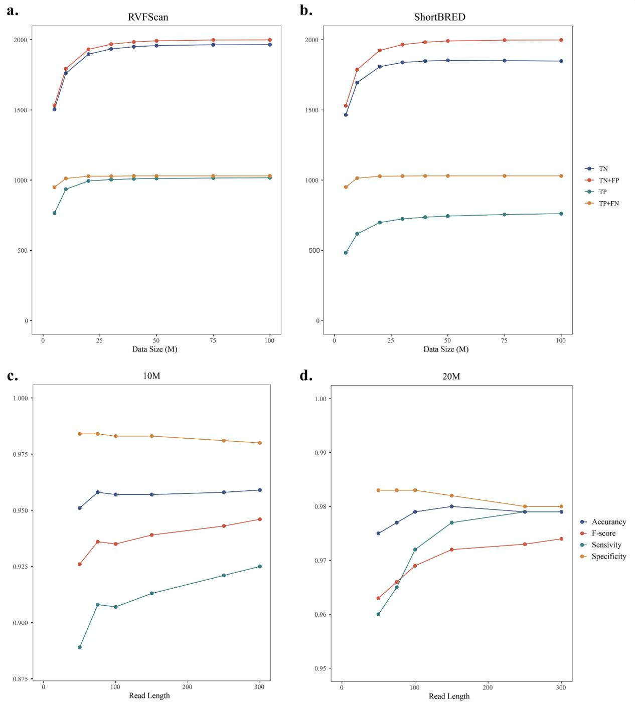Figure S1. The effect of sequencing depth and read length on VFG detection. a-b. The effect of sequencing depth on VFG detection by RVFScan and ShortBRED. c-d. Effect of read length on the performance of RVFScan.

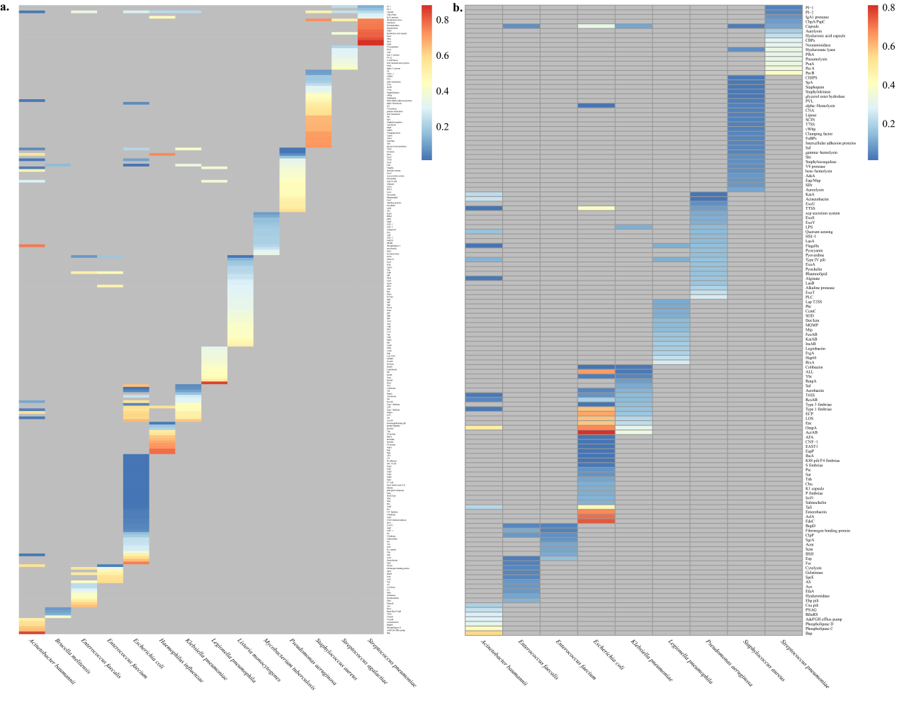
Figure S2. The rate of VFG detection for pathogens ranked according to VF units. Colors represent the VFG detection rates from high to low (red to blue). a and b indicate DNA and RNA levels, respectively.
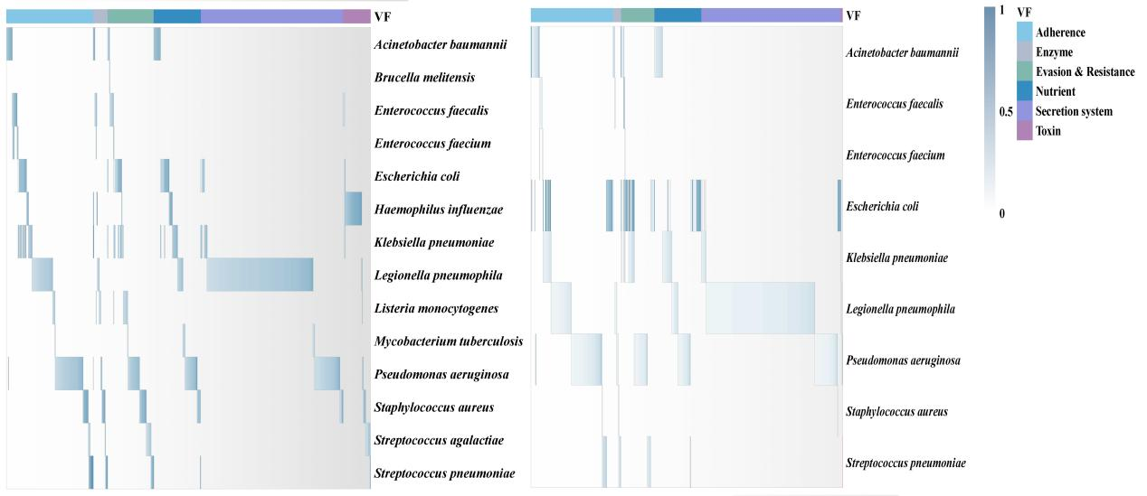
Figure S3. The functional units of high-frequency VFGs detected in DNA and RNA samples from infected patients. The left panel is the heatmap of high-frequency VFG (detection rate ≥ 0.3) in DNA samples. The right panel is the heatmap of high-frequency VFG (detection rate ≥ 0.1) in RNA samples.
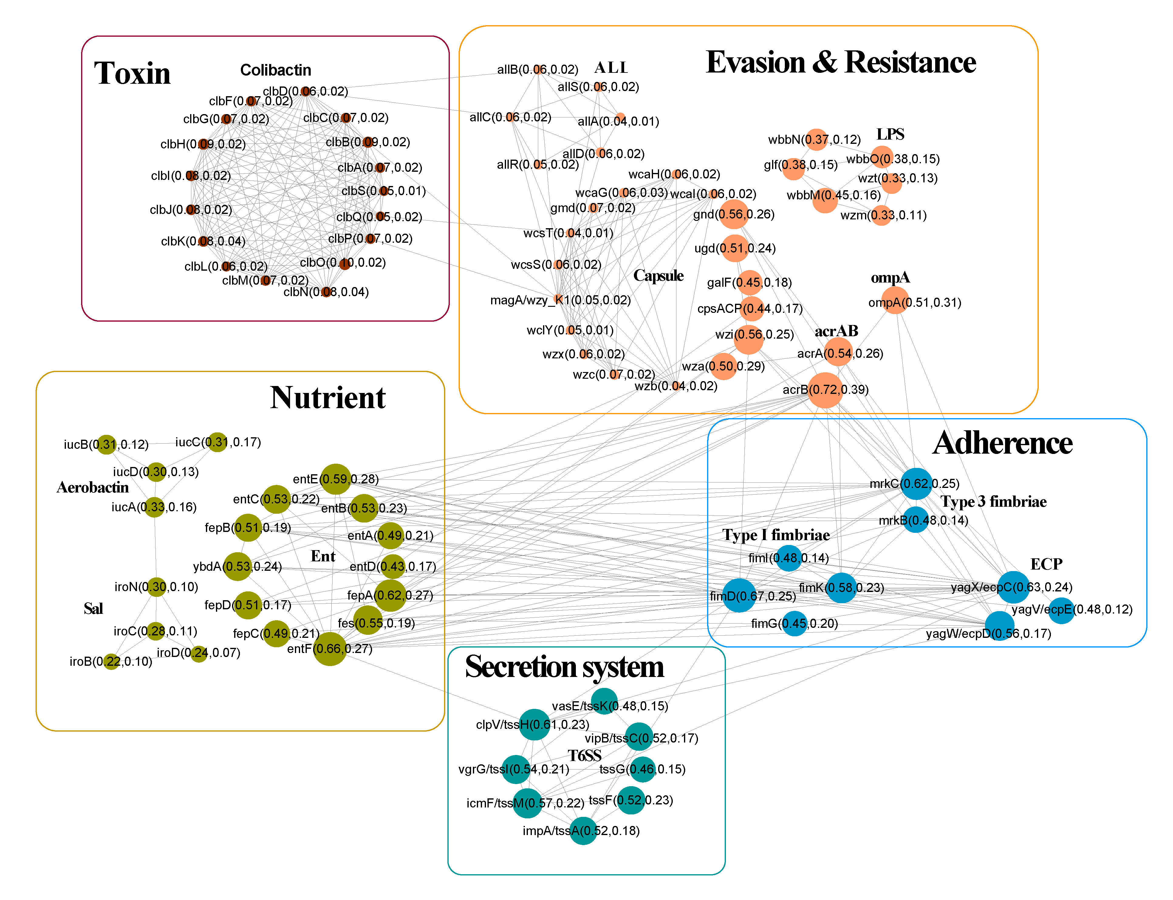
Figure S4. VFG co-occurrence network in K. pneumoniae. Different colors represent different functional units. The node size represents the frequency of VFGs at the DNA level. The node label represents the VFG symbol and the frequency at the DNA and RNA levels, respectively.
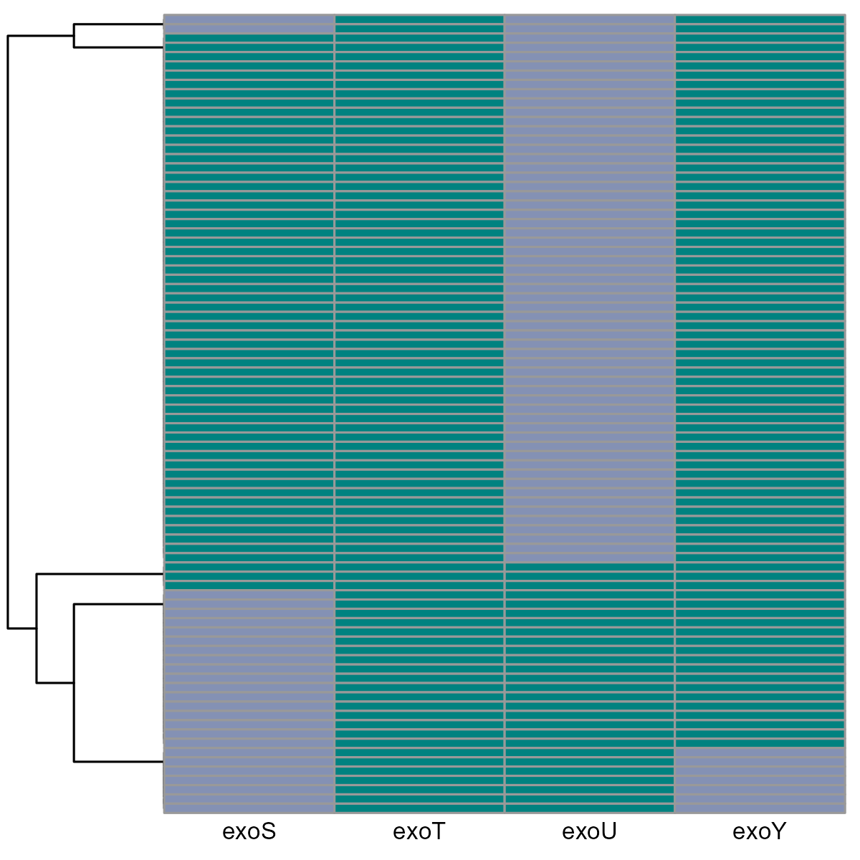
Figure S5. Four most relevant P. aeruginosa VFGs detected in mNGS samples using RVFScan. The four most relevant P. aeruginosa VFGs (exoU, exoS, exoY and exoT) were validated using RVFScan based on 311 P. aeruginosa mNGS samples. A total of 86 samples with total reads of these four VFGs > = 10 were selected and presented in the cluster diagram. Green shows the presence of the VFG, while gray indicates the absence of the VFG. ExoU and exoS are mutually exclusive in P. aeruginosa. This cluster diagram indicates that RVFScan could aid in the detection of hypervirulent P. aeruginosa infections.

