Supporting Information

CO₂ Electroreduction towards CO with Near-unity Selectivity on NiCu-embedded ZIF-derived N-doped Carbon Nanoparticles

Weiting Yu, Jieyun Zhu, Sizhuo Chen, Juntao Tang, Jiexu Ye, Shuang Song*

College of Environment, Zhejiang University of Technology, Hangzhou 310032, People’s Republic of China

∗Corresponding author: Shuang Song
E-mail: ss@zjut.edu.cn

Supplementary Figures
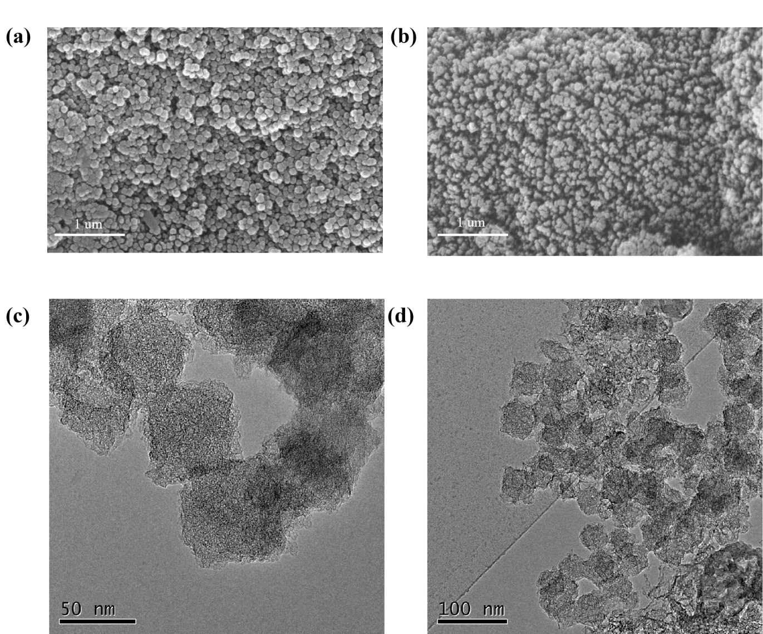

Figure S1. SEM images of (a) Cu@NCNPs and (b) Ni@NCNPs, as well as TEM images of (c) Cu@NCNPs and (d) Ni@NCNPs.

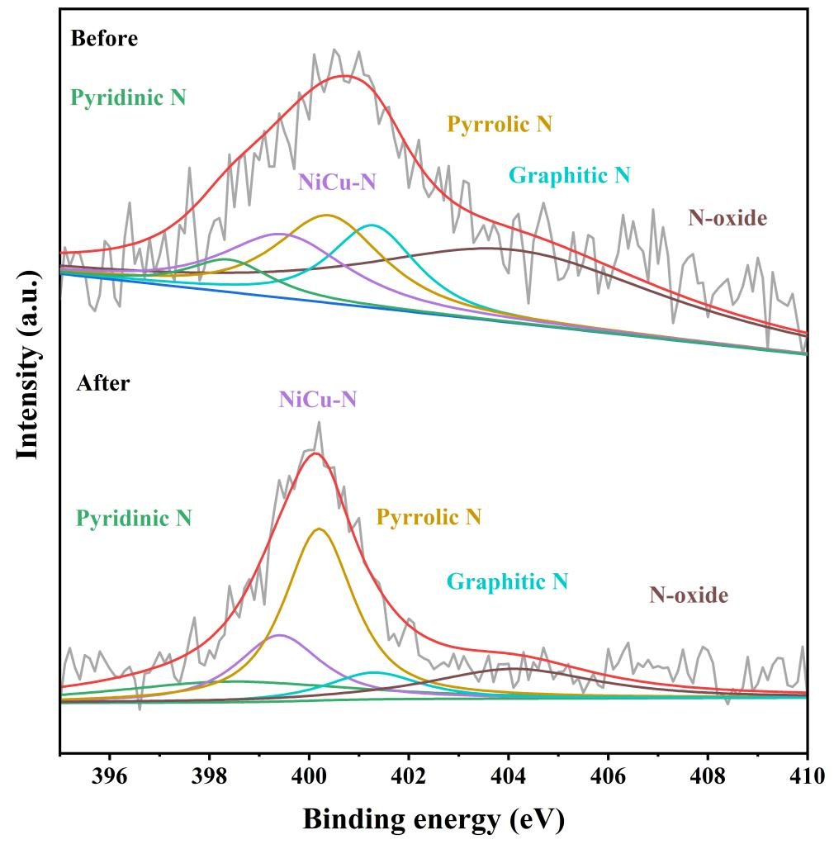
Figure S2. XPS of N 1s spectrum for NiCu@NCNPs before and after CO₂ reduction reaction.

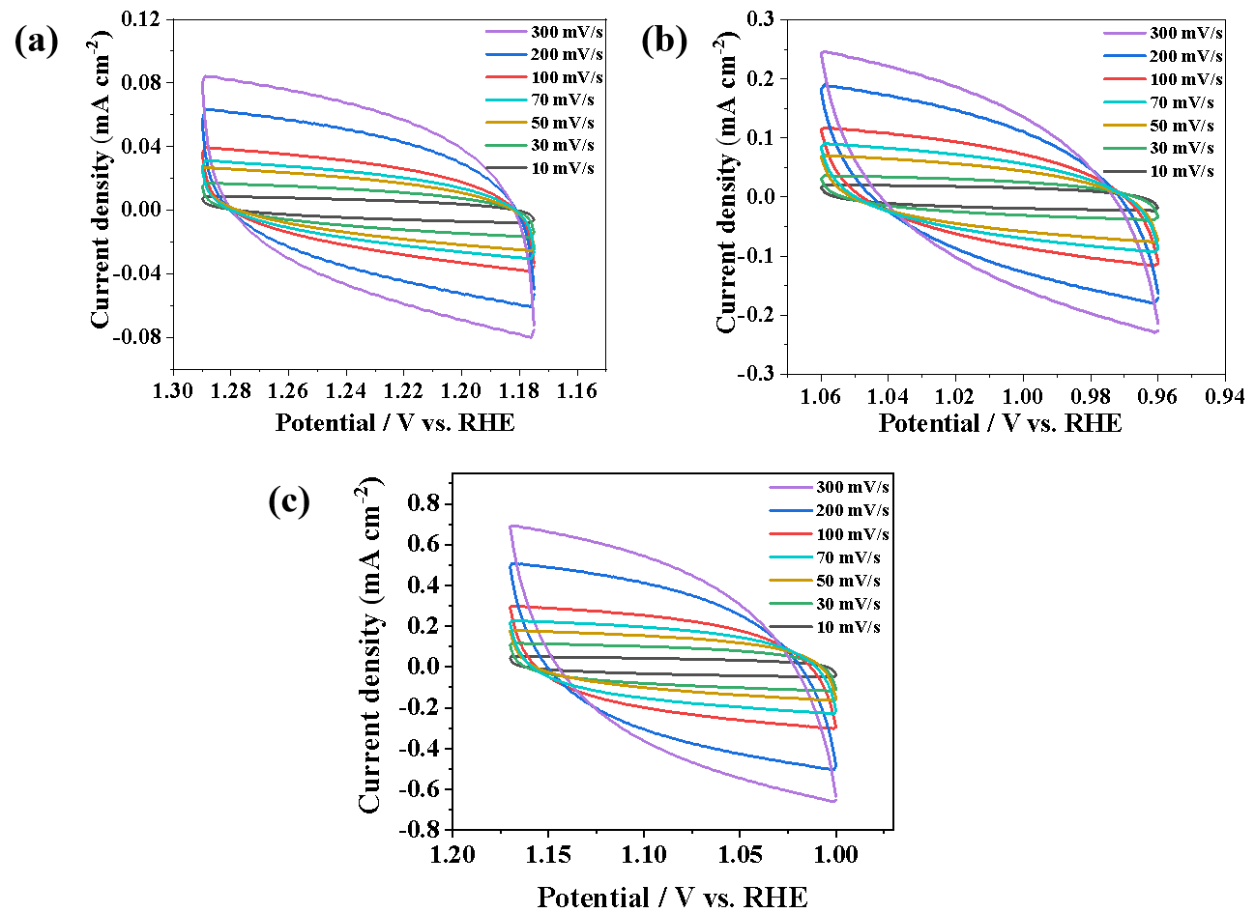
Figure S3. Cyclic voltammograms for (a) Cu@NCNPs, (b) Ni@NCNPs and (c) NiCu@NCNPs.

