Differential microbial assemblages associated with shikonin-producing Borage species in two distinct soil types
Aliya Fazal^{1¶}, Minkai Yang^{1¶}, Zhongling Wen^{1¶}, Farman Ali¹, Ran Ren¹, Chenyu Hao¹, Xingyu Chen¹, Jiangyan Fu¹, Xuan Wang¹, Wencai Jie¹, Tongming Yin², Guihua Lu^{1,2,3}*, Jinliang Qi^{1,2}*, Yonghua Yang^{1,2}*

¹ State Key Laboratory of Pharmaceutical Biotechnology, Institute for Plant Molecular Biology, School of Life Sciences, Nanjing University, Nanjing 210023, China.
² Co-Innovation Center for Sustainable Forestry in Southern China, Nanjing Forestry University, Nanjing 210037, China.
³ School of Life Sciences, Huaiyin Normal University, No.111 Changjiang west road, Huaian, 223300, P. R. China.

¶ These authors contributed equally to this work.

* Corresponding author
Yonghua Yang
Email: yangyh@nju.edu.cn
Tel (Fax): 86-25-89686305

Fig. S1 Representative Growth phenotypes of two inter-genera E. plantagineum (EP) and L. erythrorhizon (LE). Photographs taken at almost 18 weeks after planting. NCS and PPS represent Natural campus soil and Peat potting artificial soil correspondingly

Fig. S2 Diagrammatic representation of an experimental system designed for capturing root exudates from intact E. plantagineum (EP) and L. erythrorhizon (LE) roots grown in two different soil types

Fig. S3 Both the E. plantagineum (EP) and L. erythrorhizon (LE) plants were harvested post 18 weeks of cultivation for rhizosphere soil (RS) sampling.

Fig. S4 Rhizosphere (RS), rhizoplane (RP) and endosphere/endophytic compartment (EC) soil sampling. Adopted from Edwards et al. PNAS, 2015

Fig. S5 Chromatograms via HPLC Agilent 1200 Series, of root exudates samples obtained for E. plantagineum (EP) and L. erythrorhizon (LE) plants grown in Peat potting artificial (PP), and Natural campus soil (NC). Each sample is labeled by a four-letter code, e.g. LE.PP stands for L. erythrorhizon species grown in Peat potting artificial soil. Resulting peaks corresponded to shikonin (SK), acetylshikonin (AS); isobutyrylshikonin (IBS); and isovalerylshikonin (IVS). No chromatogram was observed for EP grown in NC soil which could possibly be due to sampling error

Fig. S6 Total relative abundances of 6 dominant phyla in different rhizo-compartments as well as bulk soil samples of E. plantagineum and L. erythrorhizon.

Fig.S7 Relative abundance of differentially abundant microbes in the rhizosphere compartments of (a) EP; (b) LE compared to bulk soil control at orders level

Fig. S8 Venn diagram showing differentially abundant OTUs in Rhizosphere (RS) compartment of (A) E. plantagineum (EP), (B) L. erythrorhizon (LE) grown in natural campus (NC) and peat potting artificial (PP) soil

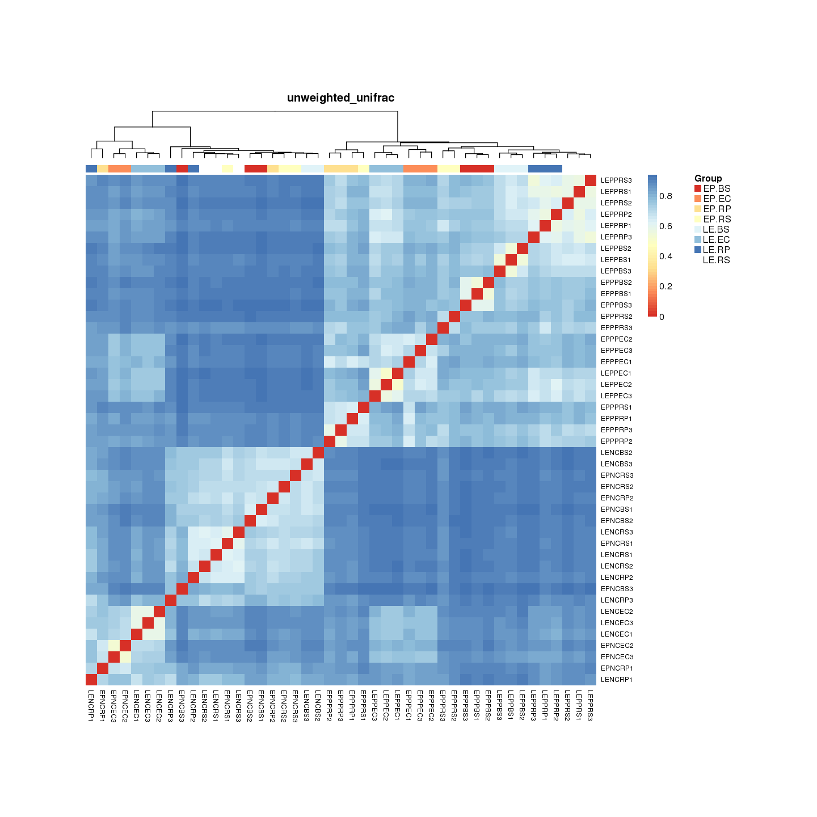
Fig. S9 Heatmap based on unweighted Unifrac distance (UUF) metric of E. plantagineum (EP), and L. erythrorhizon (LE) samples grown in Natural campus (NC), and Peat potting artificial (PP) soil. Three rhizo-compartments i.e. endosphere/endophytic compartment (EC), rhizoplane (RP), rhizosphere (RS), and bulk soil (BS). Each sample is labeled by a six-letter code, such as EPPPEC stands for endophytic compartment of E. plantagineum species grown in Peat potting artificial soil

Fig. S10 Cumulative histogram showing distribution of top 20 OTUs in 3 rhizo-compartments of (A) E. plantagineum ; (B) L. erythrorhizon along with their phylum level phylogenetic relatedness. Red rectangle represents mutually shared OTUs among both EP and LE rhizo-compartments. X-axis shows relative abundance, Y-axis shows top 20 differentially enriched OTUs

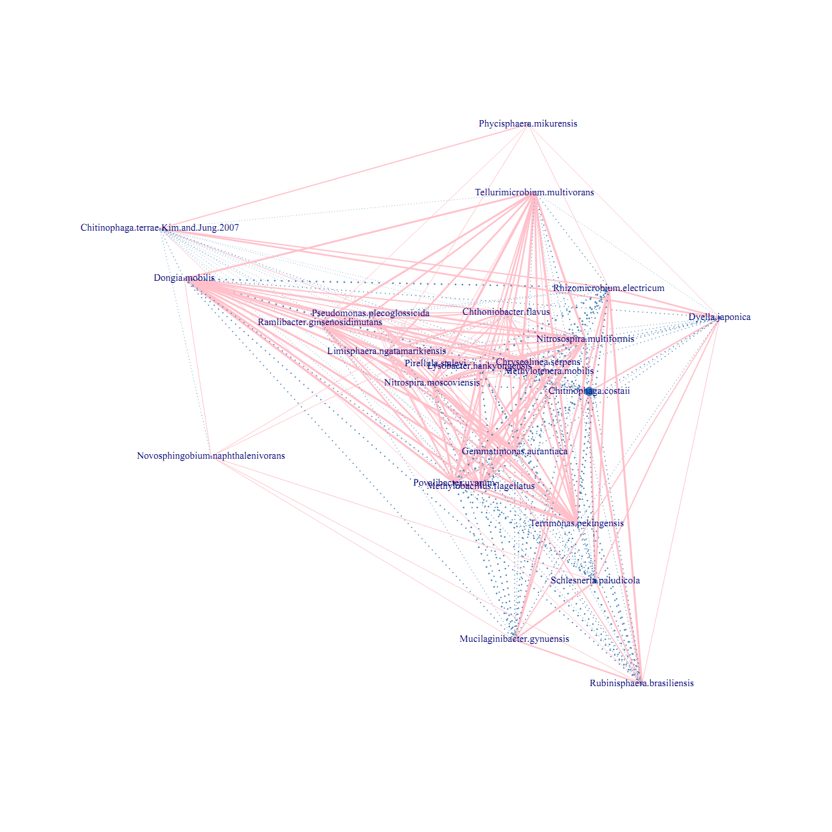
Fig. S11 Cytoscape showing correlation between species from visual perspective. Each node represents a species, and the node size represents the relative abundance of that species. Edges represent co-relation, thicker the edge, stronger the correlation. Pink edge represents a positive correlation while blue edge represents a negative correlation

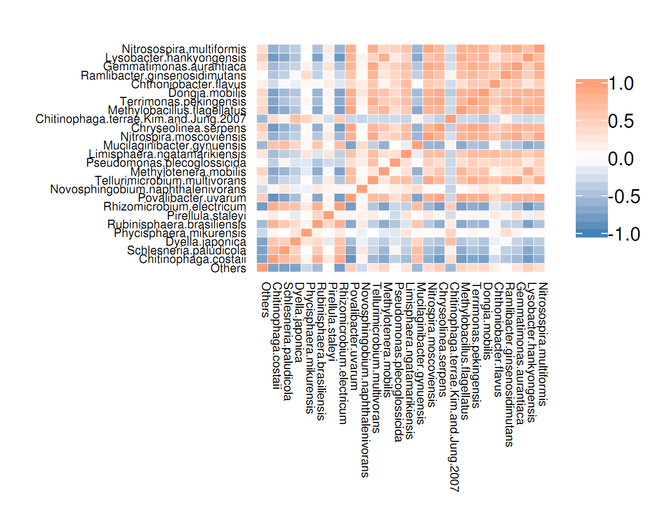
Fig. S12 Heatmap showing positively and negatively co-related OTUs in 3 rhizo-compartments of E. plantagineum and L. erythrorhizon. Blue shows negative co-relation, red shows positive co-relation. This figure only shows the relationship between the species with correlation coefficient greater than 0.2

