Supplementary material

Table of contents
Supplement A. Codebook 3
Publication and study 3
Participants 4
Professional development 5
Outcomes 6
Supplement B. Risk of Study Bias Assessment 8
Supplement C. List of Included Studies 9
Supplement D. Effect Sizes from Primary Studies (Forest Plots) 27
Figure 5a Effect Sizes of the Effects of Teacher Training on Self-rated Knowledge Regarding Inclusive Education 27
Figure 5b Effect Sizes of the Effects of Teacher Training on Tested Knowledge Regarrding Inclusive Education 28
Figure 6a Effect Sizes of the Effects of Teacher Training on the Implementation Quality of Inclusive Teaching Strategies 29
Figure 6b Effect Sizes of the Effects of Teacher Training on the Use of Inclusive Teaching Strategies 30
Figure 6c Effect Sizes of the Effects of Teacher Training on Self-Efficacy for Inclusive Teaching 32
Figure 7a Effect Sizes of the Effects of Teacher Training on the Attitude Towards Inclusive Education 35
Figure 7b Effect Sizes of the Effects of Teacher Training on Concerns Towards Inclusive Education 42
Figure 7c Effect Sizes of the Effects of Teacher Training on the Perception of Inclusive Teaching Strategies 43
Figure 8a Effect Sizes of the Effects of Teacher Training Addressing Inclusive Education on Student Achievement 44
Figure 8b Effect Sizes of the Effects of Teacher Training Addressing Inclusive Education on Other Student Behavior 46
Supplement E. Overview of Mean Effects and Variance 48
Supplement F. Moderation Analyses for Effect Size Calculation Methods and Publication Bias 49
Supplement G. Analyses of Study Bias 50
Supplement H. Traditional Funnel Plots 52
Supplement I. Power Enhanced Funnel Plots 54
Supplement J. Moderation Analyses of Effects of Teacher Training on Knowledge about Inclusive Education 56
Supplement K. Moderation Analyses of the Effects of Teacher Training on Skills Regarding Inclusive Education 58
Supplement L. Moderation Analyses of Effects of Teacher Training on Beliefs Regarding Inclusive Education 60
Supplement M. Moderation Analyses of Student Behavior 62
Supplement N. List of References of Included Studies 64

Supplement A. Codebook

Publication and study
Name | type | description | coding
coderID | categorical | initials of coder
studyID | numeric | study ID
authors | string | last names of authors
pubyear | numeric | year of publication
title | string | title of publication
doi | string | Doi of the publication
pubtype | categorical | Type of publication | 1 - journal article  2 - dissertation  3 - conference proceedings  4 - project report
country | string | Country where the study was conducted
studyyear | numeric | year in which study was conducted  for intervention study: start of professional development program
design | categorical | please indicate the design of the study  single-group design: intervention study without control group, can also account for studies with several intervention groups  independent groups pretest-posttest design: intervention study with control group and pre- and posttest assessment in both groups  independent groups posttest design: intervention with control group and assessment in both groups after the intervention  cross-sectional study: assessment of an outcome measure that is related in analyses to former participation in professional development (e.g. correlation analysis, anova, t-test, etc.) | 1 - single-group design  2 - independent groups pretest-posttest design  3 - independent groups posttest design  4 – cross-sectional study
samplesize | numeric | number of participants included in the study in all samples, please indicate the number of valid data sets, hence the number of participants that were included in the analysis
sampledef | string | Please define a number to each sample and indicate the differences between the samples, e.g. 1 – general educators, 2 – special educators
sampling | categorical | Sampling strategy used in the study | 1 - random  2 – non-random
allocation | categorical | Allocation of the participants to the different conditions, only relevant for intervention studies | 1 – non-random  2 – quasi-experimental  3 – random
responserate | numeric | If a survey was sent out to a certain number of people, please report the percentage of people responding to the survey
missings | dummy | Does the publication provide any information about dealing with incomplete data or excluding data? For example, amount of people excluded from the analysis because of incomplete data, imputation of missings, etc. | Yes/No

Participants
Name | type | description | coding
sampleN | numeric | size of this sample
profession | categorical | Profession of the participants in this sample, if you choose 'other' or ‘combination’ indicate this information in the variable 'partcomment' | 1 - general educators  2 - special educators  3 - general and special educators  4 - kinder garden educators  5 - teaching assistants  6 - administrative staff (includes principles)  7 - combination  8 - other  9 - students
percgeneral | numeric | percentage general educators in this sample
percfemale | numeric | Percentage of female participants in this sample
ageM | numeric | Mean age of participants
ageSD | numeric | Standard deviation of the sample age
teachexpM | numeric | Mean years of teaching experience
teachexpSD | numeric | Standard deviation of teaching experience in this sample
schooltype | categorical | School type where participants work at | 1 - kinder garden  2 - primary school  3 – secondary school  5 - K-12 (participants from all school types can participate)
expIE | numeric | Percentage of participants with experience implementing inclusive education (e.g., teaching SEN students)
attrition | numeric | percentage of participants of the professional development program leaving study, only relevant for pretest-posttest designs

Professional development
Name | type | description | coding
percPD | numerical | Percentage of study participants that participated in professional development (only relevant for correlational studies)
divfeature | categorical | please indicate the diversity feature that was focused on in the professional development program  for correlative studies: the diversity feature the study focused on  if you select 'combination' or 'other' please indicate the information on the diversity feature in the variable PDcomment
  1 -SEN
  2- gender
  3 - migration
  4 - second language learners
  5 - religion
  6 - low socio-economic status
  7 - at-risk students
  8 - giftedness
  9 - combination
  10 - sexual orientation
  11 - psychological diseases
  12 - other
PDtype | categorical | name used in the publication for the type of professional development program, if further terms are being used please choose ‘other’ and indicate it in the next column | 1 - informative seminar  2 - workshop  3 – training  4 - university course  5 - on-site training (placed at school)  6 - online course  7 - blended learning course (mixture of attendance and online sessions)
PDduration | numeric | Hours spent in professional development program
PDtimespan | string | Time span from first to last session in weeks
practice  opportunity | dummy | Does the professional development program provide opportunity to practice inclusive strategies in the professional development session? | Yes/No
casestudies | Dummy | Are case studies used for practice in PD sessions? | Yes/No
Implementation planning | dummy | Is the implementation of content provided planned in the PD sessions? | Yes/No
certification | dummy | Do participants receive a certification after finishing the professional development program? | Yes/No
jointPD | dummy | Is it mentioned that joint participation in the professional development program was required? With whom were educators asked to participate? | 1 - single participation  2 - joint participation (at least two colleagues)  3 - team participation  4 - school participation (all/most school staff)
coaching | dummy | Does the professional development program offer additional coaching? | Yes/No
topic | dummy | Does the professional development program address inclusive education in general or a specific topic related to it? | Yes/No
topicsubject | string | if the professional development program addresses educators teaching a certain school subject please indicate this subject | Yes/No
topicmethod | string | if a specific inclusive teaching method is addressed in the professional development program (e.g., UDL), please note this method | Yes/No
prereq | dummy | Do educators need to fulfill certain prerequisites in order to participate in this professional development program (e.g., motivational letter)? | Yes/No
postdata | string | Time between pre- and posttest in weeks

Outcomes
Name | type | description | coding
effectsizeID | string | Please indicate the number for the effect size for each sample (studyID_sampleID_effectsizeID), please number them consecutively
studydesign | categorical | please indicate the study design again for automatically filling out irrelevant variables
dv | string | indicate what type of dependent variable is being reported, if several dependent variables are reported in the study fill out a line for each dV
dvtype | categorical | can the dependent variable be assigned to one of the categories? | 1 - knowledge  2 - beliefs  3 - skills  4 - student behavior
measurement | categorical | type of measurement used to assess the indicated variable in 'dV' | 1 - questionnaire (validated scales/questionnaires)  2 - survey (no validated scales/questionnaires)  3 - single-items  4 - observation  5 - test scores
instrument | string | instrument used to measure the indicated dV
relmeasure | string | Type of reliability measure
rel | numeric | Value of the reliability measure
items | numeric | indicate number of items used in the questionnaire/survey
statistic | string | statistical test used to calculate difference between groups/measurement times
pexact | numeric | reported exact p-value of the statistical test of interest

Supplement B. Risk of Study Bias Assessment

Domain | Item | score
- Study design | Cross-sectional design | 1
 | Single-group design | 1.5
 | Independent groups posttest design | 2
 | Independent groups pre-posttest design | 3
- Response rate | Not reported or not applicable | 0
 | < 50% | 0.5
 | 50% - 75% | 1
 | >75% | 1.5
- Sampling procedure | Non-random | 0
 | random | 1
- Allocation to conditions | Non-random or not applicable | 0
 | random | 1
- Type of data | Assessment by study participant | 0
 | Objective measurement | 1
- Use of standardized instrument | Single-items or self-developed instrument | 0
 | Standardized instrument | 1
- Reporting quality | Reliability data not reported | 0
 | Reliability data reported | 1
- Handling of missing data | Not reported | 0
 | reported | 1

Supplement C. List of Included Studies

Authors and date | type | Country | Study design | N | Outcome type
Abdulaziz Alhamad (2006) | Dissertation | USA | Cross-sectional | 205 | Beliefs – attitude  Skills – self-efficacy
Adhabi (2018) | Dissertation | Saudi Arabia | Cross-sectional | 202 | Beliefs – attitude  Skills – self-efficacy
Aerni (2009) | Dissertation | USA | Single-group | 96 | Skills – self-efficacy  Skills - use of strategies  Beliefs – attitude
Ahmmed, Sharma & Deppeler (2012) | Journal article | Bangladesh | Cross-sectional | 408 | Beliefs – attitude
Akcan & Ilgar (2016) | Journal article | Turkey | Cross-sectional | 252 | Skills – use of strategies
Al-Assaf (2017) | Dissertation | Saudi Arabia | Posttest | 59 | Beliefs – perception of strategies  Beliefs - attitude
Al-Faiz (2006) | Dissertation | Saudi Arabia | Cross-sectional | 231 | Beliefs - attitude
Alasim (2017) | Dissertation | Saudi Arabia | Cross-sectional | 300 | Beliefs – attitude
Albulayhi (2018) | Dissertation | Saudi Arabia | Cross-sectional | 516 | Beliefs – attitude
Alhassan & Abosi (2014) | Journal article | Ghana | Cross-sectional | 387 | Skills – self-efficacy
Alhudaithi (2015) | Dissertation | Saudi Arabia | Cross-sectional | 497 | Beliefs – attitude
Alnemary (2017) | Dissertation | Saudi Arabia | Cross-sectional | 135 | Knowledge – tested  Skills – self-efficacy
Alquraini (2012) | Journal article | Saudi Arabia | Cross-sectional | 303 | Beliefs - attitude
Alsedrani (2018) | Dissertation | Saudi Arabia | Cross-sectional | 237 | Beliefs – attitude
Alshahrani (2014) | Dissertation | Saudi Arabia | Cross-sectional | 120 | Beliefs – attitude
Alshenaifi (2018) | Dissertation | Saudi Arabia | Cross-sectional | 209 | Beliefs – attitude  Beliefs – concerns  Beliefs – perception of strategies
Amundson (1993) | Dissertation | USA | Posttest | 223 | Beliefs – attitude
Anderson (2016) | Journal article | USA | Cross-sectional | 31 000 | Student behavior – other behavior
Angiulo (2014) | Dissertation | USA | Cross-sectional | 154 | Skills – self-efficacy
Armstrong, Cusumano, Todd & Cohen (2008) | Journal article | USA | Single-group | 95 | Knowledge – tested  Beliefs – perception of strategies  Skills – self-efficacy
Arcangeli, Baccherini, Gaggioli, Sannipoli & Balboni (2020) | Journal article | Italy | Cross-sectional | 307 | Beliefs – attitude  Knowledge – self-rated
Atanasova-Trifonova, Alexandrova-Karamanova & Peneva (2018) | Journal article | Russia | Cross-sectional | 906 | Skills – self-efficacy
Avramidis & Kalyva (2007) | Journal article | Greece | Cross-sectional | 155 | Beliefs – attitude
Avramidis, Bayliss & Burden (2000) | Journal article | UK | Cross-sectional | 81 | Beliefs – attitude
Bae (2012) | Dissertation | South Korea | Cross-sectional | 76 | Beliefs – attitude
Bakkaloglu, Sucuoglu & Yilmaz (2019) | Journal article | Turkey | Cross-sectional | 47 | Skills – quality of implementation
Baldiris Navarro, Zervas, Fabregat Gesa & Sampson (2016) | Journal article | Colombia | Single-group | 47 | Skills – quality of implementation
Bang (1993) | Conference proceeding | USA | Cross-sectional | 110 | Skills – use of strategies
Barnes (2008) | Dissertation | USA | Cross-sectional | 93 | Beliefs – attitude
Barnes (2020) | Dissertation | USA | Cross-sectional | 34 | Skills – use of strategies
Barrett (1996) | Dissertation | USA | Control-group | 324 | Beliefs – concerns  Knowledge – tested
Bartholomaeus, Riggs & Andrew (2017) | Journal article | Australia | Cross-sectional | 75 | Beliefs – attitude  Skills – self-efficacy
Baxter (2014) | Dissertation | UK | Single-group | 3 | Student behavior – other behavior
Beasley (2012) | Dissertation | USA | Cross-sectional | 22 | Beliefs – attitude
Benayon (2012) | Dissertation | Canada | Single-group | 23 | Beliefs – attitude
Bender, Boon, Hinrichs & Lawson (2008) | Journal article | USA | Cross-sectional | 91 | Skills – use of strategies  Beliefs – attitude
Bertuccio, Runion, Culler, Moeller & Hall (2019) | Journal article | USA | Single-group | 87 | Knowledge – tested  Skills – self-efficacy
Bhatnagar & Das (2014) | Journal article | India | Cross-sectional | 470 | Beliefs – attitude
Blauer Ziegler (2002) | Dissertation | USA | Posttest | 279 | Skills – use of strategies  Student behavior – achievement  Student behavior - other behavior
Boudah, Schumacher & Deshler (1997) | Journal article | USA | posttest | 72 | Skills – quality of implementation  Student behavior – other behavior
Bourke (2014) | Dissertation | USA | Cross-sectional | 29 | Skills – self-efficacy
Boyle, Topping & Jindal-Snape (2013) | Journal article | UK | Cross-sectional | 391 | Beliefs – attitude
Brady & Wolfsoon (2008) | Journal article | UK | Cross-sectional | 118 | Beliefs – attitude
Breslow (1996) | Dissertation | USA | Cross-sectional | 473 | Beliefs – attitude
Brewer (1996) | Dissertation | USA | Posttest | 32 | Beliefs – perception of strategies  Skills – use of strategies  Skills – self-efficacy
Brown, Straub, Bohnacker & Plener (2018) | Journal article | Germany | Single-group | 603 | Beliefs – attitude  Knowledge – self-rated  Skills – self-efficacy
Bruce (2011) | Dissertation | USA | Cross-sectional | 156 | Beliefs – attitude
Brusca-Vega, Brown & Yasutake (2011) | Journal article | USA | Single-group | 62 | Student behavior – achievement
Brusca-Vega, Alexander & Kamin (2014) | Journal article | USA | Single-group | 58 | Skills – use of strategies  Skills – quality of implementation  Student behavior – other behavior
Bussue (2015) | Dissertation | USA | Cross-sectional | 100 | Beliefs – attitude
Butler (2019) | Dissertation | USA | Single-group | 165 | Beliefs – attitude  Student behavior – achievement
Carew, Deluca, Groce & Kett (2018) | Journal article | Kenya | Single-group | 123 | Beliefs – attitude  Beliefs – concerncs  Skills – self-efficacy
Catellani, Ilyasov, Cherepov, Sevryukova, Selivanova, Kudinov & Nikolov (2018) | Journal article | Russia | Control-group | 378 | Skills – self-efficacy
Cefai, Ferrario, Cavioni, Carter & Grech (2014) | Journal article | Malta | Control-group | 75 | Student behavior – other behavior
Cestaro (2008) | Dissertation | USA | Cross-sectional | 42 | Beliefs – attitude
Chao, Forlin & Ho (2016), Chao, Wing Sze, Forlin & Ho (2017) | Journal article | Hong Kong | Single-group | 417 | Knowledge – self-rated  Skills – self-efficacy
Chatman (2018) | Dissertation | USA | Cross-sectional | 74 | Beliefs - attitude
Cheen (2007) | Dissertation | Taiwan | Cross-sectional | 532 | Beliefs - attitude
Christiansen, Hirsch, Knig, Steinmayr & Roehrle (2015) | Journal article | Germany | Control-group | 457 | Skills – self-efficacy  Student behavior – other behavior
Chu, Craig, Yeworiew & Xu (2020) | Journal article | USA | Cross-sectional | 143 | Student behavior – achievement
Chung (1998) | Dissertation | USA | Cross-sectional | 386 | Beliefs – perception of strategies  Skills – use of strategies
Ciraci & Isidori (2017) | Journal article | Italy | Posttest | 198 | Skills – quality of implementation  Skills – self-efficacy
Clench & Smyth King (2014) | Book chapter | UK, Australia | Single-group | 13465 | Knowledge – self-rated  Skills – use of strategies  Skills – self-efficacy
Cohen (2015) | Journal article | Israel | Cross-sectional | 96 | Beliefs – attitude  Beliefs – concerns  Skills – self-efficacy
Cole (2012) | Dissertation | UK | Control-group | 204 | Beliefs – attitude  Skills – self-efficacy  Student behavior – other behavior
Colling, Fishbaugh & Hermanson (2003) | Conference proceeding | USA | posttest | 490 | Beliefs – attitude  Skills – self-efficacy
Coombs-Richerdson & Mead (2001) | Journal article | USA | Single-group | 34 | Knowledge – tested
Cooney (2017) | Dissertation | USA | Cross-sectional | 76 | Beliefs – attitude
Cooper-Jones (2013) | Dissertation | UK | Single-group | 24 | Knowledge – tested  Knowledge – self-rated  Skills – self-efficacy
Coutsocostas & Alborz (2010) | Journal article | Greece | Cross-sectional | 138 | Beliefs – attitude  Knowledge – tested  Skills – self-efficacy
Crossett (1993) | Dissertation | USA | Cross-sectional | 95 | Beliefs - attitude
Crotteau (2009) | Dissertation | USA | Single-group | 31 | Skills – self-efficacy
Currie (2005) | Dissertation | USA | Cross-sectional | 45 | Beliefs - attitude
Dalanon & Matsuka (2017) | Journal article | Phillipine | Cross-sectional | 30 | Skills – self-efficacy
Davis (1993) | Dissertation | USA | Cross-sectional | 285 | Beliefs – perception of strategies
De Wet (2006) | Journal article | USA | Cross-sectional | 308 | Beliefs - attitude
Dea & Negassa (2019) | Journal article | Ethiopia | Cross-sectional | 100 | Skills – use of strategies
Dedrick, Marfo & Harris (2007) | Journal article | USA | Cross-sectional | 288 | Beliefs - concerns
Delkamiller, Swain, Ritzman & Leader-Janssen (2016) | Journal article | Nicaragua | Single-group | 14 | Knowledge - tested
Dellicarpini & Alonso (2014) | Journal article | USA | Single-group | 33 | Beliefs - attitude
Detzer (2016) | Dissertation | USA | Single-group | 26 | Beliefs – attitude  Knowledge – self-rated  Skills – self-efficacy
Dev (1996) | Dissertation | USA | Cross-sectional | 278 | Beliefs - attitude
Dias (2015) | Journal article | Portugal | Cross-sectional | 150 | Beliefs - attitude
Dickens-Smith (1995) | Project report | USA | Single-group | 30 | Beliefs - attitude
Drandic & Paic (2020) | Journal article | Croatia | Cross-sectional | 170 | Skills – use of strategies
Durtschi (2005) | Dissertation | USA | Cross-sectional | 566 | Beliefs - attitude
Dyer (2003) | Dissertation | USA | Cross-sectional | 67 | Beliefs - attitude
Edwards, Carr & Siegel (2006) | Journal article | USA | Single-group | 34 | Beleifs – perception of strategies  Skills – use of strategies  Skills – self-efficacy
Ellis & Rowe (2020) | Journal article | UK | Single-group + posttest | 7170 | Student behavior – achievement  Student behavior - achievement
Engstrand & Roll-Pettersson (2014) | Journal article | Sweden | Cross-sectional | 21 | Skills – self-efficacy
Ernst & Rogers (2009) | Journal article | USA | Cross-sectional | 134 | Beliefs - attitude
Eskridge (2009) | Dissertation | USA | posttest | 30 | Skills – quality of implementation
Evans (1997) | Journal article | USA | Control-group | 345 | Skills – use of strategies  Student behavior - achievement
Faraclas (2015) | Dissertation | USA | Control-group | 25 | Skills – use of strategies
Farquharson (1995) | Dissertation | USA | Single-group | 12 | Beliefs – attitude
Ferguson et al. (1992) | Project report | USA | Single-group | 68 | Student behavior – other behavior
Fernandez-Batanero, Cabero & Lopez (2019) | Journal article | Spain | Cross-sectional | 777 | Beliefs – attitude  Beliefs – perception of strategies
Ferrara & Pedone (2019) | Journal article | Italy | Single-group | 450 | Skills – use of strategies  Skills – self-efficacy
Finegan (2004) | Dissertation | USA | Cross-sectional | 1341 | Beliefs - attitude
Fisher (1996) | Dissertation | USA | Control-groip | 19 | Beliefs – attitude  Knowledge - tested
Fisher (2013) | Dissertation | USA | Cross-sectional | 52 | Skills – self-efficacy
Flannery, Lombardi & McGrath Kato (2015) | Journal article | USA | Single-group | 27 | Skills – quality of implementation
Forlin (2001) | Journal article | Australia | Cross-sectional | 571 | Beliefs - concerncs
Forlin & Sin (2010) | Journal article | Hong Kong | Single-group | 567 | Beliefs – attitude  Beliefs – concerns  Skills – self-efficacy
Forlin, Loreman & Sharma (2014) | Journal article | Hong Kong | Single-group | 737 | Skills – self-efficacy
Forlin, Sharma & Loreman (2014)b | Journal article | Hong Kong | Single-group | 2361 | Beliefs – attitude  Beliefs – concerns  Skills – self-efficacy
Frumos (2018) | Journal article | Romania | Cross-sectional | 126 | Beliefs - attitude
Galano (2012) | Dissertation | USA | Cross-sectional | 56 | Beliefs - attitude
Garret & Spano (2017) | Journal article | USA | Cross-sectional | 300 | Beliefs – attitude  Skills – self-efficacy
Gayle-Evans (1992) | Dissertation | USA | Cross-sectional | 165 | Beliefs – perception of strategies  Skills – use of strategies
Georgiadis, Nikolajevic & van Driel (2011) | Journal article | Europe | Single-group | 27225 | Skills – self-efficacy
Gertler (1994) | Dissertation | USA | Cross-sectional | 201 | Beliefs - attitude
Giannopoulou, Pasalari, Korkoliakou & Douzenis (2019) | Journal article | Greece | Single-group | 67 | Knowledge - tested
Giovanetti (1999) | Dissertation | USA | Single-group | 62 | Beliefs - attitude
Goetz (2001) | Dissertation | USA | Single-group | 25 | Beliefs – attitude  Knowledge – self-rated  Skills – quality of implementation  Skills – self-efficacy
Goley (2013) | Dissertation | USA | Cross-sectional | 96 | Beliefs - attitude
Gonzalez Dekutoski (2011) | Disseration | USA | Cross-sectional | 100 | Beliefs – attitude
Gordon (2008) | Dissertation | USA | Cross-sectional | 152 | Beliefs - attitude
Graham-Young (2004) | Dissertation | USA | Cross-sectional | 219 | Skills – use of strategies
Green-Causey (1999) | Dissertation | USA | Cross-sectional | 153 | Beliefs - attitude
Gu (2013) | Dissertation | China | Cross-sectional | 203 | Beliefs – attitude  Beliefs – concerns  Skills – self-efficacy
Güner (2012) | Journal article | Turkey | posttest | 45 | Skills – use of strategies
Haciibrahimoglu & Kargin (2017) | Journal article | Turkey | Cross-sectional | 209 | Beliefs - concerns
Hadjikakou, Petridou & Stylianou (2008) | Journal article | Cyprus | Cross-sectional | 367 | Beliefs – perception of strategies
Hardin, Lower, Smallwood, Chakravarthi, Li & Jordan (2010) | Journal article | USA | Single-group | 40 | Skills – use of strategies
Harris, Lane, Graham, Driscoll, Sandmel, Brindle & Schatschneider (2012) | Journal article | USA | Control-group + single-group | 282 | Student behavior – achievement  Beliefs – perception of strategies
Harris, Graham & Adkins (2015) | Journal article | USA | Control-group | 53 | Student behavior – achievement  Student behavior – other behavior
Haegele, Hodge, Barbosa Gutierres Filho & Goncalves de Rezende (2018) | Journal article | Brazil | Single-group | 90 | Beliefs - attitude
Healey, Block & Kelly (2020) | Journal article | USA | Control-group | 44 | Knowledge - tested
Hegler (1995) | Project report | USA | Single-group | 181 | Beliefs - attitude
Heller (2012) | Project report | USA | Control-group | 5541 | Skills – self-efficacy  Student behavior - achievement
Hellman (2007) | Dissertation | USA | Posttest | 1314 | Skills – quality of implementation  Student behavior - achievement
Hilsenbeck (2000) | Project report | USA | Single-group | 30 | Knowledge – tested  Skills - quality
Holland et al. (1997) | Project report | USA | Single-group | 166 | Student behavior – other behavior
Houtveen & Van de Grift (2001) | Journal article | Netherlands | Single-group | 309 | Skills – quality of implementation
Hsieh, Hsieh, Ostrosky & McCollum (2012) | Journal article | Taiwan | Cross-sectional | 321 | Beliefs - attitude
Huai, Braden & White (2006) | Journal article | USA | Control-group | 55 | Knowledge – self-rated  Skills – self-efficacy
Huddleston (1996) | Dissertation | USA | Cross-sectional | 292 | Beliefs - attitude
Hurt (2007) | Dissertation | USA | Single-group | 50 | Beliefs - attitude
Huszar (1997) | Dissertation | USA | Cross-sectional | 56 | Beliefs - attitude
Hutzler & Barak (2017) | Journal article | ISrael | Cross-sectional | 94 | Skills – self-efficacy
Jäntsch, Jaeuthe, Bosse & Sporer (2017) | Project report | Germany | Single-group | 493 | Beliefs – attitude  Knowledge self-rated
Jamsai (2018) | Dissertation | Thailand | Cross-sectional | 370 | Beliefs - attitude
Jimenez-Ruiz, Martinez-mones & Fernandez-Faundez (2020) | Journal article | Spain | Single-group | 25 | Knowledge – self-rated
Johnson (2000) | Journal article | USA | Posttest | 118 | Skills – use of strategies
Johnson (2012) | Dissertation | USA | Cross-sectional | 97 | Beliefs - attitude
Jones-Wilson (2011) | Dissertation | USA | Cross-sectional | 70 | Beliefs - attitude
Juttner (2001) | Dissertation | USA, UK | Cross-sectional | 301 | Beliefs - attitude
Kandel (2000) | Dissertation | USA | Cross-sectional | 651 | Beliefs - attitude
Katz (2015) | Journal article | Canada | Control-group | 58 | Skills – use of strategies
Katz, Sokal & Wu (2019) | Journal article | Canada | Control-group | 736 | Skills – use of strategies  Student behavior - achievement
Kennedy, Rodgers, Romig, Lloyd & Brownell (2017) | Journal article | USA | Single-group | 3 | Skills – use of strategies
Kennedy, Rodgers, Romig, Mathews & Peeples (2018) | Journal article | USA | Control-group | 279 | Skills – quality of implementation  Skills – use of strategies  Student behavior - achievement
Kieran (2012) | Dissertation | USA | Cross-sectional | 77 | Beliefs – attitude
Kihura (2020) | Dissertation | Kenya | Cross-sectional | 200 | Beliefs – attitude
Klehm (2013) | Dissertation | USA | Cross-sectional | 209 | Skills – use of strategies
Klein, Geiss, Kushner & Hill (2003) | Project report | USA | Control-group | 57 | Student behavior – other behavior
Kovinthan & McPherson (2017) | Journal article | Jamaica | Single-group | 36 | Student behavior – achievement
Krawec & Huang (2017) | Journal article | USA | Control-group | 207 | Student behavior – other behavior
Kristiana & Widayanti (2017) | Journal article | Indonesia | Cross-sectional | 81 | Beliefs – attitude
Kulo (2012) | Dissertation | USA | Cross-sectional | 25 | Beliefs – attitude
Kuyini, Desai & Sharma (2020) | Journal article | Ghana | Cross-sectional | 134 | Beliefs – attitude  Beliefs – concerns  Skills – self-efficacy
Kumar (2019) | Dissertation | USA | Cross-sectional | 198 | Beliefs – attitude  Beliefs – concerns  Skills – self-efficacy
Kurniawati, Minnaert, Mangunsong & Ahmed (2012) | Journal article | Indonesia | Cross-sectional | 208 | Beliefs – attitude
Kurniawati, de Boer, Minnaert & Mangunsong (2017) | Journal article | Indonesia | Control-group | 67 | Beliefs – attitude  Knowledge – tested
Kwon, Hong & Jeon (2017) | Journal article | USA | Cross-sectional | 26 | Beliefs – attitude  Skills – use of strategies
Ladner (2009) | Dissertation | USA | Cross-sectional | 216 | Skills – use of strategies
Lauth-Lebens, Lauth & Rohrsdorfer (2016) | Journal article | Germany | Single-group | 25 | Student behavior – other behavior
Layne, Jules, Kutnick & Layne (2008) | Journal article | Trinidad and Barbados | Single-group | 259 | Student behavior – achievement
Leandres-Vaughn (2017) | Dissertation | USA | Cross-sectional | 113 | Skills – use of strategies  Skills – self-efficacy
Leckie (2018) | Dissertation | USA | Single-group | 13 | Beliefs – attitude  Skills – self-efficacy
Lee (2012) | Dissertation | USA | Cross-sectional | 127 | Beliefs – perception of strategies  Skills – self-efficacy
Lee (2013) | Dissertation | USA | Cross-sectional | 79 | Skills – self-efficacy
Leith (2007) | Dissertation | USA | Single-group | 2695 | Beliefs – attitude  Student behavior – other behavior
Leonard & Smyth (2020) | Journal article | Ireland | Cross-sectional | 315 | Beliefs – attitude
Lika (2016) | Journal article | Albania | Cross-sectional | 146 | Beliefs – attitude
Lindsey (2009) | Dissertation | USA | Cross-sectional | 120 | Beliefs – attitude
Lorenzo (1993) | Dissertation | USA | Control-group | 99 | Student behavior – achievement  Student behavior – other behavior
Lussi (1996) | Dissertation | USA | Cross-sectional | 251 | Beliefs – attitude
Lusk (2006) | Dissertation | USA | Cross-sectional | 63 | Skills – use of strategies
MacAllister (2017) | Dissertation | USA | Cross-sectional | 24 | Beliefs – attitude
Macfarlane & Woolfson (2013) | Journal article | USA | Cross-sectional | 111 | Beliefs – attitude
Machu (2015) +  Machu & Luke (2019) | Journal article | Czeck Republic | Cross-sectional | 345 | Skills – use of strategies
Main, Chambers & Sarah (2016) | Journal article | Seychelles | Single-group | 32 | Beliefs – attitude  Beliefs – concerns  Skills – self-efficacy
Malinen, Savolainen, Engelbrecht, Xu, Nel, Nel & Tlale (2013) | Journal article | Finland | Cross-sectional | 855 | Skills – self-efficacy
Maltese (1985) | Dissertation | USA | Cross-sectional | 238 | Skills – self-efficacy
Marlina (2017) | Journal article | Indonesia | Cross-sectional | 150 | Beliefs – attitude
Marlow, Hansford, Edwards, Ukoumunne, Norman, Ingarfield, Sharkey, Logan & Ford (2015) | Journal article | UK | Single-group | 40 | Skills – self-efficacy
Martfeld (2016) | Dissertation | USA | Cross-sectional | 45 | Beliefs – attitude
Martinez (2015) | Dissertation | USA | Cross-sectional | 137 | Skills – use of strategies
Raimundo Martins (2014) | Journal article | Portugal | Cross-sectional | 53 | Beliefs – attitude
Mason, Cramer, Garwood, Varghese, Hamm & Murray (2017) | Journal article | USA | Posttest | 555 | Student behavior – other behavior
Ryan & Mathews (2022) | Journal article | Ireland | Cross-sectional | 139 | Skills – self-efficacy
Mauerberg-Decastro, Paiva, Figueiredo, da Costa, de Castro & Campbell (2013) | Journal article | Brazil | Single-group | 75 | Beliefs – attitude
McBride (2012) | Dissertation | USA | Cross-sectional | 503 | Student behavior – achievement
McCann (2008) | Dissertation | USA | Cross-sectional | 30 | Knowledge – self-rated  Skills – self-efficacy
McCarthy (2019) | Dissertation | USA | Cross-sectional | 163 | Beliefs – attitude
McElvany, Schwabe, Hartwig & Igler (2018) | Journal article | Germany | Cross-sectional | 203 | Beliefs – attitude  Beliefs – concerns
McQuivey & Thorson (1994) | Project report | USA | Single-group | 60 | Skills – quality of implementation  Skills – use of strategies
McQuone Mulholland (2011) | Dissertation | USA | Cross-sectional | 440 | Beliefs - attitude
Miller & Savage (1995) | Conference | USA | Single-group | 135 | Beliefs – attitude  Beliefs – percpetion of strategies  Skills – self-efficacy
Mishra, Siddharth, Bhardwaj, Elhence & Jalan (2018) | Journal article | India | Cross-sectional | 169 | Beliefs – attitude
Misoka (2017) | Dissertation | USA | Cross-sectional | 679 | Beliefs – concerns  Skills – self-efficacy
Mitchell (2016) | Dissertation | USA | Cross-sectional | 286 | Beliefs – attitude  Beliefs – perception of strategies  Skills – use of strategies
Mngo (2017) | Dissertation | Cameroon | Cross-sectional | 344 | Beliefs – attitude  Skills – self-efficacy
Mobley (2018) | Dissertation | USA | Single-group | 56 | Student behavior – other behavior
Moll (1996) | Dissertation | USA | Single-group | 46 | Beliefs – perception of strategies
Montague, Enders & Dietz (2011) | Journal article | USA | Control-group | 779 | Student behavior – achievement
Moran (2015) | Dissertation | USA | Cross-sectional | 46 | Skills – self-efficacy
Morgan (2019) | Dissertation | USA | Cross-sectional | 93 | Beliefs – attitude  Skills – self-efficacy
Morris (2013) | Dissertation | USA | Cross-sectional | 100 | Beliefs - attitude
Morrissey (2008) | Dissertation | USA | Control-group | 107 | Skills – quality of implementation  Student behavior – achievement  Student behavior – other behavior
Morrow (2000) | Dissertation | USA | Single-group | 7 | Beliefs – perception of strategies  Skills – use of strategies
Murry & Murry (2000) | Conference | USA | Single-group | 30 | Beliefs – perception of strategies  Skills – self-efficacy
Murthy, Rajaram, Mudiyanuru, Marimuthu, Govindappa & Dasgupta (2019) | Journal article | India | Single-group | 89 | Beliefs – attitude  Knowledge – self-rated  Skills – use of strategies  Student behavior – other behavior
Mutch-Jones, Puttick & Minner (2012) | Journal article | USA | Cross-sectional | 391 | Beliefs - attitude
Myhill, Hill, Link, Small & Bunch (2012) | Journal article | USA | Single-group | 88 | Knowledge – self-rated  Skills – self-efficacy
Nordike (2018) | Dissertation | USA | Single-group | 22 | Beliefs - attitude  Knowledge – tested
Nwaesi (2019) | Dissertation | USA | Cross-sectional | 32 | Beliefs - attitude
Ocampo Gomez & Souto (2012) | Journal article | Spain | Cross-sectional | 93 | Beliefs - attitude
O'Hara (2018) | Dissertation | USA | Cross-sectional | 69 | Beliefs - attitude
Ojok & Wormnaes (2013) | Journal article | Uganda | Cross-sectional | 125 | Beliefs - attitude
Opoku, Cuskelly, Rayner & Pedersen (2020) | Journal article | Ghana | Cross-sectional | 457 | Beliefs – attitude  Skills – self-efficacy
Orr (2016) | Dissertation | USA | Cross-sectional | 51 | Beliefs – attitude
Owens-Twaites (2013) | Dissertation | USA | Single-group + Posttest | 296 | Skills – self-efficacy  Student behavior - achievement
Ozokcu (2018) | Journal article | Turkey | Cross-sectional | 318 | Skills – self-efficacy
Özsirkinti & Akay (2019) | Journal article | Turkey | Single-group | 14 | Beliefs – attitude  Skills – self-efficacy
Pancsofar & Petroff (2016) | Journal article | USA | Cross-sectional | 70 | Skills – use of strategies
Pare (2011) | Dissertation | Canada | Cross-sectional | 138 | Skills – use of strategies
Park, Dimitrov & Park (2018) | Journal article | USA | Cross-sectional | 679 | Beliefs – concerns  Skills – self-efficacy
Parsons (2014) | Dissertation | USA | Cross-sectional | 95 | Beliefs - attitude
Patterson (1997) | Dissertation | USA | Control-group | 10 | Skills – quality of implementation
Pearl, Dieker & Kirkpatrick (2012) | Journal article | USA | Single-group | 264 | Beliefs – perception of strategies  Skills – use of strategies
Peña (2018) | Dissertation | USA | Single-group | 32 | Knowledge – self-rated  Skills – use of strategies
Perez (1997) | Dissertation | USA | Cross-sectional | 94 | Beliefs – attitude  Knowledge – self-rated  Skills – self-efficacy
Perold, Louw & Kleynhans (2010) | Journal article | South Africa | Cross-sectional | 552 | Knowledge – tested  Skills – use of strategies  Skills – self-efficacy
Persinger (1999) | Dissertation | USA | Cross-sectional | 186 | Beliefs - attitude
Pigford (1998) | Dissertation | USA | Cross-sectional | 304 | Beliefs - attitude
Poon, Ng, Wong & Kaur (2016) | Journal article | Singapoore | Cross-sectional | 131 | Beliefs – attitude  Beliefs - concerns
Pryor (2003) | Dissertation | USA | Posttest + single-group | 38 | Beliefs – attitude  Knowledge – tested  Skills – self-efficacy
Puchalik (2017) | Dissertation | USA | Cross-sectional | 38 | Beliefs – attitude
Pursley (2014) | Dissertation | Turkey | Cross-sectional | 220 | Beliefs - attitude
Rabiola (2021) | Dissertation | USA | Cross-sectional | 100 | Beliefs – attitude  Skills – self-efficacy
Rae, Mckenzie & Murray (2011) | Journal article | UK | Single-group | 40 | Knowledge – self-rated
Rajic, Vorkapic & Mihic (2017) | Journal article | Serbia | Cross-sectional | 32 | Skills – quality of implementation
Rapanta, Garcia-Mila, Remesal & Goncalves (2021) | Journal article | Portugal, Spain | Single-group | 208 | Skills – quality of implementation
Reese (2007) | Dissertation | USA | Single-group | 18 | Beliefs – attitude  Knowledge - tested
Reese (2018) | Dissertation | USA | Cross-sectional | 59 | Skills – use of strategies
Reina, Hemmelmayr & Sierra-Marroquin (2016) | Journal article | Spain | Cross-sectional | 102 | Skills – self-efficacy
Reina, Healy, Roldan, Hemmelmayr & Klavina (2019) | Journal article | Spain | Control-group | 269 | Skills – self-efficacy
Resch (2015) | Dissertation | USA | Single-group | 99 | Student behavior – achievement
Reyes, Hutchinson & Little (2017) | Journal article | USA | Single-group | 47 | Knowledge – self-rated  Skills – self-efficacy
Roberts (1996) | Dissertation | USA | Posttest | 378 | Student behavior - achievement
Rodriguez & Zozakiewicz (2005) | Journal article | USA | Single-group | 40 | Student behavior – other behavior
Romer (2004) | Dissertation | Bahamas | Cross-sectional | 122 | Beliefs – attitude  Skills – use of strategies
Royster (2011) | Journal article | USA | Single-group | 19 | Beliefs – attitude  Knowledge - tested
Rulo (1997) | Dissertation | USA | Cross-sectional | 180 | Beliefs – attitude
Sabella (2016) | Dissertation | El Salvador | Cross-sectional | 43 | Beliefs – attitude  Skills – self-efficacy
Saffar (2020) | Dissertation | Saudi Arabia | Posttest | 40 | Beliefs – attitude  Beliefs – concerns  Student behavior - achievement
Sahbaz (2011) | Journal article | Turkey | Single-group | 14 | Beliefs – attitude
Salim, Furqon, Permata & Dian (2019) | Journal article | Indonesia | Single-group | 30 | Knowledge - tested
Samms (2017) | Dissertation | Jamaica | Cross-sectional | 191 | Beliefs – attitude  Skills – self-efficacy
Sanches-Ferreira, Lopes-dos-Santos, Alves & Silveira-Maia (2018) | Journal article | Portugal | Single-group | 118 | Skills – quality of implementation  Skills – use of strategies
Sari (2007) | Journal article | Turkey | Control-group | 122 | Beliefs – attitude  Beliefs – concerns  Knowledge - tested
Scott McNamara (2018) | Dissertation | USA | Single-group | 29 | Knowledge – self-rated
Schenck, Feighan, Coffey & Rui (2011) | Project report | USA | Single-group + Posttest | 396 | Skills – quality of implementation  Skills – use of strategies  Student behavior - achievement
Schmidt (2020) | Dissertation | USA | Single-group | 8 | Beliefs – attitude  Knowledge – tested  Skills – use of strategies  Skills – self-efficacy  Student behavior – other behavior
Schroth et al. (1997) | Conference | USA | Control-group | 40 | Beliefs - concerns
Schuilwerve (2011) | Dissertation | Saudi Arabia | Cross-sectional | 193 | Beliefs - attitude
Scruggs (2018) | Dissertation | USA | Posttest | 337 | Skills – self-efficacy
Secer (2010) | Journal article | Turkey | Single-group | 66 | Beliefs – attitude  Skills – self-efficacy
Seibert (2003) | Dissertation | USA | Single-group | 48 | Beliefs – attitude  Knowledge – tested  Skills – quality of implementation  Skills – self-efficacy  Student behavior – other behavior
Selickaite, Hutzler, Pukenas, Block & Reklaitiene (2019) | Journal article | Lithuania | Cross-sectional | 171 | Skills – self-efficacy
Shurman (2016) | Dissertation | USA | Single-group | 8 | Beliefs – attitude  Beliefs – perception of strategies  Skills – self-efficacy
Siegel & Jausovec (1994) | Conference | USA | Single-group | 23 | Beliefs – attitude  Beliefs – concerns
Sims (2010) | Dissertation | USA | Single-group | 7 | Beliefs – perception of strategies
Smith (2008) | Dissertation | USA | Cross-sectional | 173 | Beliefs – attitude  Skills – self-efficacy
Smith Canter, King, Williams, Metcalf & Rhys Myrick Potts (2017) | Journal article | USA | Single-group | 14 | Beliefs – perception of strategies  Skills – use of strategies
Sucuoglu, Bakkaloglu, Akalin, Demir & Iscen-Karasu (2015) | Journal article | Turkey | Single-group | 30 | Beliefs – attitude  Beliefs – perception of strategies  Knowledge – tested  Skills – quality of implementation  Skills – use of strategies  Skills – self-efficacy
Sokal & Katz (2017) | Journal article | Canada | Single-group + Posttest | 111 | Beliefs – concerns  Beliefs – perception of strategies  Skills – use of strategies  Skills – self-efficacy
Sokal & Sharma (2014) | Journal article | Canada | Cross-sectional | 131 | Beliefs – attitude  Beliefs - concerns
Southern (2011) | Dissertation | USA | Cross-sectional | 57 | Beliefs – attitude
Speicher (1995) | Dissertation | USA | Cross-sectional | 390 | Beliefs – attitude
Spektor-Levy & Yifrach (2019) | Journal article | USA | Cross-sectional | 215 | Beliefs – attitude  Beliefs – perception of strategies  Skills – self-efficacy
Spence (2016) | Dissertation | USA | Single-group | 51 | Skills – self-efficacy
Spirko (2015) | Dissertation | USA | Cross-sectional | 238 | Beliefs – attitude
Srivastava, de Boer & Pijl (2015) | Journal article | India | Control-group | 79 | Beliefs – attitude  Knowledge - tested
Staube (2009) | Dissertation | USA | Cross-sectional | 182 | Beliefs - attitude
Stavroussi, Didaskalou & Green (2020) | Journal article | Greece | Cross-sectional | 315 | Beliefs – attitude  Beliefs – concerns
Stemberge & Kiswarday (2018) | Journal article | Slovenia | Cross-sectional | 261 | Beliefs – attitude
Stephens (1993) | Project report | USA | Single-group | 65 | Skills – quality of implementation  Student behavior - achievement
Stoler (1991) | Dissertation | USA | Cross-sectional | 182 | Beliefs - attitude
Stradford Boyce, Travers, Rothbart, Santiago & Bedell (2018) | Journal article | USA | Control-group | 2029 | Student behavior – other behavior
Strieker, Logan & Kuhel (2012) | Journal article | USA | Single-group | 338 | Skills – use of strategies
Strigel (2020) | Dissertation | Ethiopia | Single-group | 109 | Beliefs – attitude  Skills – use of strategies  Skills – self-efficacy
Stubbs (2009) | Dissertation | Bahamas | Cross-sectional | 234 | Beliefs – attitude  Skills – self-efficacy
Sun (2017) | Dissertation | China | Cross-sectional | 816 | Beliefs – attitude  Skills – self-efficacy
Sunardi, Maryardi & Sugini (2014) | Journal article | Indonesia | Single-group | 50 | Knowledge – self-rated  Skills – self-efficacy
Sutton (2013) | Dissertation | USA | Cross-sectional | 105 | Beliefs - attitude
Swanson (1995) | Project report | USA | Posttest | 671 | Beliefs – perception of strategies  Student behavior - achievement
Tabarlet (1994) | Dissertation | USA | Cross-sectional | 39 | Skills – use of strategies
Tapasak & Walther-Thomas (1999) | Journal article | USA | Single-group | 110 | Student behavior - other behavior
Thompson (1992) | Dissertation | USA | Single-group | 71 | Knowledge - tested
Thompson & Byrnes (2011) | Journal article | USA | Posttest | 242 | Student behavior – other behavior
Thornton (2016) | Dissertation | USA | Single-group | 21 | Skills – self-efficacy
Todorovic, Stojiljkovic, Djigic & Ristanic (2012) | Journal article | Serbia | Cross-sectional | 100 | Beliefs - attitude
Tomei (2000) | Dissertation | USA | Cross-sectional | 430 | Beliefs - attitude
Tur-Porcar, Llorca-Mestre & Mestre-Escriva (2021) | Journal article | Spain | Control-group | 555 | Student behavior - other behavior
Turner (1996) | Dissertation | USA | Cross-sectional | 205 | Beliefs - attitude
Turvey (1996) | Dissertation | USA | Single-group | 36 | Knowledge - tested
Tzivinikou (2015) | Journal article | Greece | Single-group | 30 | Skills – self-efficacy
Vanfleet (2002) | Dissertation | USA | Single-group | 43 | Skills – use of strategies  Skills – self-efficacy
Vaz, Wilson, Falkmer, Sim, Scott, Cordier & Falkmer (2015) | Journal article | Australia | Cross-sectional | 74 | Beliefs - attitude
Villa, Thousand, Meyers & Nevin (1996) | Journal article | USA | Cross-sectional | 578 | Beliefs - attitude
Vincent & Shobha (2020) | Journal article | India | Cross-sectional | 82 | Skills – use of strategies
Vlachou & Fyssa (2016) | Journal article | Greece | Cross-sectional | 96 | Skills – quality of implementation
Vrdoljak (2010) | Dissertation | USA | Single-group | 22 | Beliefs - concerns
Vuorinen, Erikivi & Uusitalo-Malmivaara (2019) | Journal article | Finland | Control-group + single-group | 253 | Student behavior - other behavior
Webb (1994) | Dissertation | USA | Posttest | 113 | Beliefs – attitude  Beliefs – perception of strategies  Skills – use of strategies
Webb-Kidd (1996) | Dissertation | USA | Control-group | 250 | Student behavior – achievement
Weisel & Dror (2006) | Journal article | Israel | Cross-sectional | 139 | Beliefs – attitude  Skills – self-efficacy
Whipple (2012) | Dissertation | USA | Cross-sectional | 81 | Knowledge – tested  Skills – quality of implementation
Wiese, Mayr, Kramer, Seeger, Muller & Mezger (2017) | Journal article | Germany | Control-group | 149 | Beliefs - attitude
Wilkerson (2012) | Dissertation | USA | Cross-sectional | 635 | Beliefs - attitude
Wilkins & Nietfeld (2004) | Journal article | USA | Posttest | 89 | Beliefs – attitude  Skills – self-efficacy
Witherspoon (2005) | Dissertation | USA | Cross-sectional | 131 | Beliefs – attitude  Beliefs – perception of strategies  Skills – self-efficacy
Wogamon (2013) | Dissertation | USA | Cross-sectional | 245 | Beliefs – attitude
Wong, Chan & Chik (2019) | Journal article | Hong Kong | Cross-sectional | 309 | Skills – self-efficacy
Woodward (2017) | Dissertation | USA | Control-group | 32 | Beliefs - attitude
Wright (2015) | Dissertation | USA | Single-group | 6 | Knowledge – tested  Skills – self-efficacy
Wright (2016) | Dissertation | USA | Cross-sectional | 173 | Knowledge - tested
Wyndham (2010) | Dissertation | USA | Posttest | 688 | Beliefs - attitude
Yada, Tolvanen & Savolainen (2018) | Journal article | Finland, Japan | Cross-sectional | 1231 | Beliefs – attitude  Beliefs – concerns  Skills – self-efficacy
Yates (1995) | Dissertation | USA | Cross-sectional | 261 | Beliefs – attitude  Beliefs – concerns
Young (2018) | Dissertation | USA | Cross-sectional | 7 | Beliefs – attitude  Student behavior - achievement
Young, Mannix McNamara & Coughlan (2017) | Journal article | Ireland | Cross-sectional | 126 | Knowledge – self-rated  Skills – self-efficacy
Youngs & Youngs (2001) | Journal article | USA | Cross-sectional | 143 | Beliefs - attitude
Zhang (2005) | Dissertation | USA | Cross-sectional | 283 | Skills – use of strategies

Supplement D. Effect Sizes from Primary Studies (Forest Plots)

Figure 5a Effect Sizes of the Effects of Teacher Training on Self-rated Knowledge Regarding Inclusive Education
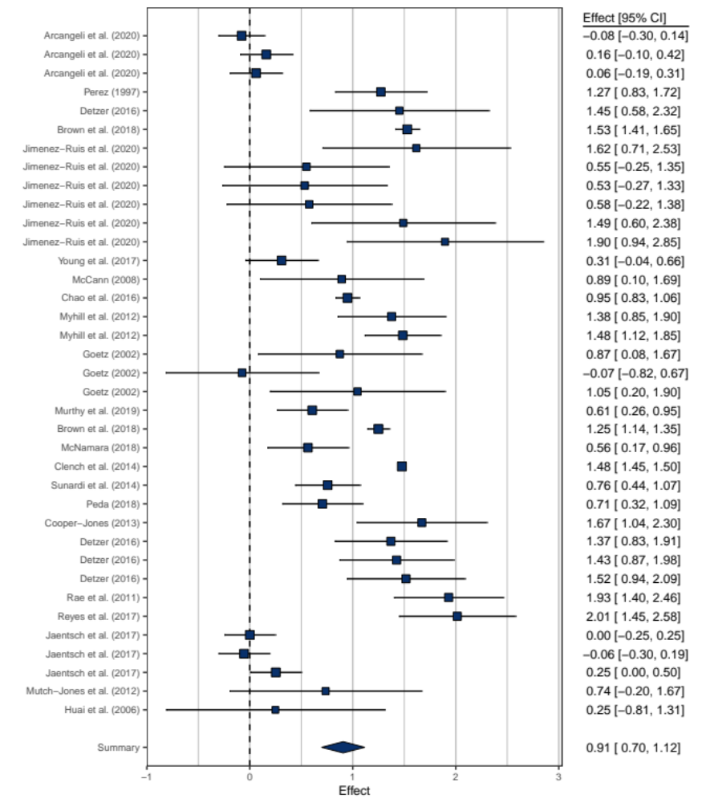

Figure 5b Effect Sizes of the Effects of Teacher Training on Tested Knowledge Regarrding Inclusive Education
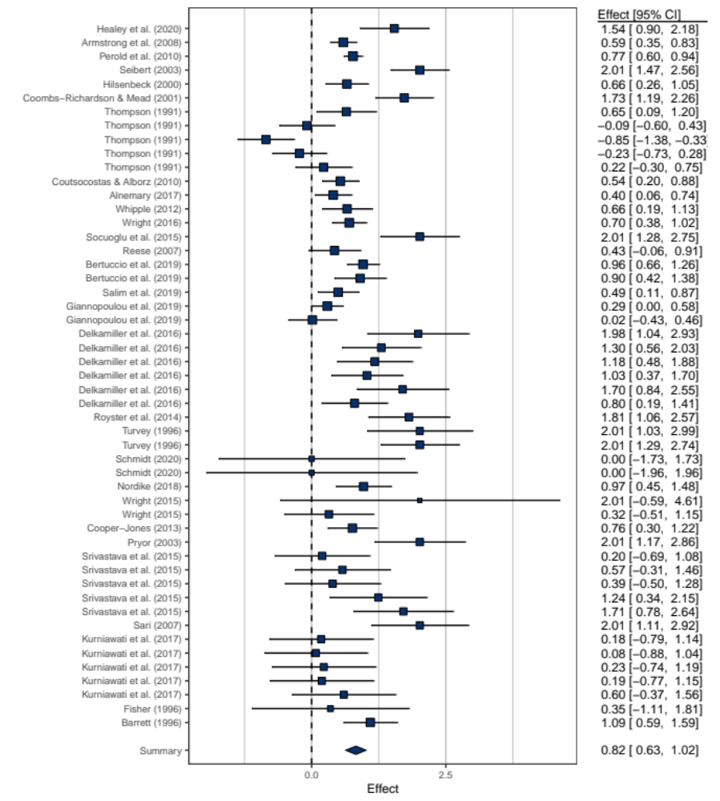

Figure 6a Effect Sizes of the Effects of Teacher Training on the Implementation Quality of Inclusive Teaching Strategies
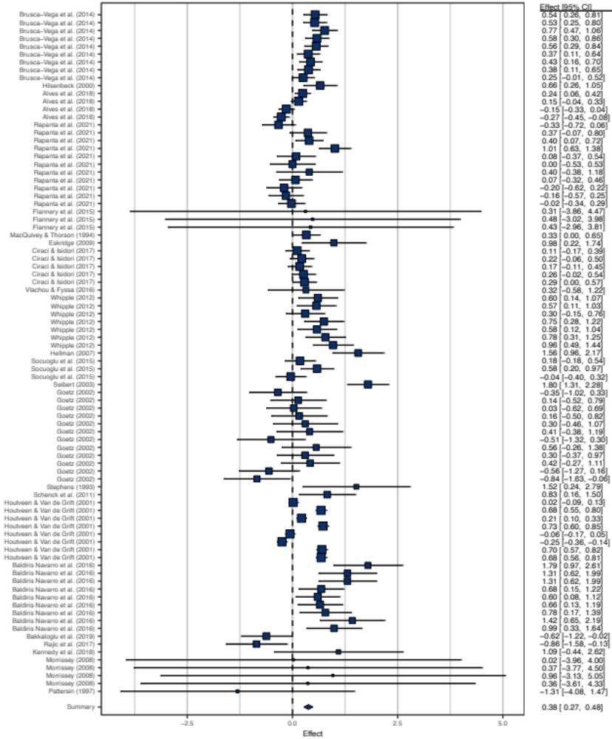

Figure 6b Effect Sizes of the Effects of Teacher Training on the Use of Inclusive Teaching Strategies
first part
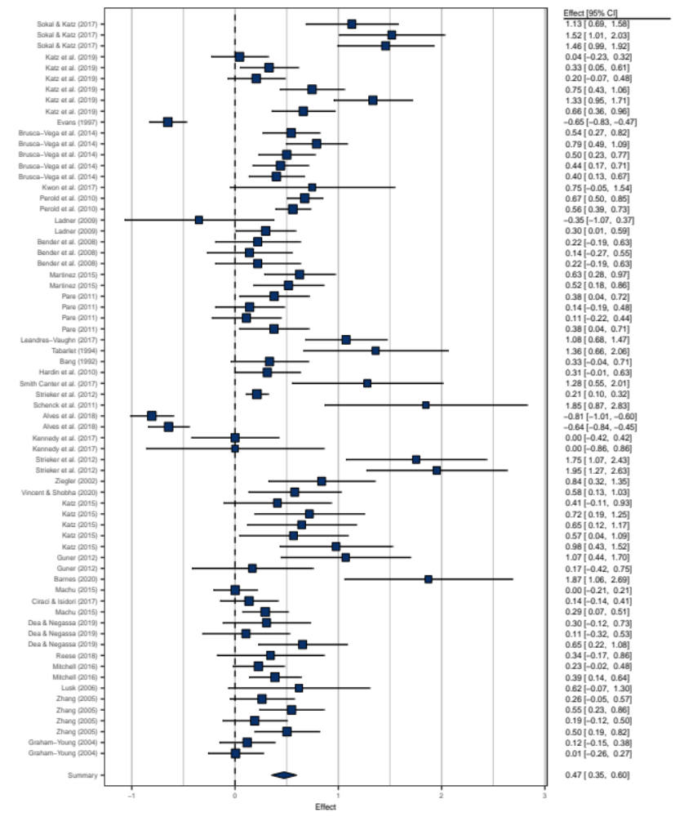

Figure 6b Effect Sizes of the Effects of Teacher Training on the Use of Inclusive Teaching Strategies, second part
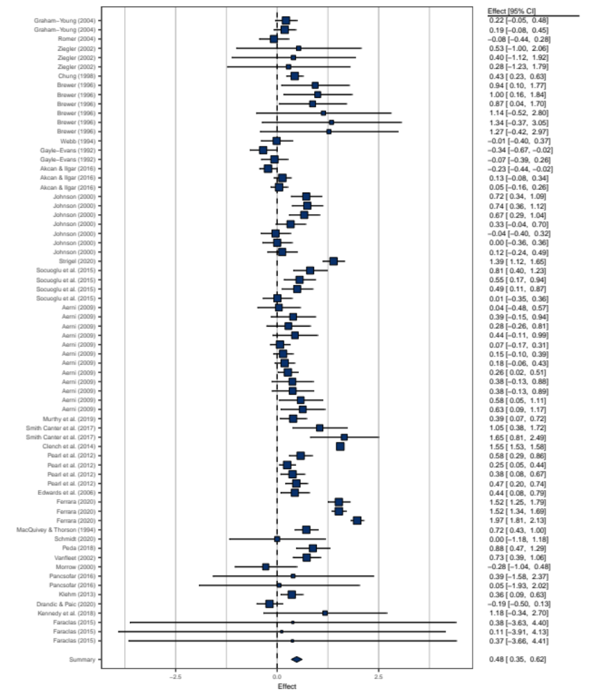

Figure 6c Effect Sizes of the Effects of Teacher Training on Self-Efficacy for Inclusive Teaching
first part
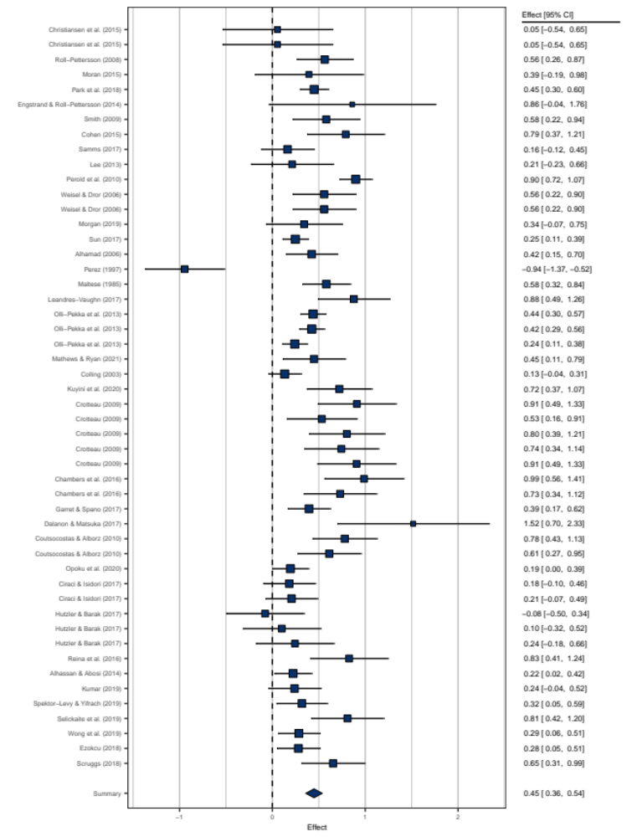

Figure 6c Effect Sizes of the Effects of Teacher Training on Self-Efficacy for Inclusive Teaching, second part
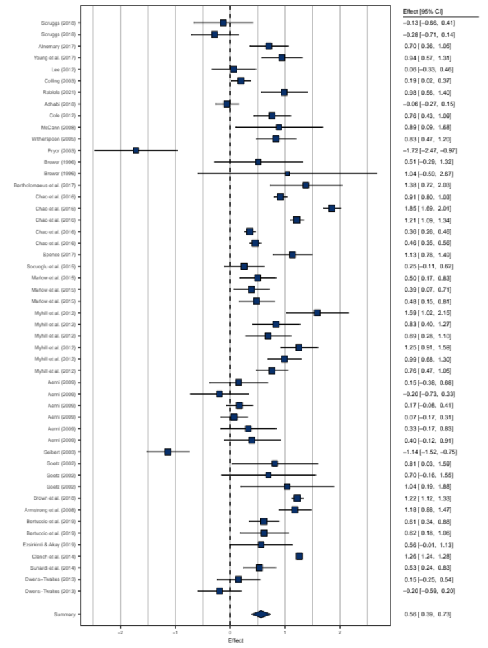

Figure 6c Effect Sizes of the Effects of Teacher Training on Self-Efficacy for Inclusive Teaching, third part
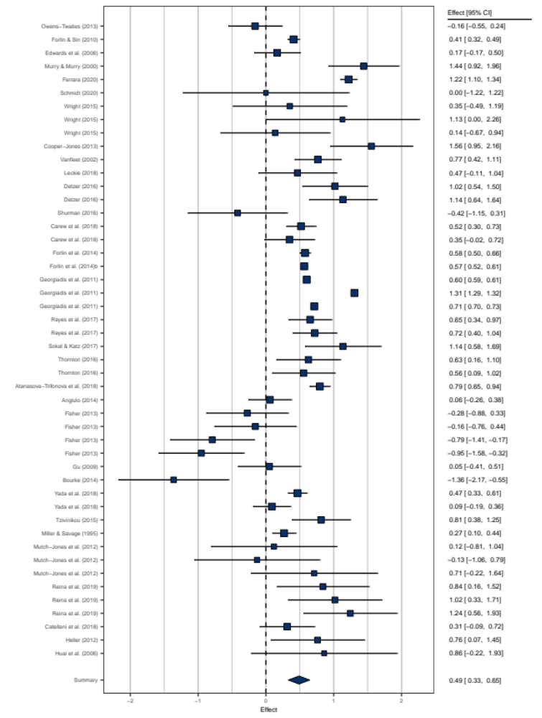

Figure 7a Effect Sizes of the Effects of Teacher Training on the Attitude Towards Inclusive Education
first part
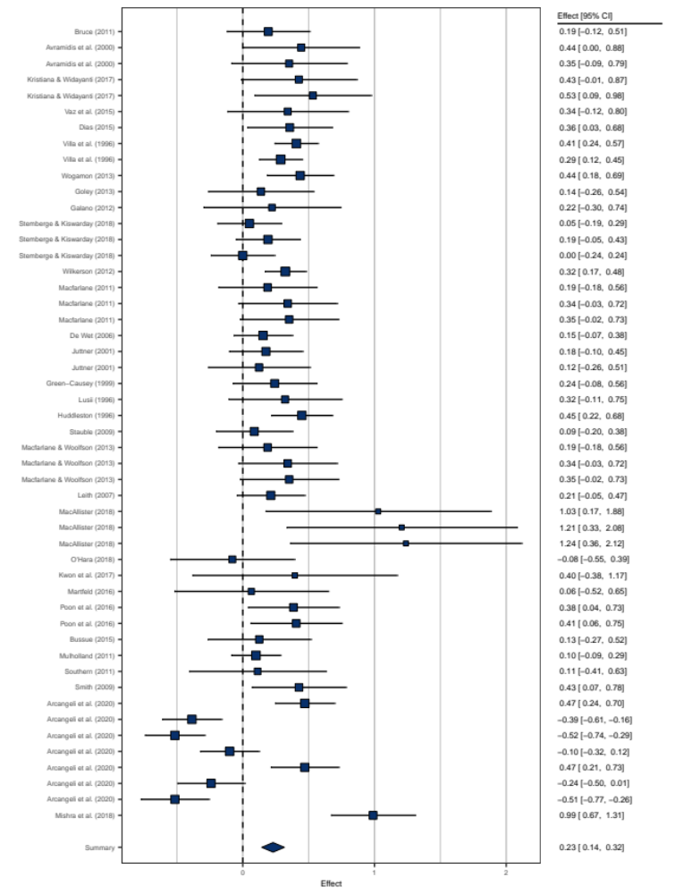
Figure 7a Effect Sizes of the Effects of Teacher Training on the Attitude Towards Inclusive Education, second part
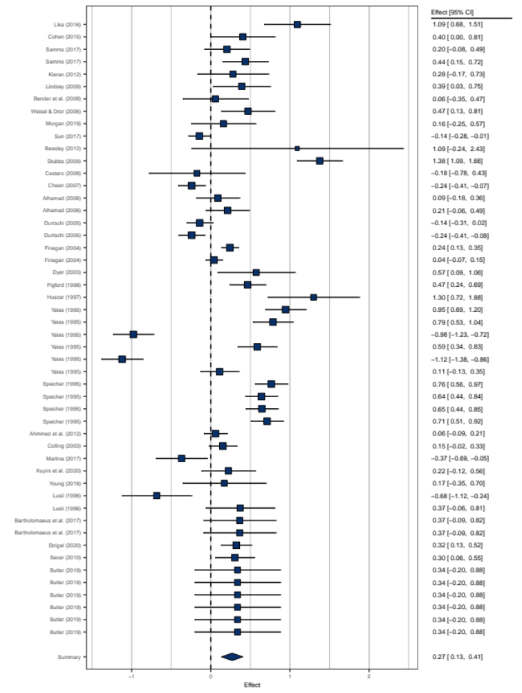

Figure 7a Effect Sizes of the Effects of Teacher Training on the Attitude Towards Inclusive Education, third part
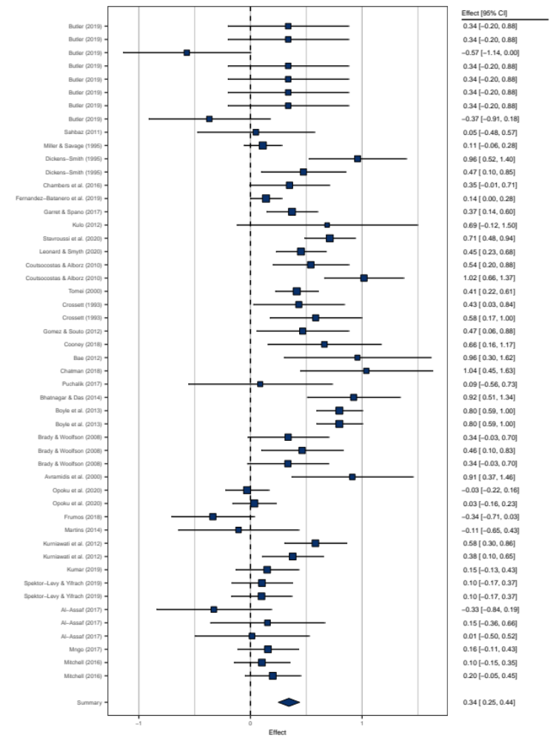

Figure 7a Effect Sizes of the Effects of Teacher Training on the Attitude Towards Inclusive Education, fourth part
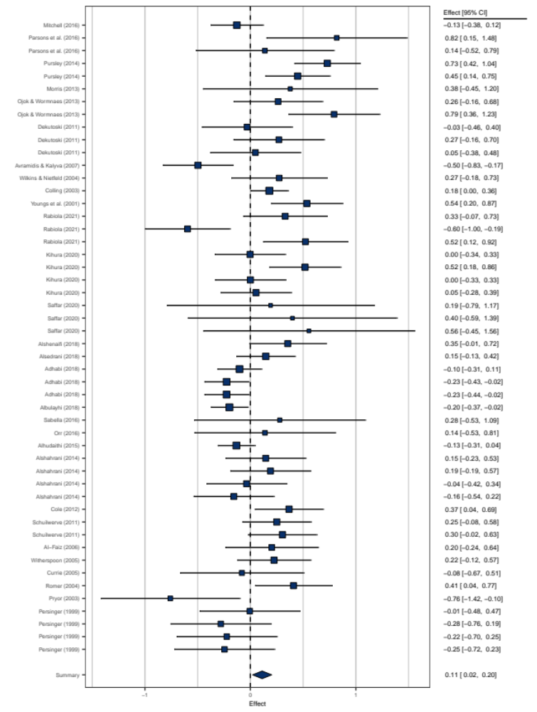

Figure 7a Effect Sizes of the Effects of Teacher Training on the Attitude Towards Inclusive Education, fifth part
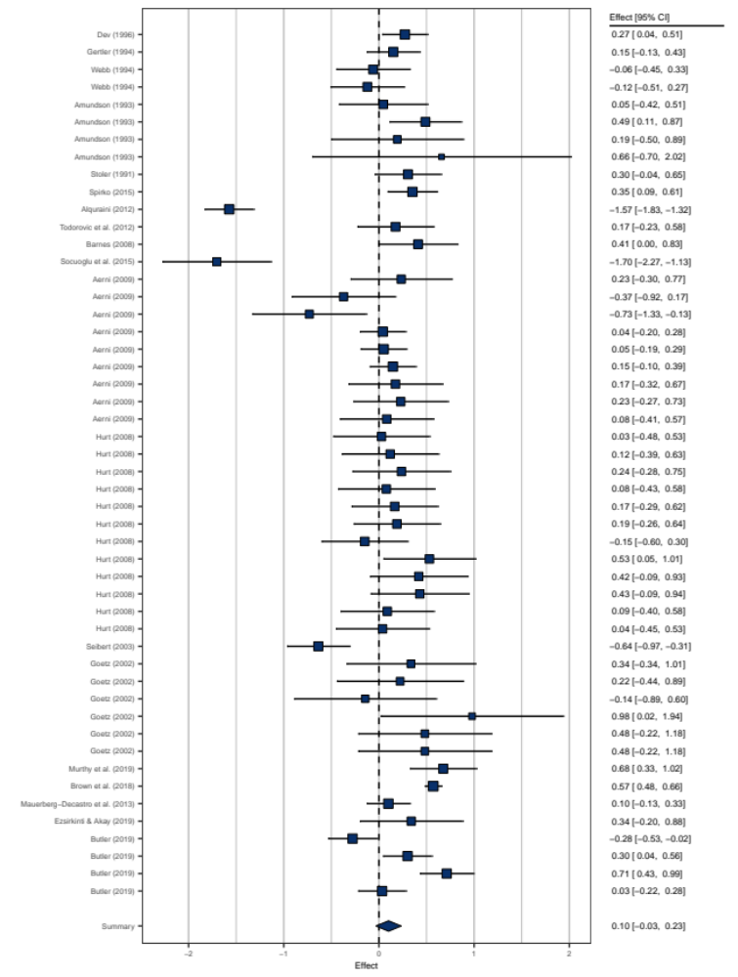

Figure 7a Effect Sizes of the Effects of Teacher Training on the Attitude Towards Inclusive Education, sixth part
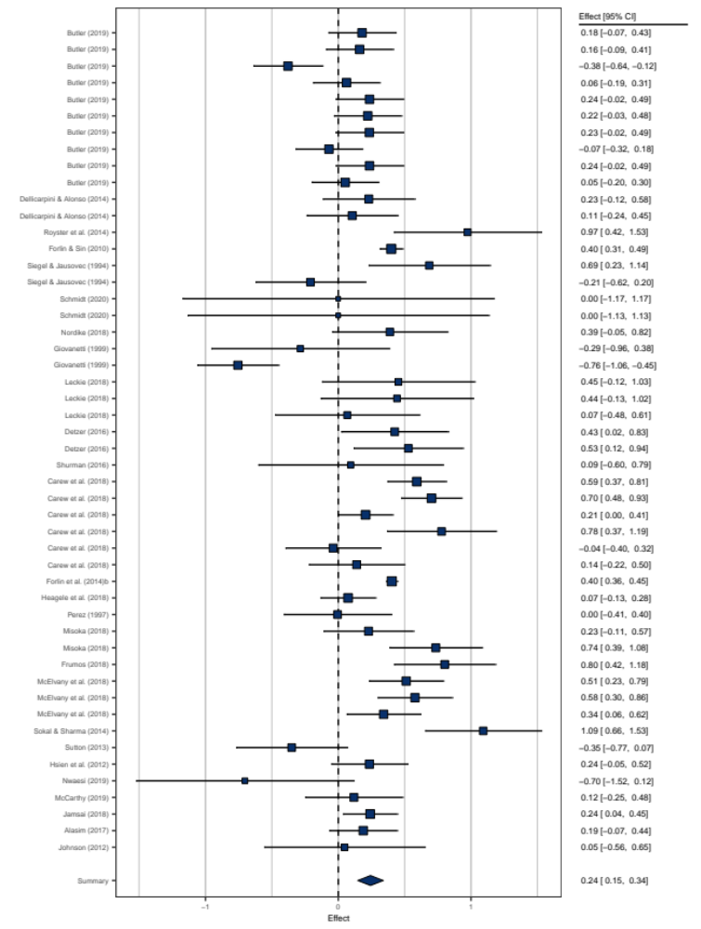

Figure 7a Effect Sizes of the Effects of Teacher Training on the Attitude Towards Inclusive Education, seventh part
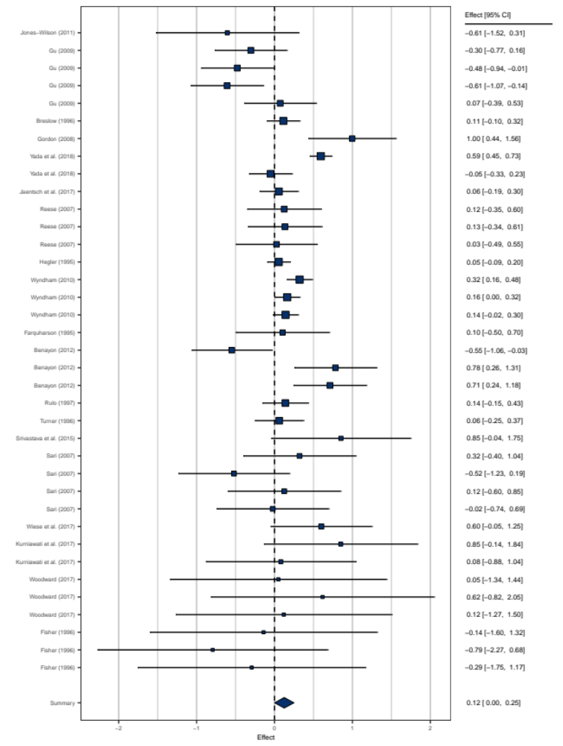

Figure 7b Effect Sizes of the Effects of Teacher Training on Concerns Towards Inclusive Education
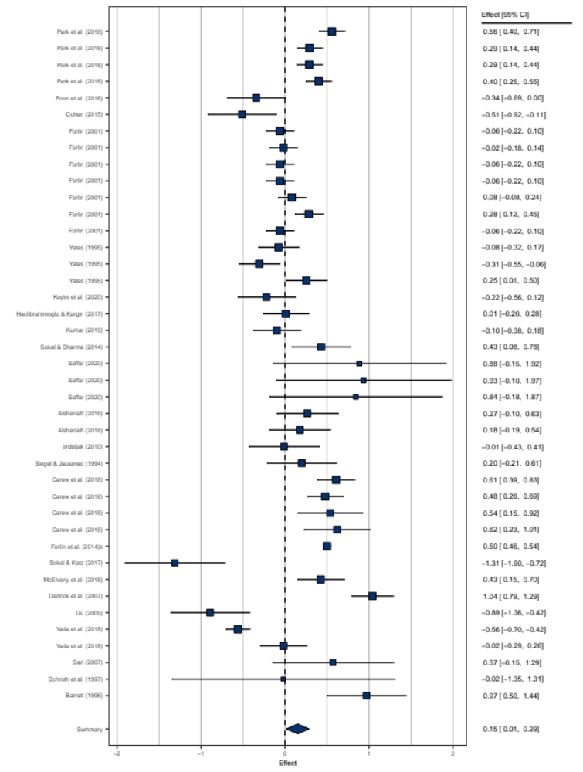

Figure 7c Effect Sizes of the Effects of Teacher Training on the Perception of Inclusive Teaching Strategies
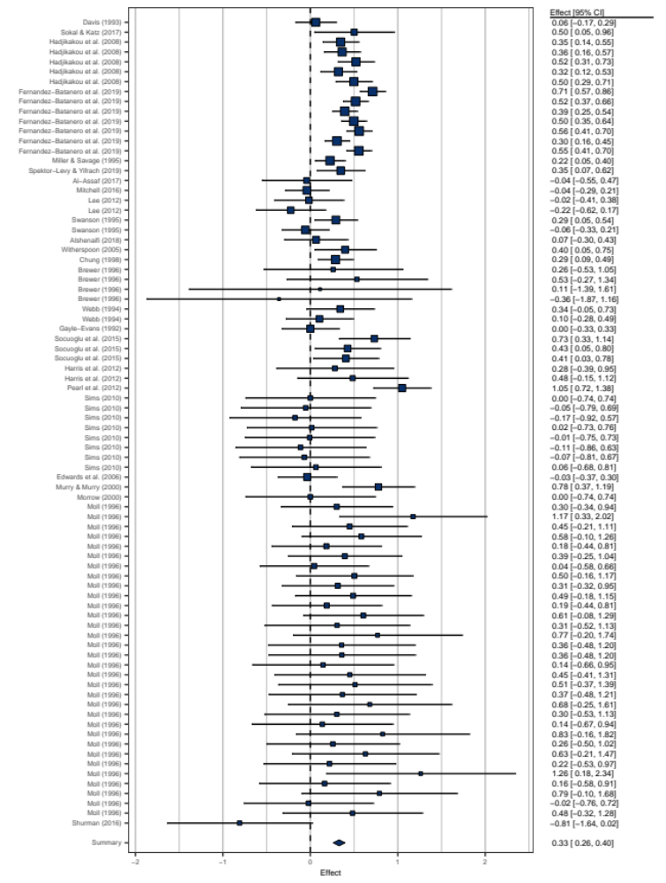

Figure 8a Effect Sizes of the Effects of Teacher Training Addressing Inclusive Education on Student Achievement
first part
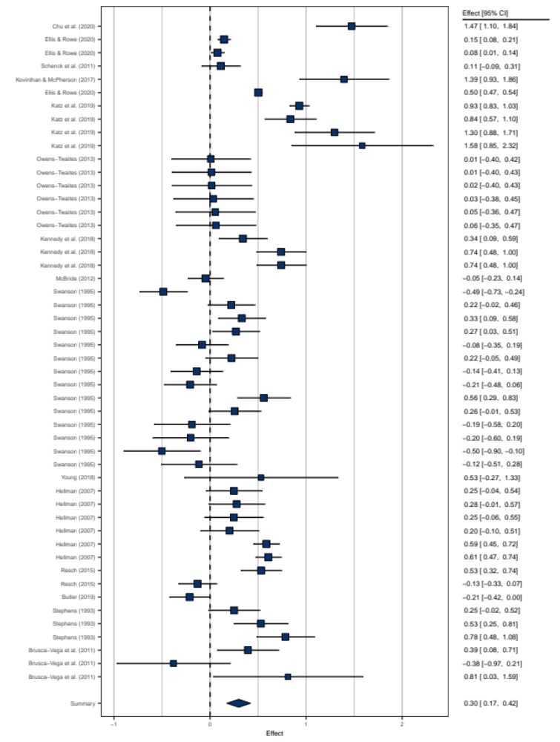
Figure 8a Effect Sizes of the Effects of Teacher Training Addressing Inclusive Education on Student Achievement, second part
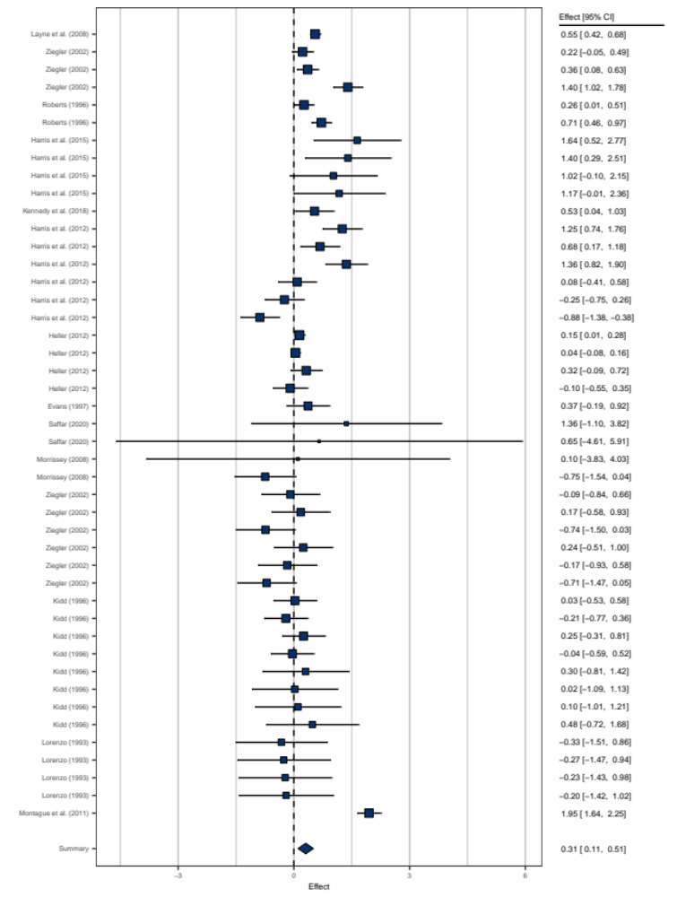

Figure 8b Effect Sizes of the Effects of Teacher Training Addressing Inclusive Education on Other Student Behavior
first part
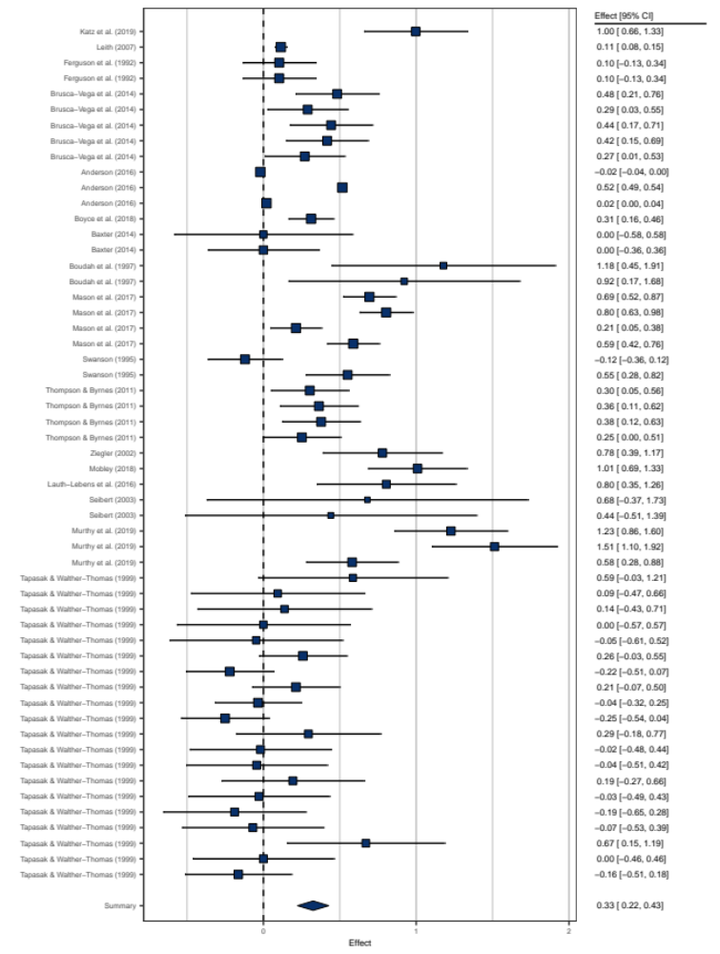

Figure 8b Effect Sizes of the Effects of Teacher Training Addressing Inclusive Education on Other Student Behavior, second part
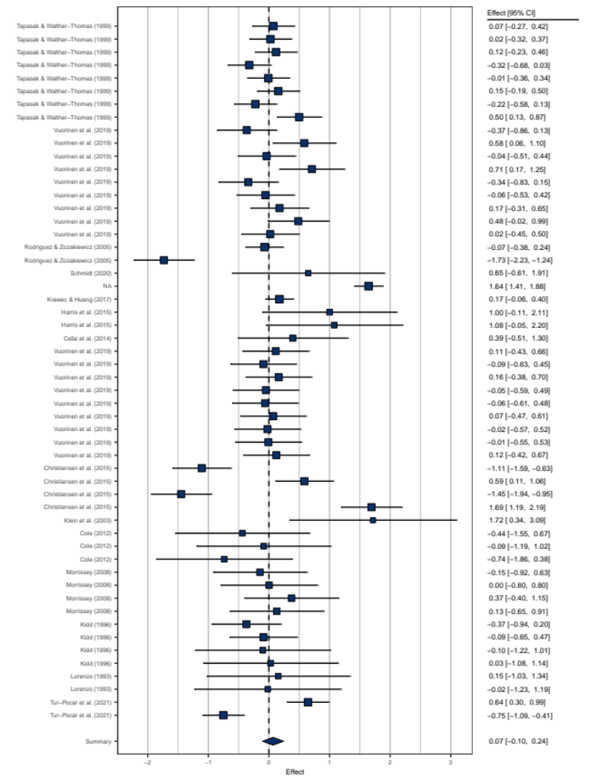

Supplement E. Overview of Mean Effects and Variance

Outcome dimension | k | Effect size | 95% CI | Q | p_{Q} | Within-study variance (%) | Between-study variance (%) | Median power (%)
Knowledge | 88 | 0.926 | [0.76; 1.10] | 1482.96 | <0.00001 | 10.24 | 83.35 | 90.2
Self-rated knowledge | 37 | 0.957 | [0.70; 1.28] | 953.87 | <0.00001 | 5.29 | 90.75 | 94.3
Tested knowledge | 51 | 0.913 | [0.68; 1.15] | 224.49 | <0.00001 | 15.46 | 68.05 | 77.5
Skills | 371 | 0.485 | [0.41; 0.56] | 7446.14 | <0.00001 | 34.19 | 63.76 | 69.2
Implementation quality | 87 | 0.469 | [0.21; 0.73] | 628.49 | <0.00001 | 21.83 | 71.36 | 47.7
Use of strategies | 136 | 0.525 | [0.36; 0.69] | 5191.60 | <0.00001 | 16.06 | 77.76 | 73.7
Self-efficacy | 148 | 0.501 | [0.40; 0.60] | 8458.36 | <0.00001 | 32.75 | 66.17 | 71.8
Beliefs | 461 | 0.230 | [0.18; 0.28] | 2745.3 | <0.00001 | 53.21 | 32.59 | 21.5
Attitude | 338 | 0.227 | [0.18; 0.28] | 1979.4 | <0.00001 | 57.69 | 27.88 | 20.6
Perception of strategies | 83 | 0.270 | [0.16; 0.39] | 167.81 | <0.00001 | 6.81 | 62.09 | 8.8
Concerns | 40 | 0.081 | [-0.14; 0.30] | 533.28 | <0.00001 | 7.61 | 88.36 | 12.9
Student behavior | 203 | 0.372 | [0.23; 0.51] | 3339.81 | <0.00001 | 39.36 | 58.51 | 41.8
Achievement | 95 | 0.409 | [0.21; 0.61] | 987.28 | <0.00001 | 36.69 | 59.31 | 50.9
Other Behavior | 108 | 0.328 | [0.14; 0.51] | 2105.53 | <0.00001 | 43.18 | 55.13 | 28.3

Supplement F. Moderation Analyses for Effect Size Calculation Methods and Publication Bias

Outcome dimension | Calculation from M(SD) | Egger regression test | Publication status
Knowledge | F(1, 86)=0.202, p=0.654 | F(1, 86)=0.016, p=0.900 | F(1, 86)=0.884, p=0.350
Self-rated knowledge | F(1, 35)=0.038, p=0.846 | F(1, 35)=0.294, p=0.591 | F(1, 35)=0.267, p=0.609
Tested knowledge | F(1, 49)=0.025, p=0.875 | F(1, 49)=0.004, p=0.953 | F(1, 49)=0.394, p=0.533
Skills | F(1, 369)=2.045, p=0.154 | F(1, 369)=0.724, p=0.395 | F(1, 368)=2.074, p=0.151
Quality of implementation | F(1, 85)=3.775, p=0.055 | F(1, 85)=0.400, p=0.529 | F(1, 85)=5.546, p=0.021
Use of teaching strategies | F(1, 134)=0.013, p=0.909 | F(1, 134)=1.265, p=0.263 | F(1, 134)=0.002, p=0.967
Self-efficacy | F(1, 146)=1.430, p=0.234 | F(1, 146)=0.109, p=0.742 | F(1, 146)=9.877, p=0.002
Beliefs | F(1, 459)=2.580, p=0.109 | F(1, 459)=0.155, p=0.694 | F(1, 457)=6.847, p=0.009
Attitude | F(1, 336)=3.158, p=0.077 | F(1, 336)=0.307, p=0.580 | F(1, 609)=4.662, p=0.032
Concerns | F(1, 38)=0.483, p=0.491 | F(1, 38)=0.129, p=0.721 | F(1, 38)=0.109, p=0.743
Perception of teaching strategies | F(1, 81)=0.455, p=0.502 | F(1, 81)=0.073, p=0.788 | F(1, 81)=11.979, p=0.001
Student behavior | F(1, 201)=2.857, p=0.093 | F(1, 201)=0.608, p=0.436 | F(1, 200)=4.771, p=0.030
Student achievement | F(1, 93)=0.606, p=0.438 | F(1, 93)=0.250, p=0.618 | F(1, 93)=17.645, p<.0001
Other student behavior | F(1, 106)=2.684, p=0.104 | F(1, 106)=0.546, p=0.462 | F(1, 102)=0.139, p=0.710

Supplement G. Analyses of Study Bias

Study bias: Knowledge about inclusive education
 | Knowledge | Self-rated knowledge | Tested knowledge
Study bias (sum score) | F(1, 86)=2.741, p=0.101 | F(1, 35)=11.060, p=0.002 | F(1, 49)=0.493, p=0.486
Study design | F(2, 85)=1.966, p=0.146 | F(2, 34)=1.691, p=0.200 | F(2, 48)=0.726, p=0.489
Response rate | F(1, 22)=4.281, p=0.051 | F(1, 7)=9.592, p=0.017 | F(1, 13)=1.102, p=0.313
Sampling procedure | F(1, 86)=0.096, p=0.758 | F(1, 35)=0.006, p=0.941 | F(1, 49)=0.228, p=0.636
Allocation to conditions | F(1, 75)=0.184, p=0.669 | F(1, 35)=2.137, p=0.155 | F(1, 44)=1.864, p=0.179
Type of data (self-report vs. objective measure) | F(1, 86)=0.497, p=0.483 | - | -
Standardized instrument | F(1, 86)=1.435, p=0.234 | F(1, 35)=5.842, p=0.021 | F(1, 49)=0.011, p=0.917
Reliability of the instrument reported | F(1, 86)=1.402, p=0.240 | F(1, 35)=7.941, p=0.008 | F(1, 49)=0.065, p=0.800
Handling of missing data reported | F(1, 86)=1.516, p=0.222 | F(1, 35)=0.042, p=0.839 | F(1, 49)=2.107, p=0.153

Study bias: Skills to implement inclusive education
Moderator | Skills | Quality of implementation | Use of inclusive teaching strategies | Self-efficacy for inclusive teaching
Study bias (sum score) | F(1, 367)=1.562, p=0.212 | F(1, 85)=0.326, p=0.569 | F(1, 133)=4.890, p=0.029 | F(1, 145)=1.614, p=0.206
Study design | F(3, 367)=3.089, p=0.027 | F(3, 83)=1.212, p=0.311 | F(3, 133)=0.836, p=0.476 | F(3, 144)=3.671, p=0.014
Response rate | F(1, 107)=2.013, p=0.159 | F(1, 6)=0.003, p=0.958 | F(1, 47)=0.393, p=0.534 | F(1, 50)=1.560, p=0.218
Sampling procedure | F(1, 368)=1.982, p=0.160 | F(1, 85)=0.493, p=0.485 | F(1, 134)=0.343, p=0.559 | F(1, 146)=1.617, p=0.206
Allocation to conditions | F(1, 257)=0.186, p=0.667 | F(1, 75)=0.055, p=0.816 | F(1, 88)=0.299, p=0.586 | F(1, 91)=1.892, p=0.172
Type of data (self-report vs. objective measure) | F(1, 169)=1.780, p=0.183 | F(1, 85)=0.001, p=0.972 | F(1, 134)=4.977, p=0.027 | -
Standardized instrument | F(1, 369)=2.244, p=0.135 | F(1, 85)=0.653, p=0.421 | F(1, 134)=7.421, p=0.007 | F(1, 146)=0.236, p=0.628
Reliability of the instrument reported | F(1, 368)=3.209, p=0.074 | F(1, 85)=0.817, p=0.369 | F(1, 135)=8.172, p=0.005 | F(1, 145)=2.608, p=0.109
Handling of missing data reported | F(1, 368)=0.530, p=0.467 | F(1, 85)=0.009, p=0.924 | F(1, 134)=0.848, p=0.359 | F(1, 146)=0.432, p=0.512

Study bias: Beliefs regarding inclusive education
 | Beliefs | Attitude | Concerns | Perception of strategies
Study bias (sum score) | F(1, 457)=0.488, p=0.485 | F(1, 336)=1.351, p=0.246 | F(1, 38)=0.096, p=0.758 | F(1, 81)=0.314, p=0.577
Study design | F(3, 456)=0.305, p=0.822 | F(3, 334)=0.523, p=0.667 | F(3, 36)=0.853, p=0.474 | F(2, 80)=1.171, p=0.315
Response rate | F(1, 179)=3.603, p=0.059 | F(1, 149)=3.443, p=0.066 | F(1, 9)=0.752, p=0.409 | F(1, 17)=2.101, p=0.165
Sampling procedure | F(1, 457)=0.140, p=0.709 | F(1, 337)=0.635, p=0.426 | F(1, 38)=0.527, p=0.472 | F(1, 81)=0.481, p=0.490
Allocation to conditions | F(1, 209)=0.001, p=0.973 | F(1, 136)=0.178, p=0.674 | F(1, 11)=0.697, p=0.421 | F(1, 60)=0.604, p=0.440
Type of data (self-report vs. objective measure) | - | - | - | -
Standardized instrument | F(1, 457)=0.585, p=0.445 | F(1, 336)=1.765, p=0.185 | F(1, 38)=0.685, p=0.413 | F(1, 81)=0.799, p=0.374
Reliability of the instrument reported | F(1, 457)=0.071, p=0.790 | F(1, 336)=0.045, p=0.831 | F(1, 38)=0.000, p=0.987 | F(1, 81)=0.001, p=0.979
Handling of missing data reported | F(1, 457)=0.368, p=0.545 | F(1, 336)=0.120, p=0.729 | F(1, 38)=2.58, p=0.117 | F(1, 81)=0.004, p=0.947

Study bias: student behavior
 | Student behavior | Student achievement | Other student behavior
Study bias (sum score) | F(1, 200)=0.276, p=0.600 | F(1, 92)=0.091, p=0.763 | F(1, 105)=2.125, p=0.148
Study design | F(3, 199)=1.004, p=0.392 | F(3, 91)=1.891, p=0.137 | F(3, 104)=0.665, p=0.575
Response rate | F(1, 59)=0.091, p=0.764 | F(1, 20)=0.388, p=0.540 | F(1, 37)=0.033, p=0.857
Sampling procedure | F(1, 200)=0.185, p=0.668 | F(1, 93)=3.562, p=0.062 | F(1, 105)=7.872, p=0.006
Allocation to conditions | F(1, 194)=0.244, p=0.622 | F(1, 93)=0.914, p=0.342 | F(1, 105)=0.120, p=0.730
Type of data (self-report vs. objective measure) | F(1, 201)=13.35, p=0.0003 | - | F(1, 106)=19.474, p<.001
Standardized instrument | F(1, 201)=4.462, p=0.034 | F(1, 93)=5.504, p=0.021 | F(1, 106)=1.562, p=0.214
Reliability of the instrument reported | F(1, 201)=3.522, p=0.062 | F(1, 93)=15.457, p=0.0002 | F(1, 106)=0.938, p=0.335
Handling of missing data reported | F(1, 200)=0.844, p=0.360 | F(1, 93)=0.737, p=0.393 | F(1, 105)=0.049, p=0.826

Supplement H. Traditional Funnel Plots

Attitude towards inclusive education | Concerns regarding inclusive education | Perception of inclusive teaching strategies
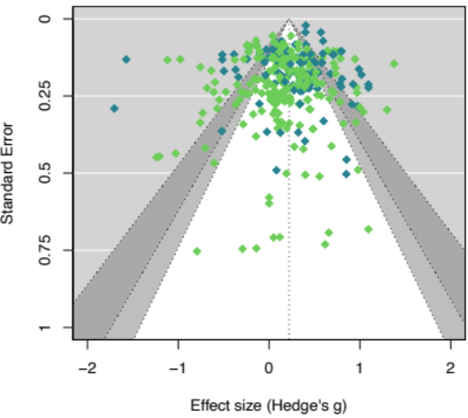 | 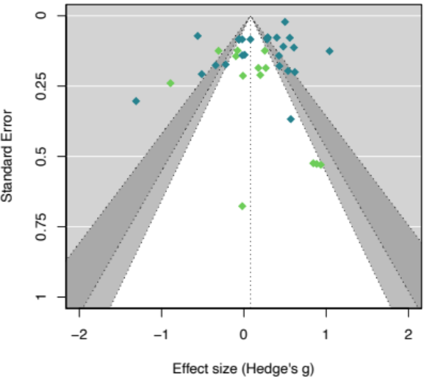 | 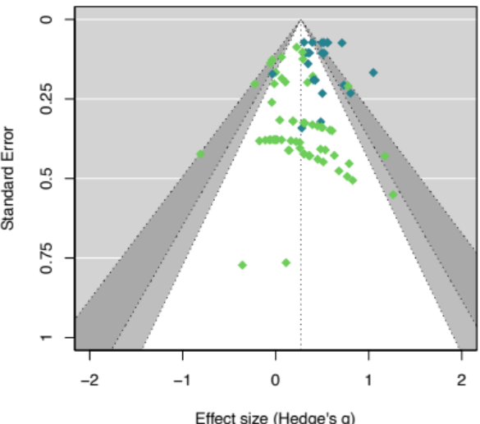
Quality of implementation | Use of inclusive teaching strategies | Self-efficacy for inclusive teaching
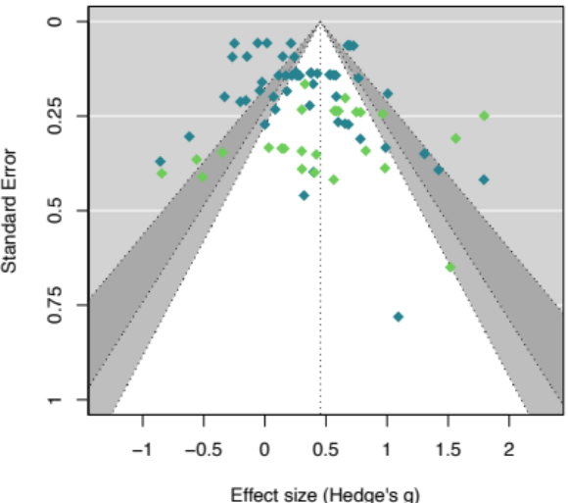 | 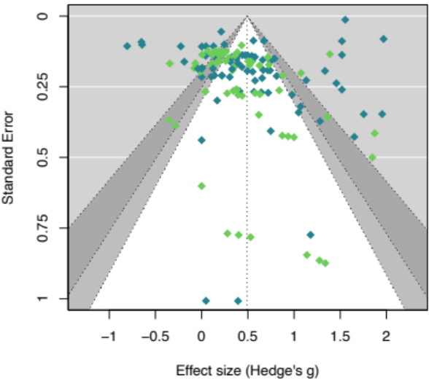 | 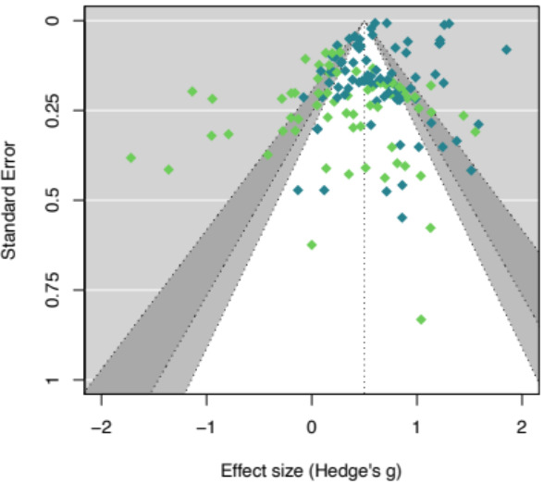
Publication status  published  unpublished

Self-rated knowledge about inclusive education | Tested knowledge about inclusive education
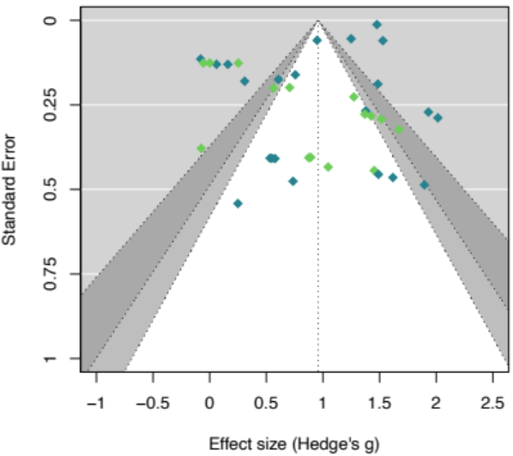 | 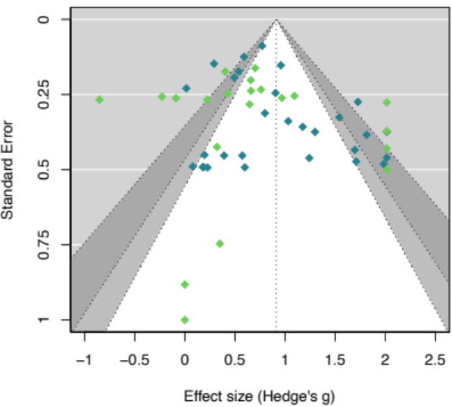
Student achievement | Other student behavior
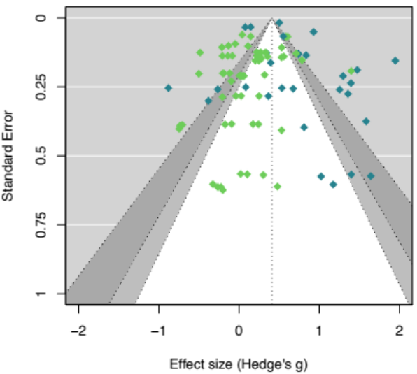 | 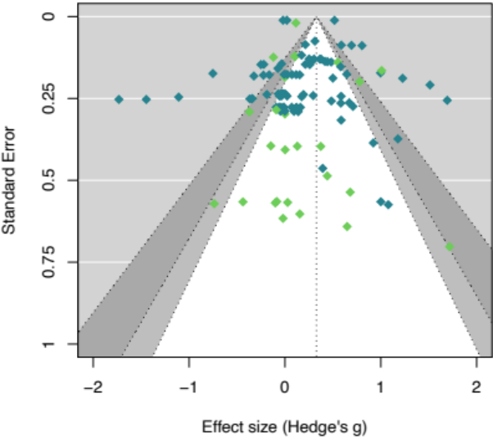
Publication status published unpublished

Supplement I. Power Enhanced Funnel Plots

Attitude towards inclusive education | Concerns regarding inclusive education | Perception of inclusive teaching strategies
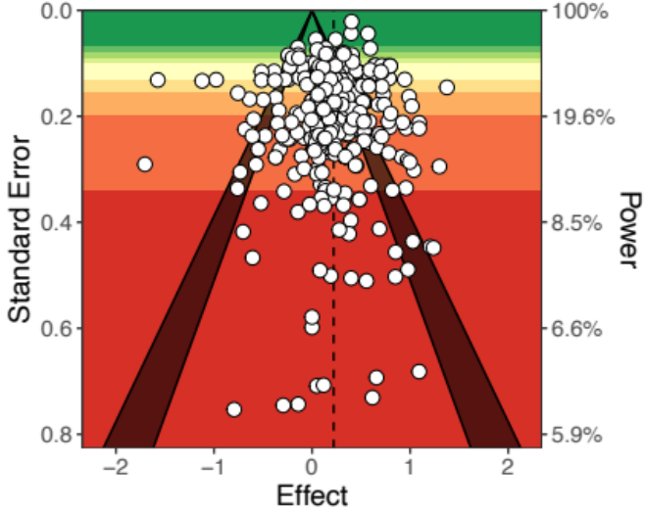 | 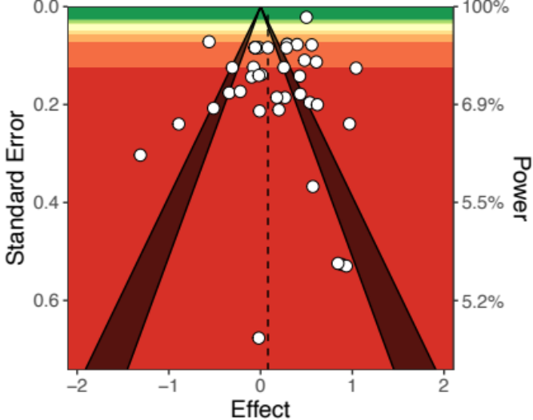 | 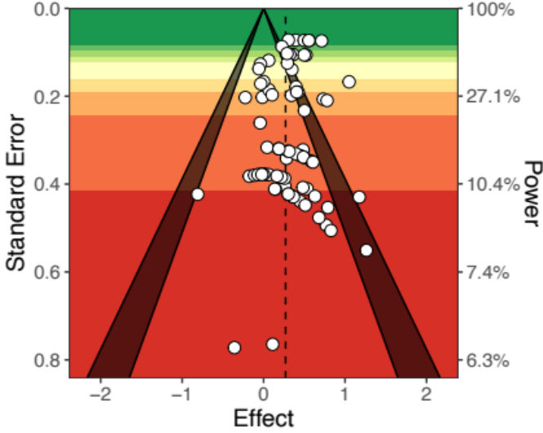
Quality of implementation | Use of inclusive teaching strategies | Self-efficacy for inclusive teaching
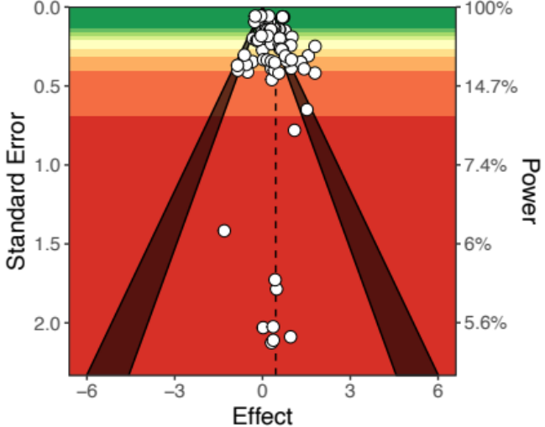 | 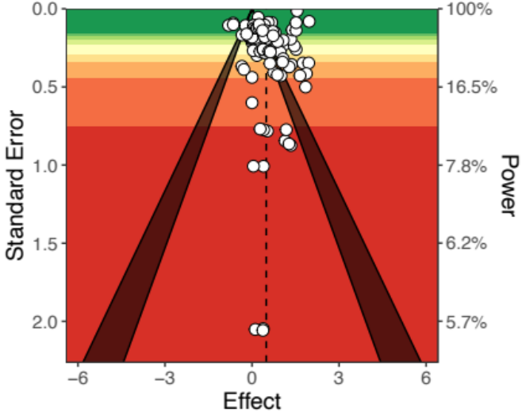 | 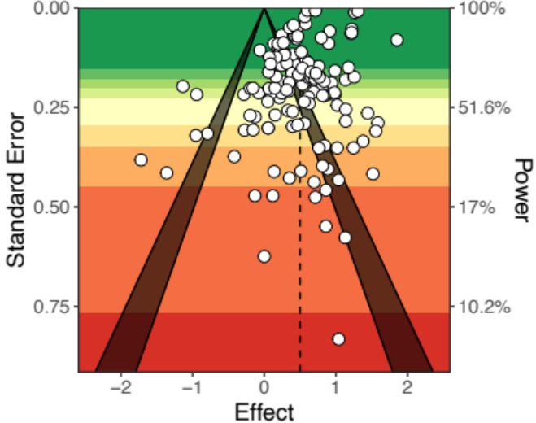

Self-rated knowledge about inclusive education | Tested knowledge about inclusive education
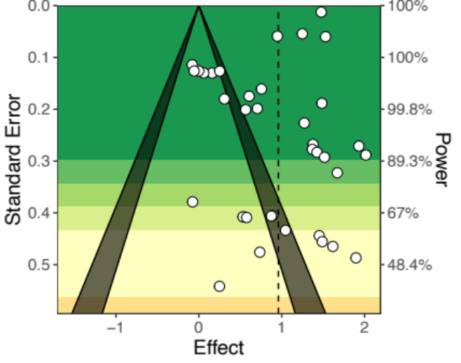 | 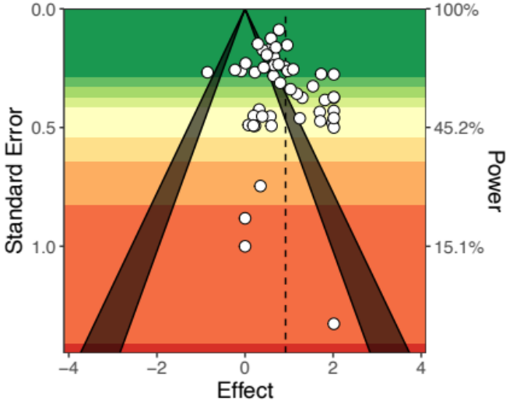
Student achievement | Other student behavior
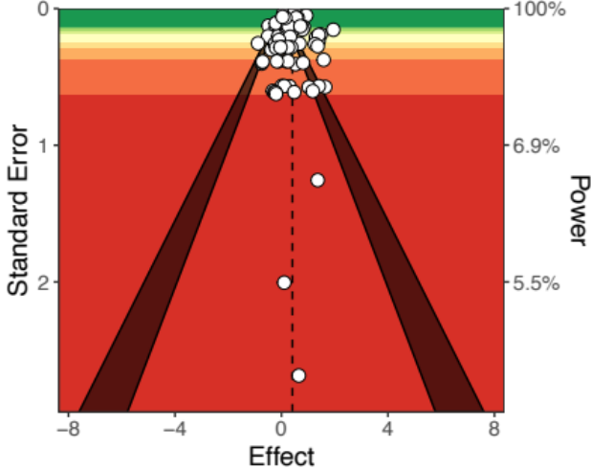 | 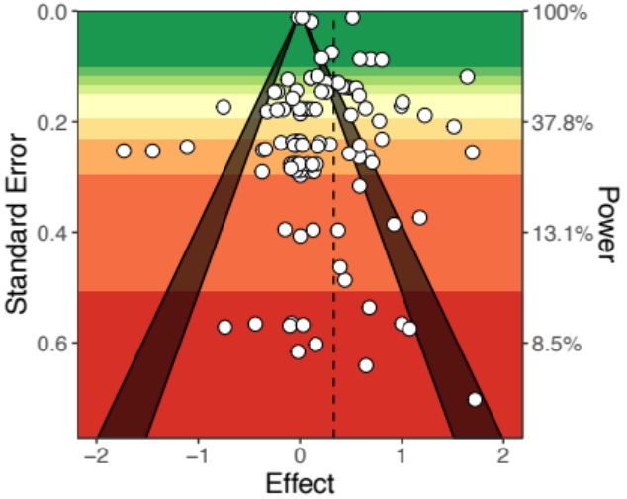

Supplement J. Moderation Analyses of Effects of Teacher Training on Knowledge about Inclusive Education

 | Knowledge | Self-rated knowledge | Tested knowledge
Effect size estimate | 0.926 [0.756; 1.097] | 0.957 [0.697; 1.217] | 0.913 [0.677; 1.148]
Number of effect sizes | 88 | 37 | 51
Components of outcome dimension | F(1, 86)=0.497, p=0.483
Characteristics of the study
Intervention study | F(1, 86) = 3.733, p=0.057 | F(1, 35)=2.216, p=0.146 | F(1, 49)=1.497, p=0.227
Publication year | F(1, 86)=1.060, p=0.306 | F(1, 35)=0.466, p=0.500 | F(1, 49)=0.703, p=0.406
Years since legal introduction ofIE | F(1, 86)=0.218, p=0.642 | F(1, 35)=0.031, p=0.861 | F(1, 49)=0.566, p=0.456
Continent | F(6, 81)=0.669, p=0.675 | F(1, 35)=0.457, p=0.702 | F(5, 45)=0.495, p=0.778
Characteristics of the data collection
Time between end of PD and post-data collection | F(1, 75)=0.380, p=0.540 | F(1, 29)=0.127, p=0.724 | F(1, 44)=0.938, p=0.338
Type of measurement | F(2, 85)=1.992, p=0.143 | F(2, 34)=1.668, p=0.204 | F(2, 48)=3.537, p=0.037
Instrument focusses on specific diversity feature | F(1, 86)=6.573, p=0.012 | F(1, 35)=0.107, p=0.756 | F(1, 49)=5.543, p=0.023
Instrument focusses on specific method | F(1, 86)=0.031, p=0.861 | F(1, 35)=0.020, p=0.889 | F(1, 49)=0.095, p=0.759
Charakteristics of the participants
Mean age | F(1, 34)=1.663, p=0.206 | F(1, 9)=0.004, p=0.951 | F(1, 23) 8.496, p=0.008
Mean teaching experience | F(1, 53)=1.403, p=0.241 | F(1, 19)=0.079, p=0.782 | F(1, 32)=2.769, p=0.106
School type | F(3, 84)=0.568, p=0.637 | F(2, 34)=0.387, p=0.692 | F(3, 47)=0.311, p=0.817
participants with inclusive education experience (%) | F(1, 39)=3.885, p=0.056 | F(1, 11)=2.152, p=0.170 | F(1, 26)=1.880, p=0.182
Characteristics of the professional development design
Content focus | F(1, 75)=0.007, p=0.936 | F(1, 29)=0.024, p=0.879 | F(1, 44)=0.025, p=0.876
Specific topic | F(1, 75)=1.199, p=0.277 | F(1, 29)=2.465, p=0.127 | F(1, 44)=0.014, p=0.906
Specific subject | F(1, 75)=1.285, p=0.261 | F(1, 29)=2.157, p=0.153 | F(1, 44)=0.090, p=0.765
Specific method | F(1, 75)=0.036, p=0.849 | F(1, 29)=1.107, p=0.302 | F(1, 44)=0.162, p=0.690
Active learning | F(1, 75)=0.001, p=0.978 | F(1, 29)=0.302, p=0.587 | F(1, 44)=0.159, p=0.693
Practice opportunities are offered in sessions | F(1, 75)=0.731, p=0.395 | F(1, 29)=1.920, p=0.176 | F(1, 44)=0.015, p=0.903
Sandwich | F(1, 75)=0.001, p=0.981 | F(1, 29)=2.381, p=0.134 | F(1, 44)=3.025, p=0.089
Case studies are used in sessions | F(1, 75)=0.732, p=0.395 | F(1, 29)=0.016, p=0.902 | F(1, 44)=0.635, p=0.430
Coherence with other learning activities | F(1, 75)=0.695, p=0.407 | F(1, 29)=0.861, p=0.361 | F(1, 44)=0.033, p=0.857
Additional coaching | F(1, 75)=4.661, p=0.034 | F(1, 29)=0.653, p=0.426 | F(1, 44)=4.502, p=0.040
Implementation is planned in session | F(1, 75)=0.202, p=0.654 | F(1, 29)=1.264, p=0.270 | F(1, 44)=0.095, p=0.760
Prerequisites to participate in PD | F(1, 75)=1.500, p=0.211 | F(1, 29)=0.115, p=0.737 | F(1, 44)=1.671, p=0.203
Duration | F(1, 75)=0.019, p=0.890 | F(1, 29)=0.021, p=0.887 | F(1, 44)=0.001, p=0.974
Collective participation | F(1, 75)=1.894, p=0.173 | F(1, 29)=0.040, p=0.843 | F(1, 44)=2.220, p=0.143
Certification | F(1, 75)=8.266, p=0.005 | F(1, 29)=2.136, p=0.155 | F(1, 44)=6.140, p=0.017

Supplement K. Moderation Analyses of the Effects of Teacher Training on Skills Regarding Inclusive Education

 | Skills | Implementation quality | Use of inclusive teaching strategies | Self-efficacy towards inclsuive education
Effect size estimate | 0.485 [0.408; 0.562] | 0.469 [0.212; 0.726] | 0.525 [0.362; 0.687] | 0.501 [0.400; 0.601]
Number of effect sizes | 371 | 87 | 136 | 148
Components of outcome dimension | F(2, 368)=0.153, p=0.859
Characteristics of the study
Intervention study | F(1, 369)=8.126, p=0.005 | F(1, 85)=3.166, p =0.079 | F(1, 135)=2.639, p=0.107 | F(1, 146)=2.522, p=0.114
Publication year | F(1, 368)=3.220, p=0.074 | F(1, 85)=3.072, p=0.083 | F(1, 134)=3.304, p=0.071 | F(1, 146)=2.286, p=0.133
Years since legal introduction of inclusive education | F(1, 368)=0.115, p=0.735 | F(1, 85)=0.219, p=0.641 | F(1, 134)=2.949, p=0.088 | F(1, 146)=1.125, p=0.291
Continent (Europe) | F(1, 368)=0.006, p=0.938 | F(1, 85)=11.862, p=0.001 | F(1, 133)=1.979, p=0.162 | F(1, 146)=4.174, p=0.043
Characteristics of the data collection
Time between end of PD and post-data collection | F(1, 257)=1.633, p=0.202 | F(1, 75)=1.785, p=0.186 | F(1, 88)=0.232, p=0.631 | F(1, 91)=2.749, p=0.101
Type of measurement | F(5, 365)=1.400, p=0.224 | F(5, 81)=0.249, p=0.939 | F(3, 133)=2.190, p=0.092 | F(2, 145)=0.734, p=0.482
Instrument focusses on specific diversity feature | F(1, 369)=0.003, p=0.954 | F(1, 85)=1.516, p=0.222 | F(1, 135)=1.525, p=0.219 | F(1, 146)=0.126, p=0.723
Instrument focusses on specific method | F(1, 369)=0.859, p=0.355 | F(1, 85)=0.061, p=0.805 | F(1, 135)=0.120, p=0.729 | F(1, 146)=1.322, p=0.252
Charakteristics of the participants
Mean age | F(1, 89)=0.8434, p=0.361 | F(1, 10)=0.540, p=0.479 | F(1, 25)=0.698, p=0.411 | F(1, 50)=0.114, p=0.737
Mean teaching experience | F(1, 197)=0.011, p=0.916 | F(1, 33)=0.045, p=0.833 | F(1, 72)=0.375, p=0.542 | F(1, 88)=0.013, p=0.908
School type | F(3, 366)=1.567, p=0.197 | F(3, 83)=1.614, p=0.192 | F(3, 132)=0.658, p=0.579 | F(3, 144)=0.582, p=0.628
participants with inclusive education experience (%) | F(1, 214)=2.156, p=0.144 | F(1, 51)=0.014, p=0.908 | F(1, 88)=10.910, p=0.001 | F(1, 71)=0.875, p=0.353
Characteristics of the professional development design
Content focus | F(1, 257)=0.017, p=0.896 | F(1, 75)=0.532, p=0.468 | F(1, 87)=0.208, p=0.650 | F(1, 91)=0.283, p=0.596
Specific topic | F(1, 257)=0.698, p=0.404 | F(1, 75)=0.405, p=0.526 | F(1, 88)=0.009, p=0.925 | F(1, 91)=0.778, p=0.380
Specific subject | F(1, 257)=0.022, p=0.882 | F(1, 75)=1.204, p=0.276 | F(1, 88)=0.865, p=0.355 | F(1, 91)=0.069, p=0.793
Specific method | F(1, 257)=0.355, p=0.552 | F(1, 75)=0.087, p=0.768 | F(1, 88)=1.385, p=0.242 | F(1, 91)=0.016, p=0.899
Active learning | F(1, 368)=7.840, p=0.005 | F(1, 85)=2.938, p=0.090 | F(1, 133)=4.772, p=0.031 | F(1, 146)=0.535, p=0.466
Practice opportunities are offered in sessions | F(1, 257)=0.005, p=0.946 | F(1, 75)=0.092, p=0.762 | F(1, 88)=0.003, p=0.959 | F(1, 91)=0.006, p=0.940
Sandwich | F(1, 257)=3.263, p=0.072 | F(1, 75)=2.295, p=0.134 | F(1, 88)=9.031, p=0.004 | F(1, 91)=0.429, p=0.514
Case studies are used in sessions | F(1, 257)=0.939, p=0.334 | F(1, 75)=0.217, p=0.643 | F(1, 88)=1.415, p=0.237 | F(1, 91)=0.721, p=0.398
Coherence with other learning activities | F(1, 368)=2.095, p=0.149 | F(1, 85)=1.574, p=0.213 | F(1, 133)=0.462, p=0.498 | F(1, 146)=0.027, p=0.870
Additional coaching | F(1, 257)=0.301, p=0.584 | F(1, 75)=0.057, p=0.812 | F(1, 88)=0.003, p=0.954 | F(1, 91)=0.120, p=0.730
Implementation is planned in session | F(1, 257)=0.762, p=0.383 | F(1, 75)=1.665, p=0.201 | F(1, 88)=0.841, p=0.362 | F(1, 91)=0.729, p=0.395
Prerequisites to participate in PD | F(1, 257)=1.707, p=0.193 | F(1, 75)=0.017, p=0.896 | F(1, 88)=3.342, p=0.071 | F(1, 91)=0.394, p=0.532
Duration | F(1, 245)=0.561, p=0.455 | F(1, 70)=0.052, p=0.821 | F(1, 83)=1.161, p=0.284 | F(1, 88)=0.000, p=0.999
Collective participation | F(1, 257)=0.068, p=0.794 | F(1, 75)=1.500, p=0.225 | F(1, 87)=0.253, p=0.616 | F(1, 91)=0.148, p=0.702
Certficication | F(1, 257)=0.735, p=0.392 | F(1, 75)=0.160, p=0.690 | F(1, 88)=1.727, p=0.192 | F(1, 91)=0.011, p=0.916

Supplement L. Moderation Analyses of Effects of Teacher Training on Beliefs Regarding Inclusive Education

 | Beliefs | Attitude | Concerns | Perception of strategies
Effect size estimate | 0.220 [0.18; 0.28] | 0.227 [0.176; 0.278] | 0.081 [-0.143; 0.304] | 0.270 [0.155; 0.385]
Number of effect sizes | 461 | 338 | 40 | 83
Components of outcome dimension | F(2, 457)=2.339, p=0.098
Characteristics of the study
Intervention study | F(1, 458)=0.040, p=0.842 | F(1, 336)=1.210, p=0.272 | F(1, 38)=0.658, p=0.422 | F(1, 81)=0.795, p=0.375
Publication year | F(1, 458)=0.084, p=0.772 | F(1, 336)=0.314, p=0.575 | F(1, 38)=0.018, p=0.893 | F(1, 81)=0.454, p=0.503
Years since legal introduction ofIE | F(1, 458)=0.909, p=0.341 | F(1, 336)=1.684, p=0.195 | F(1, 38)=0.049, p=0.827 | F(1, 81)=0.548, p=0.461
Continent (Europe) | F(1, 458)=3.451, p=0.064 | F(1, 336)=0.851, p=0.357 | F(1, 38)=0.608, p=0.441 | F(1, 81)=5.536, p=0.021
Characteristics of the data collection
Time between end of PD and post-data collection | F(1, 210)=0.407, p= 0.524 | F(1, 136)=0.021, p=0.885 | F(1, 11)=0.037, p=0.851 | F(1, 60)=1.685, p=0.199
Type of measurement | F(3, 456)=1.574, p=0.195 | F(3, 334)=1.775, p=0.152 | F(2, 37)=0.118, p=0.889 | F(2, 80)=2.385, p=0.100
Instrument focusses on specific diversity feature | F(1, 458)=6.212, p=0.013 | F(1, 337)=4.174, p=0.042 | F(1, 38)=0.016, p=0.899 | F(1, 80)=3.939, p=0.051
Instrument focusses on specific method | F(1, 458)=6.343, p=0.012 | F(1, 337)=0.155, p=0.694 | F(1, 38)=2.223, p=0.144 | F(1, 81)=2.075, p=0.154
Charakteristics of the participants
Mean age | F(1, 170)=0.027, p=0.870 | F(1, 134)=1.559, p=0.214 | F(1, 22)=0.172, p=0.683 | F(1, 11)=0.244, p=0.631
Mean teaching experience | F(1, 316)=0.173, p=0.678 | F(1, 219)=1.891, p=0.171 | F(1, 24)=0.257, p=0.617 | F(1, 67)=2.405, p=0.126
School type | F(3, 456)=2.655, p=0.048 | F(3, 334)=3.292, p=0.021 | F(3, 36)=1.276, p=0.297 | F(3, 79)=0.140, p=0.936
participants with inclusive education experience (%) | F(1, 281)=0.081, p=0.777 | F(1, 202)=0.180, p=0.672 | F(1, 19)=1.982, p=0.175 | F(1, 57)=0.626, p=0.432
Characteristics of the professional development design
Content focus | F(1, 210)=0.377, p=0.540 | F(1, 136)=0.080, p=0.777 | F(1, 11)=0.037, p=0.851 | F(1, 60)=0.436, p=0.512
Specific topic | F(1, 210)=0.394, p=0.531 | F(1, 136)=0.128, p=0.721 | F(1, 11)=0.001, p=0.983 | F(1, 60)=0.201, p=0.656
Specific subject | F(1, 210)=0.248, p=0.619 | F(1, 136)=0.308, p=0.580 | F(1, 11)=1.202, p=0.296 | F(1, 60)=0.152, p=0.698
Specific method | F(1, 210)=0.629, p=0.429 | F(1, 136)=0.180, p=0.672 | F(1, 11)=1.327, p=0.274 | F(1, 60)=1.096, p=0.299
Active learning | F(1, 210)=2.142, p=0.145 | F(1, 136)=4.834, p=0.030 | F(1, 11)=1.213, p=0.294 | F(1, 60)=2.111, p=0.152
Practice opportunities are offered in sessions | F(1, 210)=1.709, p=0.193 | F(1, 136)=1.494, p=0.224 | F(1, 11)=1.529, p=0.242 | F(1, 60)=0.074, p=0.786
Sandwich | F(1, 210)=1.262, p=0.263 | F(1, 136)=3.998, p=0.048 | F(1, 11)=2.086, p=0.177 | F(1, 60)=2.734, p=0.104
Case studies are used in sessions | F(1, 210)=0.121, p=0.728 | F(1, 136)=0.956, p=0.330 | F(1, 11)=0.165, p=0.693 | F(1, 60)=0.007, p=0.934
Coherence with other learning activities | F(1, 210)=0.914, p=0.340 | F(1, 136)=0.229, p=0.633 | F(1, 11)=0.138, p=0.718 | F(1, 60)=4.801, p=0.032
Additional coaching | F(1, 210)=1.697, p=0.194 | F(1, 136)=1.460, p=0.229 | F(1, 11)=0.224, p=0.646 | F(1, 60)=0.182, p=0.671
Implementation is planned in session | F(1, 210)=0.849, p=0.358 | F(1, 136)=0.907, p=0.343 | F(1, 11)=1.113, p=0.314 | F(1, 60)=0.925, p=0.340
Prerequisites to participate in PD | F(1, 210)=4.080, p=0.045 | F(1, 136)=2.022, p=0.157 | F(1, 11)=1.882, p=0.197 | F(1, 60)=16.269, p=0.000
Duration | F(1, 209)=1.050, p=0.307 | F(1, 135)=0.009, p=0.923 | F(1, 11)=0.000, p=0.990 | F(1, 59)=2.468, p=0.122
Collective participation | F(1, 210)=0.850, p=0.358 | F(1, 136)=0.058, p=0.809 | F(1, 11)=0.302, p=0.593 | F(1, 60)=1.376, p=0.245
Certification | F(1, 209)=0.927, p=0.337 | F(1, 136)=3.809, p=0.053 |  | F(1, 60)=0.491, p=0.486

Supplement M. Moderation Analyses of Student Behavior

 | Student behavior | Student achievement | Other student behavior
Effect size estimate | 0.372 [0.231; 0.512] | 0.409 [0.213; 0.606] | 0.328 [0.144; 0.512]
Number of effect sizes | 203 | 95 | 108
Components of outcome dimension | F(1, 201)=0.001, p=0.978
Characteristics of the study
Intervention study | F(1, 201)=0.156, p=0.694 | F(1, 93)=0.505, p=0.479 | F(1, 106)=0.125, p=0.724
Publication year | F(1, 200)=2.558, p=0.111 | F(1, 93)=3.596, p=0.061 | F(1, 105)=1.100, p=0.297
Years since legal introduction of inclusive education | F(1, 200)=0.604, p=0.438 | F(1, 93)=0.120, p=0.730 | F(1, 105)=1.047, p=0.309
Continent (Europe) | F(1, 200)=4.170, p=0.042 | F(1, 93)=0.128, p=0.722 | F(1, 105)=4.083, p=0.046
Characteristics of the data collection
Time between end of PD and post-data collection | F(1, 194)=2.717, p=0.101 | F(1, 90)=2.591, p=0.111 | F(1, 102)=0.824, p=0.366
Type of measurement | F(4, 198)=8.534, p<.0001 | F(2, 92)=1.973, p=0.145 | F(4, 130)=9.301, p<.0001
Instrument focusses on specific diversity feature | F(1, 201)=1.076, p=0.301 | - | F(1, 106)=1.576, p=0.212
Instrument focusses on specific method | F(1, 201)=0.152, p=0.698 | F(1, 93)=0.032, p=0.858 | F(1, 106)=0.103, p=0.749
Charakteristics of the participants
Mean age of students | F(1, 41)=0.071, p=0.791 | F(1, 10)=0.162, p=0.696 | F(1, 29)=0.045, p=0.834
School type | F(3, 198)=2.575, p=0.055 | F(3, 91)=1.578, p=0.200 | F(3, 103)=0.947, p=0.421
Characteristics of the professional development design
Content focus | F(1, 194)=2.550, p=0.112 | F(1, 90)=5.655, p=0.020 | F(1, 102)=0.192, p=0.662
Specific topic | F(1, 194)=2.319, p=0.129 | F(1, 90)=0.511, p=0.477 | F(1, 102)=2.391, p=0.125
Specific subject | F(1, 194)=0.895, p=0.345 | F(1, 90)=3.274, p=0.074 | F(1, 102)=0.453, p=0.502
Specific method | F(1, 194)=1.323, p=0.252 | F(1, 90)=3.621, p=0.060 | F(1, 102)=0.050, p=0.824
Active learning | F(1, 194)=0.015, p=0.901 | F(1, 90)=0.004, p=0.949 | F(1, 102)=0.006, p=0.941
Practice opportunities are offered in sessions | F(1, 194)=2.759, p=0.098 | F(1, 90)=1.324, p=0.253 | F(1, 102)=1.569, p=0.213
Sandwich | F(1, 194)=0.568, p=0.452 | F(1, 90)=0.223, p=0.638 | F(1, 102)=0.142, p=0.707
Case studies are used in sessions | F(1, 194)=1.096, p=0.297 | F(1, 90)=0.412, p=0.523 | F(1, 102)=0.463, p=0.498
Coherence with other learning activities | F(1, 194)=1.676, p=0.197 | F(1, 90)=1.486, p=0.226 | F(1, 102)=0.379, p=0.540
Additional coaching | F(1, 194)=0.562, p=0.454 | F(1, 90)=0.570, p=0.452 | F(1, 102)=0-281, p=0.596
Implementation is planned in session | F(1, 194)=2.930, p=0.089 | F(1, 90)=1.238, p=0.269 | F(1, 102)=2.793, p=0.098
Prerequisites to participate in PD | F(1, 194)=3.944, p=0.045 | F(1, 90)=5.197, p=0.025 | F(1, 102)=0.124, p=0.725
Duration | F(1, 188)=0.010, p=0.919 | F(1, 89)=0.006, p=0.941 | F(1, 97)=0.137, p=0.712
Collective participation | F(1, 194)=3.864, p=0.051 | F(1, 90)=7.714, p=0.007 | F(1, 102)=0.011, p=0.915
Certficication | F(1, 194)=0.069, p=0.793 | F(1, 90)=0.097, p=0.756 | F(1, 102)=0.056, p=0.814

Supplement N. List of References of Included Studies

Abdulaziz Alhamad, K. (2006). General education and special education teachers’ attitudes toward inclusive education of students with emotional and or behavioral disabilities (EBD). University of Northern Colorado.
Adhabi, E. (2018). The perceptions of elementary school special education and general education teachers on full inclusion of students with autism spectrum disorder (ASD) in Saudi Arabia. [Saint Louis University]. https://search-proquest-com.ezproxy.uws.edu.au/docview/2070964371?pq-origsite=primo%0Ahttp://ovidsp.ovid.com/ovidweb.cgi?T=JS&PAGE=reference&D=psyc15&NEWS=N&AN=2018-40524-300
Aerni, P. W. (2008). Teacher self-efficacy and beliefs for teaching mathematics in inclusive settings [Dissertations, & Master Projects]. https://doi.org/10.25774/w4-ngyp-5s56
Ahmmed, M., Sharma, U., & Deppeler, J. (2012). Variables affecting teachers’ attitudes towards inclusive education in Bangladesh. Journal of Research in Special Educational Needs, 12(3), 132–140. https://doi.org/10.1111/j.1471-3802.2011.01226.x
Akcan, E., & Ilgar, L. (2016). Investigating the adequacy of inclusive classroom teachers about inclusion. Hasan Ali Yücel Egitim Fakültesi Dergisi, 13(25), 27–39.
Al-Assaf, S. (2017). An Evaluation of the New Inclusion Model in Saudi Arabia: Teachers’ Knowledge and Perspectives [Edgewood College]. https://search.proquest.com/dissertations-theses/evaluation-new-inclusion-model-saudi-arabia/docview/1935581723/se-2?accountid=41849
Al-Faiz, H. S. (2006). Attitudes of elementary school teachers in Riyadh, Saudi Arabia toward the inclusion of children with autism in public education. University of Arkansas.
Alasim, K. N. (2017). Teachers attitudes towards the inclusion of students who are hard of hearing in elementary schools in Saudi Arabia [Ohio State University]. https://www.proquest.com/openview/1462277bdade7d6110f79291426084a9/1?pq-origsite=gscholar&cbl=18750&diss=y
Albulayhi, A. (2018). Teachers’ attitudes regarding the inclusion of students with visual impairment in Saudi Arabian public schools [Saint Louis University]. https://www.proquest.com/openview/7264392b4963cd54c21552fb8938b93d/1?pq-origsite=gscholar&cbl=18750
Alhassan, A.-R. K., & Abosi, O. C. (2014). Teacher effectiveness in adapting instruction to the needs of pupils with learning difficulties in regular primary schools in Ghana. SAGE Open, 4(1), 1–16. https://doi.org/10.1177/2158244013518929
Alhudaithi, G. S. S. (2015). Saudi Arabian female teachers’ attitudes towards the inclusion of children with autism into mainstream classrooms [University of Leads]. https://etheses.whiterose.ac.uk/12373/1/PhD FINAL after viva edits now %2B the full name.pdf
Alnemary, F. M. (2017). Knowledge, self-efficacy, use of practices and focus of teaching among teachers of students with autism spectrum disorder in Saudi Arabia: A cross-sectional study [University of California]. https://escholarship.org/uc/item/9g46c573
Alquraini, T. A. (2012). Factors related to teachers’ attitudes towards the inclusive education of students with severe intellectual disabilities in Riyadh, Saudi. Journal of Research in Special Educational Needs, 12(3), 170–182. https://doi.org/10.1111/j.1471-3802.2012.01248.x
Alsedrani, R. (2018). General education teachers’ attitudes toward the inclusion of students with autism in general education classrooms in saudi Arabia [Saint Louis University]. https://etheses.whiterose.ac.uk/12373/1/PhD FINAL after viva edits now %2B the full name.pdf
AlShahrani, M. M. (2014). Saudi educators’ attitudes towards deaf and hard of hearing inclusive education in Jeddah, Saudi Arabia [University of Exeter]. https://ore.exeter.ac.uk/repository/bitstream/handle/10871/15846/AlshahraniM.pdf;sequence=3
Alshenaifi, A. A. (2018). The policy and practice of inclusion of children with specific learning difficulties in mainstream primary girls’ schools in Riyadh, Saudi Arabia: Exploring the attitudes and experiences of teachers [University of Plymouth]. https://pearl.plymouth.ac.uk/bitstream/handle/10026.1/12231/2018Alshenaifi10257323PhD.pdf?sequence=3&isAllowed=y
Amundson, N. T. (1993). Effective strategies for change: tTe preparation of a school community for total inclusion of children with disabilities into the mainstream [University of South Carolina]. https://www.proquest.com/openview/f815b0d2156b8de2b6e7260d3709e864/1?pq-origsite=gscholar&cbl=18750&diss=y
Anderson, K. A. (2016). Examining organizational practices that predict persistence among high-achieving black males in high school. Teachers College Record, 118, 1–26.
Angiulo, S. M. (2014). Relationship among factors affecting teacher attitudes toward students with autism [Hofstra University]. https://eric.ed.gov/?id=ED569064
Arcangeli, L., Bacherini, A., Gaggioli, C., Sannipoli, M., & Balboni, G. (2020). Attitudes of mainstream and special-education teachers toward intellectual disability in Italy: The relevance of being teachers. International Journal of Environmental Research and Public Health, 17(19), 1–23. https://doi.org/10.3390/ijerph17197325
Armstrong, K., Cusumano, D. L., Todd, M., & Cohen, R. (2008). Literacy training for early childhood providers: Changes in knowledge, beliefs, and instructional practices. Journal of Early Childhood Teacher Education, 29(4), 297–308. https://doi.org/10.1080/10901020802470085
Atanasova-Trifonova, M., Alexandrova-Karamanova, A., & Peneva, L. (2018). Teachrs’ professional experience and qualification for successul inclusion in the kindergartens. Pedagogy, 90(8), 1122–1133.
Avramidis, E., Bayliss, P., & Burden, R. (2000). A survey into mainstream teachers’ attitudes towards the inclusion of children with special educational needs in the ordinary school in one local education authority. Educational Psychology, 20(2), 191–211. https://doi.org/10.1080/713663717
Avramidis, E., & Kalyva, E. (2007). The influence of teaching experience and professional development on Greek teachers’ attitudes towards inclusion. European Journal of Special Needs Education, 22(4), 367–389. https://doi.org/10.1080/08856250701649989
Bae, Y. (2012). Attitudes of preschool teachers in South Korea toward inclusion: Using the rasch model to construct a teacher attitude measure [University of Toledo]. https://etd.ohiolink.edu/apexprod/rws_olink/r/1501/10?clear=10&p10_accession_num=toledo1341633294
Bakkaloglu, H., Socouglu, B., & Yilmaz, B. (2019). Quality of inclusion preschool classrooms: Predictive variables. Education and Science, 44, 223–238. https://doi.org/10.15390/EB.2019.7839
Bang, M.-Y. (1993). Factors Related to the Use of Instructional Strategies that Facilitate Inclusion of Students with Moderate and Severe Impairments in General Education Classes. (p. Keat, J. B. (2008, January 1). Decreasing child de). http://proxy.mul.missouri.edu/login?url=https://search.proquest.com/docview/62800660?accountid=14576
Barnes, B. (2020). Perceptions of educators implementing a collaborative teaching framework to support special education students [Lamar University]. https://www.proquest.com/openview/1beeea92ec46bfac9db6fb969423655d/1?pq-origsite=gscholar&cbl=18750&diss=y
Barnes, K. (2008). The attitudes of regular education teachers regarding inclusion for students with autism [Walden University]. https://scholarworks.waldenu.edu/cgi/viewcontent.cgi?article=1013&context=dilley
Barrett, J. C. (1996). Effects of nursing intervention on teacher inclusion anxiety [University of Alabama]. https://www.proquest.com/openview/41ae4ff2193620097126e399db02319d/1?pq-origsite=gscholar&cbl=18750&diss=y
Bartholomaeus, C., Riggs, D. W., & Andrew, Y. (2017). The capacity of South Australian primary school teachers and pre-service teachers to work with trans and gender diverse students. Teaching and Teacher Education, 65, 127–135. https://doi.org/https://doi.org/10.1016/j.tate.2017.03.006
Baxter, K. E. (2014). An Initial Evaluation of a Teaching Assistant Delivered Intervention to Increase Peer Interaction for Pupils With ASD Within a Mainstream Primary School. PQDT - UK & Ireland, 236. http://ezproxy.library.usyd.edu.au/login?url=https://www.proquest.com/docview/1774246148?accountid=14757%0Ahttps://sydney.alma.exlibrisgroup.com/openurl/61USYD_INST/61USYD_INST:sydney?genre=dissertations+%26+theses&issn=&title=An+Initial+Evaluation+of+a+T
Baxter, P. A. (1999). Teachers’ attitudes toward inclusion when implementing choice theory in the classroom [D’Youville College]. https://www.proquest.com/openview/fc10bfc9e69a5e576750b029f23bf4dc/1?pq-origsite=gscholar&cbl=18750&diss=y
Beasley, K. (2012). The relationship between secondary teachers’ attitudes toward inclusion and professional learning [University of Phoenix]. https://www.proquest.com/openview/515ed8651e928a75605dc3fdd6875975/1?pq-origsite=gscholar&cbl=18750
Benayon, M. (2012). Special education instruction in the jewish ultra Orthodox and Hassidic communities in Toronto [University of Toronto]. https://www.proquest.com/openview/515ed8651e928a75605dc3fdd6875975/1?pq-origsite=gscholar&cbl=18750
Bender, W. N., Boon, R. T., Ann Hinrichs, J., & Lawson Sr, C. (2008). Instructional tactics that facilitate inclusion: Are we doing successful inclusion in secondary classrooms? Journal of the American Academy of Special Education Professionals, 5, 5–17.
Bertuccio, R. F., Runion, M. C., Culler, E. D., Moeller, J. D., & Hall, C. M. (2019). A comparison of autism-specific training outcomes for teachers and paraeducators. Teacher Education and Special Education, 42(4), 338–354. https://doi.org/10.1177/0888406419839771
Bhatnagar, N., & Das, A. (2014). Attitudes of secondary school teachers towards inclusive education in New Delhi, India. Journal of Research in Special Educational Needs, 14(4), 255–263. https://doi.org/10.1111/1471-3802.12016
Blauer Ziegler, C. (2002). The effect of technology-rich learning environments on instructional practice, student behavior and achievement in general education settings. University of Kansas.
Boudah, D. J., Schumacher, J. B., & Deshler, D. D. (1997). Collaborative instruction: Is it an effective option for inclusion in secondary classrooms? Learning Disability Quarterly, 20(4), 293–316. https://www.jstor.org/stable/1511227
Bourke, J. L. (2014). The effects of inclusive professional development on general education teachers. Capella University.
Boyle, C., Topping, K., & Jindal-Snape, D. (2013). Teachers’ attitudes towards inclusion in high schools. Teachers and Teaching, 19(5), 527–542. https://doi.org/10-1080/13540602.2013.827361
Brady, K., & Woolfson, L. (2008). What teacher factors influence attributions for childrens difficulties in learning. British Journal of Educational Psychology, 78, 527–544. https://doi.org/10.1348/0000709907X268570
Breslow, E. N. (1996). Variables affecting attitudes of regular education elementary school teachers toward selected issues on inclusion [Florida Atlantic University]. https://www.proquest.com/openview/fd55021c8edfba51edd347f933122c40/1?pq-origsite=gscholar&cbl=18750&diss=y
Brewer, J. C. (1996). Collaborative consultation as a means of facilitating inclusion [University of Alabama]. https://www.proquest.com/openview/fa072840fee175afbf30a527603346ad/1?pq-origsite=gscholar&cbl=18750&diss=y
Brown, R. C., Straub, J., Bohnacker, I., & Plener, P. L. (2018). Increasing knowledge, skills, and confidence concerning students’ suicidality through a gatekeeper workshop for school staff. Frontiers in Psychology, 9(JUL), 1–7. https://doi.org/10.3389/fpsyg.2018.01233
Bruce, J. R. (2010). Teachers’ perceptions of the inclusion of students with disabilities in the general education classroom [Tennessee State University]. https://www.proquest.com/openview/1b2d1442a8e2dd2084e156db39ab8786/1?pq-origsite=gscholar&cbl=18750
Brusca-Vega, R, Brown, K., & Yasutake, D. (2011). Science achievement of students in co-taught, inquiry-based classrooms. Learning Disabilities: A Multidisciplinary Journal, 17(1), 23–31. http://www.mendeley.com/research/science-achievement-students-cotaught-inquirybased-classrooms/
Brusca-Vega, Rita, Alexander, J., & Kamin, C. (2014). In Support of Access and Inclusion: Joint Professional Development for Science and Special Educators. Global Education Review, 1(4), 37–52. http://ezproxy.library.yorku.ca/login?url=http://search.proquest.com/docview/1697485773?accountid=15182
Bussue, A. A. (2014). Predictors of teacher attitude toward inclusion in St. Kitts and Nevis [Walden University]. https://www.proquest.com/openview/e4f9fdda60feb6425bb314566cc087c7/1?pq-origsite=gscholar&cbl=18750
Butler, A. (2019). Implementing and supporting inclusion in an elementary school [Trevecca Nazarene University]. https://www.proquest.com/openview/d9017c9dd1fa574ffb3a3bc2efc5afe8/1?pq-origsite=gscholar&cbl=18750&diss=y
Carew, M. T., Deluca, M., Groce, N., & Kett, M. (2019). The impact of an inclusive education intervention on teacher preparedness to educate children with disabilities within the Lakes Region of Kenya. International Journal of Inclusive Education, 23(3), 229–244. https://doi.org/10.1080/13603116.2018.1430181
Catellani, N., Ilyasov, D. F., Cherepov, E. A., Sevryukova, A. A., Selivanova, E. A., Kudinov, V. V., & Nikolov, N. O. (2018). Development of psychological readiness in physical education teachers for the implementation of inclsuive education. Human Sport Medicine, 18(1), 125–137. https://doi.org/10.14529/hsm180111
Cefai, C., Ferrario, E., Cavioni, V., Carter, A., & Grech, T. (2014). Circle time for social and emotional learning in primary school. Pastoral Care in Education, 32(2), 116–130. https://doi.org/10.1080/02643944.2013.861506
Cestaro, N. A. (2008). Attitudes towards inclusion: A survey study on New York State certified general education teachers’ verse New York State certified special education teachers’ attitudes towards teaching inclusion. Hofstra University.
Chao, C. N. G., Chow, W. S. E., Forlin, C., & Ho, F. C. (2017). Improving teachers’ self-efficacy in applying teaching and learning strategies and classroom management to students with special education needs in Hong Kong. Teaching and Teacher Education, 66(1), 360–369. https://doi.org/10.1016/j.tate.2017.05.004
Chao, C. N. G., Forlin, C., & Ho, F. C. (2016). Improving teachers self-efficacy for teachers in inclusive classrooms in Hong Kong. International Journal of Inclusive Education, 20(11), 1142–1154. https://doi.org/10.1080/13603116.2016.1155663
Chatman, P. (2017). Relationship between teachers’ attitudes toward inclusion and professional development [Walden university]. https://www.proquest.com/openview/963d024b5e6d9fa7290424e2f5009217/1?pq-origsite=gscholar&cbl=18750
Cheen, J.-R. (2007). Attitudes of elementary physical educators toward teaching students with disabilities in Taiwan [Texas Woman’s University]. https://www.proquest.com/openview/5f3e0c7eef32170a81d561411f6af616/1?pq-origsite=gscholar&cbl=18750
Christiansen, H., Hirsch, O., König, A., Steinmayr, R., & Roehrle, B. (2015). Prevention of ADHD related problems: A universal preschool program. Health Education, 115(3), 285–300. https://doi.org/10.1108/HE-03-2014-0040
Chu, M. W., Craig, H. L., Yeworiew, L. B., & Xu, Y. (2020). Teachers’ Unpreparedness to Accommodate Student Needs. Canadian Journal of School Psychology, 35(3), 210–224. https://doi.org/10.1177/0829573520916610
Chung, S.-H. (1998). The compatibility of reform initiatives in inclusion and science education- perceptions of science teachers [Purdue University]. https://www.proquest.com/openview/0ef1e779e1a6b602a1bfe25f45d172ac/1?pq-origsite=gscholar&cbl=18750&diss=y
Ciraci, A. M., & Isidori, M. V. (2017). Inclusive teachers: An empirical survey on teachers training for special educational needs. Journal of Educational, Cultural and Psychological Studies, 2017(16), 207–234. https://doi.org/10.7358/ecps-2017-016-cira
Clench, H., & Smyth King, B. (2014). Learner Diversity a succesdul blended learning approach promoting quality inclusion in the United Kingdom and New South Wales, Australia. The Journal of the International Association of Special Education, 15(2), 127–132.
Cohen, E. (2015). Principal leadership styles and teacher and principal attitudes, concerns and competencies regarding inclusion. Procedia - Social and Behavioral Sciences, 186, 758–764. https://doi.org/10.1016/j.sbspro.2015.04.105
Cole, M. J. (2012). Promoting emotional well being and inclusion for children identified with emotional and behavioral difficulties in mainstream primary schools: An evaluation of a psychotherapeutic approach [University of Exeter]. https://ore.exeter.ac.uk/repository/handle/10871/9923
Colling, K., Fishbaugh, M. S. E., & Hermanson, M. (2003). The montana training for inclusive education (TIE) Final evaluation. Annual Conference of the American Council on Rural Special Education (ACRES), 1–13.
Coombs-Richardson, R., & Mead, J. (2001). Supporting General Educators’ Inclusive Practices. Teacher Education and Special Education: The Journal of the Teacher Education Division of the Council for Exceptional Children, 24(4), 383–390. https://doi.org/10.1177/088840640102400412
Cooney, K. M. (2017). High school teacher attitudes towards students with disabilties in the inclusion setting [Farleigh Dickinson University]. https://www.proquest.com/openview/97bbcec10a9dff3e28bc896f084ac5ff/1?pq-origsite=gscholar&cbl=18750
Cooper-Jones, C. (2013). An Evaluation of the Rochdale Autism Initiative (TRAIn); a Training Initiative for Primary School Staff, Partially Based on the Inclusion and Development Plan Resources for Autism [University of Manchester]. https://www.proquest.com/dissertations-theses/evaluation-rochdale-autism-initiative-train/docview/1780277634/se-2?accountid=13963%0Ahttps://libkey.io/libraries/2281/openurl?genre=dissertations&au=Cooper-Jones%2C+Claire&aulast=Cooper-Jones&issn=&isbn=97810
Coutsocostas, G. G., & Alborz, A. (2010). Greek mainstream secondary school teachers’ perceptions of inclusive education and of having pupils with complex learning disabilities in the classroom/school. European Journal of Special Needs Education, 25(2), 149–164. https://doi.org/10.1080/08856251003658686
Crossett, S. A. (1983). Mainstream teacher perception of adaptions and interventions necessary for the inclusion of multiply handicapped elementary students [University of Minnesota]. https://www.proquest.com/openview/3cafd3c4ac1d456de0e3e01def3d0e67/1?pq-origsite=gscholar&cbl=18750&diss=y
Crotteau, M. M. (2009). Effects of a professional development intervention on middle and high school English teachers’ sense of efficacy for teaching writing to students with disabilities. University of Virgina.
Currie, L. C. (2005). The effects of the adequacy of general education teachers on special needs students in inclusive classrooms [Tennessee State University]. https://doi.org/10.1016/b978-012397720-5.50034-7
Dalanon, J., & Matsuka, Y. (2017). Filipino teachers sense of efficacy in inclusion classes. Asia Pacific Journal of Research ISSN, 1(18), 2347–4793. www.apjor.com
Darling-Hammond, L., Hyler, M. E., & Gardner, M. (2017). Effective teacher professional devlopment. Learning Policy Institute.
Davis, C. A. H. (1993). A comparative study of teaching strategies for multicultural students based on teacher type, grade level, and exposure to training [University of Kansas]. https://www.proquest.com/openview/2fe0156e99b7167e8c20debe582147cc/1?pq-origsite=gscholar&cbl=18750&diss=y
de Wet, C. F., & Gubbins, E. J. (2011). Teachers’ beliefs about culturally, linguistically, and economically diverse gifted students: A quantitative study. Roeper Review, 33(2), 97–108. https://doi.org/10.1080/02783193.2011.554157
Dea, P., & Negassa, D. (2019). The influence of demographic factors on teachers’ instructional practices and challenges in including students with visual impairment in government secondary schools of Harari region. International Journal of Education and Literacy Studies, 7(3), 19. https://doi.org/10.7575/aiac.ijels.v.7n.3p.19
Dedrick, R. F., Marfo, K., & Harris, D. M. (2007). Experimental analysis of question wording in an instrument measuring teachers’ attitudes toward inclusive education. Educational and Psychological Measurement, 67(1), 116–131. https://doi.org/10.1177/0013164406292034
Delkamiller, J., Swain, K. D., Ritzman, M. J., & Leader-Janssen, E. M. (2016). Evaluating a Special Education Training Programme in Nicaragua. International Journal of Disability, Development and Education, 63(3), 322–333. https://doi.org/10.1080/1034912X.2015.1112365
Dellicarpini, M., & Alonso, O. B. (2014). Teacher education that works: Preparing secondary-level math and science teachers for success with english language learners through content-based instruction. Global Education Review, 1(4), 155–178.
Detzer, A. (2016). Neurodiversity in the Classroom: Pilot of a Training Resource for Teachers Educating Autistic Inclusion Students in a General Education Setting. ProQuest Dissertations and Theses, May, 296. https://search.proquest.com/docview/1970839090?accountid=11862%0Ahttp://sfx.kcl.ac.uk/kings?url_ver=Z39.88-2004&rft_val_fmt=info:ofi/fmt:kev:mtx:dissertation&genre=dissertations+%26+theses&sid=ProQ:Education+Database&atitle=&title=Neurodiversity+in+the+Cl
Dev, P. C. (1996). Mainstreaming and inclusion of student with learning disabilities: Perspectives of general educators in elementary and secondary schools [Purdue University]. https://doi.org/https://www.proquest.com/openview/fe0e18689cdc3bd3cd82a8c959cd8b9b/1?pq-origsite=gscholar&cbl=18750&diss=y
Dias, P. C. (2015). For a qualitative leap in inclusion: Illusions and Ddlusions from teacher’s perspective. Procedia - Social and Behavioral Sciences, 191, 1119–1123. https://doi.org/10.1016/j.sbspro.2015.04.453
Dickens-Smith, M. (1995). The effects of inclusion training on teacher attitude.
Drandić, D., & Radetić Paić, M. (2020). Cooperation in inclusive schools: How do learning support teachers evaluate their cooperation with class teachers? Ljetopis Socijalnog Rada, 27(1), 151–178. https://doi.org/10.3935/ljsr.v27i1.287
Durtschi, E. B. (2005). Elementary school principals’ involvement in special education: Roles, attitudes, and training [University of Wisconsin-Madison]. https://www.proquest.com/openview/9c753c1d780a9027886d3414427a03c1/1?pq-origsite=gscholar&cbl=18750&diss=y
Dyer, R. (2003). A survey of the influence of general outcome measurement on teachers’ beliefs and attitudes concerning inclusion [University of Nevada]. https://www.proquest.com/openview/7f31a305c66aac8dd04371f1800fee4b/1?pq-origsite=gscholar&cbl=18750&diss=y
Edwards, C. J., Carr, S., & Siegel, W. (2006). Influences of experiences and training on effective teaching practices to meet the needs of diverse learners in schools. Educator, 126(3), 580–592.
Ellis, S., & Rowe, A. (2020). Literacy, social justice and inclusion: A large-scale design experiment to narrow the attainment gap linked to poverty. Support for Learning, 35(4), 418–439. https://doi.org/10.1111/1467-9604.12324
Engstrand, R. Z., & Roll-Pettersson, L. (2014). Inclusion of preschool children with autism in Sweden: Attitudes and perceived efficacy of preschool teachers. Journal of Research in Special Educational Needs, 14(3), 170–179. https://doi.org/10.1111/j.1471-3802.2012.01252.x
Ernst, C., & Rogers, M. R. (2009). Development of the inclusion attitude scale for high school teachers. Journal of Applied School Psychology, 25(3), 305–322. https://doi.org/10.1080/15377900802487235
Eskridge, A. M. (2009). Measuring program-wide positive behavior support implementation in preschools [Northern Arizone University]. https://doi.org/10.1017/S0165115300023299
Evans, W. (1997). Can change happen fast? Preliminary findings of a comprehensive school reform effort. Spotlight on student access. https://files.eric.ed.gov/fulltext/ED461696.pdf
Faraclas, K. L. (2015). The effect of professional development training on the instructional behaviors of middle and high school co-teachers [Columbia University]. https://www.proquest.com/openview/da74ad6a8c3c0d6ae09a8f7e966ffa7a/1?pq-origsite=gscholar&cbl=18750
Farquharson, P. E. (1995). Establishing a public school and community based program partnership through the implementation of an inclusion model [Nova Southeastern University]. https://medium.com/@arifwicaksanaa/pengertian-use-case-a7e576e1b6bf
Ferguson, D. (1992). Regular class participation system (RCPS) final report. https://files.eric.ed.gov/fulltext/ED359741.pdf
Fernández-Batanero, J. M., Cabero, J., & López, E. (2018). Knowledge and degree of training of primary education teachers in relation to ICT taught to students with disabilities. British Journal of Educational Technology, 50(4), 1961–1978. https://doi.org/10.1111/bjet.12675
Ferrara, G., & Pedone, F. (2019). Teachers and inclusion : an empirical survey on specialist training for support teachers Docenti e inclusione : un ’ indagine empirica sulla formazione specialistica degli insegnanti di sostegno. 19(3), 221–233. https://doi.org/10.13128/form-7728
Fisher, J. B. (1996). The effect of an educational program on teacher and school counselor knowledge, attitudes, and beliefs regarding homosexuality and gay youth [University of Utah]. http://ovidsp.ovid.com/ovidweb.cgi?T=JS&CSC=Y&NEWS=N&PAGE=fulltext&D=psyc3&AN=1996-95020-144%5Cnhttp://vq2st5lq8v.search.serialssolutions.com?url_ver=Z39.88-2004&rft_val_fmt=info:ofi/fmt:kev:mtx:journal&rfr_id=info:sid/Ovid:psyc3&rft.genre=article&rft_id=
Fisher, K. G. (2013). Teacher perceptions of working with children with specific speacial education exceptionalities in the general education classroom [University of Southern Mississippi]. https://aquila.usm.edu/cgi/viewcontent.cgi?article=1433&context=dissertations
Flannery, K. B., Lombardi, A., & Mcgrath Kato, M. (2015). The impact of professional development on the quality of the transition components of IEPs. Career Development and Transition for Exceptional Individuals.
Forlin, C. (2001). Inclusion: Identifying potential stressors for regular class teachers. Educational Research, 43(3), 235–245. https://doi.org/10.1080/00131880110081017
Forlin, C., Loreman, T., & Sharma, U. (2014). A system-wide professional learning approach about inclusion for teachers in Hong Kong. Asia-Pacific Journal of Teacher Education, 42(3), 247–260. https://doi.org/10.1080/1359866X.2014.906564
Forlin, C., Sharma, U., & Loreman, T. (2014). Predictors of improved teaching efficacy following basic training for inclusion in Hong Kong. International Journal of Inclusive Education, 18(7), 718–730. https://doi.org/10.1080/13603116.2013.819941
Forlin, C., & Sin, K.-F. (2010). Developing support for inclusion: A professional learning approach for teachers in Hong Kong. International Journal of Whole Schooling, 6(1).
Frumos, L. (2018). Attitudes and self‐efficacy of romanian primary school teachers towards including children with special educational needs in regular classrooms. Revista Romaneasca Pentru Educatie Multidimensionala, 10(4), 118–135. https://doi.org/10.18662/rrem/77
Galano, J. A. (2012). Urban elementary school prinicipals’ attitudes toward the inclusive environment [Seton Hall University]. https://scholarship.shu.edu/cgi/viewcontent.cgi?article=2813&context=dissertations
Garrett, M. L., & Spano, F. P. (2017). An examination of lgbtq-inclusive strategies used by practicing music educators. Research Studies in Music Education, 39(1), 39–56. https://doi.org/10.1177/1321103X17700702
Gayle-Evans, G. G. (1992). A survey of kindergarten teachers’ implementation of multicultural education in the classroom [Indiana State University]. https://www.proquest.com/openview/a880be9691b4eaded283f4a885ea5349/1?pq-origsite=gscholar&cbl=18750&diss=y
Georgiadis, F., Nikolajevic, D., & van Driel, B. (2011). Evaluating a project on Roma education. Intercultural Education, 22(1), 105–113. https://doi.org/10.1080/14675986.2011.549649
Gertler, J. F. (1994). Teachers, principals, and severely disabled students in the regular classroom: A change perspective. Fordham University.
Giannopoulou, I., Pasalari, E., Korkoliakou, P., & Douzenis, A. (2019). Raising autism awareness among Greek teachers. International Journal of Disability, Development and Education, 66(1), 70–81. https://doi.org/10.1080/1034912X.2018.1462474
Giovannetti, D. (1999). Improving attitudes toward inclusion: The importance of in-service training for regular education teachers [California State University]. https://www.proquest.com/openview/e03b841c596e71d16568dc7344abd3d3/1?pq-origsite=gscholar&cbl=18750&diss=y
Goetz, D. M. (2001). An evaluation of the effect of inservice training and collaborative consultation on classroom teachers’ ability to accommodate children with behavioral challenges in the regular education classroom [University of Wisconsin-Milwaukee]. https://www.proquest.com/openview/cb8d27074cc8f18fe413e7aff67b65c0/1?pq-origsite=gscholar&cbl=18750&diss=y
Goley, B. (2013). Are school administrators and teachers’ attitudes toward inclusion influence by the change process [University of Louisville]. https://doi.org/10.18297/etd/512
Gonzalez Dekutoski, C. (2011). Mainstream teacher attitudes toward english language learners [Wayne State University]. http://proxy.binghamton.edu/login?url=http://search.ebscohost.com/login.aspx?direct=true&db=eric&AN=ED533136&site=ehost-live%5Cnhttp://gateway.proquest.com/openurl?url_ver=Z39.88-2004&rft_val_fmt=info:ofi/fmt:kev:mtx:dissertation&res_dat=xri:pqdiss&rft_da
Gordon, L. S. (2008). A preliminary investigation of disability awareness in the curriculum and teachers’ attitudes toward inclusion in New York State elementary schools [University at Albany]. https://www.proquest.com/openview/d66180c72e756cfe392ba07ab40d5939/1?pq-origsite=gscholar&cbl=18750
Graham-Young, A. (2004). Pedagogical practices and diversity in the classroom [University of Southern Mississippi]. https://www.proquest.com/openview/5f20e2f2a3b693b049eb6c1d2bba2b36/1?pq-origsite=gscholar&cbl=18750&diss=y
Green-Causey, R. (1999). The impact of experience with inclusion on elementary teachers’ attitudes toward the integration of students with disabilities [Mississippi State University]. https://www.proquest.com/openview/b48628158754362a12efbb4bcfd0a423/1?pq-origsite=gscholar&cbl=18750&diss=y
Gu, D. (2013). Teachers’ attitudes toward kindergarten inclusion in China [Pennsylvania State University]. http://ovidsp.ovid.com/ovidweb.cgi?T=JS&PAGE=reference&D=psyc10&NEWS=N&AN=2013-99010-341
Güner, N. (2012). The effect of preventive classroom management training program on approval and disapproval behaviors of teachers. International Journal of Instruction, 5(1), 153–166. www.e-iji.net
Hadjikakou, K., Petridou, L., & Stylianou, C. (2008). The academic and social inclusion of oral deaf and hard-of-hearing children in Cyprus secondary general education: Investigating the perspectives of the stakeholders. European Journal of Special Needs Education, 23(1), 17–29. https://doi.org/10.1080/08856250701791211
Haegele, J. A., Hodge, S., Filho, P. J. B. G., & de Rezende, A. L. G. (2018). Brazilian physical education teachers’ attitudes toward inclusion before and after participation in a professional development workshop. European Physical Education Review, 24(1), 21–38. https://doi.org/10.1177/1356336X16662898
Hardin, B. J., Lower, J. K., Smallwood, G. R., Chakravarthi, S., Li, L., & Jordan, C. (2010). Teachers, families, and communities supporting english language learners in inclusive pre-kindergartens: An evaluation of a professional development model. Journal of Early Childhood Teacher Education, 31(1), 20–36. https://doi.org/10.1080/10901020903539580
Harris, K. J., Graham, S., & Adkins, M. (2014). Practice-based professional development and self-regulated strategy development for tier 2, at-risk writers in second grade. Contemporary Educational Psychology, 40, 5–16. https://doi.org/10.1016/j.cedpsych.2014.02.003
Harris, K. R., Lane, K. L., Graham, S., Driscoll, S. A., Sandmel, K., Brindle, M., & Schatschneider, C. (2012). Practice-based professional development for self-regulated strategies development in writing: A randomized controlled study. Journal of Teacher Education, 63(2), 103–119. https://doi.org/10.1077/0022487111429005
Healey, S., Block, M. E., & Kelly, L. (2020). The impact of online professional development on physical educators’ knowledge and implementation of peer tutoring. International Journal of Disability, Development and Education, 67(4), 424–426. https://doi.org/10.1080/1034912X.2019.1599099
Hegler, K. L. (1995). The “what, why, how and if” of inclusion processes in rural schools: Supporting teachers during attitude and teaching behavior change. Annual International Convention of the Council for Exceptional Children, 1–22.
Heller, J. I. (2012). Effects of making sense of SCIENCE professional development on the achievement of middle school students, including english language learners.
Hellman, D. W. (2007). Implementing differentiated instruction in urban, title I schools: Effects of facilitated support groups and program fidelity on student achievement [University of South Florida]. https://digitalcommons.usf.edu/cgi/viewcontent.cgi?article=3208&context=etd
Hilsenbeck, D. (2000). Reaching individuals with disabilities early (RIDE) project: Individuals with disabilities act, non-directed model demonstration project. Final report.
Holland, F. (1997). Eliminating boundaries trhough family centered developmentally appropriate practices for preschool and primary children with disabilities. Final report.
Houtveen, T., & Van de Grift, W. (2001). Inclusion and adaptive instruction in elementary education. Journal of Education for Students Placed At Risk, 6(4), 389–409. https://doi.org/10.1207/S15327671ESPR0604
Hsieh, W. Y., Hsieh, C. M., Ostrosky, M., & McCollum, J. (2012). Taiwanese first-grade teachers’ perceptions of inclusive education. International Journal of Inclusive Education, 16(1), 71–88. https://doi.org/10.1080/13603111003592283
Huai, N., Braden, J. P., White, J. L., & Elliott, S. N. (2006). Effect of an internet-based professional development program on teachers’ assessment literacy for all students. Teacher Education and Special Education, 29(4), 244–260. https://doi.org/10.1177/088840640602900405
Huddleston, W. J. (1996). An examination of teacher opinions related to the implementation of full inclusion as a service delivery model for speacial education in New Mexico [University of new mexico]. https://www.proquest.com/openview/e530e6688a0bb49684d2aeda7f0b0b65/1?pq-origsite=gscholar&cbl=18750&diss=y
Hurt, A. P. (2007). The impact of professional development on general-education teachers’ attitudes toward the inclusion of students with disabilities in the inclusive environment [Northern Illinois Univversity]. http://commons.lib.niu.edu/handle/10843/17296
Huszar Murray, P. J. (1997). The inclusion of special education students in general education classrooms: Attitudes of special education and general education teachers. University of Pittsburgh.
Hutzler, Y., & Barak, S. (2017). Self-efficacy of physical education teachers in including students with cerebral palsy in their classes. Research in Developmental Disabilities, 68, 52–65. https://doi.org/10.1016/j.ridd.2017.07.005
Jamsai, P. (2019). Thai secondary teachers ’ attitudes toward inclusion of students with learning disabilities into general education classrooms. University of Northern Colorado.
Jäntsch, C., Jaeuthe, J., Bosse, S., & Spörer, N. (2015). Fortbildung und beratung zum inklusiven Unterricht. In Inklusives Lernen und Lehren im Land Brandenburg Abschlussbericht zur Begleitforschung des Pilotprojekts „Inklusive Grundschule“ (pp. 155–180). Landesinstitut für Schule und Medien berlin-Brandenburg (LISUM).
Jiménez-Ruiz, M., Martínez-Monés, A., & Fernández-Faúndez, E. M. (2020). Actitudes del profesorado sobre la innovación con herramientas TIC multisensoriales en entornos inclusivos. RELATEC Revista Latinoamericana de Tecnología Educativa, 19(2), 29–45. https://doi.org/10.17398/1695-288X.19.2.29
Johnson, C. N. (2012). An examination of the relationship between an autism label and teachers’ attitudes, expectations, and behavioral intentions [University of Mississippi]. https://search.proquest.com/docview/1033569124?accountid=13042%0Ahttp://oxfordsfx.hosted.exlibrisgroup.com/oxford?url_ver=Z39.88-2004&rft_val_fmt=info:ofi/fmt:kev:mtx:dissertation&genre=dissertations+%26+theses&sid=ProQ:ProQuest+Dissertations+%26+Theses+G
Johnson, L. R. (2000). Inservice training to facilitate inclusion: An outcomes evaluation. Reading and Writing Quarterly, 16(3), 281–287. https://doi.org/10.1080/105735600406751
Jones-Wilson, S. (2011). Perception is reality: A study on co-teachers’ perceptions of the inclusion of students with disabilities. Capella University.
Juttner, A. C. (2001). Attitudes toward inclusion: A comparative study of general education teachers in the United States and England. University of New orleans.
Kandel, M. W. (1999). Measuring the attitudes and beliefs of high school general education teachers towards the inclusion of students with learning disabilities [University of Maryland]. https://www.proquest.com/openview/2de0f911ab1ec37bcf8516044739b557/1?pq-origsite=gscholar&cbl=18750&diss=y
Katz, J. (2015). Implementing the Three Block Model of Universal Design for Learning: Effects on teachers’ self-efficacy, stress, and job satisfaction in inclusive classrooms K-12. International Journal of Inclusive Education, 19(1), 1–20. https://doi.org/10.1080/13603116.2014.881569
Katz, J., Sokal, L., & Wu, A. (2021). Academic achievement of diverse K-12 students in inclusive three-block model classrooms. International Journal of Inclusive Education, 25(12), 1391–1409. https://doi.org/10.1080/13603116.2019.1613450
Kennedy, M. J., Rodgers, W. J., Romig, J. E., Lloyd, J. W., & Brownell, M. T. (2017). Effects of a multimedia professional development package on inclusive science teachers’ vocabulary instruction. Journal of Teacher Education, 68(2), 213–230. https://doi.org/10.1177/0022487116687554
Kennedy, M. J., Rodgers, W. J., Romig, J. E., Mathews, H. M., & Peeples, K. N. (2018). Introducing the content acquisition podcast professional development process: Supporting vocabulary instruction for inclusive middle school science teachers. Teacher Education and Special Education, 41(2), 140–157. https://doi.org/10.1177/0888406417745655
Kieran, L. (2012). High school teachers’ attitudes toward the inclusion of students with high-functioning autism. Walden University.
Kihura, R. W. (2020). Investigating primary teachers attitudes towards the inclusion of students with disabilities in general education classroom - Embu County (Kenya). University of Iowa.
Klehm, M. (2013). Teacher attitudes: The effects of teacher beliefs on teaching practices and achievement of students with disabilities. University of Rhode Island.
Klein, E. R., Geiss, D., Kushner, R., & Hill, D. (2003). The early childhood inclusion support program incorporating discrete skills into comprehensive units for learning. American Educational Reserach Association (AERA) Annual Meeting, 12.
Kovinthan, T., & McPherson, K. (2017). The ethics of inclusion: Digital approaches to literacy among struggling readers in two Jamaican high schools. In International Perspectives on Inclusive Education (Vol. 9, pp. 145–164). Emerald Group Publishing Ltd. https://doi.org/10.1108/S1479-363620170000009006
Krawec, J., & Huang, J. (2017). Modifying a research-based problem-solving intervention to improve the problem-solving performance of fifth and sixth graders with and without learning disabilities. Journal of Learning Disabilities, 50(4), 468–480. https://doi.org/10.1177/0022219416645565
Kristiana, I. F., & Widayanti, C. G. (2017). Teachers’ attitude and expectation on inclusive education for children with disability a frontier study in Semarang, Central Java, Indonesia. Advanced Science Letters, 23, 3504–3506. https://doi.org/10-1166/asl.2017.9149
Kulo, M. (2012). Comparison of inclusive trained and nontrained elementary teachers’ attitudes toward teaching special needs students [Walden university]. https://www.proquest.com/openview/a4073bc56dfca8e5170ee9875a6523d2/1?pq-origsite=gscholar&cbl=18750
Kumar, S. (2019). An investigation of teachers’ attitudes, concerns and self-efficacy towards inclusive education in STEM classrooms [Souther University and A&M College]. https://eric.ed.gov/?id=ED608873
Kurniawati, F., de Boer, A. A., Minnaert, A. E. M. G., & Mangunsong, F. (2017). Evaluating the effect of a teacher training programme on the primary teachers’ attitudes, knowledge and teaching strategies regarding special educational needs. Educational Psychology, 37(3), 287–297. https://doi.org/10.1080/01443410.2016.1176125
Kurniawati, Farida, Minnaert, A., Mangunsong, F., & Ahmed, W. (2012). Empirical study on primary school teachers’ attitudes towards inclusive education in Jakarta, Indonesia. Social and Behavioral Sciences, 69, 1430–1436. https://doi.org/10.1016/j.sbspro.2012.12.082
Kuyini, A. B., Desai, I., & Sharma, U. (2020). Teachers’ self-efficacy beliefs, attitudes and concerns about implementing inclusive education in ghana. International Journal of Inclusive Education, 24(14), 1509–1526. https://doi.org/10.1080/13603116.2018.1544298
Kwon, K.-A., Hong, S.-Y., & Jeon, H.-J. (2017). Classroom readiness for successful inclusion teacher factors and preschool children’s experience with and attitudes toward peers with disabilities. Journal of Research in Childhood Education, 31(3), 360–378. https://doi.org/10.1080/02568543.2017.1309480
Ladner, M. C. D. (2009). Classroom management: teacher training, attitudes and beliefs, and intervention practices. University of Southern Mississippi.
Lauth-Lebens, M., Lauth, G., & Rohrsdorfer, I. (2016). Effects of a training for schoolteachers on behavioural problems of ADHD students and teacher strain. Verhaltenstherapie & Verhaltensmedizin, 37(2), 140–153.
Lawson McBride, T. C. (2012). The impact of Georgia’s english to speakers of other languages (ESOL) endorsement on teachers attitudes and secondary english language learners (ELLS)’ achievement [Liberty University]. https://digitalcommons.liberty.edu/cgi/viewcontent.cgi?article=1575&context=doctoral&httpsredir=1&referer=
Layne, A., Jules, V., Kutnick, P., & Layne, C. (2008). Academic achievement, pupil participation and integration of group work skills in secondary school classrooms in Trinidad and Barbados. International Journal of Educational Development, 28(2), 176–194. https://doi.org/10.1016/j.ijedudev.2007.01.001
Leandres-Vaughn, E. (2017). Exploring relationships among professional development, teacher efficacy, and implementation of evidence-based practices in inclusive settings [Northcentral University]. https://www.proquest.com/openview/5c861ff2e2e043b27bc9dcdfd29dced4/1?pq-origsite=gscholar&cbl=18750
Leckie, A. (2018). (Dis)ability workshop: The effect of growth mindset and universal design for learning on teacher understanding of disability and intelligence. Arizona State University.
Lee, S. E. (2013). Professional development and teacher perception of efficacy for inclusion. East tennessee State University.
Lee, Y. G. (2012). Teacher perceptions of inclusionary practices for students with emotional. University of North texas.
Leith, L. M. (2006). The impact of professional development on teacher attitudes and school climate. University of Colorado.
Leonhard, N. M., & Smyth, S. (2020). Does training matter exploring teachers’ attitudes towards the inclusion of children with autism spectrum disorder in mainstream education in Ireland. International Journal of I, 1–16. https://doi.org/10.1080/13603116.2020.1718221
Lika, R. (2016). Teacher’s attitude towards the inclusion of students with disabilities in regular schools. International Conferende on Innovations in Science and Education (CBU), 1–6. https://doi.org/10.12955/cbup.v4.817
Lindsey, G. D. (2009). Middle schools principals’ attitudes about inclusion. Arkansas State University.
Lorenzo, S. lee. (1993). Effects of an experimental mentoring program on measures of performance of at-risk elemantary students. University of South Florida.
Lusk, A. H. (2006). Algebra I teachers’ perceptions of inclusion and their use of instructional strategies for students with specific learning disabilities. University of Alabama.
Lussi, J. (1996). Characteristics of instructional support teachers and perceptions of program effectiveness in phase I school districts in Pennsylvania. Widener University.
MacAllister, D. (2017). Teacher beliefs on inclusion of students with disabilities in kindergarten, first grade, and second grade in one Southern California urban school district [Pepperdine University]. https://www.proquest.com/openview/24b8f70672e6b5b7021914f3f1f54c42/1?pq-origsite=gscholar&cbl=18750
MacFarlane, K., & Woolfson, L. M. (2013). Teacher attitudes and behavior toward the inclusion of children with social, emotional and behavioral difficulties in mainstream schools: An application of the theory of planned behavior. Teaching and Teacher Education, 29, 46–52. https://doi.org/https://doi.org/10.1016/j.tate.2012.08.006
Machů, E. (2015). Analyzing differentiated instructions in inclusive education of gifted preschoolers. Procedia - Social and Behavioral Sciences, 171, 1147–1155. https://doi.org/10.1016/j.sbspro.2015.01.224
Machů, E., & Lukeš, P. (2019). Teachers’ work with taxonomy of educational objectives as one of the forms of the gifted preschoolers’ development. Acta Educationis Generalis, 9(3), 1–15. https://doi.org/10.2478/atd-2019-0011
Main, S., Chambers, D. J., & Sarah, P. (2016). Supporting the transition to inclusive education: teachers’ attitudes to inclusion in the Seychelles. International Journal of Inclusive Education, 20(12), 1270–1285. https://doi.org/10.1080/13603116.2016.1168873
Malinen, O.-P., Savolainen, H., Engelbrecht, P., Xu, J., Nel, M., Nel, N., & Tlale, D. (2013). Exploring teacher self-efficacy for inclusive practices in three diverse countries. Teaching and Teacher Education, 33, 34–44. https://doi.org/https://doi.org/10.1016/j.tate.2013.02.004
Maltese, E. D. (1985). Teacher perception of preservice field experience preparation for the multicultural, urban classroom. State University of new York.
Marlina, M. (2017). Teacher’s attitude and peer acceptance to children with special needs in inclusive primary schools. Advances in Social Science, Education and Humanities Reserach, 118, 245–252.
Marlow, R., Hansford, L., Edwards, V., Ukoumunne, O., Norman, S., Ingarfield, S., Sharkey, S., Logan, S., & Ford, T. (2015). Teaching classroom management – A potential public health intervention? Health Education, 115(3–4), 230–248. https://doi.org/10.1108/HE-03-2014-0030
Martfeld, K. (2015). Teachers’ beliefs on educating students with emotional and behavioral disorders as a predictor of stress [Northcentral University]. https://www.proquest.com/openview/e7cf1a0bb71d6b06d59f18dba8f679ef/1?pq-origsite=gscholar&cbl=18750
Martinez, C. (2015). Examining school culture and resources as predictors of the implementation of evidence-based intervention. Walden university.
Mason, L. H., Cramer, A. M., Garwood, J. D., Varghese, C., Hamm, J., & Murray, A. (2017). Efficacy of self-regulated strategy development instruction for developing writers with and without disabilities in rural schools: A randomized controlled trial. Rural Special Education Quarterly, 36(4), 168–179. https://doi.org/10.1177/8756870517723617
Mauerberg-deCastro Ana Clara de Souza Paiva Gabriela Andreeta Figueiredo Thais Delamuta Ayres da Costa Marcela Rodrigues de Castro Debra Frances Campbell, E. (2013). Attitudes about inclusion by educators and physical educators: Effects of participation in an inclusive adapted physical education program. Motriz: Revista de Educacao Fisica, 19(3), 649–661.
McCann, B. C. (2008). An examination of teachers’ attitudes toward co-teaching and inclusion. George Mason University.
McCarthy, M. (2019). Factors predicting teacher attitudes toward inclusive education [Indiana State University]. https://www.proquest.com/openview/b9f582eb8f302d83a432f518be35c424/1?pq-origsite=gscholar&cbl=18750&diss=y
McElvany, N., Hartwig, F., Svenja, J., & Igler, J. (2018). Inklusive Lehr-Lern-Settings: Einstellungen und Motivation von Lehrkräften. Zeitschrift Für Pädagogik, 64(6), 831–851. https://doi.org/10.25656/01:22178
McQuivey, C., & Thorson, N. (1994). Variables affecting itinerant model service delivery in rural settings. Annual National Conference of the American Council on Rural Special Education (ACRES))), 12. https://eric.ed.gov/?id=ED417056
McQuone Mulholland, S. (2011). The factors that influence the attitudes of teachers and administrators affliliated with the national association of independent schools (NAIS) regarding the inclusion of students with disabilities [Duquesne University]. https://dsc.duq.edu/etd/961
Miller, K. J., & Savage, L. B. (1995). Including general educators in inclusion. American Council on Rural Special Education (ACRES), 6.
Mishra, K., Siddharth, V., Bhardwaj, P., Elhence, A., & Jalan, D. (2018). Perception of school teachers towards inclusive education system in Jodhpur City, Rajasthan, India. Journal of Clinical and Diagnostic Research, 12(4), JC19–JC23. https://doi.org/10.7860/JCDR/2018/31714.11433
Misoka, J. (2017). Attitudes of urban-high school teachers toward students with dyslexia and instructional accommodations in inclusion classrooms [Northcentral University]. https://www.proquest.com/openview/89eb6507a11be955727f2a996b32be0c/1?pq-origsite=gscholar&cbl=18750
Mitchell, S. L. (2007). Relationships among teachers’ attitudes, behaviors toward English language learners, experience, and training [Walden University]. https://www.proquest.com/openview/5c430200922f5a3deb0fdeb26bf05140/1?pq-origsite=gscholar&cbl=18750
Mngo, A. Y. (2017). An investigation of the attitudes held by general education teachers toward students with disabilities in a pilot inclusive education program in Cameroon [Andrews University]. https://digitalcommons.andrews.edu/dissertations/1627/
Mobley, K. B. (2017). Social/emotional professional development: The balancing component for success in an inclusive classroom in a school district in Delaware [Wilmington University]. https://www.proquest.com/openview/0ff01153c3d4ac46dc9c161777b8a692/1?pq-origsite=gscholar&cbl=18750
Moll, A. M. (1996). Creating a single service delivery system in education: The impact of the collaborative teaching model training project on Kentucky schools. University of Louisville.
Montague, M., Enders, C., & Dietz, S. (2011). Effects of cognitive strategy instruction on math problem solving of middle school students with learning disabilities. Learning Disability Quarterly, 34(4), 262–272. https://doi.org/10.1177/0731948711421762
Moran, L. C. (2015). Teacher efficacy for secondary general education teachers supporting students with specific learning disabilities (SLD) in inclusive classrooms. Indiana University of Pennsylvania.
Morgan, E. S. (2019). General education teachers’ knowledge of, training in, attitudes toward, and self-efficacy in implementing inclusive practices [State University of New jersey]. http://www.scopus.com/inward/record.url?eid=2-s2.0-84865607390&partnerID=tZOtx3y1%0Ahttp://books.google.com/books?hl=en&amp;lr=&amp;id=2LIMMD9FVXkC&amp;oi=fnd&amp;pg=PR5&amp;dq=Principles+of+Digital+Image+Processing+fundamental+techniques&amp;ots=HjrHeuS_
Morris, A. K. (2013). How dare they enter my classroom: A study of teachers’ attitudes towards the inclusion process in a rural area in a South Atlantic state [Capella University]. https://www.proquest.com/openview/053c9f65d69727b55e177c9774a89677/1?pq-origsite=gscholar&cbl=18750
Morrissey, K. L. (2008). The effects of universal design for learning as a secondary support on student behaviors and academic achievement in an urban high school implementing primary level positive behavior support. Loyola University Chicago.
Morrow, R. G. (2000). Helping teachers provide a safe, inclusive climate for physical education. University of North Carolina.
Murry, F. R., & Murry, G. B. (2000). Using a Lesson Template To Integrate General and Special Education: Teaching Lesson Template Use to Educators of Students with Special Needs. National Convention of the Association for Educational Communications and Technology, 10. http://eric.ed.gov/ERICWebPortal/Home.portal?_nfpb=true&ERICExtSearch_SearchValue_0=template+instructional+design&ERICExtSearch_SearchType_0=eric_metadata&_pageLabel=RecordDetails&objectId=0900000b8006ce4b
Murthy, M. K. S., Rajaram, P., Mudiyanuru, K. S., Marimuthu, P., Govindappa, L., & Dasgupta, M. (2019). Potential for increased epilepsy awareness: Impact of health education program in school on teachers and children. Journal of Neurosciences in Rural Practice, 10(4), 625–630. https://doi.org/10.1055/s-0039-3399473
Mutch-Jones, K., Puttick, G., & Minner, D. (2012). Lesson study for accessible science: Building expertise to improve practice in inclusive science classrooms. Journal of Research in Science Teaching, 49(8), 1012–1034. https://doi.org/10.1002/tea.21034
Myhill, W. N., Hill, R. F., Link, K., Small, R. V., & Bunch, K. (2012). Developing the capacity of teacher-librarians to meet the diverse needs of all schoolchildren: Project ENABLE. Journal of Research in Special Educational Needs, 12(4), 201–216. https://doi.org/10.1111/j.1471-3802.2012.01240.x
Navarro, S. B., Zervas, P., Gesa, R. F., & Sampson, D. G. (2016). Developing teachers’ competences for designing inclusive learning experiences. Educational Technology and Society, 19(1), 17–27.
Nordike, J. (2018). A professional development intervention for teachers to promote a positive learning environment for students with autism spectrum disorder in rural communities in Southern Illinois [McKendree University]. https://medium.com/@arifwicaksanaa/pengertian-use-case-a7e576e1b6bf
Nwaesei, M. I. (2019). Attitude of teachers toward inclusion of students with disabilities in middle school general education classroom. Northcentral University.
O’hara, D. (2016). Predictors of attitudes of private school teachers toward inclusion of students with special needs in New Mexico [Liberty University]. https://www.proquest.com/openview/29d58f9d33d4f3aa498ddf490544528d/1?pq-origsite=gscholar&cbl=18750
Ocampo Gómez, C. I., & Souto, B. C. (2012). Formación, experciancia docente y actitudes de los profesores de infantil y primaria ante la educación escolar de hijos de personas immigrantes en Espana. Revista de Investigación Educativa, 30(1), 111–130.
Ojok, P., & Wormnæs, S. (2013). Inclusion of pupils with intellectual disabilities: Primary school teachers’ attitudes and willingness in a rural area in Uganda. International Journal of Inclusive Education, 17(9), 1003–1021. https://doi.org/10.1080/13603116.2012.728251
Opoku, M., Cuskelly, M., Rayner, C., & Pedersen, S. (2022). The impact of teacher attributes on intentions to practice inclusive education in secondary schools in Ghana. International Journal of Disability, Development and Education, 69(2), 382–398. https://doi.org/10.1080/1034912X.2020.1731434
Orr, S. M. R. (2015). Learning for all: Student and teacher perspectives about inclusive education. Wilmington University.
Owens-Twaites, L. (2013). The effects of staff development on teacher self-efficacy and student achievement in an elementary inclusion program [Walden University]. https://eric.ed.gov/?id=ED552072
Ozokcu, O. (2018). Investigating preschool teachers’ self-efficacy in inclusion practices in Turkey. International Education Studies, 11(9), 79. https://doi.org/10.5539/ies.v11n9p79
Özsirkinti, D., & Akay, C. (2019). The effectiveness of pilot in-service training program developed on inclusive practices for preschool teachers. The Journal of Academic Social Science Studies, 2(Number: 75), 17–33. https://doi.org/10.9761/jasss8018
Pancsofar, N., & Petroff, J. G. (2016). Teachers’ experiences with co-teaching as a model for inclusive education. International Journal of Inclusive Education, 20(10), 1043–1053. https://doi.org/10.1080/13603116.2016.1145264
Paré, M. (2011). Practiques d’individualisation en enseignement primaire au Québec visant á faciliter l’intégration des éléves handicapés ou des éléves en difficulté au programme de formation générale. Université de Montréal.
Park, M. H., Dimitrov, D. M., & Park, D. Y. (2018). Effects of background variables of early childhood teachers on their concerns about inclusion: The mediation role of confidence in teaching. Journal of Research in Childhood Education, 32(2), 165–180. https://doi.org/10.1080/02568543.2017.1417926
Parsons, L. (2014). The effects of special education training on educator efficacy in classroom management and inclusive strategy use for students with autism in inclusion classes [Northcentral University]. https://www.proquest.com/openview/d894adaa26079f132db143e6b767b989/1?pq-origsite=gscholar&cbl=18750
Patterson, D. L. B. (1997). Using the McGill action planning system and total quality management to faciltate development of quality individual education programs. University of Alabama.
Pearl, C., Dieker, L. A., & Kirkpatrick, R. M. (2012). A five-year retrospective on the Arkansas Department of Education Co-teaching Project. Professional Development in Education, 38(4), 571–587. https://doi.org/10.1080/19415257.2012.668858
Peña, J. M. (2018). Teaching evidence-based practices to teachers. University of New mexico.
Perez, B. (1997). Teachers’ attitudes and perceptions towards inclusion of gifted students. University of Texas-Pan American.
Perold, M., Louw, C., & Kleynhans, S. (2010). Primary school teachers’ knowledge and misperceptions of attention deficit hyperactivity disorder (ADHD). In South African Journal of Education Copyright © 2010 EASA (Vol. 30).
Persinger, J. D. (1999). Inclusion in a rural midwestern school district: Classroom teachers’ opinions of inclusive beliefs and practices. University of Kansas.
Pigford, P. M. (1998). A survey og general education elementary teachers’ attitudes toward including students with disabilities in the general education classroom. University of Memphis.
Poon, K. K., Ng, Z., Wong, M. E., & Kaur, S. (2016). Factors associated with staff perceptions towards inclusive education in Singapore. Asia Pacific Journal of Education, 36, 84–97. https://doi.org/10.1080/02188791.2014.922047
Pryor, M. L. (2003). Effects of online inclusive teacher training on the attitudes and self-efficacy beliefs of general education teachers towards students with learning disabilities. Columbia University.
Puchalik, S. Z. (2016). The variables impacting teacher attitude toward inclusion [Farleigh Dickinson University]. https://www.proquest.com/openview/ded36e7a4e1bdabc2a51f666e09dc80e/1?pq-origsite=gscholar&cbl=18750
Pursley, L. (2013). International teachers’ attitudes towards inclusion in Turkey. Regent University.
Rabiola, S. T. (2021). Exploring educators’ multidimensional attitudes and self-efficacy toward inclusive education. Concordia University.
Rae, H., McKenzie, K., & Murray, G. (2011). The impact of training on teacher knowledge about children with an intellectual disability. Journal of Intellectual Disabilities, 15(1), 21–30. https://doi.org/10.1177/1744629511401168
Raimundo Martins, L. C. (2014). Inclusive physical education: Teachers’ attitudes. Movimiento, 20(2), 637–656.
Rajić, M., Tatalović Vorkapić, S., & Mihić, I. (2017). Relations between teacher and a child with disability: Experience of teachers from preschool facilities in Serboia and Croatia. ICERI Conference, 3240–3246.
Rapanta, C., Garcia-Mila, M., Remesal, A., & Goncalves, C. (2021). The challenge of inclusive dialogic teaching in public secondary school. Revista Científica de Educomunicación, 66, 21–31. https://doi.org/10.3916/C66-2021-02
Reese, G. (2007). Collaborative, professional learning groups that foster improved attitudes towards inclsuion among regular and special education teachers. Boston College.
Reese, S. (2018). Assessing the perceived and actual use of evidence-based interventions for children with autism spectrum disorders in general education preschool programs [Robert Morris University]. https://www.proquest.com/openview/34e0eac1829e3f99e7f46ad4cf27d407/1?pq-origsite=gscholar&cbl=18750
Reina, R., Healy, S., Roldán, A., Hemmelmayr, I., & Klavina, A. (2019). Incluye-T: A professional development program to increase the self-efficacy of physical educators towards inclusion. Physical Education and Sport Pedagogy, 24(4), 319–331. https://doi.org/10.1080/17408989.2019.1576863
Reina, Raúl, Hemmelmayer, I., & Sierra-Marroquín, B. (2016). Self-efficacy of physical education teachers toward inclusion of students with disabilities and regarding their previous training and experiences. Psychology, Society, & Education, 8(2), 93–103.
Resch, L. J. (2014). A formative evaluation of Midwest District’s integrated services pilot [University of Minnesota]. https://www.proquest.com/openview/f63dc94e1eedf0324e4b60440a99be0d/1?pq-origsite=gscholar&cbl=18750
Reyes, M., Hutchinson, C., & Little, M. (2017). Preparing Educators to Teach Effectively in Inclusive Settings. SRATE Journal, 26(1), 21–29.
Roberts, L. D. (1996). The class within a class model: A study of the effects on academic achievement of regular education students in a middle school setting. University of Kansas.
Rodriguez, A. J., & Zozakiewicz, C. (2005). Using sociotransformative constructivism (STC) to unearth gender identity discourses in upper elementary schools. Perspectives on Urban Education, 3(2), 1–14. https://urbanedjournal.gse.upenn.edu
Romer, V. A. (2004). Attitudes of junior high teachers towards teaching students with learning disabilities in inclusive classes in public schools in New Providence, Bahamas. Andrews University.
Royster, O. (2011). Effects of an inclusion professional development model on inclusion knowledge and perceptions of regular middle school educators [Nova Southeastern University]. https://www.proquest.com/openview/82b397b7ba430d6242cb721a8020799f/1?pq-origsite=gscholar&cbl=18750
Rulo, M. A. (1997). Characteristics of regular educators who include moderately and severly disabled students in their classroom. Saint Louis University.
Ryan, A., & Mathews, E. S. (2022). Teacher self-efficacy of primary school teachers working in Irish ASD classes. European Journal of Special Needs Education, 37(2), 249–263. https://doi.org/10.1080/08856257.2021.1872996
Sabella, T. V. (2015). Teachers’ attitudes toward inclusion of children with disabilities in rural El Salvador. University of Maryland.
Saffar, O. A. (2020). The effect of using universal design for learning (UDL) to improve vocational programme with cognitive disability and the challenges facing this method [University of Strathclyde]. https://ethos.bl.uk/OrderDetails.do?uin=uk.bl.ethos.808870
Şahbaz, Ü. (2011). The effectiveness of in-service training for school counselors on the inclusion of students with disabilities. Educational Research and Reviews, 6(8), 580–585. http://www.academicjournals.org/ERR
Salim, A., Hidayatullah, M. F., Nugraheni, P. P., & Dian Atnantomi, W. (2019). Investigating effectiveness of disability friendly education training modules in Indonesian schools. International Journal of Education and Practice, 7(3), 286–293. https://doi.org/10.18488/journal.61.2019.73.286.293
Samms, J. (2017). Inclusion in Jamaican primary schools: Teachers’ self-efficacy, attitudes, and concerns [Walden University]. https://www.proquest.com/openview/1d82c486ed238082ac3999941ea5251d/1?pq-origsite=gscholar&cbl=18750
Sanches-Ferreira, M., Lopes-dos-Santos, P., Alves, S., & Silveira-Maia, M. (2018). The use of the ICF-CY for describing dynamic functioning profiles: outcomes of a teacher training programme applied in Portugal. International Journal of Inclusive Education, 22(7), 734–750. https://doi.org/10.1080/13603116.2017.1412507
Sari, H. (2007). The influence of an in-service teacher training (INSET) programme on attitudes towards inclusion by regular classroom teachers who teach deaf students in primary schools in Turkey. Deafness and Education International, 9(3), 131–146. https://doi.org/10.1002/dei.220
Schenck, A., Geighan, K., Coffey, D., & Rui, N. (2011). Memphis striving readers project.
Schmidt, E. M. (2019). Supporting preschool teachers to promote physically active play among children with autism spectrum disorders [Northeastern University]. https://www.proquest.com/dissertations-theses/supporting-preschool-teachers-promote-physically/docview/2305850353/se-2?accountid=12470
Schroth, G. (1997). Effects of training on teacher’s stages of concern regarding inclusion. https://files.eric.ed.gov/fulltext/ED406091.pdf
Schuilwerve, J. (2011). Teachers’ attitudes towards ESL students in mainstream classrooms. Walden University.
Scott Mcnamara, B. (2018). Effectiveness of ppodcasts as professional development for Texas special education administrators [Texas Woman’s University]. https://twu-ir.tdl.org/handle/11274/10727
Scruggs, L. A. (2018). A comparative analysis of required continuing education in Florida SB1108 and teacher self-efficacy for inclusion [Florida Atlantic University]. https://www.proquest.com/openview/30510e8aef53e7df55058488b3198ff3/1?pq-origsite=gscholar&cbl=18750
Seçer, Z. (2010). An analysis of the effects of in-service teacher training on Turkish preschool teachers’ attitudes towards inclusion. International Journal of Early Years Education, 18(1), 43–53. https://doi.org/10.1080/09669761003693959
Seibert, J. K. (2002). Enhancing teacher competence in accomodating challenging behaviors: Investigating the effects of an experimental professional development program [University of Wisconsin-Madison]. https://www.proquest.com/openview/33f287ccdac97eb1d1576c1a09764f6a/1?pq-origsite=gscholar&cbl=18750&diss=y
Selickaitė, D., Hutzler, Y., Pukėnas, K., Block, M. E., & Rėklaitienė, D. (2019). The analysis of the structure, validity, and reliability of an inclusive physical education self-efficacy instrument for Lithuanian physical education teachers. In SAGE Open (Vol. 9, Issue 2, pp. 1–17). SAGE Publications Inc. https://doi.org/10.1177/2158244019852473
Shurman, J. L. (2016). Three’s a team: Increasing collaboration among instructional assistants, general, and special educators teaching students with disabilities. Arizona State University.
Siegel, J., & Jausovec, N. (1994). Improving Teachers’ Attitudes toward Students with Disabilities. Conference of the International Council on Education for Teaching, 1–21. http://search.ebscohost.com/login.aspx?direct=true&db=psyh&AN=2020-67310-272&amp%0Alang=de&site=ehost-live
Sims, K. (2010). The impact of professional development on high school teachers’ attitudes about students with special education needs, collaboration, and instructional efficacy. Arizona State University.
Smith, C. T. (2008). An analysis of special education teachers’ overall sense of efficacy beliefs and attitudes toward co-taught classrooms [University of North Carolina]. https://www.proquest.com/openview/727c9d3482c6a2d30dc97da942a886ee/1?pq-origsite=gscholar&cbl=18750
Smith Canter, L. L., King, L. H., Williams, J. B., Metcalf, D., Rhys, K., & Potts, M. (2017). Evaluating pedagogy and practice of universal design for learning in public schools. Exceptionality Education International, 27(1), 1–16. https://doi.org/10.5206/eei.v27i1.7743
Sokal, L., & Katz, J. (2017). Effects of the three-block model of universal design for learning on teachers’ behaviors, efficacy, and concerns about inclusive teaching. Teacher Education and Practice, 30(1), 157–176.
Sokal, L., & Sharma, U. (2013). Canadian in-service teachers’ concerns, efficacy, and attitudes about inclusive teaching. Exceptionality Education International, 23(1), 59–71.
Southern, C. (2010). General education teachers’ attitudes toward the inclusion of students with disabilities [Walden University]. https://www.proquest.com/openview/8d6c7da18cc05a9e2d852f11553522e0/1?pq-origsite=gscholar&cbl=18750
Speicher, D. E. (1995). The use of professional development in establishing an inclusion program in Indiana public schools. Ball State University.
Spektor-Levy, O., & Yifrach, M. (2019). If science teachers are positively inclined toward inclusive education, why is it so difficult? Research in Science Education, 49(3), 737–766. https://doi.org/10.1007/s11165-017-9636-0
Spence, C. J. (2016). Impact of professional development in response to intervention on secondary teachers’ efficacy [Walden University]. https://scholarworks.waldenu.edu/dissertations
Spirko, C. L. (2015). Teacher attitudes: Factors contributing to teacher attitudes toward students with autism spectrum disorders. Capella University.
Srivastava, M., de Boer, A. A., & Pijl, S. J. (2015). Know How to Teach Me… Evaluating the Effects of an In-Service Training Program for Regular School Teachers Toward Inclusive Education. International Journal of School and Educational Psychology, 3(4), 219–230. https://doi.org/10.1080/21683603.2015.1064841
Staube, K. R. (2009). Teacher attitudes toward inclusion and the impact of teacher and school variables. University of Louisville.
Stavroussi, P., Didaskalou, E., & Greif Green, J. (2021). Are teachers’ democratic beliefs about classroom life associated with their perceptions of inclusive education? International Journal of Disability, Development and Education, 68(5), 627–642. https://doi.org/10.1080/1034912X.2020.1716961
Štemberger, T., & Kiswarday, V. R. (2018). Attitude towards inclusive education: The perspective of Slovenian preschool and primary school teachers. European Journal of Special Needs Education, 33(1), 47–58. https://doi.org/10.1080/08856257.2017.1297573
Stephens, M. A. (1993). Developing and implementing a curriculum and instructional program to improve reading achievement of middle-grade students with learning disabilities in a rural school district [Nova university]. https://eric.ed.gov/?id=ED359492
Stoler, R. D. (1991). Attitudes and perceptions of regulater education teachers toward inclusion of all handicapped students in their classrooms. Wayne State University.
Stradford Boyce, K., Travers, M., Rothbart, B., Santiago, V., & Bedell, J. (2018). Adapting evidence-based teen pregnancy programs to be LGBT-inclusive: Lessons learned. Lessons Learned From Health Promotion Practice and Research, 19(3), 445–454. https://doi.org/10.1177/1524839918756888
Strieker, T., Logan, K., & Kuhel, K. (2012). Effects of job-embedded professional development on inclusion of students with disabilities in content area classrooms: Results of a three-year study. International Journal of Inclusive Education, 16(10), 1047–1065. https://doi.org/10.1080/13603116.2020.538868
Strigel, C. (2019). Improving inclusive instruction with assistive technology in Ethiopia and exploring intervention replicability [Johns Hopkins University]. https://www.proquest.com/openview/a7106c3947d6970022c449eba92331bf/1?pq-origsite=gscholar&cbl=18750&diss=y
Stubbs, S. (2009). Attitudes of general education teachers in grades one through six toward inclusion in New Providence, Bahamas. The George Washington University.
Sucuoğlu, N. B., Bakkaloğlu, H., Akalin, S., Demir, Ş., & İşcen-Karasu, F. (2015). The effects of the preschool inclusion program on teacher outcomes in Turkey. Journal of Early Childhood Teacher Education, 36(4), 324–341. https://doi.org/10.1080/10901027.2015.1105328
Sun, C. (2017). Attitudes of chinese preschool teachers towards inclusion of students with special needs in relation to teacher self-efficacy and school climate. University of the Pacific.
Sunardi, S., Maryadi, M., & Sugini, S. (2014). The Effectiveness of a Two-day Inclusion Workshop on Teachers’Attitudes, Understanding, and Competence in Inclusive Education. World Journal of Education, 4(5), 77–85. https://doi.org/10.5430/wje.v4n5p77
Sutton, J. E. (2013). Teacher attitudes of inclusion and academic performance of students with disabilities [University of Southern Mississippi]. https://www.proquest.com/openview/2eefc05fb9c92c58f865f912bae37b21/1?pq-origsite=gscholar&cbl=18750
Swanswon, J. D. (1995). Project SEARCH: Selection, enrichment, and acceleration of rural children. Final report.
Tabarlet, J. E. (1994). Teacher implementation of alternative procedures for student learning in selected Texas school districts: An examination of the causal variables. Texas A&M University.
Tapasak, R. C., & Walther-Thomas, C. S. (1999). Evaluation of a first-year inclusion program student perceptions and classroom performance. Remedial and Special Education, 20(4), 216–225.
Thompson, J., & Byrnes, D. (2011). A more diverse circle of friends. Multicultural Perspectives, 13(2), 93. https://doi.org/10.1080/15210960.2011.571552
Thompson, J. T. (1992). Developing and implementing an inservice program designed to change teacher attitudes toward mainstreamed learning disabled students at the secondary level [Nova University]. https://eric.ed.gov/?id=ED351811
Thornton, K. M. (2016). The impact of professional development on teacher efficacy specific to strategies for success with ADHD students in inclusive private school classrooms. Johns Hopkins University.
Todorovic, J., Stojiljkovi, S., Djigi, G., & Ristanic, S. (2012). Basic Personality Dimensions and the Attitudes of Primary and Secondary School Teachers towards Inclusive Education. Journal of Educational Sciences and Psychology, II(1), 66–75.
Tomei, L. J. (2000). A study of central Florida elementary teachers’ attitudes toward inclusion and the factors which affect those attitudes. University of Central Florida.
Tur-Porcar, A.-M., Llorca-Mestre, A., & Mestre-Escrivá, V. (2021). Agresividad, inestabilidad y educación socioemocional en un entorno inclusivo. Comunicar, 66, 45–55. www.comunicarjournal.com
Turner, B. (1996). Teachers’ perceptions of inclusionary practices in an urban school setting. Illinois State University.
Turvey, P. J. (1996). Providing inservice strategies to motivate and improve middle school teachers’ use of inclusion teaching. Nova Southeastern University.
Tzivinikou, S. (2015). The impact of an in-service training program on the self-efficacy of special and general education teachers. Problems of Education in the 21st Century, 64(1), 95–107. https://doi.org/10.33225/pec/15.64.95
Vanfleet, K. P. (2002). An analysis of differentiated instruction applied to teaching academics in secondary schools as a means to facilitate the inclusion of students with mild to moderate disabilities in the general education classroom. University of Alabama.
Vaz, S., Wilson, N., Falkmer, M., Sim, A., Scott, M., Cordier, R., & Falkmer, T. (2015). Factors associated with primary school teachers’ attitudes towards the inclusion of students with disabilities. PLoS ONE, 10(8), 1–12. https://doi.org/10.1371/journal.pone.0137002
Villa, R. A., Thousand, J. S., Meyers, H., & Nevin, A. (1996). Teacher and administrator perceptions of heterogenous education. Exceptional Children, 63(1), 29–45.
Vincent, R. G., & G, S. (2020). Classroom practices of teachers on learning disabilities in children. International Journal of Educational Management, 34(3), 562–575. https://doi.org/10.1108/IJEM-07-2019-0228
Vlachou, A., & Fyssa, A. (2016). ‘Inclusion in practice’: Programme practices in mainstream preschool classrooms and associations with context and teacher characteristics. International Journal of Disability, Development and Education, 63(5), 529–544. https://doi.org/10.1080/1034912X.2016.1145629
Vrdoljak, J. (2009). Project study: A research-based inclsuion model for a catholic school [Walden University]. https://www.proquest.com/openview/d0f3c9f4c747346e822934faad5b89ae/1?pq-origsite=gscholar&cbl=18750
Vuorinen, K., Erikivi, A., & Uusitalo-Malmivaara, L. (2019). A character strength intervention in 11 inclusive Finnish classrooms to promote social participation of students with special educational needs. Journal of Research in Special Educational Needs, 19(1), 45–57. https://doi.org/10.1111/1471-3802.12423
Webb, M. A. (1994). A study of teachers’ perceptions of current practices in the teaching of science inquiry skills to children with special needs. Boston College.
Weisel, A., & Dror, O. (2006). School climate, sense of efficacy and Israeli teachers’ attitudes toward inclusion of students with special needs. Education, Citizenship and Social Justice, 1(2), 157–174. https://doi.org/10.1177/1746197906064677
Whipple, K. A. (2012). Differentiated instruction: a survey study of teacher understanding and implementation in a southeast Massachusetts school district. Northeastern University.
Wiese, H., Mayr, K., Krämer, P., Seeger, P., Müller, H. G., & Mezger, V. (2017). Changing teachers’ attitudes towards linguistic diversity: Effects of an antibias programme. International Journal of Applied Linguistics (United Kingdom), 27(1), 198–220. https://doi.org/10.1111/ijal.12121
Wilkerson, S. E. (2012). Assessing teacher attitude toward the inclusion of students with autism. University of Louisville.
Wilkins, T., & Nietfeld, J. L. (2004). The effect of a school-wide inclusion training programme upon teachers’ attitudes about inclusion. Journal of Research in Special Educational Needs, 4(3), 115–121. https://doi.org/10.1111/j.1471-3802.2004.00026.x
Witherspoon, C. K. (2005). Teachers’ attitudes towards inclusion of special education students and their instructional adaptability to students with disabilities. South Carolina State College.
Wogamon, L. S. (2013). Examining the relationships between secondary general education teachers’ attitudes toward inclusion, professional development, and support from special education personnel [Liberty University]. https://digitalcommons.liberty.edu/doctoral/773/
Wong, M. W. yee, Chan, E. S. S., & Chik, M. P. yuk. (2019). Primary music teachers’ efficacy in Hong Kong’s inclusive classrooms. Music Education Research, 21(5), 517–528. https://doi.org/10.1080/14613808.2019.1670151
Woodward, J. (2017). A quasi-experimental study of the effects of teacher training on attitudes towards inclusion settings [University of Phoenix]. https://www.proquest.com/openview/1db8b5c350a85879f79ff1ac20462be0/1?pq-origsite=gscholar&cbl=18750
Wright, K. (2015). Teaching for inclusion: The effects of a professional development course for secondary general and special education mathematics teachers for increasing teacher knowledge and self-efficacy in geometry. University of Maryland.
Wright, T. L. (2016). GIFTED WITH ASPERGER ’ S SYNDROME ( TWICE-EXCEPTIONAL ): THE DIFFERENCE POST-GRADUATE CERTIFICATIONS HELD MAKE ON EARLY CHILDHOOD TEACHERS ’ KNOWLEDGE by A Dissertation Presented in Partial Fulfillment of the Requirements for the Degree Doctor of Educatio.
Wyndham, S. M., Advisor, D., & Harvey, M. W. (2010). School faculty perceptions of the use of technology to accomodate diverse learners: A universal design for learning framework [Ball State University]. https://www.proquest.com/openview/8cb915983eaac68cf3d8776cbfb258c3/1?pq-origsite=gscholar&cbl=18750
Yada, A., Tolvanen, A., & Savolainen, H. (2018). Teachers’ attitudes and self-efficacy on implementing inclusive education in Japan and Finland: A comparative study using multi-group structural equation modelling. Teaching and Teacher Education, 75, 343–355. https://doi.org/https://doi.org/10.1016/j.tate.2018.07.011
Yates, C. M. (1995). Attitudes of school personnel in South Mississippi towards inclusion of students with disabilities. University of Southern Mississippi.
Yıldırım Hacıibrahimoğlu, B., & Kargin, T. (2017). Determining the difficulties children with special needs experience during the transition to primary school. Kuram ve Uygulamada Egitim Bilimleri, 17(5), 1487–1524. https://doi.org/10.12738/estp.2017.5.0135
Young, K., Mannix McNamara, P., & Coughlan, B. (2017a). Authentic inclusion-utopian thinking? – Irish post-primary teachers’ perspectives of inclusive education. Teaching and Teacher Education, 68, 1–11. https://doi.org/https://doi.org/10.1016/j.tate.2017.07.017
Young, K., Mannix McNamara, P., & Coughlan, B. (2017b). Post-primary school teachers’ knowledge and understanding of autism spectrum disorders. Irish Educational Studies, 36(3), 399–422. https://doi.org/10.1080/03323315.2017.1350594
Youngs, C. S., & Youngs, G. A. (2001). Predictors of mainstream teachers’ attitudes toward ESL students. TESOL Quarterly, 35(1), 97. https://doi.org/10.2307/3587861
Zhang, G. (2006). Teachers’ perceptions of inclusion and their implementation of accomodations for students with disabilities in general education classrooms. University of South Dakota.

