Enzyme PTP-1B Inhibition Studies by Vanadium Metal Complexes: A Kinetic Approach
Ayub Shaik*¹, Vani Kondaparthy², Alia Begum³, Ameena Husain³ and Deva Das Manwal^{1,}
¹Department of Chemistry, Osmania University, Hyderabad 500007, Telangana, India
²Department of chemistry, Tara Government College (A), Sangareddy, Telangana, India.
³Department of chemistry, Telangana Mahila Vishwavidyalaya, Telangana, India.
Email: drayubsk@osmania.ac.in Tel: +91-40-27682337, Mobile: +919553924876

Reaction conditions optimization
Determination of λmax for hydrolysis of pNPP
The hydrolysis reaction of pNPP by enzyme PTP-1B is given in Fig.1 One of the products in the reaction is colored. It absorbs maximum at 405nm. It is therefore easy to perform a spectrophotometric enzyme assay. Foremost thing is to fixe out the wavelength at which there will be a maximum of absorbance (A). For this purpose, solution of pNPP is made and recorded the OD at different wavelengths. A graph is plotted between obtained OD values against different wavelengths. From the graph it is found that the maximum OD occurs at 405nm which is in agreement with literature value.
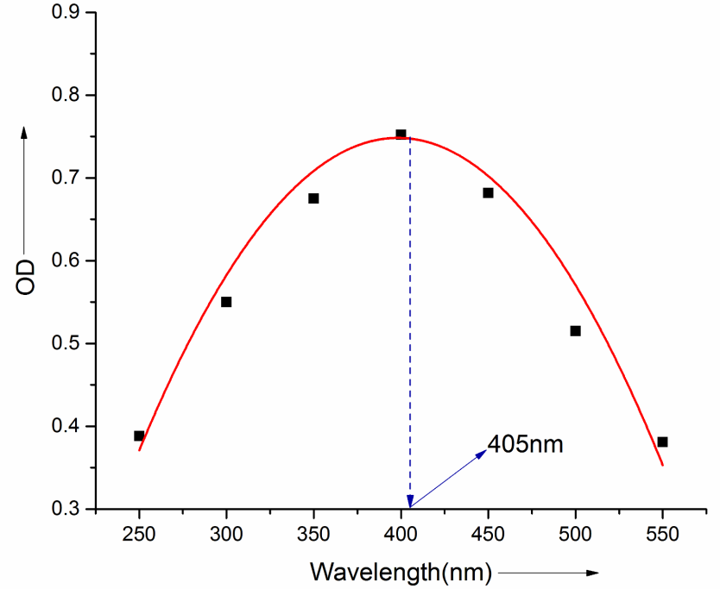
Fig.1 Graph between wavelength Vs OD
Determination of optimal pH for hydrolysis of pNPP:
p^{H} has various effects on enzyme:
- pH influence the catalytic site directed by altering the charge of the protein in its region
- pH influence the tertiary structure of the enzyme
- pH influence the ability of the enzyme to bind the substrate.
Each enzyme exhibits its greatest activity at a particular pH. This pH is called “enzyme optimal pH”
Again, excess acidity or alkalinity of the medium causes considerable damage to enzyme. The rate of a reaction increases with increase in pH up to certain pH and then starts decreasing. The value of pH at maximum rate found is called as “optimal pH”. Different enzymes have different optimal values.To know the optimal pH of the enzyme for hydrolysis of pNPP by PTP-1B enzyme, following experiment was done. Different buffer solutions with pH 2 to 11 were prepared. Eleven test tubes were used to conduct the experiments.For the first test tube para-nitrophenylphosphate (pNPP, 5mM) and buffer (with pH of 2) and o.3μl of PTP-1B was added to make a final volume of 3ml. For the second test tube para-nitrophenylphosphate (pNPP, 5mM) and buffer (with pH of 3) and o.3μl of PTP-1B was added to make a final volume of 3ml. The steps were repeated for the rest of the test tubes, but each time a buffer with a pH of 1 higher than the previous was added, results in test tube 11 ending with a pH 12. Once the enzyme was added to a test tube it was transferred into a cuvette and incubated at 27˚C and after 10 minutes, reaction was terminated by adding 10 M NaOH. The cuvette was placed into the spectrophotometer and absorbencies are each solution was recorded. The OD was then plotted against pH (Fig.2 ) and a standard curve was drawn. The peak of the curve indicated the optimal pH of enzyme. It is found at 7.5pH. This value matches with value found in literature.
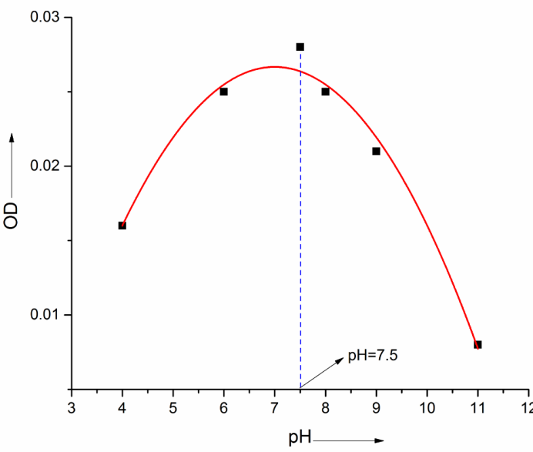

Fig. 2 Graph between p^{H} Vs Rate of hydrolysis

Determination of optimal temp for hydrolysis of pNPP
The rate of reaction generally increases with an increase in temperature. But this is not the case with enzyme in living cells. Rise in temperature results in denaturation (destruction) of enzyme, thereby decreasing effective concentration of the enzyme. However, the rate of reaction in presence of enzyme increases up to certain temperature and then starts decreasing. The temperature at which maximum rate is observed generally referred as “Optimal temperature” of the enzyme. To know the optimal temp of the PTP-1B enzyme, solution of pNPP (5mM) is made. As soon as the enzyme (0.3μl) was added, transferred into a cuvette and incubated at 27˚C after 10min reaction was terminated by adding concentrated NaOH, record the OD values. Similarly pNPP and enzyme solution was incubated at different temperatures (22, 25, 27, 30 and 37) each time and record the OD values. The OD at different temps was plotted as a graph (Fig.3). From graph, it was found that maximum OD is at 27˚C.
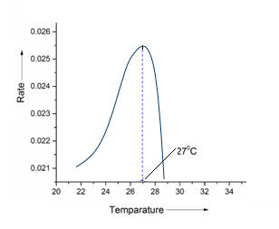
Fig. 3 Graph between Temperature Vs Rate showing the optimum temperature

Determination of optimal Concentration of enzyme for hydrolysis of pNPP
The enzyme activity depends on the concentration of enzyme, it has an effect on kinetics. To find out the concentration of enzyme at which maximum activity is seen, the following experiment was designed; different concentrations of enzyme (0.1μl, 0.2μl, 0.3μl, 0.4μl, 0.5μl) were added at constant concentration of pNPP (5mM). The graph was plotted (Fig.5) between OD Vs [E]. The concentration is 0.4 μl at which maximum rate was taken as standard.

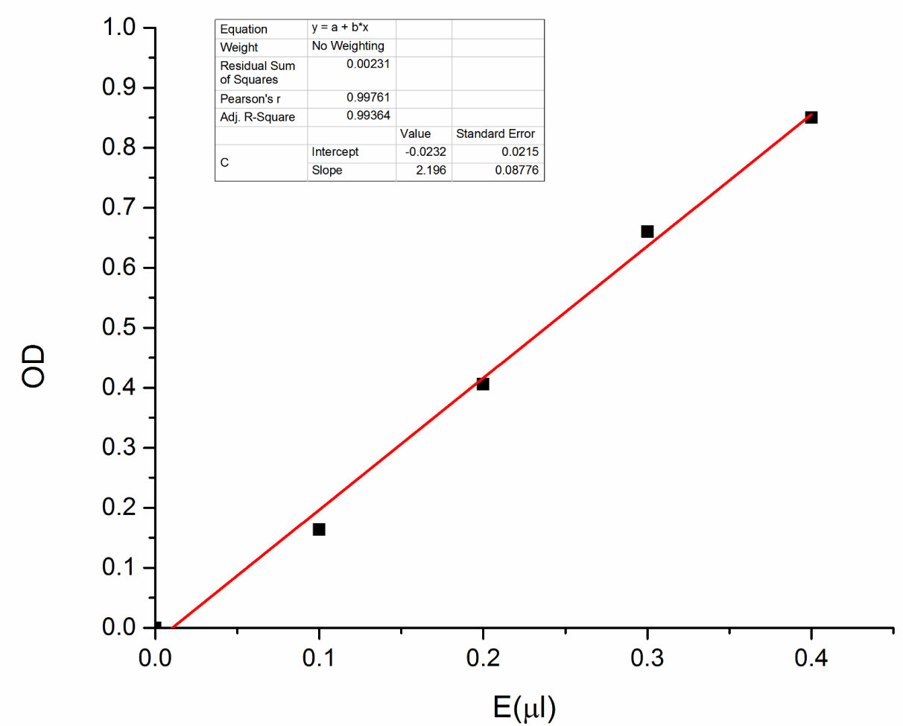
Fig. 5 Graph between E (μl) Vs OD.

Determination of optimal concentration of substrate for hydrolysis of pNPP:

The substrate has larger effect on the kinetics. Hence, knowing the concentration of substrate at which the hydrolysis has maximum rate has become inevitable. For this, the experiment was carried by taking different concentration of substrate (5mM, 7.5mM, 15mM, 30mM and 50mM) at fixed concentration of enzyme (o.4μl) and observed the OD at different intervals of time. The rates were calculated from slope obtained by plotting a graph between time Vs OD. The optimum substrate concentration was calculated from M-M plot (Fig. 6) and it was found to 15mM.
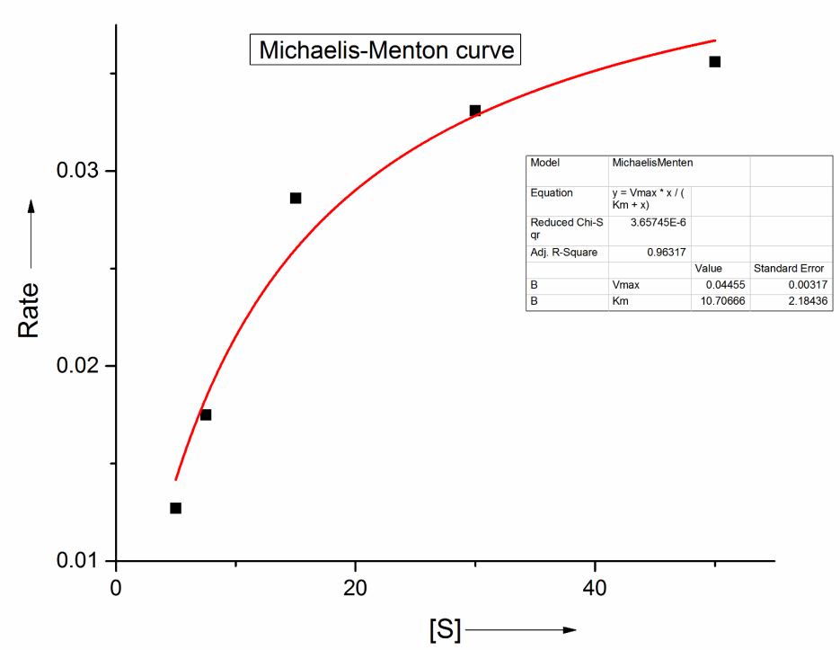
Fig. 6 M-M plot showing the effect of different concentrations of substrate on rate of hydrolysis of pNPP by enzyme.
Determination of optimal concentration of inhibitor for hydrolysis of pNPP
The activity of an enzyme can be lowered by the addition of certain inhibitors. Antibiotics are effective inhibitors for enzyme activity. They inhibit the growth of bacteria by retarding the process of protein synthesis in them.
Inhibition blocks the active site of the enzyme which is used by the substrate. In our studies pNPP hydrolysis is done in presence of PTP-1B enzyme. The metal complexes may act as inhibitors in reducing the hydrolysis of pNPP by enzyme. To know the particular concentration of inhibitor where maximum inhibition takes place, we have conducted the following experiments. Reaction was carried out at various concentrations of inhibitor (0.5μM, 2.5μM, 5μM, and 10μM) by keeping substrate concentration and enzyme concentration as constant. Calculated the rate (activity) of the hydrolysis at different concentration of inhibitors. Maximum inhibition was observed at [I] =10 μM. [I] Vs rate graph is shown in Fig.77
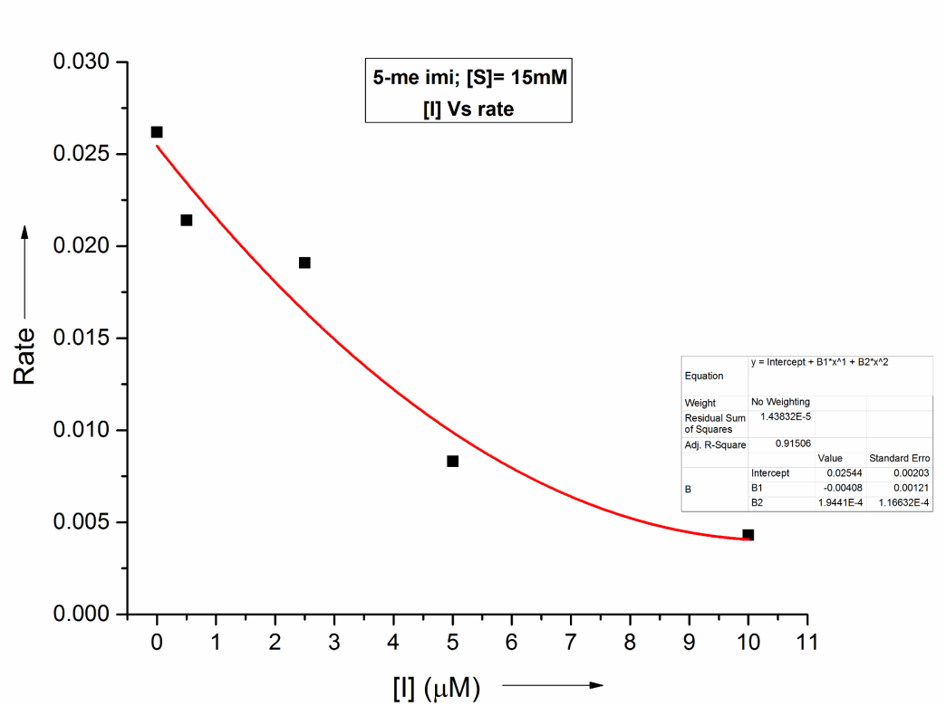
Fig.7 Time Vs OD graph showing the effect of different concentrations of Inhibitors at fixed concentration of substrate(15mM) on rate of hydrolysis of pNPP by enzyme
The determined optimal conditions for the “hydrolysis of pNPP by PTP-1B enzyme” are as follows. λ_{max}= 405nm, T = 27ºC, pH = 7.5, [E]= 40nM, [S] = 15mM, [I] = 10μM. Once the optimal conditions for pNPP catalytic activity were determined, the enzyme kinetics can be studied.

PTP-1B binding studies by Fluorescence technique
The experimental data for other spectra are found in table S1 to S2 and corresponding figures are found in Figure S1 to S6.
Table S1: Experimental data obtained by Fluorescence technique along with other relevant data. ( Protein : PTP-1B , Metal complex : [6-Imi], Temp : 25°C, Buffer : 10mM Tris; pH : 7.5 , λmax= 338nm)
S.No | Concentration of Enzyme (μM) | Conc of metal complex[C]  (μM) | Log[C] | Intensity(I)*  From experiment | I₀ /I | I₀-I / I | Log I₀-I / I
1 | 0.05 | 0.004963 | -2.30428 | 753.77 | 1.1429 | 0.1429 | -0.84483
2 | 0.05 | 0.009877 | -2.0054 | 720.27 | 1.1961 | 0.1961 | -0.70752
3 | 0.05 | 0.014742 | -1.83144 | 677.92 | 1.2708 | 0.2708 | -0.56731
4 | 0.05 | 0.01956 | -1.70863 | 635.36 | 1.3559 | 0.3559 | -0.44861
5 | 0.05 | 0.024331 | -1.61384 | 584.02 | 1.4751 | 0.4751 | -0.32317
6 | 0.05 | 0.029056 | -1.53677 | 558.19 | 1.5434 | 0.5434 | -0.26487
Note : Intensity (I₀) of free PTP-1B is 861.517 which is constant at particular volume of PTP-1B(~ 5 μL) at λmax= 338nm *Intensities observed at λmax= 338nm alone are given in table 2.2.16.

Figure S1 PTP-1B's fluorescence emission spectra in the presence and absence of various concentrations of the [6-imi] complex at λ_{max} =338nm. PTP-1B ~ 0.05μM, [6-me-imi]= (0.0049, 0.0098, 0.0147, 0.0195, 0.0243) ˟ 10⁻⁶ M. Buffer: Tris at pH=7.5

Figure S2 PTP-1B and [6- imi] complex double logarithmic plots
Figure S3 Stern-Volmer curve for PTP-1B binding with [6-imi] intensity values (I) measured at λ_{max} = 338 nm.
Table S2: : Experimental data obtained by Fluorescence technique along with other relevant data. (Protein: PTP-1B, Metal complex: [6-B], Temp: 25°C, Buffer: 10mM Tris; pH: 7.5, λ_{max}= 338nm)
S.No | Concentration of Enzyme (μM) | Conc of metal complex[C]  (μM) | Log[C] | Intensity(I)*  From experiment | I₀ /I | I₀-I / I | Log I₀-I / I
1 | 0.05 | 0.004963 | -2.30428 | 772.92 | 1.3272 | 0.3272 | -0.4851
2 | 0.05 | 0.009877 | -2.0054 | 739 | 1.3881 | 0.3881 | -0.41096
3 | 0.05 | 0.014742 | -1.83144 | 695.09 | 1.4758 | 0.4758 | -0.3225
4 | 0.05 | 0.01956 | -1.70863 | 604.97 | 1.6957 | 0.6957 | -0.15755
5 | 0.05 | 0.024331 | -1.61384 | 561.18 | 1.8280 | 0.8280 | -0.08194
6 | 0.05 | 0.029056 | -1.53677 | 537.35 | 1.9091 | 0.9091 | -0.04137
Note : Intensity (I₀) of free PTP-1B is 1025.87which is constant at particular volume of PTP-1B(~ 5 μL) at λmax= 338nm *Intensities observed at λmax= 338nm alone are given in table 2.2.19.
Figure S4 PTP-1B's fluorescence emission spectra in the presence and absence of various concentrations of the [6-B] complex at λ_{max} =338nm. PTP-1B ~ 0.05μM, [6-B]= (0.0049, 0.0098, 0.0147, 0.0195, 0.0243) ˟ 10⁻⁶ M. Buffer: Tris at pH=7.5

Figure S5 PTP-1B and [6-B] complex double logarithmic plots

Figure S6 Stern-Volmer curve for PTP-1B binding with [6-B] intensity values (I) measured at λ_{max} = 338 nm.

