Supporting Information
Cu-doped SnO₂/rGO nanocomposites for ultrasensitive H₂S detection under low temperature
Tingting Chen^{1,2}, Jianhai Sun^{1 ,*}, Ning Xue ¹, Wen Wang³, Kaisheng Jiang ^{1,2}, Tianye Zhou^{1 ,2}, Hao Quan ^{1,2}
¹ State Key Laboratory of Transducer Technology, Aerospace Information Research Institute, Chinese Academy of Sciences, Beijing 100194, China.
² School of Electronic, Electrical and Communication Engineering, University of Chinese Academy of Sciences, Beijing 100049, China.
³ State Key Laboratory of Acoustics, Institute of Acoustics, Chinese Academy of Sciences, Beijing 100190, China.
Corresponding Author
* Prof. J. Sun - E-mail: sunjh@aircas.ac.cn

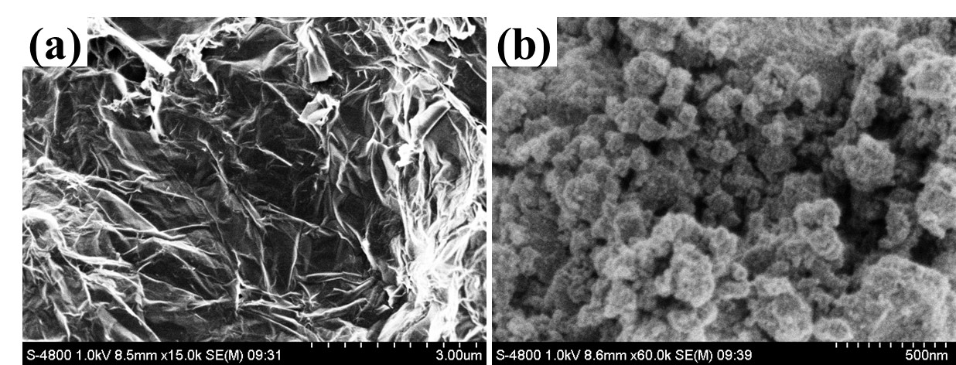
Figure S1. SEM patterns of rGO and Cu-SnO₂/rGO-2.
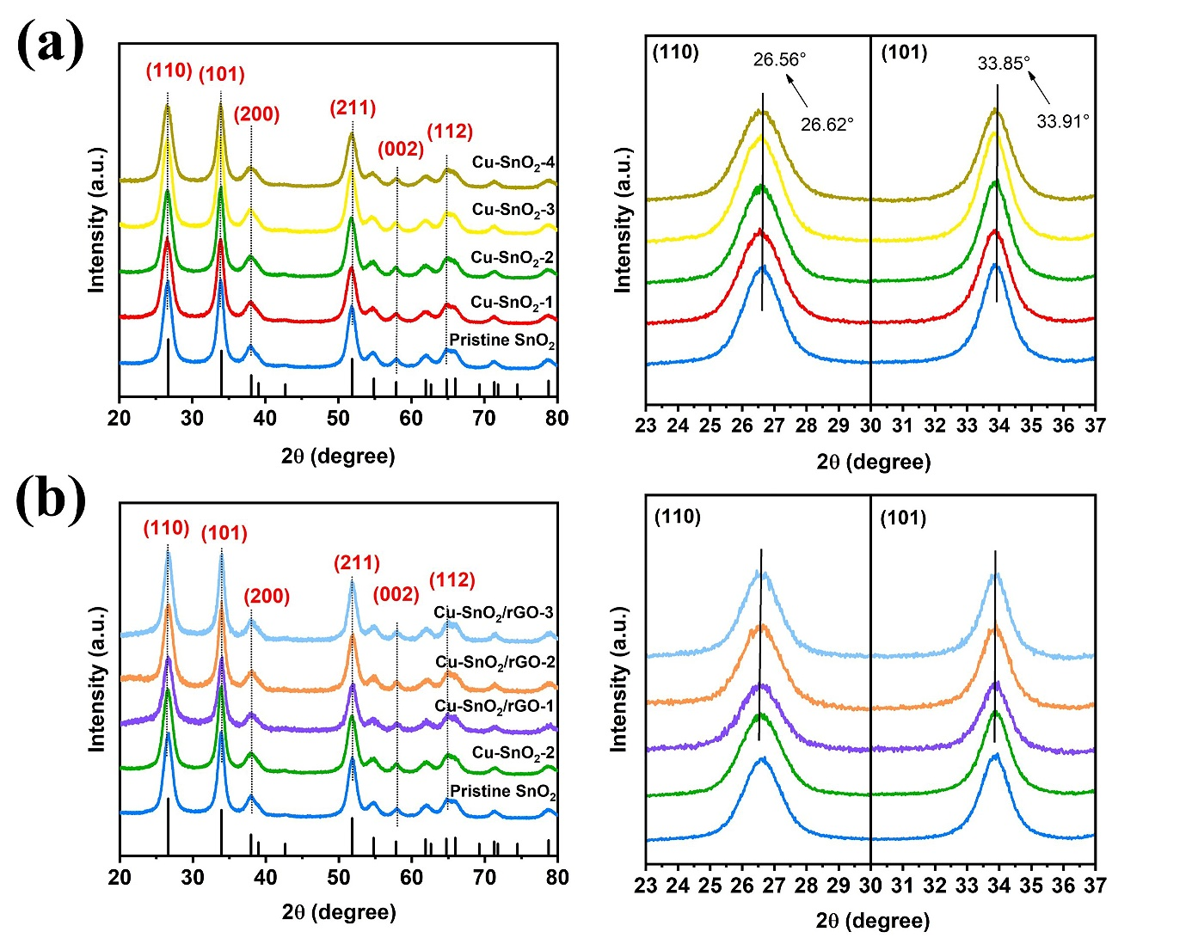
Figure S2. XRD patterns of samples: (a) pure SnO₂ and Cu-SnO₂-(1-4), (b) pure SnO₂, Cu-SnO₂-2, and Cu-SnO₂/rGO-(1-3). The right side shows the corresponding enlarged views of (110) and (101) peaks.
Table S1. Recent literature about H₂S sensors based on SnO₂.
Sensing Materials | Temp. [℃] | Con. [ppm] | Res. ^{a)} | Res./Rec. time [s] | LOD [ppb] | Ref.
Cu-SnO₂/rGO | 120 | 10 | 1415.7 | 120/15 | 50 | This work
Cu-SnO₂ | 180 | 100 | 25.3 | 10.1/42.4 | 10 | [1]
Nb₂O₅/SnO₂ | 275 | 20 | 4 | 20/97 | 1 [ppm] | [2]
SnO₂-CuO | 200 | 5 | 1395 | 5.27/- | 1 [ppm] | [3]
ZnO-SnO₂ | 350 | 1 | 317 | ~10/450 | 100 | [4]
Co,N-GQDs/SnO₂ | 260 | 100 | 37.3 | 3/13 | 50 | [5]
Si/SiO₂ | 100 | 50 | 3.5 | - | 10 [ppm] | [6]
CNTs/SnO₂/CuO | RT | 50 | 400 | 4/10 [min] | 10 [ppm] | [7]
WO₃-coated SnO₂ | 200 | 1 | 177 | - | 100 | [8]
SnO₂@ZnO NW | 250 | 1 | 6.24 | 14/39 | 1 [ppm] | [9]
a-SnO₂ | 250 | 1 | 2.4 | 540/- | 210 | [10]
LLTO-SnO₂ | 260 | 30 | 19 | <1/60 | 500 | [11]
CuO-SnO₂ | 125 | 10 | 1056 | - | - | [12]

Table S2. Peak position to peak area ratio for three oxygen species in O1s of pristine SnO₂, Cu-SnO₂-2 and Cu-SnO₂/rGO-2.
Materials | Absorbed oxygen (O_{abs}) |  | Oxygen vacancy (O_{v}) |  | Lattice oxygen (O_{lat})
Materials | Binding energy [eV] | Peak area [%] | Binding energy [eV] | Peak area [%] | Binding energy [eV] | Peak area [%]
Pristine SnO₂ | 532.2 | 10.5 | 531.0 | 27.0 | 530.4 | 62.5
Cu-SnO₂-2 | 532.2 | 13.3 | 531.1 | 31.1 | 530.5 | 55.6
Cu-SnO₂/rGO-2 | 532.1 | 20.0 | 531.0 | 27.4 | 530.5 | 52.6

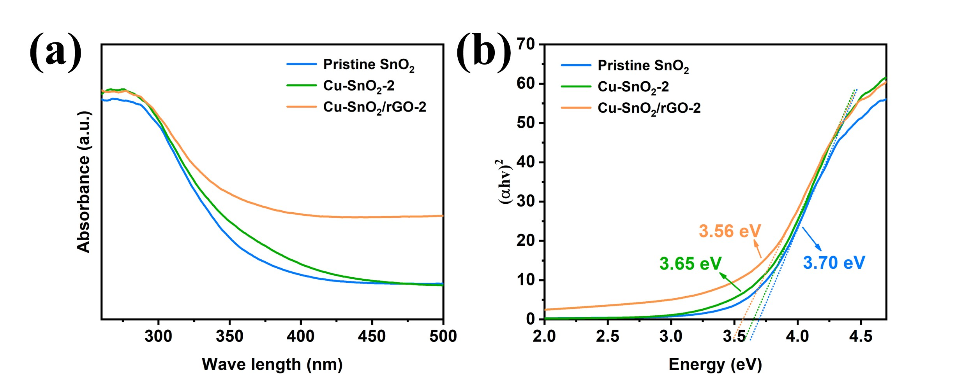
Figure S3. (a) UV-vis diffuse reflectance spectrum and (b) Kubelka-Munk function curve plotted against photon versus the energy of absorbed light of pristine SnO₂, Cu-SnO₂-2, and Cu-SnO₂/rGO-2. The relationship between (αhv)² and photon energy hv is obtained according to the formula (αhv)² = A (hv-E_{g}), where α, A, h and v are the absorption coefficient, absorption constant, Plank constant and light frequency, respectively. The bandgap of pristine SnO₂, Cu-SnO₂-2, and Cu-SnO₂/rGO-2 are 3.70, 3.65, and 3.56 eV, respectively.

Reference
- Zhang, S., et al. Facile fabrication of a well-ordered porous Cu-doped SnO₂ thin film for H₂S sensing. ACS Appl. Mater. Interfaces 6, 14975-14980 (2014).
- Mao, L. et al. Excellent long-term stable H₂S gas sensor based on Nb₂O₅/SnO₂ core-shell heterostructure nanorods. Appl. Surf. Sci. 602, 154339 (2022).
- Park, K. R. et al. Design of highly porous SnO₂-CuO nanotubes for enhancing H₂S gas sensor performance. Sens. Actuators B Chem. 302, 127179 (2020).
- Phuoc, P. H. et al. Comparative study on the gas-sensing performance of ZnO/SnO₂ external and ZnO–SnO₂ internal heterojunctions for ppb H₂S and NO₂ gases detection. Sens. Actuators B Chem. 334, 129606 (2021).
- Chen, T. et al. Co, N-doped GQDs/SnO₂ mesoporous microspheres exhibit synergistically enhanced gas sensing properties for H₂S gas detection. J. Mater. Chem. A 10, 10759 (2022).
- Bang, J. H. et al. Porous Si/SnO₂ nanowires heterostructures for H₂S gas sensing. Ceram. Int. 46, 604-611 (2020).
- Zhao, Y., Zhang, J., Wang, Y. & Chen, Z. A highly sensitive and room temperature CNTs/SnO₂/CuO sensor for H₂S gas sensing applications. Nanoscale Res. Lett. 15, 1-8 (2020).
- Hoa, T. T. N. et al. Highly selective H₂S gas sensor based on WO₃-coated SnO₂ nanowires. Mater. Today Commun. 26, 102094 (2021).
- Zhu, L. et al. Hierarchical highly ordered SnO₂ nanobowl branched ZnO nanowires for ultrasensitive and selective hydrogen sulfide gas sensing. Microsyst. Nanoeng. 6, 1-13 (2020).
- Paolucci, V. et al. Bidimensional Engineered Amorphous a-SnO₂ Interfaces: Synthesis and Gas Sensing Response to H₂S and Humidity. ACS Sens. 7, 2058-2068 (2022).
- Li, X. et al. Mechanism of enhanced H₂S sensor ability based on emerging Li_{0.5}La_{0.5}TiO₃-SnO₂ core-shell structure. Sens. Actuators B Chem. 352, 131054 (2022).
- Chen, Z., Xu, Z. & Zhao, H. Flame spray pyrolysis synthesis and H₂S sensing properties of CuO-doped SnO₂ nanoparticles. Proc. Combust. Inst. 38, 6743-6751 (2021).

