Supporting information for:

Landward mantle flow associated with the Pacific subduction system opened the South China Sea

Yanhui Suo^{1,2*}, Hao Dong^{1,2}, Lijun Liu^{3*}, Diandian Peng³, Yanchong Li³, Jinping Liu^{1,2}, Liming Dai^{1,2}, Xianzhi Cao^{1,2}, Sanzhong Li^{1,2*}

¹ Frontiers Science Center for Deep Ocean Multispheres and Earth System, Key Lab of Submarine Geosciences and Prospecting Techniques, MOE and College of Marine Geosciences, Ocean University of China, Qingdao 266100, China
² Laboratory for Marine Mineral Resources, National Laboratory for Marine Science and Technology (Qingdao), Qingdao 266237, China
³ Department of Geology, University of Illinois at Urbana-Champaign, Urbana, IL 61801, USA

*Corresponding authors: Yanhui Suo (suoyh@ouc.edu.cn);
Lijun Liu (ljliu@illinois.edu);
Sanzhong Li (sanzhong@ouc.edu.cn).

This file includes: Figures S1-S2, Table S1 and Additional references.

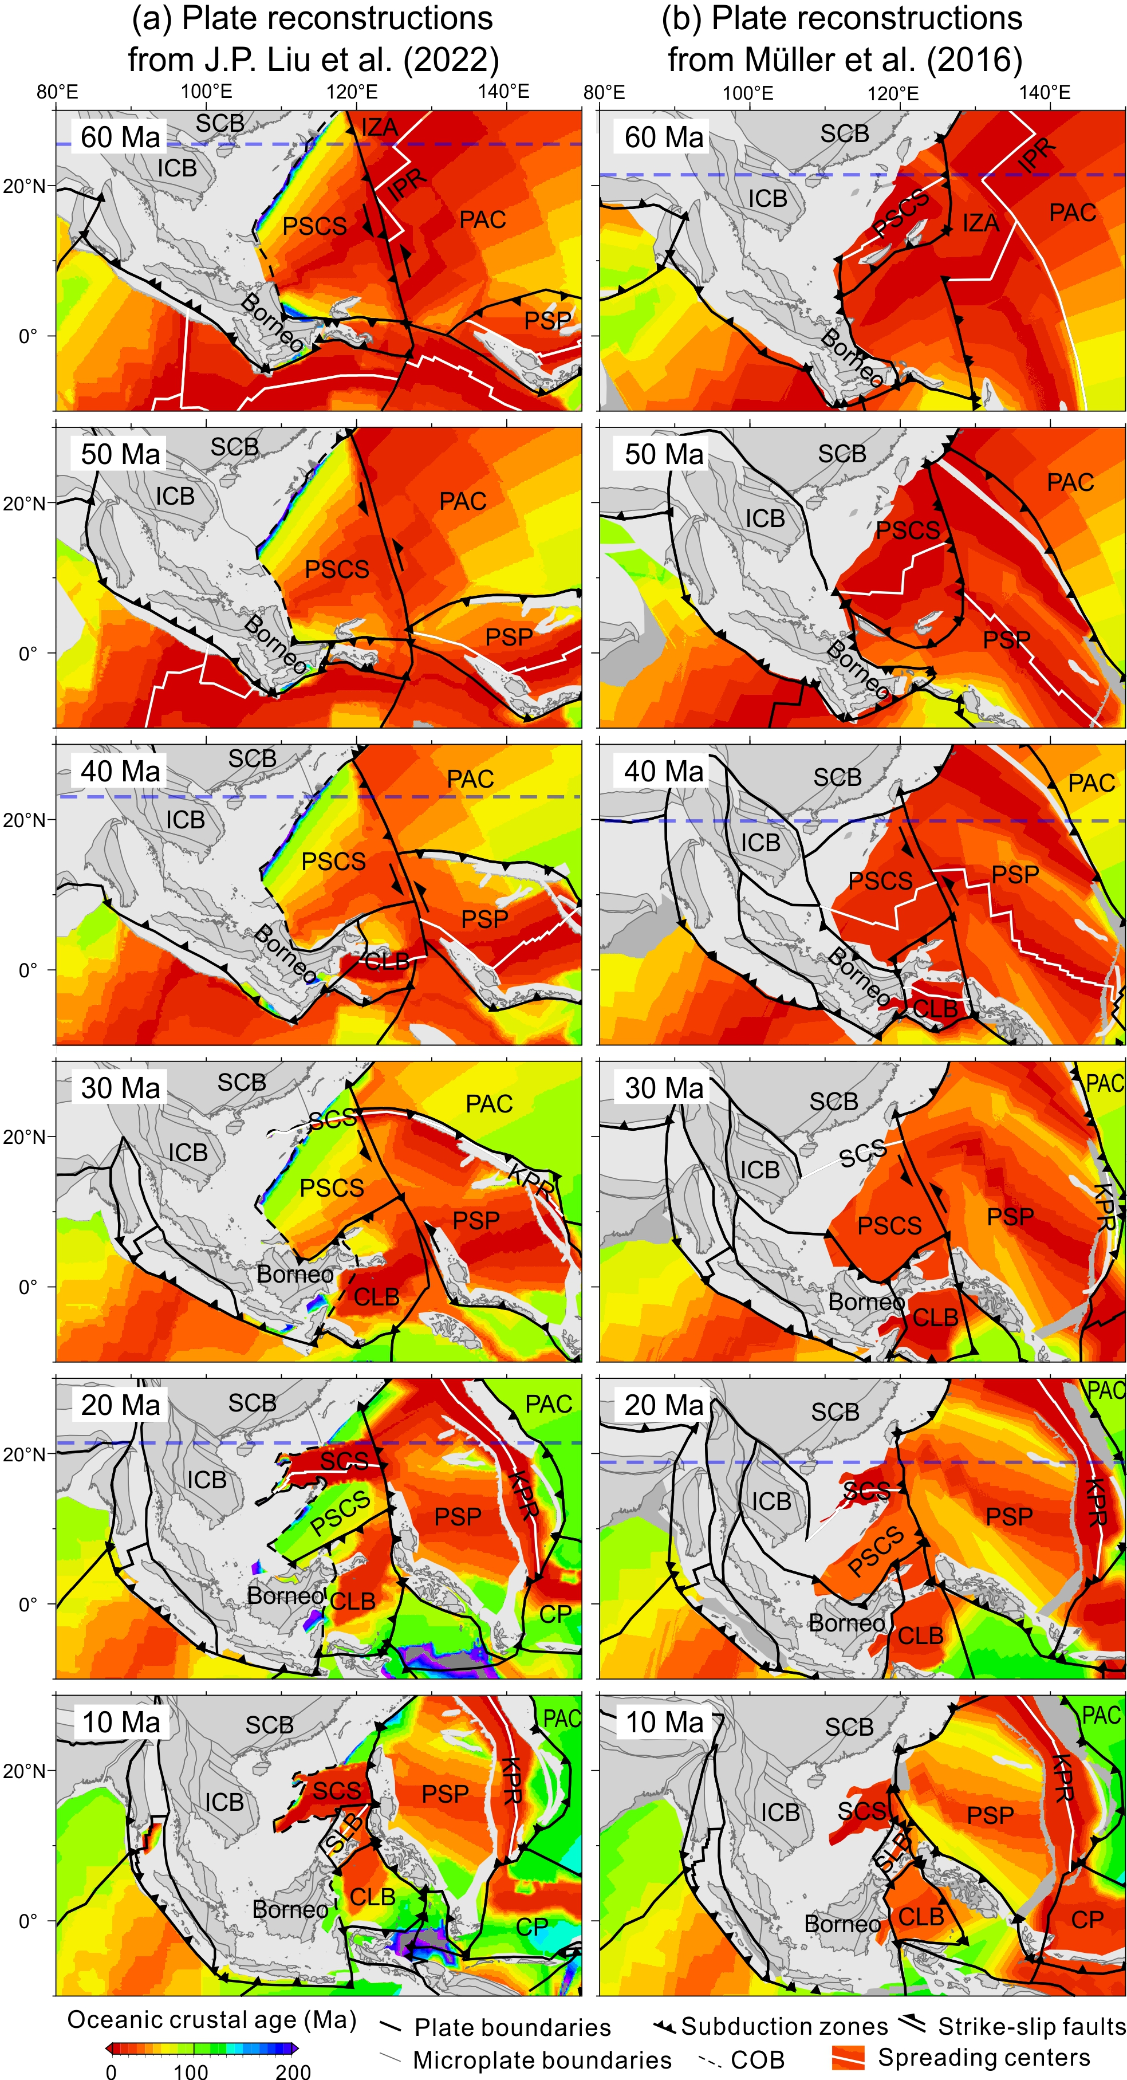
Figure S1 Two plate reconstructions around the South China Sea (SCS) region that are assimilated into mantle flow models in this study. (a) J.P. Liu et al. (2022)¹ for Model 1, and (b) Müller et al. (2016)² for Model 2. Blue dashed lines mark the profile locations in Figure 3. The South China Block (SCB) and the Indochina Block (ICB) have different motion histories in the two reconstructions due to different reference frames. Absolute plate motions for the reconstruction in ref.² were based on a moving hotspot reference frame for the period 100–0 Ma and a true polar wander-corrected reference frame for the period 230–100 Ma. While the reconstruction in ref.¹ used the reference frame from ref.³, which was an optimized mantle reference frame through fitting age-dated hot spot tracks (80–0 Ma) and minimizing both global trench motion and lithospheric net rotation following the method of ref.⁴. Some other major differences between the two plate reconstructions are: (1) the Philippine Sea Plate (PSP) has occupied the region to the east of the proto-SCS (PSCS) as early as ~50 Ma in ref.², while it moved clockwise from the equatorial region at ~55 Ma northward to the region near the PSCS at ~40 Ma and then until to its present position in ref.¹, which is more consistent with paleomagnetic and provenance constraints⁵; (2) The PSCS opened at ~65 Ma in ref.², while it became fossilized at this time in ref.¹; (3) A NW-trending transform plate boundary along the eastern PSCS and SCS existed during 40-20 Ma in ref.², and during 55-22 Ma in ref.¹. CP- Caroline Plate, IZA- Izanagi Plate, PAC- Pacific Plate, IPR- Izanagi-Pacific mid-ocean ridge, KPR- Kyushu-Palau Ridge, CLB- Celebes Basin, SLB- Sulu Basin.

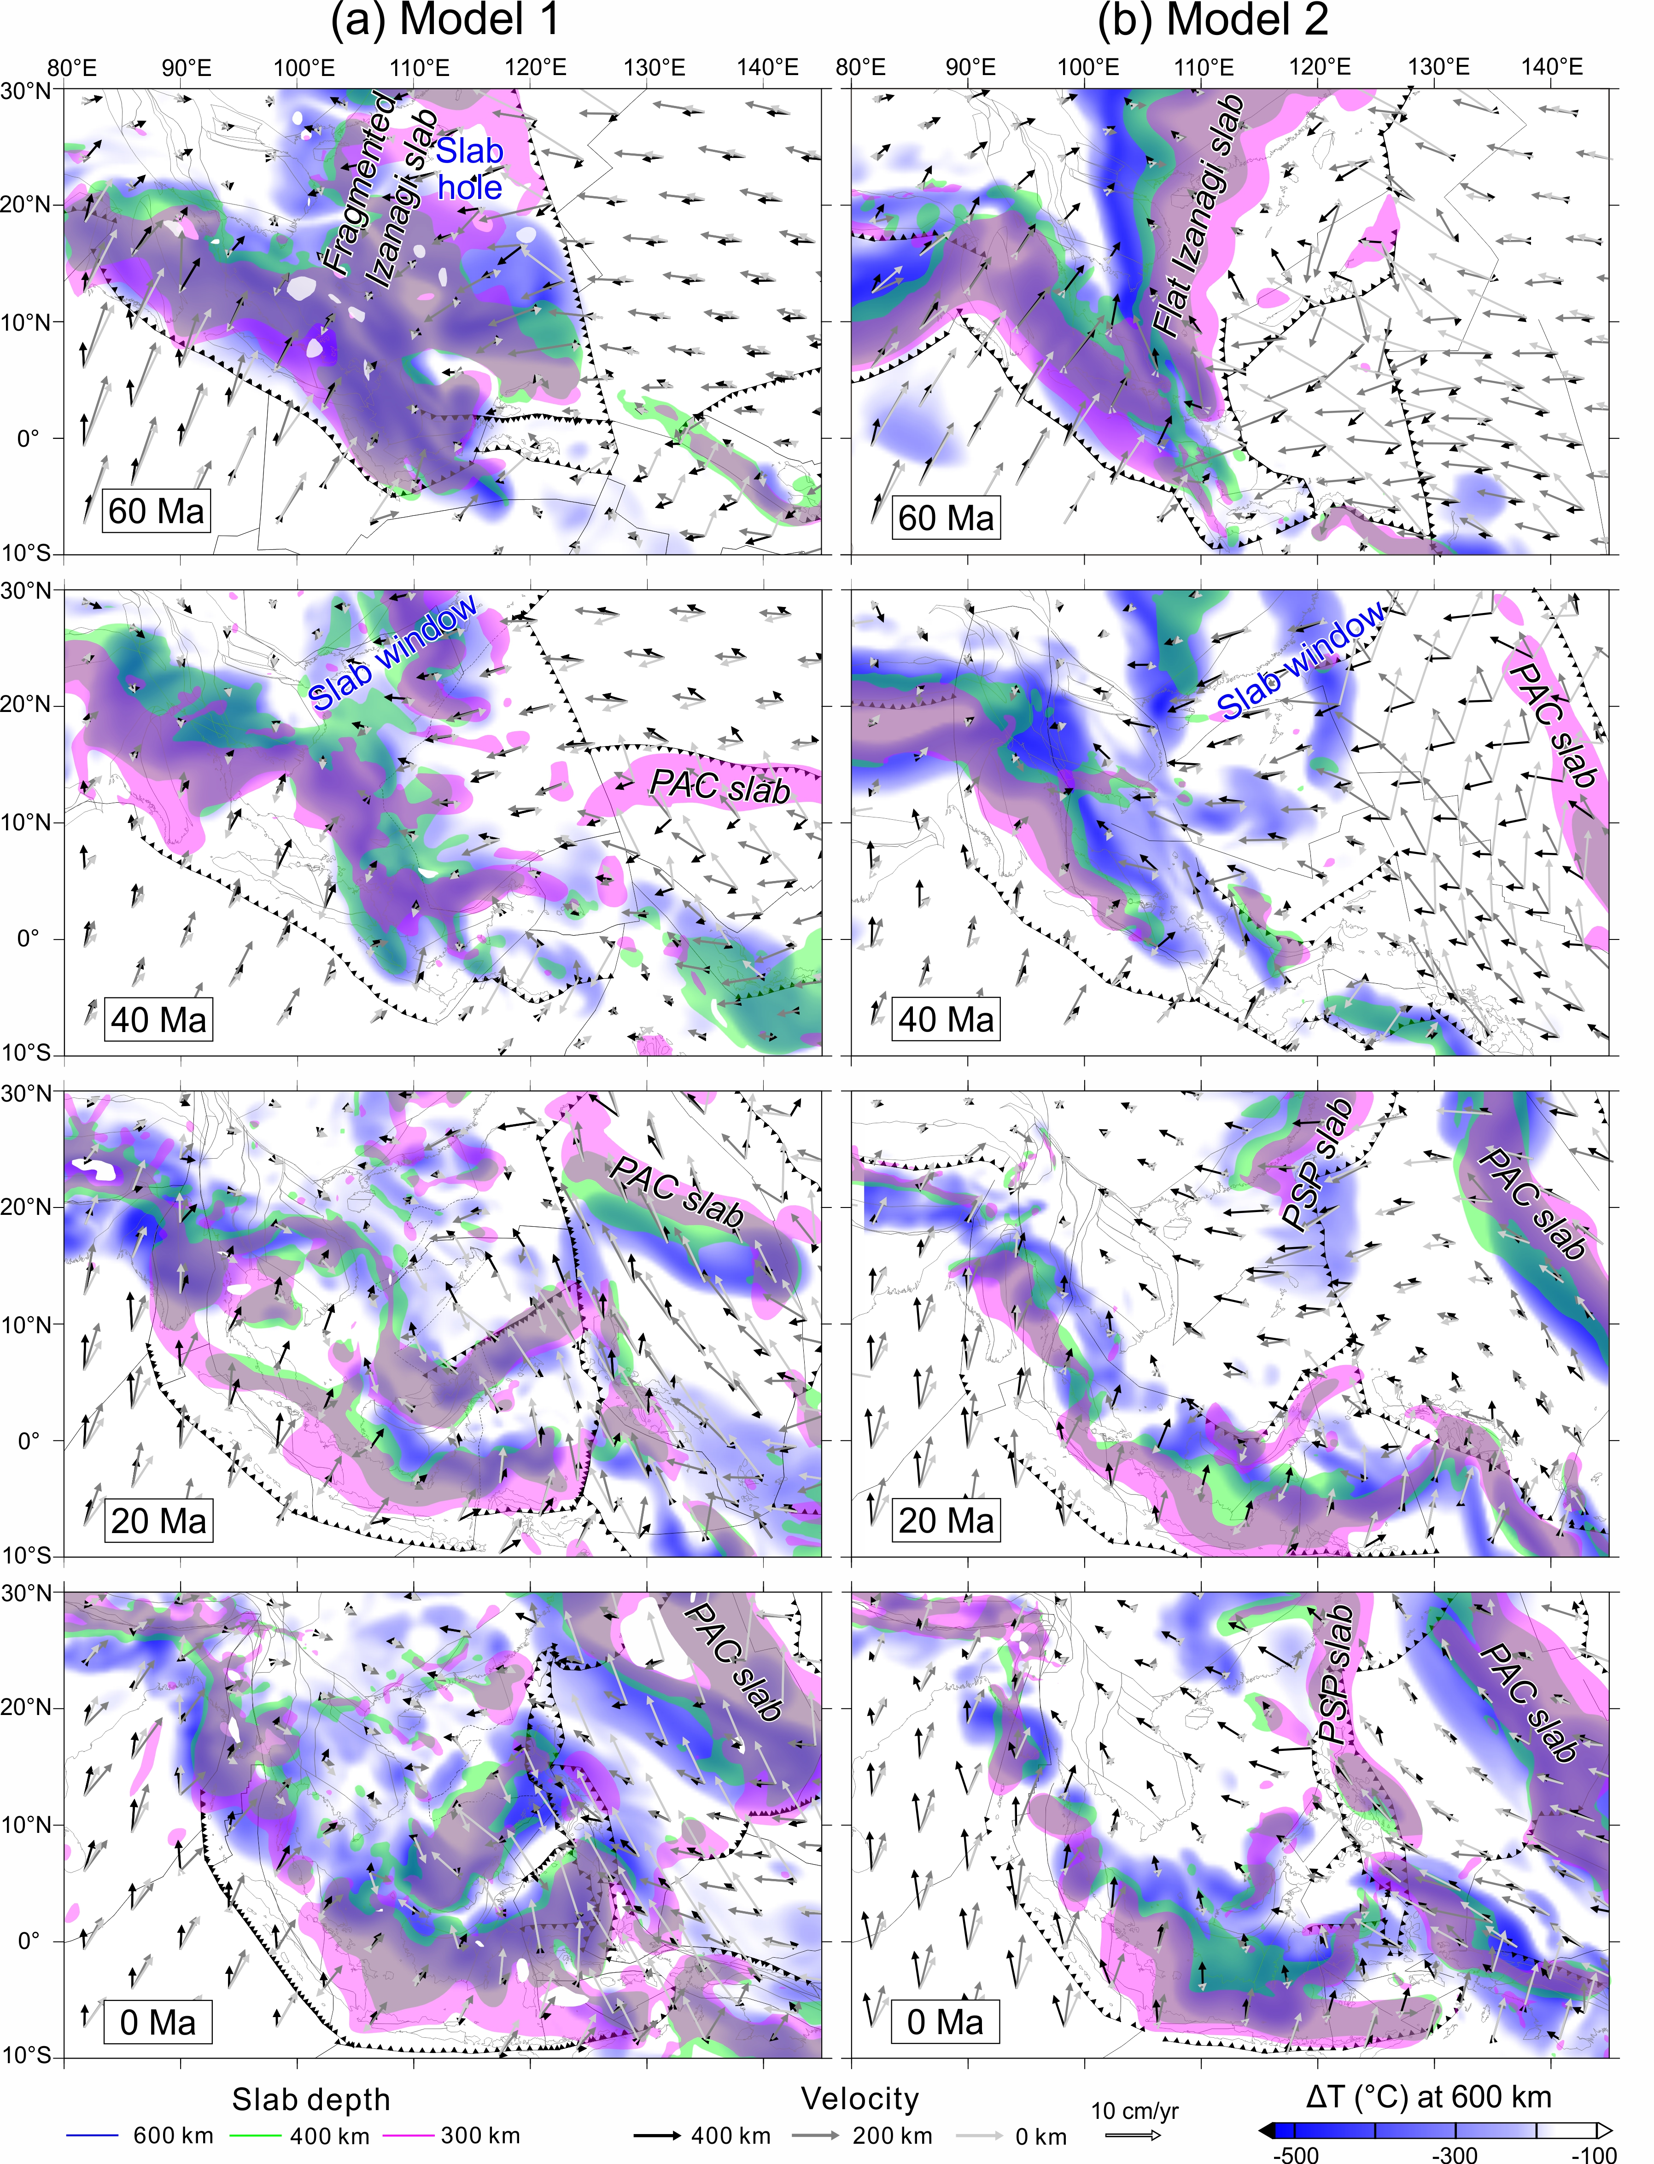
Figure S2 A pseudo 3D visualization of the evolving subducted slabs and mantle flow in Model 1 (a) and Model 2 (b). The color areas represent the slabs at different depths and the arrows show the mantle velocities at different depths, assuming a view prospective from the top. The background temperature is shown for the depth at 600 km. In Model 1, a fragmented flat Izanagi slab and a slab hole under the northern PSCS were predicted at 60 Ma. While, a smooth flat Izanagi slab was observed at 60 Ma in Model 2. The Izanagi slab in both models were totally detached and developed into a broad trench-parallel slab window at 40 Ma, giving rise to the landward mantle wind. At ~20 Ma, the mantle wind was blocked by the PAC slab in Model 1 and was blocked by the PSP slab in Model 2. Other legends same as Fig. S1.

Table S1 Constant parameter settings in the geodynamic modelling
Parameter | Symbol | Value | Unit | Non-dimensional  value
Earth‘s radius | $$R$$ | 6371 | km | 1
Mantle thickness | $$h$$ | 2867 | km | 0.45
Mantle density | $$ρ_{m}$$ | 3340 | kg/m³ | 1
Gravitational acceleration | g | 9.8 | m/s² | -
Thermal diffusivity | $$κ$$ | 10⁻⁶ | m²/s | -
Thermal expansivity | $$a$$ | 3×10⁻⁵ | K⁻¹ | -
Mantle temperature | $$T_{m}$$ | 700 | ℃ | 0.7
Temperature difference across mantle | $$-$$ | 1200 | ℃ | 1.2
Reference viscosity | $$η_{0}$$ | 10²¹ | Pa·s | 1
Rayleigh number | $$Ra$$ | 2.6×10⁸ | - | -
Maximum viscosity cutoff | $$η_{max}$$ | 10²³ | Pa·s | 100
Minimum viscosity cutoff | $$η_{min}$$ | 10¹⁹ | Pa·s | 0.01
Clapeyron slope at 410 km | $$-$$ | 4.0 | MPa/K | 0.019
Clapeyron slope at 670 km | $$-$$ | -2.0 | MPa/K | -0.01

Additional references
- Liu, J. P., Li, S. Z., Cao, X. Z., Dong, H., Suo, Y. H., Jiang, Z. X., Zhou, J., Li, X. Y., Zhang, R. X., Liu, L. J. & Foulger, G. R. Back-arc tectonic response to mantle micro-block deep processes as revealed by reconstruction of the Philippine Sea-South China Sea region since the Eocene. Under review by Geophysical Research Letters (2022).
- Müller, R. D., Seton, M., Zahirovic, S., Williams, S. E., Matthews, K. J., Wright, N. M., Shephard, G., Maloney, K. T., Barnett-Moore, N., Hosseinpour, M., Bower, D. J. & Cannon, J. Ocean basin evolution and global-scale plate reorganization events since Pangea breakup. Annu. Rev. Earth Planet. Sci. 44 (2016).
- Cao, X., Zahirovic, S., Li, S., Suo, Y., Wang, P., Liu, J. & Müller, R. D. A deforming plate tectonic model of the South China Block since the Jurassic. Gondwana Research 102, 3–16 (2022).
- Tetley, M. G., Williams, S. E., Gurnis, M., Flament, N. & Müller, R. D. Constraining absolute Plate Motions since the Triassic. J. Geophys. Res. Solid Earth 124 (7), 7231–7258 (2019).
- Liu, W., Gai, C., Feng, W., Cao, W., Guo, L., Zhong, Y., et al. Coeval evolution of the Eastern Philippine Sea Plate and the South China Sea in the Early Miocene: Paleomagnetic and provenance constraints from ODP Site 1177. Geophysical Research Letters 48, e2021GL093916 (2021).

