Electrically stimulated Acetobacter xylinum for the production of aligned 3D Microstructured Bacterial Cellulose

Li Wang^{a,b,†}, Manjila Adhikari^{a,†}, Liu Li^{c}, Shuangshuang Liª, Bricard Mbituyimanaª, Xiaohong Li^{d}, Victor V. Revin^{e}, Sabu Thomas^{f}, Zhijun Shi^{a,}*, Guang Yang^{a,}*
ª Department of Biomedical Engineering, College of Life Science and Technology, Huazhong University of Science and Technology, Wuhan 430074, PR China
^{b}Wuhan Branch of the National Science Library,Chinese Academy of Sciences, Wuhan, 430071, China
^{c}Medical Research Center, Affiliated Hospital of North Sichuan Medical College, Nanchong, 637000, China
^{d}State Key Laboratory of High Performance Ceramics and Superfine Microstructure, Shanghai Institute of Ceramics, Chinese Academy of Sciences, Shanghai, 200050, China
^{e}School of Chemical Sciences &International and Inter-University, Centre for Nanoscience and Nanotechnology, Mahatma Gandhi University, Kottayam, Kerala, India -686 560
^{f}Federal State-Financed Academic Institution of Higher Education, National Research Ogarev Mordovia State University, Saransk 430005, Russia

† These authors contributed equally to this work.
⁎ Corresponding authors.
Guang Yang (Email: gyang-hust@hust.edu.cn)
Zhijun Shi (Email: shizhijun@hust.edu.cn)

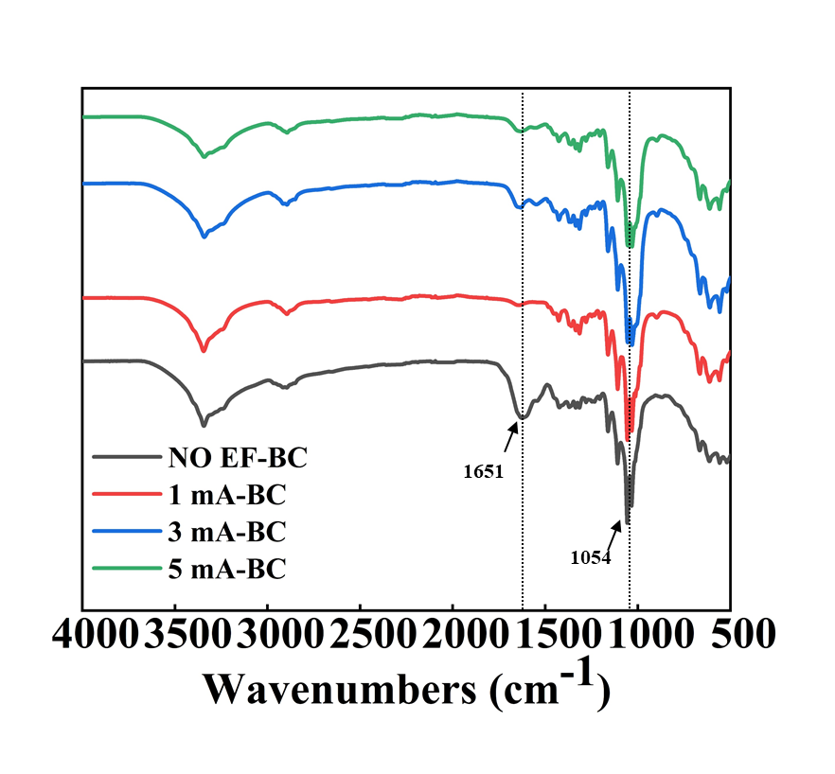

Fig. S1 The ATR-FTIR spectra of NO EF-BC, 1mA-BC, 3 mA-BC, and 5 mA-BC hydrogels.
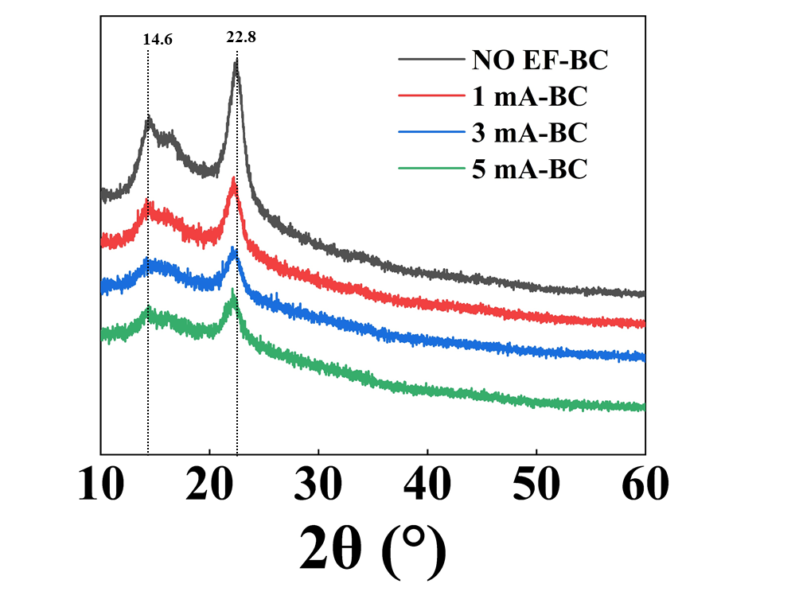

Fig. S2 The XRD spectra of NO EF-BC, 1mA-BC, 3 mA-BC, and 5 mA-BC hydrogels

