Table S1. Soil pH and selenium content in rhizosphere of millet under different selenium application levels
Treatment | pH |  | Se content (mg/kg)
Treatment | Jigu 38 | Jigu 19 | Jigu 38 | Jigu 19
CK | 7.46±0.09a | 7.44±0.09a | 0.20±0.00a | 0.21±0.00a
Se1 | 7.72±0.10a | 7.52±0.09a | 0.22±0.01a | 0.22±0.01a
Se2 | 7.57±0.12a | 7.57±0.08a | 0.21±0.00a | 0.21±0.00a
Se3 | 7.58±0.05a | 7.59±0.06a | 0.22±0.00a | 0.20±0.01a
Note: different letters in the table represent statistical difference among different selenium application treatments (P≤0.05).

Table S2. Enzyme activities of millet rhizosphere soil under different selenium application levels
Treatment | Urease activity  (mg/g/d) |  | Acid Phosphatase activity  (μmol/g/h) |  | Sucrase activity  (mg/g/h)
Treatment | Jigu 38 | Jigu 19 | Jigu 38 | Jigu 19 | Jigu 38 | Jigu 19
CK | 0.40±0.03a | 0.46±0.01a | 5.40±0.21a | 5.49±0.12ab | 21.07±1.36a | 21.15±1.18b
Se1 | 0.37±0.05a | 0.45±0.01a | 5.21±0.17a | 5.73±0.13a | 20.22±2.03a | 25.76±1.26a
Se2 | 0.38±0.05a | 0.48±0.01a | 5.52±0.28a | 6.13±0.32a | 24.62±2.60a | 25.86±1.04a
Se3 | 0.46±0.01a | 0.47±0.01a | 5.23±0.17a | 4.94±0.26b | 22.18±1.16a | 19.85±1.41b
Note: different letters in the table represent statistical difference among different selenium application treatments (P≤0.05).

Table S3. Bacterial Sobs and Shannon index of millet rhizosphere soil under different selenium fertilizer treatments
Treatments | Sobs |  | Shannon
Treatments | Jigu 38 | Jigu 19 | Jigu 38 | Jigu 19
CK | 3030±73.44a | 2959±53.51b | 6.79±0.06a | 6.74±0.03a
Se1 | 3047±75.09a | 3133±64.54a | 6.80±0.05a | 6.84±0.06a
Se2 | 3032±68.06a | 3089±48.91ab | 6.79±0.05a | 6.79±0.05a
Se3 | 3141±60.63a | 3189±51.27a | 6.80±0.05a | 6.87±0.04a
Note: different letters in the table represent statistical difference among different selenium application treatments (P≤0.05).
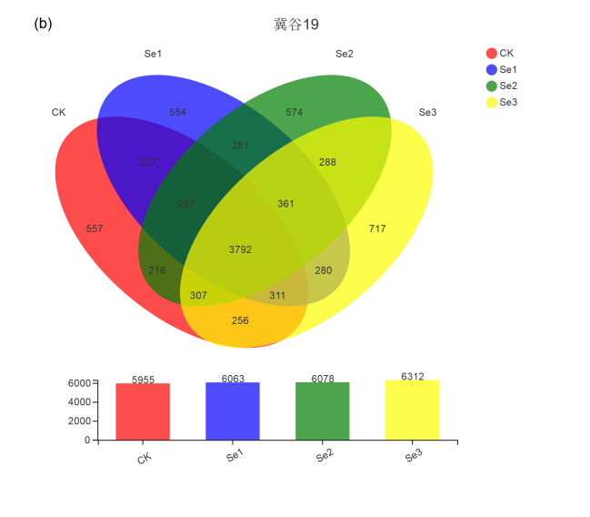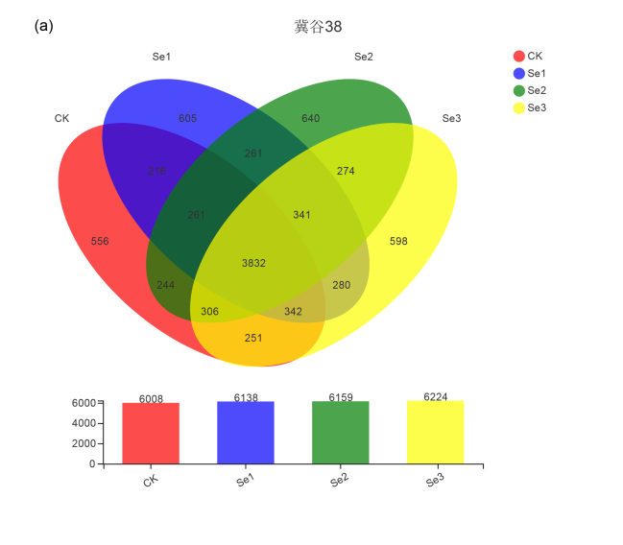
(a)
(b)
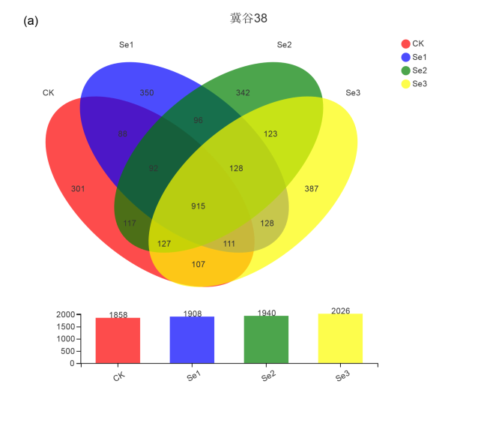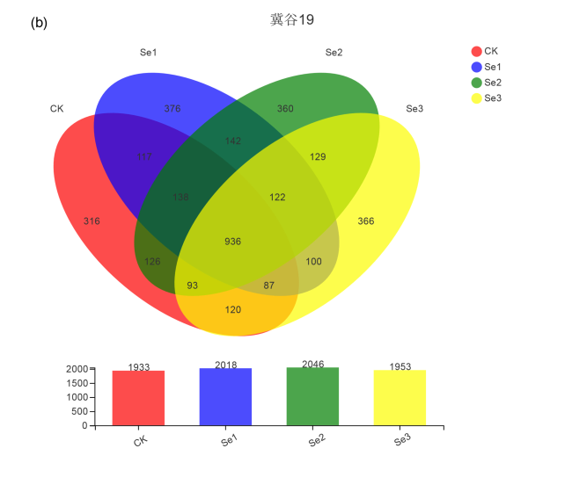
(c)
(d)
Figure S1. Venn analysis of OTU level of rhizosphere soil. (a) Jigu 38 bacterial community; (b) Jigu 19 bacterial community; (c) Jigu 38 fungal community; (d) Jigu 19 fungal community.

