Supplementary Information

Long-wave infrared transparent sulfur polymers enabled by symmetric thiol cross-linker
Miyeon Lee^{a,c}, Yuna Ohª, Jaesang Yuª, Se Gyu Jangª, Hyeonuk Yeo^{b}, Jong-Jin Park^{c}, Nam-Ho You^{a,*}

ªCarbon Composite Materials Research Center, Institute of Advanced Composite Materials and Functional Composite Materials Research Center, Korea Institute of Science and Technology (KIST), Jeonbuk 565-902, Republic of Korea
^{b}Department of Chemistry Education, Kyungpook National University, Daegu 41566, Republic of Korea
^{c}Department of Polymer Engineering, Chonnam National University, Gwangju, 61186 Republic of Korea

Table of Contents
- Experimental Section
- Materials
- Instruments for characterization
- Thermal and mechanical properties
- Chemical properties
- Optical properties
- Experimental procedures
- General procedure for synthesis of poly(S-r-BTT) copolymers
- Synthesis of a poly(S₇₀-r-BDT₃₀) copolymer
- Synthesis of a poly(S₇₀-r-DIB₃₀) copolymer
- Synthesis of a poly(S₇₀-r-DVB₃₀) copolymer
- General procedure for the preparation of bulk polymer free-standing thin films
- General procedure for the preparation of 1 mm thick polymer lenses (Dia. 25 mm × Thickness 1 mm)

- Results and Discussion
- Properties of poly(S₇₀-r-BDT₃₀) copolymer
- Properties of poly(S₉₀-r-BTT₁₀) copolymer
- Glass transition temperature (T_{g}) of poly(S₇₀-r-DIB₃₀), poly(S₇₀-r-DVB₃₀) and poly(S₇₀-r-BTT₃₀) copolymers
- Solubility test of poly(S₇₀-r-DIB₃₀), poly(S₇₀-r-DVB₃₀) and poly(S₇₀-r-BTT₃₀) copolymers
- MD simulations of poly(S-r-BTT) copolymers
- DFT calculation of models compounds
- DMA curves of poly(S-r-BTT) thin films
- Refractive indices of poly(S-r-BTT) thin films
- FT-IR transmission (%) spectra of Ge, commercial polymers, ARTON D4000, S70-DIB30 and S70-DVB30 1 mm thick lenses
- FT-IR transmission (%) spectra of S-BTT 1 mm thick lenses
- Average FT-IR transmission (%) spectrum of Ge and polymer lenses
- FT-IR transmission (%) spectra of S70-BTT30 lenses according to hot-pressing condition
- Optical stability of S70-DIB30, S70-DVB30 and S70-BTT30 lenses
- Elemental analyses of poly(S-r-BTT), poly(S₇₀-r-DIB₃₀) and poly(S₇₀-r-DVB₃₀) copolymers
- Infrared (IR) imaging experiments

- References

- Experimental Section
- Materials
Sulfur (S₈, powder, 98.0 % extra pure, SAMCHUN), 1,3,5-Benzenetrithiol (BTT, > 98.0 % (GC), TCI), 1,3-Benzenedithiol (BDT, > 95.0 % (GC), TCI), 1,3-Diisopropenylbenzene (DIB, > 97.0 % (GC), TCI), Divinylbenzene (DVB, 80.0 % technical grade, Aldrich), Polyethylene (PE, low density, Aldrich), Poly(methyl methacrylate) (PMMA, Aldrich), Cyclic olefin polymer (ARTON D4000, JSR Corporation), Polyimide film (Kapton), Dichloromethane (DCM) and Tetrahydrofuran (THF) were purchased and used as received. Uncoated Germanium windows (Ge, Dia. 25.00 (mm) × Thickness 1.00 (mm)) and USAF 1951 target were purchased from Edmund Optics.
- Instruments for characterization
- Thermal and mechanical properties
Differential scanning calorimetry (DSC, DSC 8000, PerkinElmer, U.S.A) was carried out under N₂ flow at a heating (cooling) rate of 10 °C/min from -45 °C to 165 °C. Thermogravimetric analysis (TGA, Setaram Solutions, France) was performed under N₂ flow at a heating rate of 10 °C /min from 30 °C to 600 °C. Dynamic mechanical analysis (DMA, DMA Q800, TA Instruments, U.S.A) was carried out -45 °C to 165 °C at a scanning rate of 5 °C/min with a preload of 0.01 N. The specimens were prepared thin film (30 mm length, 10 mm wide, and ca. 0.4 mm thickness).

- Chemical properties
Elemental analyzer (EA, IT/Flash 2000, Thermo Fisher Scientific, U.S.A) was conducted to determine the C, H, N, S content of the copolymers synthesized by inverse vulcanization. X-ray diffractometer (XRD, SmartLab, Rigaku Corporation, Japan) was performed in the 2Theta/Theta mode from 5 ° to 80 ° (200 mA, 45 kV). Attenuated total reflectace–Fourier transforminfrared (ATR-FTIR) spectra were obtained with a Nicolet iS10 (Thermo Fisher Scientific, U.S.A) with 32 scans per spectrum from 4000-550 cm⁻¹.

- Optical properties
Transmittance–Fourier transforminfrared (Transmittance-FTIR) spectra were recorded with a Spectrum 100 (PerkinElmer, U.S.A) with 16 scans per spectrum from 4000-400 cm⁻¹, or Nicolet iS10 (Thermo Fisher Scientific, U.S.A) with 72 scans per spectrum from 4000-500 cm⁻¹. IR transmission spectra of previously studied inverse vulcanization polymers were extracted from their result section using the open source software (Plot Digitizer). IR transmission (%) of Mid-wave infrared (MWIR) region (3–5 μm, 3300-2000 cm⁻¹) and Long-wave infrared (LWIR) region (7–14 μm, 1420-710 cm⁻¹) were calculated from average Y value of each spectral region. Refractive indices of polymer films were measured using a prism coupler (PC-2000, Metricon Corporation, U.S.A). The In-plane/out-of-plane birefringence calculated as Δn = n_{TE} – n_{TM} and the average refractive index (n_{AV}) was calculated using the following equation. n_{AV} = [(2n_{TE}² + n_{TM}²)/³]^{1/2}. The Abbe’s number is given by as V_{NIR} = (n₈₂₉ − 1)/(n₆₃₇ − n₁₃₀₆). X-ray microscopy (XRM, Zeiss Xradia 520 Versa, Germany) with the parameters of 40.21 kV voltage and 3.03 W power was used to image the internal features of the polymer lens. IR imaging experiments were performed using various objects (e. g. female subject, USAF 1951 target and various pattered PMMA mask). Near infrared (NIR) imaging was performed using a Digital Night Vision Binocular (APL-NV001+, Apexel Technology, China) in IR illumination of 850 nm. Mid-wave infrared (MWIR) images were captured using a Themos mini(C-10614-02) thermal emission microscope (Hamamatsu Photonics, Japan) with a 3−5 μm lens. Long-wave infrared (LWIR) images were taken using a FLIR T335 (Teledyne FLIR, U.S.A) with a 7.5−13 μm wavelength range.

- Experimental procedures
- General procedure for synthesis of poly(S-r-BTT) copolymers
To a glass vial equipped with a magnetic stir bar was added sulfur (S₈) and heated in a 185 °C oil bath until yellow sulfur powder turn into orange liquid sulfur. 1,3,5-Benzenetrithiol (BTT) was added directly to the liquid sulfur. The sulfur and BTT mixture reacted in a 185 °C oil bath, generating vigorous gas. After 1 hour, the glass vial with product was quenched in liquid nitrogen bath and product was separated from the vial. All experimental procedures were carried out in a fume hoods. It should be noted that toxic H₂S gas generated during inverse vulcanization, requiring operator care for safety.
- Synthesis of poly(S₉₀-r-BTT₁₀): The synthesis was carried out by following the general procedure written above with S₈ (3.6 g, 90 wt%) and BTT (0.4 g, 10 wt%) to obtain a yellow solid.
- Synthesis of poly(S₈₀-r-BTT₂₀): The synthesis was carried out by following the general procedure written above with S₈ (3.2 g, 80 wt%) and BTT (0.8 g, 20 wt%) to obtain a yellow glassy solid.
- Synthesis of poly(S₇₀-r-BTT₃₀): The synthesis was carried out by following the general procedure written above with S₈ (2.8 g, 70 wt%) and BTT (1.2 g, 30 wt%) to obtain a yellow glassy solid.
- Synthesis of poly(S₆₀-r-BTT₄₀): The synthesis was carried out by following the general procedure written above with S₈ (2.4 g, 60wt%) and BTT (1.6 g, 40 wt%) to obtain a yellow glassy solid.
- Synthesis of poly(S₅₀-r-BTT₅₀): The synthesis was carried out by following the general procedure written above with S₈ (2.0 g, 50 wt%) and BTT (2.0 g, 50 wt%) to obtain a yellow glassy solid.

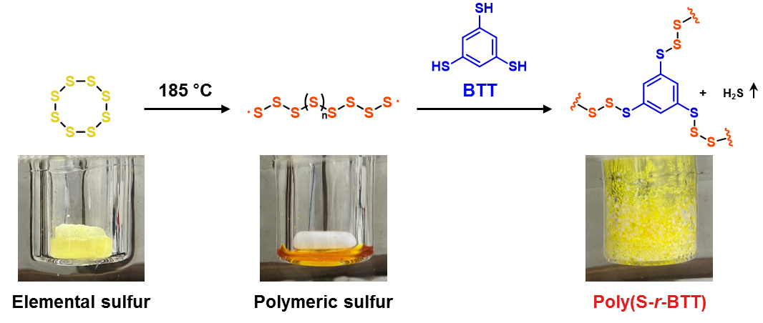
Figure S1. Synthesis of poly(S-r-BTT) copolymer via inverse vulcanization.
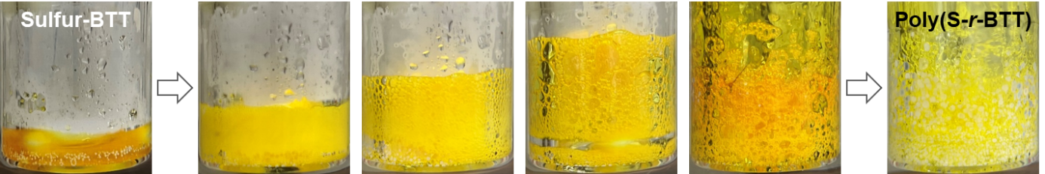
Figure S2. Digital image showing the process of S-BTT mixture curing into a poly(S-r-BTT) in a 185 °C oil bath.
- Synthesis of a poly(S₇₀-r-BDT₃₀) copolymer
To a glass vial equipped with a magnetic stir bar was added sulfur (S_{8,} 2.8 g, 70 wt%) and heated in a 185 °C oil bath until yellow sulfur powder turn into orange liquid sulfur. 1,3-Benzenedithiol (BDT, 1.2 g, 0.97 ml, 30 wt%) was added directly to the liquid sulfur via syringe. The sulfur and BDT mixture reacted in a 185 °C oil bath, generating vigorous gas. After 1 hour, the glass vial with product was quenched in liquid nitrogen bath and product was separated from the vial. The product is obtained as a yellow solid.

- Synthesis of a poly(S₇₀-r-DIB₃₀) copolymer
To a glass vial equipped with a magnetic stir bar was added sulfur (S_{8,} 2.8 g, 70 wt%) and heated in a 185 °C oil bath until yellow sulfur powder turn into orange liquid sulfur. 1,3-Diisopropenylbenzene (DIB, 1.2 g, 0.92 ml, 30 wt%) was added directly to the liquid sulfur via syringe. The sulfur and DIB mixture reacted in a 185 °C oil bath for 1 hour. The glass vial with product was quenched in liquid nitrogen bath and product was separated from the vial. The product is obtained as a cherry-colored solid.

- Synthesis of a poly(S₇₀-r-DVB₃₀) copolymer
To a glass vial equipped with a magnetic stir bar was added sulfur (S_{8,} 2.8 g, 70 wt%) and heated in a 160 °C oil bath until yellow sulfur powder turn into orange liquid sulfur. Divinylbenzene (DVB, 1.2 g, 0.91 ml, 30 wt%) was added directly to the liquid sulfur via syringe. The sulfur and DIB mixture reacted in a 160 °C oil bath for 1 hour. The glass vial with product was quenched in liquid nitrogen bath and product was separated from the vial. The product is obtained as a brown glassy solid.

- General procedure for the preparation of bulk polymer into free-standing thin films
The bulk polymer samples prepared as written above and commercial polymers were hot-pressed between two polyimide films with a stainless steel plate under a pressure of 5 MPa for 10 minutes (specific hot-pressing temperatures noted below).
- Processing of poly(S-r-BTT) into free-standing thin films: The S-BTT thin films were prepared via the general procedure described above at hot-pressing temperature T = 185 °C.
- Processing of poly(S₇₀-r-BDT₃₀) into free-standing thin film: The S70-BDT30 thin film was prepared via the general procedure described above at hot-pressing temperature T = 30 °C.
- Processing of poly(S₇₀-r-DIB₃₀) into free-standing thin film: The S70-DIB30 thin film was prepared via the general procedure described above at hot-pressing temperature T = 85 °C.
- Processing of poly(S₇₀-r-DVB₃₀) into free-standing thin film: The S70-DVB30 thin film was prepared via the general procedure described above at hot-pressing temperature T = 160 °C.
- Processing of commercial polymers and ARTON D4000 into free-standing thin films : The commercial polymers (i.e. Polyethylene (PE) and Poly(methyl methacrylate) (PMMA)) and ARTON D4000 thin film were prepared via the general procedure described above at hot-pressing temperature T = 180-200 °C.

- General procedure for the preparation of 1 mm thick polymer lenses (Dia. 25 mm × Thickness 1 mm)
The bulk polymer samples prepared as written above and commercial polymers were hot-pressed between two polyimide films with a stainless steel mold (Dia. 25 mm × Thickness 1 mm) under a pressure of 20 MPa for 30 minutes (specific hot-pressing temperatures noted below). After cooling to room temperature, the polymer lens was carefully removed from the mold. The polymer lens thickness was measured for 3 point using an ABS digital thickness gauge (MITUTOYO, Japan). See tables below for thickness specific to each polymer lenses.
- Processing for 1 mm thick lenses of poly(S-r-BTT): The S-BTT lenses were prepared via the general procedure described above at hot-pressing temperature T = 185 °C.
- Processing for 1 mm thick lens of poly(S₇₀-r-BDT₃₀): The S70-BDT30 lens was prepared via the general procedure described above at hot-pressing temperature T = 30 °C.
- Processing for 1 mm thick lens of poly(S₇₀-r-DIB₃₀): The S70-DIB30 lens was prepared via the general procedure described above at hot-pressing temperature T = 85 °C.
- Processing for 1 mm thick lens of poly(S₇₀-r-DVB₃₀): The S70-DVB30 lens was prepared via the general procedure described above at hot-pressing temperature T = 160 °C.
- Processing for 1 mm thick lenses of commercial polymers and ARTON D4000: The commercial polymers (i.e. Polyethylene (PE) and Poly(methyl methacrylate) (PMMA)) and ARTON D4000 lenses were prepared via the general procedure described above at hot-pressing temperature T = 180-200 °C.

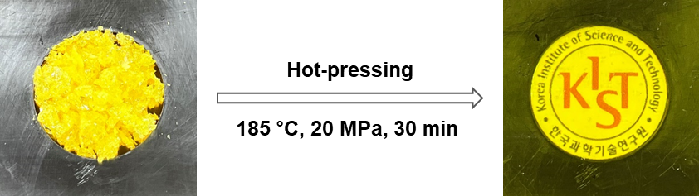
Figure S3. Photograph of the hot-pressed S70-BTT30 lens using stainless steel mold (Dia. 25 mm × Thickness 1 mm)

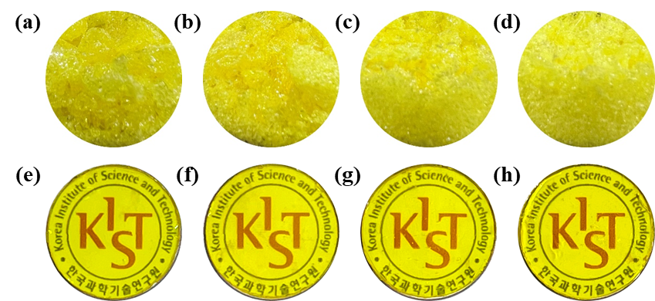
Figure S4. Photographs of bulk poly(S-r-BTT) and poly(S-r-BTT) lenses (a)&(e) S80-BTT20, (b)&(f) S70-BTT30, (c)&(g) S60-BTT40 and (d)&(h) S50-BTT50.

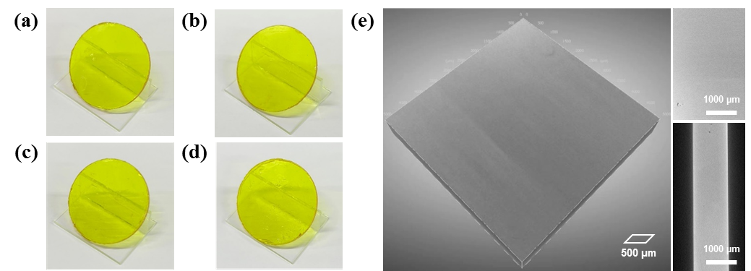
Figure S5. Photographs of poly(S-r-BTT) lenses according to sulfur content (a) S80-BTT20, (b) S70-BTT30, (c) S60-BTT40, (d) S50-BTT50 and (e) 3D X-ray microscope image of S70-BTT30 lens.

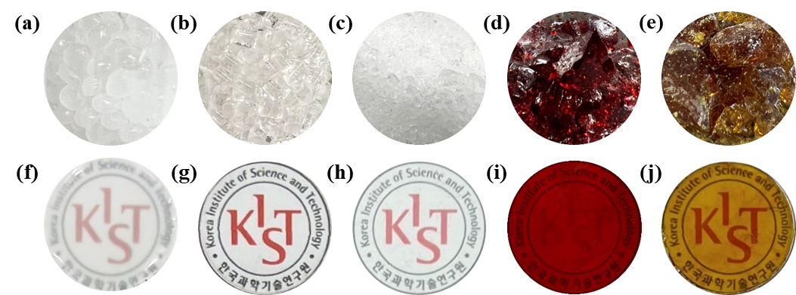
Figure S6. Photographs of bulk polymers and polymer lenses (a)&(f) PE (polyethylene), (b)&(g) COP (cyclic olefin copolymer), (c)&(h) PMMA (poly(methyl methacrylate)), (d)&(i) S70-DIB30 and (e)&(j) S70-DVB30.

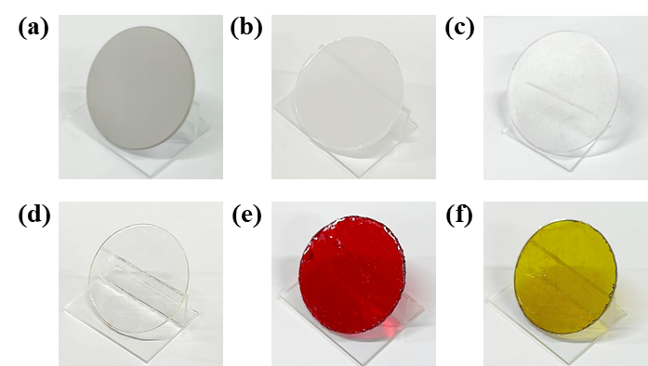
Figure S7. Photographs of Ge and polymer lenses (a) Ge lens, (b) PE (polyethylene), (c) COP (cyclic olefin copolymer), (d) PMMA (poly(methyl methacrylate)), (e) S70-DIB30 and (f) S70-DVB30.

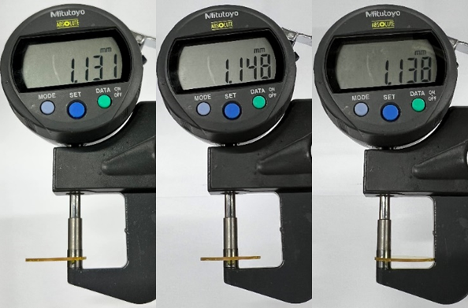
Figure S8. Digital image of S70-BTT30 lens thickness measurement using an ABS Digital Thickness Gauge (MITUTOYO, Japan).

 | Thickness (mm)*
Ge (Germanium) | 1.087
PE (Polyethylene) | 1.090
COP (Cyclic olefin copolymer) | 1.098
PMMA (Poly(methyl methacrylate)) | 1.153
S70-DIB30 | 1.281
S70-DVB30 | 1.276
S80-BTT20 | 1.156
S70-BTT30 | 1.139
S60-BTT40 | 1.144
S50-BTT50 | 1.156
Table S1. Average thickness of the Ge lens and polymer lenses.

* Average of 3 point measurements, using an ABS Digital Thickness Gauge (MITUTOYO, Japan).

For the purchased Ge lens and the fabricated polymer lenses, the thicknesses of the three points were measured as shown in figure S8, and the average values were summarized in Table S1.

- Results and Discussion
- Properties of poly(S₇₀-r-BDT₃₀) copolymer
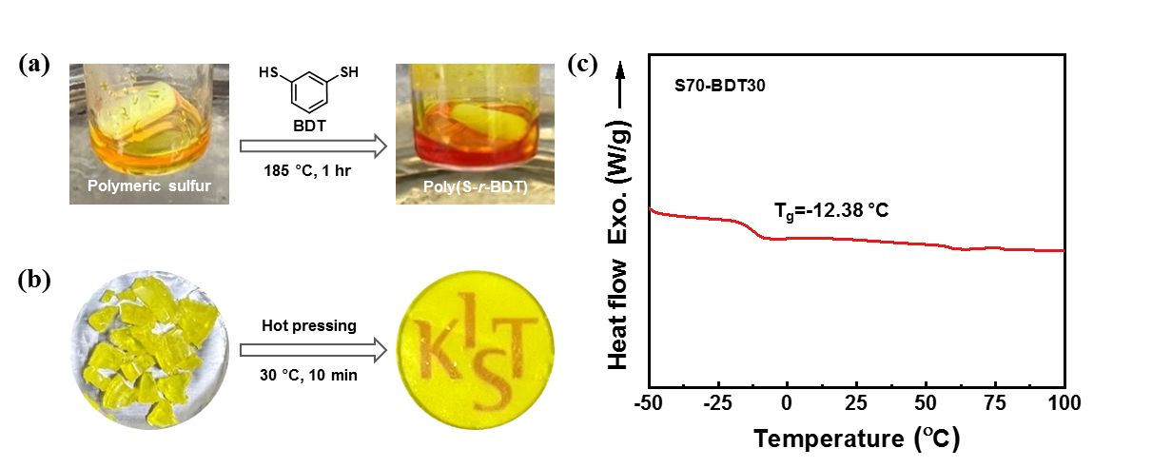
Figure S9. (a) Synthesis of poly(S₇₀-r-BDT₃₀) copolymer via inverse vulcanization, (b) photographs of hot-pressing of S70-BDT30 lens and (c) DSC curve indicating the glass transition temperatures (T_{g}) of S70-BDT30.

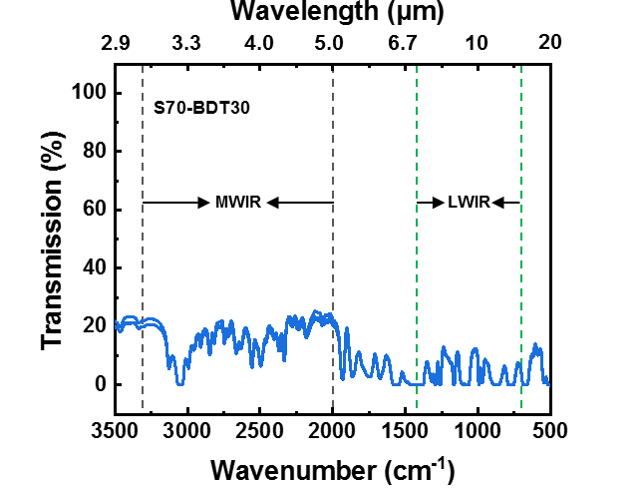
Figure S10. FT-IR transmission (%) spectra of the S70-BDT30 lens (3 point measurements).
 | Thickness (mm) | Refractive index (n_{TE})ª | Transmission (%)
 | Thickness (mm) | Refractive index (n_{TE})ª | MWIR | LWIR
S70-BDT30 | 1.187 | 1.92911 | 16.12 | 4.30
S70-BDT30 | 1.187 | 1.92911 | 15.64 | 4.00
S70-BDT30 | 1.187 | 1.92911 | 16.94 | 4.10
S70-BDT30 | 1.187 | 1.92911 | 16.23^{b} | 4.13^{c}
Table S2. Optical properties of the S70-BDT30 lens.
ªMeasured at 637 nm, ^{b&c}Average of 3 point measurements.

As described in the manuscript, we first confirmed the reactivity of sulfur and thiol monomer using 1,3-benzenedithiol (BDT). Elemental sulfur and BDT cross-linker were successfully inverse vulcanized via condensation reaction at 185 °C. About 1 mm thick S70-BDT30 (70 wt% sulfur and 30 wt% BDT) lens was prepared by low-temperature pressing of the yellow bulk copolymer. The S70-BDT30 lens had a low glass transition temperature (T_{g}), making it difficult to persist shape at room temperature, so detailed optical characterization was not performed (Figure S9). Nevertheless, a high refractive index of n_{TE}>1.92 at 637 nm and IR transparency were confirmed (Figure S10 and Table S2).

- Properties of poly(S₉₀-r-BTT₁₀) copolymer


Figure S11. After 1-day storage at room temperature, the S90-BTT10 lens observed crystallization due to unreacted sulfur.

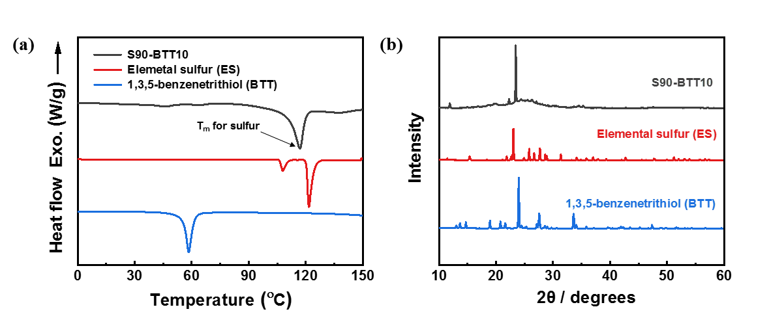
Figure S12. Thermal and chemical properties of the S90-BTT10 (a) DSC curves of 1st heating cycle and (b) XRD spectrum of S90-BTT10 (dark gray), elemental sulfur (red), 1,3,5-benzenetrithiol (blue).

 | Transmission (%)
 | MWIR | LWIR
S90-BTT10 | 61.63 | 32.18
S90-BTT10 | 58.03 | 33.88
S90-BTT10 | 62.37 | 34.81
S90-BTT10 | 62.44 | 35.53
S90-BTT10 | 57.92 | 29.90
Average | 60.48 | 33.26
Table S3. IR transmission (%) of the S90-BTT10 lens (thickness: 1.100 mm).

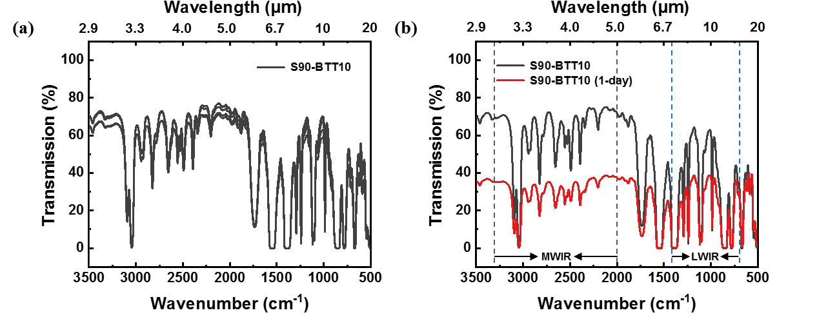
Figure S13. FT-IR transmission (%) spectra of the S90-BTT10 lens (thickness : 1.100 mm) (a) initial S90-BTT10 lens measured 5 times and (b) initial and 1-day room temperature storage S90-BTT10 lens.

 | Thickness* (mm) | Transmission (%)
 | Thickness* (mm) | MWIR | LWIR
S90-BTT10 | 1.100 | 60.48 | 33.26
S90-BTT10 (RT, 1-day ) | 1.100 | 30.55 | 20.34
Table S4. Average IR transmission (%) of the initial and 1-day room temperature storage S90-BTT10 lens.

*Average of 3 point measurements using an ABS Digital Thickness Gauge (MITUTOYO, Japan).

Crystallization of unreacted sulfur, which was not observed in sulfur content of 80~50 wt% copolymer, was clearly observed in the S90-BTT10 copolymer (Figure S11-12). The results summarized in Table 3 showed the high MWIR and LWIR transmittance of the S90-BTT10 lens. In contrast, S90-BTT10 lenses stored for 1-day at room temperature showed significantly reduced IR transmittance due to the presence of residual unreacted sulfur (Figure 13 and Table 4).

- Glass transition temperature (T_{g}) of poly(S₇₀-r-DIB₃₀), poly(S₇₀-r-DVB₃₀) and poly(S₇₀-r-BTT₃₀) copolymers

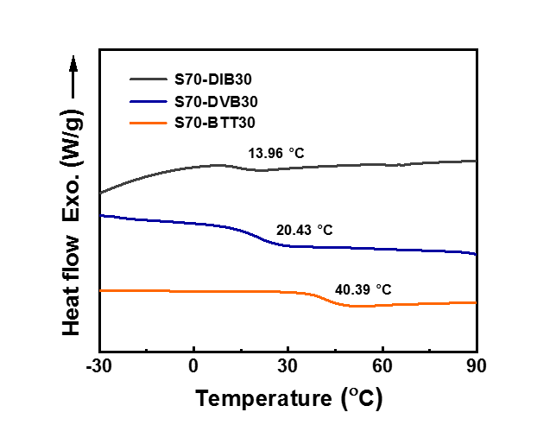
Figure S14. DSC curves of 2nd heating cycles indicating the glass transition temperatures (T_{g}) of S70-DIB30, S70-DVB30 and S70-BTT30.

- Solubility test of poly(S₇₀-r-DIB₃₀), poly(S₇₀-r-DVB₃₀) and poly(S₇₀-r-BTT₃₀) copolymers

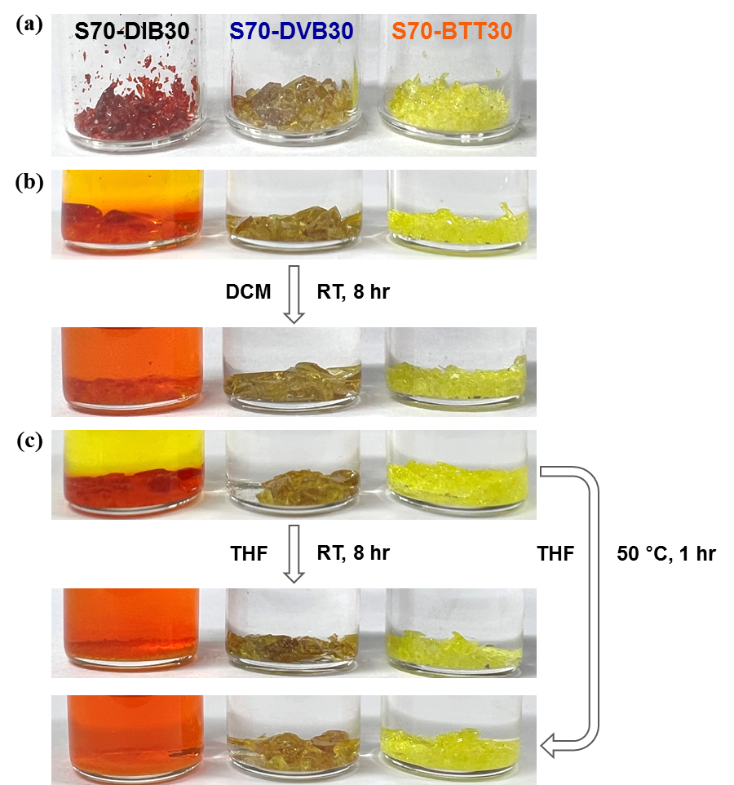
Figure S15. Solubility test of the S70-DIB30, S70-DVB30 and S70-BTT30 (from left to right)
(a) bulk copolymers, (b) Dichloromethane (DCM) and (c) Tetrahydrofuran (THF).

- MD simulations of poly(S-r-BTT) copolymer

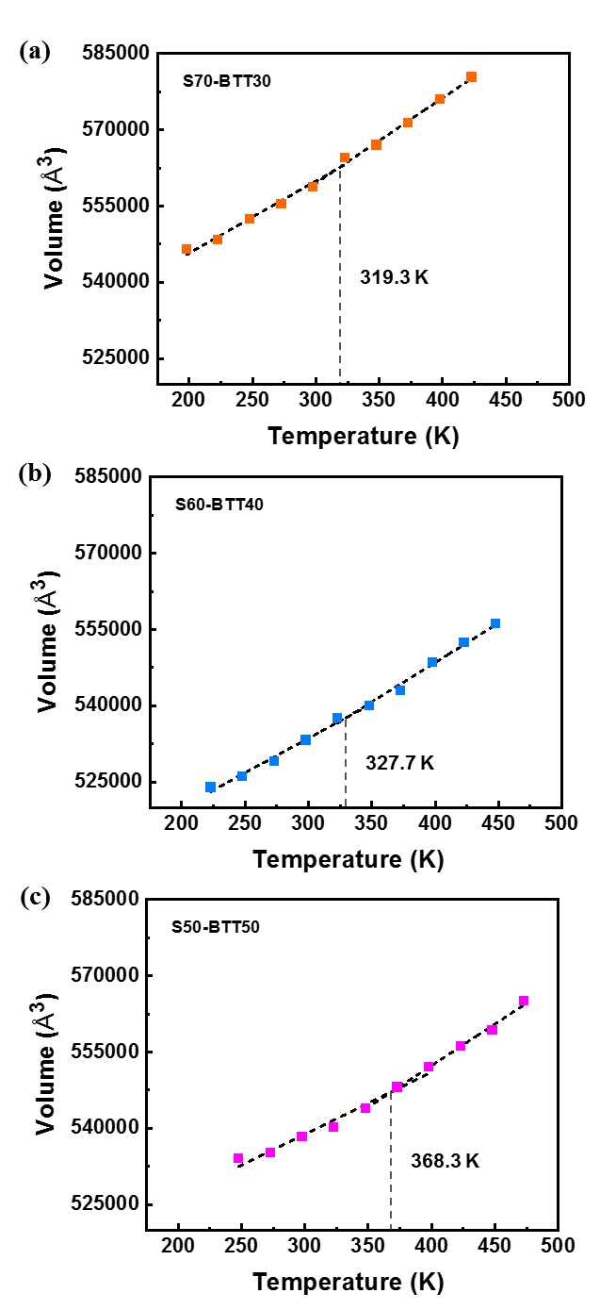
Figure S16. Glass transition temperatures of poly(S-r-BTT) copolymers calculated by the MD simulations (a) S70-BTT30, (b) S60-BTT40 and (c) S50-BTT50.
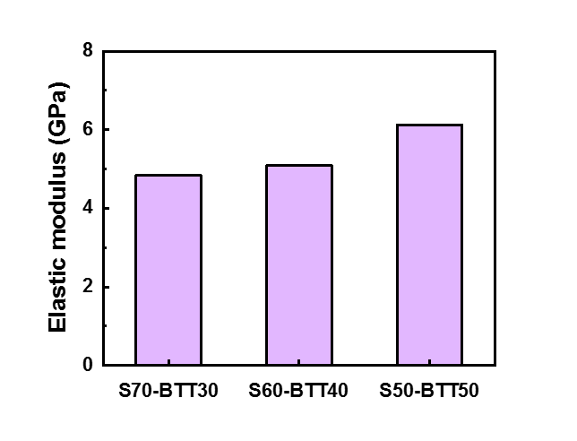
Figure S17. Elastic moduli of S-BTT models calculated by the MD simulations.

The elastic moduli of poly(S-r-BTT) copolymers were calculated by the MD simulations using the constant-strain method.¹ The elastic moduli of S-BTT models according to the contents of the sulfur and the BTT were 4.8, 5.1, and 6.1 GPa for the S70-BTT30, S60-BTT40, and S50-BTT50 models, respectively. The elastic modulus of the S50-BTT50 model increased up to 27 % compared to that of the S70-BTT30 model. This result related to the rigidity of the polymer chain. The rigidity of the polymer chain containing the sulfur increased by the addition of the BTT as the organic cross-linker. The increase of the rigidity of the flexible polymer chain led to the improvement of the elastic modulus of the poly(S-r-BTT) copolymer. Therefore, the S50-BTT50 model with the high BTT content has the highest elastic modulus.

- DFT calculation of models compounds

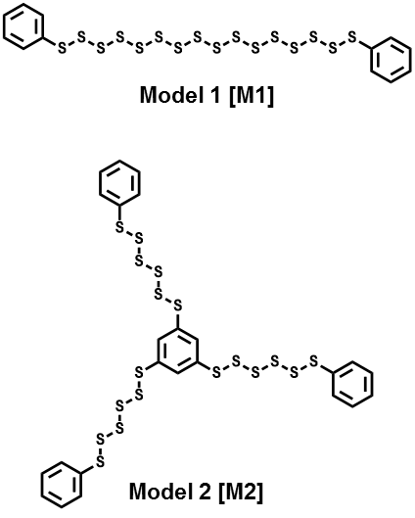
Figure S18. Chemical structures of model compounds, model 1 (M1) and model 2 (M2).

Sample | Molecular  Volume (V_{mol})ª  [Bohr³/mol] | Polarizability (α_{λ})^{b}  [Bohr³] |  |  |  | Refractive Index (n_{λ})^{c}
Sample | Molecular  Volume (V_{mol})ª  [Bohr³/mol] | 637 nm | 829 nm | 1306 nm | 1549 nm | 637 nm | 829 nm | 1306 nm | 1549 nm | n∞^{d} | D^{d}  [×10⁴]
Model 1  [PhS₁₆Ph] | 4577.572 | 554.40 | 513.98 | 491.27 | 487.49 | 2.022 | 1.914 | 1.857 | 1.848 | 1.806 | 8.431
Model 2  [(PhS₆)₃Ph] | 6405.127 | 797.77 | 746.85 | 714.2 | 708.59 | 2.067 | 1.966 | 1.905 | 1.895 | 1.855 | 8.366
Table S5. DFT calculation results with model compounds on molecular volume, polarizability, and refractive index.
ªCalculated volume inside a contour of 0.001 electrons/Bohr³ density in optimized structure at B3LYP/6-31G level, ^{b}Calculated polarizability at B3LYP/6-31G level, ^{c}Calculated refractive index by Lorentz-Lorenz equation [(n_{λ}² – 1)/(n_{λ}² + 2) = (4π/3)(α_{λ}/V_{mol})], ^{d}Calculated refractive index at infinite wavelength determined by fitting with the simplified Cauchy’s formula (n_{λ} = n∞ + D/λ²).

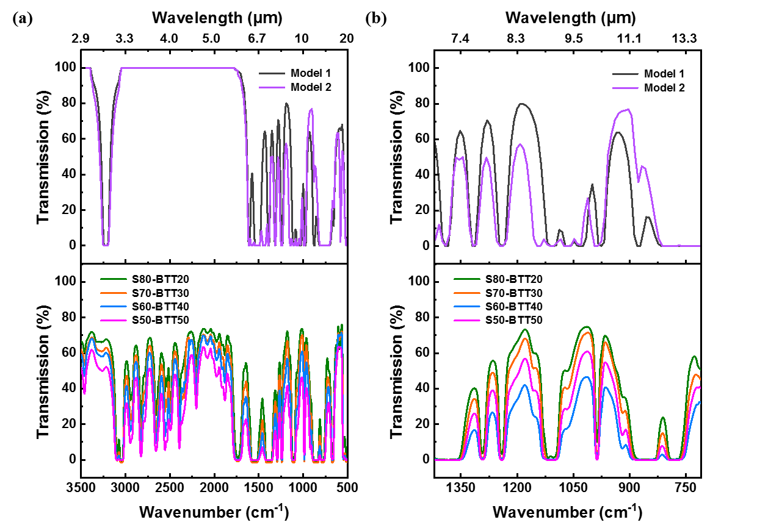
Figure S19. IR spectra for comparison between experimental and calculated data (a) IR full region and (b) Long-wave infrared (LWIR) region.

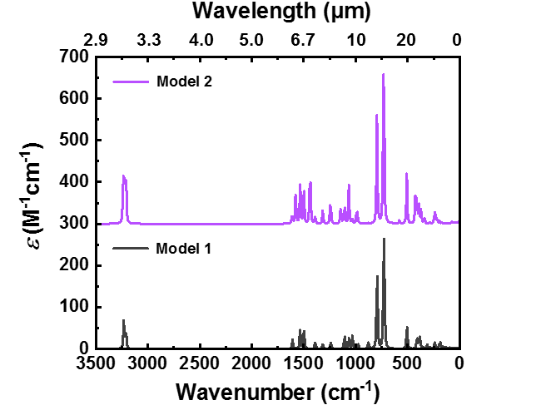
Figure S20. Calculated IR absorption spectra.
- DMA curves of poly(S-r-BTT) thin films
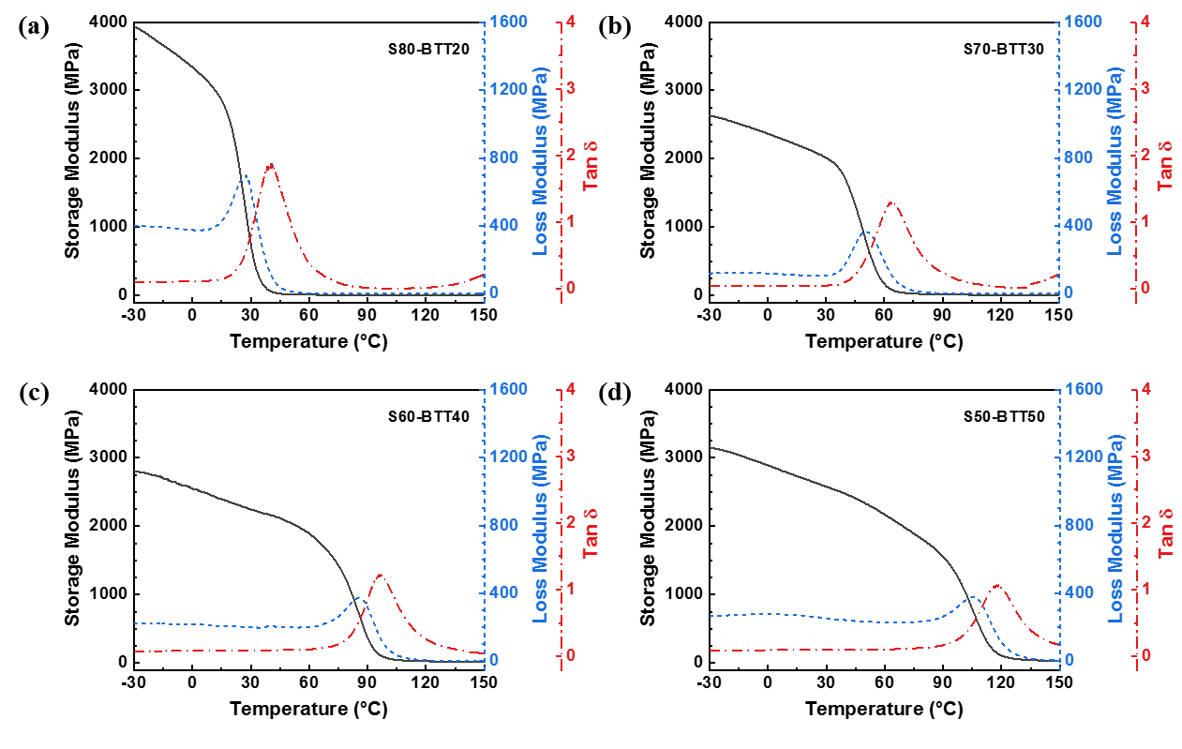
Figure S21. DMA curves of the poly(S-r-BTT) thin film for varying sulfur content
(a) S80-BTT20, (b) S70-BTT30, (c) S60-BTT40 and (d) S50-BTT50.
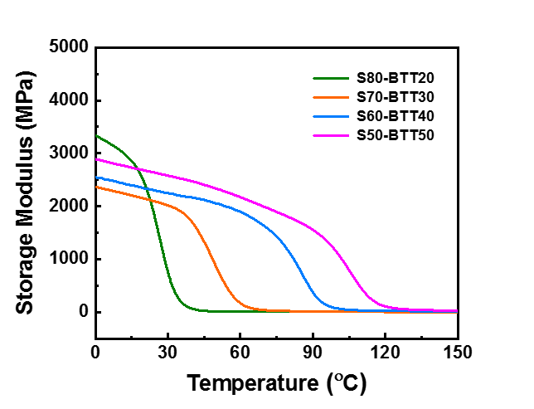
Figure S22. Plot of storage modulus (E′) for poly(S-r-BTT) thin films of varying sulfur content.

 | T_{d5%} (°C)ª | T_{d10%} (°C)^{b} | T_{g} (DSC) (°C) | T_{g} (DMA) (°C)
S80-BTT20 | 205.21 | 237.80 | 14.85 | 40.83
S70-BTT30 | 305.53 | 345.60 | 40.39 | 64.28
S60-BTT40 | 306.94 | 352.21 | 66.21 | 96.31
S50-BTT50 | 369.31 | 391.66 | 100.14 | 118.25
Table S6. Thermal properties of poly(S-r-BTT) copolymers of varying sulfur content.

ªDecomposition temperature, defined as 5 wt% loss, ^{b}Decomposition temperature, defined as 10 wt% loss.

Table S7. Cross-linking density of poly(S-r-BTT) copolymers of varying sulfur content.
 | S80-BTT20 | S70-BTT30 | S60-BTT40 | S50-BTT50
ν_{e}* (mol/m³) | 1294 | 1598 | 2488 | 2767

*Cross-linking density calculated as ν_{e}=E′/3RT, where E′, R, and T are the storage modulus at rubbery plateau regime, ideal gas constant and temperature at E′, respectively.² Each E′ values were applied from DMA curves of Figure S22.

- Refractive indices of poly(S-r-BTT) thin films

 | Wavelength (nm) | n_{TE}ª | n_{TM}^{b} | n_{av.}^{c} | Δn^{d}
S80-BTT20 | 637 | 2.00130 | 2.00105 | 2.00122 | 0.00025
S80-BTT20 | 829 | 1.96723 | 1.96710 | 1.96719 | 0.00013
S80-BTT20 | 1306 | 1.94278 | 1.94254 | 1.94270 | 0.00024
S80-BTT20 | 1549 | 1.93784 | 1.93564 | 1.93711 | 0.00220
S70-BTT30 | 637 | 1.99078 | 1.98829 | 1.98995 | 0.00249
S70-BTT30 | 829 | 1.95721 | 1.95468 | 1.95637 | 0.00253
S70-BTT30 | 1306 | 1.93199 | 1.93071 | 1.93156 | 0.00128
S70-BTT30 | 1549 | 1.92874 | 1.92595 | 1.92781 | 0.00279
S60-BTT40 | 637 | 1.96797 | 1.96686 | 1.96760 | 0.00111
S60-BTT40 | 829 | 1.93816 | 1.93537 | 1.93723 | 0.00279
S60-BTT40 | 1306 | 1.91345 | 1.91175 | 1.91288 | 0.00170
S60-BTT40 | 1549 | 1.90919 | 1.90634 | 1.90824 | 0.00285
S50-BTT50 | 637 | 1.94536 | 1.94207 | 1.94426 | 0.00329
S50-BTT50 | 829 | 1.91428 | 1.91231 | 1.91362 | 0.00197
S50-BTT50 | 1306 | 1.89107 | 1.88900 | 1.89038 | 0.00207
S50-BTT50 | 1549 | 1.88680 | 1.88591 | 1.88650 | 0.00089
Table S8. Refractive indices of the poly(S-r-BTT) films at different wavelengths.
ªIn-plane refractive index, ^{b}Out-of-plane refractive index, ^{c}Average refractive index calculated as n_{av} = [(2n_{TE}² + n_{TM}²)/3]^{1/2}, ^{d}In-plane/out-of-plane birefringence calculated as Δn = n_{TE} – n_{TM}.

Table S9. Optical properties of S70-DIB30, S70-DVB30 and poly(S-r-BTT) lenses of varying sulfur content.
 | Refractive indices and birefringence at 637 nm |  |  |  | V_{NIR}^{e}
 | n_{TE}ª | n_{TM}^{b} | n_{av.}^{c} | Δn^{d} | V_{NIR}^{e}
S70-DIB30 | 1.86103 | 1.86100 | 1.86102 | 0.00003 | 19.8
S70-DVB30 | 1.86818 | 1.86696 | 1.86777 | 0.00122 | 19.0
S80-BTT20 | 2.00130 | 2.00105 | 2.00122 | 0.00025 | 16.5
S70-BTT30 | 1.99078 | 1.98829 | 1.98995 | 0.00249 | 16.3
S60-BTT40 | 1.96797 | 1.96686 | 1.96760 | 0.00111 | 17.2
S50-BTT50 | 1.94536 | 1.94207 | 1.94426 | 0.00329 | 16.8
ªIn-plane refractive index, ^{b}Out-of-plane refractive index, ^{c}Average refractive index calculated as n_{av} = [(2n_{TE}² + n_{TM}²)/3]^{1/2}, ^{d}In-plane/out-of-plane birefringence calculated as Δn = n_{TE} – n_{TM}. ^{e}Abbe’s number is given by as V_{NIR} = (n₈₂₉ − 1)/(n₆₃₇ − n₁₃₀₆).

- FT-IR transmission (%) spectra of Ge, commercial polymers, ARTON D4000, S70-DIB30 and S70-DVB30 1 mm thick lenses

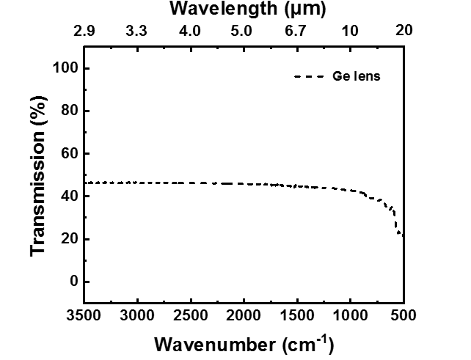
Figure S23. FT-IR transmission (%) spectrum of the Ge lens.

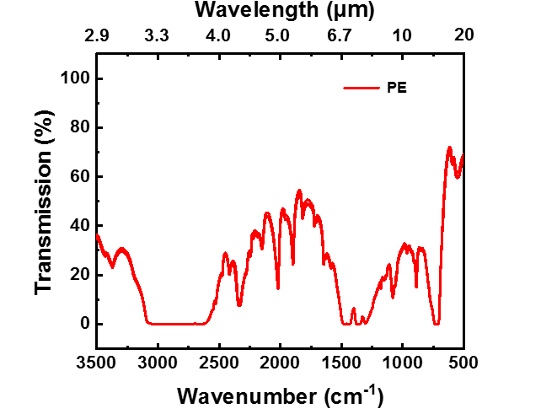
Figure S24. FT-IR transmission (%) spectra of the PE (Polyethylene) lens (5 measurements).

 | Transmission (%)
 | MWIR | LWIR
PE  (Polyethylene) | 14.18 | 15.76
PE  (Polyethylene) | 14.16 | 15.56
PE  (Polyethylene) | 14.19 | 15.47
PE  (Polyethylene) | 14.30 | 15.54
PE  (Polyethylene) | 14.78 | 16.07
Average | 14.32 | 15.68
Table S10. IR transmission (%) of the PE lens (thickness: 1.090 mm).

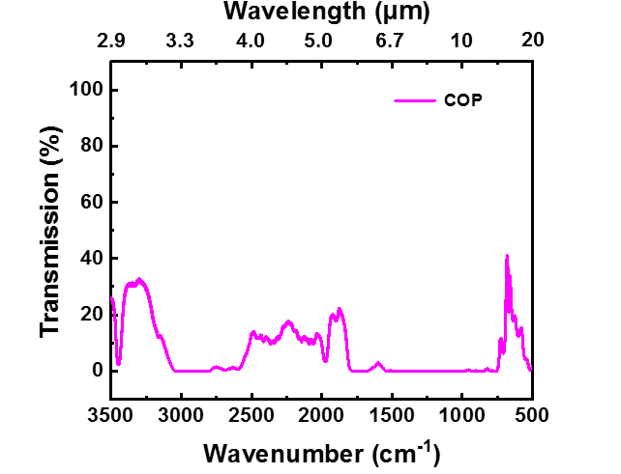
Figure S25. FT-IR transmission (%) spectra of the COP (Cyclic olefin copolymer) lens (5 measurements).

 | Transmission (%)
 | MWIR | LWIR
COP  (Cyclic olefin copolymer) | 8.67 | 0.46
COP  (Cyclic olefin copolymer) | 8.31 | 0.44
COP  (Cyclic olefin copolymer) | 8.44 | 0.45
COP  (Cyclic olefin copolymer) | 8.42 | 0.44
COP  (Cyclic olefin copolymer) | 8.40 | 0.45
Average | 8.45 | 0.45
Table S11. IR transmission (%) of the COP lens (thickness: 1.098 mm).

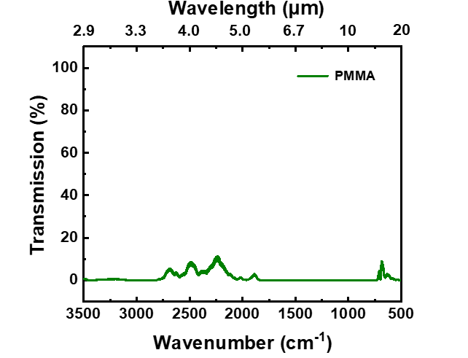
Figure S26. FT-IR transmission (%) spectra of the PMMA (Poly(methyl methacrylate) lens (5 measurements).

 | Transmission (%)
 | MWIR | LWIR
PMMA  (Poly(methyl methacrylate) | 2.65 | 0.05
PMMA  (Poly(methyl methacrylate) | 2.55 | 0.05
PMMA  (Poly(methyl methacrylate) | 2.89 | 0.05
PMMA  (Poly(methyl methacrylate) | 2.27 | 0.04
PMMA  (Poly(methyl methacrylate) | 2.31 | 0.04
Average | 2.53 | 0.05
Table S12. IR transmission (%) of the PMMA lens (thickness: 1.153 mm).

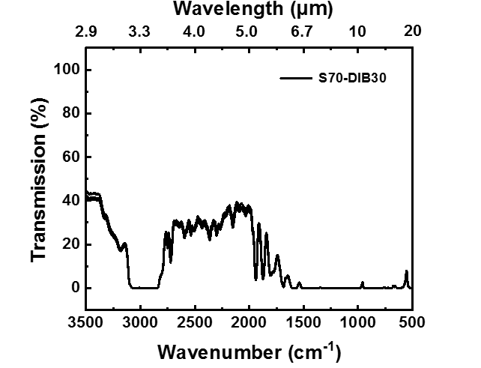
Figure S27. FT-IR transmission (%) spectra of the S70-DIB30 lens (5 measurements).

 | Transmission (%)
 | MWIR | LWIR
S70-DIB30 | 20.96 | 0.08
S70-DIB30 | 20.50 | 0.08
S70-DIB30 | 21.76 | 0.08
S70-DIB30 | 20.68 | 0.08
S70-DIB30 | 21.89 | 0.09
Average | 21.16 | 0.08
Table S13. IR transmission (%) of the S70-DIB30 lens (thickness: 1.281 mm).

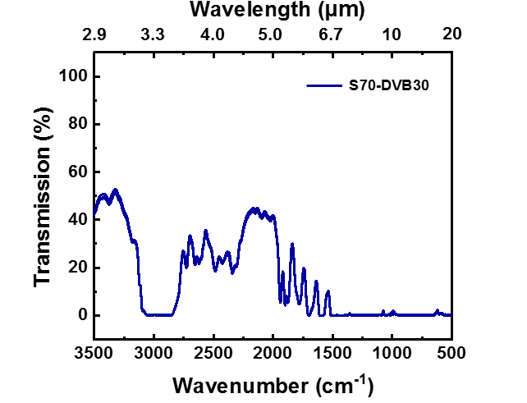
Figure S28. FT-IR transmission (%) spectra of the S70-DVB30 lens (5 measurements).

 | Transmission (%)
 | MWIR | LWIR
S70-DVB30 | 24.23 | 0.33
S70-DVB30 | 23.57 | 0.12
S70-DVB30 | 23.75 | 0.30
S70-DVB30 | 23.73 | 0.29
S70-DVB30 | 23.57 | 0.17
Average | 23.77 | 0.24
Table S14. IR transmission (%) of the S70-DVB30 lens (thickness: 1.276 mm).

- FT-IR transmission (%) spectra of S-BTT 1 mm thick lenses

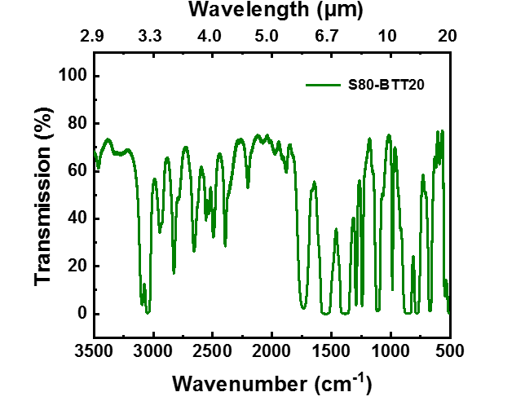
Figure S29. FT-IR transmission (%) spectra of the S80-BTT20 lens (5 measurements).

 | Transmission (%)
 | MWIR | LWIR
S80-BTT20 | 54.25 | 32.52
S80-BTT20 | 53.83 | 32.30
S80-BTT20 | 54.49 | 32.69
S80-BTT20 | 53.92 | 32.38
S80-BTT20 | 54.09 | 32.47
Average | 54.12 | 32.47
Table S15. IR transmission (%) of the S80-BTT20 lens (thickness: 1.156 mm).

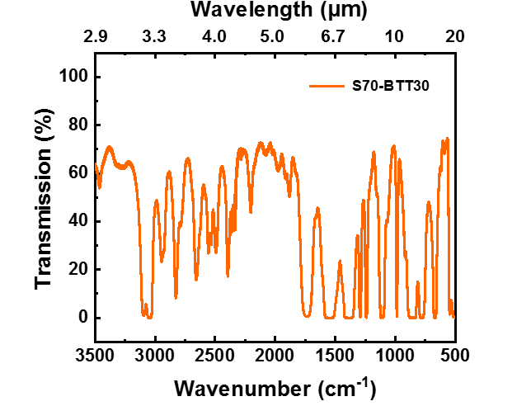
Figure S30. FT-IR transmission (%) spectra of the S70-BTT30 lens (5 measurements).

 | Transmission (%)
 | MWIR | LWIR
S70-BTT30 | 47.04 | 26.47
S70-BTT30 | 47.38 | 26.86
S70-BTT30 | 47.20 | 26.62
S70-BTT30 | 47.56 | 26.99
S70-BTT30 | 48.02 | 27.23
Average | 47.44 | 26.83
Table S16. IR transmission (%) of the S70-BTT30 lens (thickness: 1.139 mm).

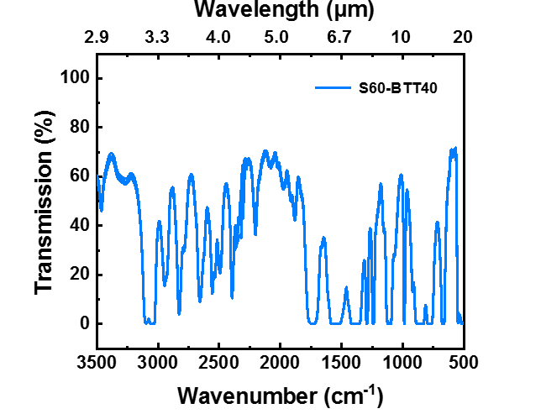
Figure S31. FT-IR transmission (%) spectra of the S60-BTT40 lens (5 measurements).

 | Transmission (%)
 | MWIR | LWIR
S60-BTT40 | 40.43 | 19.82
S60-BTT40 | 41.55 | 20.37
S60-BTT40 | 41.11 | 19.97
S60-BTT40 | 42.19 | 20.58
S60-BTT40 | 42.06 | 20.51
Average | 41.47 | 20.25
Table S17. IR transmission (%) of the S60-BTT40 lens (thickness: 1.144 mm).

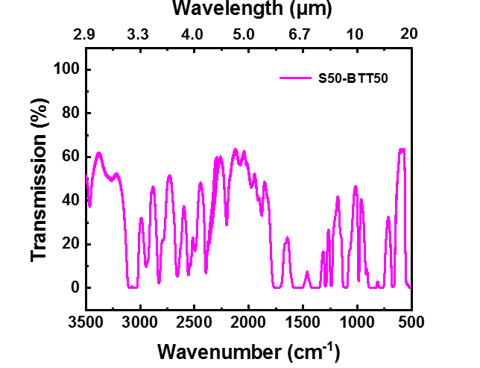
Figure S32. FT-IR transmission (%) spectra of the S50-BTT50 lens (5 measurements).

 | Transmission (%)
 | MWIR | LWIR
S50-BTT50 | 34.08 | 13.91
S50-BTT50 | 33.50 | 13.93
S50-BTT50 | 33.59 | 13.93
S50-BTT50 | 33.39 | 13.91
S50-BTT50 | 33.37 | 13.88
Average | 33.59 | 13.91
Table S18. IR transmission (%) of the S50-BTT50 lens (thickness: 1.156 mm).

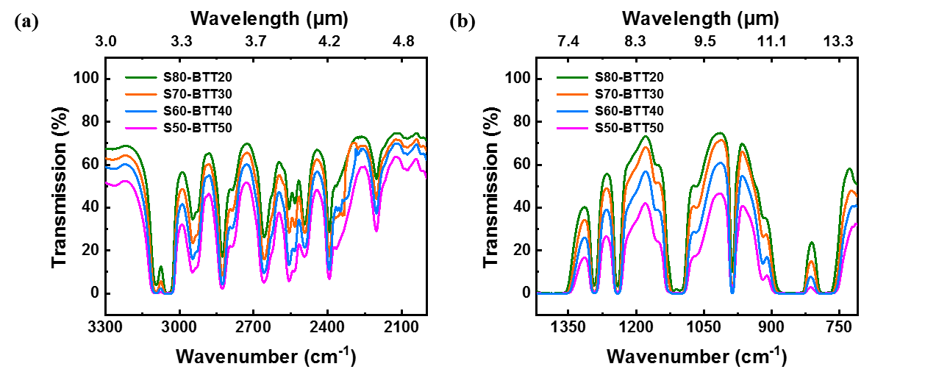
Figure S33. Average FT-IR transmission (%) spectra of poly(S-r-BTT) lenses (a) MWIR region and (b) LWIR region.

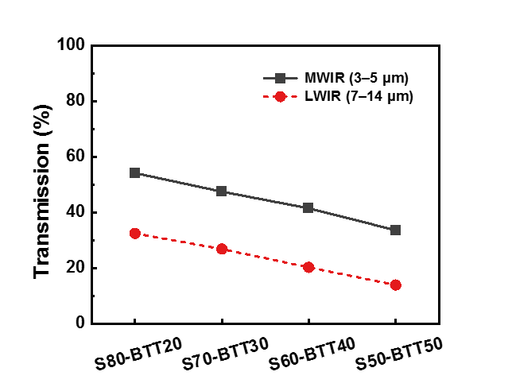
Figure S34. MWIR and LWIR average IR transmission (%) of poly(S-r-BTT) lenses.

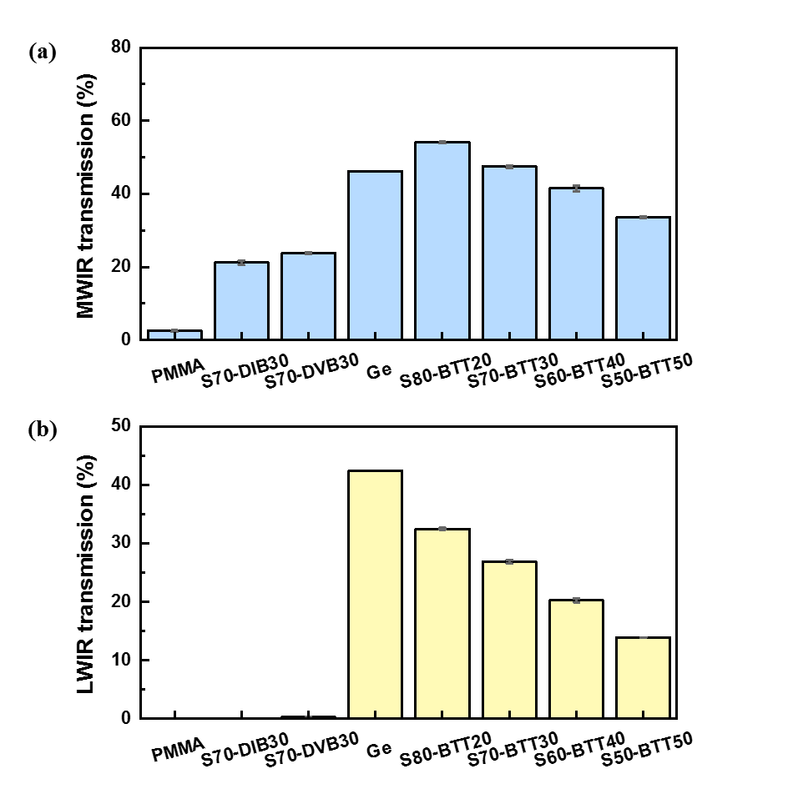
Figure S35. Average IR transmission (%) of Ge and various polymer lenses (a) MWIR region and (b) LWIR region.

Table S19. Average thickness and IR transmission (%) of Ge and polymer lenses.
 | Thickness (mm) | Transmission (%)
 | Thickness (mm) | MWIR | LWIR
Ge | 1.087 | 46.19 | 42.35
PMMA | 1.153 | 2.53 | 0.09
S70-DIB30 | 1.281 | 21.16 | 0.08
S70-DVB30 | 1.276 | 23.77 | 0.24
S80-BTT20 | 1.156 | 54.12 | 32.38
S70-BTT30 | 1.139 | 47.44 | 26.72
S60-BTT40 | 1.144 | 41.47 | 20.21
S50-BTT50 | 1.156 | 33.59 | 13.93

- Average FT-IR transmission (%) spectrum of Ge and polymer lenses
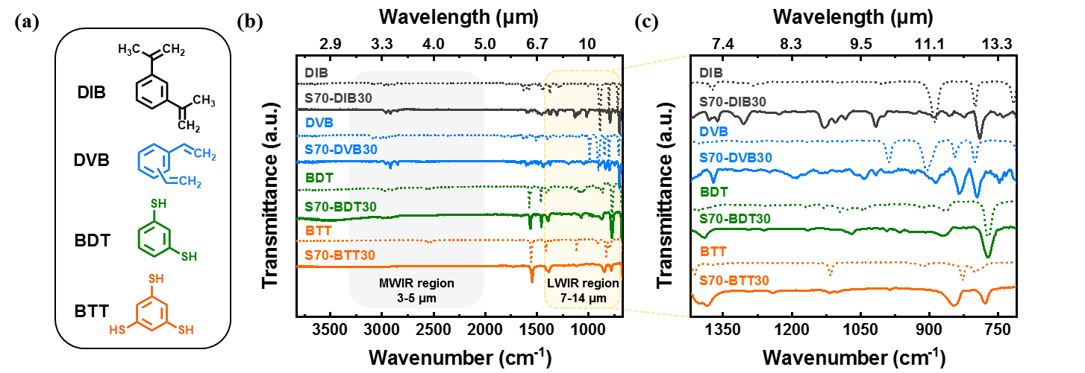
Figure S36. (a) Comonomer structure used for inverse vulcanization : DIB (1,3-diisopropenylbenzene), DVB (Divinylbenzene) BDT (1,3-benzenedithiol) and BTT (1,3,5-benzenetrithiol), (b) Expended FT-IR spectra of monomers and polymers and (c) LWIR spectra of monomers and polymers.
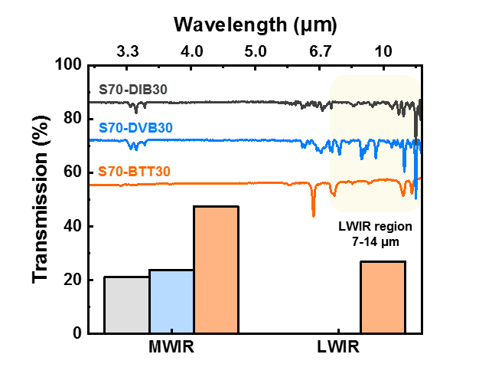
Figure S37. Average FT-IR spectra and average IR transmission (%) of S70-DIB30, S70-DVB30 and S70-BTT30.
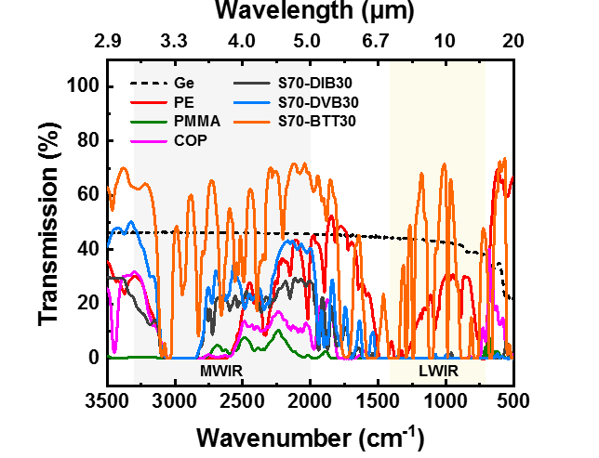
Figure S38. Average FT-IR transmission (%) spectra of the Ge and polymer lenses.

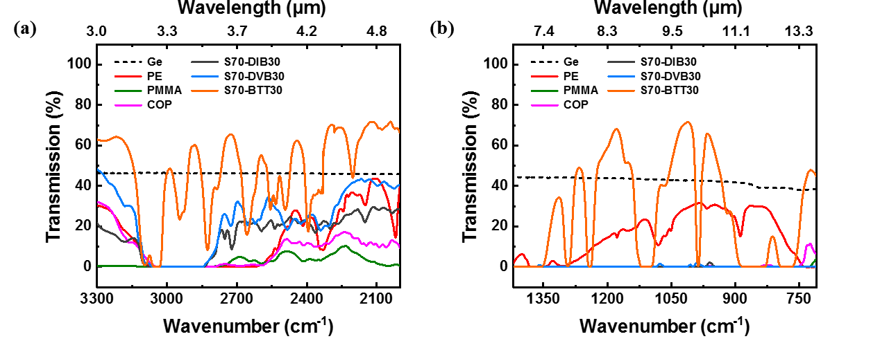
Figure S39. Average FT-IR transmission (%) spectra of the Ge and polymer lenses (a) MWIR region and (b) LWIR region.

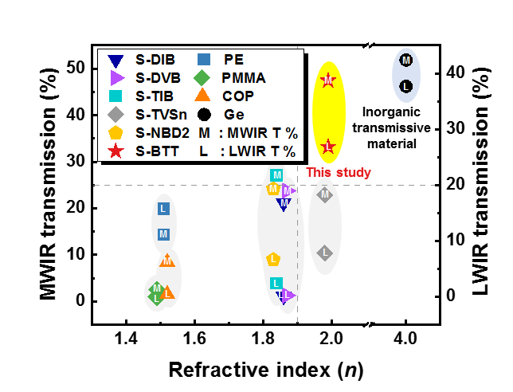
Figure S40. Optical properties of Ge and polymer lenses (S-DIB, S-DVB, S-TIB, S-TVSn, S-NBD2 and S-BTT with sulfur content of 70 wt%).
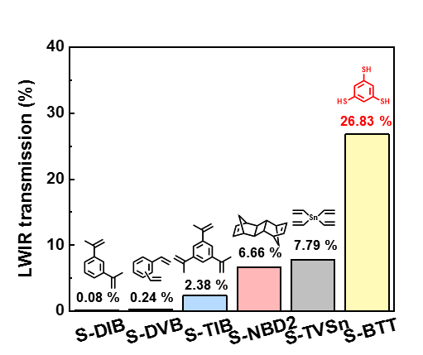
Figure S41. LWIR transmission (%) of 1 mm thick sulfur copolymer lenses (S-DIB, S-DVB, S-TIB, S-NBD2, S-TVSn and S-BTT with sulfur content of 70 wt%).

 | Sulfur content (wt%) | Thickness (mm) | Refractive index (n)ª | Transmission (%) |  | Ref
 |  |  |  | MWIR | LWIR | Ref
Ge  (Germanium) | - | 1.087 | 4.00^{b}  * approximate value in the 2-14 μm region | 46.19 | 42.37 | -
S-BTT | 70 | 1.139 | 1.99 | 47.44 | 26.83 | -
S-TVSn^{c} | 70 | 1.550 | 1.98 | 22.89 | 7.79 | 3
S-NBD2^{d} | 70 | 1.000 | 1.83 | 24.18 | 6.66 | 4
S-TIB^{e} | 70 | 1.000 | 1.84 | 27.01 | 2.38 | 5
S-DVB | 70 | 1.276 | 1.87 | 23.77 | 0.24 | 6
S-DIB | 70 | 1.281 | 1.86 | 21.16 | 0.08 | 7
PE  (Polyethylene) | - | 1.090 | 1.51 | 14.32 | 15.68 | -
COP  (Cyclic olefin copolymer) | - | 1.098 | 1.52^{f} | 8.45 | 0.45 | -
PMMA  (Poly(methyl methacrylate)) | - | 1.153 | 1.49 | 2.53 | 0.05 | -
Table S20. Comparison of optical properties with Ge and polymer lenses
ªMeasured at 637 nm, ^{b}Edmund Optics, ^{c}Tetravinyltin (TVSn), ^{d}A dimer of norbornadiene (NBD), ^{e}1,3,5-Triisopropenylbenzene (TIB) and ^{f}JSR Corporation.

- FT-IR transmission (%) spectra of S70-BTT30 lenses according to hot-pressing condition

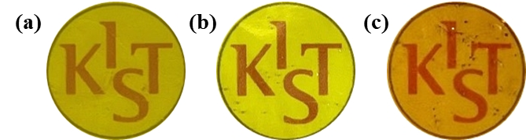
Figure S42. Photographs of S70-BTT30 lenses according to hot-processing temperature (a) 150 °C, (b) 185 °C and (c) 230 °C (processing time: 30 min).

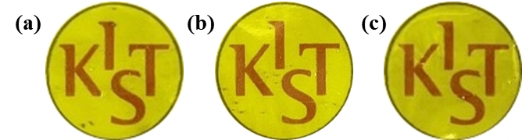
Figure S43. Photographs of S70-BTT30 lenses according to hot-processing time (a) 10 min, (b) 30 min and (c) 1 hr (processing temperature : 185 °C).

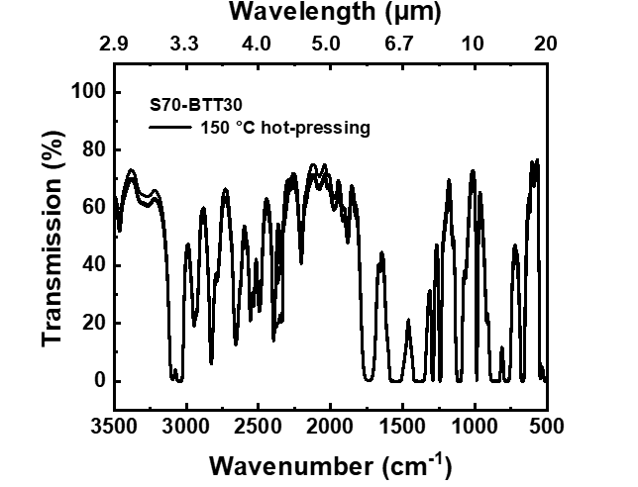
Figure S44. FT-IR transmission (%) spectra of the 150 °C hot-pressed S70-BTT30 lens (5 measurements).

S70-BTT30 | Transmission (%)
S70-BTT30 | MWIR | LWIR
150 °C hot-pressing | 45.15 | 24.85
150 °C hot-pressing | 45.63 | 24.68
150 °C hot-pressing | 44.31 | 24.72
150 °C hot-pressing | 47.27 | 26.24
150 °C hot-pressing | 44.45 | 24.58
Average | 45.36 | 25.01
Table S21. IR transmission (%) of the 150 °C hot-processed S70-BTT30 lens (pressing time: 30 min, thickness: 1.274 mm).

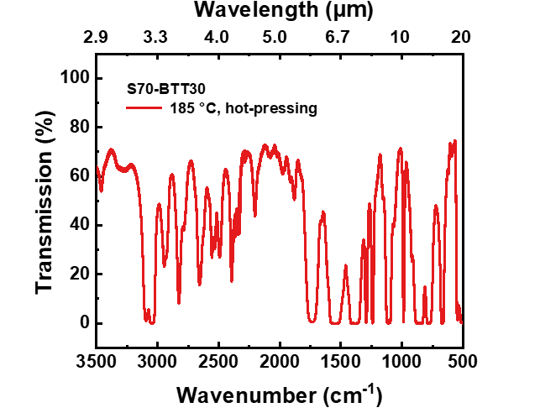
Figure S45. FT-IR transmission (%) spectra of the 185 °C hot-pressed S70-BTT30 lens (5 measurements).

S70-BTT30 | Transmission (%)
S70-BTT30 | MWIR | LWIR
185 °C hot-pressing | 47.04 | 26.47
185 °C hot-pressing | 47.38 | 26.86
185 °C hot-pressing | 47.20 | 26.62
185 °C hot-pressing | 47.56 | 26.99
185 °C hot-pressing | 48.02 | 27.23
Average | 47.44 | 26.83
Table S22. IR transmission (%) of the 185 °C hot-processed S70-BTT30 lens (pressing time: 30 min, thickness: 1.139 mm).

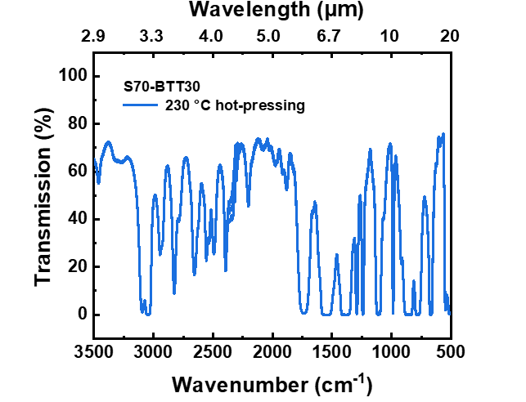
Figure S46. FT-IR transmission (%) spectra of the 230 °C hot-pressed S70-BTT30 lens (5 measurements).

S70-BTT30 | Transmission (%)
S70-BTT30 | MWIR | LWIR
230 °C hot-pressing | 47.90 | 26.49
230 °C hot-pressing | 47.96 | 26.74
230 °C hot-pressing | 47.83 | 26.63
230 °C hot-pressing | 48.71 | 26.98
230 °C hot-pressing | 48.27 | 26.73
Average | 48.14 | 26.71
Table S23. IR transmission (%) of the 230 °C hot-processed S70-BTT30 lens (pressing time: 30 min, thickness: 1.127 mm).

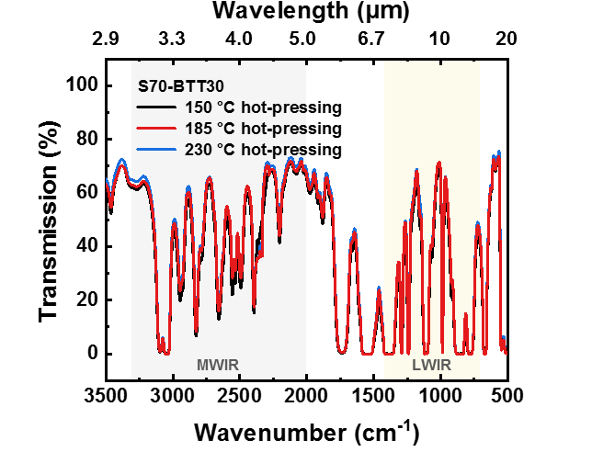
Figure S47. Average FT-IR transmission (%) spectra of S70-BTT30 lenses according to hot-processing temperature (processing time: 30 min).
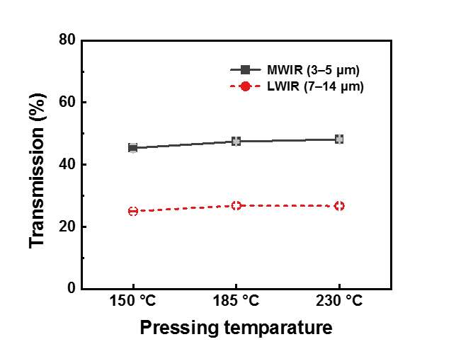
Figure S48. Average MWIR and LWIR transmission (%) of S70-BTT30 lenses according to hot-processing temperature (processing time: 30 min).

S70-BTT30 | Hot-pressing time | Thickness* (mm) | Transmission (%)
S70-BTT30 | Hot-pressing time | Thickness* (mm) | MWIR | LWIR
150 °C hot-pressing | 30 min | 1.274 | 45.36 | 25.01
185 °C hot-pressing | 30 min | 1.139 | 47.44 | 26.83
230 °C hot-pressing | 30 min | 1.127 | 48.14 | 26.71
Table S24. Average thickness and average IR transmission (%) of S70-BTT30 lenses according to hot-processing temperature.
*Average of 3 point measurements using an ABS Digital Thickness Gauge (MITUTOYO, Japan).

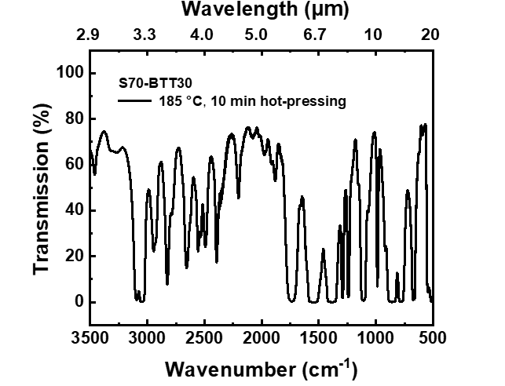
Figure S49. FT-IR transmission (%) spectra of 185 °C for 10 min hot-pressed S70-BTT30 lens (5 measurements).

S70-BTT30 | Transmission (%)
S70-BTT30 | MWIR | LWIR
185 °C, 10 min | 48.51 | 27.16
185 °C, 10 min | 48.49 | 27.14
185 °C, 10 min | 48.47 | 27.13
185 °C, 10 min | 48.25 | 27.00
185 °C, 10 min | 48.27 | 26.95
Average | 48.40 | 27.08
Table S25. IR transmission (%) of 185 °C for 10 min hot-pressed S70-BTT30 lens (thickness: 1.212 mm).

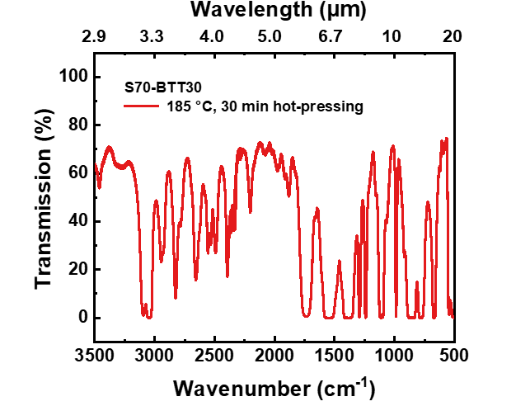
Figure S50. FT-IR transmission (%) spectra of 185 °C for 30 min hot-pressed S70-BTT30 lens (5 measurements).

S70-BTT30 | Transmission (%)
S70-BTT30 | MWIR | LWIR
185 °C, 30 min | 47.04 | 26.47
185 °C, 30 min | 47.38 | 26.86
185 °C, 30 min | 47.20 | 26.62
185 °C, 30 min | 47.56 | 26.99
185 °C, 30 min | 48.02 | 27.23
Average | 47.44 | 26.83
Table S26. IR transmission (%) of 185 °C for 30 min hot-pressed S70-BTT30 lens (thickness: 1.139 mm).

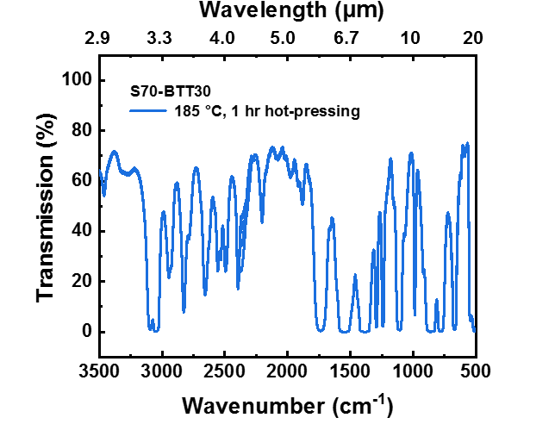
Figure S51. FT-IR transmission (%) spectra of 185 °C for 1 hr hot-pressed S70-BTT30 lens (5 measurements).

S70-BTT30 | Transmission (%)
S70-BTT30 | MWIR | LWIR
185 °C, 1 hr | 46.21 | 26.19
185 °C, 1 hr | 46.21 | 26.19
185 °C, 1 hr | 46.13 | 26.50
185 °C, 1 hr | 46.83 | 26.73
185 °C, 1 hr | 47.10 | 26.73
Average | 46.50 | 26.47
Table S27. IR transmission (%) of 185 °C for 1 hr hot-pressed S70-BTT30 lens (thickness: 1.191 mm).

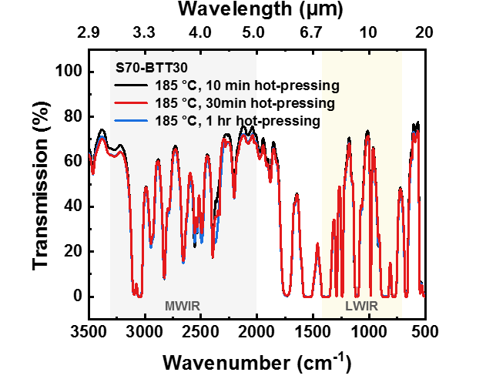
Figure S52. Average FT-IR transmission (%) spectra of S70-BTT30 lenses according to hot-processing time (processing temperature: 185 °C).

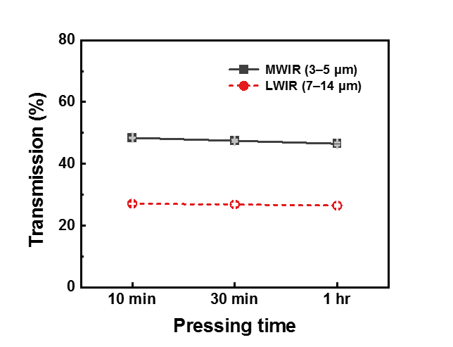
Figure S53. Average MWIR and LWIR transmission (%) of S70-BTT30 lenses according to hot-processing time (processing temperature: 185 °C).

S70-BTT30 | Thickness* (mm) | Transmission (%)
S70-BTT30 | Thickness* (mm) | MWIR | LWIR
185 °C, 10 min | 1.212 | 48.40 | 27.08
185 °C, 30 min | 1.139 | 47.44 | 26.83
185 °C, 1 hr | 1.191 | 46.50 | 26.47
Table S28. Average thickness and average IR transmission (%) of S70-BTT30 lenses according to hot-processing temperature.

*Average of 3 point measurements using an ABS Digital Thickness Gauge (MITUTOYO, Japan).

- Optical stability of S70-DIB30, S70-DVB30 and S70-BTT30 lenses

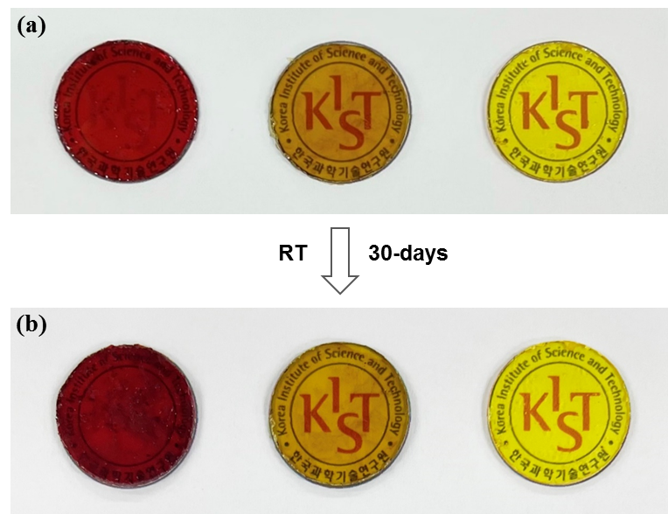
Figure S54. Photographs of S70-DIB30, S70-DVB30 and S70-BTT30 lenses (a) initial and (b) stored at room temperature for 30-days (from left to right).

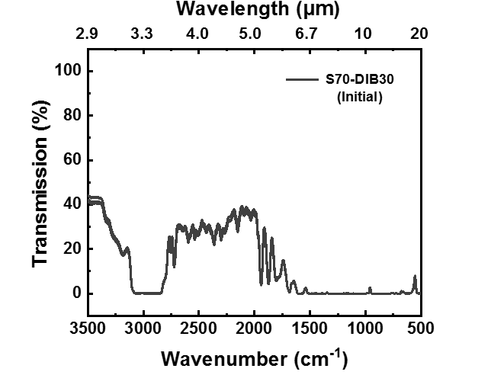
Figure S55. FT-IR transmission (%) spectra of the initial S70-DIB30 lens (5 measurements).

 | Transmission (%)
 | MWIR | LWIR
S70-DIB30  (Initial) | 20.96 | 0.08
S70-DIB30  (Initial) | 20.50 | 0.08
S70-DIB30  (Initial) | 21.76 | 0.08
S70-DIB30  (Initial) | 20.68 | 0.08
S70-DIB30  (Initial) | 21.89 | 0.09
Average | 21.16 | 0.08
Table S29. IR transmission (%) of the initial S70-DIB30 lens (thickness: 1.281 mm).

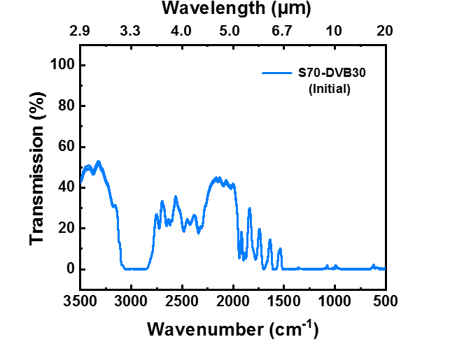
Figure S56. FT-IR transmission (%) spectra of the initial S70-DVB30 lens (5 measurements).

 | Transmission (%)
 | MWIR | LWIR
S70-DVB30  (Initial) | 24.23 | 0.33
S70-DVB30  (Initial) | 23.57 | 0.12
S70-DVB30  (Initial) | 23.75 | 0.30
S70-DVB30  (Initial) | 23.73 | 0.29
S70-DVB30  (Initial) | 23.57 | 0.17
Average | 23.77 | 0.24
Table S30. IR transmission (%) of the initial S70-DVB30 lens (thickness: 1.276 mm).

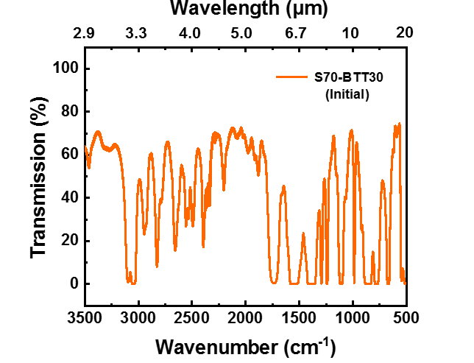
Figure S57. FT-IR transmission (%) spectra of the initial S70-BTT30 lens (5 measurements).

 | Transmission (%)
 | MWIR | LWIR
S70-BTT30  (Initial) | 47.04 | 26.47
S70-BTT30  (Initial) | 47.38 | 26.86
S70-BTT30  (Initial) | 47.20 | 26.62
S70-BTT30  (Initial) | 47.56 | 26.99
S70-BTT30  (Initial) | 48.02 | 27.23
Average | 47.44 | 26.83
Table S31. IR transmission (%) of the initial S70-BTT30 lens (thickness: 1.139 mm).

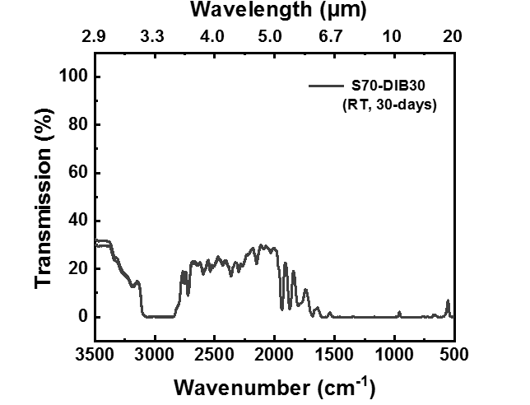
Figure S58. FT-IR transmission (%) spectra of 30-days room temperature storage S70-DIB30 lens (5 measurements).

 | Transmission (%)
 | MWIR | LWIR
S70-DIB30  (RT, 30 days) | 15.98 | 0.06
S70-DIB30  (RT, 30 days) | 15.97 | 0.06
S70-DIB30  (RT, 30 days) | 16.39 | 0.06
S70-DIB30  (RT, 30 days) | 16.38 | 0.06
S70-DIB30  (RT, 30 days) | 16.21 | 0.06
Average | 16.21 | 0.06
Table S32. IR transmission (%) of the S70-DIB30 lens stored at room temperature for 30-days (thickness: 1.281 mm).

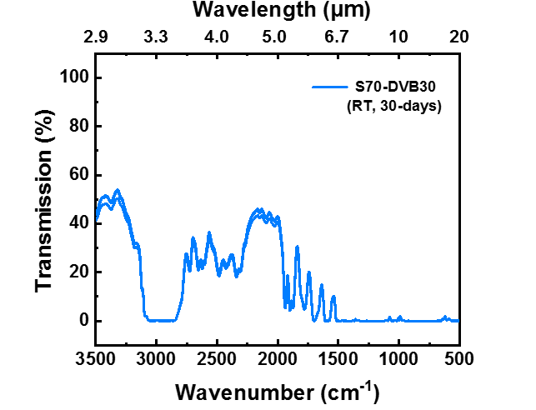
Figure S59. FT-IR transmission (%) spectra of 30-days room temperature storage S70-DVB30 lens (5 measurements).

 | Transmission (%)
 | MWIR | LWIR
S70-DVB30  (RT, 30 days) | 24.76 | 0.12
S70-DVB30  (RT, 30 days) | 23.37 | 0.12
S70-DVB30  (RT, 30 days) | 23.36 | 0.12
S70-DVB30  (RT, 30 days) | 24.80 | 0.11
S70-DVB30  (RT, 30 days) | 24.54 | 0.12
Average | 24.17 | 0.12
Table S33. IR transmission (%) of the S70-DVB30 lens stored at room temperature for 30-days (thickness: 1.276 mm).

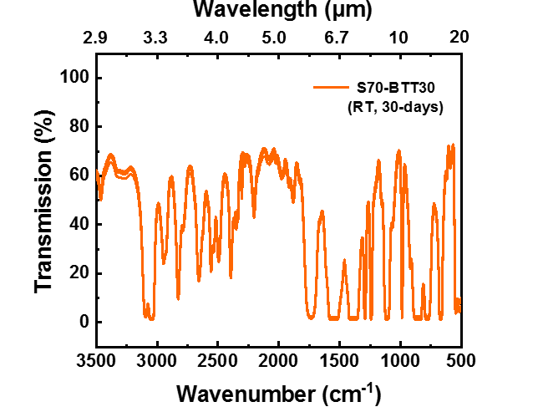
Figure S60. FT-IR transmission (%) spectra of 30-days room temperature storage S70-BTT30 lens (5 measurements).

 | Transmission (%)
 | MWIR | LWIR
S70-BTT30  (RT, 30 days) | 47.36 | 27.13
S70-BTT30  (RT, 30 days) | 46.51 | 26.59
S70-BTT30  (RT, 30 days) | 45.29 | 26.45
S70-BTT30  (RT, 30 days) | 46.47 | 27.11
S70-BTT30  (RT, 30 days) | 46.52 | 26.82
Average | 46.43 | 26.82
Table S34. IR transmission (%) of the S70-BTT30 lens stored at room temperature for 30-days (thickness: 1.139 mm).

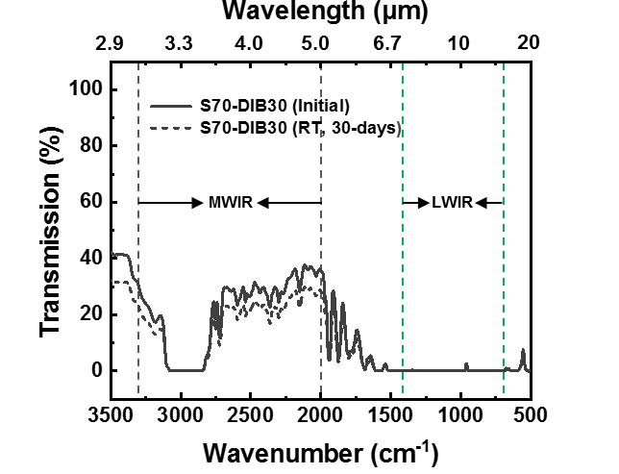
Figure S61. Average FT-IR transmission (%) spectra of initial and 30-days room temperature storage S70-DIB30 lens.

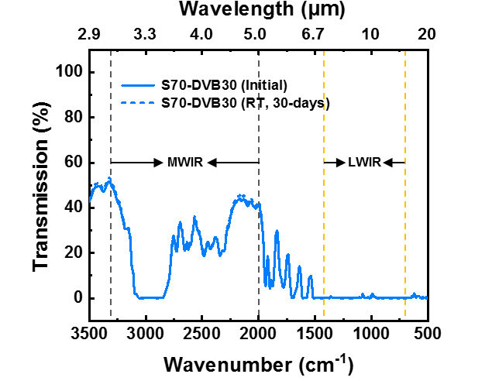
Figure S62. Average FT-IR transmission (%) spectra of initial and 30-days room temperature storage S70-DVB30 lens.
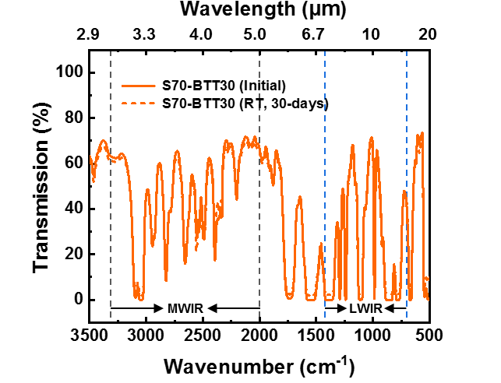
Figure S63. Average FT-IR transmission (%) spectra of initial and 30-days room temperature storage S70-BTT30 lens.

 | Thickness* (mm) | Transmission (%)
 | Thickness* (mm) | MWIR | LWIR
S70-DIB30 | 1.281 | 21.16 | 0.08
S70-DIB30 (RT, 30-days) | 1.281 | 16.21 | 0.06
S70-DVB30 | 1.276 | 23.77 | 0.24
S70-DVB30 (RT, 30-days) | 1.276 | 24.17 | 0.12
S70-BTT30 | 1.139 | 47.44 | 26.83
S70-BTT30 (RT, 30-days) | 1.139 | 46.43 | 26.82
Table S35. Average thickness and average IR transmission (%) of initial and 30-days room temperature storage S70-DIB30, S70-DVB30 and S70-BTT30 lenses.

*Average of 3 point measurements using an ABS Digital Thickness Gauge (MITUTOYO, Japan).

- Elemental analyzes of poly(S-r-BTT), poly(S₇₀-r-DIB₃₀) and poly(S₇₀-r-DVB₃₀) copolymers

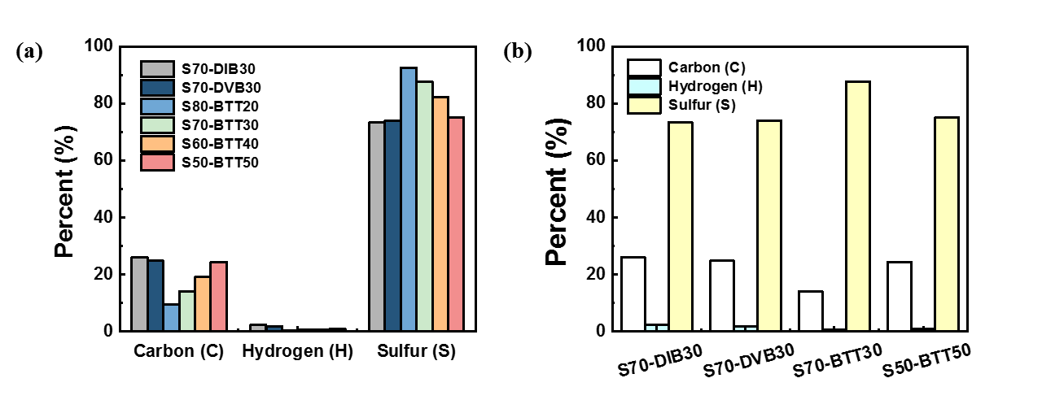
Figure S64. Elemental analysis of (a) S70-DIB30, S70-DVB30 and poly(S-r-BTT) copolymers for varying sulfur content, (b) S70-DIB30, S70-DVB30, S70-BTT30 and S50-BTT50.

 | Content (wt%) |  | Carbon (C) % | Hydrogen (H) % | Nitrogen (N) % | Sulfur (S) % | %
 | Sulfur | Comonomer
S70-DIB30 | 70 | 30 | 26.072 | 2.228 | 0.015 | 73.299 | 101.614
S70-DVB30 | 70 | 30 | 24.754 | 1.881 | 0.006 | 74.018 | 100.659
S80-BTT20 | 80 | 20 | 9.500 | 0.321 | 0.015 | 92.473 | 102.309
S70-BTT30 | 70 | 30 | 14.009 | 0.483 | 0.015 | 87.682 | 102.189
S60-BTT40 | 60 | 40 | 19.118 | 0.683 | 0.000 | 82.337 | 102.138
S50-BTT50 | 50 | 50 | 24.339 | 0.896 | 0.000 | 75.120 | 100.355
Table S36. Elemental analysis of the S70-DIB30, S70-DVB30 and poly(S-r-BTT) copolymers for varying sulfur content.

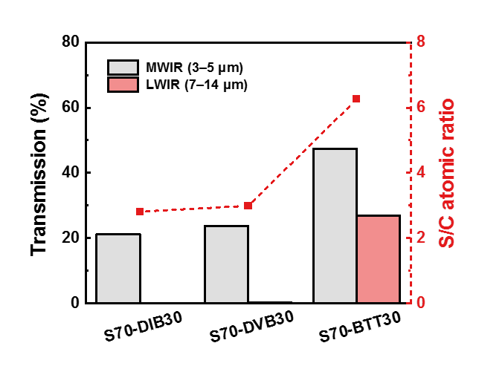
Figure S65. Average IR transmission (%) and S/C atomic ratio in the polymers as determined from elemental analysis.

 | Content (wt%) |  | Carbon (C) % | Hydrogen (H) % | Sulfur (S) % | S/C ratio
 | Sulfur | Comonomer
S70-DIB30 | 70 | 30 | 26.072 | 2.228 | 73.299 | 2.811
S70-DVB30 | 70 | 30 | 24.754 | 1.881 | 74.018 | 2.990
S70-BTT30 | 70 | 30 | 14.009 | 0.483 | 87.682 | 6.259
Table S37. Elemental analysis of the S70-DIB30, S70-DVB30 and S70-BTT30.

- Infrared (IR) imaging experiments

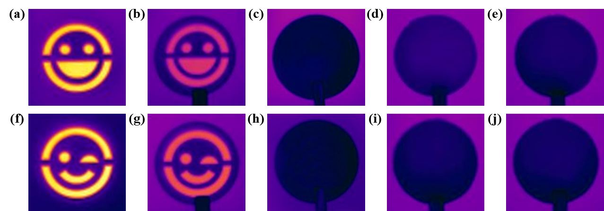
Figure S66. LWIR region images of various patterned PMMA mask through Ge and various polymer lenses (ca. 1 mm) (a)&(f) direct image (without lenses), (b)&(g) Ge, (c)&(h) PMMA (Poly(methyl methacrylate), (d)&(i) S70-DIB30 and (e)&(j) S70-DVB30.

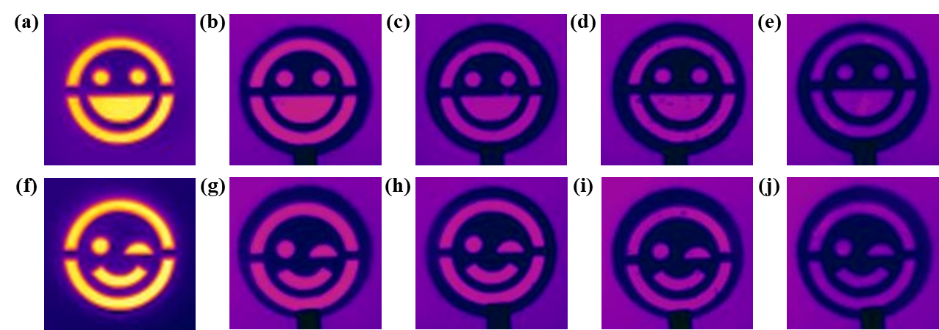
Figure S67. LWIR region images of various patterned PMMA mask through poly(S-r-BTT) lenses (ca. 1 mm) (a)&(f) direct image (without lenses), (b)&(g) S80-BTT20, (c)&(h) S70-BTT30, (d)&(i) S60-BTT40 and (e)&(j) S50-BTT50.

- References

- Han Y and Elliott J. Molecular dynamics simulations of the elastic properties of polymer/carbon nanotube composites. Comput Mater Sci. 39, 315-323 (2007).
- P. J. Flory, Molecular theory of rubber elasticity, Polymer, 20, 1317-1320 (1979).
- Darryl A. Boyd. et al. Optical Properties of a Sulfur-Rich Organically Modified Chalcogenide Polymer Synthesized via Inverse Vulcanization and Containing an Organometallic Comonomer. ACS Macro Lett. 8, 113-116 (2019).
- Tristan S. Kleine. et al. Infrared Fingerprint Engineering: A Molecular-Design Approach to Long-Wave Infrared Transparency with Polymeric Materials. Angew. Chem. Int. Ed. 58, 17656-17660 (2019).
- Tristan S. Kleine. et al. High Refractive Index Copolymers with Improved Thermomechanical Properties via the Inverse Vulcanization of Sulfur and 1,3,5-Triisopropenylbenzene. ACS Macro Lett. 5, 1152-1156 (2016).
- Sangwoo Park. et al. Inverse Vulcanization Polymers with Enhanced Thermal Properties via Divinylbenzene Homopolymerization-Assisted Cross-Linking. ACS Macro Lett. 8, 1670-1678 (2019).
- Jared J. et al. New Infrared Transmitting Material via Inverse Vulcanization of Elemental Sulfur to Prepare High Refractive Index Polymers. Adv. Mater. 26, 3014-3018 (2014).

