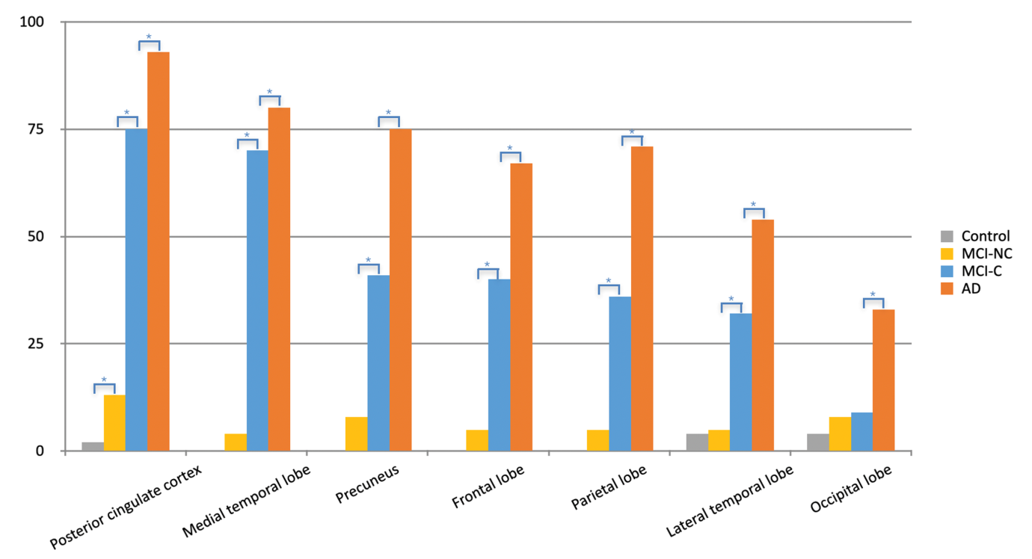
Supplementary Figure 1. Percentages of hypometabolism of seven preselected volume-of-interests in first visit FDG-PET among four groups. Hypometabolism was defined as having a Z score of < -2. * p < 0.05.
Abbreviations: MCI-NC, non-converter of mild cognitive impairment; MCI-C, converter of mild cognitive impairment; AD, Alzheimer’s disease.

Supplementary Table 1. Correlations between first visit FDG-PET Z scores and CASI
 | Mental manipulate | Attention | Orientation | Long-term memory | Short-term memory | Abstract thinking | Drawing | Verbal fluency | Language | Total score
AD
Frontal | .115 | .26 | .294 | .182 | .436** | .022 | .141 | .317* | .124 | .261
PCC | .423** | .517** | .622** | .364* | .648** | .115 | .486** | .464** | .496** | .585**
Precuneus | .353* | .447** | .473** | .342* | .527** | .076 | .420** | .432** | .409** | .487**
Parietal | .349* | .540** | .461** | .343* | .466** | .078 | .469** | .404** | .477** | .497**
Occipital | .388* | .509** | .457** | .365* | .431** | .058 | .549** | .352* | .512** | .504**
Lat. temporal | .438** | .520** | .534** | .460** | .577** | .214 | .442** | .470** | .566** | .588**
Med. temporal | .28 | .217 | .547** | .383* | .549** | .263 | .428** | .302 | .466** | .499**
MCI-C
Frontal | -.21 | -.036 | -.057 | -.167 | -.013 | -.049 | -.108 | .085 | -.062 | -.103
PCC | .155 | .204 | .376* | .101 | .225 | .182 | .222 | .312* | .208 | .351*
Precuneus | .013 | .033 | .073 | .015 | .046 | .06 | .035 | .22 | .151 | .104
Parietal | .007 | .066 | .145 | .107 | .173 | .183 | .129 | .16 | .16 | .191
Occipital | -.003 | -.03 | .083 | .075 | .126 | .093 | .016 | .158 | .098 | .111
Lat. temporal | .037 | .062 | .195 | .154 | .26 | .282 | .092 | .201 | .108 | .245
Med. temporal | -.142 | .001 | .123 | -.033 | .306* | .177 | -.075 | -.002 | .018 | .085
MCI-NC
Frontal | -.227 | -.253 | .178 | -.021 | .271 | -.105 | -.046 | -.001 | -.177 | -.017
PCC | -.004 | -.188 | .163 | .205 | .449** | .02 | .036 | .129 | -.103 | .173
Precuneus | -.027 | -.162 | .053 | .126 | .337* | -.041 | .034 | .087 | -.123 | .086
Parietal | -.006 | -.17 | .082 | .125 | .31 | -.089 | .063 | -.014 | -.102 | .071
Occipital | -.061 | -.167 | -.123 | -.021 | .099 | -.136 | .072 | -.151 | -.185 | -.098
Lat. temporal | .018 | -.214 | .076 | .078 | .257 | -.014 | .141 | -.014 | -.235 | .065
Med. temporal | .067 | -.321* | -.044 | .148 | .168 | .133 | .104 | -.126 | .009 | .052
Control
Frontal | .112 | -.185 | .017 | .25 | .054 | -.024 | -.103 | .292 | .289 | .176
PCC | -.109 | -.183 | -.164 | .12 | .009 | .024 | -.056 | .29 | .125 | .048
Precuneus | .05 | -.262 | -.022 | .156 | -.005 | -.088 | .032 | .297 | .179 | .097
Parietal | -.012 | -.249 | .014 | .229 | -.127 | -.223 | -.011 | .328 | .246 | .045
Occipital | .112 | -.246 | .064 | .285 | -.11 | -.227 | .041 | .402* | .255 | .133
Lat. temporal | .075 | -.174 | -.012 | .311 | .054 | -.155 | -.068 | .307 | .295 | .147
Med. temporal | .218 | -.037 | .153 | .284 | .291 | .159 | -.154 | .32 | .273 | .368*

Data represents correlation coefficient, adjusted for years of education. * p < 0.05; ** p < 0.01.
Abbreviations: MCI-NC, non-converter of mild cognitive impairment; MCI-C, converter of mild cognitive impairment; AD, Alzheimer’s disease; CASI, cognitive ability screening instrument; FDG-PET, fluorodeoxyglucose positron emission tomography; PCC, posterior cingulate cortex; Lat. temporal, lateral temporal; Med. temporal, medial temporal.

Supplementary Table 2. Comparisons between two MCI groups in the first six consecutive cognitive tests
Case numbers | Total (n=82) | MCI-NC (n=38) | MCI-C (n=44) | P value
Serial age
age at 1st test | 70.73±7.48 | 69.42±7.46 | 71.86±7.39 | .117
age at 2nd test | 71.73±7.59 | 70.34±7.50 | 72.93±7.55 | .105
age at 3rd test | 72.79±7.74 | 71.24±7.77 | 73.95±7.59 | .115
age at 4th test | 73.68±7.60 | 71.90±7.44 | 74.95±7.54 | .078
age at 5th test | 74.61±7.66 | 72.41±7.20 | 76.17±7.67 | .033*
age at 6th test | 75.89±7.86 | 74.00±7.59 | 77.11±7.89 | .098
Serial MMSE
MMSE¹ (n=82) | 22.61±4.06 | 23.50±4.36 | 21.84±3.66 | .019*
MMSE² (n=82) | 22.00±4.18 | 22.71±4.41 | 21.39±3.91 | .116
MMSE³ (n=77) | 21.26±4.59 | 22.79±4.19 | 20.11±4.58 | .003**
MMSE⁴ (n=74) | 20.49±5.50 | 22.39±4.77 | 19.12±5.63 | .006**
MMSE⁵ (n=70) | 19.94±5.71 | 22.38±4.62 | 18.22±5.83 | .001**
MMSE⁶ (n=61) | 19.10±6.24 | 21.96±5.98 | 17.24±5.76 | .003**
Difference of MMSE
MMSE²-MMSE¹(n=82) | -0.61±2.42 | -0.79±2.61 | -0.45±2.26 | .851
MMSE³-MMSE¹ (n=77) | -1.13±2.95 | -0.33±2.90 | -1.73±2.87 | .067
MMSE⁴-MMSE¹ (n=74) | -1.82±4.21 | -0.68±3.40 | -2.65±4.57 | .117
MMSE⁵-MMSE¹ (n=70) | -2.37±4.00 | -0.97±2.98 | -3.37±4.35 | .025*
MMSE⁶-MMSE¹ (n=61) | -3.11±5.03 | -0.83±4.67 | -4.59±4.75 | .003**
Serial CDR
CDR¹ (n=82) | 0.52±0.17 | 0.50±0.16 | 0.53±0.17 | .354
CDR² (n=82) | 0.52±0.18 | 0.47±0.20 | 0.56±0.16 | .043*
CDR³ (n=77) | 0.56±0.19 | 0.53±0.17 | 0.59±0.20 | .169
CDR⁴ (n=74) | 0.64±0.28 | 0.56±0.21 | 0.70±0.31 | .048*
CDR⁵ (n=70) | 0.70±0.37 | 0.60±0.25 | 0.77±0.42 | .110
CDR⁶ (n=61) | 0.77±0.37 | 0.69±0.36 | 0.82±0.38 | .070
Serial CASI
CASI¹ (n=82) | 76.24±13.01 | 77.84±13.91 | 74.85±12.17 | .110
CASI² (n=81) | 74.96±13.23 | 76.22±14.69 | 73.90±11.94 | .350
CASI³ (n=75) | 73.77±15.81 | 79.02±14.06 | 69.87±16.05 | .006**
CASI⁴ (n=72) | 69.80±17.70 | 76.02±13.73 | 65.60±18.95 | .011*
CASI⁵ (n=66) | 65.60±20.96 | 75.60±16.64 | 59.11±21.10 | .001**
CASI⁶ (n=59) | 61.98±21.23 | 71.49±18.71 | 56.33±20.83 | .002**
Difference of CASI
CASI²-CASI¹ (n=81) | -1.21±7.81 | -1.51±9.45 | -0.95±6.21 | .898
CASI³-CASI¹ (n=75) | -1.85±10.11 | 2.08±9.26 | -4.77±9.82 | .002**
CASI⁴-CASI¹ (n=72) | -6.01±12.55 | -1.51±9.15 | -9.04±13.68 | .021*
CASI⁵-CASI¹ (n=66) | -9.99±14.51 | -2.08±12.00 | -15.12±13.79 | <.001***
CASI⁶-CASI¹ (n=59) | -13.66±15.30 | -5.97±13.29 | -18.24±14.72 | .001**

Data represents mean ± standard deviations; Mann-Whitney test for continuous variables (MMSE, CASI), Fisher’s exact test for category variables (CDR). Superscript of number following test score represents the time of measurement. * p < 0.05; ** p < 0.01; *** p < 0.001
Abbreviations: MCI-NC, non-converter of mild cognitive impairment; MCI-C, converter of mild cognitive impairment; MMSE, mini-mental state examination; CDR, clinical dementia rating; CASI: cognitive ability screening instrument total scores.

