Supplementary Information

Close-to-Atom Scale Laser Manufacturing for 30-Color Turn-Key Single-Photon Emitters
Xiao-Jie Wang¹, Hong-Hua Fang¹*, Zhen-Ze Li², Dan Wang², Hong-Bo Sun^{1,2}*

¹ State Key Laboratory of Precision Measurement Technology and Instruments, Department of Precision Instrument, Tsinghua University, Beijing, 100084, China
² State Key Laboratory of Integrated Optoelectronics, College of Electronic Science and Engineering, Jilin University, 2699 Qianjin Street, Changchun, 130012, China

Supplementary Notes
Supplementary Note 1. The physical limit of determinism and precision
  - The traditional description of laser ablation under the continuous medium hypothesis
In this section, we first review the physical description of the laser ablation process under the continuous medium hypothesis. In the typical experimental studies of the ultrafast laser-matter interaction,^{1, 2} the laser damage threshold is usually associated with the specific light energy flux $F_{th}$, as it determines the energy absorbed per unit area and ultimately leads to ultrafast heating of the electron/lattice system. One of the most famous equations describing this process is the two-temperature model³:
$C_{e}\frac{∂T_{e}}{∂t} = ∇ (k_{e}∇T_{e})-G_{el}(T_{e}-T_{l})+A$ (1)
$C_{l}\frac{∂T_{l}}{∂t} = G_{el}(T_{e}-T_{l})$ (2)
Where $C_{e}$ and $C_{l}$ in the equation represent the heat capacities of the electronic system and lattice system, respectively, $k_{e}$ is the thermal conductivity of the electron, and $G_{el}$ is the electro-acoustic coupling coefficient.
Although the mechanism of laser damage to materials can be divided into many types, such as Coulomb explosion and thermal ablation/evaporation. These damage thresholds can be measured using a parameter critical temperature, $T_{cr}$, of a particular electron/lattice system. That is when the system reaches a critical temperature, the total energy absorbed by the system exceeds the critical value that triggers a particular damage mechanism. Considering that Gaussian beam with A ∝ $e^{-βr^{2}}$ is usually used in machining, the damaged area of the ideal laser machining should be at the geometric center of the laser focus spot, and the radius of the damaged area will decrease rapidly as the laser energy gradually approaches the threshold $F_{th}$.

  - The statistical (thermodynamics) description of laser-matter interaction
The above theory implies that the radius of an area damaged by a laser can be continuously reduced to the level of a single atom. However, the assumptions underlying the above discussion will fail when it goes to the single-atom scale. This assertion is based on the following considerations: it becomes undefined when the laser energy is highly close to the so-called laser processing threshold. It is known from statistical physics that the relative average fluctuation grows up as the average number of microscopic particles goes to zero in an open system. The relative error in measuring the ablation threshold for a decreasing number of ablated atoms will increase. Therefore, the threshold for a single atom ablation is not a physically determinate value. In the case of the femtosecond laser-matter interaction, a laser-excited atom lattice remains intact, i.e., the macroscopic atomic motion could be neglected. An atom could be removed from a solid (ablated) if it receives energy above the binding energy, $ε_{b}$. Despite it is possible to choose a low enough energy theoretically to obtain $P\left(E≥ϵ_{b}\right) \sim 1/N_{0}$ to realize single-atom processing. However, according to statistical thermodynamics, the ablated atom must be randomly localized within the laser spot, even when the laser spot is spatially uniform. Thus, the position precision suffers an uncertainty limit. The uncertainty limit originates from the quiver energy acquired from the light field and thermodynamics. It can be described by using a minimum machining radius $r_{m}$, in which range the atomic ablation occurs, as discussed below.
In ultrafast laser ablation, the target material absorbs more photons than the minimum number required for photoionization. The free carrier could obtain quiver kinetic energy from an oscillating electric field of the light field, according to:
$K\left(t\right)=K\left(t_{0}\right)-\frac{e}{ℏ}\int{F(t')dt'}$ (3)
where $K\left(t_{0}\right)$ is central crystal momentum, describing the carrier’s initial state; the second term represents the kinetic momentum of a free electron in an external electric field.
In the approximation of purely intraband motion, the electron's energy is periodically changed by the oscillating electric field. The cycled-average energy of intraband motion is called Pondermotive energy and can be described by the following equation:^{4, 5}

$U^{n}\left(k\right)= \frac{1}{T_{0}}\int_{0}^{T_{0}}{[E_{n}\left(K\left(t\right)\right)-E_{n}\left(k\right)]}dt$ (4)
where n is the energy band index, $T_{0}$ is the oscillation period of the laser field with the main frequency ω. In the effective mass approximation, the ponderomotive energy of an electron-hole pair can be expressed as follows:
$U\left(k\right)=U= \frac{e^{2}E_{0}^{2}}{4μω_{0}^{2}}$ (5)
$μ$ is the effective mass, E₀ is the amplitude of the oscillating electric field, and ω₀ is the frequency of the light field. Note that atomic ionization processes are mainly produced near the maximum amplitude of the electric field. In the view of thermodynamics, kinetic energy can be described as temperature. The equipartition theorem tells us that the average kinetic energy is $E_{kin}=\frac{3k_{B}T}{2}$ for a carrier and the specific heat for the system from the laser is $C_{V}=\frac{3k_{B}N}{2}$. The fluctuation of the system temperature can be expressed as: ${∆E}_{kin}$=$\sqrt{\frac{2}{3N}}E_{kin}$. N is the number of free carriers in the photoexcitation region. In the case of an ideal Gaussian beam focusing, the ponderomotive energy provides an initial gradient of the energy for ionization and defines the atomic ionization region spatially. However, when the laser intensity is reduced to a critical level close to the threshold, the number of excited electrons N is greatly reduced and mainly located at the spot center. The kinetic energy fluctuations ${∆E}_{kin}$ of the system will be comparable with the additional Energy provided by Pondermotive motion $U$. When ${∆E}_{kin}/U$ ~ 1, we get the photon ablation uncertainty limit:
$r_{m}$ ~ $\sqrt{\frac{2}{3πρ}}\frac{{\overline{E}}_{kin}}{U}$ (6)
where $ρ$ is the carrier density per unit area, and $ρ_{cr}=ϵ_{0}μω^{2}/e^{2}$ is usually required for ultrafast laser ablation. For the single crystal of hBN, we consider $ρ$ ~ $0.1ρ_{cr}$, ${\overline{E}}_{kin}$~1 eV, and $μ$ ~ 0.6. Therefore, we have $r_{m}$ ~ 3 nm, which is consistent with the experimental results.

Supplementary Note 2. Laser writing threshold tracking in hBN crystal
Firstly, we perform the laser writing experiments as a function of the number of applied pulses and laser energy. The laser fabrication process of the sample is in situ monitored by a microscope (50× objective, NA 0.95) allowing for visualization of its surface. Supplementary Fig. 3 shows a typical optical image of laser-produced matrices of 54 (6 × 9) in hBN taken by a CCD camera (Pixel size: 5.3 μm) in monochrome mode. The images are systematically normalized and binarized to avoid issues caused by different observer interpretations. The laser energy decreases laterally and the number of applied pulses increases longitudinally. We observe that the pulse number impacts the spot size significantly when the number is justly varied from one to three. From the optical image, the damage caused by the first pulse was not observable in the camera when laser energy was lower than 4.84 nJ. It became visible when the craters were produced with two at the same laser energy. Three pulses are required when laser energy is lowered to 4.62 nJ. When the energy is below 4.60 nJ, no visible damage was observed even with multiple pulses. In this method, we can determine the laser energy (E_{th0}) for close-to-atom scale optical breakdown.
To further investigate the pulse number and laser energy effect on the size of the laser-produced spot. We repeated producing matrix and characterized finer features with TEM microscopy. Supplementary Fig. 4a shows a TEM image of the morphology of laser-induced modification in hBN flakes. From left to right, the pulse energy was increased from 4.66 nJ to 4.90 nJ. Each vertical axis of the grids was created with the same pulse energy but with varied pulse numbers from one to three, as marked in the image. As illustrated, the feature size is strongly dependent on the pulse numbers. A nanoscale lattice breakdown with a size of less than 10 nm (~ 6 nm) is induced by a single pulse with an energy of 4.66 nJ, as presented in higher magnification (Supplementary Fig. 4b). The laser-induced size is increased to be more than 30 nm with two pulses, (Supplementary Fig. 4d) and larger than 200 nm with three pulses. The sequent pulses irradiation will lead to an enlarged written void and induce uncontrolled cracks, which could be observed under an optical microscope. These findings enable us to push writing resolution to the physical limits of optical damage.
The TEM image in Supplementary Fig. 5 shows a typical laser-modified range with single pulse writing. We used the near-threshold energy E_{p} at 0.5% above E_{th0} to write the color center in hBN. The size distributes from 3-8 nm. The single pulse energy stability we measured shows a standard deviation (SD, so-called RMS stability) of approximately 0.3% (Supplementary Fig. 6).

Supplementary Note 3. Photophysics of single photon emitters
3.1 Statistics of the distributions of saturation intensity
To evaluate the brightness of laser-created quantum emitters, we recorded their PL intensity as a function of incident laser power and fitted experimental data using a model: I=I_{sat} P/(P+P_{sat}), where I (I_{sat}) and P (P_{sat}) are the PL intensity (saturation intensity) and laser power (saturation power), respectively. The representative data and fitting curves are shown in Supplementary Fig. 16. Supplementary Fig. 17a shows statistics of the distributions of saturation intensity with respect to emission wavelength. The saturation intensity of more than 80% of emitters exceeds 5 Mcounts s⁻¹ and nearly 15% exceeds 10 Mcounts s⁻¹, as shown in Supplementary Fig. 17b. A wide range of emitter intensities are observed in our experiments. This may arise from different light absorption capacities or radiation modes, including non-radiative means to certain lower energy radiation states or to other defects.

3.2 Stability of an individual single-photon emitter
Another key property of emitters is their optical stability. Supplementary Fig. 20 shows the time-series spectra mapping over 5 minutes for part of the emitters. No spectral diffusion or intensity fluctuation was observed. We have tested 200 emitters, of which 188 emitters (94%) showed neglected wavelength diffusion and intensity fluctuation. We also record the time trace of intensity with a binning time of 50 ms acquired by APD, during which no blinking or bleaching occurred, as shown in Supplementary Fig. 21. In addition, the single emitters exhibit nearly perfect stability under ambient conditions. We didn’t find emission intensity degradation after storage on the shelf for more than half a year. These results show the superiority of close-atom-scale manufacturing by single laser pulse for inducing spectral-stable QEs.

3.3 Statistics ZPL Linewidth distribution
The PL linewidth of hundreds of SPEs was extracted by fitting spectra with a single Lorentz fitting. As shown in Supplementary Fig. 18b, approximately 95% of the laser-written SPEs exhibit line widths smaller than 10 nm, 75% less than 6 nm, and 35% less than 4 nm at room temperature. The narrowed linewidth can be attributed to the small writing size with minimal residual lattice damage, which particularly reduces charge noise in the surrounding environment. Spectroscopy on single photon emitters has been performed also at cryogenic temperature. The minimum linewidth of the ZPL emission measured at cryogenic temperature is reduced to be less than 0.2 nm, as shown in Supplementary Fig. 19.

3.4 g²(t) of the single-photon emitters
Supplementary Fig. 15 shows the photon antibunching g²(0) statistics data obtained at room temperature. Photon correlation measurements were performed on more than 150 emitters. 83% of emitters are below 0.3, 56% below 0.2, and 5% below 0.1. It is noted that these measurements were conducted without background correction. The g²(0) value may be affected by the dark noise of the single-photon detector and disturbances in the surrounding environment. The emission of single photon in a solid-state defect system can be explained theoretically by a two-level model. However, these defect centers could be disturbed by the surrounding dielectric environment, which may introduce an intermediate level to participate in optical transitions. In our case, a three-level system was used to analyze the hBN quantum emitter, as shown in Supplementary Fig. 12b.
The antibunching curves of these emitters were fitted by the following equation:
g²(t)$=1-a{ e}^{-\frac{\left|t\right|}{τ_{1}}}+b { e}^{-\frac{\left|t\right|}{τ_{2}}}$
where parameters $τ_{1}$ and $τ_{2}$ are lifetimes of the excited and meta-stable states, respectively. We performed statistics of the $τ_{1}$ and $τ_{2}$ extracted by a fitted curve. The $τ_{1}$ value is 1~5 ns, while $τ_{2}$ value is 10~50 ns.

Supplementary Note 4. The influence of the environment on laser-processed defects
To verify whether air atmosphere plays a role in the formation of single-photon emitters. We performed the laser writing experiments in a controlled environment. A custom-enclosed chamber with vacuum or filled with nitrogen was used for the controlled environment, as shown in Supplementary Fig. 22a. A long-distance infinity-corrected objective with a numerical aperture of 0.6 (40× Nikons) was used to focus the laser beam. Then the samples were annealed with the same procedure as described in the methods. Supplementary Fig. 22b and Supplementary Fig. 22c show confocal PL mapping of laser-written regions in vacuum and nitrogen atmosphere, respectively. We find that bright luminescent defects could be created in either vacuum or nitrogen atmosphere. We did not observe a significant difference in the photophysical properties of emitters from that of air conditions. Supplementary Fig. 22d shows the typical spectra of emitters produced in vacuum and nitrogen atmosphere, both show sharp ZPL emission peaks with low fluorescence backgrounds. Supplementary Fig. 22e shows their corresponding autocorrelation curves g²(t). All autocorrelation curves show that g²(0) < 0.5.

Supplementary Note 5. The origin of single-photon emitters
The origins of single-photon emitters in hBN have been intensively under investigation theoretically and experimentally. We have compared the emission wavelength to the results reported in the literature. The wide span of the emission energy has been attributed to the different defect types including boron and nitrogen vacancies, atom impurities such as oxygen, carbon, silicon, or different charge states of the defect, or defects complexes, donor-accepter pair. Supplementary Fig. 24 summarizes the wavelength and possible defects reported in the literature.⁶⁻¹⁴

Supplementary Note 6. Optical properties of the emitter from high-power laser writing condition
The laser-ablated morphology plays a critical role in the emission properties of emitters. We have produced a group of spots with a laser energy of 6.8 nJ. The average lateral sizes of the laser-induced defect patterns are around 1 μm. The pulses cause ablation at the center of the laser beam and leave a hole at each laser-written spot. Supplementary Fig. 25a presents a fluorescence image of the pattern. The emitters are mostly observed at the edge of the hole. As shown in Supplementary Fig. 25b, the typical spectra display a broad linewidth and low emission intensity. Under the same condition of photoluminescence excitation, PL intensity from these large-sized defects is much lower in comparison to the sites where the laser energy is well controlled. And only a few sites exhibit quantum emission. In addition, these emitters created by high-energy pulses exhibited poor stability such as blinking and bleaching. We attribute these effects to the fact that the extra pulse or excessive pulse energy causes severe damage to the lattice, leading to a low creation yield of single-photon emitters.

Supplementary Note 7. Assembly and performance of compactly integrated turn-key monochromatic single-photon emitters.
Supplementary Fig. 26 shows the integration process of a compactly integrated turn-key monochromatic single-photon light-emitting device. The laser-fabricated single-photon emitter was pre-characterized and labeled for integration. A plano-convex lens with a diameter of 1 mm, and a focal length of 0.6 mm, is used as light condensation for excitation. The laser diode emission wavelength is 450 nm. A transition stage is used for the three-dimension adjustment and alignment of the single-photon emitter and laser focus spot. Once the laser focus is positioned on the site of the pre-selected quantum emitter, the quartz substrate and lens are bonded by the photoresist of NOA61 with UV light irradiation. Supplementary Fig. 27 shows the lens for the excitation light condensing and the optical image of the focused spot on the hBN flake. Typical spectra and antibunching measurements taken from representative single photon emitters from the integrated device are presented in Supplementary Fig. 28.

Supplementary Figures

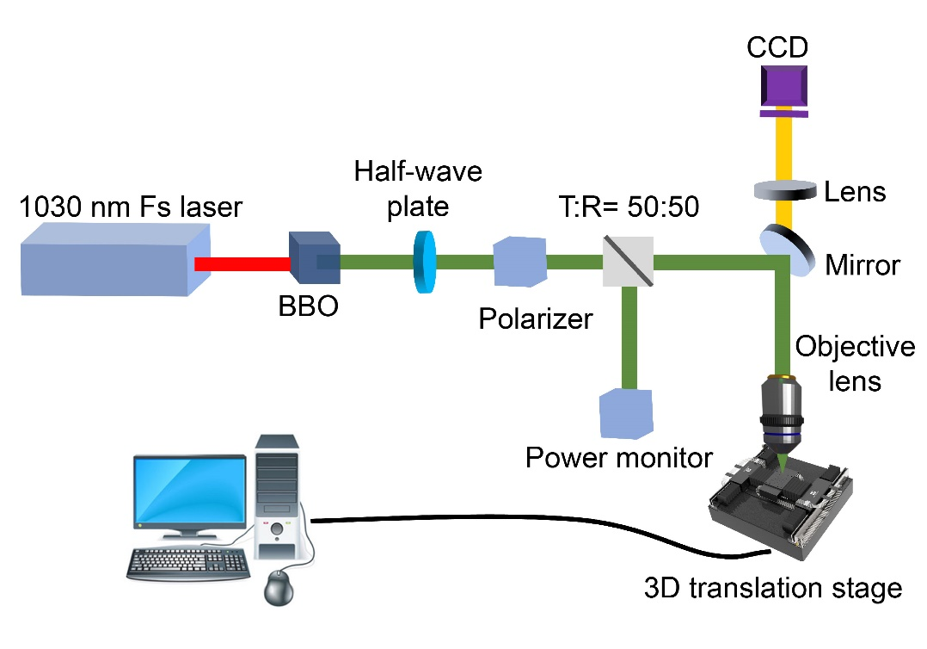
Supplementary Fig. 1| Schematic of the setup for ultrafast laser direct writing. A Yb:KGW amplifier at a wavelength of 1030 nm is used as the light source. 515 nm laser is produced by the second-harmonic generation of 1030 nm using (beta-BaB₂O₄) crystal. Pulse energy is controlled using a combination of a half-wave plate and a polarizer. The beam splitter (50/50 splitting ratio) is inserted, and the laser pulse is monitored by a photodetector.

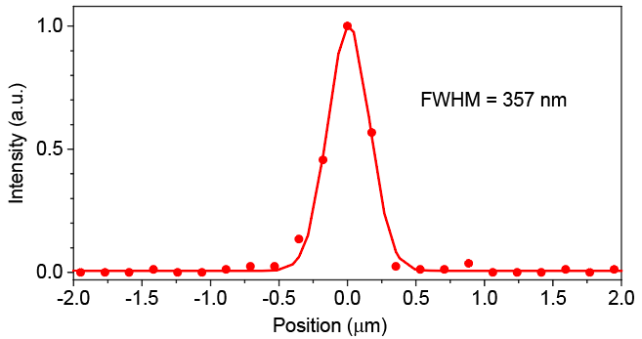
Supplementary Fig. 2| The Line profile of the focal spot of the 515 nm femtosecond laser. The circle and the solid traces are the experimental data and a Gaussian fit, respectively.

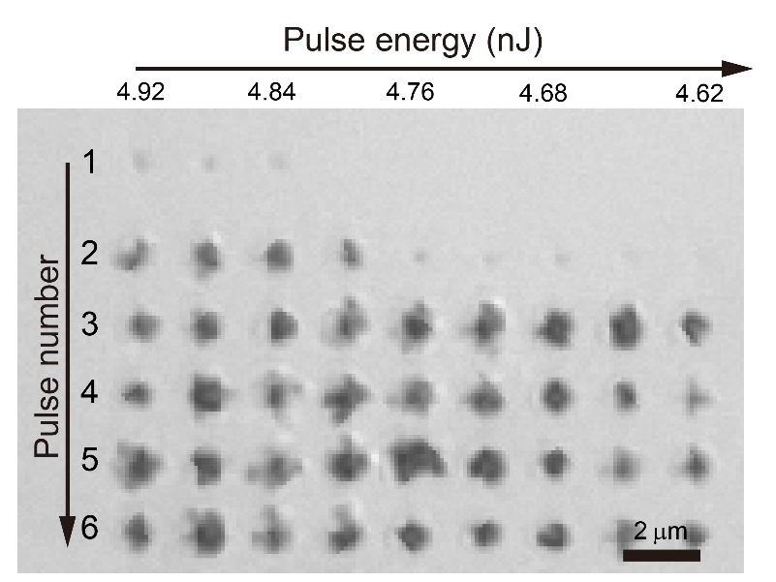
Supplementary Fig. 3| Optical image of laser-written hBN flakes. The number of pulses and the pulse energy have marked in the image. (The thickness of the hBN flake is ~70 nm)

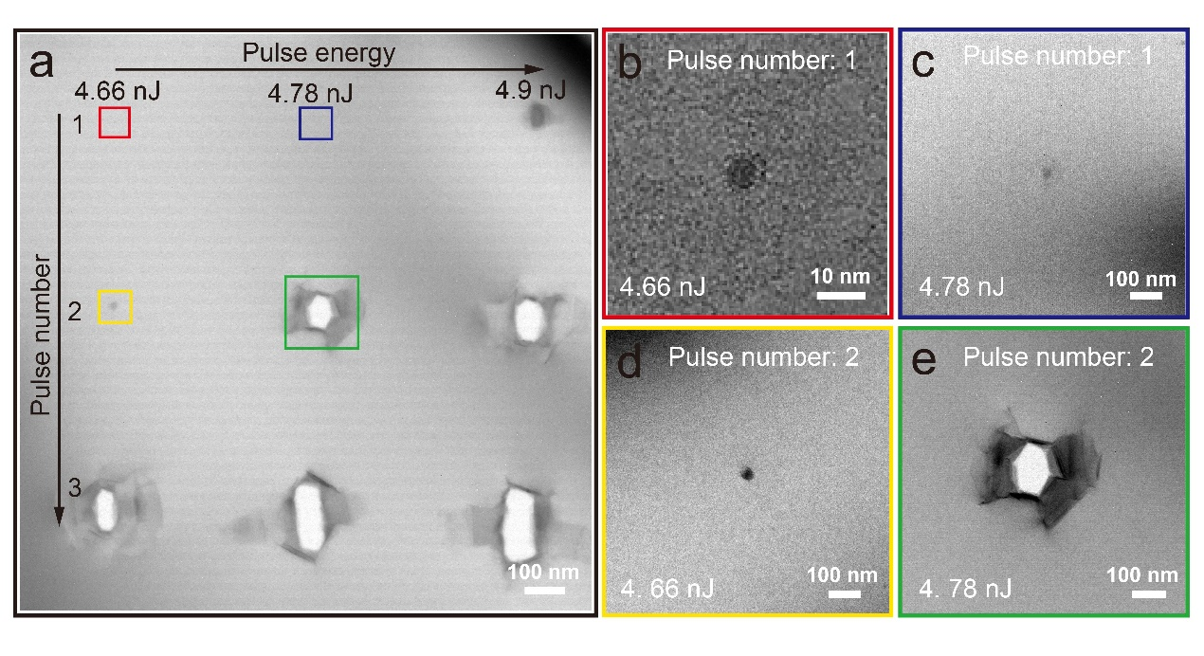
Supplementary Fig. 4| TEM images of laser-induced lattice modification. a, The number of pulses and the pulse energy increase longitudinally and laterally, respectively, as marked in the image. b-c, TEM image of single-pulse induced hBN morphology with pulse energy of 4.66 nJ and 4.78 nJ; d-e, TEM image of two-pulses induced hBN morphology with pulse energy of 4.66 nJ and 4.78 nJ.

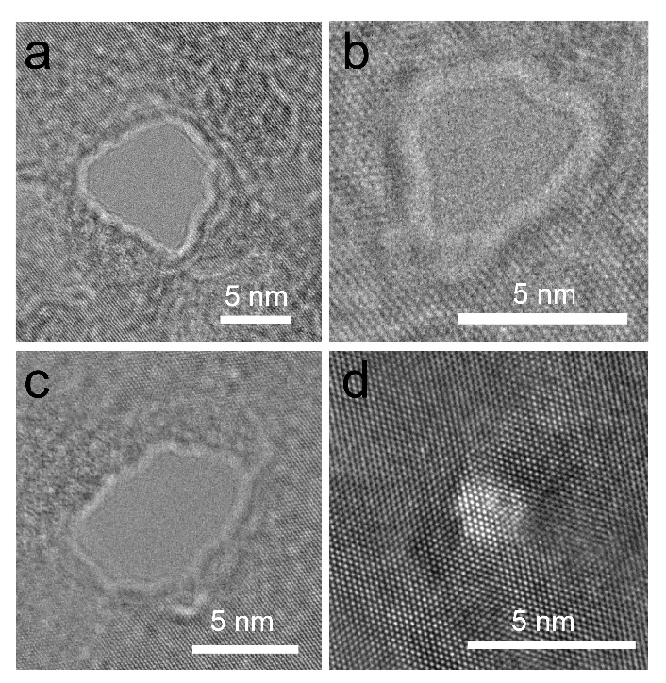
Supplementary Fig. 5| TEM images of laser-induced nanoscale damage.

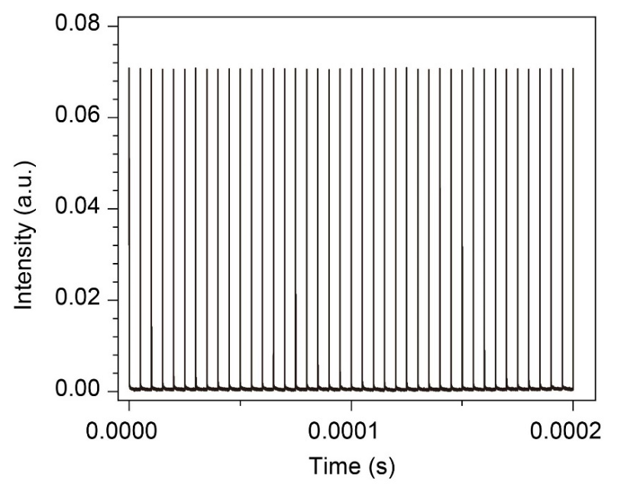
Supplementary Fig. 6| Fluctuations of laser energy from pulse to pulse. (RMS $≈$ 0.3 %)

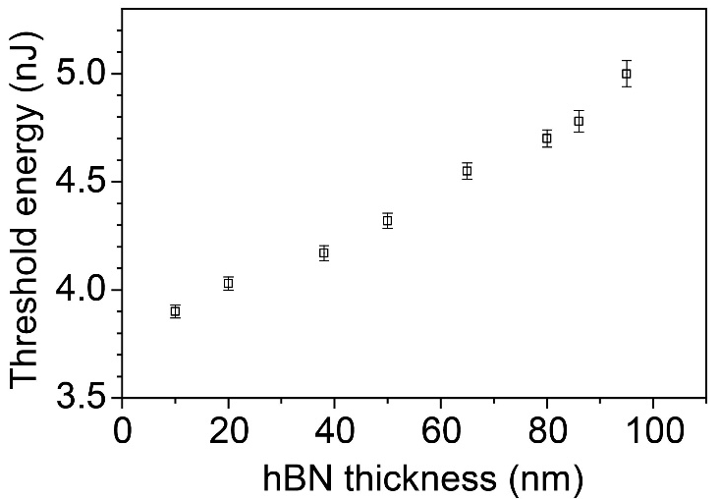
Supplementary Fig. 7| Laser threshold energy for hBN breakdown as a function of hBN thickness.

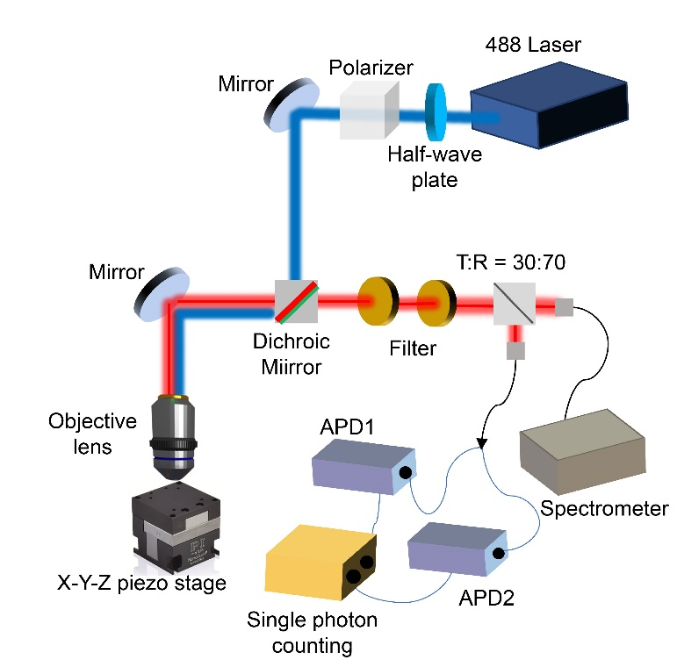
Supplementary Fig. 8| Optical measurement confocal microscopy setup. In the excitation path, a continuous wave (CW) 488 nm laser is focused on the sample after passing through the image relay system. In the detection path, the fluorescence photons are routed through a beam splitter toward the APDs or the spectrometer.

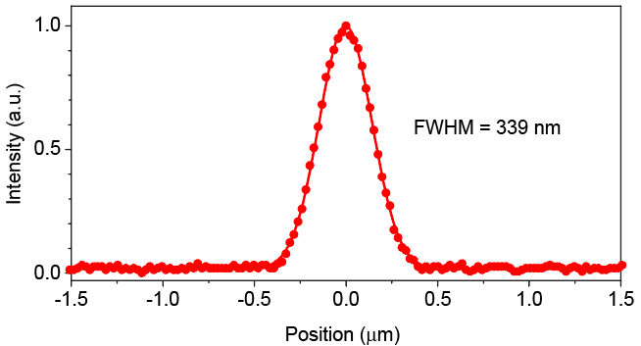
Supplementary Fig. 9| The Line profile of the focal spot of the 488 nm CW excitation laser. The circle and the solid traces are the experimental data and a Gaussian fit, respectively.

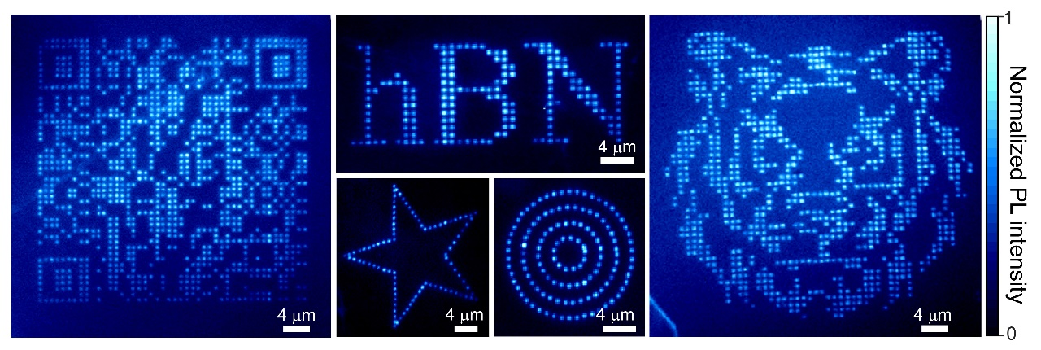
Supplementary Fig. 10| The fluorescence image of large-scale single photon emitters array created by femtosecond laser writing. (Writing energy: E_{p} = (1+5%) E_{th0} ≈ 5.2 nJ)

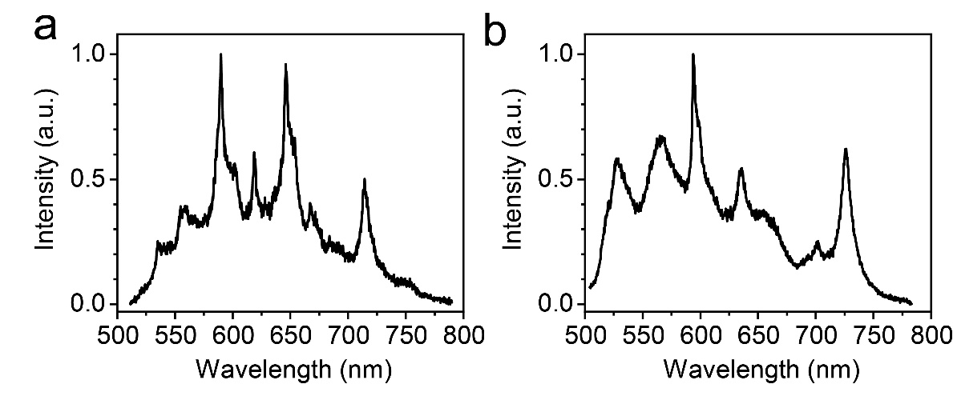
Supplementary Fig. 11| Representative PL spectra with multiple sharp emission peaks. (Writing energy: E_{p} = (1+5%) E_{th0} ≈ 5.2 nJ)

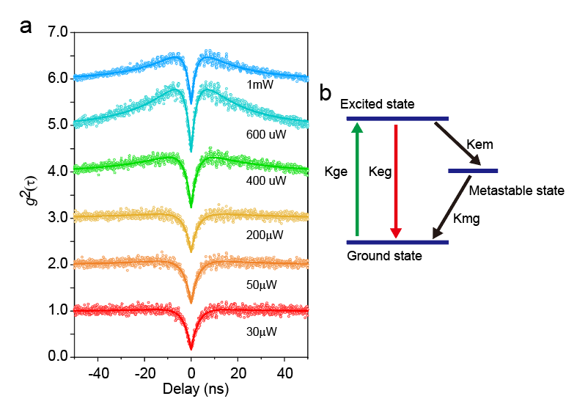
Supplementary Fig. 12| Second-order correlation functions as a function of pump power. a, Second-order autocorrelation function obtained different laser power. The pump power goes from 30 μW to 1000 μW. For the sake of visibility, the graphs are shown with an offset; b, The autocorrelation functions at high excitation power exhibit the typical shape of a three-level single photon emitter with the presence of a long-lived metastable state. A schematic diagram of a three-level model is used to describe the transition states of the emitters.

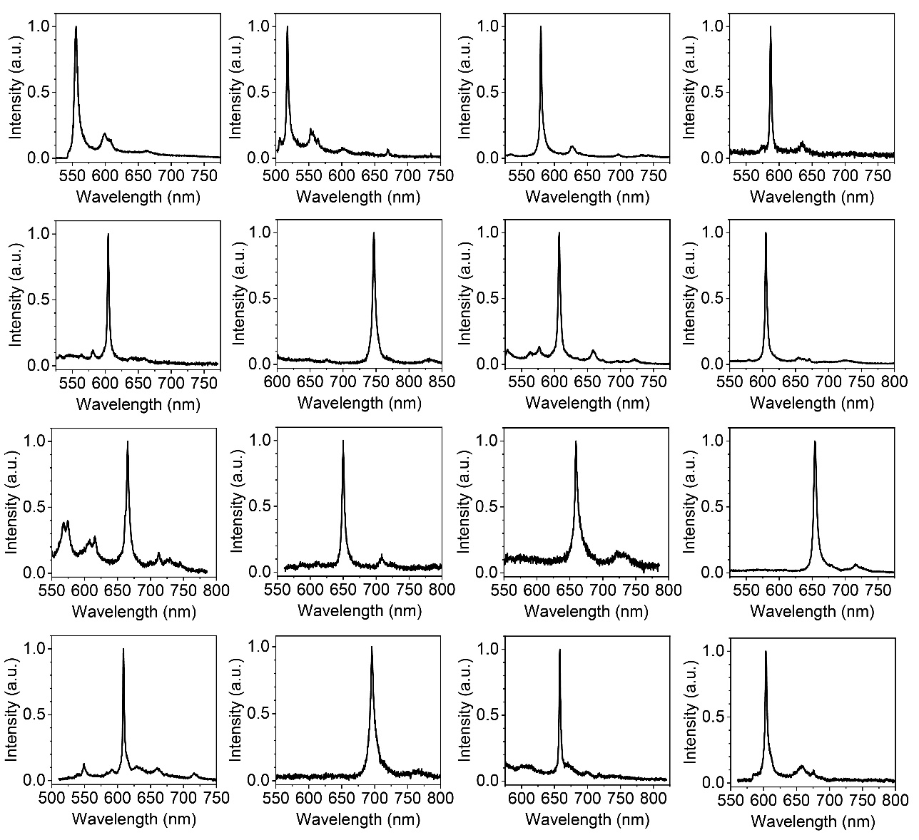
Supplementary Fig. 13| The spectra of laser-written SPEs pattern in Figure 3a. Each curve was acquired for 2s using a 250 μW, 488 nm CW laser as the excitation source.

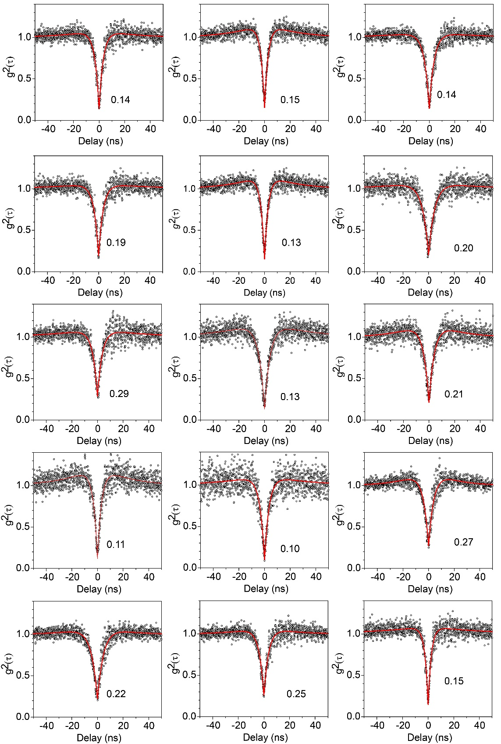
Supplementary Fig. 14| Antibunching curves from other laser-written QEs. The g²(0) value is marked for each emitter.

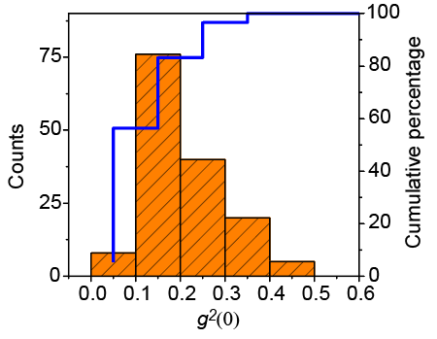
Supplementary Fig. 15| Histogram of the g²(0) value of nearly 150 emitters.

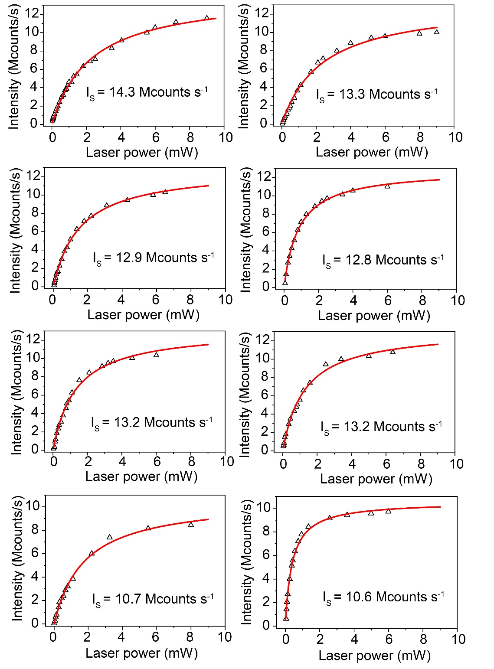
Supplementary Fig. 16| Fluorescence saturation curve of typical SPEs. The saturation intensity has been marked for each curve.
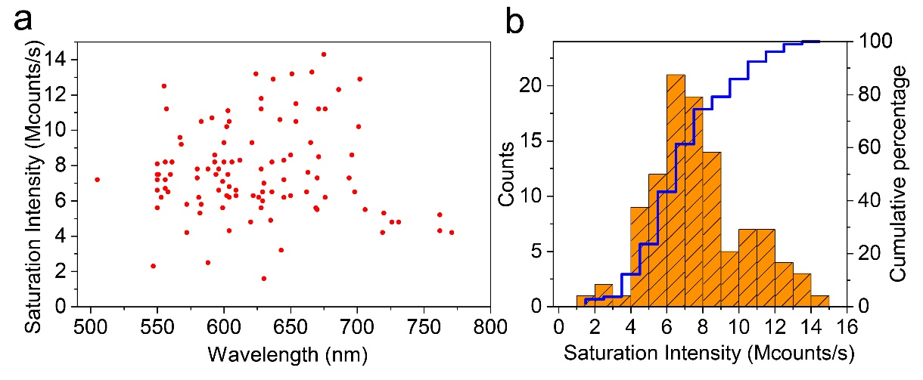
Supplementary Fig. 17| Statistics of the distributions of saturation intensity of above 100 emitters. a, Distribution of ZPL vs saturation intensity from laser written quantum emitters; b, Histogram of saturation intensity and cumulative percentage.

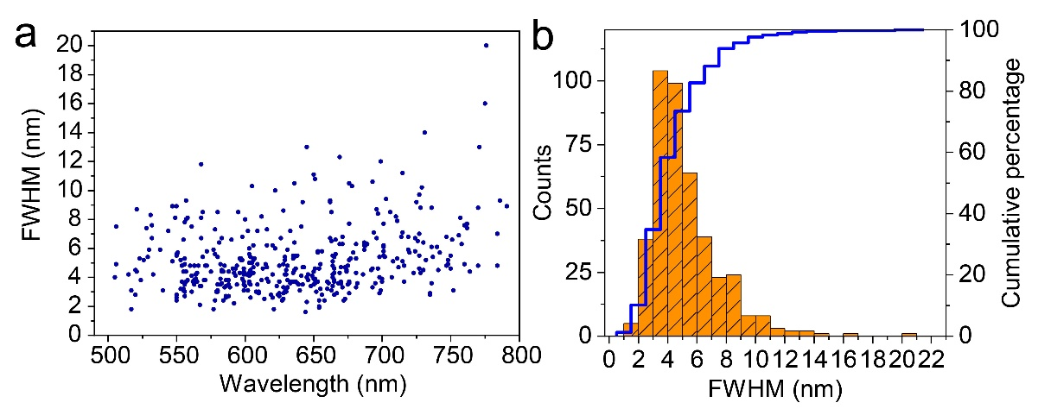
Supplementary Fig. 18| Statistics of the distributions of the linewidth of above 400 emitters. a, Distribution of ZPL vs linewidth from laser written quantum emitters; b, Histogram of linewidth distribution and cumulative percentage.
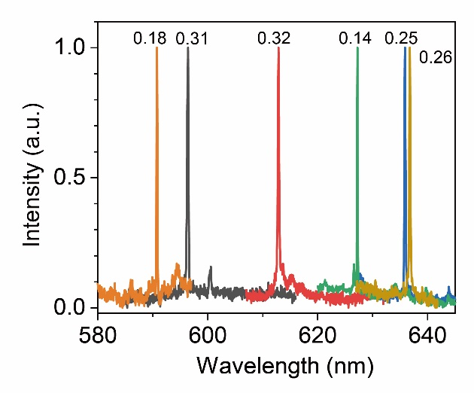
Supplementary Fig. 19| Spectras of six representative SPEs at 10 K. The spectra had an acquisition time of 10 s, at 1.5 mW, and CW 515 nm laser excitation, at 10 K. The value marked in the Figure is their emission linewidth at 10 K.
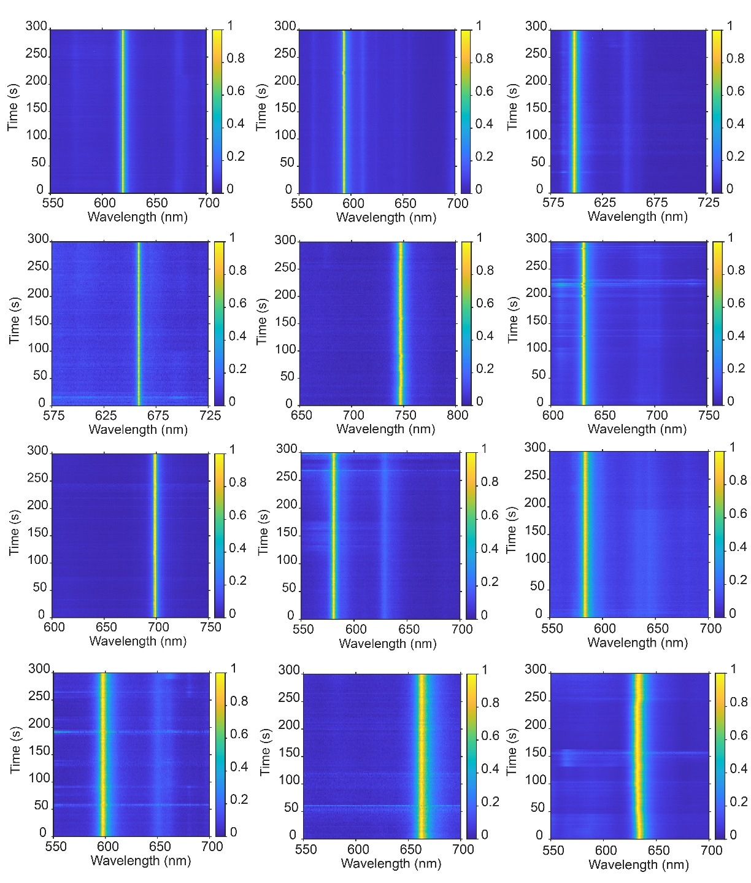
Supplementary Fig. 20| Room-temperature PL time series taken from laser-written SPEs. A frame is captured every two seconds.
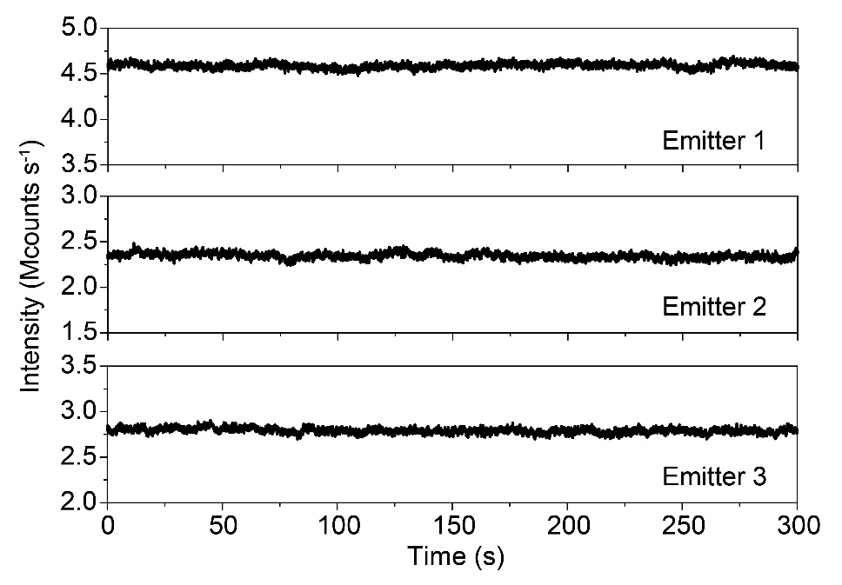
Supplementary Fig. 21| Intensity time trace acquired by APDs through the time tagged time-resolved method. The binning time is 50 ms.

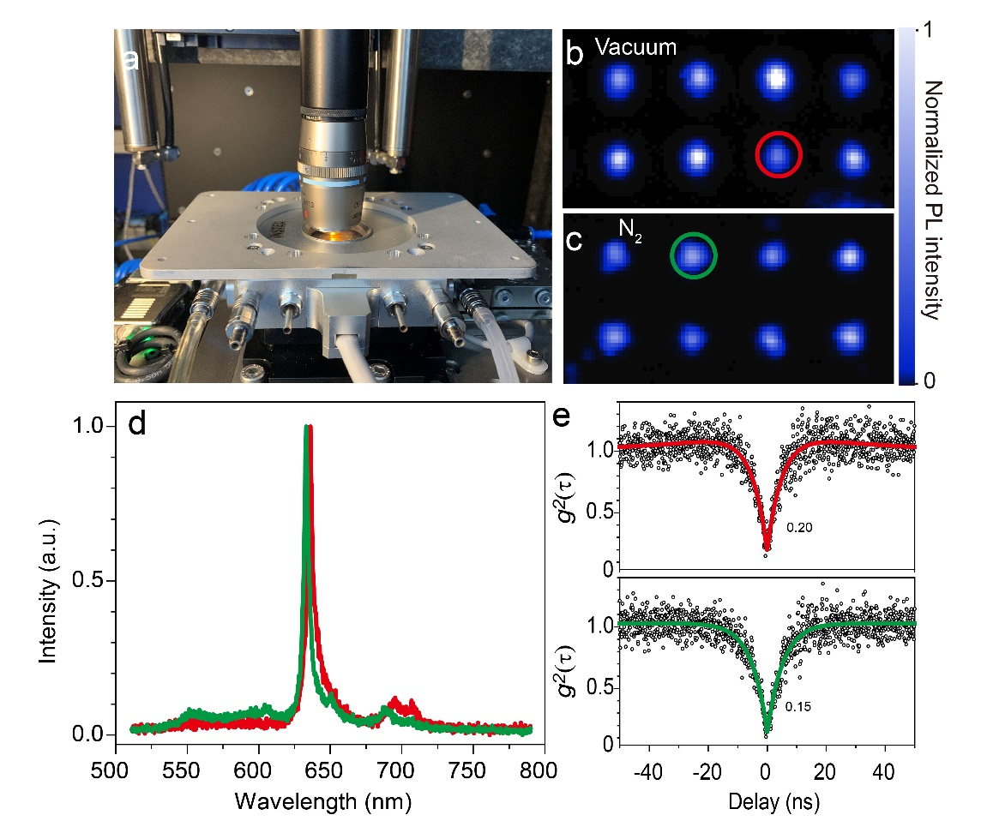
Supplementary Fig. 22| Experiment of laser written SPE in hBN in vacuum and nitrogen environment. a, Purpose-built vacuum chamber setup used in this section; b-c, Confocal PL mapping of laser-written region in vacuum and nitrogen; d, PL spectra of representative SPE obtained from Vacuum and nitrogen; e, Antibunching behavior demonstrated by autocorrelation curves g²(t) from the two emitters.

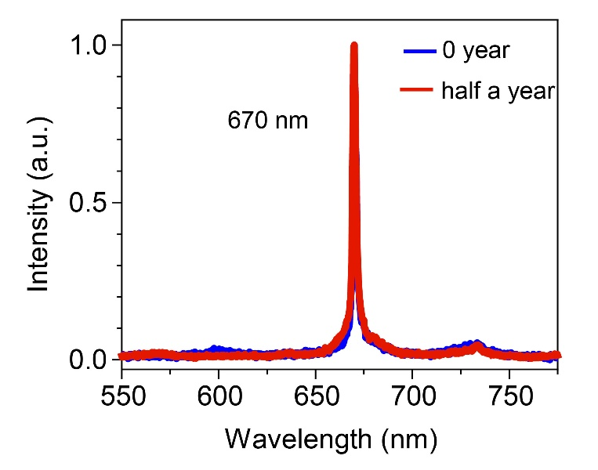
Supplementary Fig. 23| PL spectra of a representative emitter for half a year.

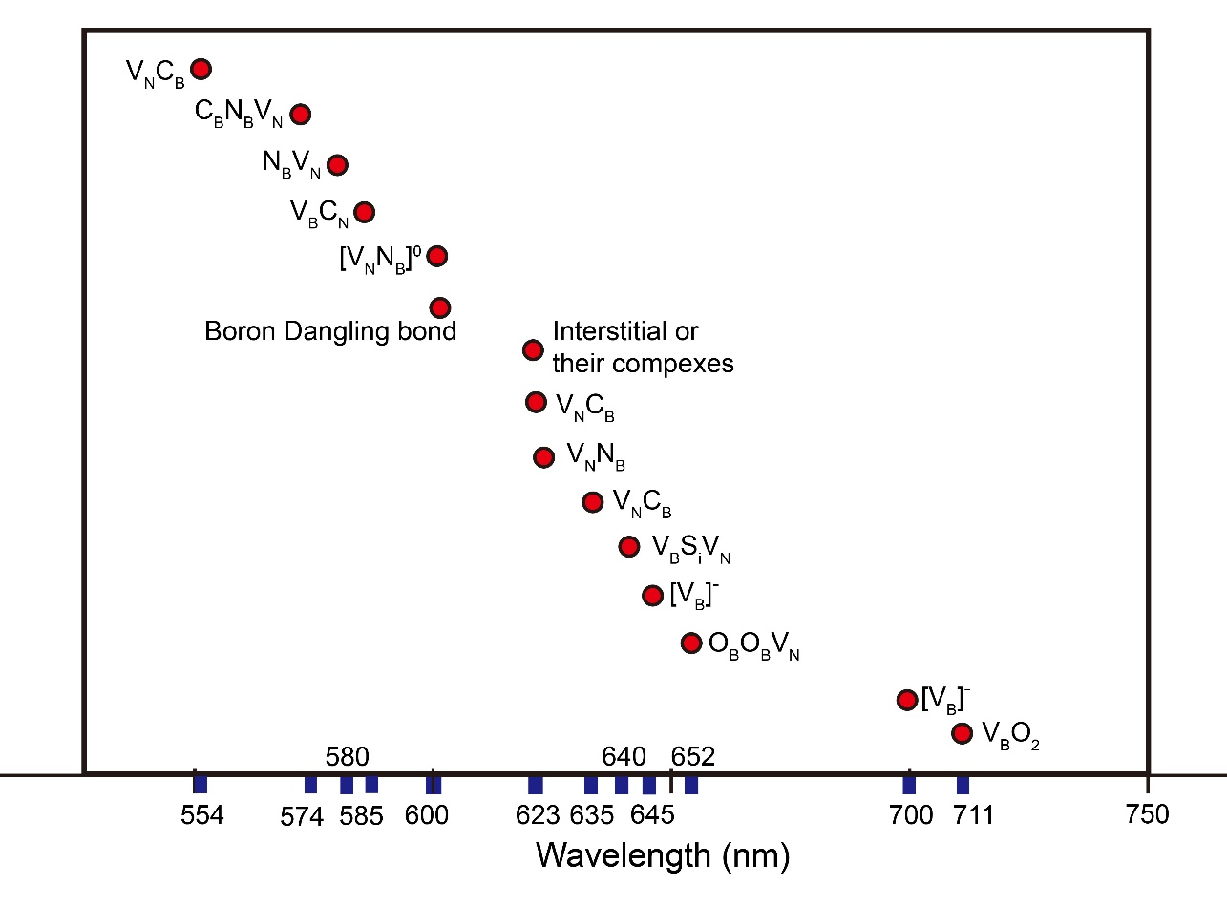
Supplementary Fig. 24| The possible defect types for SPE in hBN according to the kinds of literature that have been reported.

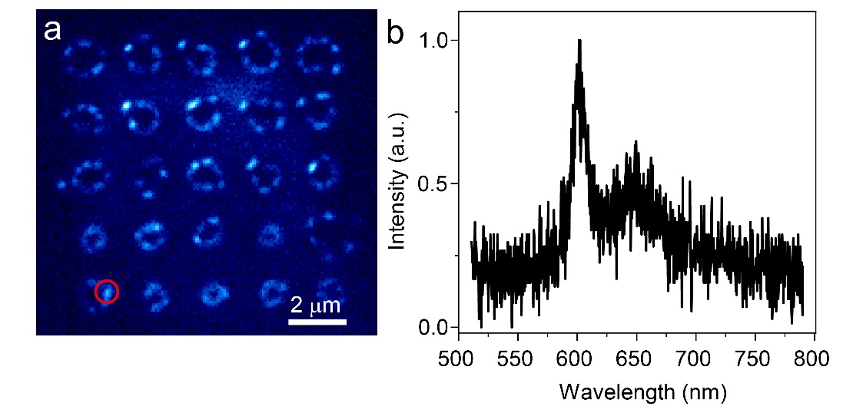
Supplementary Fig. 25| The PL property of high-energy laser pulse induced emitter.(Pulse energy:7.8 nJ) a, EMCCD fluorescence image of the corresponding region; b, The representative spectrum at red circle scale bar: 2 μm

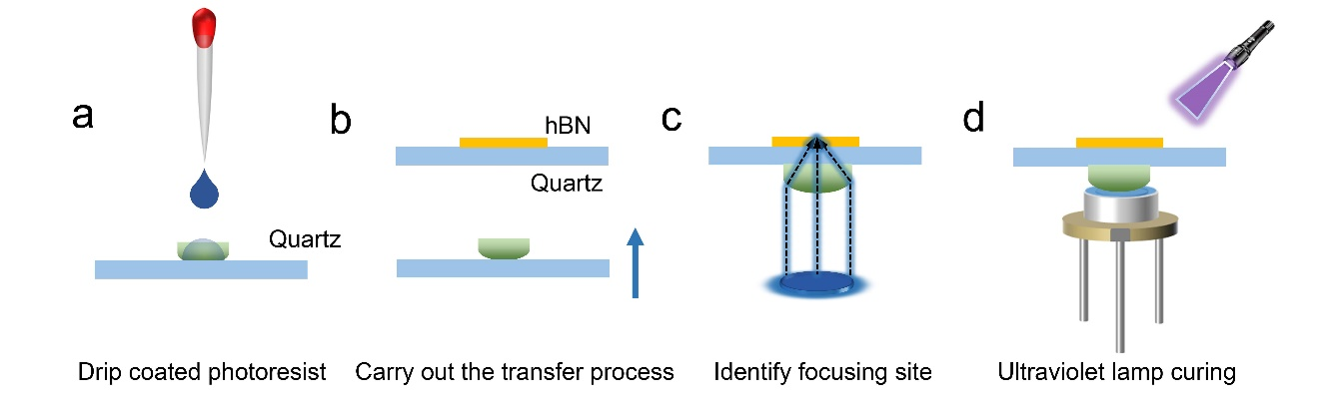
Supplementary Fig. 26| Schematic of the assembly process of the hybrid single-photon light-emitting devices. a, Placing the lens on a clean sheet of glass and drop photoresist. b, The glass carrying the lens is controlled by a three-dimensional displacement platform to move close to the bottom of the target substrate; c, The bottom is illuminated with a laser, and the lens is moved to the focused beam to the laser-written SPE. d, A laser diode is fixed at the bottom of the lens and a UV lamp is used to complete the curing of the photoresist.
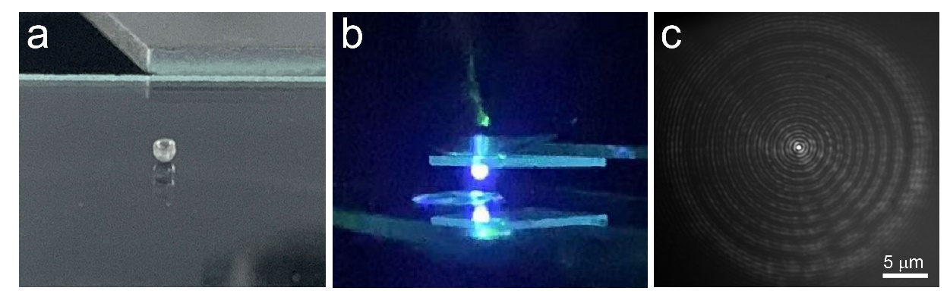
Supplementary Fig. 27| Physical drawing of device assembly. a, Optical image of a 0.6 mm focal length mini-lens; b, The lens was successfully assembled on the substrate with an hBN flake; c, Optical image of the focus spot in CCD.

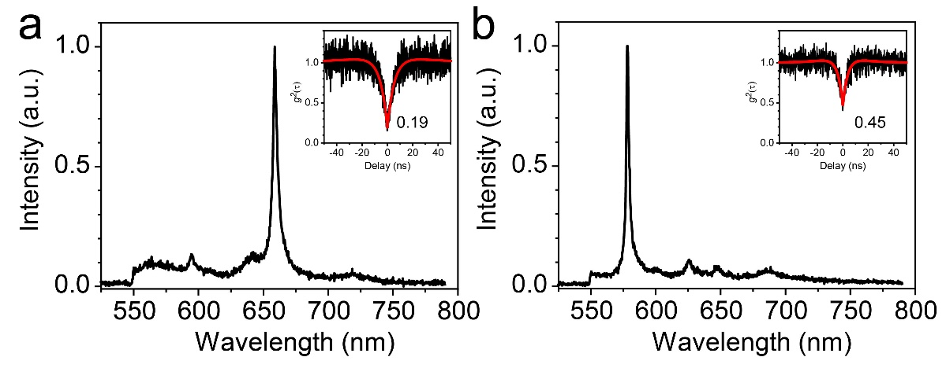
Supplementary Fig. 28| Optical performance of the packaged turn-key monochromatic single-photon emitters. The spectra are acquired for integral time 2 s. Inset is the antibunching curve of the corresponding spectra.

Supplementary References
1. Sudrie, L., A. Couairon, M. Franco, et al. Femtosecond Laser-Induced Damage and Filamentary Propagation in Fused Silica. Phys. Rev. Lett. 89, 186601 (2002).
2. Song, J., X. Wang, X. Hu, et al. Formation mechanism of self-organized voids in dielectrics induced by tightly focused femtosecond laser pulses. Appl. Phys. Lett. 92, 092904 (2008).
3. Christensen, B. H., K. Vestentoft and P. Balling. Short-pulse ablation rates and the two-temperature model. Appl. Surf. Sci. 253, 6347-6352 (2007).
4. Dombi, P., Z. Pápa, J. Vogelsang, et al. Strong-field nano-optics. Reviews of Modern Physics. 92, 025003 (2020).
5. Kruchinin, S. Y., F. Krausz and V. S. Yakovlev. Colloquium: Strong-field phenomena in periodic systems. Reviews of Modern Physics. 90, 021002 (2018).
6. Tawfik, S. A., S. Ali, M. Fronzi, et al. First-principles investigation of quantum emission from hBN defects. Nanoscale. 9, 13575-13582 (2017).
7. Abdi, M., J.-P. Chou, A. Gali, et al. Color Centers in Hexagonal Boron Nitride Monolayers: A Group Theory and Ab Initio Analysis. ACS Photonics. 5, 1967-1976 (2018).
8. Weston, L., D. Wickramaratne, M. Mackoit, et al. Native point defects and impurities in hexagonal boron nitride. Phys. Rev. B. 97, 214104 (2018).
9. Xu, Z. Q., C. Elbadawi, T. T. Tran, et al. Single photon emission from plasma treated 2D hexagonal boron nitride. Nanoscale. 10, 7957-7965 (2018).
10. Turiansky, M. E., A. Alkauskas, L. C. Bassett, et al. Dangling Bonds in Hexagonal Boron Nitride as Single-Photon Emitters. Phys. Rev. Lett. 123, 127401 (2019).
11. Sajid, A. and K. S. Thygesen. VNCB defect as source of single photon emission from hexagonal boron nitride. 2D Mater. 7, 031007 (2020).
12. Hayee, F., L. Yu, J. L. Zhang, et al. Revealing multiple classes of stable quantum emitters in hexagonal boron nitride with correlated optical and electron microscopy. Nat. Photonics. 19, 534-539 (2020).
13. Mendelson, N., D. Chugh, J. R. Reimers, et al. Identifying carbon as the source of visible single-photon emission from hexagonal boron nitride. Nat. Photonics. 20, 321-328 (2021).
14. Zhang, C., Z. Shi, T. Wu, et al. Microstructure Engineering of Hexagonal Boron Nitride for Single‐Photon Emitter Applications. Adv. Opt. Mater. 10, 2200207 (2022).

