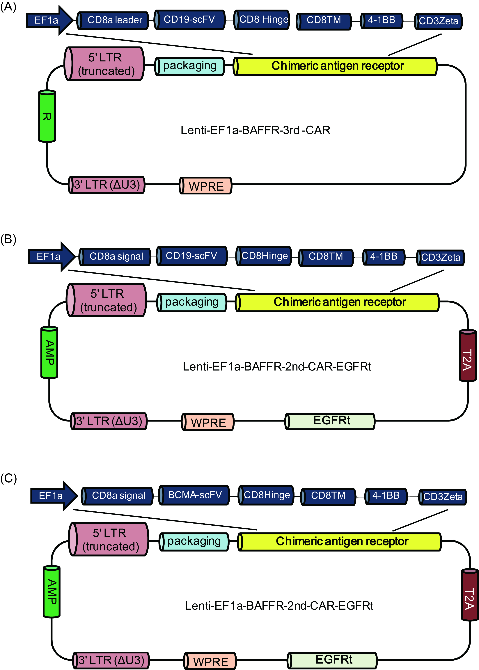
Figure S1. Design of CAR-T lentiviral vectors. The structure of anti-CD19-CAR for Patient 1 is shown in panel A. Shown in panel B and C are the structures of anti-CD19-CAR (B) and anti-BCMA-CAR (C) for Patient 2, which include a truncated EGFR (EGFRt) segment.

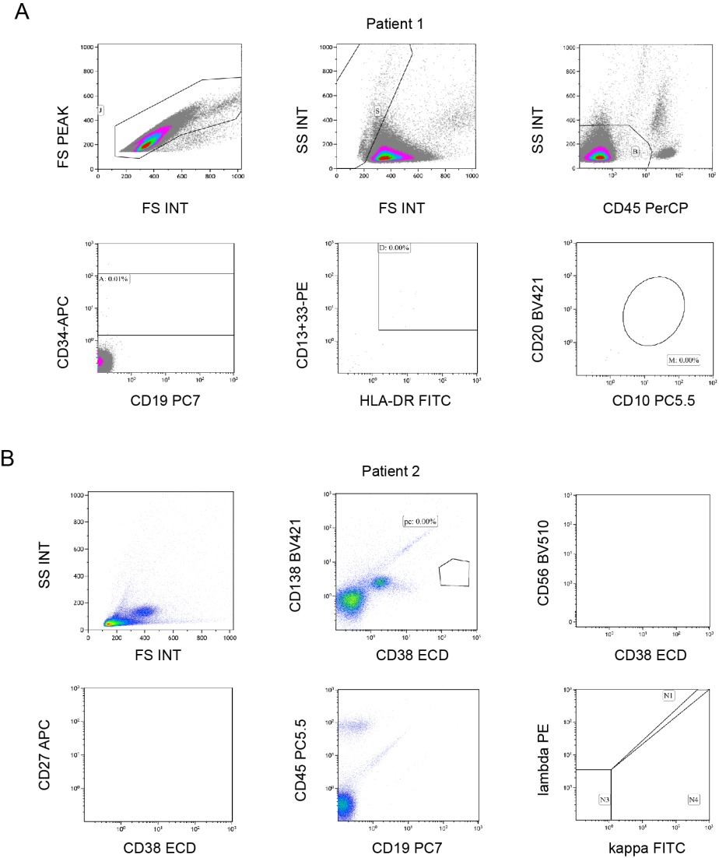
Figure S2. Minimal residual disease (MRD) after CAR-T therapy for (A) Patient 1 and (B) Patient 2. (A) The number of B-ALL cells expressing CD19, CD34, CD10, CD20, CD13, CD33, HLA-DR, and CD45 on the 24th day after CAR-T therapy was less than 10⁻⁴, confirming MRD negativity. (B) The number of multiple myeloma cells expressing CD138, CD38, CD56, CD27, CD45, CD19, c-kappa and c-lambda on the 18th day after CAR-T therapy was less than 10⁻⁴, confirming MRD negativity.

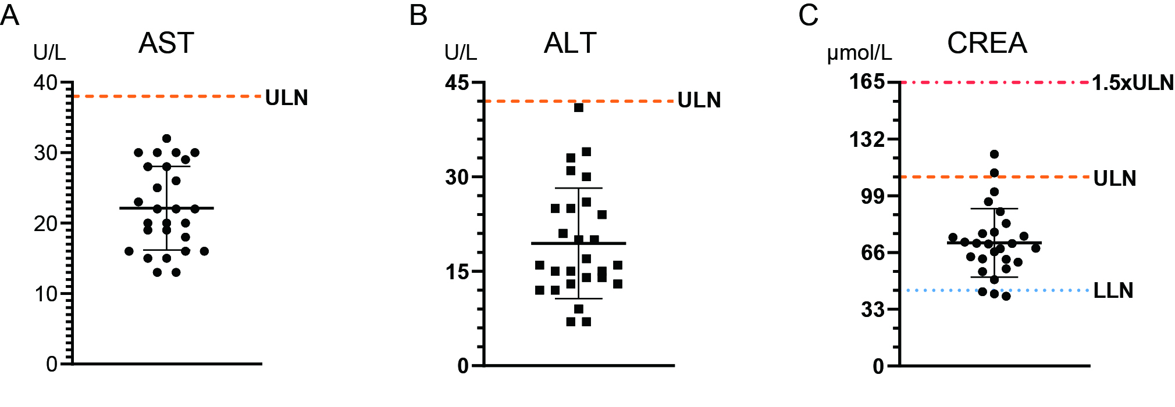
Figure S3. Effect of TG treatment on liver and renal functions in patients with autoimmune diseases in terms of (A) serum aspartate aminotransferase (AST), (B) alanine aminotransferase (ALT), (C) creatinine (CREA). 26 patients who received TG for a variety of autoimmune diseases for at least one week were included in the assessment: 19 with rheumatoid arthritis, 2 with Sjogren's syndrome, 3 with chronic glomerulonephritis,1with ankylosing spondylitis, and 1with gouty arthritis. Dosage included 10 mg TID (n=5), 20 mg BID (n=13), 20 mg TID (n=6), 30 mg BID (n=1), and 40 mg BID (n=1). The upper limit of normal value (ULN) is indicated by orange line, the 1.5×ULN is indicated by red line, and the lower limit of normal value (LLN) is indicated by blue line. One patient (an elder) has taken TG for years and had renal dysfunction prior to hospitalization (CREA = 125.5 μmol/L); her CREA decreased somewhat after receiving TG during hospitalization. Only one patient with normal measures before hospitalization had elevated CREA (112.4 μmol/L) after receiving TG during hospitalization.

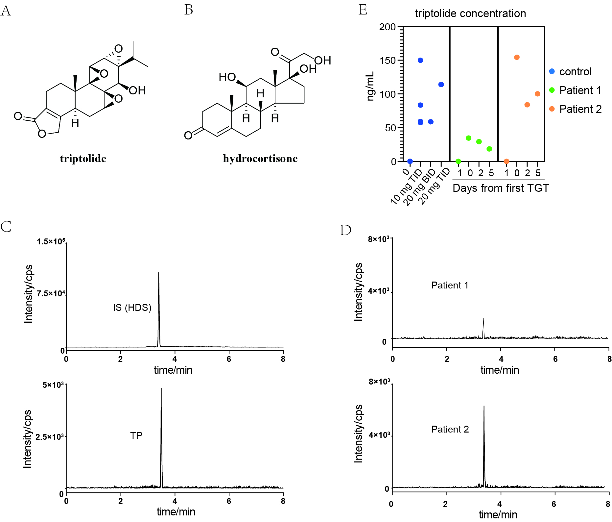
Figure S4. HPLC-MS/MS analysis of triptolide in human plasma. (A) The structure of triptolide (TP). (B) The structure of the internal standard (IS) - hydrocortisone (HDS). (C) Representative UPLC-MS/MS chromatogram of blank plasma spiked with 100 ng/mL HDS and 100 ng/mL TP. (D) Patients' plasma samples collected at two hours after receiving the first TG dosing. (E) Triptolide in human plasma during TG treatment. Each dot represents one sample. The dark blue dots represent patients with inflammatory autoimmune diseases. Six patients received TG at three doses: 10 mg TID, 20 mg BID, and 20 mg TID. Three additional patients with rheumatoid arthritis who did not receive TG are included as negative control. The green and orange dots represent Patient 1 and Patient 2, with plasma collected one day before TG treatment (Day -1), 2 hours after receiving the first TG dosing (Day 0), 2 hours before receiving the last TG tablet (Day 2), and three days after the last TG treatment (Day 5).
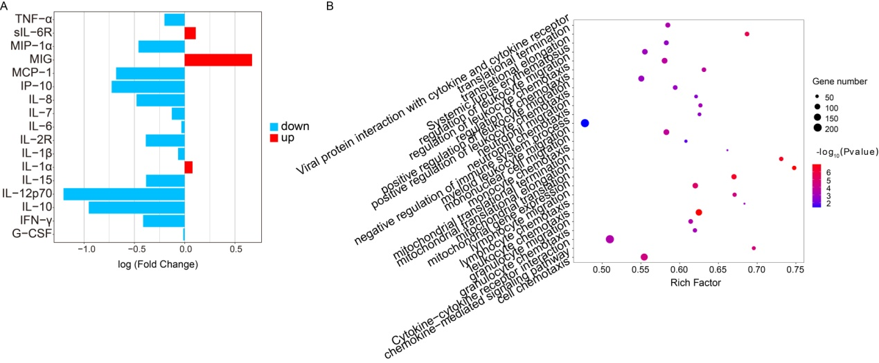
Figure S5. mRNA expression change after triptolide treatment in cultured monocytes from one patient with CAR-T induced CRS. (A) Gene expression of CRS-related cytokines. Each bar represents the log10 transformed fold change of one gene expression (triptolide treated / DMSO), with down-regulation illustrated in blue, up-regulation in red. (B) Significantly affected pathways revealed by both gene enrichment analysis and transcript enrichment analysis.
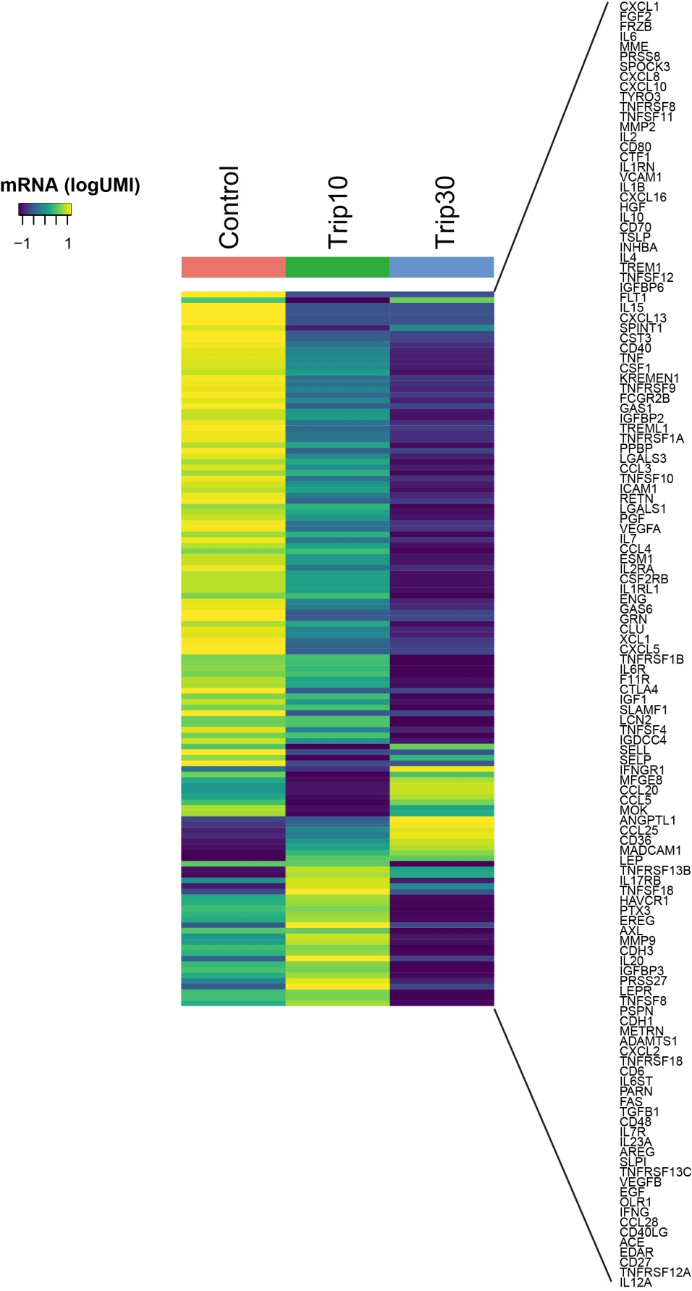
Figure S6. All cytokine and chemokine expression at single-cell level after treatment with different concentrations of triptolide. The control group received no triptolide treatment (left), the Trip10 group received 10 ng/mL of triptolide treatment (middle), the Trip30 group received 30 ng/mL of triptolide treatment (right). The expression is log10-transformed UMI (logUMI).

Table S1. Assessment of CAR-T cell therapy related side effects
Side Effect | Symptoms | Patient 1 | Patient 2
CRS | Fever | Peak: 40.0℃ | Peak: 39.9℃
CRS | Hypotension | Lowest: 89 mmHg, no vasopressors | Lowest: 78 mmHg, no vasopressors
CRS | Hypoxia | Low-flow nasal cannula | Low-flow nasal cannula
CRS | Urine decreased | - | Anuria (60 mL/24 hr)
CRS | Creatinine increased | - | 7.9×ULN
CRS | AST increased | 1.9×ULN | 41×ULN
CRS | Tachycardia | 117 times/min | 141 times/min
CRS | Tachypnea | Yes | Yes
CRS | Malaise/ fatigue | Yes | Yes
CRS | Myalgias | - | Yes
CRS | Nasal hemorrhage | Yes | -
CRS | Anorexia | Yes | -
CRS | Diarrhea | Twice | -
CRS | Final grading | Grade 2 | Grade 4
ICANS | CARTOX-10* score | - | 0
ICANS | Dysarthria | - | Severe impairment
ICANS | Final grading | - | Grade 3
HLH/MAS | Serum ferritin > 10,000 ng/mL | - | Peak: 32480 ng/mL
HLH/MAS | Grade ≥ 3 increase in AST | - | 41×ULN
HLH/MAS | Grade ≥ 3 oliguria or increase in serum creatinine | - | Anuria;  creatinine = 7.9×ULN
HLH/MAS | Presence of hemophagocytosis in bone marrow | - | No
HLH/MAS | Final diagnosis | - | HLH/MAS
Note: CRS, cytokine release syndrome; ICANS, immune effector cell-associated neurotoxicity syndrome; HLH, haemophagocytic lymphohistiocytosis; MAS, macrophage-activation syndrome; ULN, upper limit of normal value; AST, aspartate aminotransferase; CARTOX, CAR-T-cell-therapy-associated toxicity 10-point neurological assessment.
*In the CARTOX-10, one point is assigned for each of the following tasks that is performed correctly (normal cognitive function is defined by an overall score of 10): orientation to year, month, city, hospital, and President of country of residence (total of 5 points); name three objects — for example, point to clock, pen, button (maximum of 3 points); write a standard sentence, for example, ‘Americans' national bird is the bald eagle’ (1 point); count backwards from 100 in tens (1 point).
Table S2. Antibiotic susceptibility of the bacteria isolated from blood samples of Patient 2
Antibiotics name | MIC (μg/mL) | Sensitivity
Ampicillin/Sulbactam | ≥ 32.0 | R
Piperacillin/Tazobactam | ≥ 128.0 | R
Ceftriaxone | ≥ 64.0 | R
Imipenem | ≥ 16.0 | R
Gentamicin | ≥ 16.0 | R
Ciprofloxacin | ≥ 4.0 | R
Compound sulfamethoxazole | ≤ 20.0 | S
Cefotetan | ≥ 64.0 | R
Ceftazidime | ≥ 64.0 | R
Cefepime | ≥ 64.0 | R
Aztreonam | ≥ 64.0 | R
Amikacin | ≥ 64.0 | R
Levofloxacin | ≥ 8.0 | R
Tobramycin | ≥ 16.0 | R
Note: R, resistant; S, sensitive; MIG, Minimum inhibitory concentration. Sample was collected at 24 days after CAR-T cell infusion and 14 days after the last TG administration. Test results were reported after Patient 2's death. The bacteria identified from blood samples of Patient 2 was Klebsiella pneumoniae subsp. pneumoniae.

Table S3. Pathogens metagenomics analysis for Patient 2
Pathogen Type | Pathogen | Seq# | Gene | Drug
Day 12 after CAR-T infusion
Bacteria | Not detected | 0
Fungus | Not detected | 0
DNA Virus | Not detected | 0
Parasite | Not detected | 0
Mycobacterium Tuberculosis Complex | Not detected | 0
Non-tuberculosis Mycobacterium | Not detected | 0
Mycoplasma/Chlamydia | Not detected | 0
Suspected Human Skin Microecological Flora | Moraxella osloensis | 90
Suspected Human Skin Microecological Flora | Propionibacterium acnes | 9
Suspected Human Skin Microecological Flora | Staphylococcus epidermidis | 3
Day 26 after CAR-T infusion
Bacteria | Klebsiella pneumonia | 1446 | blaKPC | Carbapenems
Fungus | Aspergillus fumigatus | 18
DNA Virus | Human betaherpesvirus 5 | 29
DNA Virus | Human alphaherpesvirus 1 | 8
Parasite | Not detected | 0
Mycobacterium Tuberculosis Complex | Not detected | 0
Non-tuberculosis Mycobacterium | Not detected | 0
Mycoplasma/Chlamydia | Not detected | 0
Suspected human skin microecological flora | Propioni bacteriumacnes | 39
Suspected human skin microecological flora | Staphylococcus haemolyticus | 13
Suspected human skin microecological flora | Staphylococcus epidermidis | 11
Suspected human skin microecological flora | Moraxella osloensis | 19
Note: Seq#, number of sequences detected; Gene, antibiotic-resistant gene in the bacteria; Drug, the resistant antibiotics. Pathogen metagenomics detection was performed by Vision Medicals. It obtains species information of suspected pathogenic microorganisms through intelligent algorithms by first extracting nucleic acids from Patient 2's blood, constructing libraries, sequencing, and then aligning sequences with special databases for microorganisms. The detection is based on Illumina high-throughput sequencing platform and can completely cover 9,945 bacteria (including 144 mycobacteria and 107 mycoplasma or chlamydia), 6,760 viruses, 1,551 fungi and 305 parasites.

