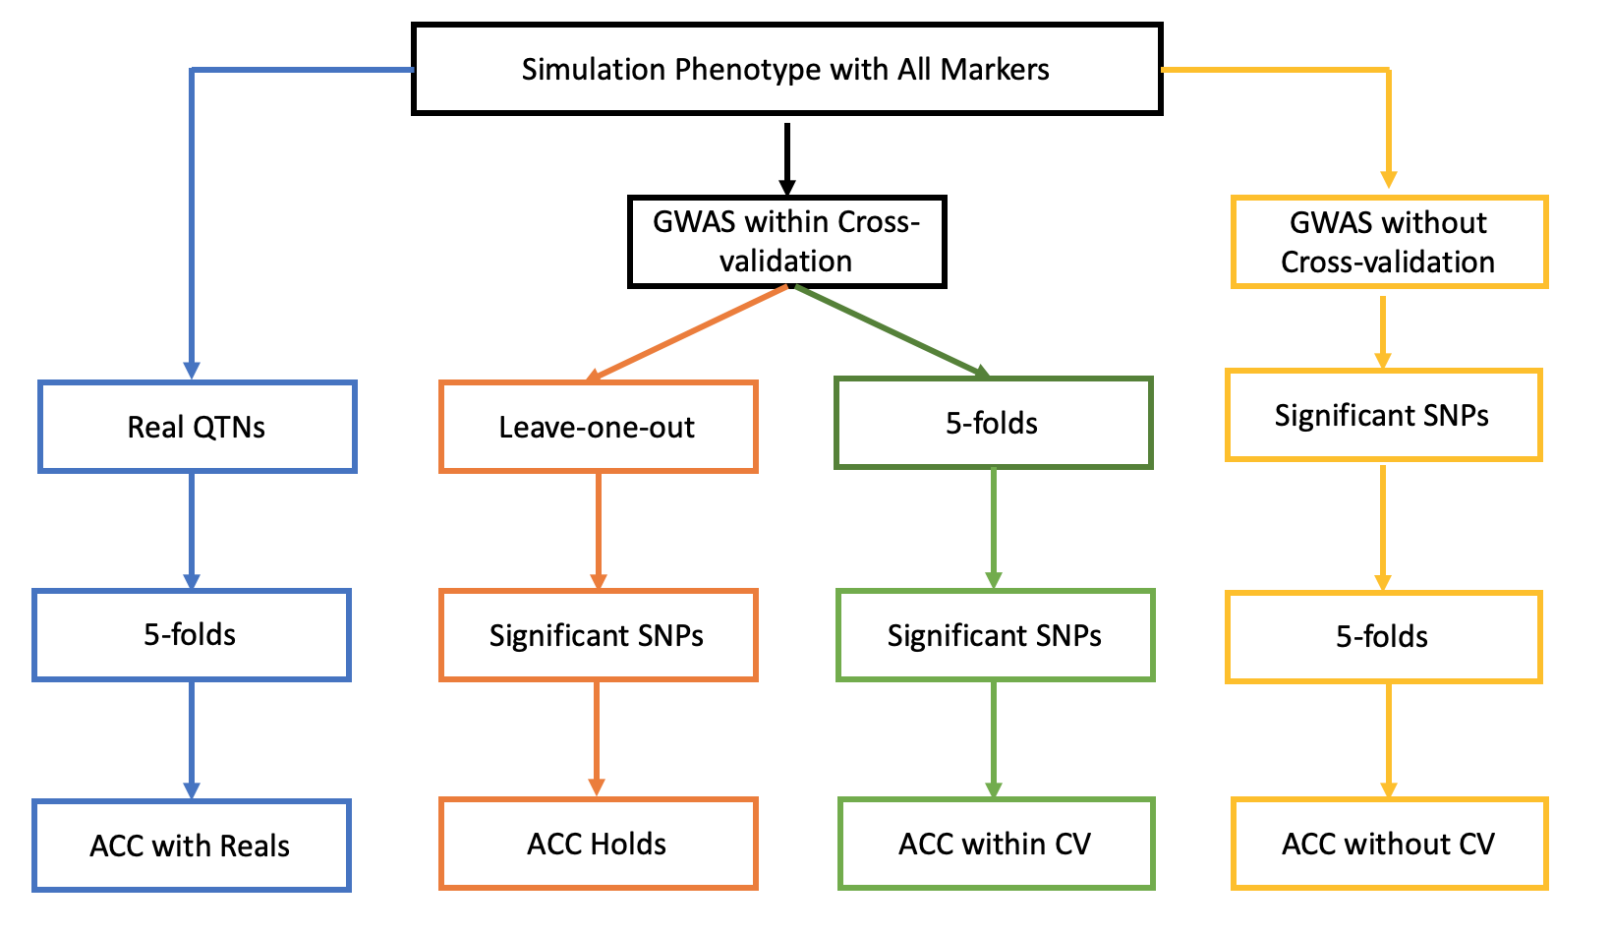
Figure S1. The pipeline of different prediction strategies from same dataset.
All experiments based on the same dataset and randomly simulated 50 times. In the blue approach, the real ﻿quantitative trait nucleotides (QTNs) were kept after simulation. Based on same random group under 5-folds, the phenotypes and QTNs genotypes of four reference groups and the QTNs genotypes of last inference group were used to predict the phenotypes of inference. In the red and green approaches, the individuals were selected into reference and inference groups before GWAS. The significant SNPs genotype from whole population and the phenotype from reference population were used to predict inference phenotype. The difference between red and green approaches is the Cross-validation, one is leave-one-out, the other is 5-folds. In the yellow approach, the whole population were used to detect significant markers in GWAS. Then the whole population was divided into 5 groups same as 5-folds cross validation. The correlation between real phenotype and predicted phenotype was considered as accuracy for each approach.

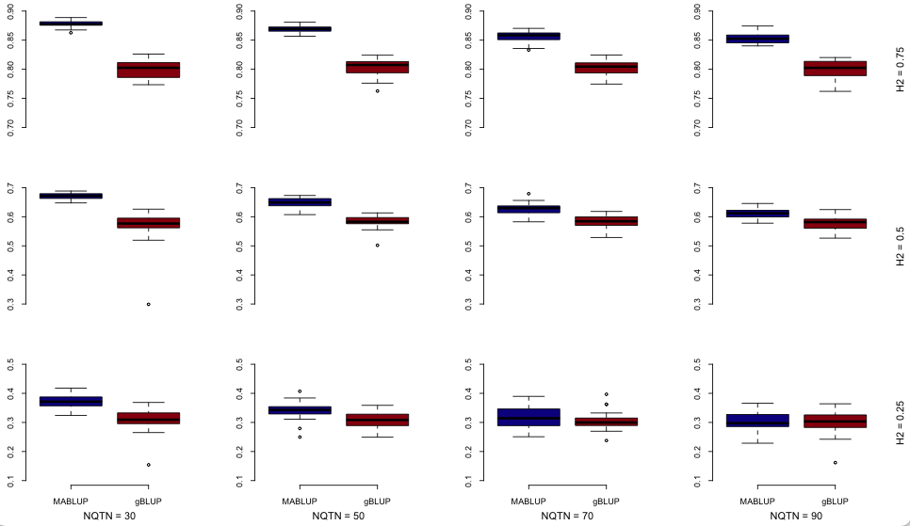
Figure S2. The accuracy of markers assistant prediction strategies between gBLUP and MABLUP.
The MABLUP (darkblue) was performed by BLINK GWAS and MABLUP Genomic Prediction strategy. All significant markers were filtered by linear dependent removing then set as fixed effect. The whole markers were created kinship matrix to reveal individuals’ relationship that is same as gBLUP (darkred). All experiments were performed using simulation traits under heritability (0.25, 0.5, and 0.75) and NQTN (30, 50, 70, and 90) with 50 times repeats and 5-folds cross validation.

