Graphical Abstracts

In this research, the data observed by the Phoenix System was used. The data contain continuous and discontinuous time-series data. As an alternative, we introduced a robust impedance estimator based on the Hilbert-Huang transform (RMHHT) and demonstrated a strategy to process the broadband MT time-series data properly by the RMHHT estimator.
we showed the capability of HHT to express the spectrum variation in the time-frequency domain. Therefore, we could combine the two-segment time-series directly, which are in a different property, and get a reliable spectrum by HHT. Because of this kind of property, we could combine the discontinuous time-series data directly and process the combined discontinuous time-series data in the same way as the continuous time-series data when we compute the impedance by RMHHT. However, The biggest problem of the estimator based on HHT is time-consuming. By this strategy, the computation time can be shortened much.
We also indicated that this technique needs 4-hour time-series data to get a reliable resistivity structure up to 1,000 seconds in the numerical simulation. This short measurement time makes it possible to carry out MT surveys in urban areas with strong noises.
This paper also demonstrated that a time window of 4-hour length was almost noise-free during the local nighttime at site L7158, L6178, and Y0625. We used the data from this quiet period alone to estimate impedances and get a reliable result.
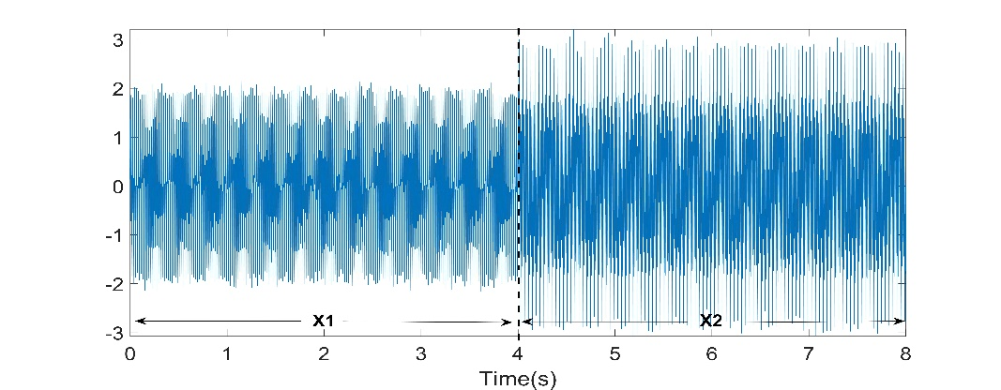
Fig. 2 The time-series x₁(t)=sin(2$π$·50t)+sin(2$π$·200t) and x₂(t)=sin(2$π$·25t)+sin(2$π$·100t)+sin(2$π$·250t). Both of the segments are added with 10% Gaussian noises.
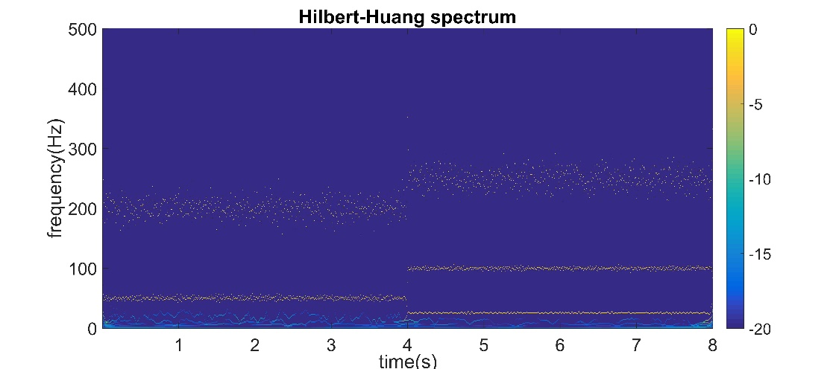
Fig. 3 The HHT spectrum of time-series data, which is shown in Fig. 1. The color denotes the value of 10·log10(amp/max), where "amp" denotes the amplitude of the IPs, "max" denotes the maximum of the amplitude of the IPs.
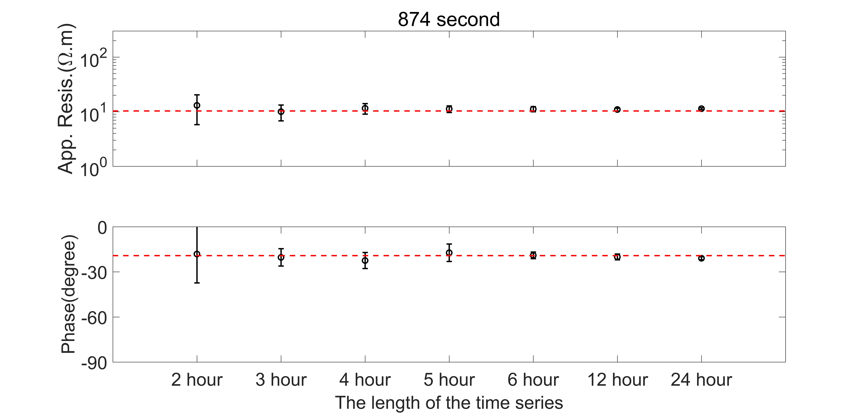
Fig. 5 The comparison of the TE mode impedance result calculated by the different lengths of time-series at the period of 874-second. The red dot line denotes the true model curves, which were calculated by the forward modeling. The horizontal axis indicates the length of the time-series.
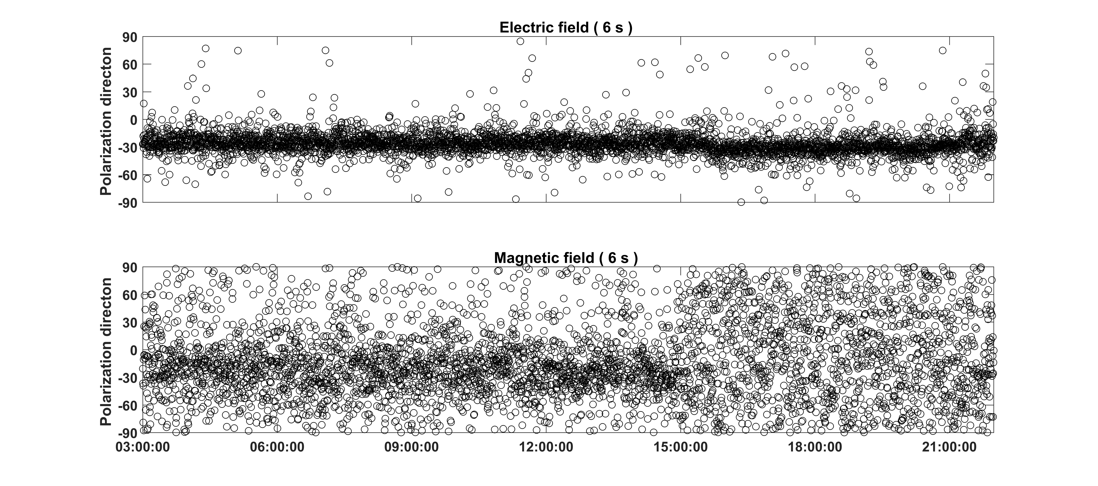
Fig. 10 The polarization direction for a period of 6-second at site L7158 from 3:00:00 to 22:00:00 in UCT time. The upper figure shows the electric field's polarization directions, and the lower is the polarization direction of the magnetic field.
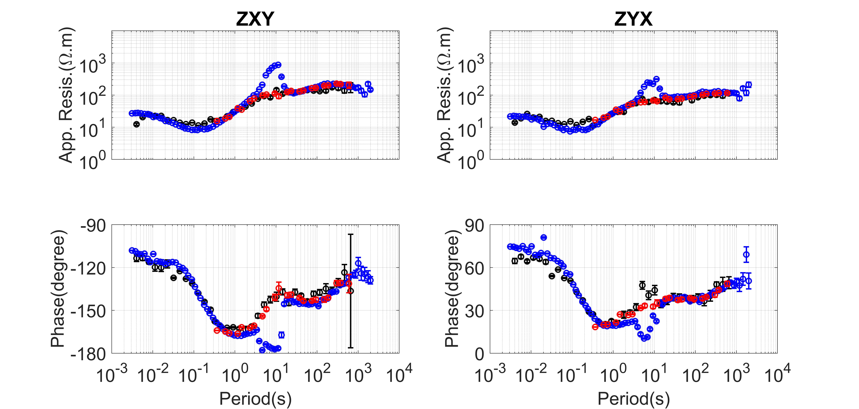
Fig. 13 The magnetotelluric sounding curves calculated using the data at site Y0626. SSMT-2000 was used to calculate the blue curves using one-day data, RMHHT was used to calculate the black curves using the nighttime data from 16:00:00 to 20:00:00 in UTC on June 26 and the data of the remote site L7158. BIRRP was used to calculate the red curves using the nighttime data from 16:00:00 to 20:00:00 in UTC on June 26.

