Appendix B - Screens Experiment UI
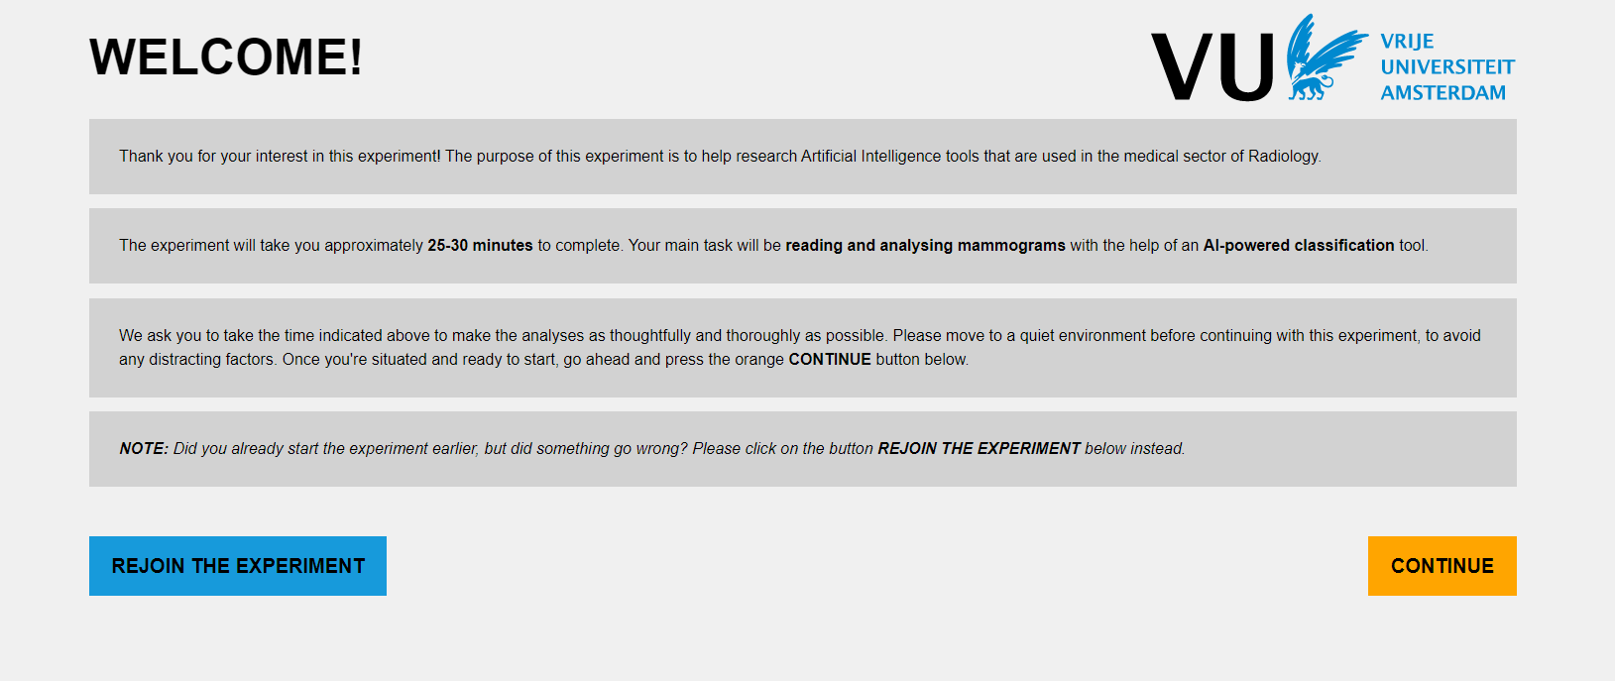
Figure 1. Home page of online experiment

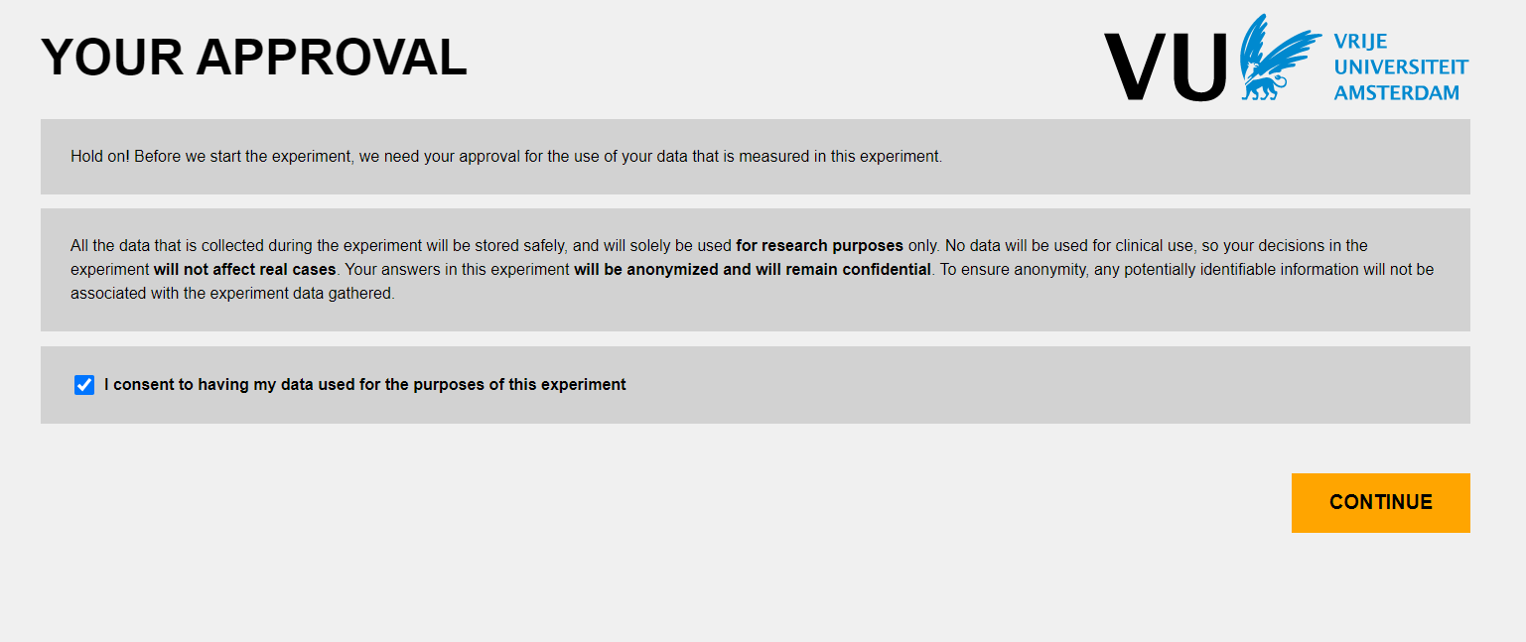
Figure 2. Consent form page of online experiment
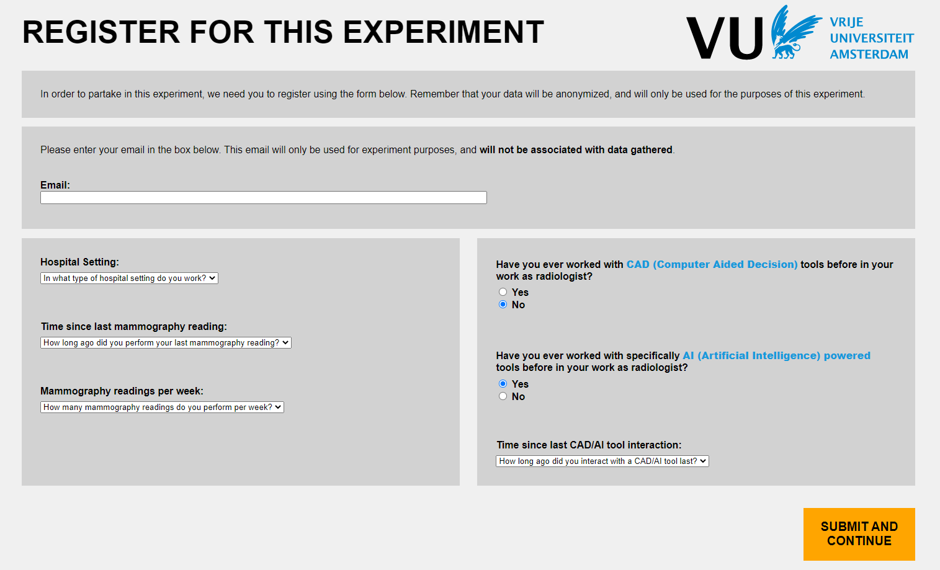
Figure 3. Registration page of online experiment

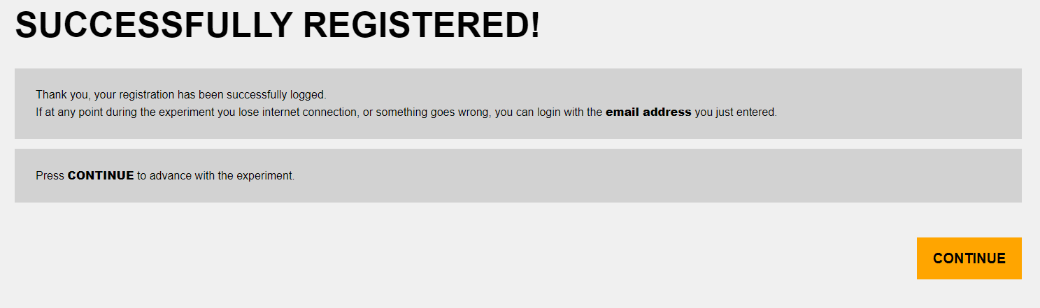
Figure 4. Registration success page of online experiment
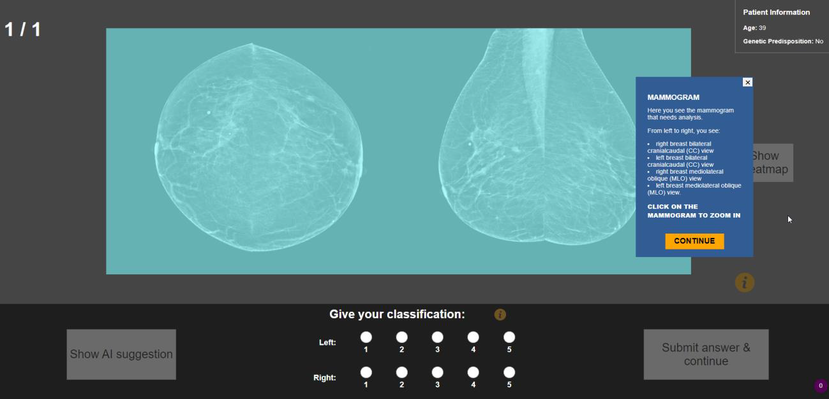
Figure 5. Interface tour page of online experiment

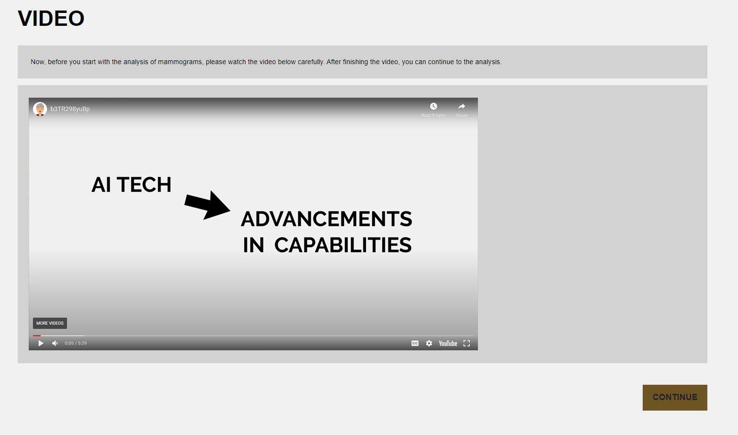
Figure 6. Priming video page of online experiment
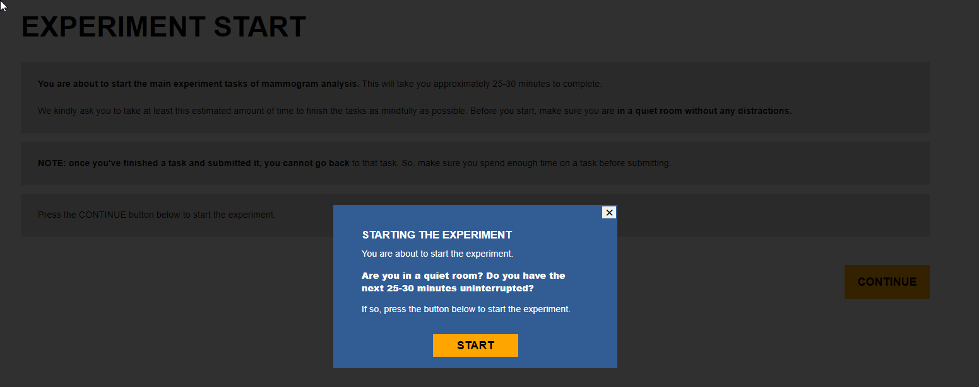
Figure 7. Pre-experimental task page of online experiment

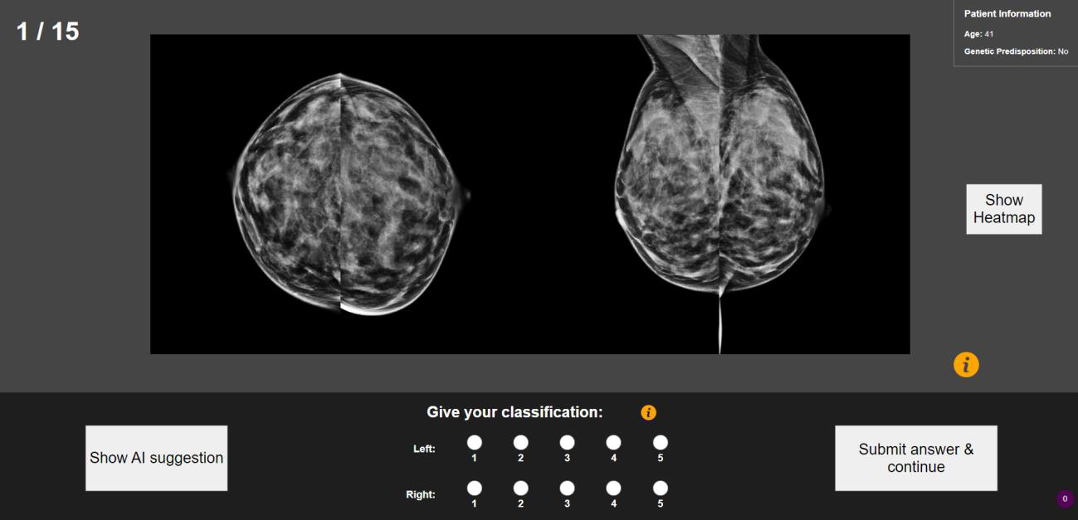
Figure 8. Experimental task page of online experiment


Figure 9. Final page of online experiment

