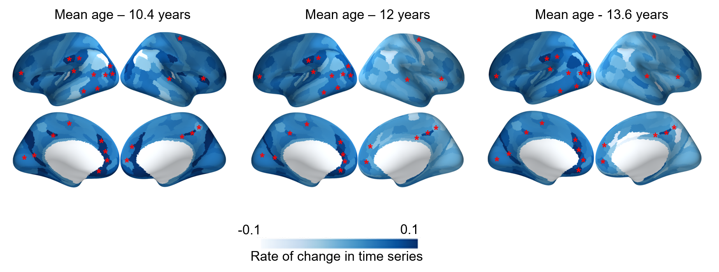
Figure S1. Illustration of the developmental change of structure-function coupling in typically developing children across 10 to 14 years of age. * Indicates age effects that survived FDR correction (p<0.05).

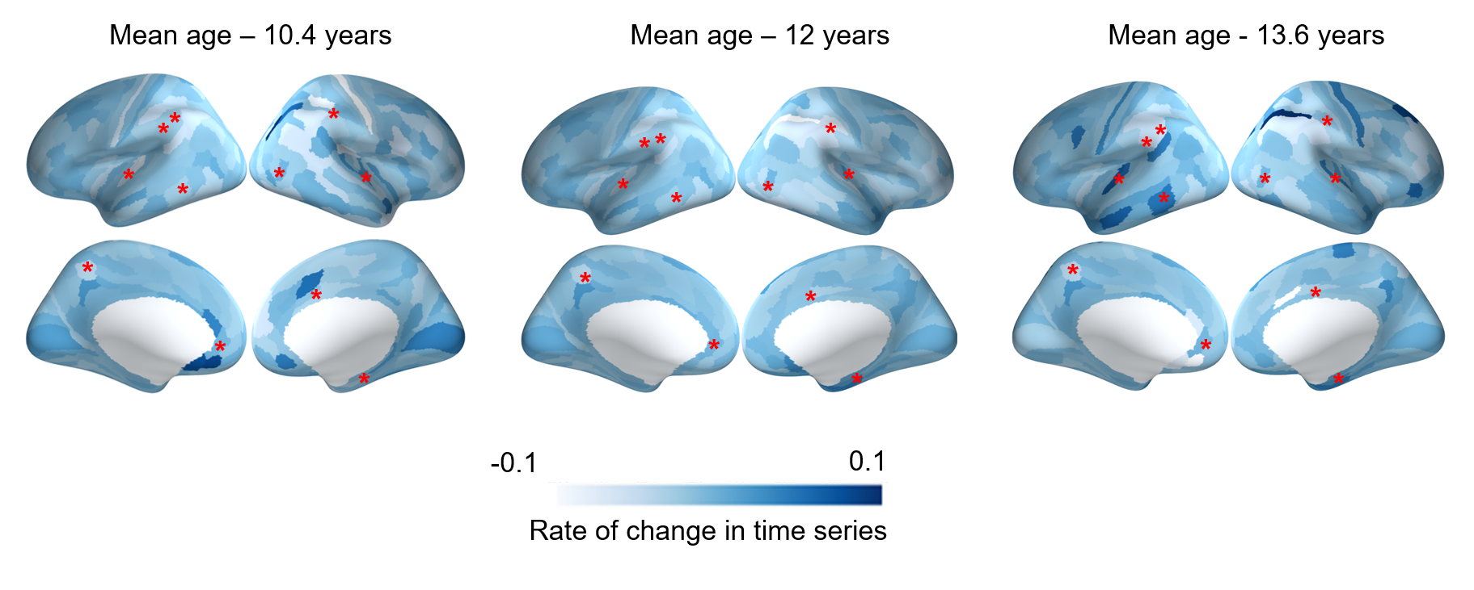
Figure S2. Illustration of the differential developmental changes of structure-function coupling in children with ADHD compared to typically developing children across 10 to 14 years of age. * Indicates group x age effects that survived FDR correction (p<0.05).

Table S1. Statistics for developmental trajectories of structure-function coupling in typically developing children (main effect of age)

Regions | edf | Ref.df | F | p-value | FDR
L prefrontal (10d) | 1.00 | 1.00 | 9.40 | <0.001 | 0.005
L anterior cingulate (p24pr) | 1.00 | 1.00 | 11.32 | <0.001 | <0.001
L anterior cingulate (a24pr) | 1.00 | 1.00 | 11.22 | <0.001 | <0.001
L posterior cingulate (POS1) | 1.00 | 1.00 | 10.24 | <0.001 | 0.002
L polar frontal cortex (11L) | 1.00 | 1.00 | 10.26 | 0.004 | 0.030
L mid cingulate (24dd) | 1.00 | 1.00 | 8.35 | <0.001 | 0.008
L inf temporal (TF) | 1.00 | 1.00 | 8.21 | <0.001 | <0.001
L inf temporal (TE2a) | 1.00 | 1.00 | 8.31 | <0.001 | <0.001
L visual cortex (V6) | 2.76 | 2.95 | 17.05 | <0.001 | <0.001
L superior temporal gyrus (A4) | 1.00 | 1.00 | 8.31 | 0.004 | 0.039
L superior parietal cortex (LIPv) | 1.00 | 1.00 | 8.22 | 0.004 | 0.043
L posterior cingulate (31pv) | 1.00 | 1.00 | 8.15 | <0.001 | 0.001
L inferior parietal (PF) | 1.00 | 1.00 | 9.58 | 0.002 | 0.043
L prefrontal cortex (46) | 1.00 | 1.00 | 9.48 | 0.002 | 0.025
L visual area_(LO1) | 2.00 | 2.00 | 30.00 | <0.001 | <0.001
L visual area (LO2) | 2.32 | 2.44 | 14.38 | <0.001 | 0.005
L visual area (LO3) | 2.24 | 2.53 | 20.00 | <0.001 | <0.001
L orbitofrontal cortex (OFC) | 1.00 | 1.00 | 17.42 | <0.001 | 0.001
R medial prefrontal cortex (s32) | 1.00 | 1.00 | 8.31 | 0.004 | 0.039
R inferior frontal cortex (IFJp) | 1.00 | 1.00 | 8.21 | 0.004 | 0.036
R medial prefrontal (p32) | 1.00 | 1.00 | 11.32 | 0.001 | 0.024
R orbitofrontal cortex (OFC) | 1.00 | 1.00 | 10.74 | 0.001 | 0.026
R sup temporal gyrus (47l) | 1.00 | 1.00 | 9.68 | 0.002 | 0.043
R posterior cingulate (31a) | 1.00 | 1.00 | 9.00 | <0.001 | 0.020
R superior parietal (7PL) | 1.00 | 1.00 | 8.25 | 0.004 | 0.042
R precuneus (v23ab) | 1.00 | 1.00 | 9.76 | 0.002 | 0.024

NB: L - left hemisphere and R - right hemisphere. All the region names in the bracket represent the label of the regions in HCP-MMP atlas (1)
Table S2. Group differences between ADHD and control in structure-function coupling

Regions | Estimate | Std.error | t-value | p-value | FDR
L superior temporal gyrus (6v) | -0.038 | 0.019 | -1.99 | 0.001 | 0.039
R inferior parietal cortex (8C) | 0.009 | 0.02 | 2.77 | 0.001 | 0.033
R medial prefrontal cortex (s32) | 0.029 | 0.012 | 2.45 | 0.002 | 0.046

NB: L - left hemisphere and R - right hemisphere. All the region names in the bracket represent the label of the regions in HCP-MMP atlas (1)

Table S3. Statistics for differential developmental trajectories of structure-function coupling
(group x age interaction)

Regions | edf | Ref.df | F | p-value | FDR
L inferior frontal gyrus(IFSa) | 1.00 | 1.00 | 9.40 | 0.007 | 0.032
L precuneus (PFt) | 1.00 | 1.00 | 11.32 | 0.004 | 0.019
L superior parietal cortex (7Pm, 7Am) | 1.00 | 1.00 | 8.67 | 0.009 | 0.042
L medial prefrontal cortex (a24pr) | 1.00 | 1.00 | 10.24 | 0.006 | 0.027
L inferior temporal cortex (TF) | 1.00 | 1.00 | 10.26 | 0.001 | 0.034
R inferior frontal gyrus(IFSa) | 1.00 | 1.00 | 9.36 | 0.007 | 0.034
R mid cingulate(24dd) | 1.00 | 1.00 | 8.50 | 0.009 | 0.045
R inferior parietal cortex (Pfm) | 1.00 | 1.00 | 8.35 | 0.001 | 0.042
R medial temporal cortex (PreS) | 1.00 | 1.00 | 10.33 | 0.001 | 0.034
R visual cortex (V6) | 1.00 | 1.00 | 8.21 | 0.008 | 0.043

NB: L - left hemisphere and R - right hemisphere. All the region names in the bracket represent the label of the regions in HCP-MMP atlas (1)

References
1. Glasser MF, Coalson TS, Robinson EC, Hacker CD, Harwell J, Yacoub E, et al. (2016): A multi-modal parcellation of human cerebral cortex. Nature. 536:171-178.

