Table S1. Full dataset for CPY in fish and ringed seal samples (separate Excel file available from the authors)

Table S2. Correlations coefficients and sample size corrected probabilities for CPY concentrations in arctic char muscle, burbot liver and lake trout muscle
 | Pearson correlation coefficients |  |  | Matrix of Bonferroni Probabilities
 | Age | Length | % Lipid | Age | Length | % Lipid
Arctic char (N=121)
Age | - |  |  | -
Length | -0.056 | - |  | 1 | -
% Lipid | -0.067 | 0.147 | - | 1 | 1 | -
CPY | -0.097 | 0.16 | 0.08 | 1 | 0.794 | 1
Log_CPY | -0.041 | 0.072 | 0.166 | 1 | 1 | 0.684
Burbot Liver (N=54)
Age | - |  |  | -
Length | 0.763 | - |  | 0.000 | -
% Lipid | 0.291 | 0.501 | - | 0.33 | 0.001 | -
CPY | 0.161 | -0.019 | -0.169 | 1 | 1 | 1
Log_CPY | -0.032 | -0.303 | -0.4 | 1 | 0.258 | 0.027
Lake Trout (N=164)
Age | - |  |  | -
Length | 0.265 | - |  | 0.006 | 0.000
% Lipid | -0.063 | 0.497 | - | 1 | 0.000 | -
CPY | -0.074 | -0.316 | -0.158 | 1 | 0.000 | 0.43
Log_CPY | 0.017 | -0.46 | -0.279 | 1 | 0.000 | 0.003

Table S3. Correlations coefficients and sample size corrected probabilities for CPY concentrations in ringed seal blubber
 | CPY | Log CPY | Blubber thickness | Length | δ13C | δ15N | Age
N of Cases | 200 | 200 | 150 | 159 | 165 | 164 | 184
Pearson correlation coefficient
 | CPY | Log CPY | Blubber thickness | Length | δ13C | δ15N | Age
Blubber thickness | -0.0723 | -0.0659 | 1.0000
Length | 0.0366 | -0.1408 | 0.0074 | 1.0000
δ13C | 0.0757 | 0.1755 | 0.0685 | 0.2029 | 1.0000
δ15N | -0.0938 | -0.0397 | -0.2906 | 0.1456 | -0.2397 | 1.0000
Age | 0.0601 | -0.1412 | 0.1647 | 0.6102 | 0.1137 | 0.0286 | 1.0000
Matrix of Bonferroni Probabilities
Blubber thickness | 1.000 | 1.000 | -
Length | 1.000 | 1.000 | 1.000 | -
δ13C | 1.000 | 1.000 | 1.000 | 0.639 | -
δ15N | 1.000 | 1.000 | 0.036 | 1.000 | 0.214 | -
Age | 1.000 | 1.000 | 1.000 | 0.0000 | 1.000 | 1.000 | -

Figure S1A. Data distributions for chlorpyrifos (CPY) in Arctic char muscle, burbot liver, and lake trout muscle and S1B. Data distributions for CPY in ringed seal blubber. Distributions for the combined data (detects and non-detects substituted with ½ DL) and the distributions of non-detects only are shown. Curved lines indicate a normal distribution. Table inserts refer to the Kolmogorov-Smirnov Test Statistic and Shapiro-Wilk Test Statistic for a normal distribution.
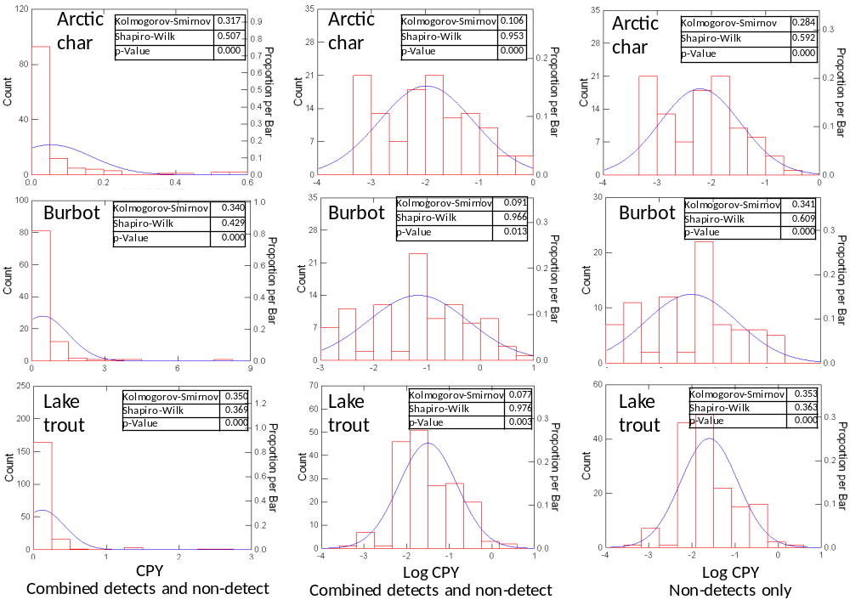
A.

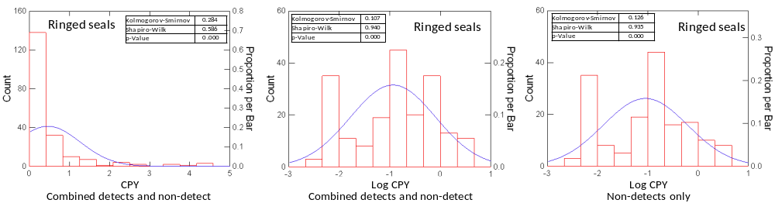
B.

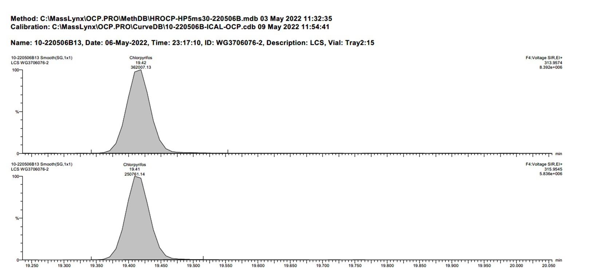
Figure S2. GC-HRMS chromatograms of a chlorpyrifos analytical standard (m/z 313.9574 and 313.9545)

Figure S3. GC-HRMS chromatograms of a method blank (m/z 313.9574 and 313.9545)
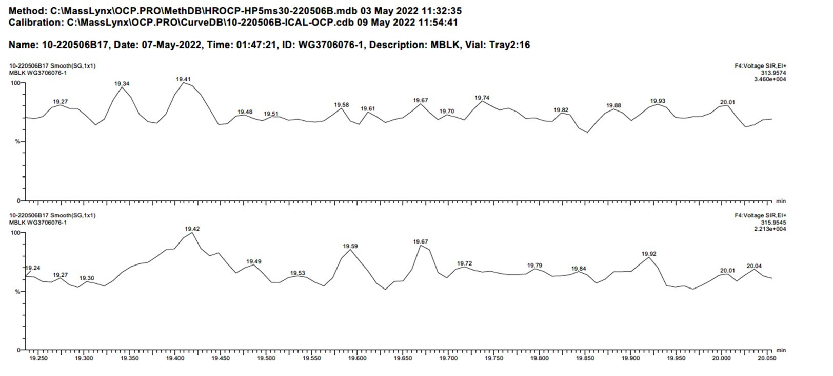

Figure S4. GC-HRMS chromatograms (m/z 313.9574 and 313.9545) of a non-detect sample, Lake Hazen char 2021-10, concentration <0.076 ng/g
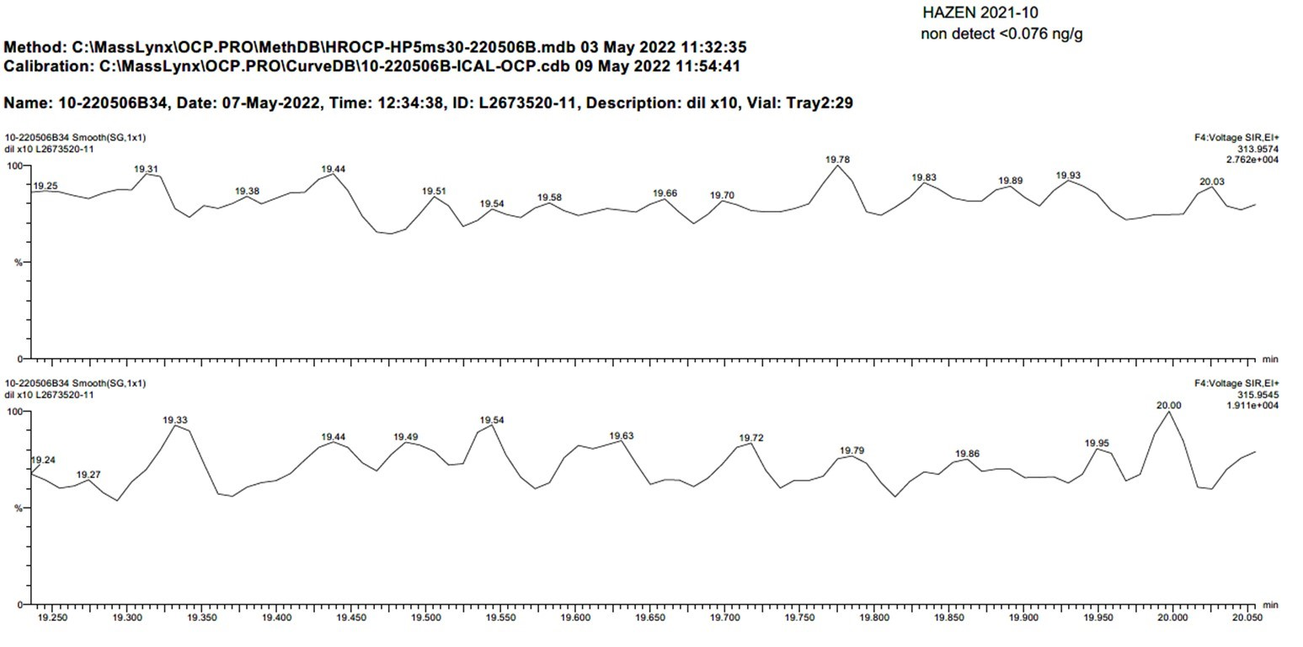

Figure S5. GC-HRMS chromatograms (m/z 313.9574 and 313.9545) of detected chlorpyrifos in Lake Hazen char 2021-12, concentration = 0.535 ng/g
