Large-scale climate drivers of interannual to multidecadal variability in rainfall occurrence during Indian summer monsoon
Lalit Pal^{1,2}* and Chandra Shekhar Prasad Ojha¹
¹Civil Engineering Department, Indian Institute of Technology Roorkee, India
²Lyles School of Civil Engineering, Purdue University, USA

Supplementary file

Figure S1. Trend in rainy days and rainfall of monsoon (June-September) season over India during 1901–2020. Observed trend in (a) rainy days (rainfall ≥ 1 mm) and (b) rainfall of monsoon season at each grid of 0.25° resolution rainfall dataset from IMD. Significance of trend in rainy days is tested using the approach proposed by Frei and Schar (2001) for count variables and using Mann-Kendall test for rainfall. Stipples denote statistically significant trends at 5% significance level. Percent area of each HMZ with significant negative (red bar) and positive (blue bar) trends in (c) rainy days and (d) rainfall. Double asterisk (**) on respective bar denotes field significant trends in the HMZ. Field significance of trends is tested using bootstrap method by Douglas et al. (2000).

Figure S2. Time series of SST indices for ENSO, IOD, and PDO for monsoon (JJAS) season and their global wavelet spectrum (GWS) computed from continuous wavelet transform (CWT).

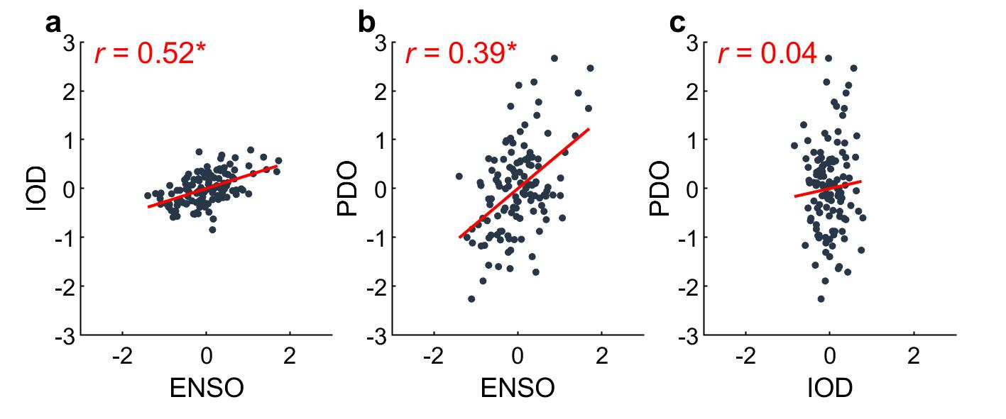
Figure S3. Scatter plot and cross-correlation between SST indices of ENSO, IOD, and PDO for monsoon (JJAS) season during 1901–2020. Correlation between (a) ENSO-IOD, (b) ENSO-PDO, and (c) IOD-PDO. Correlation is computed as Spearman Rank correlation and its statistical significance is tested using standard two-sample Student’s t-test denoted by asterisk (*).

Table S1. Years of warm (positive) and cold (negative) phase of ENSO, IOD, and PDO indices for monsoon (JJAS) season (See Methods).
Climate system | Phase | Year
ENSO | Warm (El Niño) | 1902, 1904, 1905, 1914, 1915, 1918, 1919, 1920, 1925, 1926, 1930, 1939, 1940, 1941, 1951, 1953, 1957, 1963, 1965, 1969, 1972, 1976, 1977, 1982, 1987, 1991, 1993, 1994, 1997, 2002, 2004, 2009, 2012, 2015, 2019
ENSO | Cold (La Niña) | 1909, 1910, 1916, 1922, 1924, 1933, 1938, 1942, 1945, 1947, 1949, 1950, 1952, 1954, 1955, 1956, 1959, 1964, 1970, 1971, 1973, 1974, 1975, 1978, 1984, 1985, 1988, 1989, 1998, 1999, 2000, 2007, 2010, 2011, 2020
IOD | Positive (pIOD) | 1902, 1905, 1908, 1913, 1914, 1918, 1919, 1923, 1925, 1926, 1934, 1935, 1943, 1944, 1946, 1949, 1951, 1961, 1963, 1966, 1967, 1972, 1976, 1982, 1983, 1987, 1991, 1994, 1997, 2006, 2007, 2008, 2011, 2012, 2015, 2017, 2018, 2019
IOD | Negative (nIOD) | 1901, 1906, 1909, 1910, 1911, 1916, 1928, 1933, 1942, 1945, 1947, 1954, 1955, 1956, 1958, 1959, 1960, 1964, 1968, 1969, 1970, 1971, 1973, 1980, 1981, 1984, 1985, 1986, 1989, 1990, 1992, 1996, 1998, 2004, 2005, 2013, 2014, 2016
PDO | Warm (wPDO) | 1902, 1905, 1912, 1913, 1915, 1923, 1926, 1934, 1935, 1936, 1937, 1940, 1941, 1942, 1947, 1957, 1958, 1976, 1979, 1981, 1983, 1985, 1986, 1987, 1992, 1993, 1995, 1996, 1997, 2003, 2004, 2014, 2015, 2016, 2019
PDO | Cold (cPDO) | 1901, 1904, 1909, 1916, 1920, 1922, 1933, 1944, 1946, 1948, 1949, 1950, 1951, 1952, 1955, 1956, 1961, 1962, 1963, 1964, 1967, 1970, 1971, 1972, 1973, 1975, 1978, 1999, 2000, 2001, 2008, 2010, 2011, 2012, 2013

