Table S1. Laboratory results.
Date | ACR (mg/g) | PCR (mg/g) | 24hUTP (g) | U-PRO  (g/L) | U-RBC  (Cells/μL) | Cr (μmoI/L)
Jun 19, 2019 | 4131 | - | 0.1 | ≥3.0 | TRACE | -
Jul 4, 2019 | 5755 | - | 0.23 | 0.3 | TRACE | -
Jul 19, 2019 | 1612 | - | 0.05 | 1 | TRACE | -
Aug 2, 2019 | 15 | - | 0.05 | ≥3.0 | TRACE | -
Aug 29, 2019 | 115 | - | 0.23 | NEG | TRACE | 56
 | - | - | - | ≥3.0 | TRACE | -
 | - | - | - | NEG | NEG | -
Dec 10, 2019 | 1219 | 1564 | 0.05 | ≥3.0 | 25 | 59
May 8, 2020 | - | - | 0.13 | 0.3 | NEG | -
Jun 18, 2020 | - | - | - | NEG | TRACE | 65
Aug 31, 2020 | - | - | - | ≥3.0 | NEG | 54
 | - | - | 0.05 | 1 | 25 | -
 | - | - | - | ≥3.0 | TRACE | -
Mar 15, 2021 | 1794 | 2422 | 0.1 | 1 | NEG | 62
ACR, albumin-creatinine ratio; PCR, protein-creatinine ratio; 24hUTP, 24-hour urinary total protein; U-PRO, U-RBC, urinary protein and red blood cell detected by dry chemistry method.

Table S2. Renal venous peak flow velocity
Detection Part | Velocity of RRV (m/s) | Velocity of LRV (m/s)
Resting state
IVC | 63.8 | 35.7
Near renal hilum | 73.6 | N.T.
Renal hilum | 94.2 | 47.2
After activity
IVC | 26 | 24
Renal hilum | 42.2 | 21.5
In the resting state, the velocity of LRV was 35.7m/s and 47.2m/s at the proximal and distal left renal hilum, lower than that of right side which was 63.8m/s and 94.2m/s. The moment right after her coming to the hospital, the velocity changed to 24m/s and 21.5m/s at proximal and distal part of the left hilum, and the number was 26m/s and 42.2m/s at the right side. The velocity of left hilum after exercise is the lowest, representing its highest resistance. IVC, inferior vena cava. N.T., not test.

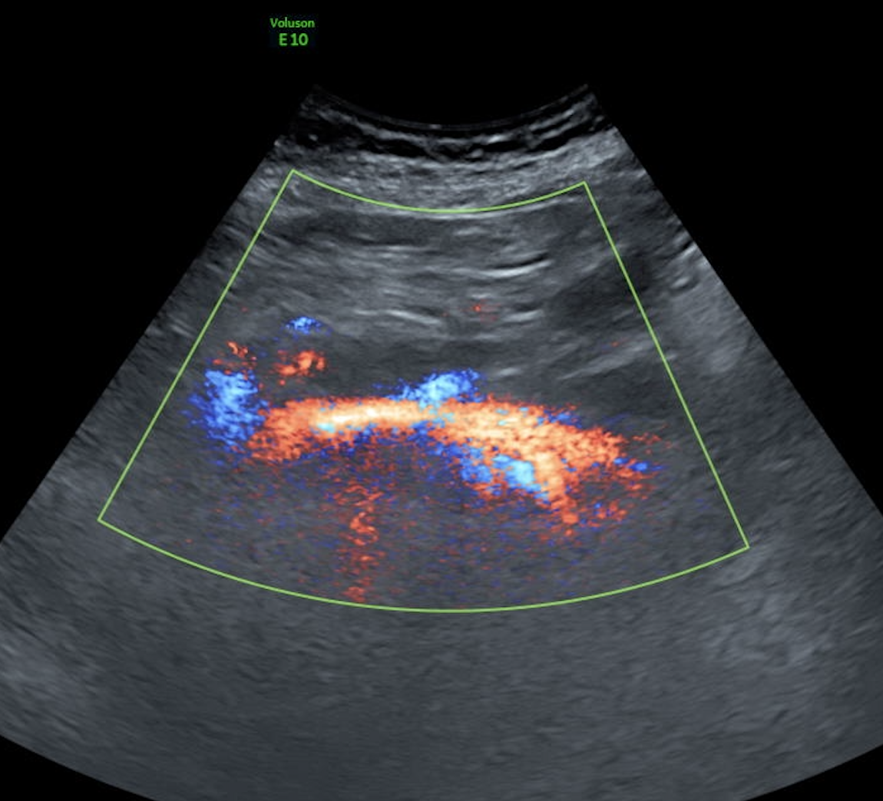
Figure S1. At the junction of LRV and RRV, the blood flow direction was from right to left, as shown by power Doppler. LRV, left renal vein; RRV, right renal vein.

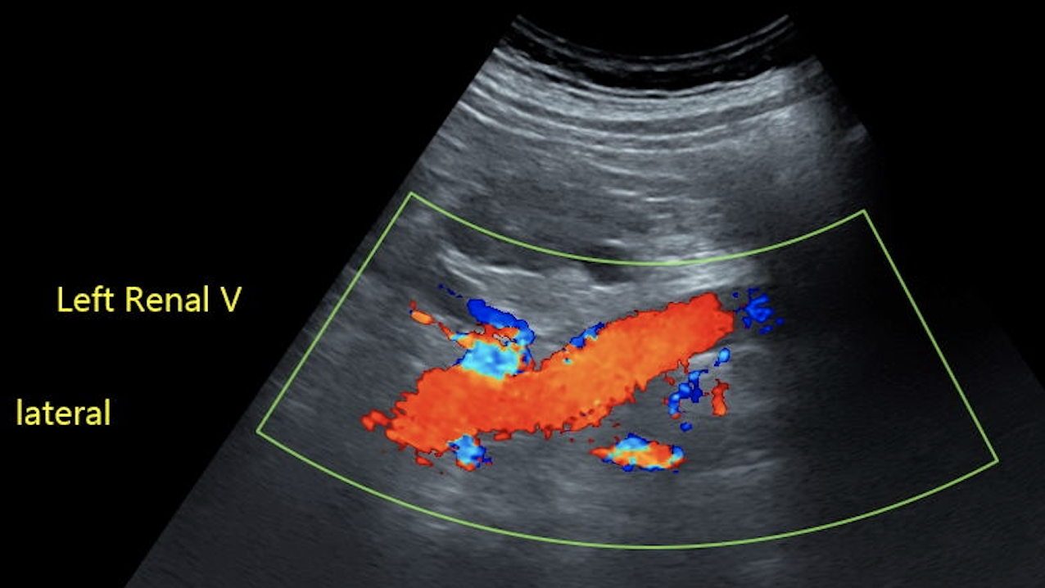
Figure S2. Nearing the left renal hilum, a bundle of blood flow originated from the LRV drained into a communicating vessel consistent with the vessel marked by % in Figure 1. LRV, left renal vein.

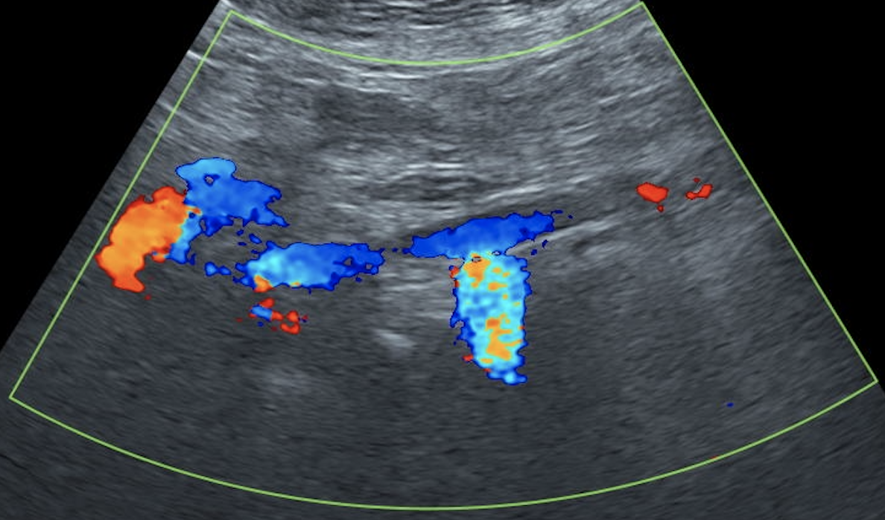
Figure S3. At one part of the IVC below the level of the RRV, a bundle of gross blood flow signal indicated that the IVC drained into the lumbar vein reversely. IVC, inferior vena cava. RRV, right renal vein.

