Supplementary Materials for

The Curious Case of the Structural Phase Transition in SnSe: Insight from Neutron Total Scattering

Bo Jiang^{1,7†}, Jennifer Neu^{2,3,4†}, Daniel Olds^{1,5}, Simon A J Kimber⁶, Katharine Page^{1,7*}, Theo Siegrist^{2,8*}
Affiliations:
¹ Neutron Scattering Division, Oak Ridge National Laboratory, Oak Ridge, TN 37830, USA.
² National High Magnetic Field Laboratory, Tallahassee, FL 32310, USA.
³ Dept. of Physics 77 Chieftain Way, Florida State University, Tallahassee, FL 32306-4350, USA.
⁴ Dept. of Chemistry & Biochemistry 95 Chieftain Way 118 DLC, Florida State University, Tallahassee, FL 32306-4390, USA.
⁵ National Synchrotron Light Source II, Brookhaven National Laboratory, Upton, NY 11973-5000, USA.
⁶ Laboratoire Interdisciplinaire Carnot de Bourgogne, UMR 6303 CNRS-Université Bourgogne Franche-Comté, 9 avenue Alain Savary, BP 47870, F-21078 Dijon Cedex, FRANCE.
⁷ Materials Science and Engineering Department and Joint Institute for Advanced Materials, Knoxville, TN 37996, USA.
⁸ Department of Chemical and Biomedical Engineering, FAMU-FSU College of Engineering, Tallahassee, FL 32310-6046, USA.
*Corresponding author email: kpage10@utk.edu; tsiegrist@fsu.edu;

†These authors contributed equally to this work.

This PDF file includes:

Figs. S1 to S12
Table S1

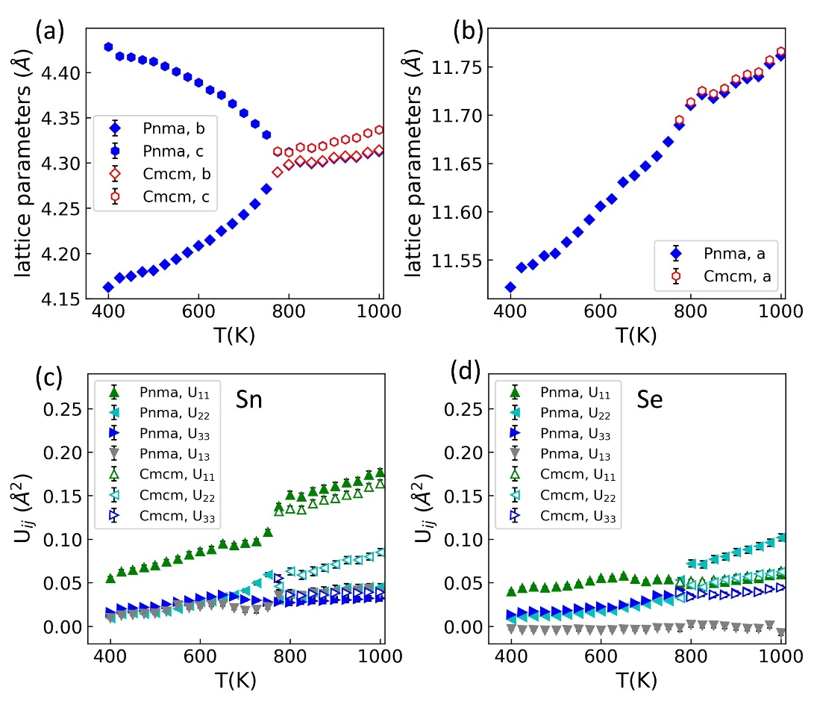
Fig. S1. Temperature dependent lattice parameters and atomic anisotropic displacement parameters (ADP) from Rietveld refinements using neutron diffraction data.

Table S1. The agreement factor (R_{w}), lattice parameters and atomic position parameters from Rietveld refinement of neutron diffraction data using the GeS-type model (Pnma, with 43 parameters) and TlI-type model (Bbmm, with 39 parameters, standard Cmcm) space group model.

T(K) | R_{w} (%) | Pnma a  (Å) | Pnma b (Å) | Pnma c (Å) | Pnma Sn x | Pnma Sn z | Pnma Se x | Pnma Se z
400 | 7.546 | 11.5216(15) | 4.1623(5) | 4.4282(5) | 0.11856(16) | 0.4008(3) | 0.35442(16) | 0.4807(3)
425 | 7.166 | 11.5420(15) | 4.1729(5) | 4.4182(5) | 0.11898(17) | 0.4040(4) | 0.35464(18) | 0.4805(3)
450 | 7.058 | 11.5454(15) | 4.1747(5) | 4.4170(5) | 0.11906(17) | 0.4044(4) | 0.35474(18) | 0.4806(3)
475 | 6.802 | 11.5543(14) | 4.1795(4) | 4.4139(5) | 0.11915(16) | 0.4056(3) | 0.35477(14) | 0.4806(2)
500 | 6.787 | 11.5565(14) | 4.1810(4) | 4.4120(5) | 0.11919(17) | 0.4062(4) | 0.35482(17) | 0.4807(3)
525 | 6.710 | 11.5685(14) | 4.1875(4) | 4.4071(5) | 0.11931(18) | 0.4083(4) | 0.35489(17) | 0.4807(3)
550 | 6.607 | 11.5789(14) | 4.1937(4) | 4.4009(5) | 0.11958(19) | 0.4106(4) | 0.35505(17) | 0.4809(3)
575 | 6.562 | 11.5915(14) | 4.2008(4) | 4.3950(5) | 0.11983(20) | 0.4129(4) | 0.35528(18) | 0.4813(3)
600 | 6.504 | 11.6054(14) | 4.2083(4) | 4.3888(5) | 0.12035(21) | 0.4155(4) | 0.35582(19) | 0.4816(3)
625 | 6.585 | 11.6130(15) | 4.2146(4) | 4.3807(5) | 0.12056(22) | 0.4183(4) | 0.35604(19) | 0.4818(3)
650 | 6.209 | 11.6305(15) | 4.2245(4) | 4.3753(5) | 0.12115(22) | 0.4219(4) | 0.35645(20) | 0.4822(4)
675 | 6.338 | 11.6373(15) | 4.2326(5) | 4.3655(5) | 0.12170(22) | 0.4264(5) | 0.35656(19) | 0.4825(4)
700 | 6.406 | 11.6471(16) | 4.2426(5) | 4.3550(6) | 0.12227(22) | 0.4317(5) | 0.35680(19) | 0.4830(4)
725 | 6.405 | 11.6575(16) | 4.2546(5) | 4.3434(6) | 0.12278(21) | 0.4385(6) | 0.35705(19) | 0.4834(5)
750 | 6.405 | 11.6725(16) | 4.2712(5) | 4.3310(6) | 0.12379(23) | 0.4473(7) | 0.35772(21) | 0.4850(6)
775 | 7.220 | 11.6898(16) | 4.2896(6) | 4.3124(7) | 0.12530(29) | 0.4602(9) | 0.35905(23) | 0.4952(7)
800 | 7.687 | 11.7102(17) | 4.2974(7) | 4.3121(7) | 0.1267(3) | 0.4726(12) | 0.35994(26) | 0.5012(10)
825 | 7.544 | 11.7212(17) | 4.3013(7) | 4.3175(7) | 0.1265(3) | 0.4723(12) | 0.35979(27) | 0.5012(10)
850 | 7.438 | 11.7173(17) | 4.2995(7) | 4.3162(7) | 0.1268(3) | 0.4733(12) | 0.36014(27) | 0.5007(10)
875 | 7.187 | 11.7234(18) | 4.3013(7) | 4.3188(7) | 0.1269(3) | 0.4732(12) | 0.36017(27) | 0.5012(10)
900 | 7.067 | 11.7332(18) | 4.3048(7) | 4.3235(7) | 0.1269(3) | 0.4729(12) | 0.36008(27) | 0.5013(10)
925 | 6.940 | 11.7379(18) | 4.3061(7) | 4.3260(7) | 0.1270(4) | 0.4729(12) | 0.36014(28) | 0.5020(10)
950 | 6.781 | 11.7400(19) | 4.3064(7) | 4.3279(7) | 0.1269(4) | 0.4730(12) | 0.36012(28) | 0.5014(11)
975 | 6.623 | 11.7530(19) | 4.3104(8) | 4.3331(7) | 0.1273(4) | 0.4731(12) | 0.36020(29) | 0.5023(11)
1000 | 6.460 | 11.7612(19) | 4.3128(8) | 4.3368(7) | 0.1276(4) | 0.4728(12) | 0.36037(29) | 0.5034(11)
T(K) | R_{w} (%) | Cmcm a  (Å) | Cmcm b (Å) | Cmcm c (Å) | Cmcm Sn x | Cmcm Sn z | Cmcm Se x | Cmcm Se z
775 | 7.634 | 11.6953(18) | 4.2898(6) | 4.3130(7) | 0.1278(3) | 0.5 | 0.35951(27) | 0.5
800 | 7.795 | 11.7134(17) | 4.2983(8) | 4.3116(8) | 0.1277(3) | 0.5 | 0.35958(27) | 0.5
825 | 7.735 | 11.7252(18) | 4.3022(8) | 4.3174(8) | 0.1275(3) | 0.5 | 0.35940(29) | 0.5
850 | 7.595 | 11.7221(19) | 4.3005(8) | 4.3166(8) | 0.1279(4) | 0.5 | 0.35985(30) | 0.5
875 | 7.275 | 11.7277(18) | 4.3023(8) | 4.3187(8) | 0.1280(4) | 0.5 | 0.35986(28) | 0.5
900 | 7.233 | 11.7374(19) | 4.3060(8) | 4.3233(8) | 0.1281(4) | 0.5 | 0.35981(28) | 0.5
925 | 7.108 | 11.7424(19) | 4.3073(8) | 4.3259(8) | 0.1282(4) | 0.5 | 0.35996(29) | 0.5
950 | 6.949 | 11.7446(19) | 4.3076(8) | 4.3277(8) | 0.1281(4) | 0.5 | 0.35986(29) | 0.5
975 | 6.864 | 11.7571(20) | 4.3116(8) | 4.3329(8) | 0.1287(4) | 0.5 | 0.36014(30) | 0.5
1000 | 6.618 | 11.7661(20) | 4.3142(8) | 4.3366(8) | 0.1288(4) | 0.5 | 0.36021(30) | 0.5
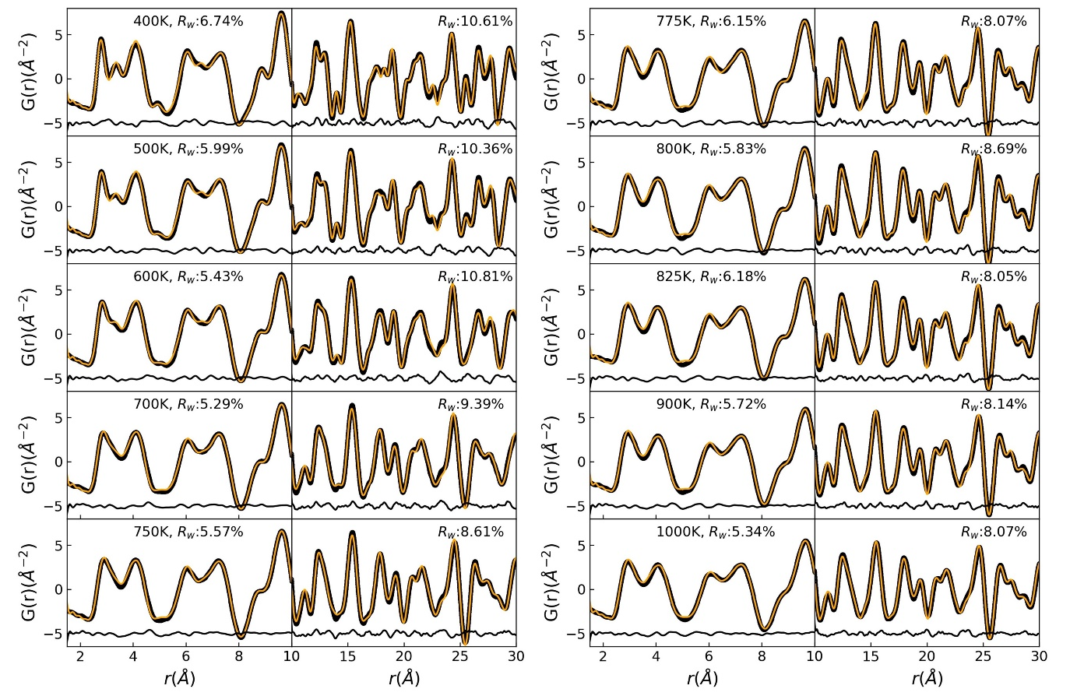
Fig. S2. Temperature dependent PDF refinements of neutron data using GeS-type (Pnma) space group at low-r range fits to the 1.5-10 Å PDF region and high-r range fits to the 10-30 Å. Selected temperature points are shown from 400 K to 1000 K.

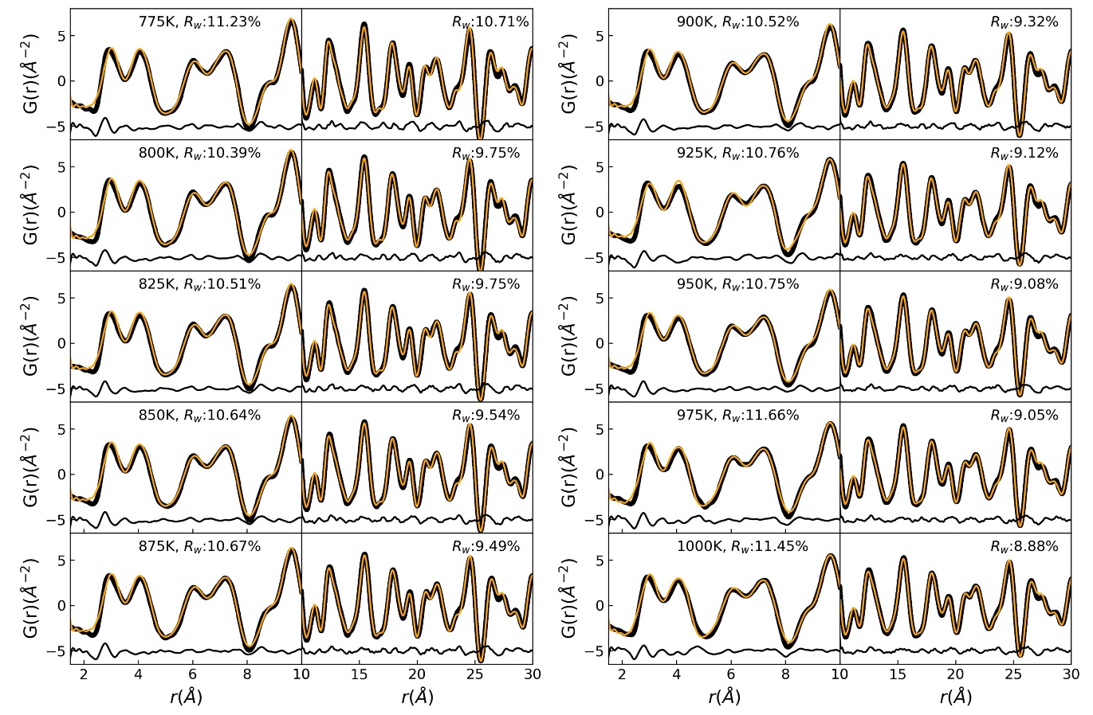
Fig. S3. Temperature dependent PDF refinements of neutron data using the TlI-type (Cmcm) space group model. Fits of the low-r range (1.5 Å -10 Å) PDF region are shown at a different scale relative to first of the high-r range (10 Å -30 Å) PDF region. Temperature points are shown from 775 K to 1000 K.

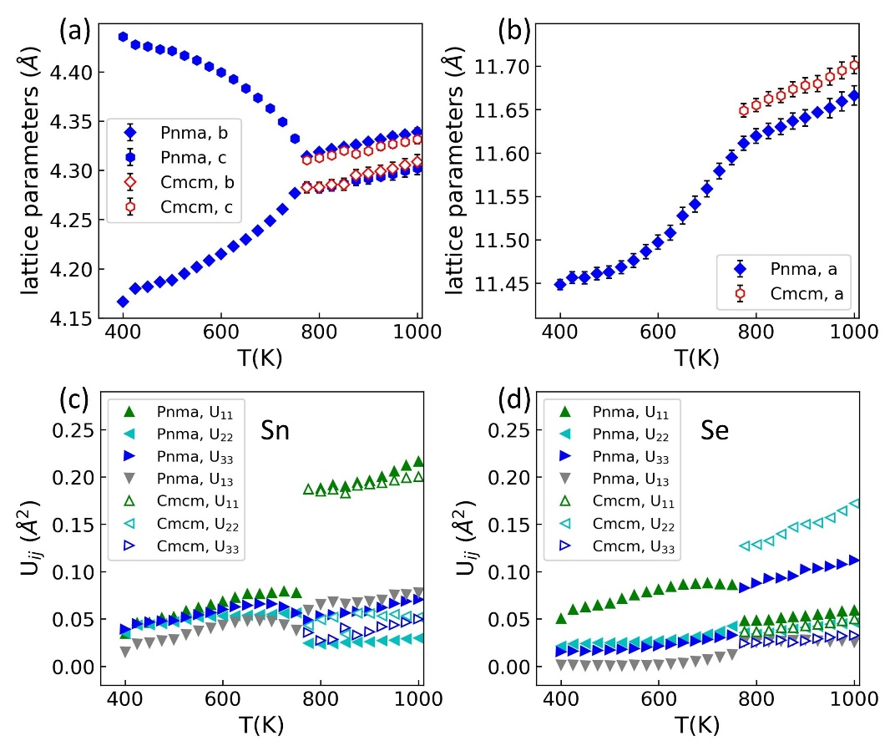
Fig. S4. Temperature dependent lattice parameters (with error bars) and atomic displacement parameters (ADP) from PDF refinements using data in the real space r-range of 1.5 Å to 30 Å. If error bars are not visible they are smaller than the data markers.

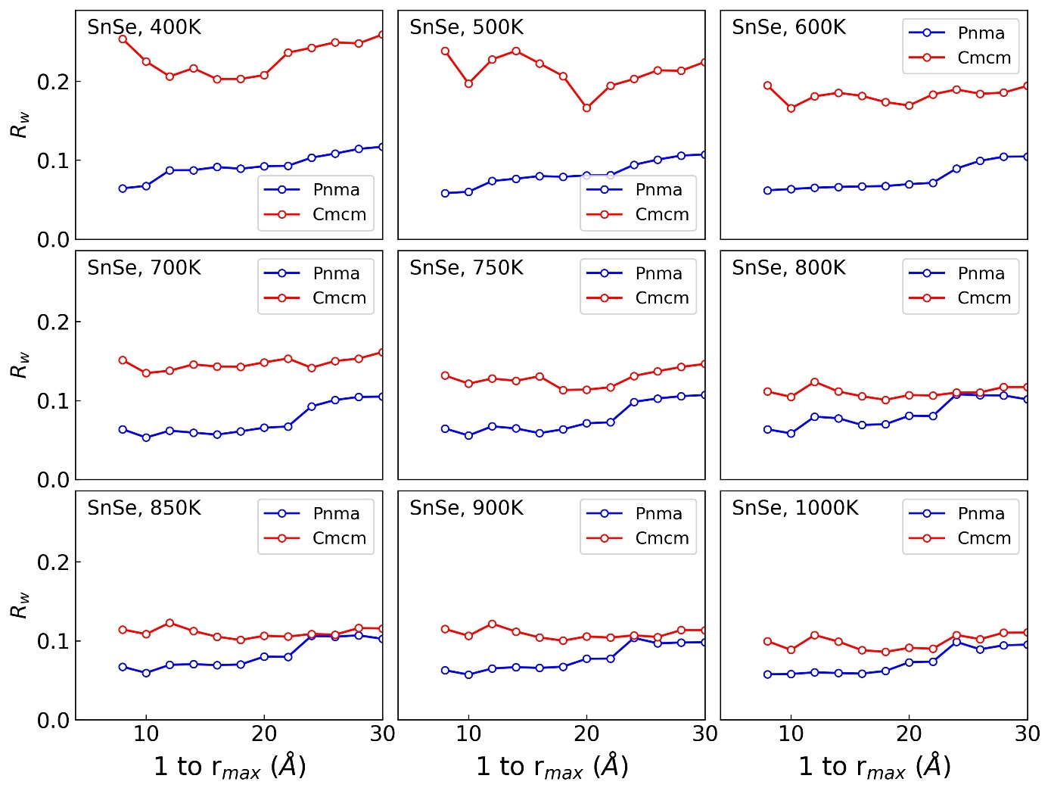
Fig. S5. A comparison of the calculated agreement factors (R_{w}) between refinements using room temperature phase Pnma and high temperature phase Cmcm models across varying r_{max} range of selected temperature datasets.

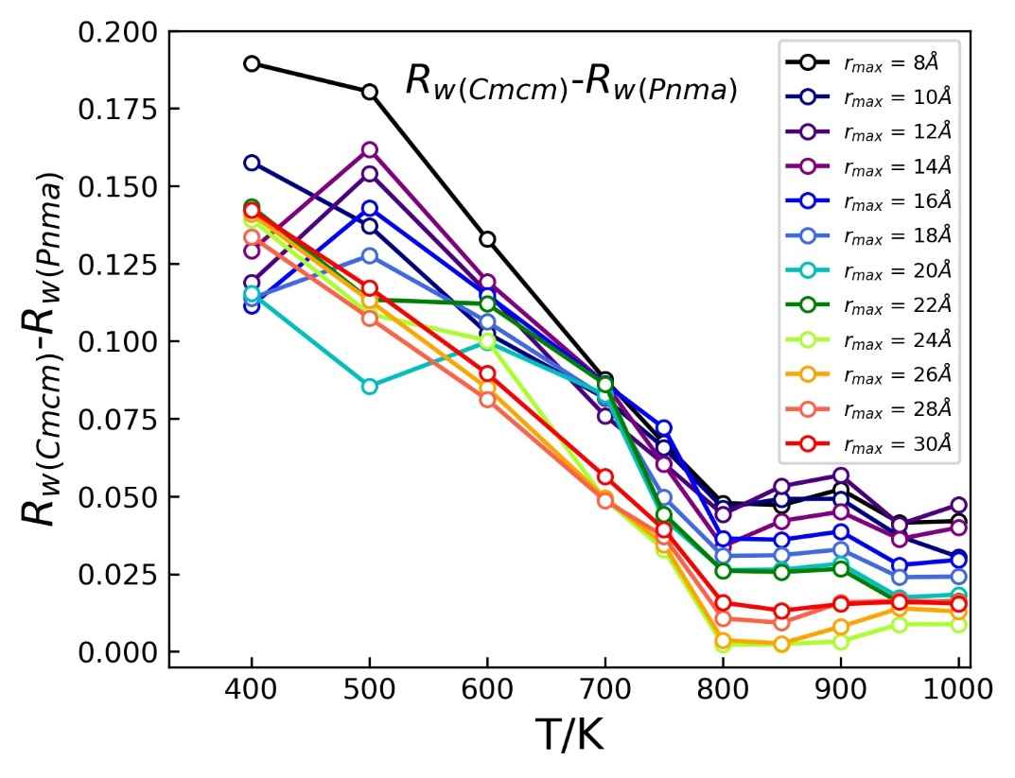

Fig. S6. The calculated agreement factor (R_{w}) difference between refinements using room temperature phase Pnma and high temperature phase Cmcm models across increasing r_{max} ranges of various temperature datasets. There are three correlation length scales: below ~12 Å, 12 Å to 24 Å, and above ~24 Å, corresponding to the approximately two unit cell lengths (2 x a lattice dimension) of the Pnma-like local order, a ‘mixed phase’ regime, and the Cmcm-like (average structure) order range. Note that the two models are symmetry related, with Pnma containing more refinable parameters. The fact that the Pnma model performs better over the entire real-space range fit (even above the average structure phase transition temperature) reflects the influence of the persistent local order observed at all temperatures.

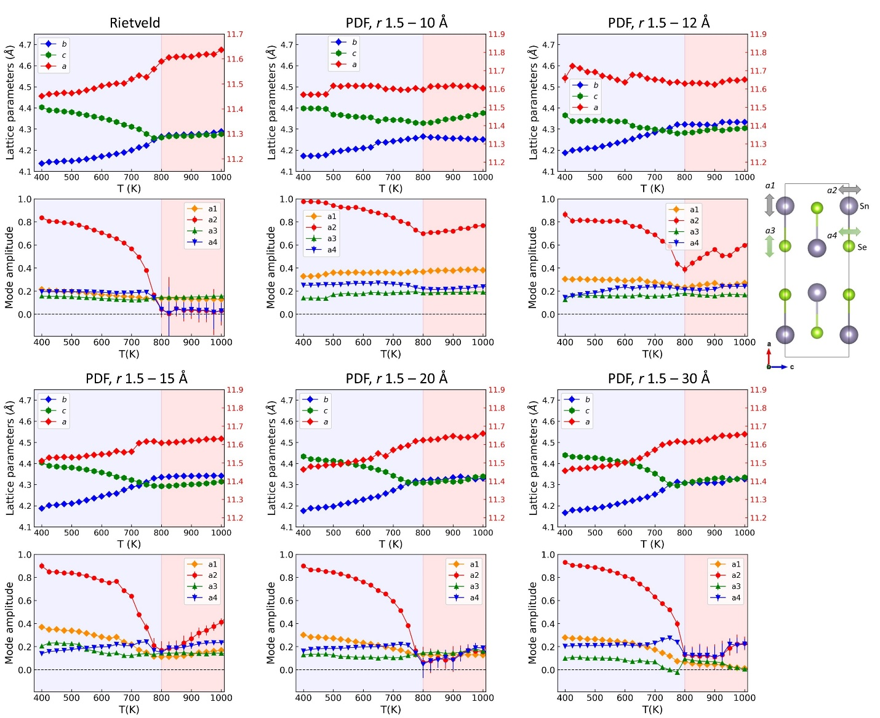
Fig. S7. Refined lattice parameters and four mode amplitudes across the SnSe phase transition, displayed separately according to discrete data length-scales. Symmetry-mode based Rietveld and PDF refinements were performed sequentially using the TOPAS v6 suite in conjunction with ISODISTORT.

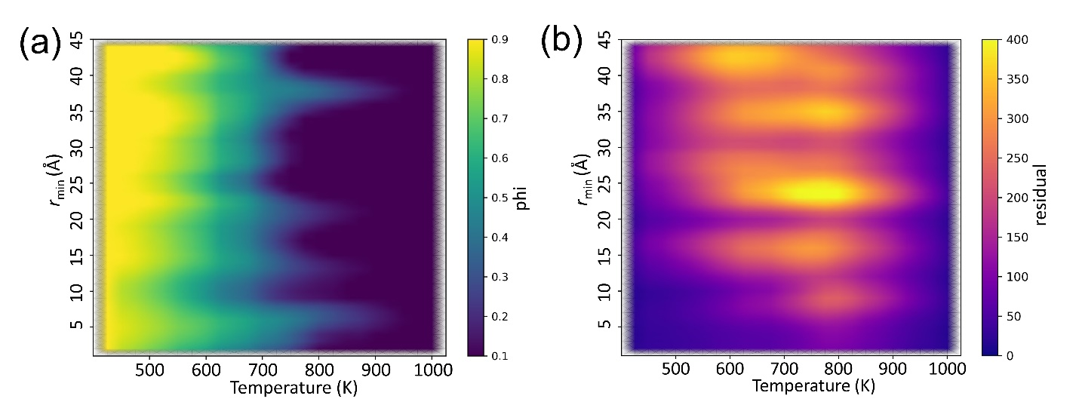

Fig. S8. (a) r-dependent CATS analysis performed with a constant box-width of 4 Å from ranges 1-5 Å up to 46-50 Å. (b) Residual map of qualitative difference in CATS fit quality above r =10 Å.

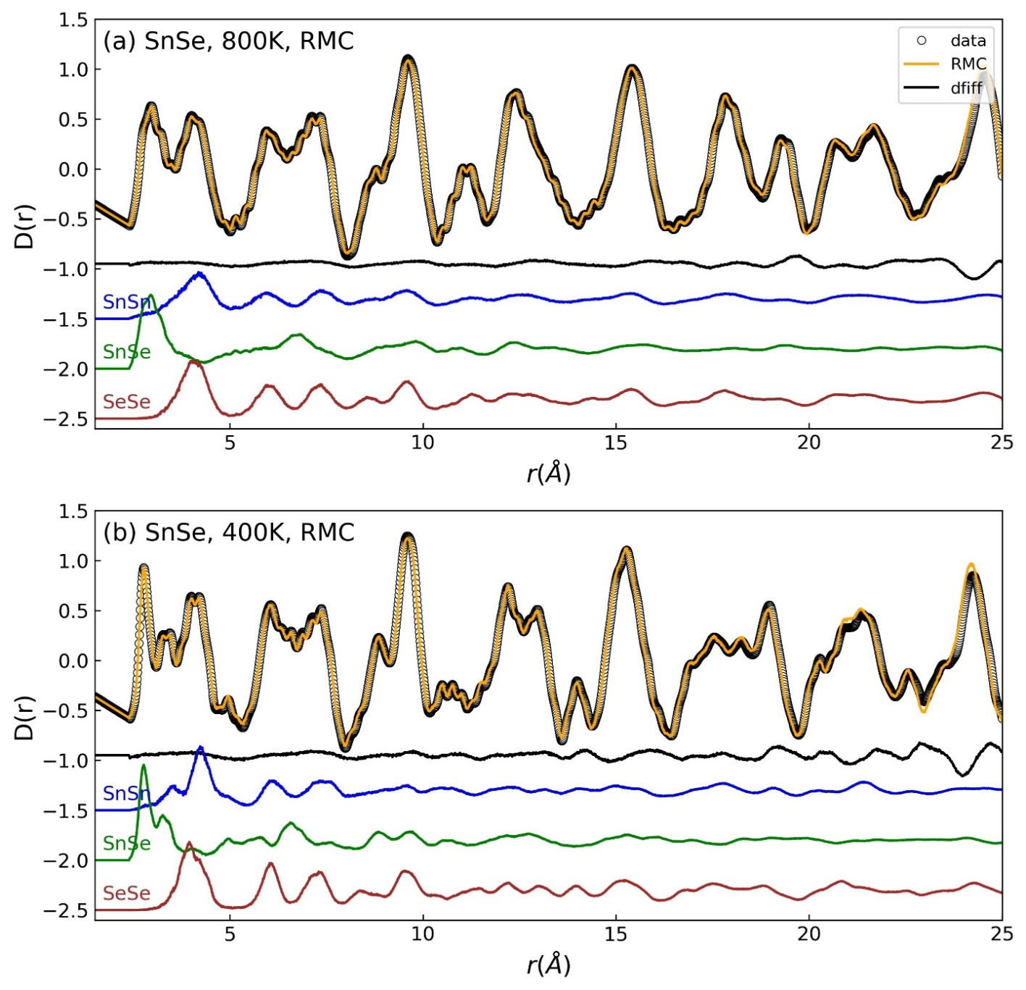
Fig. S9. Neutron total scattering fits to D(r) (black circles) in the RMC simulation (orange lines) for SnSe at (a) 800 K, and (b) 400 K, with partial pair correlation functions from models shown below as separate, labeled, colored lines.

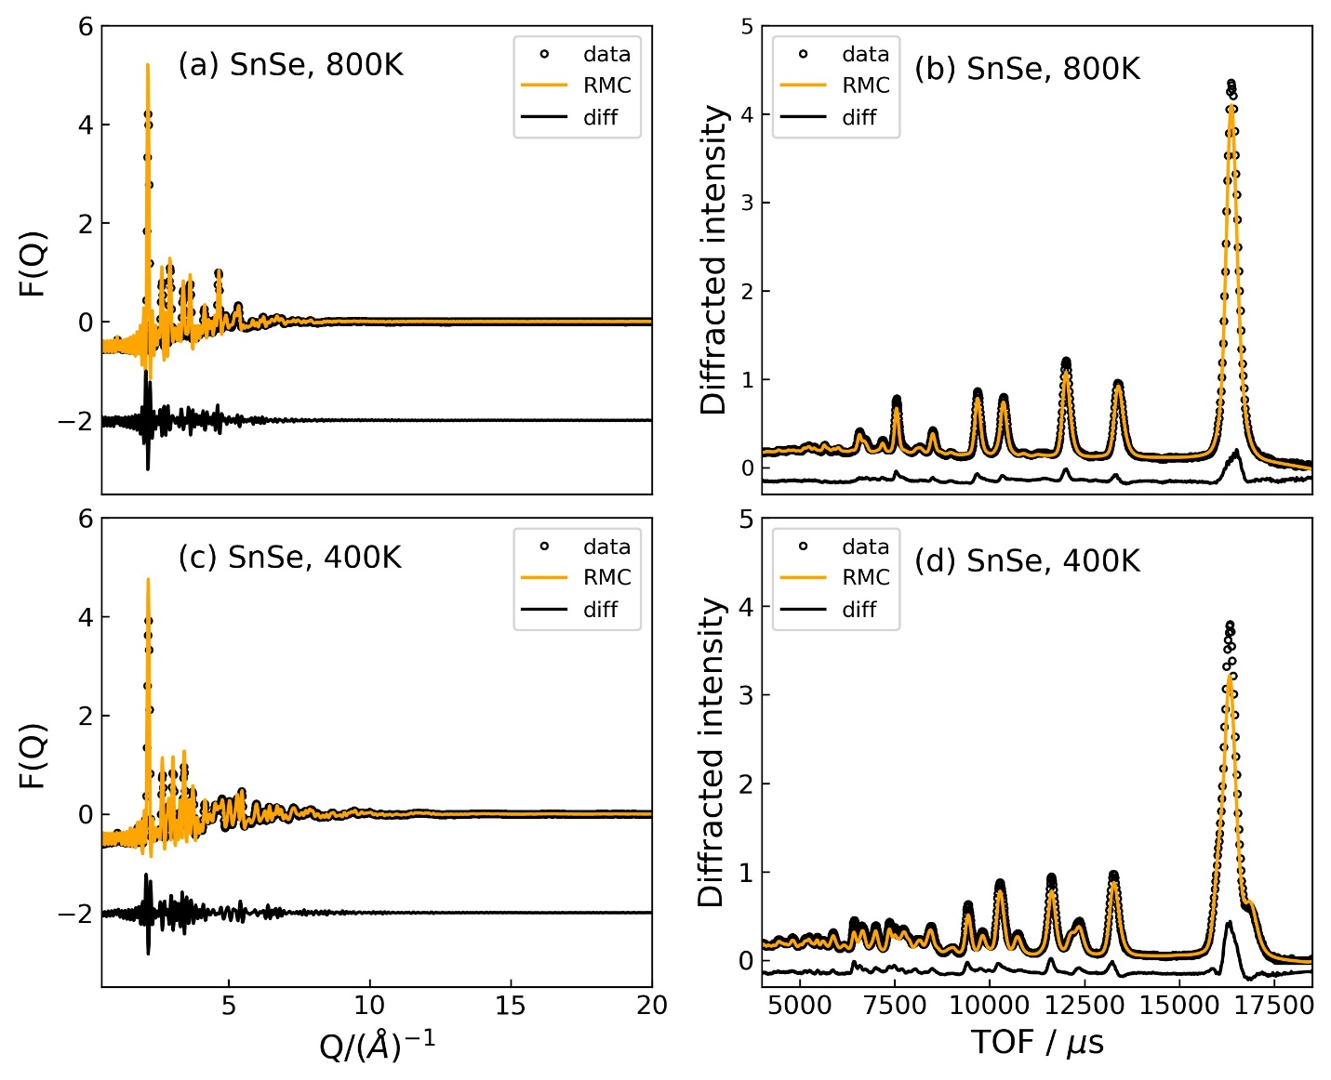
Fig. S10. Neutron total scattering fits to F(Q) and Bragg data in RMC simulation (orange lines) for SnSe at (a, b) 800 K, (c, d) 400 K. The weight assigned to D(r), F(Q) and Bragg data set were automatically adjusted during RMC simulations.

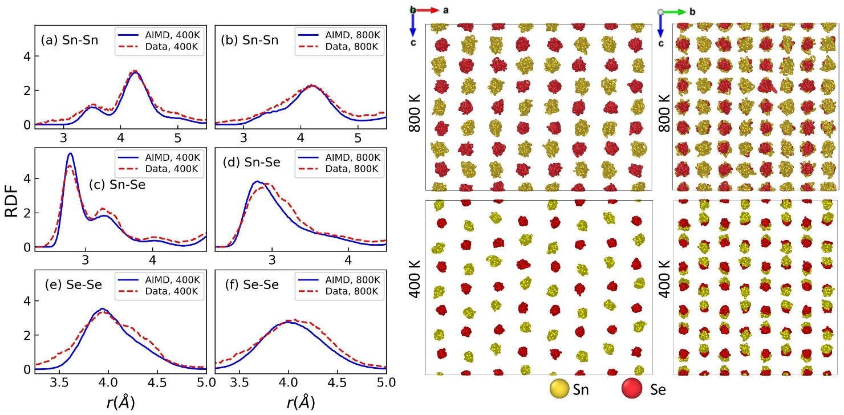
Fig. S11. Comparison of atomic pair correlations from the radial distribution function (RDF) between AIMD simulations and RMC model. The corresponding trajectory projections of AIMD simulations at 800 K and 400 K of SnSe derived from stable phase were shown on the right.

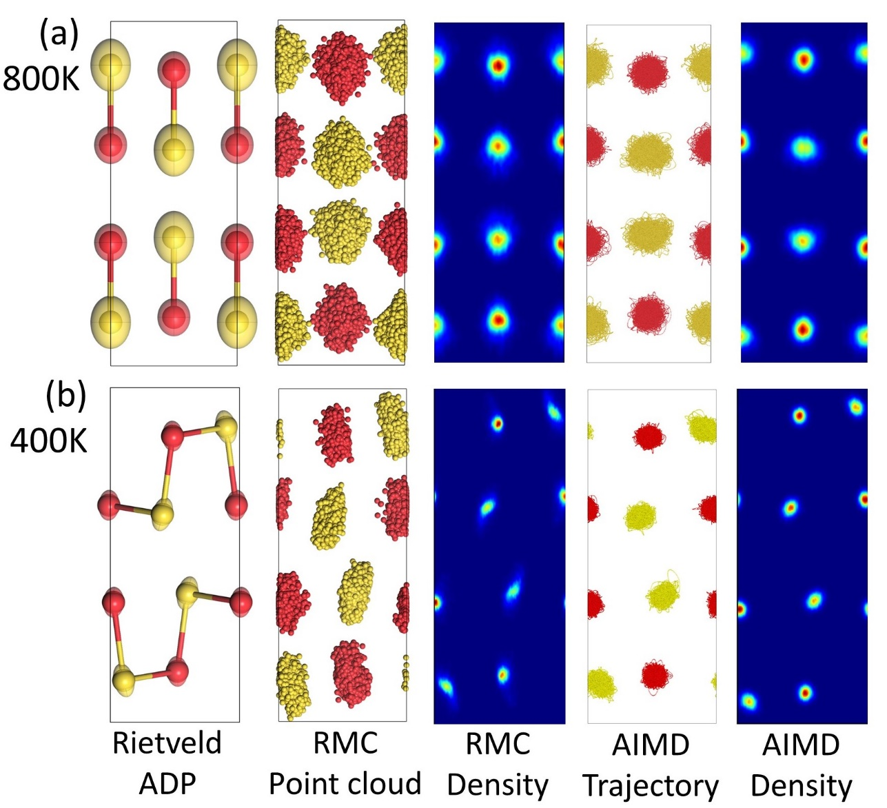
Fig. S12. Structure model results from Rietveld analysis, RMC analysis and AIMD simulation at (a) 800 K, (b) 400 K. Panels from left to right compare the unit cell contents corresponding to the determined ADP ellipsoids from Rietveld analysis (400 K using GeS-type (Pnma) model, 800 K using TlI-type (Bbmm, standard Cmcm) model, the atomic point cloud distributions (folded into a single unit cell) from RMC configurations, density plots of the RMC point clouds, AIMD trajectory projections (folded into a single unit cell), and corresponding density plots of the AIMD projections, respectively.

