Graph n°1 : Reference, societal and scientific ranking of the measures of SNB3 axis 2
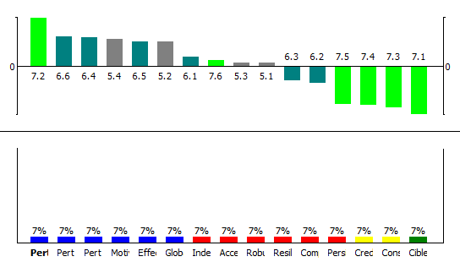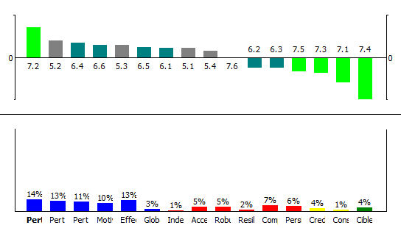
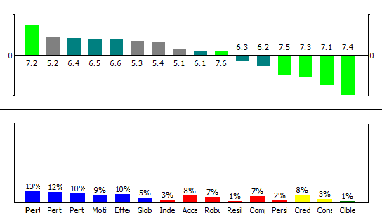
From left to right: reference scenario, societal scenario and scientific scenario

Graph n°X: Comparison of the three scenarios, axis 2

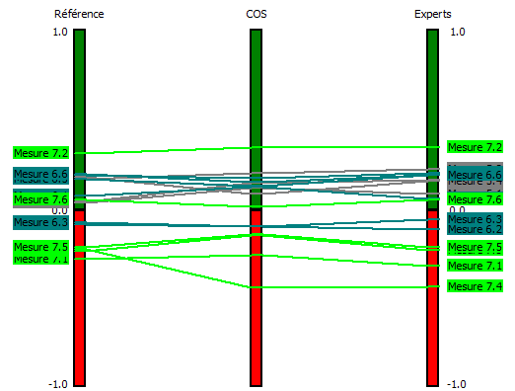

Graph n°X: Criteria involved in the ranking of Axis 2 measures - Reference scenario

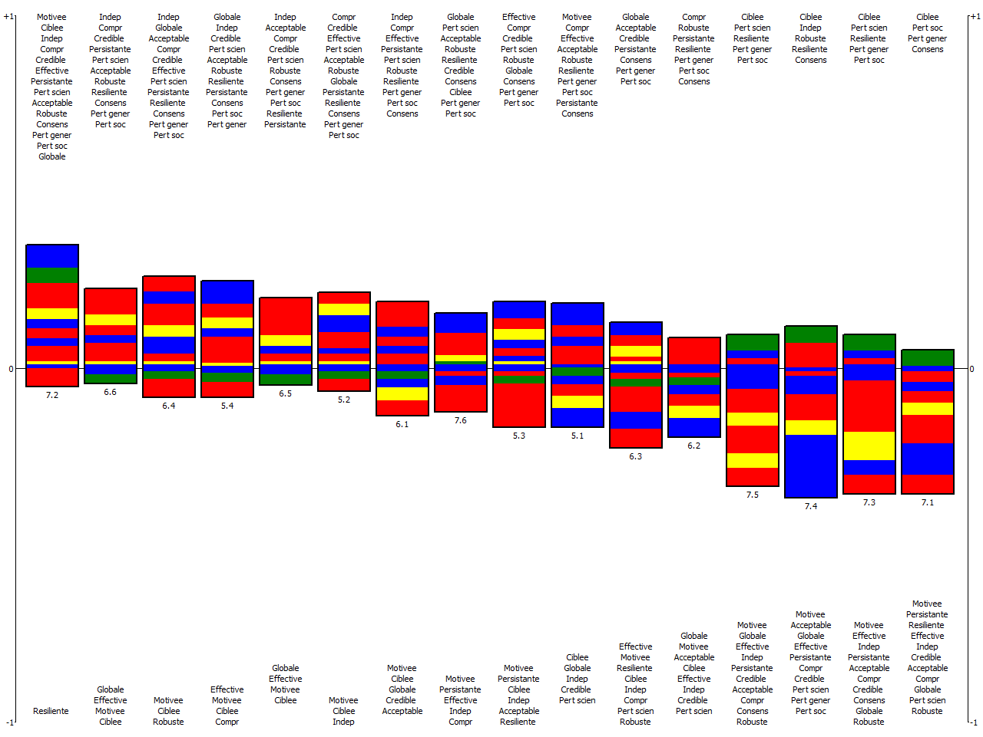

Graph n°2: Integration of the implementation criteria for measure 7.1
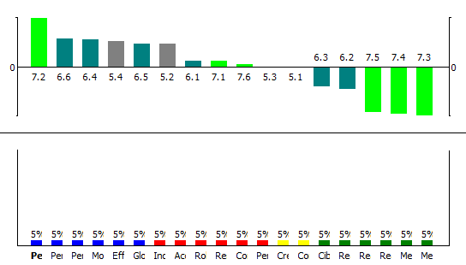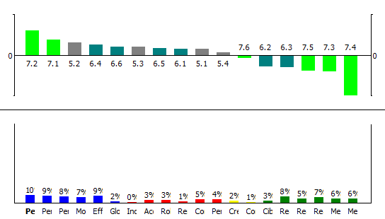
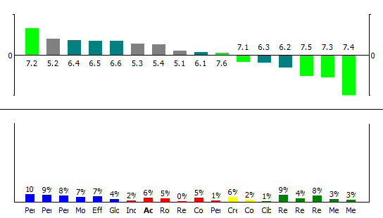
From left to right: reference scenario, societal scenario, scientific scenario.

